**SUBJECT:** Project Proposal - CitiBike NYC Value-Added Analysis

**ISSUE:** CitiBike NYC has contracted with the Data-Bootcamp Analysis Team to review their existing bike station network designed to provide an affordable and economical transportation alternative for quick trips in and around the New York City area. The team will examine CitiBike’s current “full-stack” product(s) which are geared toward the customer and served up to the public at <https://www.citibikenyc.com/>). The analysis team will develop recommended additions to existing products that go beyond the customer’s needs and focus on providing data driven insight in support of CitiBike’s resourcing decisions related specifically to network capacity and enhancing bicycle availability.



**BACKGROUD:** Citi Bike is the nation's largest bike share program, with 12,000 bikes and 750 stations across Manhattan, Brooklyn, Queens and Jersey City. The existing CitiBike NYC site offers a live dashboard of station capabilities, monthly reports, and quarterly summary statistics all geared toward their riders and the general public.

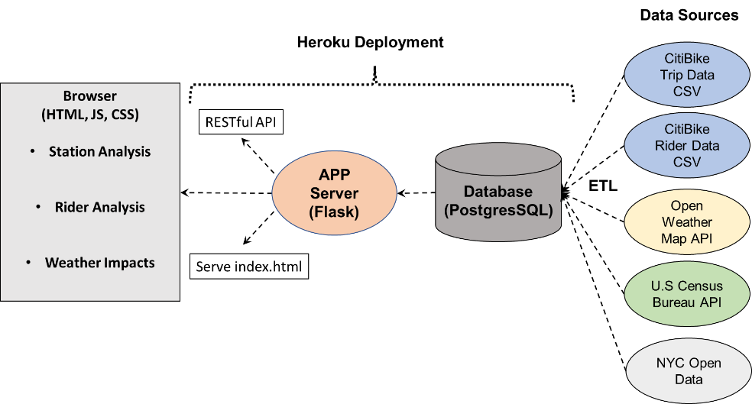**PROJECT SCOPE AND METHODOLOGY:** The Project will focus primarily on daily commuter bike use in and out of the NYC area. Initial analysis will be limited to bikes that start and end at a CitiBike station. Data from CitiBike will be combined with weather data, U.S. Census data, and data from NYC Open Data site and will be stored in PostgresSQL database. A Flask APP Server will support a RESTFul API and serve index.html files in support of the Browser. The Browser will include a nonstandard D3.js node analysis of bike trips between stations, an interactive dashboard that visualizes the team’s analysis and offers user-driven interaction allowing the user to drill down into the data for enhanced insight. The final Project will be deployed on Heroku.

**DELIVERABLES:** The Project will be presented (in-person) on Saturday, 7 September 2019. Any feedback will be incorporated and provided NLT 24 hours following the presentation. All products associated with this analysis will be published to Github at <https://jamie-miller-rva.github.io/CitiBike-Analysis/>

**SAMPLE DATA:** CitiBike shares its data at <https://www.citibikenyc.com/system-data>



**VISUALIZATIONS:** The following are provided to provide a general “flavor” of final product visualizations (and is not all inclusive). Visualizations will convey information in a similar fashion:

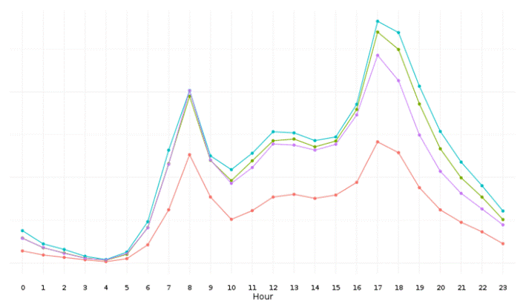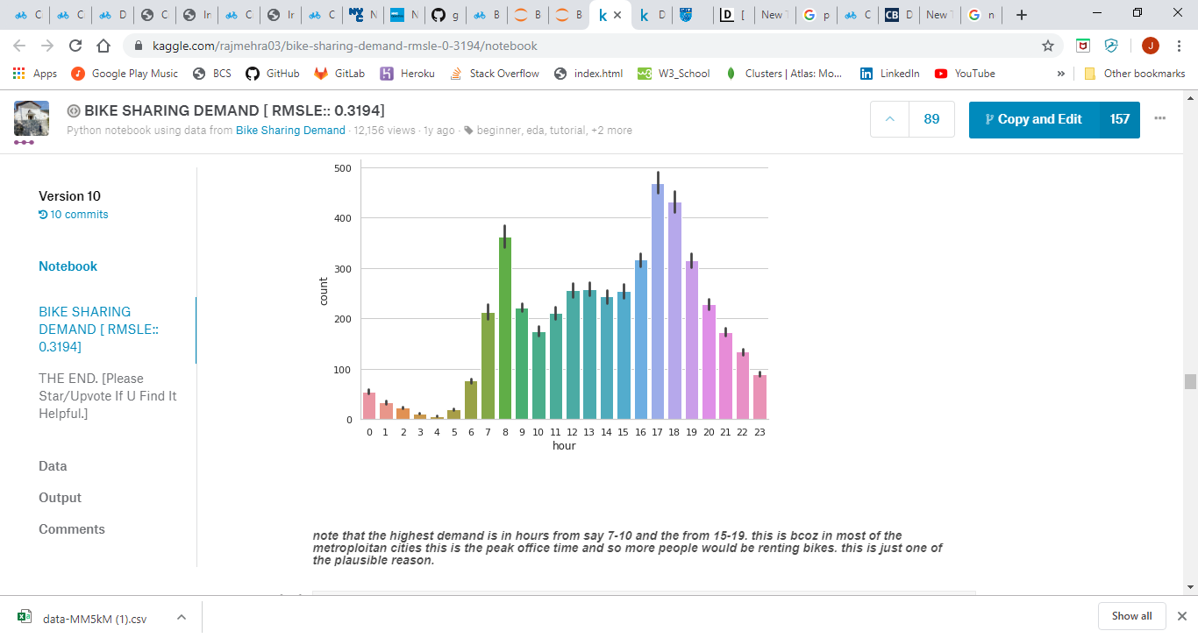

Ride data showing hourly trends Ride data showing hourly trends by season



Node analysis of trip data

**TEAM WORK BREAKDOWN STRUCTURE:**

* Database Lead: Custis Baucom
* Flask APP Lead: Smitha Lal
* Browser Lead: Danica Rios
* Dashboard Lead: Nush Rama
* Project Coordinator: Jamie Miller