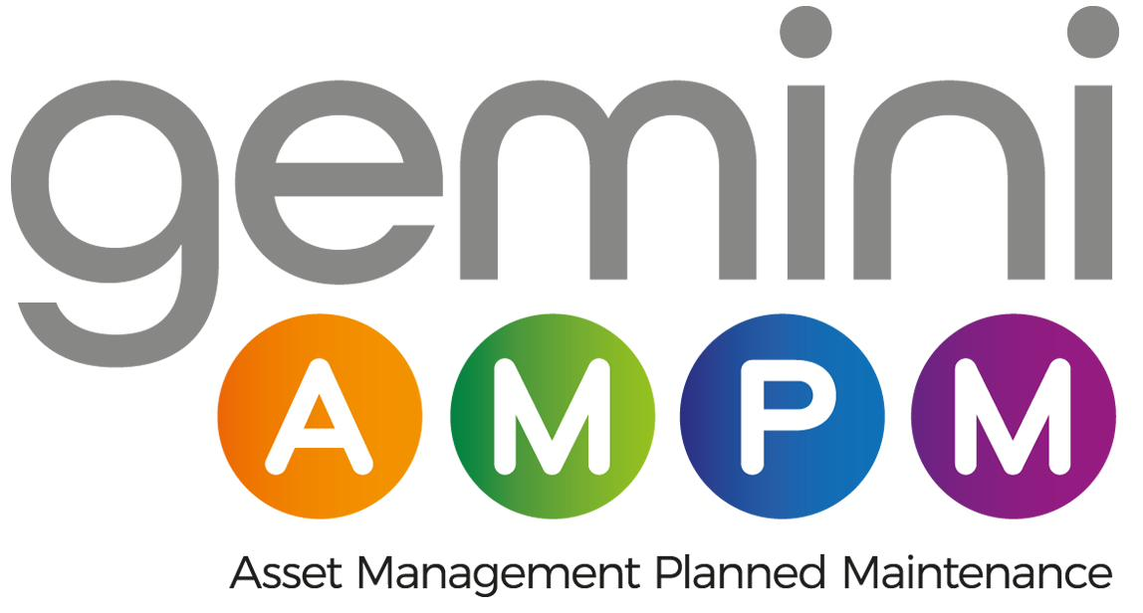

Strategic Asset Pack
Brand Positioning, Website, GTM, AI Leverage, Workstream Charter

Field | Detail
Document purpose | Consolidated strategy artefact pack. Read alongside the Project Brief.
Owner | Jamie Dawson, Chair
Audience | Chair, SMT (selective), Claude (instance)
Status | Live working document. Sections to be iterated.
Version | 1.0
Date | 7 May 2026

Contents

1. Brand positioning — Gemini Live
2. Website diagnosis and content recommendations
3. 12-month go-to-market plan
4. AI leverage roadmap
5. Workstream alignment charter
6. Sales and tender enablement
7. Measurement and KPIs

1. Brand positioning — Gemini Live

1.1 One-line positioning
Gemini AMPM is the employee-owned compliance and asset platform for buildings that cannot afford to fail.
Every other line of brand copy descends from this sentence. It signals four things at once: who owns it (EOT), what it does (compliance and asset platform), who it serves (high-stakes buildings), and what the buyer is actually buying (continuity, not callouts).

1.2 The four buyer truths the brand answers
Buyer truth | What buyers are actually thinking | How Gemini AMPM answers it
Risk | If this fails, my career, my insurance, or my regulator is in the room. | Compliance-led platform. Audit-ready by design.
Trust | Will this supplier still be around in 5 years and care about me? | Employee-owned. Long-horizon. Aligned interests.
Visibility | Can I see what is happening on my estate? | Gemini Live: real-time data, real-time response.
Cost | Am I paying for stuff I am not getting? | Single platform replaces multiple suppliers. Transparent reporting.

1.3 Brand voice
- Direct. Not breezy.
- Technical when it earns the right to be — never to show off.
- Confident, not boastful. The buyer should feel reassured, not sold to.
- UK English. Plain language. No marketing inflation (no “unlock,” “empower,” “revolutionise,” “best-in-class,” “solutions provider”).

1.4 The Gemini Live brand architecture
Gemini Live is the umbrella for the productised client experience. Underneath sit named modules:
- Gemini Live Assets — powered by Uptick. Asset register, lifecycle, condition, and replacement planning.
- Gemini Live Compliance — audit-ready evidence layer. Maps to BSA / golden thread / regulatory regime.
- Gemini Live Response — service desk, planned and reactive maintenance, SLA visibility.
- Gemini Live Intelligence — AI-assisted insight on portfolio, spend, risk, and trend.

1.5 Visual identity — light-touch refresh, not rebrand
- Keep core mark and equity.
- Tighten typography, colour use, photography direction.
- Define a digital UI system (web and Gemini Live screens) so SEO / IMADO / Paul’s compliance hub all converge visually.
- Produce a one-page brand standards card. No 60-page brand bible — nobody reads them.

1.6 Tender and bid framing
- EOT social value uplift quantified for PPN 06/20.
- Audit-ready compliance posture as a quality differentiator.
- Single-platform consolidation as a procurement saving.
- Gemini Live as a buyer-benefit, not a feature list.

2. Website diagnosis and content recommendations

2.1 Headline issues
- Homepage does not lead with EOT. Largest single missed differentiator.
- 0845 number on the site reduces buyer trust and conversion. Replace sitewide.
- Gemini Live is not yet a productised page family. It exists in the operational stack but not in the brand.
- Content engine is dormant. SEO momentum is wasted without it.
- No location pages. We are a national operator with a single-postcode digital footprint.
- No structured case study library. Tender responses pull from scattered, inconsistent sources.

2.2 Site architecture (recommended)
Section | Pages | Purpose
Homepage | Single page, hero + EOT + Gemini Live + service spine + proof | Capture, qualify, route.
Services | Fire, Security, Ventilation, Gas Suppression, Passive Fire, Compliance, Asset Management, Planned Maintenance | Service-level intent capture and SEO.
Gemini Live | Overview + Assets, Compliance, Response, Intelligence | Productised platform narrative.
Sectors | Commercial, Government, Defence, Healthcare, Education, Industrial | Buyer-pool routing and case study anchoring.
Locations | 12 location pages mapped to operational coverage | Local search visibility, local trust signals.
Insights | Articles, regulatory updates, case studies | SEO, AI search visibility, sales enablement.
About | EOT, leadership, accreditations, careers | Trust, talent, governance.
Contact | Direct number (not 0845), bid email, regional contacts | Conversion.

2.3 Content engine
- Three articles per month, minimum. Anything less is noise.
- Mix: one regulatory/explainer, one buyer-side perspective, one Gemini Live case study or operational insight.
- Every article optimised for AI search engines, not just Google. AI visibility is the next frontier and Stephen is already doing this.
- Author bylines on real Gemini AMPM people. Builds E-E-A-T (experience, expertise, authoritativeness, trustworthiness).

2.4 Paid media
Channel | Allocation | Use
Google Search | 70% | Intent capture on service + location + compliance terms.
LinkedIn Ads | 20% | Buyer-pool targeting: FM directors, estates, procurement leads.
Google LSA | 10% | Local services intent.

2.5 30/60/90 day website actions
Window | Actions
0–30 days | Replace 0845 sitewide. Homepage hero rewrite (EOT + Gemini Live). Stand up Insights template. Begin Gemini Live overview page. Set baseline analytics + tender attribution.
31–60 days | Publish first six articles. Launch Gemini Live module pages. Launch first three location pages. Begin paid media (search + LinkedIn).
61–90 days | Complete location pages (target 12). Publish first three case studies. Conversion-rate optimisation pass on homepage and service pages. AI-search visibility audit and remediation.

3. 12-month go-to-market plan

3.1 GTM thesis
The brand exists to compress the time between first awareness and first paid engagement. Every channel earns its place by either generating qualified pipeline or removing buyer objections inside the sales process. Anything that does neither is cut by month four.

3.2 Quarterly shape
Quarter | Theme | Headline outputs | Decision gate
Q1 | Foundations | Brand narrative locked. Website 30/60/90 in motion. Workstream alignment owner appointed. Two AI use cases funded. | Are foundations live and paid media baseline data in?
Q2 | Authority | Content engine producing. Three case studies. Sector pages live. AI visibility metrics tracked. | Pipeline contribution from organic + paid measurable?
Q3 | Capture | Tender win-rate uplift programme. Sales enablement v2. Gemini Live demo materials. Account-based motion on tier-1 main contractors. | Win-rate moving on bids using the new narrative?
Q4 | Compound | Public-sector framework targeting. Acquisition / acqui-hire conversations advanced. AI roadmap phase 2. | Strategic optionality for FY27?

3.3 Always-on programmes
- Content engine — three articles per month.
- Email — monthly insight to a curated buyer list. Quality over volume.
- Paid media — search-led, LinkedIn buyer targeting, LSA at the edges.
- PR — trade press placement on Gemini Live launches and case studies.
- Awards — EOT and compliance categories. Cheap proof signals.

3.4 Sales and marketing alignment
- Marketing-qualified to sales-qualified handover defined and instrumented.
- Tender team has on-demand access to the SharePoint case study library.
- Every won deal generates a one-page case study within 30 days as a hard rule.
- Lost-deal review monthly. Reasons coded. Patterns surfaced. Brand and product feedback loops closed.

4. AI leverage roadmap

AI is treated as operating leverage. Every use case must remove cost, accelerate revenue, or reduce risk — ideally all three. Each one has an owner, a budget, and a measurable outcome before it goes into build.

4.1 Phase 1 — Q1 2026 (two funded use cases)
Use case | Outcome | Owner candidate | Source data
Finance / credit control automation | Reduce DSO, surface aged debt earlier, automate chase cadence. | Joe Isaac with external dev support. | Xero.
Technical drawings assist | Reduce engineer time on takeoffs, mark-ups, and standard detail re-use. | Ryan Gemmel (projects). | Procore + drawing repositories.

4.2 Phase 2 — Q2/Q3 2026
- Sales enablement — AI-assisted bid drafting and tender response from the SharePoint library.
- Client-facing compliance chatbot — Paul Fitzpatrick’s concept productised under Gemini Live Compliance.
- Operational triage — AI-assisted ticket routing and engineer dispatch logic in BigChange.

4.3 Phase 3 — Q4 2026
- Portfolio intelligence — AI-driven trend, risk and spend insight for client estates (Gemini Live Intelligence).
- Workforce knowledge layer — internal-facing AI on operational SOPs, regulations, and historical jobs.

4.4 Governance
- Every AI use case has a written outcome statement, owner, success metric, and review date.
- Data governance: no sensitive client or compliance data goes through unvetted public AI tools.
- API keys stored in a secrets manager, never in source or chat. The board-app key incident sets the standing rule.
- Quarterly AI review at board level.

4.5 Buy / build calls
- Buy: foundation models, productivity AI, off-the-shelf finance and drawings tooling.
- Build (or freelance): the Gemini Live module integrations and the proprietary client-facing layer.
- Freelancer resourcing identified as a cost-reduction option for build work.

5. Workstream alignment charter

This is the structural fix. Three workstreams (SEO with Stephen Sumner, IMADO development, GTM strategy) plus Paul Fitzpatrick’s compliance hub are running in parallel without a synchronisation point. Until this is fixed, every other investment is at risk of being blunted.

5.1 Coordination owner
- Single named coordination owner. Accountable for the merged roadmap, weekly status, and unblocking.
- Reports to the Chair fortnightly with: progress against the merged roadmap, blockers, decisions needed.

5.2 The 60-minute alignment call
- Attendees: Chair, coordination owner, Stephen Sumner, IMADO lead, Paul Fitzpatrick.
- Output: one merged roadmap. Sequence locked. Owners named. Dependencies mapped.
- Cadence after the kick-off: 30-minute weekly with the coordination owner; full reconvene monthly.

5.3 Roadmap merge — framework
Workstream | Lead | Primary deliverable | Dependency
Brand narrative + GTM | Chair / coordination owner | Gemini Live narrative locked, content engine live. | All other workstreams point to this.
SEO + AI visibility | Stephen Sumner | Technical SEO, AI search visibility, content optimisation. | Brand narrative locked first.
Development (IMADO) | IMADO lead | Website rebuild, Gemini Live module pages. | Brand visual system + page structure decisions.
Compliance hub / chatbot | Paul Fitzpatrick | Productised under Gemini Live Compliance. | Brand architecture + AI governance.

5.4 Decision rights
- Brand narrative and visual system: Chair signs.
- Website page structure and copy: Chair signs, coordination owner runs.
- Technical SEO + AI visibility execution: Stephen Sumner runs within agreed scope.
- Compliance hub product scope: Paul Fitzpatrick runs, Chair signs scope.
- AI use cases: Chair signs scope and budget; named owner runs delivery.

6. Sales and tender enablement

6.1 The asset library
- Single SharePoint location. Versioned. Indexed. Search-friendly file names.
- Mandatory categories: case studies, capability statements, accreditations, EOT social value pack, ESG, insurance / H&S, framework agreements, references, photography.
- Owner: Sales Director (Paul Fitzpatrick on transition). Backed up by coordination owner.

6.2 Case study standard
- One page. Fixed structure: client (or sector/profile if NDA), challenge, what we did, what changed, named outcome with a number.
- Every won deal: case study within 30 days. Hard rule.
- Photography or schematic where possible — buyers respond to visuals.

6.3 Capability statements
- One per service line. One per sector. Refreshed quarterly.
- Every capability statement closes with EOT social value framing.

6.4 Bid governance
- Bid / no-bid decision documented. Win-rate tracked by sector and by buyer.
- Lost-bid debrief mandatory — even when uncomfortable.
- Top 10 RFP questions library maintained with model answers, refreshed monthly.

7. Measurement and KPIs

Numbers are the discipline. Measured monthly, reviewed quarterly, surfaced in board reporting.

7.1 Brand and visibility
Metric | Baseline | 12-month target
Branded search volume | Capture H1 2026 baseline | +50%
Non-branded organic sessions on commercial pages | Baseline at month 1 | +100%
AI search visibility (citations / mentions) | Baseline at month 1 | Visible across the top three platforms
LinkedIn follower base (company) | Baseline at month 1 | +40%

7.2 Pipeline and sales
Metric | Baseline | 12-month target
Marketing-attributed pipeline | Baseline at month 3 | Material contribution to total pipeline
Tender win rate | Baseline H1 2026 | +5–10 ppt
Average contract value | Baseline H1 2026 | Up year-on-year
Time-to-first-meeting on inbound | Baseline at month 1 | Down materially

7.3 AI leverage
Metric | Baseline | 12-month target
DSO (finance use case) | H1 2026 average | Down 5–10 days
Engineer time per drawing takeoff | Baseline measured Q1 | Down 30%
Tender response cycle time | Baseline measured Q2 | Down 25%
AI use cases live in production | 0 → 2 by Q2 | 5 by year end

7.4 Reporting
- Marketing dashboard — monthly. One page. Traffic-light status against KPIs.
- Workstream coordination report — fortnightly to Chair.
- Board pack — monthly section on brand, pipeline, AI.
- Quarterly review — Chair-led. Budget reallocation decisions made here.

Bottom line. Brand without measurement is theatre. Measurement without brand narrative is busywork. The pack above ties the two together. Iterate it as a living document, not a one-shot deliverable.

