**Bespoke osis2mod tests  
ESV and NETS LXX**

osis2mod tests



**Contents**

1 Introduction 3

2 Tests 3

2.1 Navigation 3

2.2 Basic display 3

2.3 Interlinear 4

2.4 Cross-references 4

2.5 Per-verse vocabulary 5

2.6 Detailed vocabulary 5

2.7 Search 6

2.8 TBD 6

# Introduction

This is based upon bespokeOsis2modTests.docx, using ESV as the non-reversified text and NETSLXX as the ‘reversified’ one. As a reminder, the ‘reversified’ text is not actually being reversified; instead I am creating a file which details the changes which would be applied by reversification, and Sami’s revised code then makes use of this.

Note that bespokeOsis2modTests.docx includes some tests which cannot actually be applied here, because they rely upon particular characteristics which not all texts possess.

# Tests

## Navigation

1. Check that the various navigation windows show the books and chapters present in the original text, and not the book or chapter lists which would arise from reversification mappings.
2. Where reversification gives rise to any form of mapping (renumber in situ or move), check that you can navigate to the *original* locations correctly.
3. Where reversification moves things in such a way as to create new chapters or books, check that you cannot navigate to them.

## Basic display

Check that the text displays correctly in each of the following cases. This should be carried out both with a text involving reasonably substantial reversification-related remappings and with one involving none (preferably NRSV(A), I guess).

1. Where no remapping is involved.
2. Where reversification renumbers verses in situ. Should be displayed with the original verse numbers.
3. Where reversification calls for verses to be moved elsewhere. Should be displayed with the original verse numbers and in the original location; should *not* appear at the target location.
4. Where reversification turns verses into subverses. Should be displayed with the original verse numbers and in the original location; should *not* appear at the target location.
5. Where reversification turns subverses into verses. The text should be displayed in its original location (and not at the target location), but the subverses making up the original text should have been collapsed into the parent verse, with some form of marker to indicate where the original subverse boundaries fell.
6. Where reversification turns psalm verses into canonical titles. Should still be displayed as verses.

## Interlinear

Ideally these tests should be carried out with at least three texts simultaneously – NRSV(A) and two to which reasonably substantial (but different) reversification-related remappings have been applied. Ideally one (but only one) of these texts should involve subverses and reversification-related remappings of them, and one (but only one) should involve remapping psalm verses into canonical titles. And they should be repeated with each text in turn serving as the master.

At the time of writing I have only one test text available, so references below to *three* texts should be taken instead as merely involving *two* texts – the one under test, and ESV.

1. Check that verses are aligned correctly where none of the texts is subject to remapping.

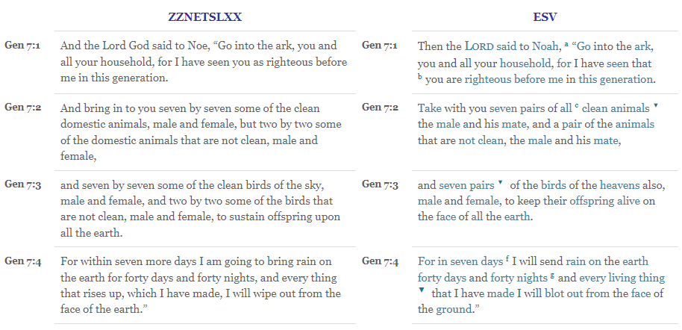

**Pass**

1. Check that verses are aligned correctly where one of the non-NRSVA texts is subject to renumber-in-situ and the other is not. (*Reinterpreted as comparing NRSVA with non-NRSVA where the latter is subject to renumber-in-situ.*)

|  |  |  |
| --- | --- | --- |
| Lev.7:1 | Lev.7:11 | Renumber verse |
| Lev.7:2 | Lev.7:12 | Renumber verse |
| Lev.7:3 | Lev.7:13 | Renumber verse |
| Lev.7:4 | Lev.7:14 | Renumber verse |

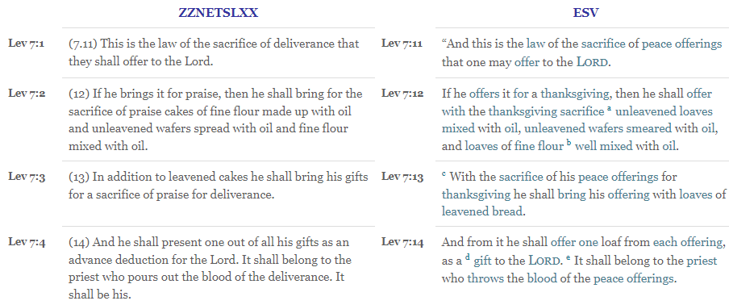

**Pass**

1. Check that verses are aligned correctly where one of the non-NRSVA texts is subject to move-within-chapter and the other is not. (*Reinterpreted as comparing NRSVA with non-NRSVA where the latter is subject to move-within-chapter.*)

|  |  |  |
| --- | --- | --- |
| Exo.20:13 | Exo.20:14 | Renumber verse* |
| Exo.20:14 | Exo.20:15 | Renumber verse* |
| Exo.20:15 | Exo.20:13 | Renumber verse* |

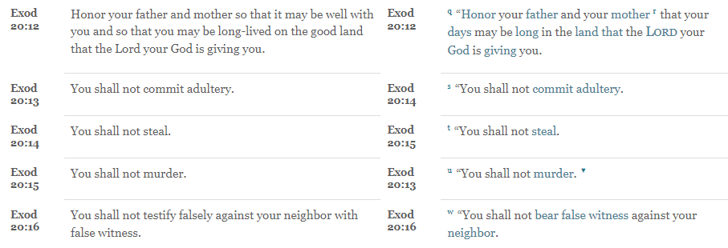

**Pass**

1. Check that verses are aligned correctly where one of the non-NRSVA texts is subject to move-to-different-chapter and the other is not. (*Reinterpreted as comparing NRSVA with non-NRSVA where the latter is subject to move-to-different-chapter.*)

|  |  |  |
| --- | --- | --- |
| 1Ki.20:1 | 1Ki.21:1 | Renumber verse* |
| 1Ki.20:2 | 1Ki.21:2 | Renumber verse* |
| 1Ki.20:3 | 1Ki.21:3 | Renumber verse* |
| 1Ki.20:4 | 1Ki.21:4 | Renumber verse* |

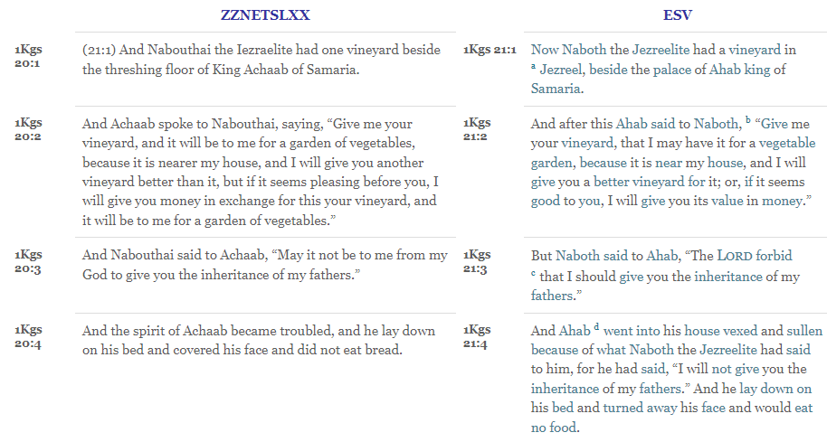

**Pass**

1. Check that verses are aligned correctly where we have one text moving subverses cross-chapter.

|  |  |  |
| --- | --- | --- |
| 1Ki.10:22.1 | 1Ki.9:15 | Renumber verse* |
| 1Ki.10:22.2 | 1Ki.9:20 | Renumber verse* |
| 1Ki.10:22.3 | 1Ki.9:22 | Renumber verse* |

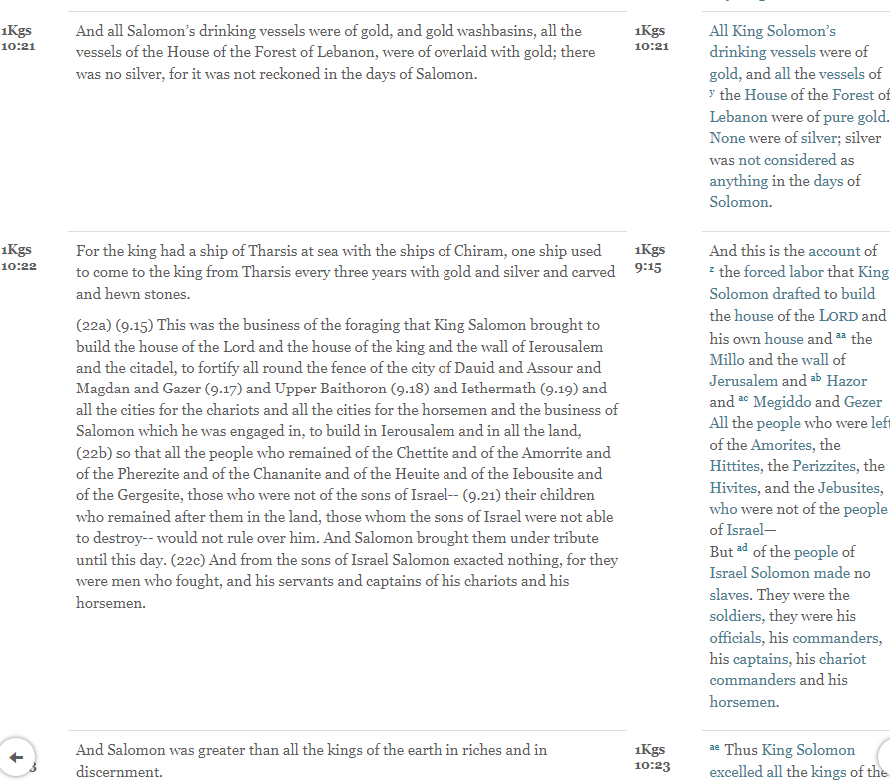

<verse sid="1KI 10:22"/>For the king had a ship of Tharsis at sea with the ships of Chiram, one ship used to come to the king from Tharsis every three years with gold and silver and carved and hewn stones.<para style='p'/><verse eid="1KI 10:22"/>

<verse sid="1KI 10:22a"/>(22a) (9.15) This was the business of the foraging that King Salomon brought to build the house of the Lord and the house of the king and the wall of Ierousalem and the citadel, to fortify all round the fence of the city of Dauid and Assour and Magdan and Gazer (9.17) and Upper Baithoron (9.18) and Iethermath (9.19) and all the cities for the chariots and all the cities for the horsemen and the business of Salomon which he was engaged in, to build in Ierousalem and in all the land,<verse eid="1KI 10:22a"/>

<verse sid="1KI 10:22b"/>(22b) so that all the people who remained of the Chettite and of the Amorrite and of the Pherezite and of the Chananite and of the Heuite and of the Iebousite and of the Gergesite, those who were not of the sons of Israel-- (9.21) their children who remained after them in the land, those whom the sons of Israel were not able to destroy-- would not rule over him. And Salomon brought them under tribute until this day.<verse eid="1KI 10:22b"/>

<verse sid="1KI 10:22c"/>(22c) And from the sons of Israel Salomon exacted nothing, for they were men who fought, and his servants and captains of his chariots and his horsemen.<verse eid="1KI 10:22c"/>

**Fail ???**

1. Check that verses are aligned correctly where both of the non-NRSVA texts are subject to the same renumber-in-situ.

***Not applicable.***

1. Check that verses are aligned correctly where both of the non-NRSVA texts are subject to different renumber-in-situ.

***Not applicable.***

1. Check that verses are aligned correctly where one of the non-NRSVA texts is subject to move and the other is not.

***Not applicable.***

1. Check that verses are aligned correctly where both of the non-NRSVA texts are subject to the same move.

***Not applicable.***

1. Check that verses are aligned correctly where both of the non-NRSVA texts are subject to different moves.

***Not applicable.***

1. Check that verses are aligned correctly where the various texts differ as to how many verses a given chapter contains.
2. Check what happens where the texts differ as to whether a given chapter exists.
3. Check what happens where the texts differ as to whether a given book exists.

## Cross-references

This should be carried out both with a text involving reasonably substantial reversification-related remappings and with one involving none (preferably NRSV(A), I guess). In each case, find a cross-reference and check it points to the correct place (which in all cases should be a place in the original text). It may be difficult to find cross-references of the appropriate kind for the various flavours of test.

1. Where the cross-reference points to a non-remapped verse.
2. Where the cross-reference points to a reference which is subject to renumber-in-situ.
3. Where the cross-reference points to a reference which is subject to move.

## Per-verse vocabulary

This should be carried out both with a text involving reasonably substantial reversification-related remappings and with one involving none (preferably NRSV(A), I guess).

1. Hover over the verse number of a verse which has not been remapped, and check the correct Greek or Hebrew vocabulary is displayed.
2. Hover over the verse number of a verse to which reversification applies renumber-in-situ, and check the correct Greek or Hebrew vocabulary is displayed. Because we are not actually applying reversification, this should be the *original* verse number, which should display the *original* text, and the vocabulary should be appropriate to that.
3. Hover over the verse number of a verse to which reversification applies a move, and check the correct Greek or Hebrew vocabulary is displayed. Because we are not actually applying reversification, this should be the *original* verse number, which should display the *original* text, and the vocabulary should be appropriate to that.
4. Hover over the verse number of a verse which reversification turns into a psalm title, and check the correct Greek or Hebrew vocabulary is displayed. Because we are not actually applying reversification, this should be the *original* verse number, which should display the *original* text, and the vocabulary should be appropriate to that.

## Detailed vocabulary

This should be carried out both with a text involving reasonably substantial reversification-related remappings and with one involving none (preferably NRSV(A), I guess).

1. Hover over a word in a verse which is not subject to remapping, and check the correct details are displayed in the pop-up window.
2. Hover over a word in a verse to which reversification applies renumber-in-situ, and check the correct details are displayed in the pop-up window. These should be the details relevant to the original verse – ie the one which is actually being displayed.
3. Hover over a word in a verse to which reversification applies move, and check the correct details are displayed in the pop-up window. These should be the details relevant to the original verse – ie the one which is actually being displayed.
4. Bring up the side window which gives more detailed vocabulary information, select the link which gives a list of other places for the given word, and check that the verses displayed do indeed all relate to that word.

## Search

Repeat for both NRSV(A) and for a text subject to reasonably substantial remapping.

1. Apply the various search options (including those involving the original language) and check that the resulting verses are indeed appropriate to the search. (Ideally the search should be organised to bring up some verses which have not been remapped, some which have been subject to renumber-in-situ, and some subject to move, but that may not be easy to arrange.)

## TBD

Do we need to do things like testing map links? And what have I missed out?

* End of document *