**Intellij Gotchas**

Intellij gotchas



**Contents**

1 Introduction 3

2 The formats 4

2.1 USX 4

2.2 Verse-per-line 4

2.3 USFM 4

2.4 OSIS 4

2.5 Others 4

3 USX 5

4 Validity of input texts 7

# Creating runnable JAR files

Bit of a nightmare …

1. Create an artifact in IDEA to represent the JAR – File / ProjectStructure/Artifacts; ‘+’ near top left (yellow below); then JAR / FromModuleWithDependencies.
2. Select the main class (red dot below); ensure ‘Extract to the target JAR’ is marked (green).
3. **IMPORTANT**: You need META-INF to appear at the top of the list of items (blue dot). To achieve this, first get rid of any reference to src or below (marked purple below – so in this example, the path will end up with TextConverter). Then you may need to play around with the button circled in blue (which controls the order of things) and / or select META-INF and the arrow buttons near the blue circle to move it up. (If you fail to do this, the JAR will crash with some message about not being able to find META-INF.)

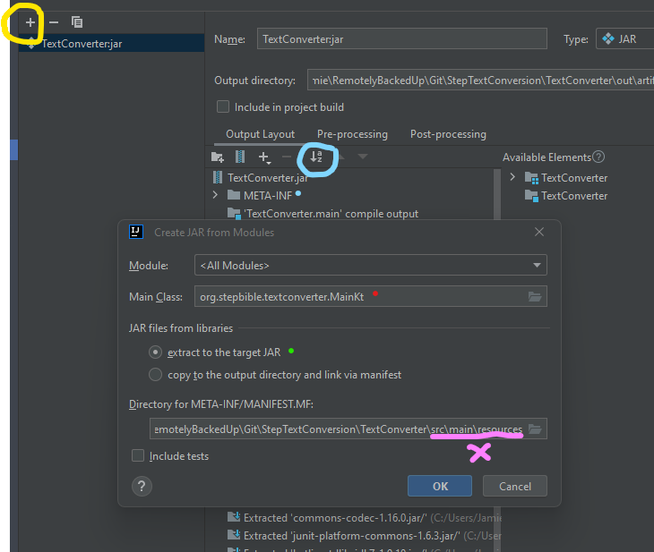

1. Build using Build/Artifacts. (You can find the resulting JAR under the ‘out’ folder in the Project window.)]
2. Use 7-zip to open the JAR file. Go to the META_INF folder and delete any files of the form *.RSA, *.SF and *.DSA. (If you fail to do this, the JAR will crash with some message or other about JNI errors.) I have a feeling it ought to be possible to configure something (build.gradle.kts?) to arrange that these files never turn up in the first place, but I don’t know how.