1st.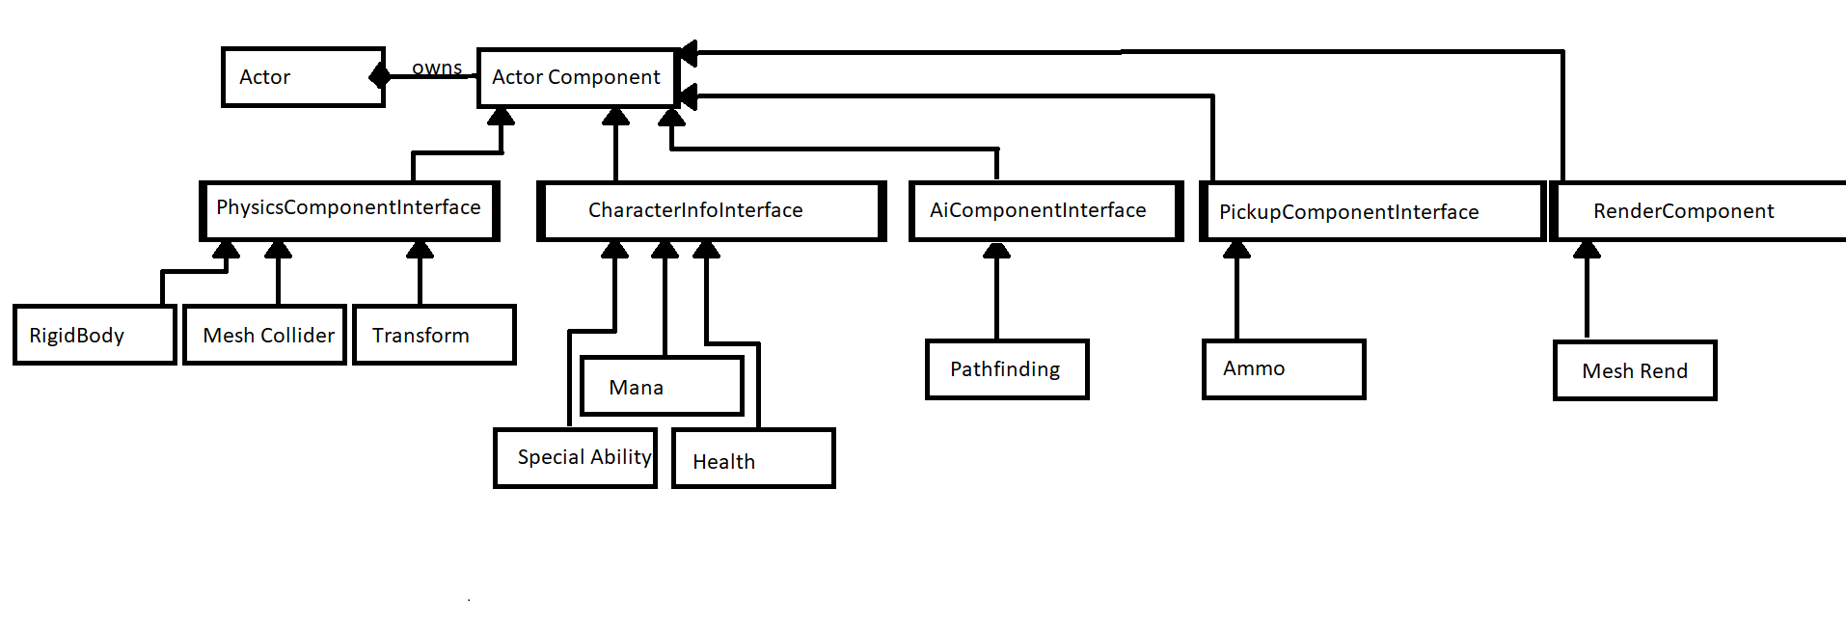2nd.

I would add to the AiComponentInterface an obstacle avoidance component which would handle the code for avoiding obstacles.

3rd.

I would add a ActorControlnterface with a Controls component owned by it for handling actor controls.

4th.