***­­­General Election Excel Analysis Findings***

The datasets given contained the final results for the 2010 and 2015 General Elections, it contained 649 constituencies within 20 regions and outlined the results per party.

Within the Excel analysis, we selected three regions and analysed the results found. We evaluated each region’s average result and compared them to the national results. The regions chosen were regions 1,2 and 3.

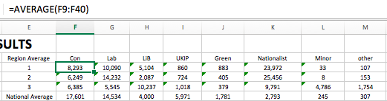

|  |  |  |  |  |  |  |  |  |  |
| --- | --- | --- | --- | --- | --- | --- | --- | --- | --- |
| **2015** |  |  |  |  |  |  |  |  |  |
| Total Electorate | Region Average | Con | Lab | LiB | UKIP | Green | Nationalist | Minor | other |
| 46428805 | 1 | 8293 | 10090 | 5104 | 860 | 883 | 23972 | 33 | 107 |
|  | 2 | 6249 | 14232 | 2087 | 724 | 405 | 25456 | 8 | 153 |
|  | 3 | 6385 | 5545 | 10237 | 1018 | 379 | 9791 | 4786 | 1754 |
|  | National Average | 17601 | 14534 | 4000 | 5971 | 1781 | 2793 | 245 | 307 |

|  |  |  |  |  |  |  |  |  |  |
| --- | --- | --- | --- | --- | --- | --- | --- | --- | --- |
| **2010** |  |  |  |  |  |  |  |  |  |
| Total Electorate | Region Average | Con | Lab | LiB | UKIP | Green | Nationalist | Minor | other |
| 45601060 | 1 | 7604 | 14360 | 9947 | 379 | 342 | 9044 | 44 | 342 |
|  | 2 | 6281 | 21334 | 5451 | 189 | 218 | 7481 | 55 | 467 |
|  | 3 | 5687 | 6165 | 9345 | 0 | 197 | 9552 | 5310 | 1181 |
|  | National Average | 16660 | 13412 | 10776 | 1415 | 438 | 1275 | 490 | 1208 |

As you can see from the graphs made, there was a significant shift in­ voters in regions 1 and 2. It can be seen that the votes shifted from the Labour Party and Liberal Democrats to the Nationalist party from 2010 to 2015. Within region 3, average votes per party experienced very little change, with the liberal democrats leading in both years with the nationalist party close behind.

Despite this significant change in votes from regions 1 and 2 regions, the National Average votes for the Nationalist party was still considerably low. Implying that regions 1 and 2 had little influence over the general election.

Next our group analysed the frequency of nth places (n=1,2,3,4) for all parties in the 2015 election.

/Users/Cameron/Desktop/Screen Shot 2017-05-12 at 18.22.02.pngWe did this by finding the nth places of each party in each constituency by using the “Rank” function.

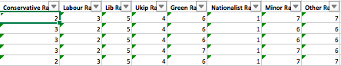

Then we used the “Countif” function to count the frequency of nth places for the selectedparty.

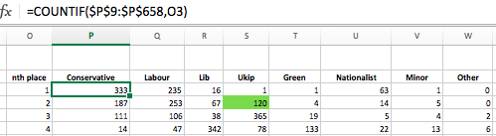

As you can see, the conservative party came first in a considerable number of constituencies. This reflects on the fact that they won the 2015 election.

The highlighted cell is the amount of times UKIP came second to other parties in 2015.

Next, we found the top ten “winnable” seats for UKIP from other parties in the next election based on the 2015 results. The results were as follows:

|  |  |
| --- | --- |
| **Ukip's Top Ten Most "Winnable" Seats from Other Parties In 2015** | **Difference in votes from the winning party** |
| Thanet South | 2,812 |
| Hartlepool | 3,024 |
| Boston and Skegness | 4,336 |
| Dagengam and Rainham | 4,980 |
| Stone-on-Trent Central | 5,179 |
| Heywood and Middleton | 5,299 |
| Rochester and Strood | 7,133 |
| Rother Valley | 7,297 |
| Basildon South and East Thurrock | 7,691 |
| West Bromwich West | 7,742 |

This was achieved by filtering the results to find all of those of which UKIP came second. Then, we found the constituencies that had the lowest difference in votes from 1st and 2nd through simply subtracting the second-place result from the first-place result. Then we used conditional formatting to find the 10 lowest values from those results.