**Section 1: Let’s connect to our VM**  
  
Step 1: Login to the portal. <https://portal.azure.com>  
  
Step 2: Use the login that we gave you last time. Use the password that you created.   
  
Step 3: Search for Resource Groups  
  
Step 4: Navigate to the resource group with your name.  
  
Step 5. Select the VM with your name.

Step 6. Click on Connect  
  
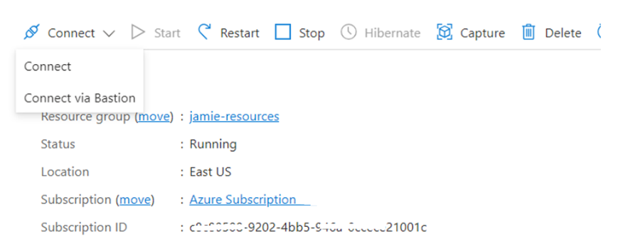

Step 7. Click on “Select” on Native RDP  
  
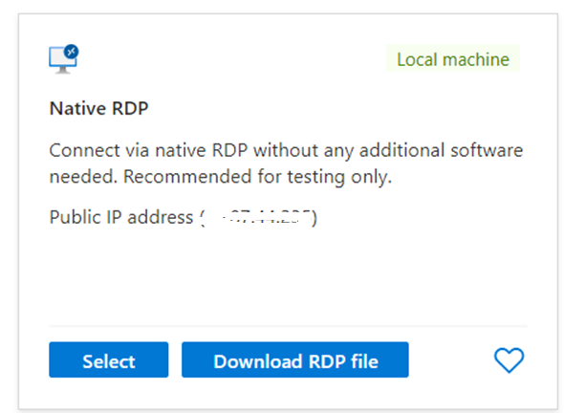  
  
Step 8. Click on “Download RDP File”  
  
Step 9. Connect to the VM and use the password we gave you.

*Why don’t we want to do this? Let’s figure out how to stop this.*

**Section 2: Let’s setup a security group.**Step 1: Search for Network Security Groups and click on it.

Step 2: Click Create

Step 3: Select your Resource Group  
  
Step 4: Name it {yourname}-nsg  
  
Step 5. Click “Review and create” and then “Create”  
  
Step 6. Search for your new security group.   
  
Step 7. Click on Settings 🡪 Subnets and Click Associate  
  
Step 8. Associate with your network and subnet  
  
Step 9: Search for Resource Groups  
  
Step 10: Navigate to the resource group with your name.

Step 11. Select the VM with your name.

Step 12. Select the VM with your name.

Step 13. Click on Networking / Network Setting and review the inbound ports. Notice how Deny All Inbound is created.   
  
Step 14. Click on Connect / Connect.   
  
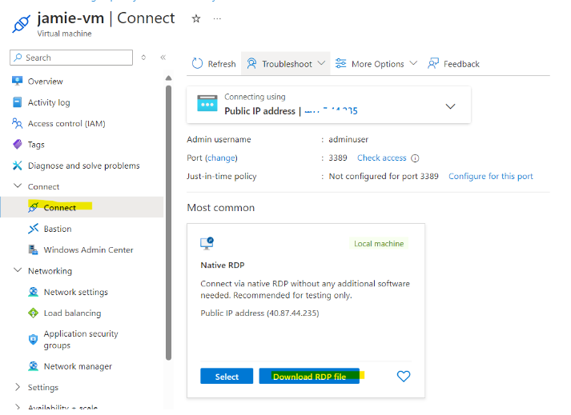

Step 15: Connect to the VM and use the password we gave you.  
  
**Just kidding – you should now be blocked. So Let’s fix it.**

**Section 3: Login via Bastion**  
  
Step 1: Login to the portal. <https://portal.azure.com>  
  
Step 2: Use the login that we gave you last time. Use the password that you created.   
  
Step 3: Search for Resource Groups  
  
Step 4: Navigate to the resource group with your name.  
  
Step 5. Select the VM with your name.

Step 6: Click on Connect  
  
