Greenfield Local Hub Development Diary
GREENFIELD LOCAL HUB
Jamie gallagher

Development Documentation
Development Diary

Version System

0.X.X – This shows that a major change has been implemented.
X.0.X – This shows that a few changes have been made.
X.X.0 – This shows that a small change or changes have been made.

Version 0.0.0 – Creating and setting up the project with ASP.NET 9.0 MVC (Model View Controller)
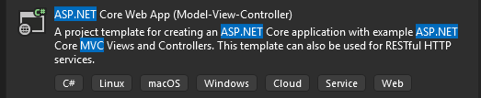
Picking the correct project template, we are going to make us of ASP.NET Core Web App MVC (Model View Controller) due to the great foundation it provides to build on. We give it the project name GFLHApp (short for Greenfield Local Hub Application). We select the framework .NET 9.0 due to the fact it is the latest version with long-term support on Visual Studio 2022 as of currently, and we select individual accounts to register and login in, which creates all the user database for us and all the functionality, being able to edit and customize it for our needs.
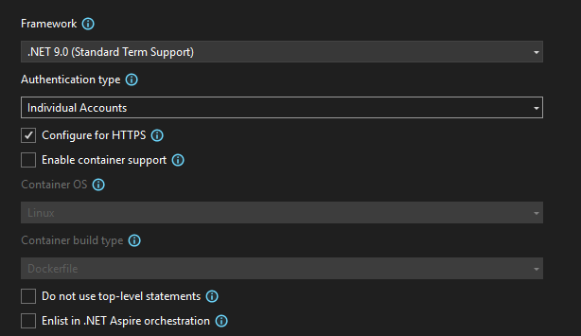
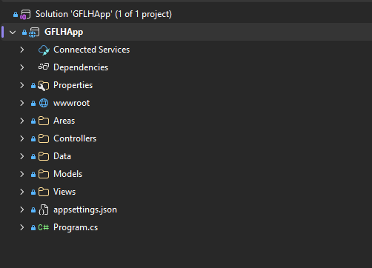
Then by pressing the Create button, the project is created, we first install base packages (typically to version 9.0.12 as it is the latest for .NET 9.0) to allow us to have extra functionality, and so that we wont have to add new migrations later on in the project.

Now we run the following commands into the Package Manager Console to install these base packages:
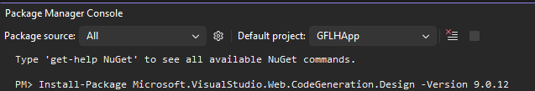
Now we run the website to see if everything works as expected.

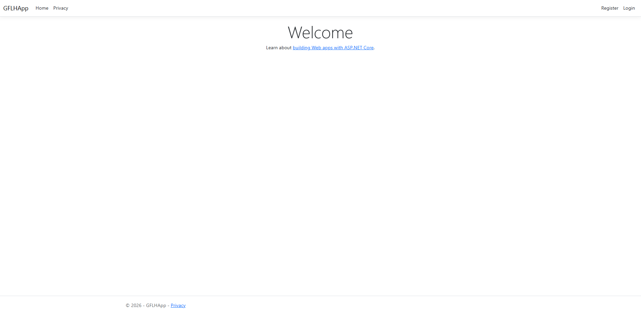
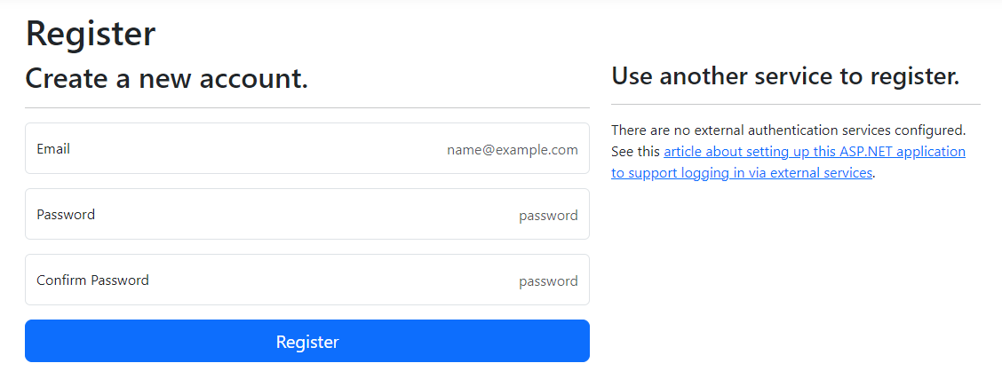
Main views seem to load as expected, however, although it may seem like it is working, upon attempting to register, I am faced with a migration error.
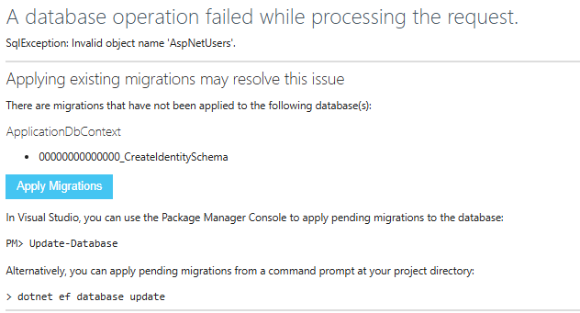
To resolve this error, we must add and update a migration, as it creates the SQL database, and any new models while also updating any changes made. We first run in the Package Manager Console:
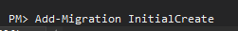
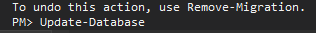
Due to it being our first migration on the solution, we name it ‘InitialMigration’ due to it being industry standard naming convention, afterwards we will name our migrations based off the basic migration reasons which are simple to keep track of.
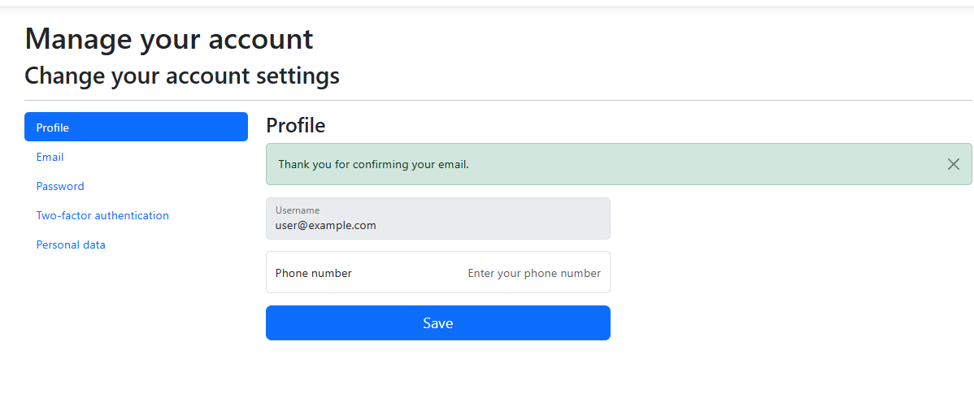
Now that a migration is added, we can create users accounts without the error occurring. This is why we made use of individual accounts, because its given us a user database with a customizable account creation system. Not only this, but it provides amazing security as it has been tested and coded by professionals in the industry.

Version 0.0.1 – Creating all models required

During Task 1, with the designs, I decided to change some of my data types of the models around. They’re minor changes but still needed to be paid attention to. I changed data types and added new attributes, I also removed and added new models. These are my models before and after, represented in a data dictionary.

Table: Address [BEFORE]
Data Property | Data Type | Purpose | PK/FK | Field Size | Required?
addressId | INT | Unique identifier for each address | PK | 10 digits | Yes
userId | NVARCHAR | References the user who owns the address | FK | 50 characters | Yes
line1 | VARCHAR | First line of the address | N/A | 100 characters | Yes
line2 | VARCHAR | Second line of the address (optional) | N/A | 100 characters | No
city | VARCHAR | City of the address | N/A | 50 characters | Yes
postcode | VARCHAR | Post code related to the address | N/A | 10 characters | Yes

Table: basket [BEFORE]
Data Property | Data Type | Purpose | PK/FK | Field Size | Required?
basketId | INT | Unique identifier for each basket | PK | 10 digits | Yes
userId | NVARCHAR | References the user who owns the basket | FK | 50 characters | Yes
createdAt | DATETIME | Date and time the basket was created | N/A | N/A | Yes

Table: basketProducts [BEFORE]
Data Property | Data Type | Purpose | PK/FK | Field Size | Required?
basketProductsId | INT | Unique identifier for basket-product relationship | PK | 10 digits | Yes
basketId | INT | References the basket | FK | 10 digits | Yes
productsId | INT | References the product | FK | 10 digits | Yes
productQuantity | INT | Numeric number of amount of the product in basket | N/A | 10 digits | Yes

Table: products [BEFORE]
Data Property | Data Type | Purpose | PK/FK | Field Size | Required?
productsId | INT | Unique identifier for each product | PK | 10 digits | Yes
itemName | VARCHAR | Name of product | N/A | 100 characters | Yes
itemPrice | DECIMAL | Price of the product | N/A | Precision 10,2 | Yes
imagePath | VARCHAR | Image of the product | N/A | 255 characters | No
quantityInStock | INT | Amount of stock available | N/A | 10 digits | Yes
available | BOOLEAN | Indicates if product is available | N/A | 1 | Yes
category | VARCHAR | Category of the product (e.g. vegetables, dairy) | N/A | 50 characters | Yes
producerName | VARCHAR | Name of the producer/farm supplying the product | N/A | 100 characters | Yes
description | VARCHAR | Description providing details about the product | N/A | 255 characters | No

Table: orderProducts [BEFORE]
Data Property | Data Type | Purpose | PK/FK | Field Size | Required?
orderProductsId | INT | Unique identifier for order-products relationship | PK | 10 digits | Yes
orderId | INT | References the order | FK | 10 digits | Yes
productsId | INT | References the product | FK | 10 digits | Yes
productQuantity | INT | Quantity of the product in order | N/A | 10 digits | Yes
productPrice | DECIMAL | Price of product at time of order | N/A | Precision 10,2 | Yes

Table: loyalty [BEFORE]
Data Property | Data Type | Purpose | PK/FK | Field Size | Required?
loyaltyId | INT | Unique identifier for loyalty record | PK | 10 digits | Yes
userId | NVARCHAR | References the user | FK | 50 characters | Yes
pointsTotal | INT | Total loyalty points earned | N/A | 10 digits | Yes

Table: loyaltyTransaction [BEFORE]
Data Property | Data Type | Purpose | PK/FK | Field Size | Required?
loyaltyTransactionId | INT | Unique identifier for transaction | PK | 10 digits | Yes
loyaltyId | INT | References loyalty account | FK | 10 digits | Yes
orderId | INT | References related order | FK | 10 digits | Yes
pointsChange | INT | Amount of points added or removed | N/A | 10 digits | Yes
transactionTimestamp | DATETIME | Time of transaction | N/A | N/A | Yes
transactionCategory | VARCHAR | Type or transaction (earn/redeem) | N/A | 50 characters | Yes

Table: order [BEFORE]
Data Property | Data Type | Purpose | PK/FK | Field Size | Required?
orderId | INT | Unique identifier for every order | PK | 10 digits | Yes
userId | NVARCHAR | References the user which placed the order | FK | 50 characters | Yes
addressId | INT | References the delivery address | FK | 10 digits | Yes
datePlaced | DATETIME | The date and time the order record was created | N/A | B/A | Yes
createdAt | DATETIME | Time and date the order record was created | N/A | N/A | Yes
status | VARCHAR | Current order status (for example shipped or pending) | N/A | 50 characters | Yes
orderTotal | DECIMAL | Total cost of the order | N/A | Precision 10.2 | Yes

This is my new data dictionary:

Table: basket [BEFORE]
Data Property | Data Type | Purpose | PK/FK | Field Size | Required?
BasketId | INT | Unique identifier for each basket | PK | 10 digits | Yes
UserId | NVARCHAR | References the user who owns the basket | FK | 450 characters | Yes
CreatedAt | DATETIME | Date and time the basket was created | N/A | N/A | Yes
Status | BOOLEAN | Indicates if the basket is active or complete | N/A | 1 | Yes

I added the Status attribute as I plan to implement logic for the basket being active or complete through controller backend.

Table: BasketProducts
Data Property | Data Type | Purpose | PK/FK | Field Size | Required?
BasketProducts | INT | Unique identifier for basket-product relationship | PK | 10 digits | Yes
BasketId | INT | References the basket | FK | 10 digits | Yes
ProductsId | INT | References the product | FK | 10 digits | Yes
ProductQuantity | INT | How many of each product is in the basket | N/A | 10 digits | Yes

Table: OrderProducts
Data Property | Data Type | Purpose | PK/FK | Field Size | Required?
OrderProductsId | INT | Unique identifier for order-products relationship | PK | 10 digits | Yes
orderIdOrderId | INT | References the order | FK | 10 digits | Yes
ProductsId | INT | References the product | FK | 10 digits | Yes
productQuantity | INT | Quantity of the product in order | N/A | 10 digits | Yes

The product price seemed unnecessary in development so I removed it, as I felt like it was over complicating the system unnecessarily.

Table: Orders
Data Property | Data Type | Purpose | PK/FK | Field Size | Required?
OrdersId | INT | Unique identifier for every order | PK | 10 digits | Yes
UserId | NVARCHAR | References the user which placed the order | FK | 450 characters | Yes
OrderDate | DATE | Date the order was placed | N/A | N/A | Yes
DeliveryMethod | VARCHAR | Selected delivery method | N/A | 50 characters | No
Delivery | BOOLEAN | Indicates if delivery was selected | N/A | 1 | Yes
Collection | BOOLEAN | Indicates if collection was selected | N/A | 1 | Yes
OrdersTotal | DECIMAL | Total cost of the order | N/A | Precision 10.2 | Yes
TrackingStatus | VARCHAR | Current order tracking status | N/A | 50 characters | Yes
DateOfCollection | DATE | Date the order will be collected | N/A | N/A | No
BillingLine1 | VARCHAR | First line of billing address | N/A | 100 characters | Yes
BillingLine2 | VARCHAR | Second line of billing address | N/A | 100 characters | No
BillingCity | VARCHAR | Billing city | N/A | 50 characters | Yes
BillingPostcode | VARCHAR | Billing postcode | N/A | 10 characters | Yes
DeliveryLine1 | VARCHAR | First line of delivery address | N/A | 100 characters | No
DeliveryLine2 | VARCHAR | Second line of delivery address | N/A | 100 characters | No
DeliveryCity | VARCHAR | Delivery city | N/A | 50 characters | No
DeliveryPostcode | VARCHAR | Delivery postcode | N/A | 10 characters | No

AddressId is removed as a foreign key, along with the Address model as a whole, as I am no longer making use of the address table. I believe it is more simple, easier and efficient for this project to just have the address information within the orders table to avoid conflict between controllers. So for this reason, I added the attributes from that model here. Not only this, but I made Delivery information a nullable selection for two reasons; firstly, the user may choose selection which wouldn’t require a delivery address, I also implemented billing address, and plan on implementing logic so that the user can select so that the billing address is the same as the delivery address for ease of use. On this topic, I have also added attributes for billing address information to the model as it is seen in industry standard checkout systems and e-commerce applications to have billing address information separate from delivery address information. Apart from this, within this model I also changed up some data types and naming conventions, and also added different attributes from the old table as I believed they’re more logical for an order system.
Table: Producers
Data Property | Data Type | Purpose | PK/FK | Field Size | Required?
ProducersId | INT | Unqiue identifier for each producer | PK | 10 digits | Yes
UserId | NVARCHAR | References the user account of the product | FK | 450 characters | Yes
ProducerName | VARCHAR | Name of producer | N/A | 100 characters | Yes
ProducerEmail | VARCHAR | Email of producer | N/A | 100 characters | Yes
ProducerInformation | VARCHAR | Information about the producer | N/A | 500 characters | Yes

I added this whole model new, this wasn’t in the first database design. I made it to link producers to the creation of products through the use of UserId. Producers will be able to access the dashboard also through this way.
Table: Products
Data Property | Data Type | Purpose | PK/FK | Field Size | Required?
ProductsId | INT | Unique identifier for each product | PK | 10 digits | Yes
ProducersId | INT | References the producer who created that product | FK | 10 digits | Yes
ItemName | VARCHAR | Name of product | N/A | 100 characters | Yes
ItemPrice | DECIMAL | Price of the product | N/A | Precision 10,2 | Yes
ImagePath | VARCHAR | Image of the product | N/A | 255 characters | No
QuantityInStock | INT | Amount of stock available | N/A | 10 digits | Yes
Available | BOOLEAN | Indicates if product is available | N/A | 1 | Yes
Category | VARCHAR | Category of the product (e.g. vegetables, dairy) | N/A | 50 characters | Yes
Description | VARCHAR | Description providing details about the product | N/A | 255 characters | No

I removed the ProducerName attribute as it is no longer necessary with the use of ProducersId being linked as a foreign key, as this is where we will grab Producer data from and link it to the product.

Apart from this, I removed the Loyalty and LoyaltyTransaction models as I realized that a loyalty system through controller logic will be more suitable for the project, and will be better to develop.
Here is the new database being used represented in a database diagram:
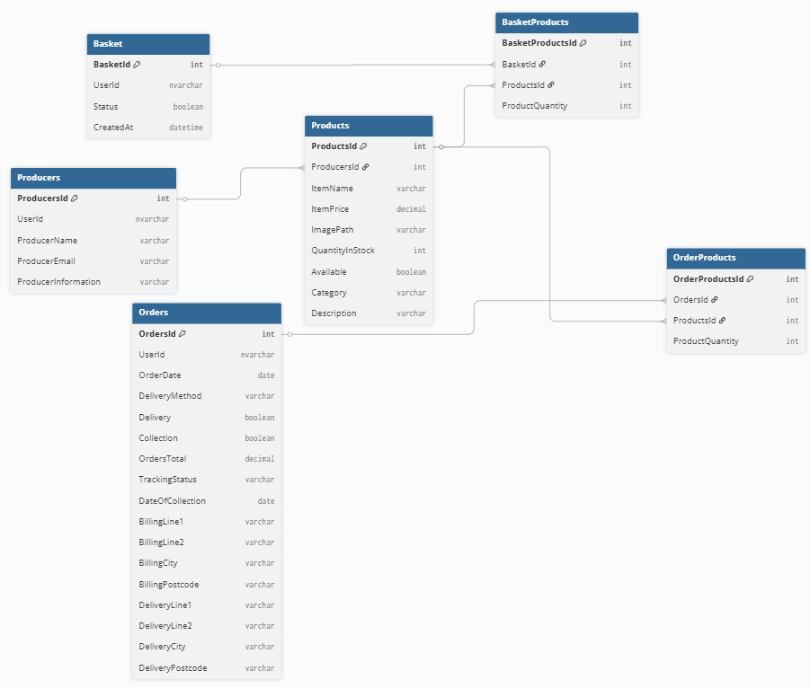

We now make the Model files with appropriate names and the data which they’ll store. This is an example from the Basket model. From this, I scaffold each model one by one, preventing the solution explorer from being untidy and making the organization and navigation of the solution easier. Although, we need to scaffold the identity pages to allow us to edit the register, sign up pages and more.
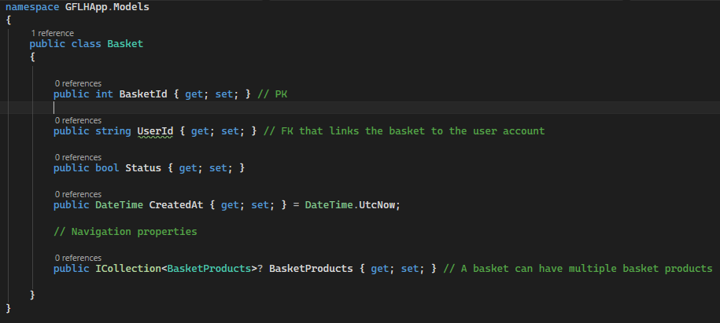

After completing each model, this is how it looks.
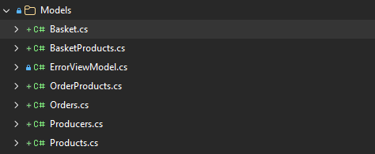
I then have to scaffold each model one by one, which will prevent the solution from being untidy and making it more organized and easy to navigate. Although, we need to scaffold the identity pages to allow us to edit the register, sign up pages and more. So, what we need to do is add an Identity to the Areas/Identity folder and override all the files.
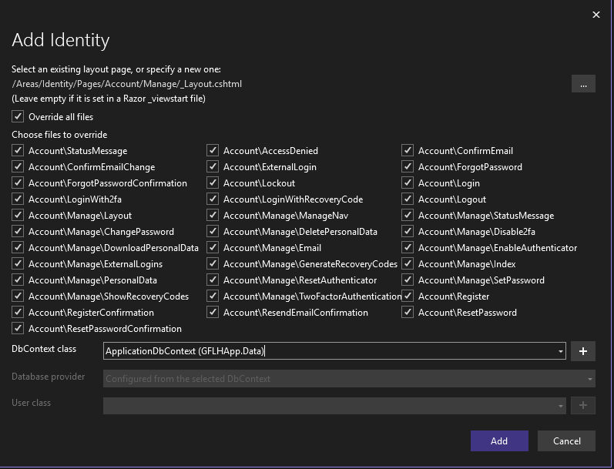
Upon selecting ApplicationDbContext and clicking add, this has been done sucessfuly.

I’ll now make a new migration and update the database as I have added my models as controllers, and scaffolded the identity.
Upon migration, I faced an error. This is because I have datatypes saved as decimal, but I didn’t tell EF core how precise they should be in the database. Usually, it would resort to something such as decimal(18,2) but I want to make use of decimal(10,2). To avoid this issue, I added the following code inside of ApplicationDbContext so that the wrong data isn’t used:

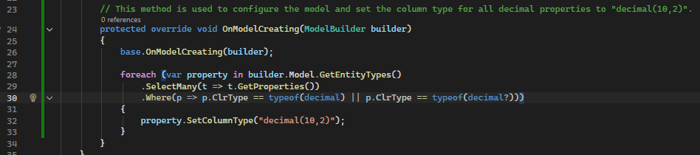
Because of this, I had to remove the previous migration.
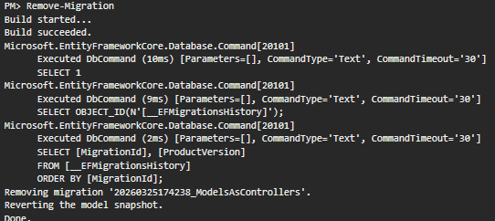

Now when I try to migrate again, and also update the database, the error is no longer present.
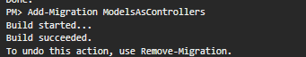
Here is how the identity scaffolded looks:
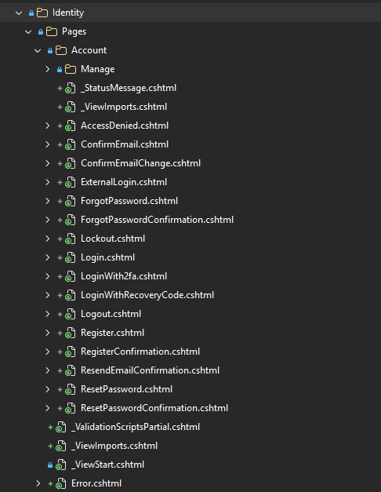
This now lets us edit all pages shown whenever we need. Not only this, but I chose to scaffold it now rather than later so its all organized into one folder which is rarely opened. However, when working on such as the HTML of the solution, we are required to open the whole folder with all other pages which would have been created when scaffolding, which is messy and a hassle to navigate through, with the biggest reason for not scaffolding so soon being able to focus on the features one by one, making sure its complete fully without providing broken or incomplete features before continuing.

Version 0.2.1 – Seeding Users and Roles

First of all, we must create a class called SeedData.cs inside of the Data folder to be able to seed users and roles.
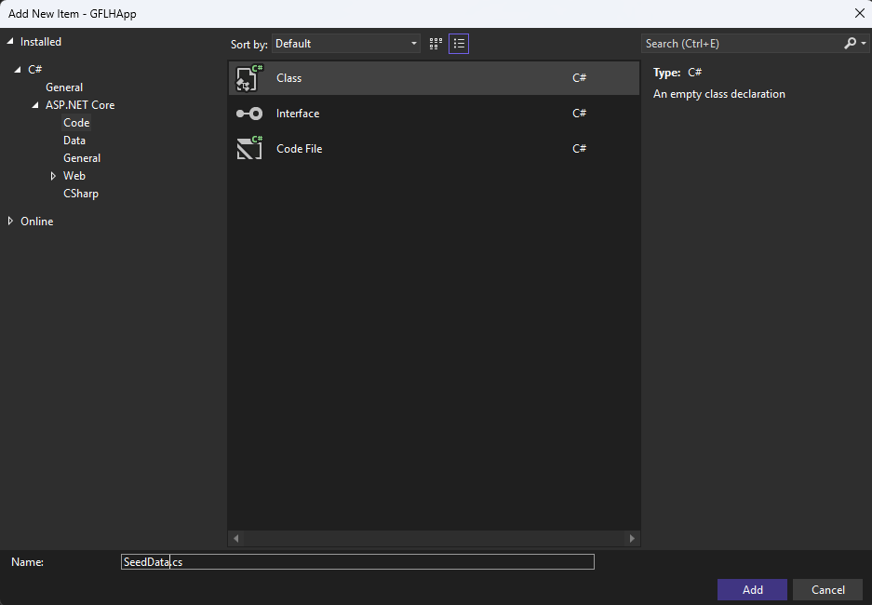
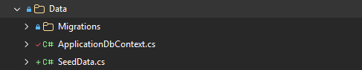

Within SeedData, we first have to create the method, I am going to call it SeedUsersAndRoles
Within this method, we must create the roles:
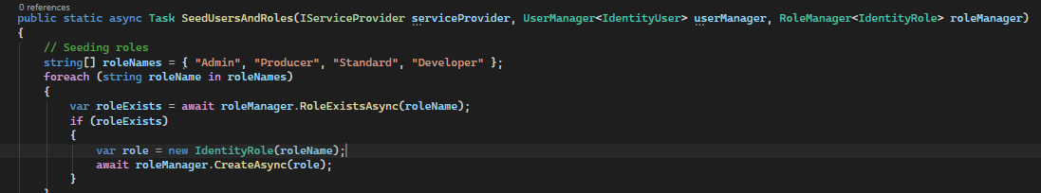
Underneath that same method, we are going to add different users. First of all, we start by adding an admin:
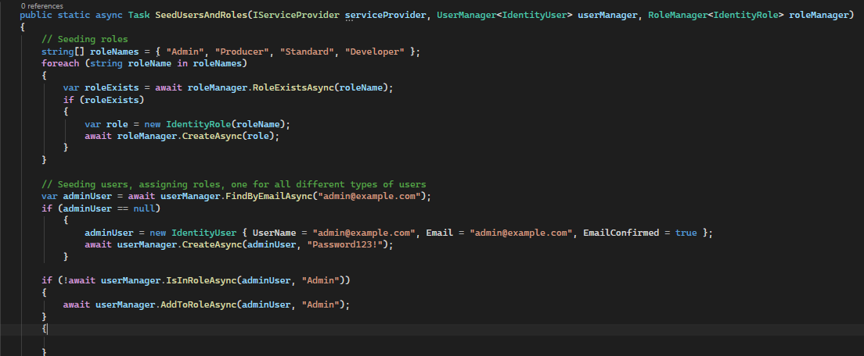

Then I added 5 different producers:
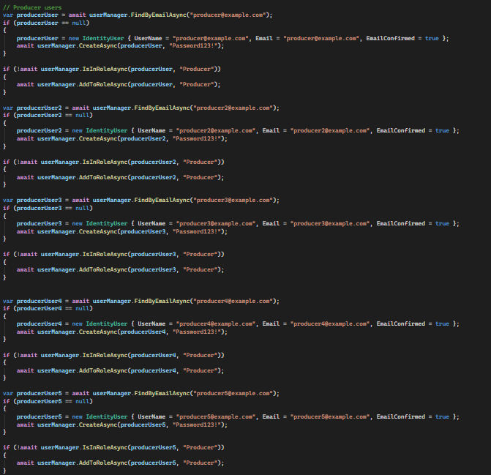
Then I seeded a normal and a developer user:
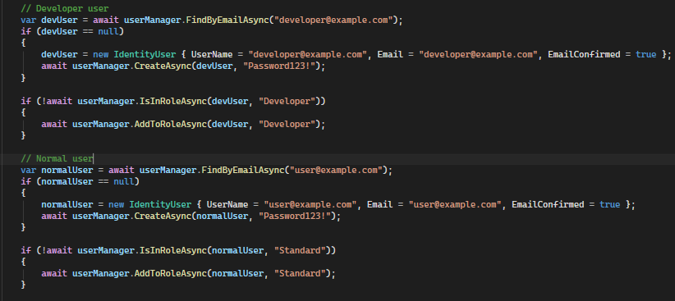

Once all of these are added to the SeedData.cs file, I then have to add the following code into program.cs
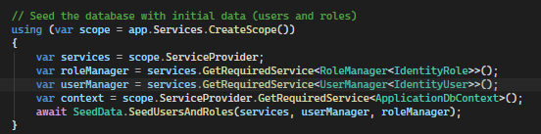

I update database just incase, once I run the program it lets me login as a seeded role.


Version 0.2.2 – Seeding Producers (data)

In the SeedData.cs program, underneath the previous method made, we are going to seed producers.
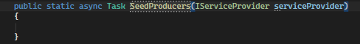
First, within this method we want to write code which will find the supplier in which you want to link.
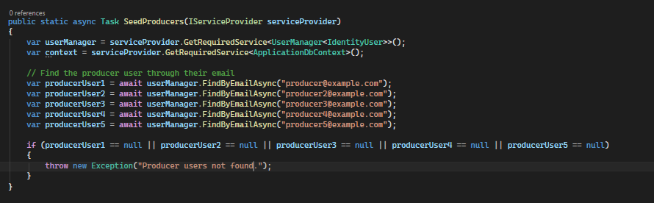
Then I added producers with a function at the end to save each producer to the database:
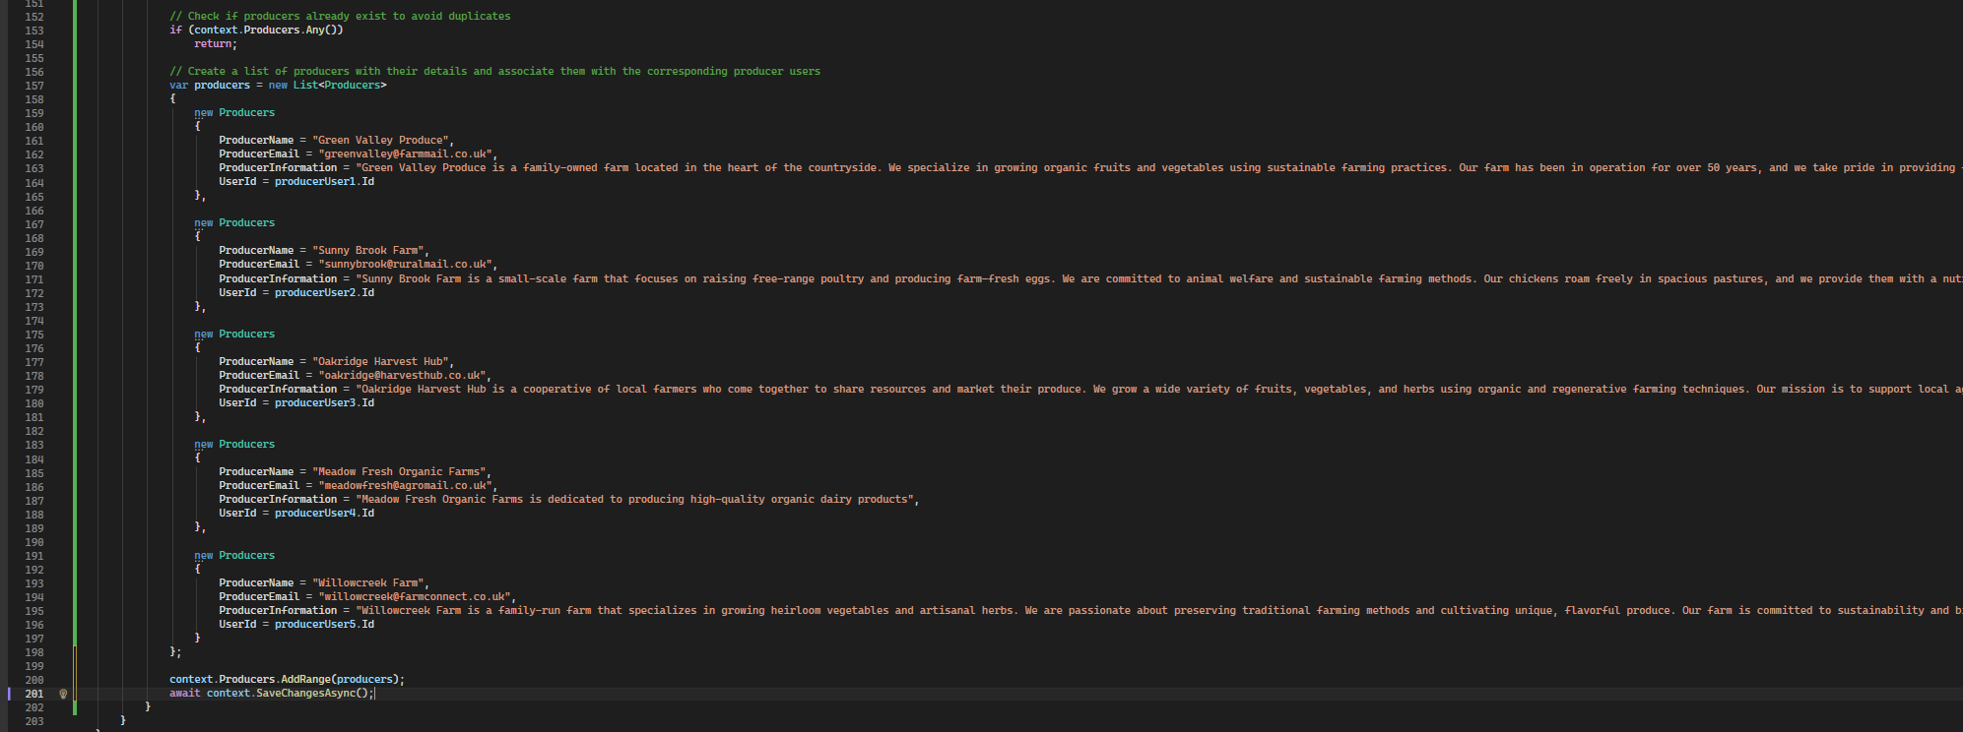
We then add these changes to program.cs:

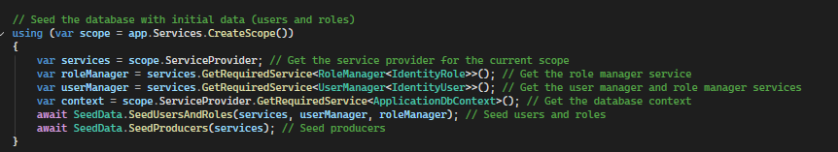

Then we run the web application to ensure changes made were successful.
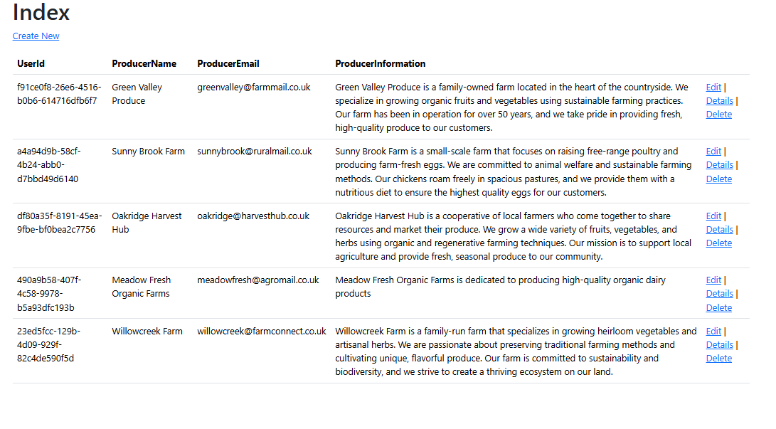
As you can see, all seeded data has been outputted onto the solution successfully.

Version 0.2.3 – Seeding Products (data)

First we are going to create a new method for seeding products.
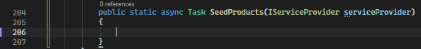
Then we code so that we can link the producers to products:
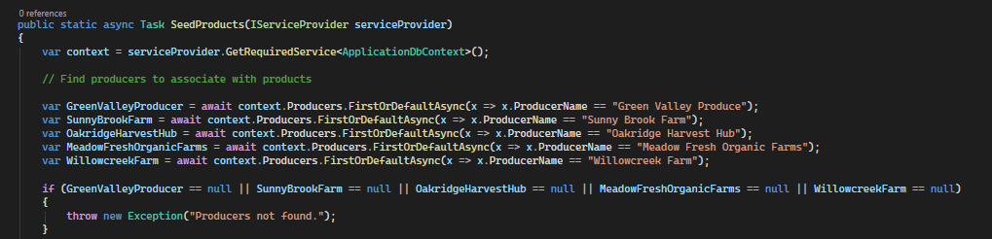

Then we seed the products and add code to add them to the database, here are a few examples:

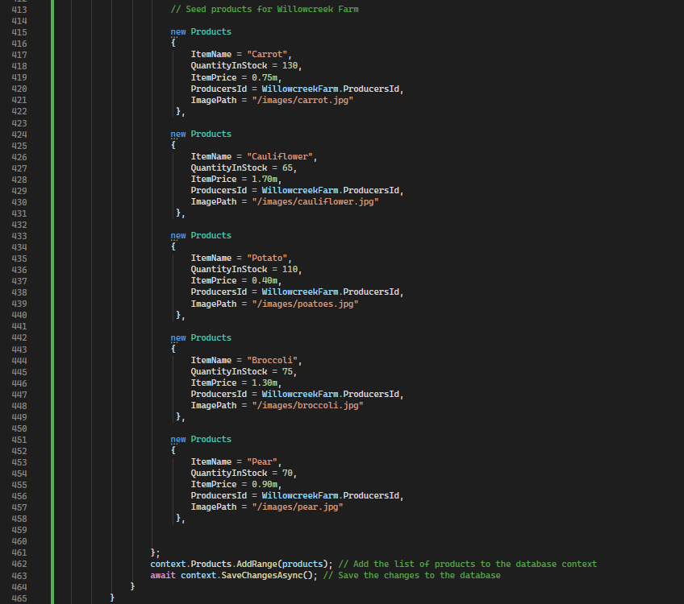

We then add these changes to Program.cs:
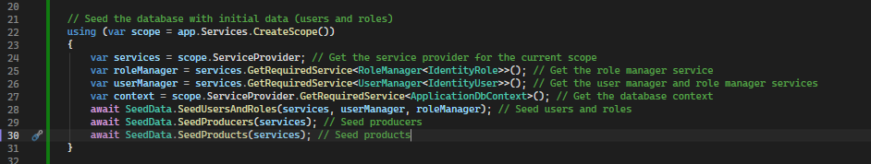

Now, if I run the program, I should be able to see the Products that I have seeded on the products page.
Upon running the program, I ran into this error.
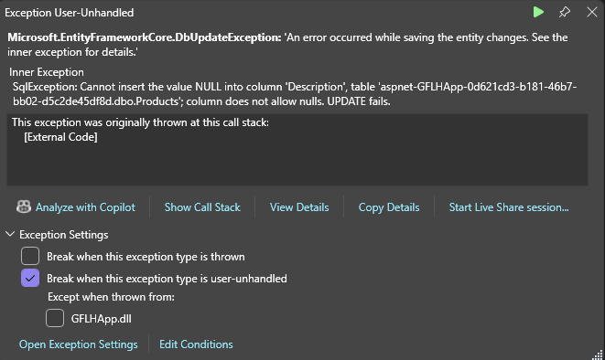
It seems that I need to add a description to each of the products. I will also run into the same error if I don’t fill out the rest of the fields, such as category.
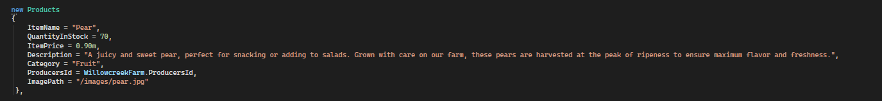
Now that description and category have been added, we can try and run the program again.
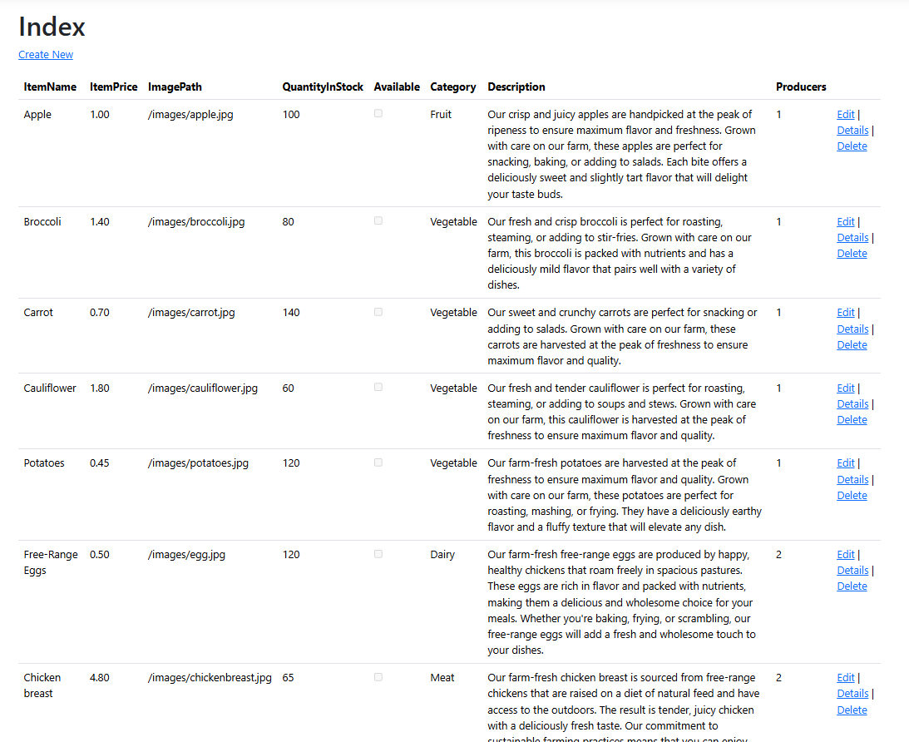
As we can see, the data has been successfully outputted onto the Products page. Although there are two things to note. First of all, available is set as empty for each product. For now, this is fine as we’re going to implement backend logic so that the QuantityInStock will affect the status of the product. Aside from this, ImagePath does not currently load the image as it is not displayed in an img tag at the moment. We will keep it this way for now, as they will not be displayed correctly anyways due to a lack of CSS in the program at this stage of development, which will cause the images to load at incorrect sizes. We will change this later on also.
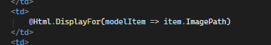

Version 0.2.4 – Add to Basket Function
We need to add a button to add products to the basket. The button needs to be next to each product and when run, it needs to send and post product data through the basket. If there isn’t an existent basket for the user who is logger in then a new basket should be created. It should also redirect them to the basket page to see their items.

Firstly, we need to add the ‘Add to Basket’ form to do this we add the following code in the Index.csthml page for Products.
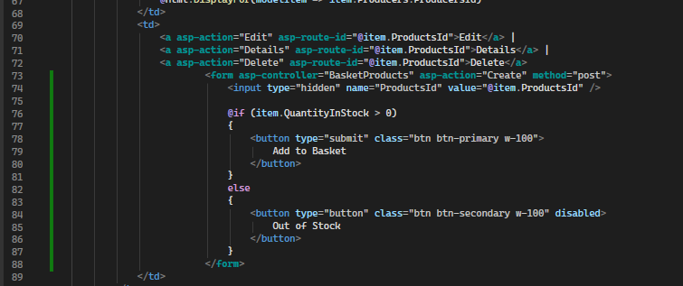
This code is a form which presents the button Add to Basket if the quantity of that product in stock is greater than 0. Otherwise, it will provide a button saying out of stock. This should now be visible once we run the program.
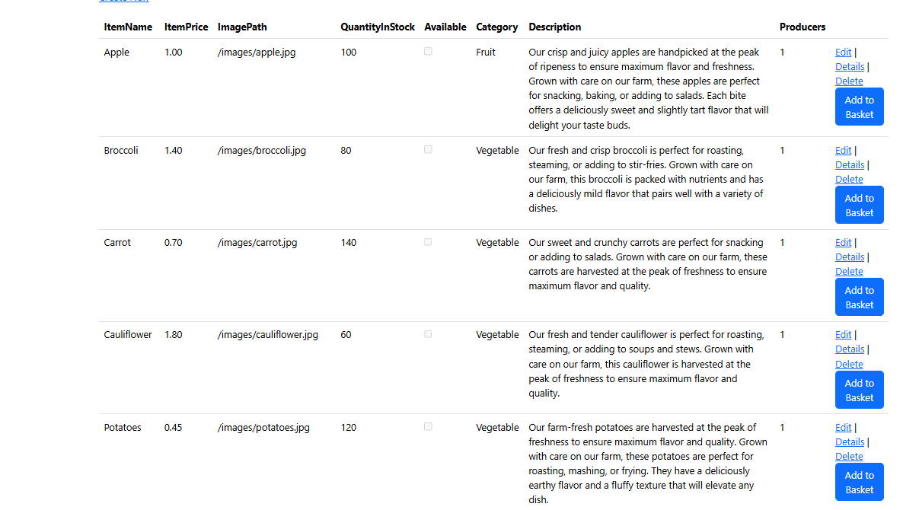
As you can see, there is an add to basket button next to each product successfully. Now, lets edit the logic through the POST create function inside of the BasketProducts controller.
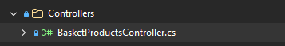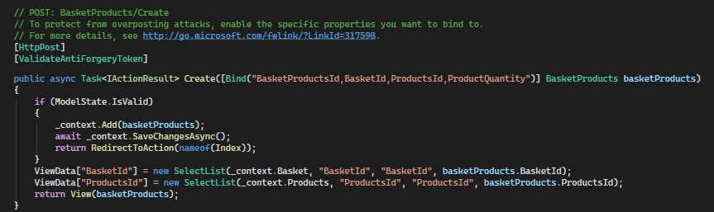

The first change we are going to make is that we are going to change the method to only have one parameter and delete everything inside so it is an empty method we can begin working new logic on.
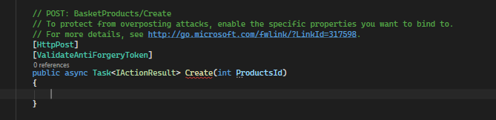
To begin with, we write code which will find the product selected by the user.
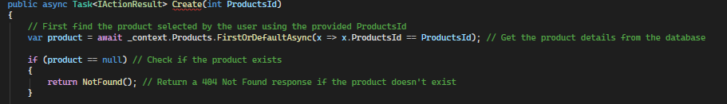
Afterwards, we want to find the current logged in user.
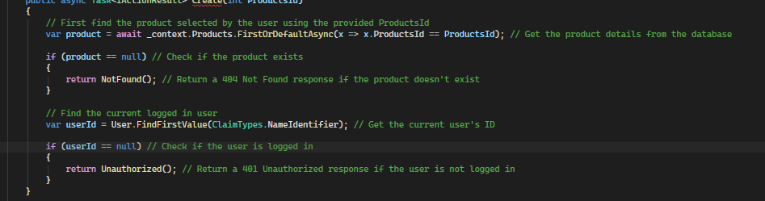
Then we add the code so that we find the users basket, and if there isn’t one then we will make one and then save any changes to the database.
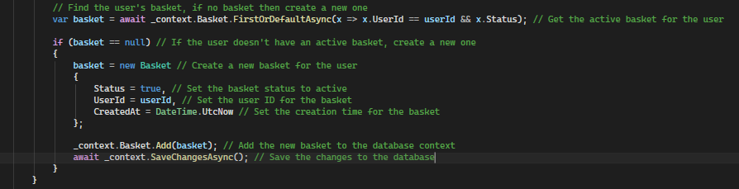

Finally, we add the logic to add the products to the basket. This works by finding to see if the product is alreadyu in the basket, if it is then it will increase the quantity by 1, if it is not then it will add the product to the basket instead.
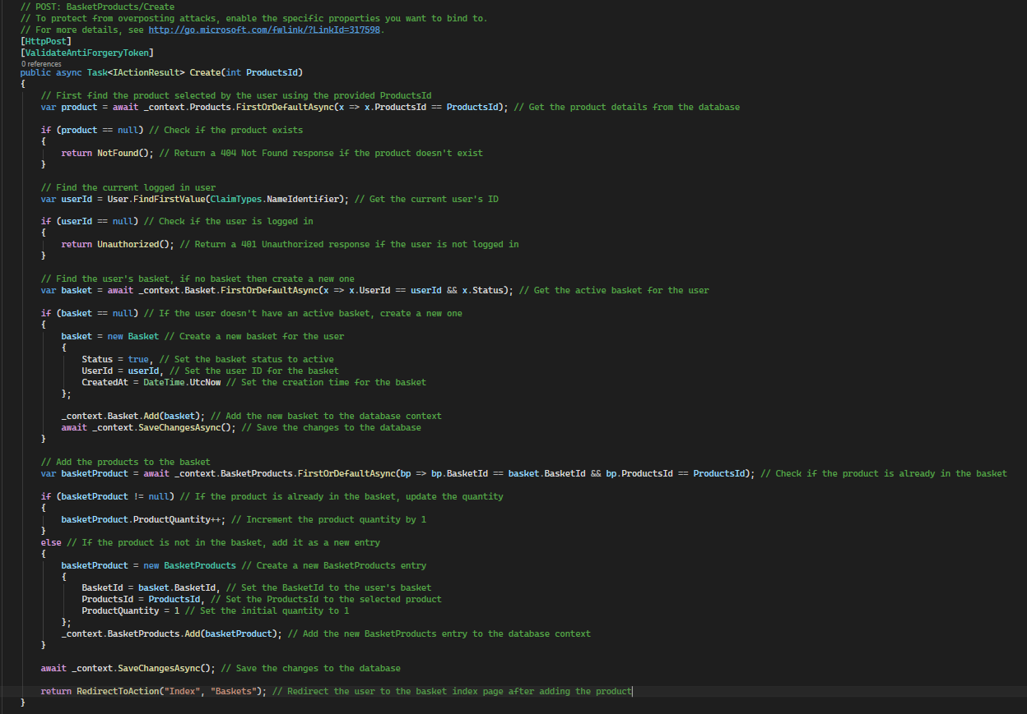
Now let’s try to add a product to the basket whilst we are logged in, it should redirect us to the basket screen sucessfully with the product in the basket.
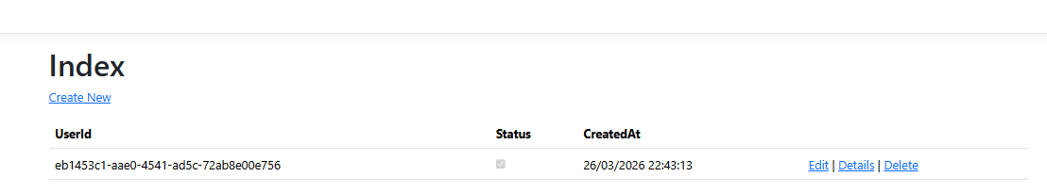
Works as expected.

Version 0.2.5 – Basket Improvement
First of all, we are going to go to the GET method inside of the Baskets controller.
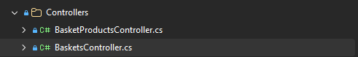
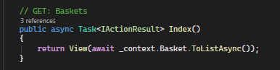
Within this method, we start by finding the user who is current logged in through a variable which scans for the userId, if the userId is null then we return an unauthorized response.
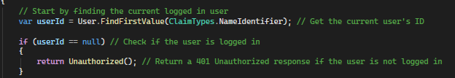
Then we check if the user has a basket, if they don’t we will create one for them. We create code, starting with making a variable called basket which finds the active basket for the user. If the variable is null (the user doesn’t have a basket) we will create a new basket for them and set their user ID, status and creation time appropriately. We will then save these changes in the database.
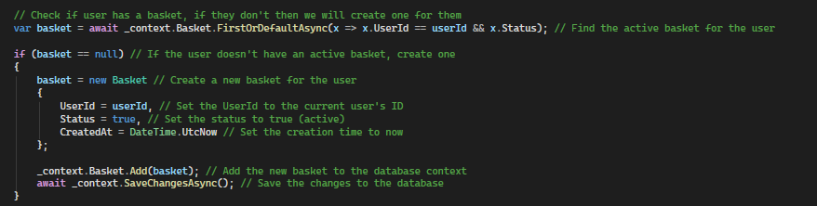
The next set of code we add into this method will find all of the products in the basket and based off all of those products, the subtotal will be found. We use a variable called basketProducts to start a query on the BasketProducts table from the database using _context, we then find all of the products in the user’s basket with the .Where and then include the related basket and related product details with the lines which use .Include, we then execute the query and get the results as a list at .ToListAsync, then initializing the subtotal variable using decimal. We then use a loop with the variable basketProducts using a new variable called basketProduct to loop through each of the products in the basket. We create a new variable called productTotal which calculates the total price for the current product by gathering the price of that product from the database and multiplying it by the quantity of that product which is in the basket, it will then add the product total to the subtotal.
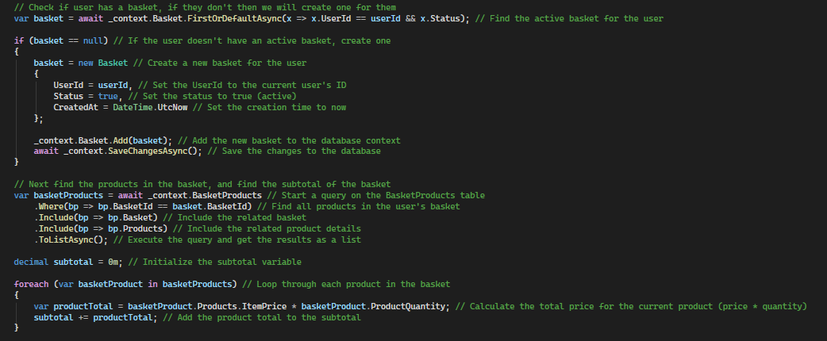
And then finally, we add a calculation function for the loyalty discount which gets the total number of orders the user has made and applies a discount to the subtotal of the order based off of that. For now I’m using 5 but we may add more calculations for loyalty discounts later on and also modify the current calculations, This data will then be sent to the ViewBag and then the whole method will be turned to the View.
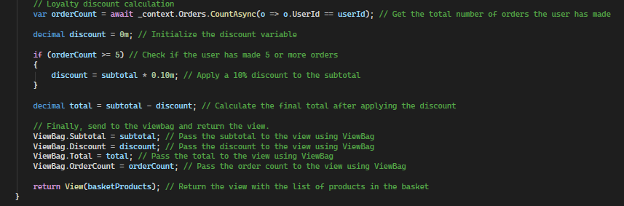

Now, let’s go to the Index.cshtml file in the Baskets view.
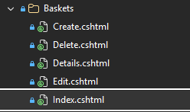
We’re going to change the model being passed through in this View from this:
To this:
Then I added some HTML with very little styling, mainly focusing on the C# logic to link the front end with the database. This is how it turned out:
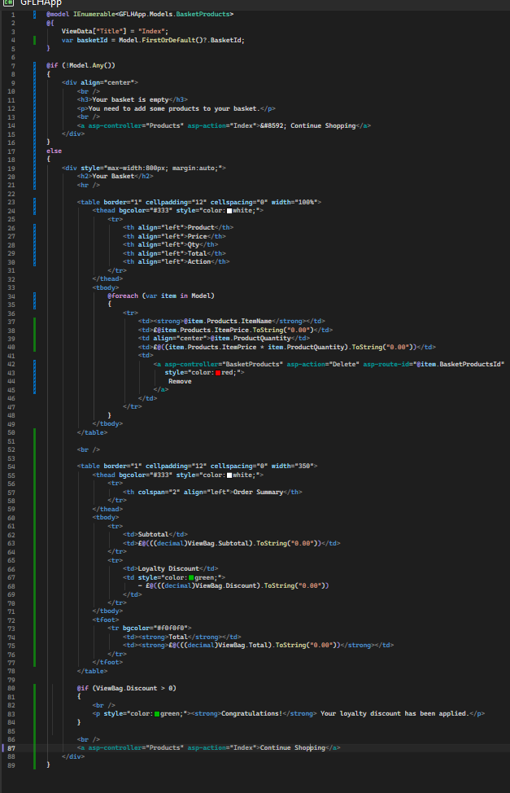

Now, when I run the app and add another item, I should be able to have multiple items in my basket, and the front-end should look as we expected. The total of each time should also be added up based on quantity and it should apply to the order summary as expected.
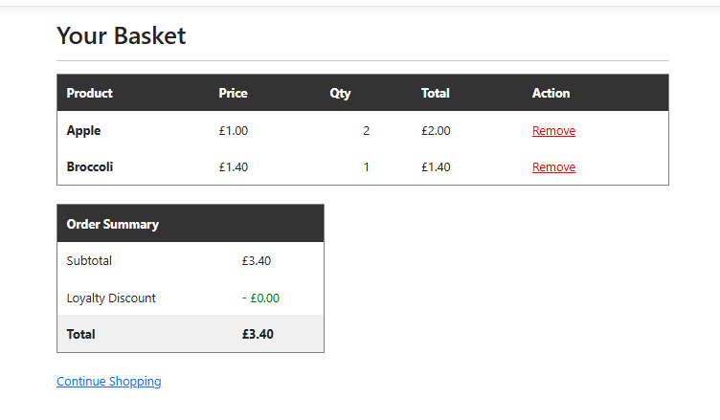
Everything works just as anticipated.

Version 0.2.6 – Adding Links to Nav Bar
For ease of navigation, we’re going to quickly add links to the navigation bar inside of the _Layout file.

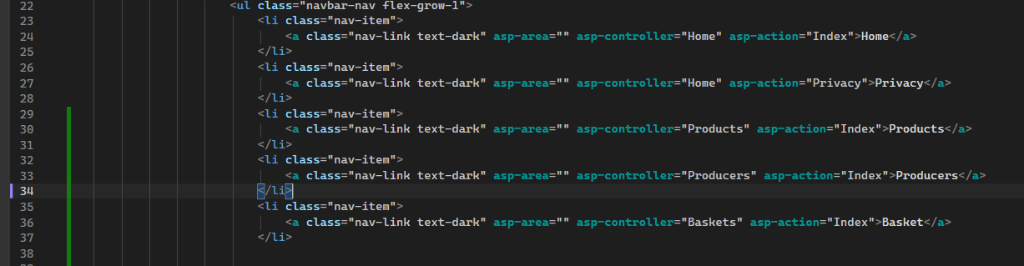
For now this should be fine, it simply allows to get through the page easier rather than using the URL bar to get to unique pages.
Once running the application, clicking each link on the navbar takes me to the correct page.
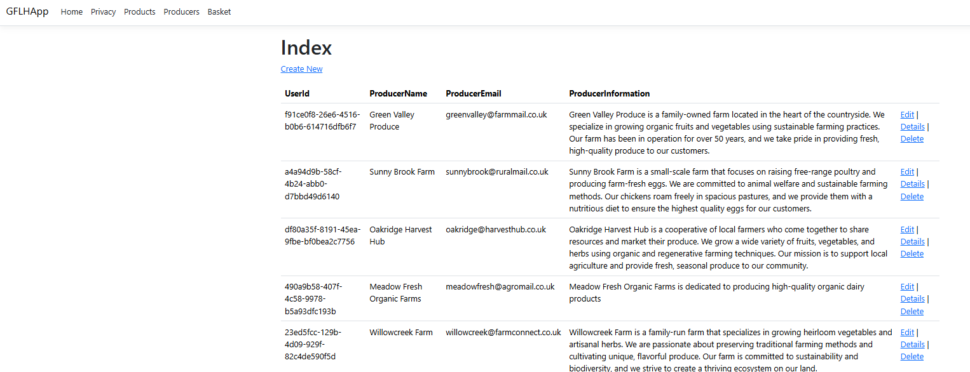
Links work as expected.

Version 0.3.6 – Checkout Functionality
First, we need to add the Checkout button to the Baskets Index.cshtml page.
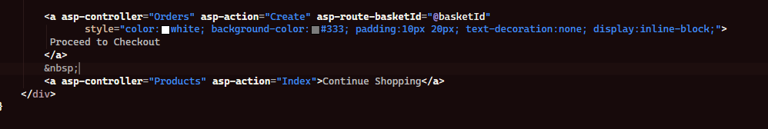
Running the code, we can see that this looks just fine. 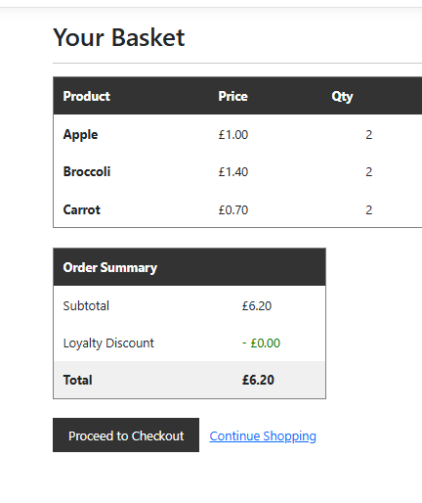
Now, we can go into the Orders Controller and modify the GET method. Here is how it looks beforehand.
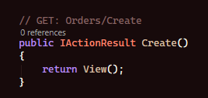
I change it to the following:
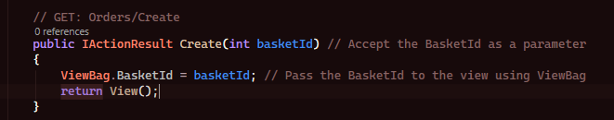
This it to make it so that the view makes use of the viewbag basketId.
I then change the Create form for Orders, (Create.cshtml) in the Orders view folder and re-create the form.
This is how it was beforehand:
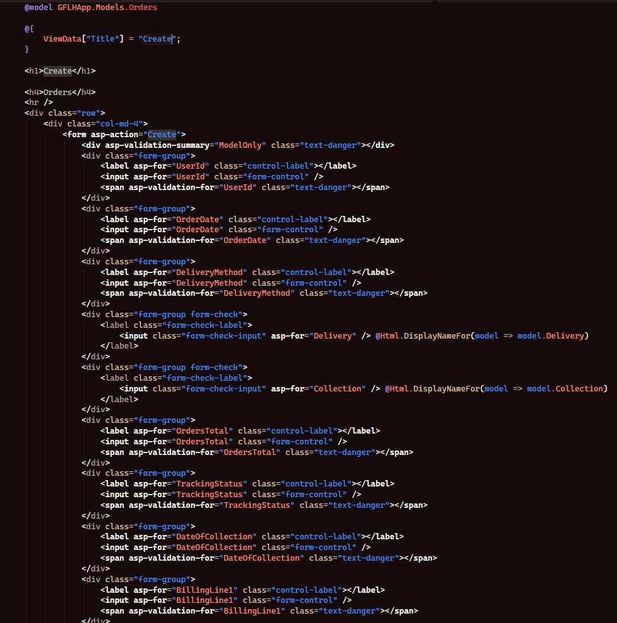
This is how I changed the form:
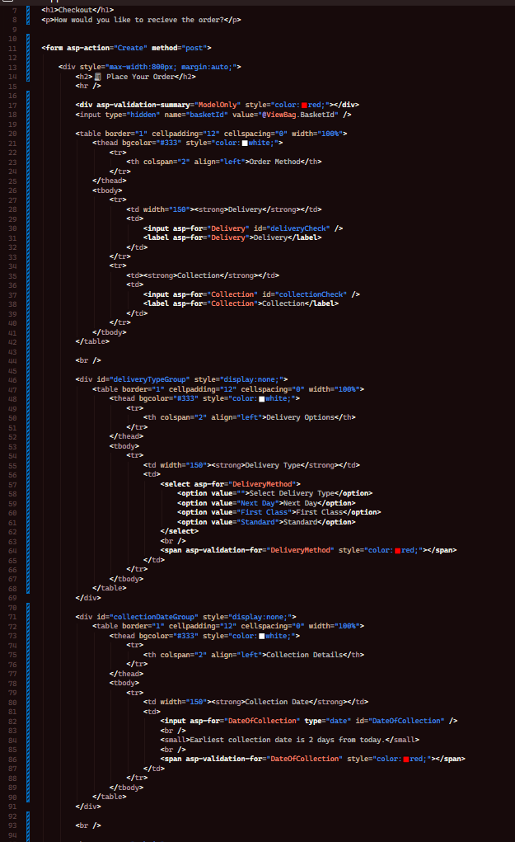
You can see I created this form with the logic that the customer ticks a checkbox. If they click the delivery checkbox they will be given 3 different delivery methods, and if they click collection then they pick a date. The basketId field is hidden and passed the basket Id through the backend so the order can know which basket it belong to. The validation summary at the top will be shown if the form isn’t submitted correctly.

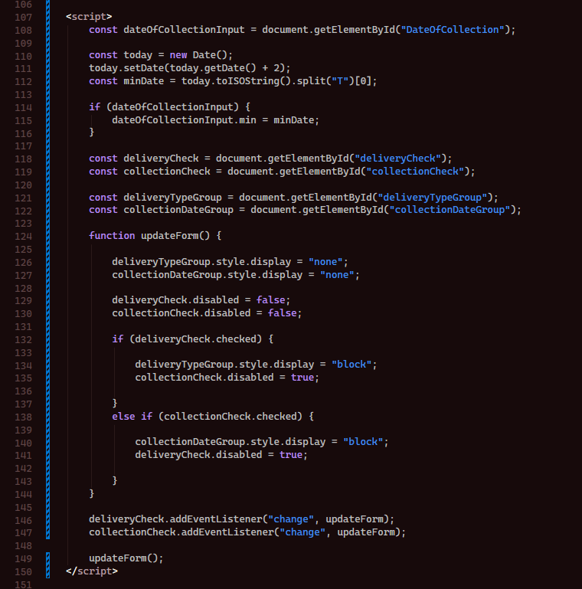

This is the JavaScript, it controls what the customer sees depending on what they tick and stops them picking both at once. On page load it runs updateForm() so everything is set to its default state which is hidden. If delivery is ticked it’ll show the dropdown for delivery and disable the collection checkbox, and if collection is ticked then it shows the collection date picker and disables the delivery checkbox so that the user can’t pick both. The date restriction at the top will calculate todays date and add 2 days to it so its set at the minimum selectable date opn the collection date picker so the customer wont be able to book a collection for today or tomorrow. The event listeners watch both checkboxes for any potential changes and re-run the updateForm() each time so its always reflected whichever option is selected. All of this code may be modified in the future for enhancement, this is just a functional base to work on, especially design wise.

I should now have a functional proceed to checkout button when I goto the basket page once running the website. 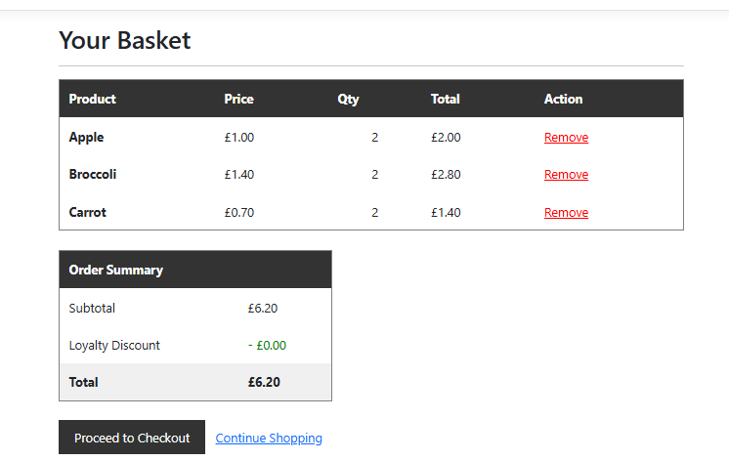
Once I click on it, it should take me to the checkout page.
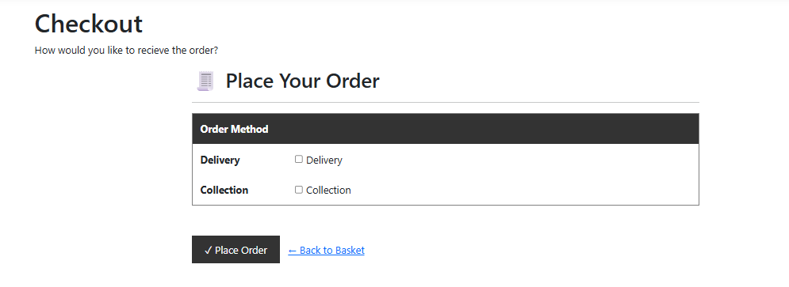

Version 0.4.6 – Placing Orders
Now that we have a place order button, we should get it working so that customers are actually able to make orders. To do this, lets begin by going into the OrderControllers Create POST method.
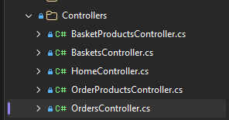
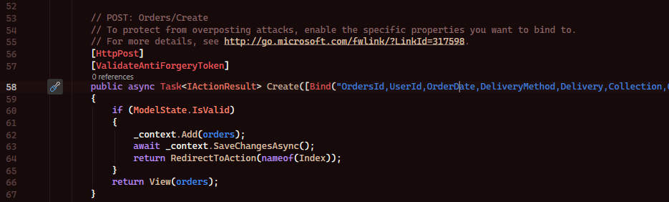
First, let’s delete the method body and change the parameters.
Then the first of all, lets find the currently logged n user and assign them values for THAT order. We can do this by accessing the ViewBag.
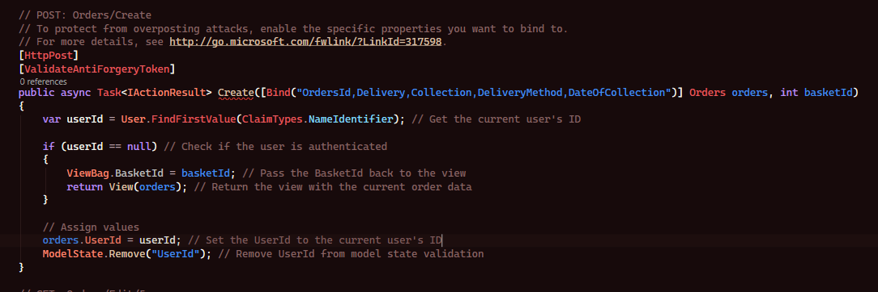
After this, lets add code to set the order date to today.
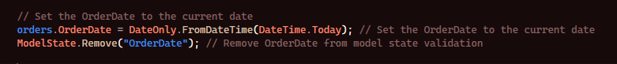
Then we add the code for finding all items in the basket. Although, it seems that I ran into an issue.
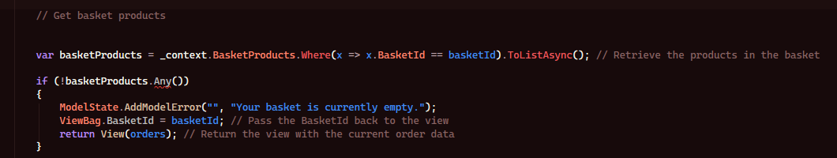
After going through the code, I realised that I didn’t use await, so the Any function wasn’t valid.
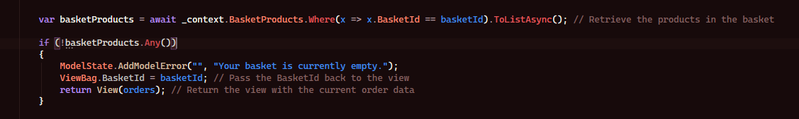
Now it is working, lets continue by adding a subtotal calculator section This will work by counting the number of orders which the user placed and based on that number it will apply a discount.
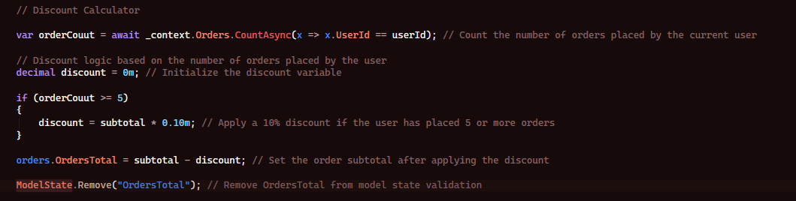
Now lets add handling of delivery or collections with an error check.
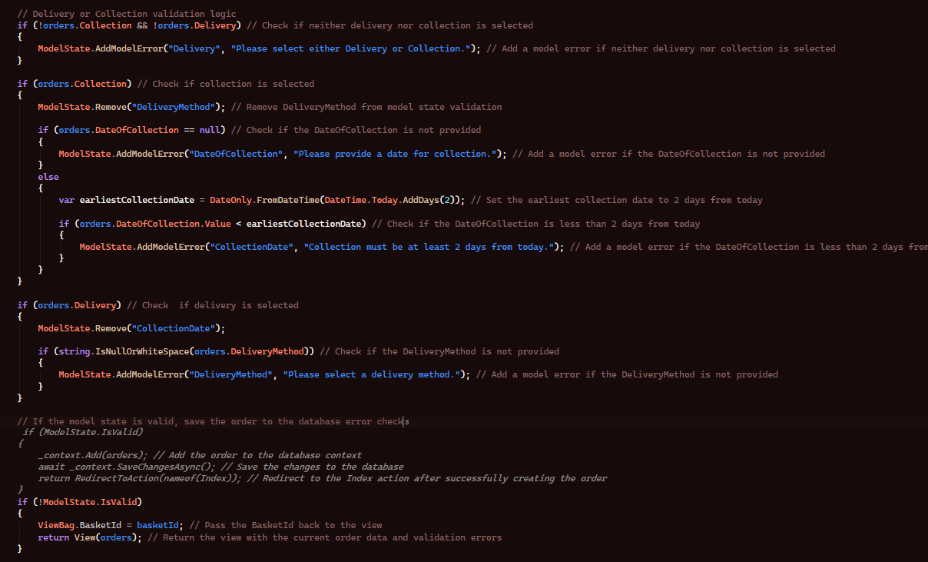
Finally. We add so we can order and update stock.
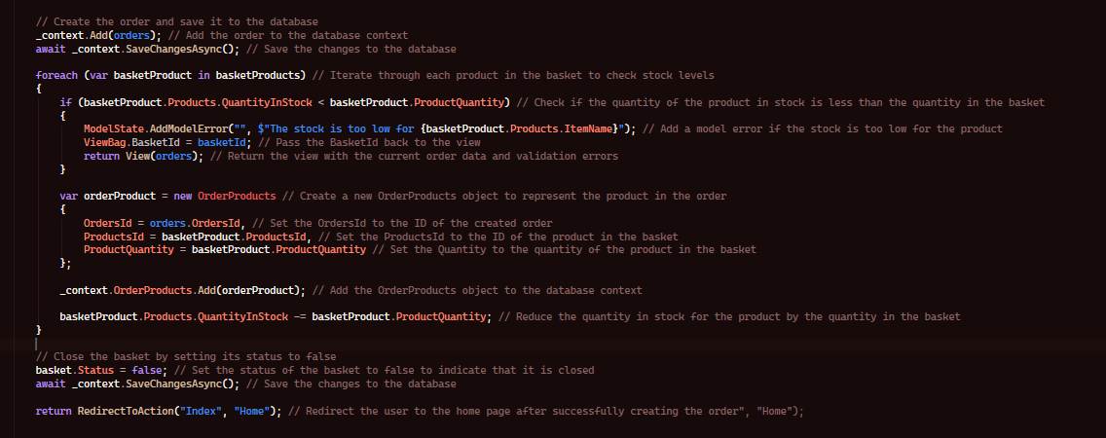
Now when we test the function, we should be able to checkout. We can see if it worked by going to the order page.
Its seems that I ran into an error when pressing the Place Order button.
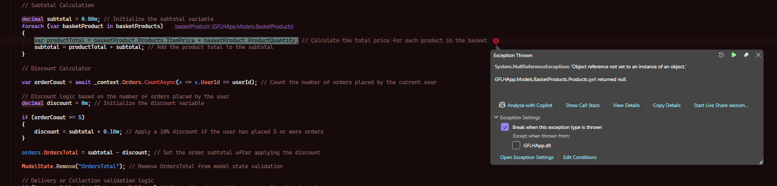
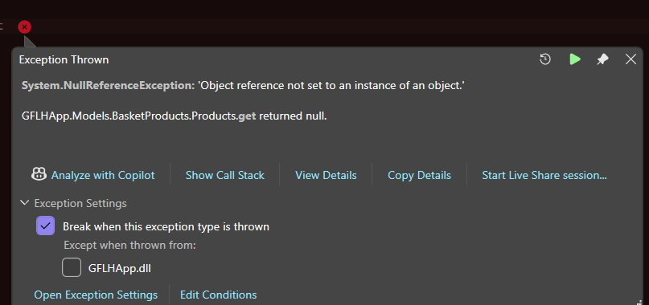
Checking the code, I realised this line needs .Include
It needs .Include because without .Include, it will load stuff like BasketProcutsId, BasketId, ProductsId and ProductQuantity , but it WONT load stuff like Products.ProductName , Products.price etc. So, when we try call basketProducts.Products stuff it will return null because Products is null.
Here is the fixed line, let’s see if this fixes the error.
I go back to the checkout page with the items in my basket and choose the following fields
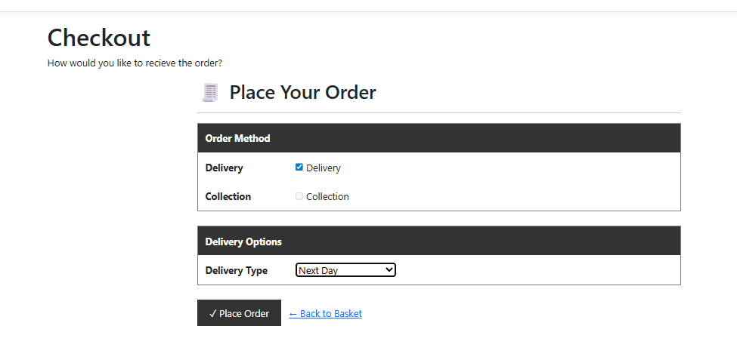
Clicking, place order. I am receiving no error message but the function isn’t responding. Going through the code, I realised something.
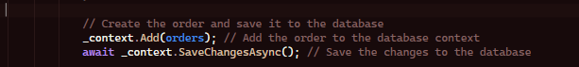
It should be _context.Orders.Add(orders), this isn’t adding the Orders to the Orders database so we aren’t getting a valid response. Lets try again,

I got the error again, let me try removing the ModelStates for the required address info.
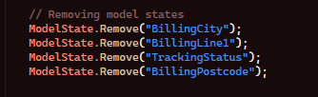
This seems to be a human error mistake, it seems because I didn’t add the option to input an address I’m getting an error. This makes sense.
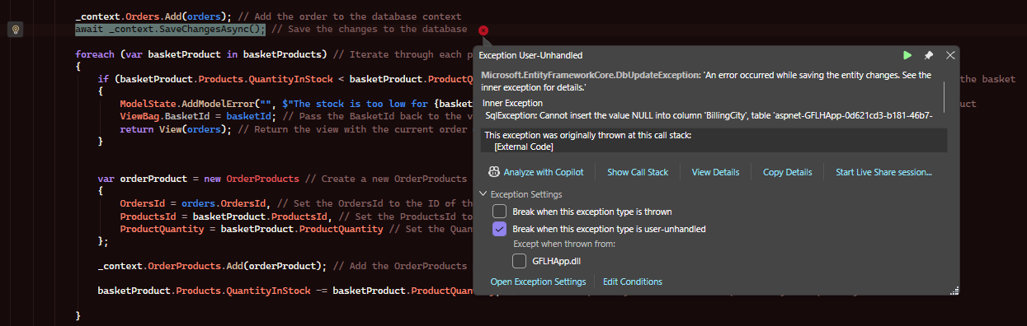

Now testing, it works. I goto the order details page and I get the following view:

Version 0.4.7 – Order Authentication

Users should only be able to see their own order history, but admins should see all orders and the supplier should see all of THEIR orders. So, I will add the following function to the index method:
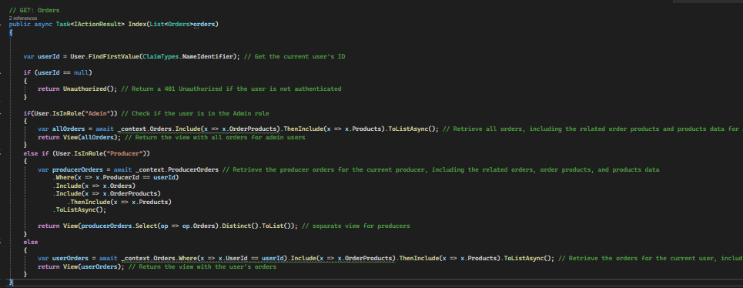
What this does, is gets the user ID and uses it to check if the user is logged in, if not they’ll be returned an unauthorised error. If the user is an admin, it will retrieve all orders and return them onto the view. Or else, if the user is a producer it will show only the orders for that current producer, including order products and product data.
Running as each role, I can see the order, producer can see their orders, admins can see all orders, users can see their own orders.
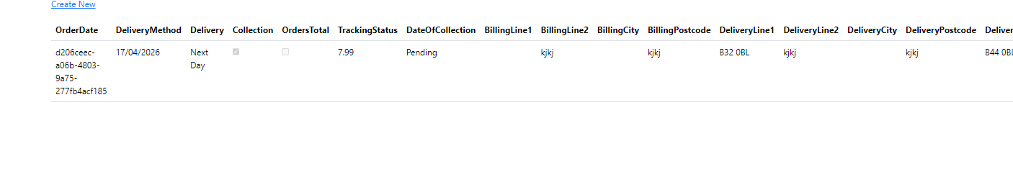

Version 1.4.7 – Producer Dashboard

First of all, we must make a new controller. Producer slices were not kept in mind during development, this change has been made to the proposal so that producers are able to only see only THEIR products inside of an order. This way, they can’t conflict with items from other producers inside of an order. This is industry standard practise used in co-operative e-commerce websites, like amazon who uses sellers.

We create a new model called ProducerOrders.cs:
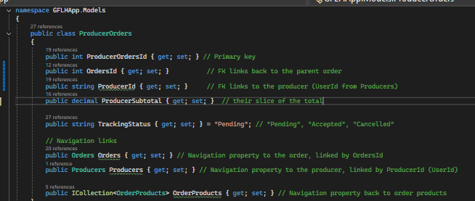
We add a primary key ProducerOrdersId so it can be uniquely identified, a link back to the parent order through the foreign key OrdersId. We have another foreign key called ProducerId to link back to the producer, using datatype string as we want the userId from the producer, we have a public decimal (decimal as it is the data type we’re using for currency) to store that prodcuers slice of the total. We also have a string for tracking status which is automatically set to pending to show whether it is complete pending cancelled or partially complete

We then make changes in the Producers.cs model:

Now that we have made all of these changes, add a migration and update the database.

Then we need to make changes to the OrdersController.cs create POST so that when the order is saved instead of one flat loop we group them by producer first and then create a ProducerOrders record for each group.
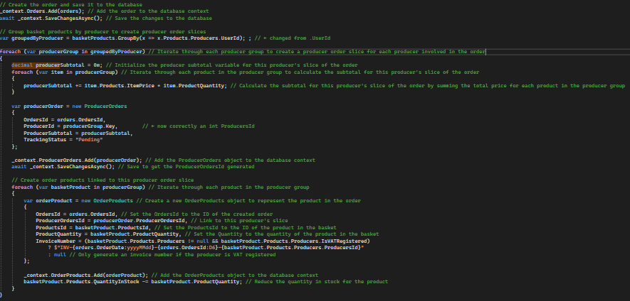
We then make changes to the OrdersController index method as the view currently queries OrderProducts directly, instead we want to point it at ProducerOrders:
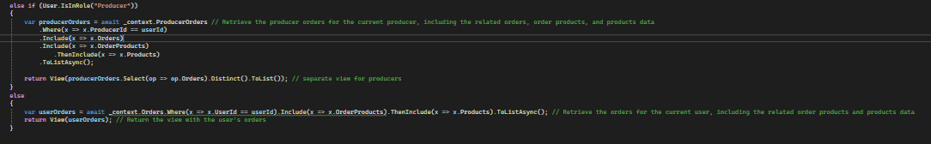
We then begin by creating a new controller called ProducerDashboardController.cs , we do not need to create a model for this as we are going to be extracting information from other models and using it inside of this one.
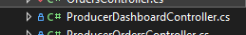
Now that the controller is made, I created a views folder and called it ProducerDashboard and added an Index.cshtml file inside of that view so producers are able to make use of the page.
Opening up the ProducerDashboard controller, I began by authorizing the producerdashboard to producers as I only want producers to open the page. I then load in the database using _context.
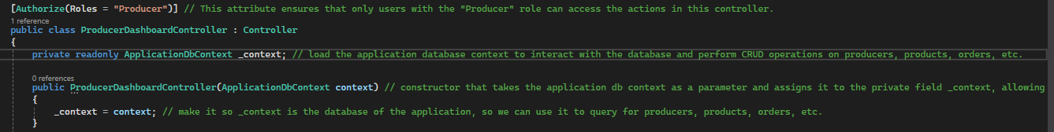
I added the following logic to the index method of the producer dashboard.
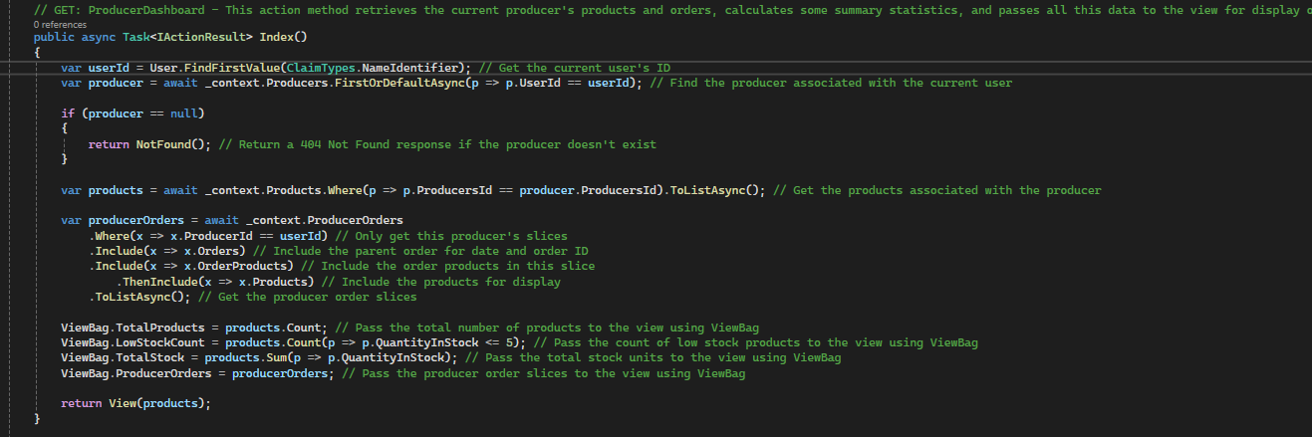

What this does is calculates a summary of statistics using the producers products and orders users have made with them, passing this data to the view so it can be used on the producer dashboard.
This would be enough logic for now, although, to make efficient use of time I believe it’s a good idea to add the rest of the functionalities I have in mind so I don’t have to re-write the front end for the view later on, so I can just do it all in one instead. So, I add this method which basically recalculates the status of the order, depending on statuses of all producers slices for a given order. It will check if theyre accepted cancelled or elsewhat to determine the final status of the order.
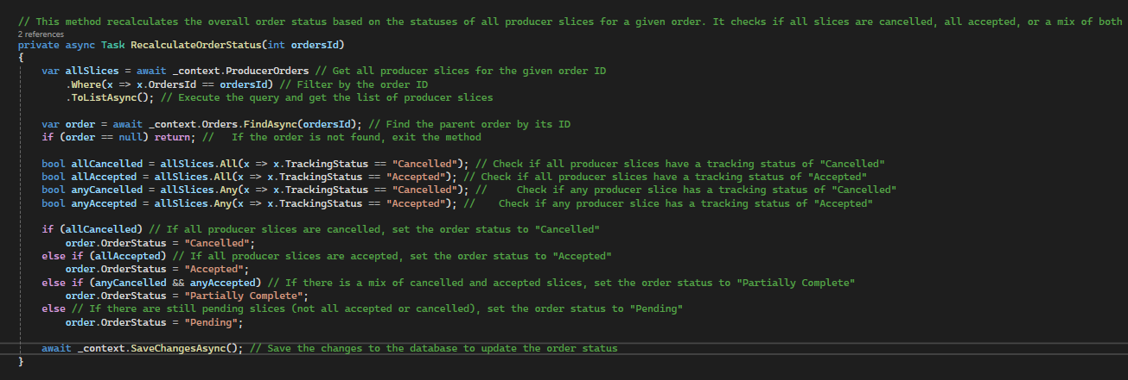

After adding this method, I create a view in the ProducerDashboard view folder called CancelProducerOrder.cshtml as I plan on allowing producers to cancel and accept orders from the dashboard. So I begin by adding the following GET method:
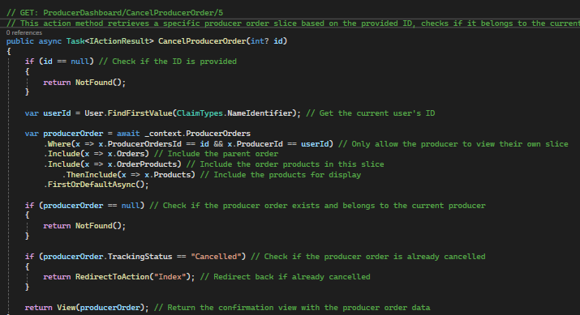
What this does is runs an IActionResult action method to retrieve the producer order slice based on provided ID, and it will check if it belongs to the producer modifying it, and if it isn’t already cancelled we will return a view to confirm that it has been cancelled.

I then added the POST method which basically manages the cancellation of the order item within the producer order slice. It checks if the order product belongs to that current producer and restock the product quantity and updates the producer and order totals, checking if the entire producer slice should be cancelled, removing the order product from the database and then recalculating the order status before redirecting to the dashboard.
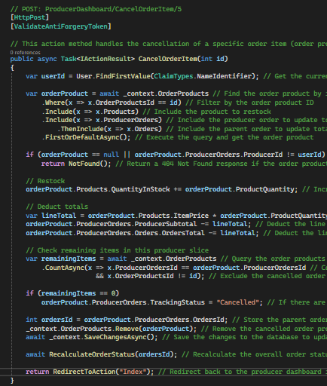
And then finally, I added the method for accepting orders. This will not require a view as it’s simply just a POST method as we do not need to make changes to individual items this time, we’re just accepting the entire order.
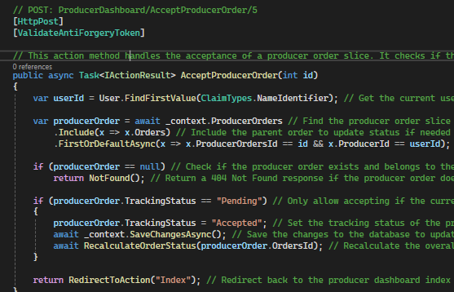
This basically checks the producer order slice belongs to the current producer and is in a pending state, and then updates its tracking status to accepted and saves the changes, then recalculates the overall order status and then redirects back to the page. This is why making use of producer slices is very efficient and is used in industry standard e-commerce systems like amazon, as it will be only shown as ‘Accepted’ for the part of the order which is linked to THAT producer. It is both efficient, practical and private.
Now I add temporary front-end to the index.cshtml page with basic HTML to ensure that the method works as functioned. I added a new migration since new views and controllers were added.
For index.cshtml, the most important logic was ensuring that only the most 5 recent orders are shown on the index.cshtml page and that all links work. Here is a snippet from the front end.
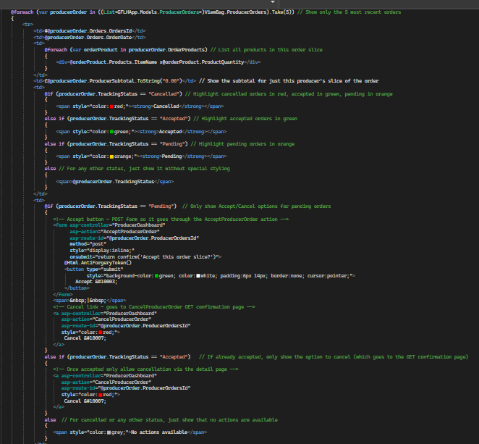
For CancelProducerOrder.cshtml , It was important that I implemented logic to only show items from that order slice and ensured that the correct attributes from the correct models were being used.
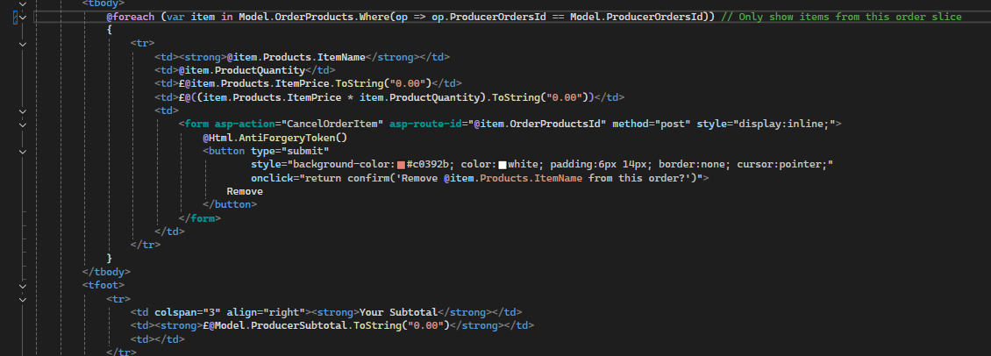
Upon running the solution, I first make an order using a user account. All works fine. Then I log in to the first producer account and I goto the page by typing it through the URL as I have not added a button to the navbar yet. The page opens.

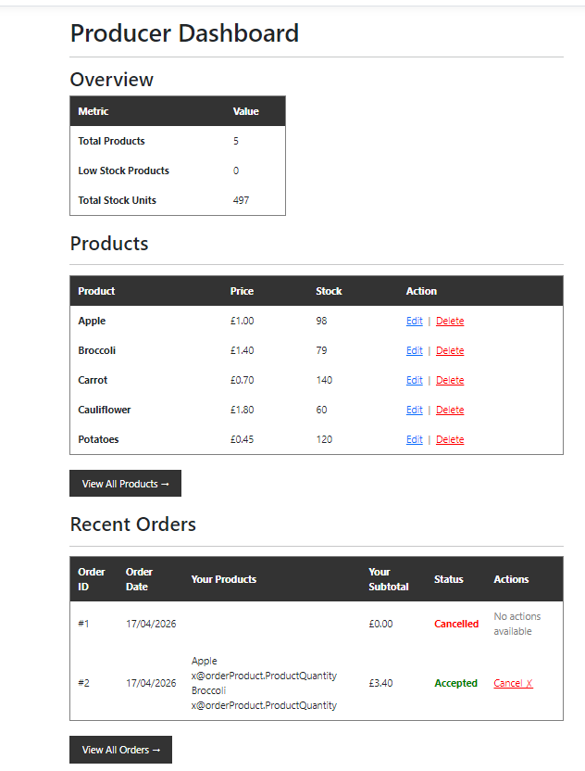
It lets me cancel and accepted orders. It also shows products. The cancel order works as expected too.
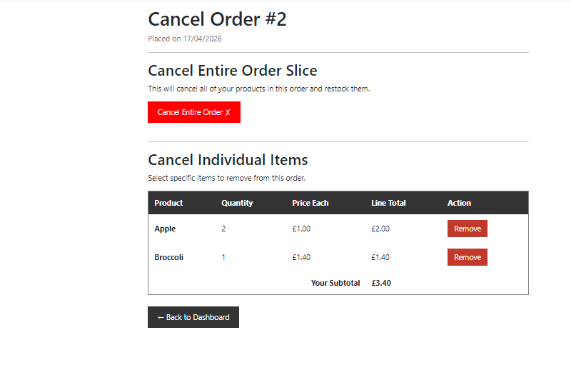

The functionality almost works perfectly as expected, although I noticed that the products aren’t loading in as expected.
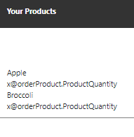
This may be a front end issue,

I suspected this was a front end issue rather than the controllers failing to load product information as it works just fine in the CancelProductOrder and the item name on Index.cshtml is loading as expected. Lets go to the line which is responsible for displaying this data.
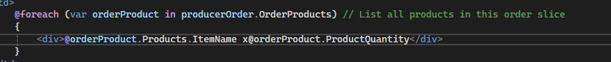
We can see that it is failing to grab the data, this is a syntax issue. I tried to make it so it was for example x3 apples but the programming language does not allow an x before the @orderProduct to call the data. So, I simply add a space behind the x
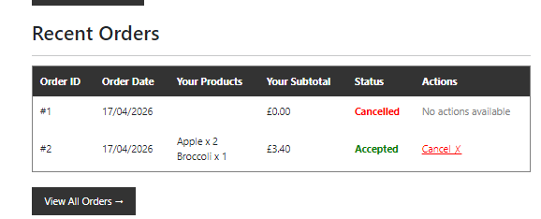
Upon running the application this issue is fixed.
If you attempt to access the page without being logged in, it prompts you to log in.
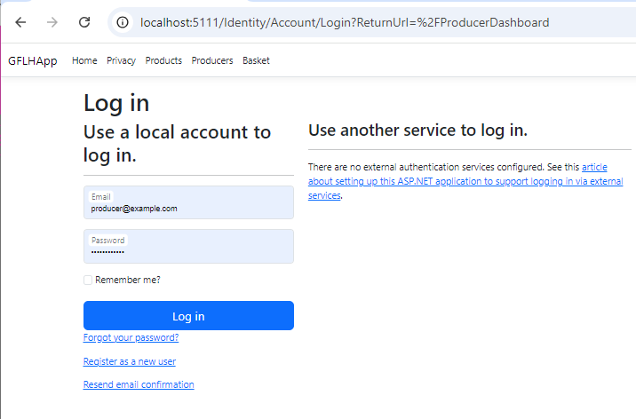

If you attempt to access the page on an account which does not have the Producer role, you’re denied access.
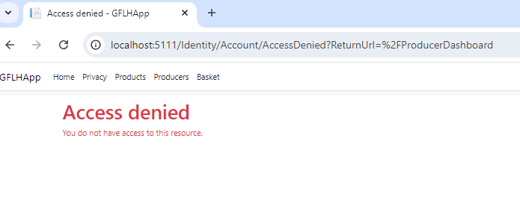
The page works as expected.

Version 1.5.7 – Order Confirmation

Currently, once you place and order you’re taken straight back to the home page. This is not good practise as it can lead to confusion in the order process which would lead to users going to support. For the order confirmation, I decided to implement a few things:
- The user should be redirected to the a confirmation page after ordering, alerting them their order was successful and giving them an order overview.
- Items should have allergen information
- Producers should be able to add their VAT status to their profile, and give users their VAT number with an automatic unqiue invoice number.
- Terms and conditions checkbox
All of these decisions were decided as it adds legality compliance to the website. It is illegal to not include VAT tax to product items and it is also illegal to not register your company as VAT registered on co-operative website, not displaying the number can lead to penalty from HMRC. Terms and conditions and allergen information improve clarity for the user and avoids misconception and complaints.

First of all, we must make changes to models.
In Orders.cs we add this:
This is not optional as the user MUST accept terms and conditions upon checkout.
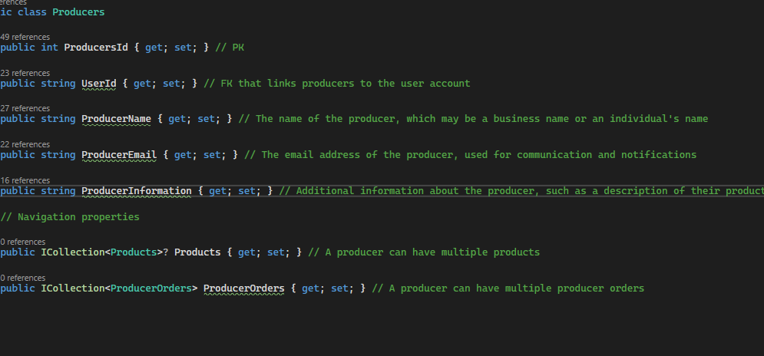

We have added VATNumber which is optional so the producer can add their VAT number if they have one. We then add a bool for IsVatRegistered to determine if they are or not, alongside a navigation ICollection property for producerORders as a producer can have multiple producerorders.

Inside of OrderProducts.cs
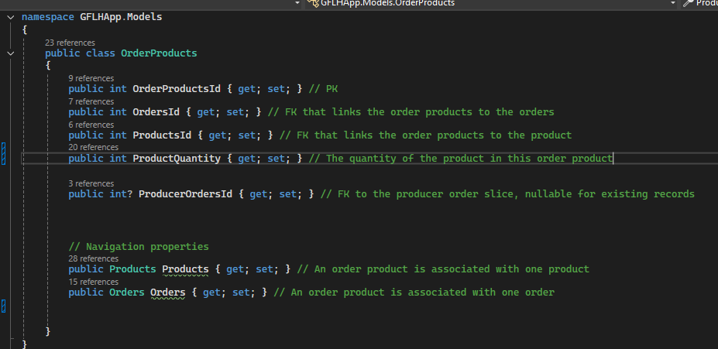
We add InvoiceNumber which is optional as we want to display an auto generated unqiue invoice number for each producer apart of the order who are VAT registered. We also add a foreign key for ProducerOrders and a navigation property for order slices.
Now that we’ve done this, we can finally add controller logic. We head to the Orders.Controller and include producers to the basketProducts variable as we need to include producers so we can check the VAT registration.
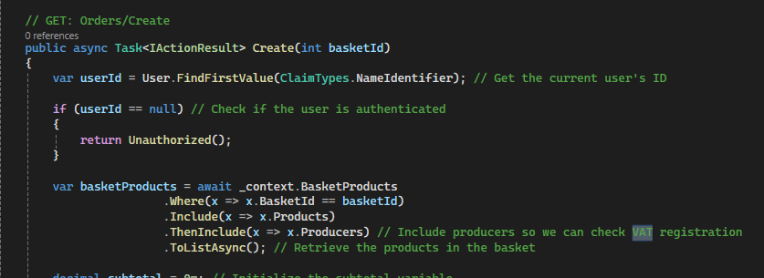
Now, within the producer order slice logic, we need to add generation of invoice numbers if the producer is VAT registered.
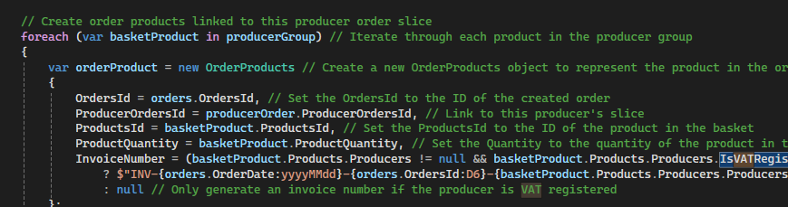

Now we’ve done that, we need to add the attributes to the binds for each method so they’re actually being used.
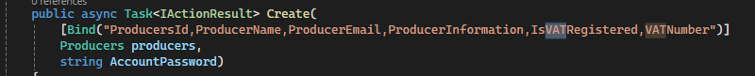
Now we have to seed the data, so we go into SeedData.cs and change add the attributes for the producers so some are VAT registered and some aren’t.
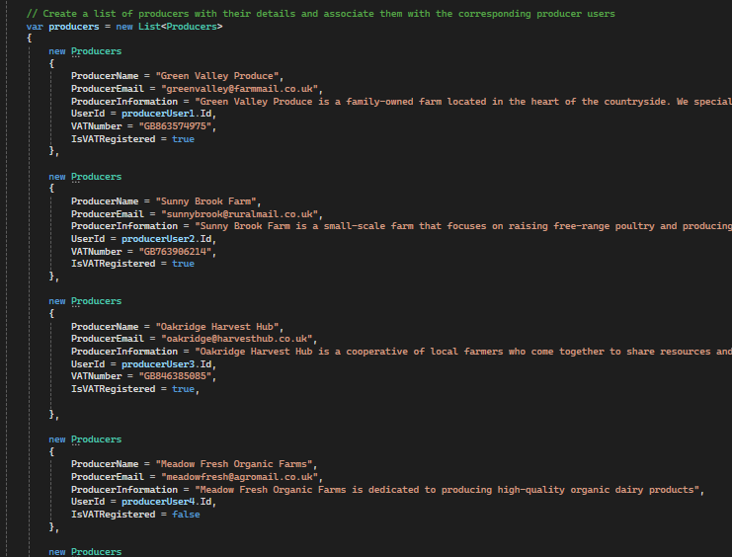
After this, lets add allergens to the products.
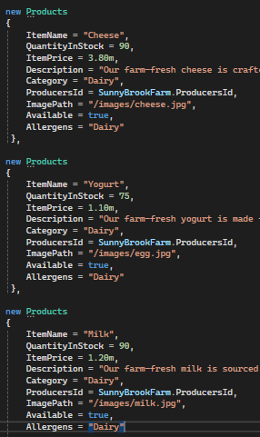
We then add so the allergens pas through the basket products to the view so they can be displayed in the viewbag in OrdersController.cs GET create.
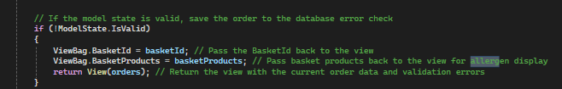
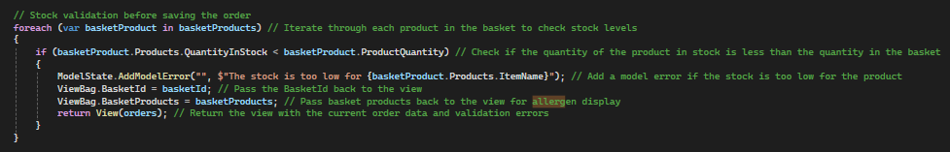
We also add allergens to the Bind of each method in the ProductsController

In the view folder, lets now add a Confirmation view
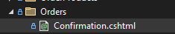
We make it so at the end of the order process you’re taken to the Confirmation.cshtml view
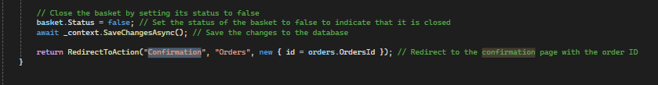
We then add a GET method for the Orders/Confirmation which retrieves the order details so it can be presented on the confirmation page, it will check if that order belongs to the current user and include related data like products and producers, and then return the order data to the confirmation view.
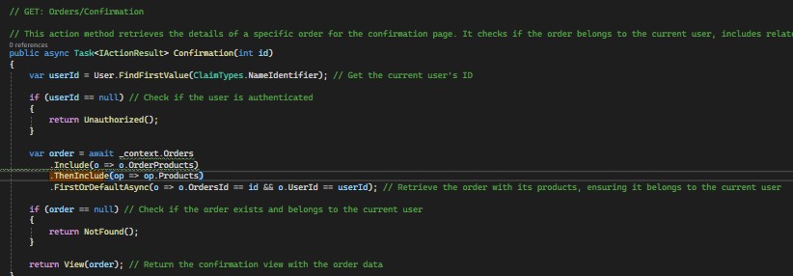
Now, we add the allergen information to the Orders Create view:
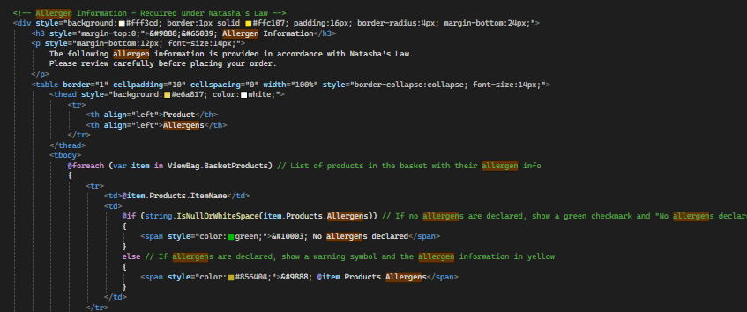
And now in the Confirmation.cshtml view, we add front end logic with the ability to go back to home page or see orders. This is temporary basic html for now, focusing on functionality, but will be kept in mind when front-end is developed on. Some important parts of the view were summary, for example showing delivery methods:
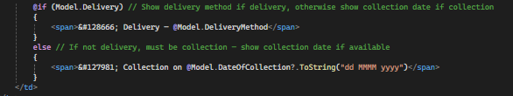
Calculating empty space:
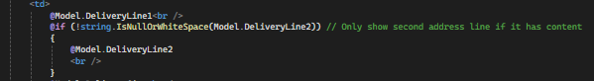
Grouping by producers and getting invoice number, only show VAT for VAT registered producers and list all the products ordered from THAT producer:

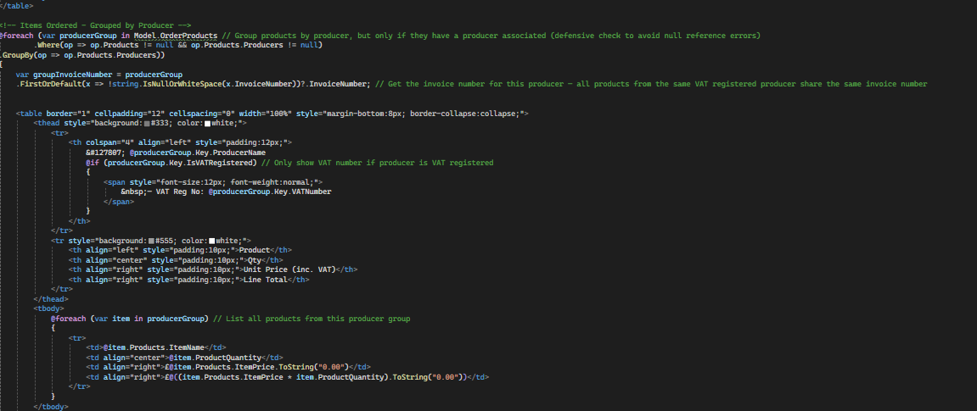

Run the calculations (20%) for VAT registered products:
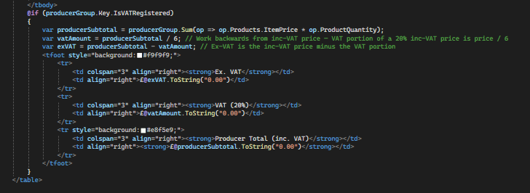
Invoice numbers per registered producer:
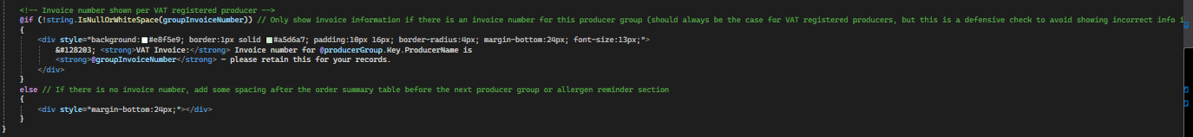
.ThenInclude(p => p.Producers) // Include producers so we can check VAT registration on the confirmation page

I then add allergen logic to the Baskets index view:
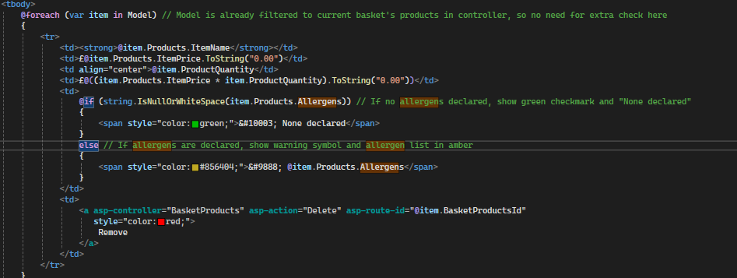
With a bit of front end:
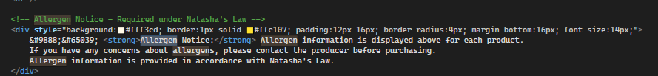
Now I’ll add two items to my basket, an item with an without an allergen and see what happens:
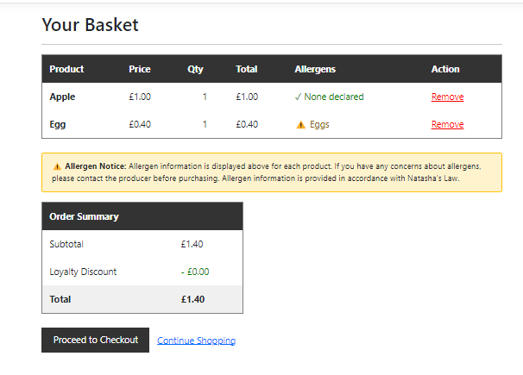
Works as expected on the basket page. Let’s continue to the checkout page. (Orders/Create)
It also works as expected here.
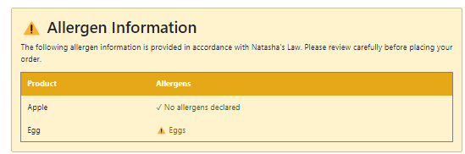
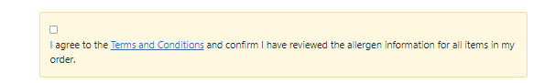
I can not continue without accepting terms and conditions, works as expected. We will make a view page for terms and conditions later on, for now it takes us to a non-existent page if the href is clicked. Now, let’s place the order using valid data fields.
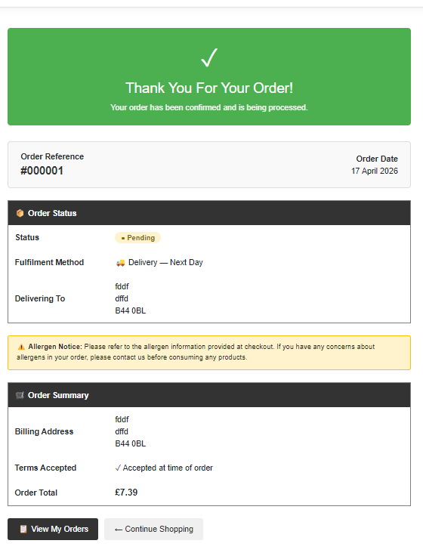
It seems that none of the data came up. It must be an issue with the confirmation page logic as the allergen data was returned on the basket page.

Reading through the code, I found that the producers are not included in the GET method for the confirmations page.
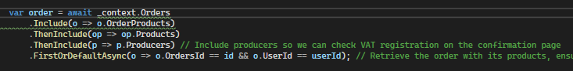
Adding the .ThenInclude line for producers should fix this issue. Let’s re-run the application using the same data fields and methods used earlier and see what happens.
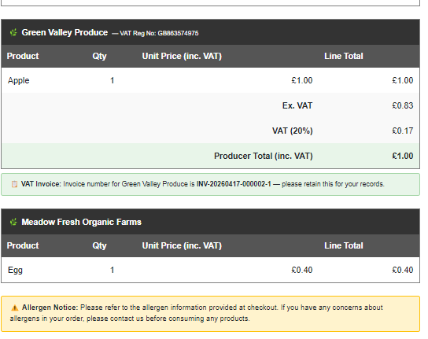
Great, it has split the order up. The first producer is VAT registered and it gave us an invoice number and displayed the producers VAT number. The invoice number is calculated through date – order number (using the unique primary identifier for that order) – producer number.
The continue shopping and view my orders buttons work as expected.

Version 1.5.8 – Producer Account Creation

Admins should be able to create producer accounts. This should be done in a secure way with validation checks and security, allowing the admin to pick a temporary password which the producer can change themselves afterwards. It should work the same way as normal account registration where it links a user ID, except it assigns the ‘Producer’ role to the account. We haven’t added much logic added to producers currently.

First we add string AccountPassword to the bind to the producers model in the controller so its an accepted additional parameter for the account password which is not part of the Producers model but is needed to create the associated Identity user account.
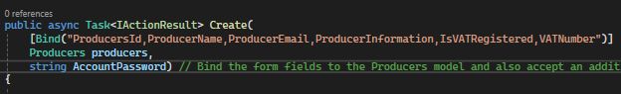
I added this method for debugging purposes:
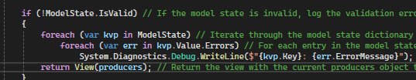

We then add uniqueness checks to ensure that accounts don’t overlap eachother:
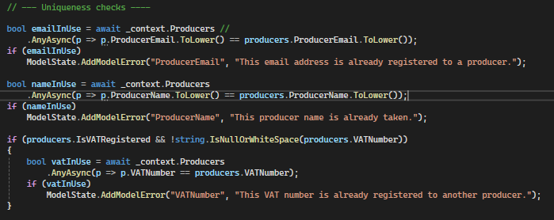
Then, we add password validation:
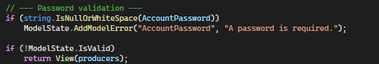
Once we’ve done that we add the logic to create the identity user account:
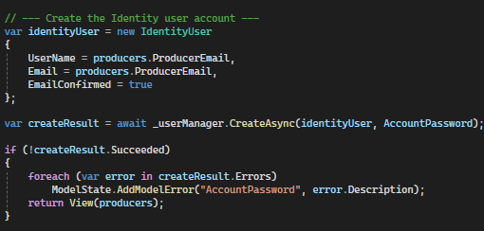
We then ensure the role exists, assign it and then link the user ID to the producer record:
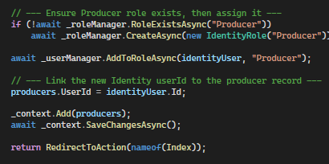

Then, in the edit post we add checks:
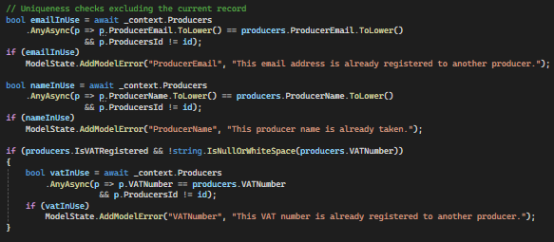
In the create.cshtml file for Producers, we add this section of code:
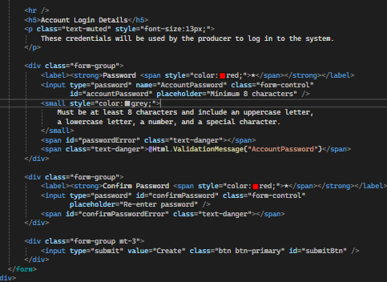
Now we add a bunch of javascript, which are just validation checks for each data field.
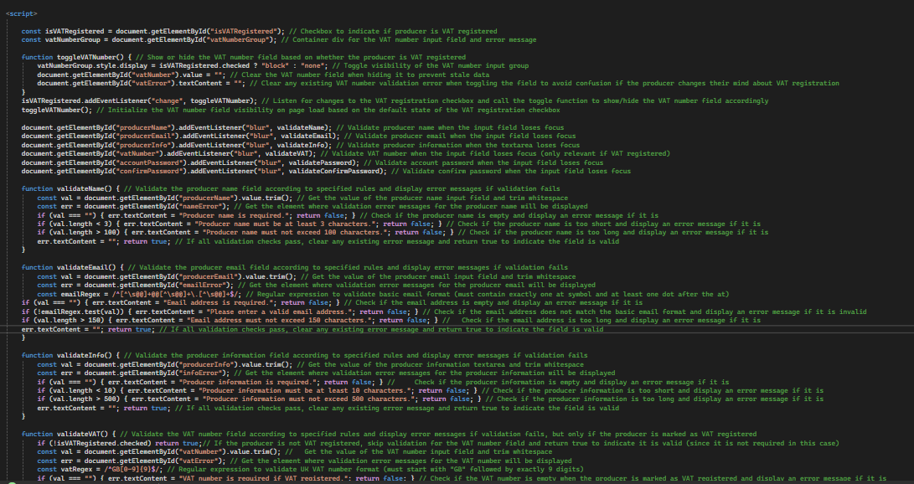
Now let’s test if it works by running the application and going to the Create page for producers. First let’s test data field validation, I should be provided error messages only after failing each data field.
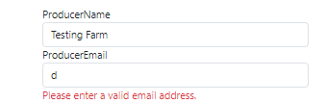
Works as expected.
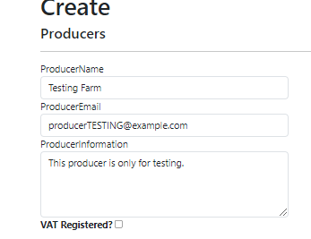
I should only see the VAT input field by clicking the checkbox and entering the VAT number and it should only let me enter VAT numbers which begin with GB with 9 digits (following british standards)
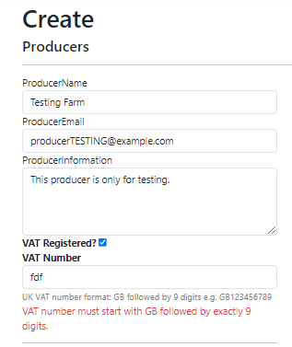
Works as expected, it also allows me to enter valid data fields.
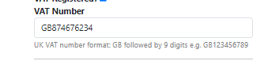
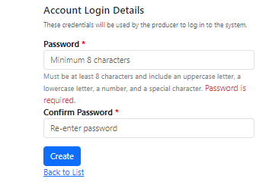
It sucessfuly checks if a password has been inputted or if it meets standards.
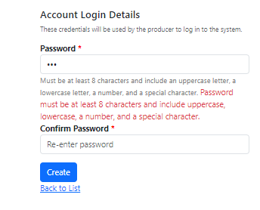
Now, lets see if account creation works by entering valid data into every data field and pressing create.
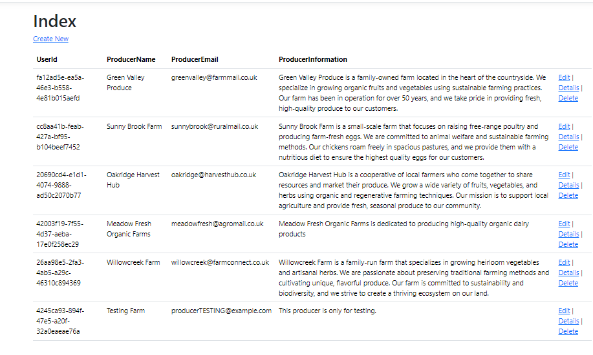
It has successfully been added and assigned a userId, lets attempt to log in to the account and go to the producer dashboard to see if it has been successfully created and assigned the Producer role.
Logging in works.
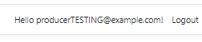
Producer dashboard also works, amazing.
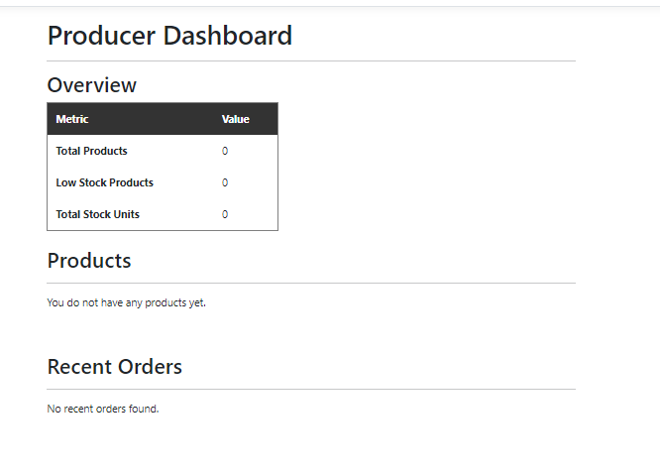
Function works as expected.
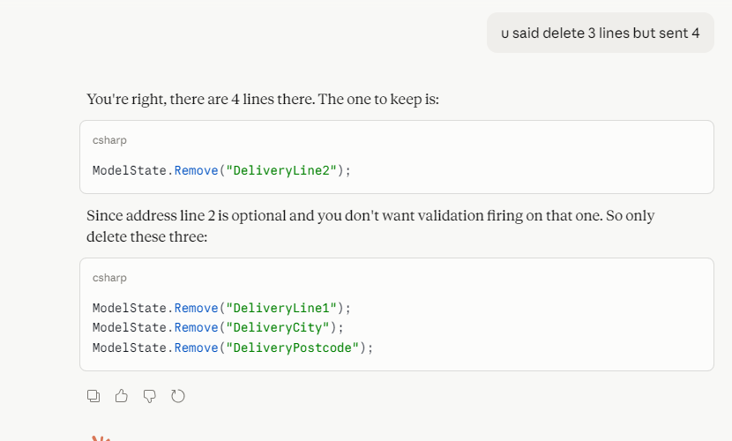

Version 1.6.8 – Front end Design Concept

Now I started working on the design of the page. However, I wanted to make changes to the design of the page. I wanted to section out the pages in the same type of way as I did in the design proposal wireframe, although using a different approach. I really like the colour scheme from the proposal as it is warm and inviting, we will take the darker greens and try to use them for pages which are more important like Create pages and check out pages, and use pale sage greens for the pages which are supposed to be more inviting, like a web page. A wireframe is unable to clearly represent animation and reactivity, and as a co-operative for producers I believe reactivity like labels popping up can draw attention to the eye so these are the sorts of changes that are necessary. Not only this, but the wireframe is very professional, I want to maintain that professionalism of the website whilst keeping the e-commerce inviting feel which makes the website feel like a shop which values you rather than the look which was on the wireframe which felt a bit too informative in chunks, instead we’re going to spread it across pages to ensure there isn’t too much eye strain on the user and instead make more use of imagery and labels. We’re going to use the same icons from the wireframe (lucide) as it works well with ASP.NET MVC C# razor views and they maintain professionalism unlike emojis. We will also keep the nav bar the same type of way, although we will change the icon and the placement of buttons alongside a clear background until you scroll down the page, with a progress bar above the nav bar which represents to the user where they are on the page as it helps the user not get lost on the page whilst keeping a modern look. On this topic, throughout the entire page we’re going to try keep a modern simplistic but yet pretty and inviting look which isn’t too formal but still enough to reach a variety of target audiences, taking influence from websites found during research like theproducebox.com . This is going to be applied for the whole website, as although we want to website to share conventions from other websites, the website should still be unique and memorable, and by making the website inviting rather than using blocks of information it will encourage user interaction and engagement. The whole web app, just like described in the wireframes made will be adjustable for screen sizes and accessibility.

Version 1.6.9 – Navbar and Footer Design


As you can see, the navbar is flexible and changes depending on the colour which is behind it. If you scroll down, the navbar will be given a border/background with a scroll progress bar to remind the user where they are at on the page. This also involves hover effects to make the website feel lively, with logic implemented so when you add items to the basket, it will update live and will play a popping animation, which is all implemented within the _Layout file.
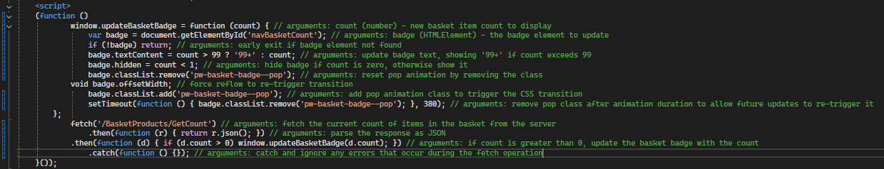

As for the footer, it was changed to black as it makes it stand out and gives the website a simplistic feel. For now, the producer dashboard is accessible through here but we may change it so the producer is automatically redirected to the dashboard upon logging in.

Version 1.6.10 – Home Page Design

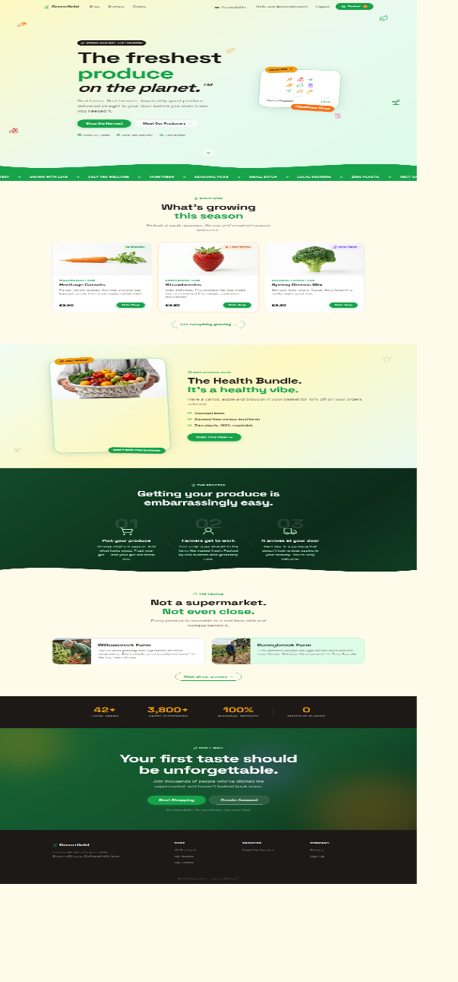
This is the home page that we designed, it looks like other competitors like theproducebox.net , making use of the same colour scheme mentioned in the proposal, greens and a creamy inviting colour with an inviting tone and small usage of ambers. The page is animated with pop effects using javascript and css.

Version 1.6.11 – Producer Pages Design
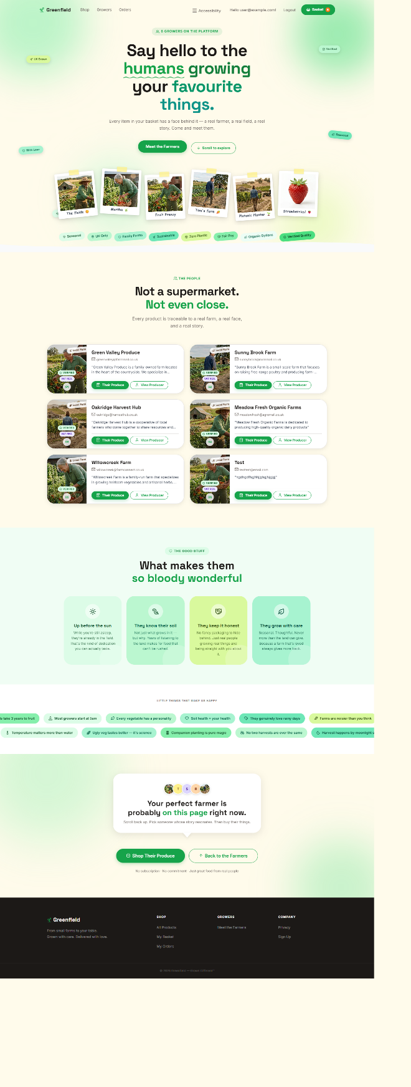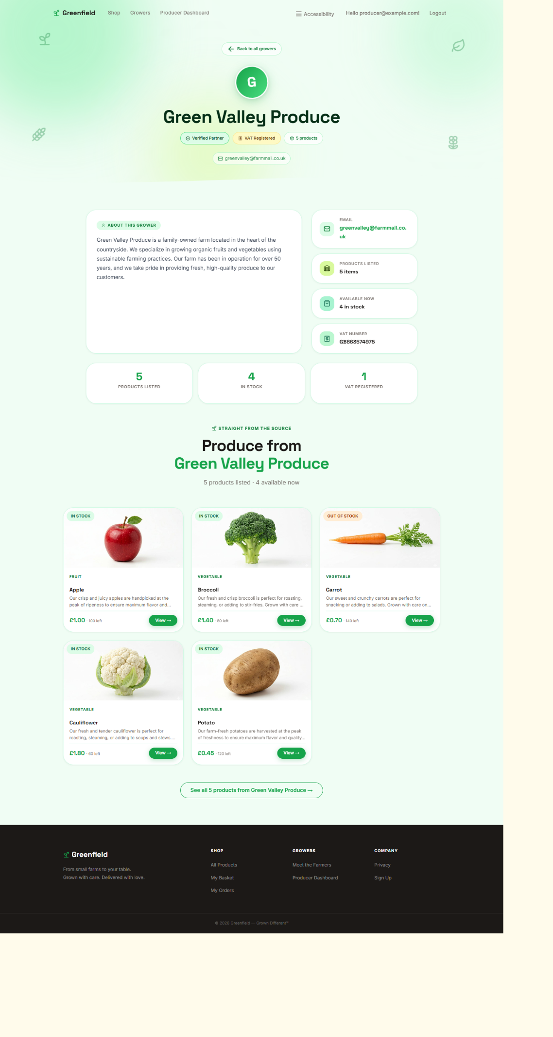
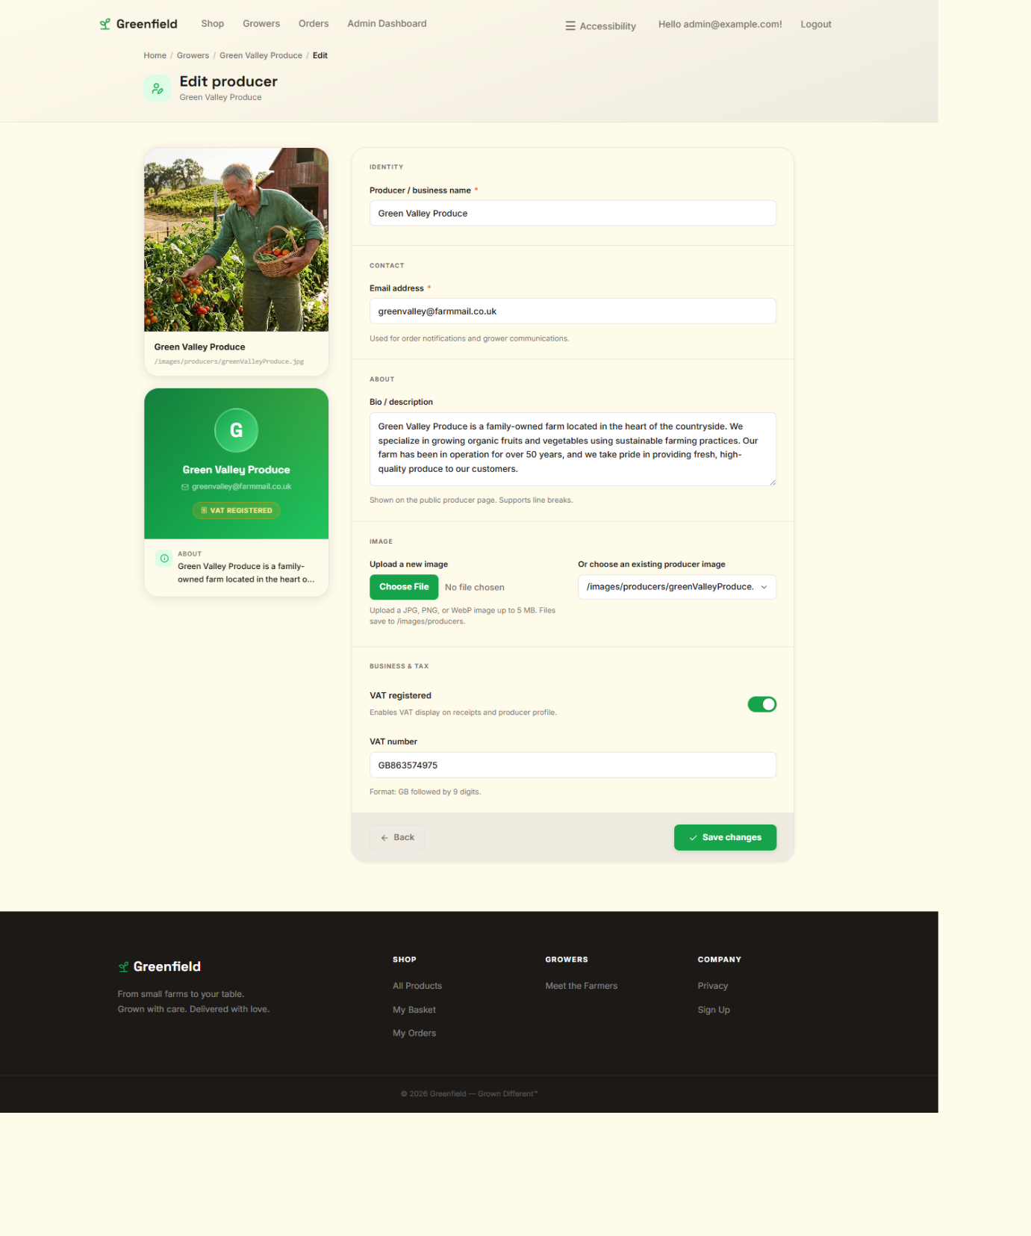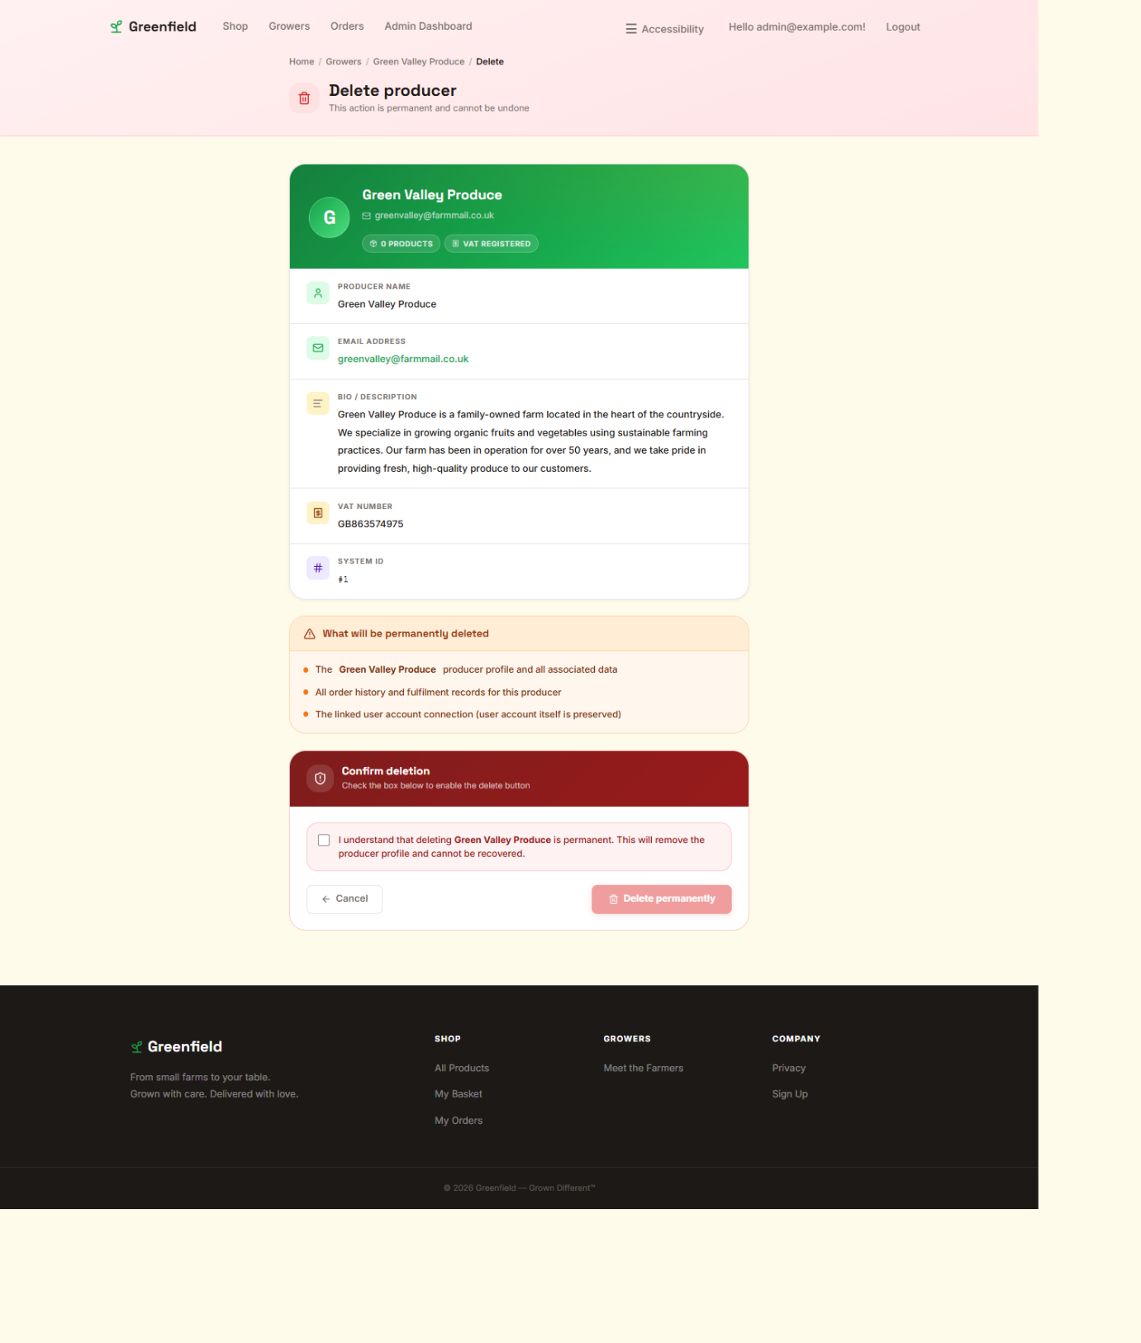
The home page design and the details design are consistent with the rest of the web page, taking consistencies from the home page and matching the inviting vibe of the website. The edit and delete producer pages are going to be used for other edit and delete pages of the website as a formula to ensure consistency throughout the website for ease of use. All pages follow clear logic using the same colour schemes from the wireframe just with an altered modernised layout. The delete and edit page follow clear fill out form logic which allows for ease of use.

Version 1.6.12 – Website Page Designs

Now I moved on to the products pages so that they match the rest of the website rather than looking like scaffolded placeholders. The products page design follows the same inviting green and cream colour scheme as the rest of the application, but still keeps clear structure so users can browse products, open details pages and navigate through the shop without confusion.
The details pages were also designed so that the product information is more visual and useful, rather than just showing raw data. This includes the product image, producer information, stock information, allergens and clear call to action buttons. The create, edit and delete pages also follow the same design formula which I already established on the producer pages, helping the application stay consistent and easier to use.

Version 1.6.13 – Role Authorization
Going through development, it was noticed that the role authorization system needed to be updated so it matched the current structure of the application rather than the older logic I first had in mind. Instead of one broad rule being applied everywhere, I now make use of more specific controller and action-based authorization depending on what each role needs access to.

For example, the basket and checkout side of the website should only be usable by customers and developers, so I added:
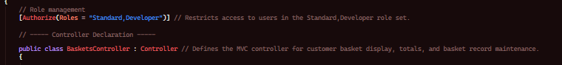And:
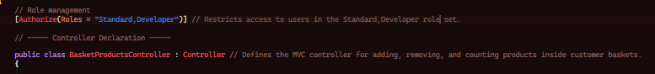This means producers and admins cannot make purchases through the customer side of the site.
For producer-only functionality, I added:
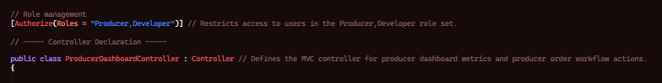This keeps the producer dashboard restricted to producers and developers only.
For the admin side, I added:
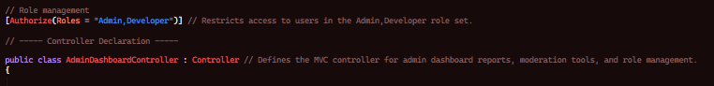This keeps the dashboard, moderation and role management tools private to admin and developer accounts.
The OrdersController now also makes use of action-based authorization rather than treating every action the same.

For example, viewing the orders index and confirming delivery are available to standard users, developers and admins, while creating orders, re-ordering and viewing the confirmation page are restricted to standard users and developers.
I also changed the producer editing system so that producers can edit their own profile, but not somebody else’s. To do this, I added the following:

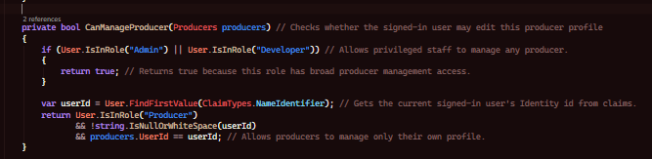

Apart from this I also changed the register system so normal account are assigned the Standard role by default when they sign up, so the role system now works properly with the application structure and the pages are restricted based on their actual purpose.

Version 1.6.14 – Google Login System Integration
To begin by adding a Google login system to the application, we must begin by going to the Google Developer Console.
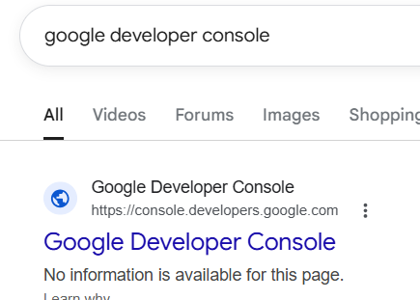
Once we are on the Google Developer Console and signed into a suitable account, we’re going to create a new project and assign it a suitable name.
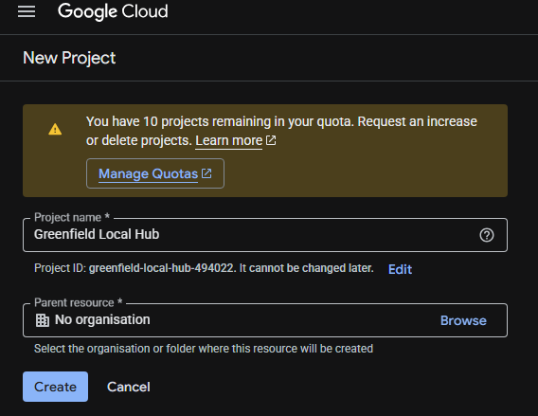
We now goto the credentials page through the dashboard
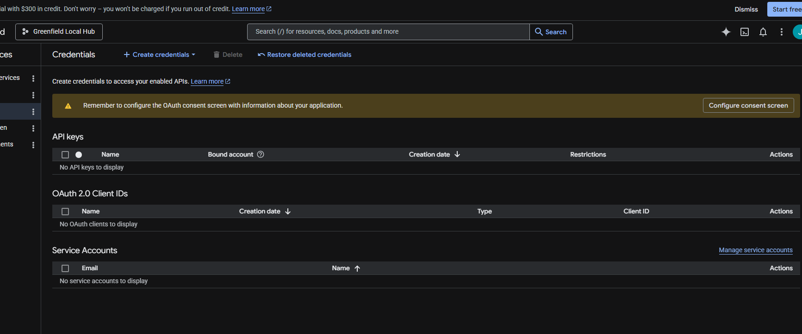
And we hit Create Credentials and select OAuth Client ID
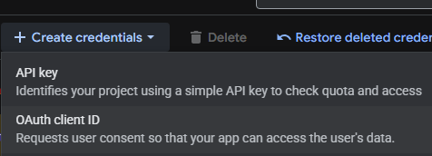
We are prompted to first fill the consent screen.
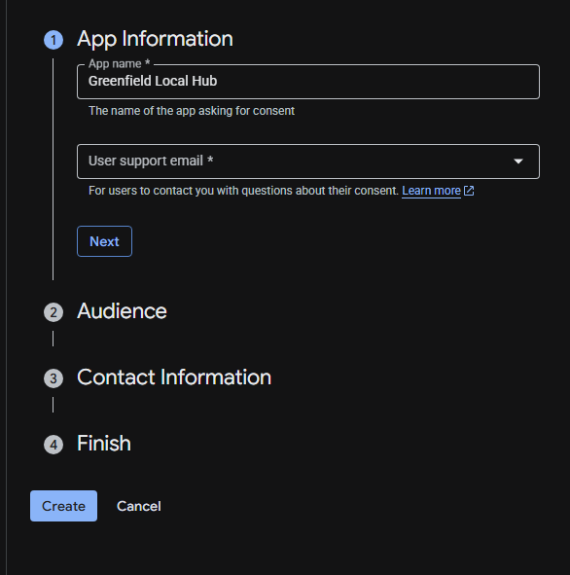
We select external and click next
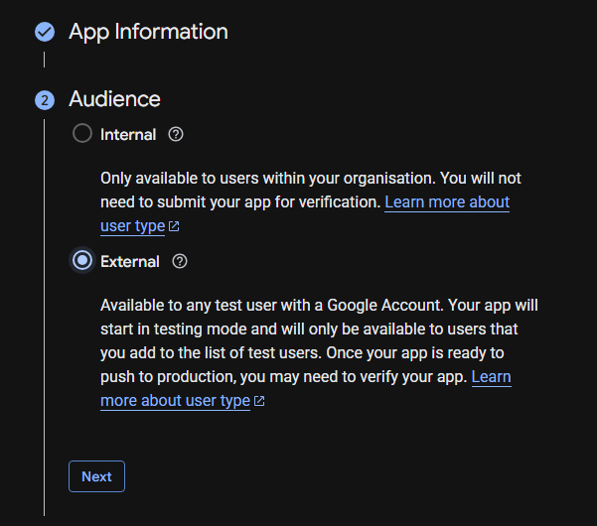
Then we continue and press create.
Now we go back to the Create credentials button and try again.
We choose application type Web application, and add the localhost into the authorized redirect URI and click create
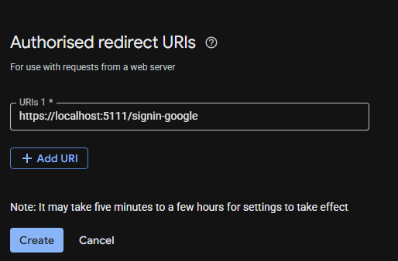
We are now provided with client Id and client secret.
Now we add some code, first we need to install the following package by installing the following package:
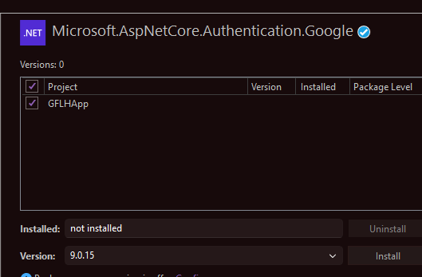
Now in appsettings.json we add our google ClientID and Client Secret.
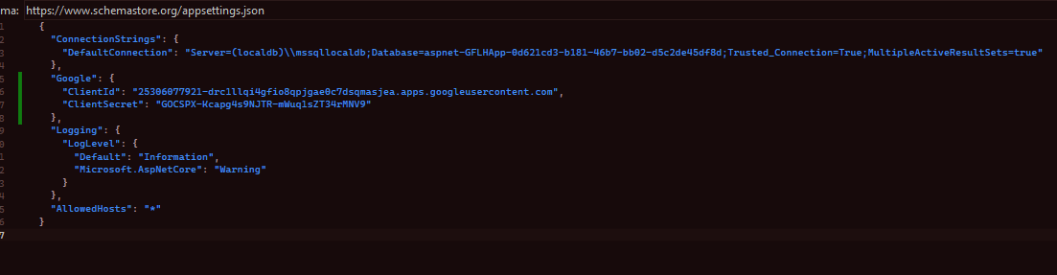
Then in the program.cs file we add the following code:
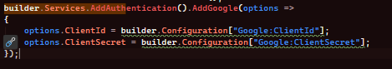
The login and register pages already make use of external login providers through Identity, so once this configuration is in place, the google sign in button is able to appear through the external login system. Now we should be able to login using google.

Version 1.6.15 – Producer Edit Fix
Through testing the application I noticed that producers can’t edit themselves.

Going through the ProducersController, I realised the issue is not with the front end, it is with the authorization logic needing to check whether the producer record belongs to the currently logged in producer account.

To fix this, I added the following method so that admins and developers can manage any producer, but producers can only manage their own profile:

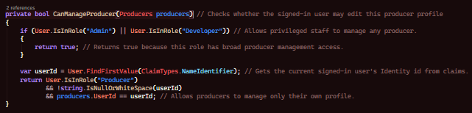This means the producer can now access and edit their own producer profile, and can still keep proper security in place so they cannot edit other producer accounts. Running the application and logging in as a producer, the edit page now opens correctly and saves the changes as expected.

Version 1.6.16 – Basket Page Checkout System Total Fix
It was noticed that the basket page checkout system total was not working when creating an order. Looking through the OrdersController, it was decided the best way to fix this was to stop relying on front-end values and instead calculate all totals through the backend using the basket data directly from the database.

So, I added the following method:
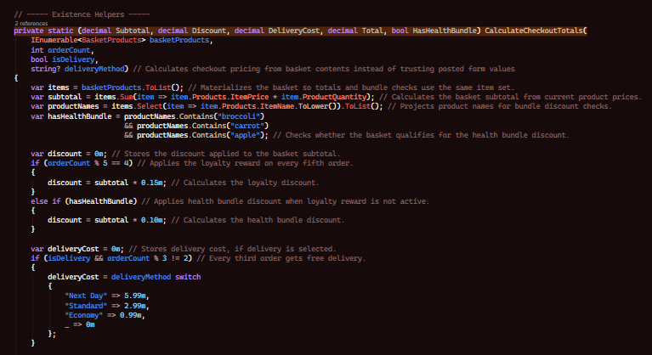
Then, in the create methods, I call the totals function and pass the data to the ViewBag, and use that total when creating the order:
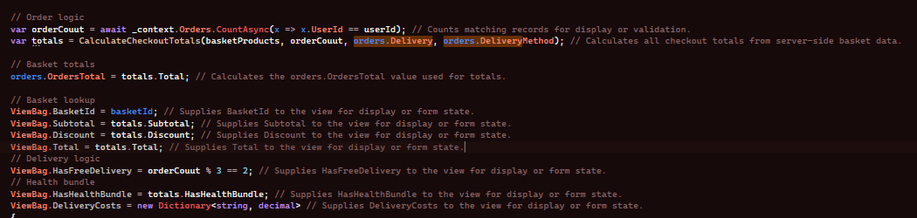This fixes the checkout total issue because the order total is now being calculated safely through backend logic rather than trusting what may or may not be shown on the front end. It also means the loyalty discount, health bundle discount and free delivery logic all work consistently.

Version 1.6.17 – Producer Page Buttons Fix
I noticed that buttons on the producers page to view details and their produce were not working. Checking through the controller, I confirmed that the details page needed to include the related products for that producer:
This is important because it allows the details page to access the producer information and all of the products linked to that producer. Once this was in place alongside the correct links on the front end, the producer details page and their produce section worked as expected when clicked.

Version 1.7.17 – Re-Order Functionality
After thinking about the customer journey more, it was thought that it would be useful if users could re-order from a previous order rather than manually adding every item back to the basket. This is good practise for e-commerce systems as it saves the user time and encourages repeat purchases.

So, I added a new POST method into OrdersController:
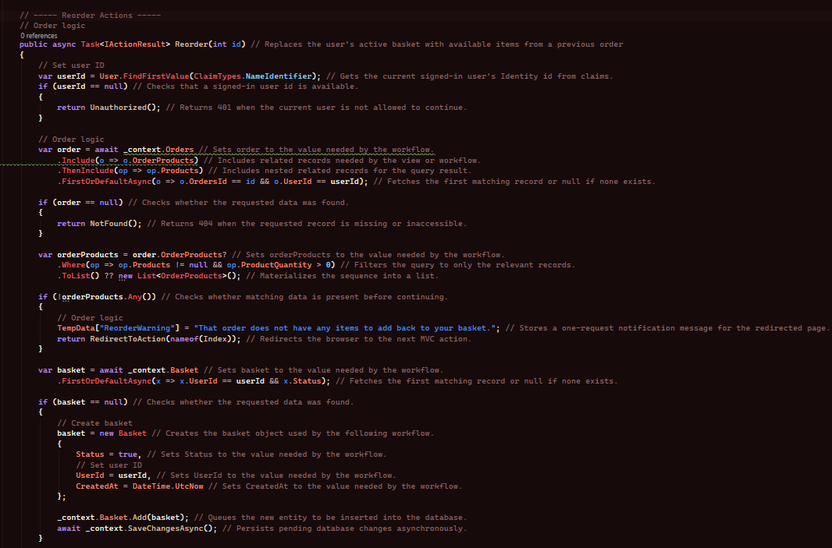The logic first finds the users previous order, then it finds or creates their active basket. If there are already items in the active basket, I clear them first as this function is supposed to replace the basket with the previous order contents.

Then, for each product in the previous order, I check if the product is still available and still has enough stock:
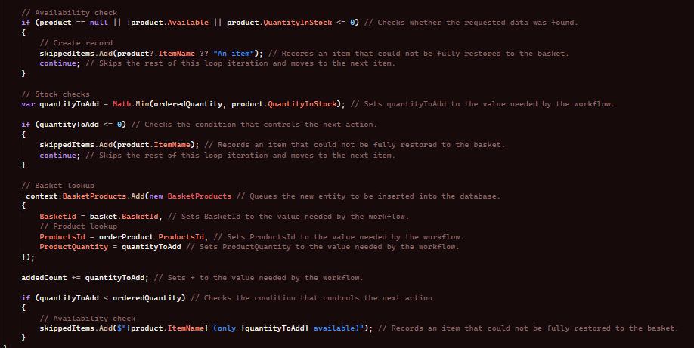
This means the user can now press re-order on an old order and get the available items placed straight back into the basket, with warning messages shown if any products are out of stock or only partially available.

Version 1.7.18 – Delivery Confirmation and Automatic Tracking Updates
When users are placing delivery orders, its also important that the tracking status changes logically rather than staying static. To do this, I added logic which updates delivery statuses based on how many days have passed and whether the user has confirmed the delivery.

The method works like this:
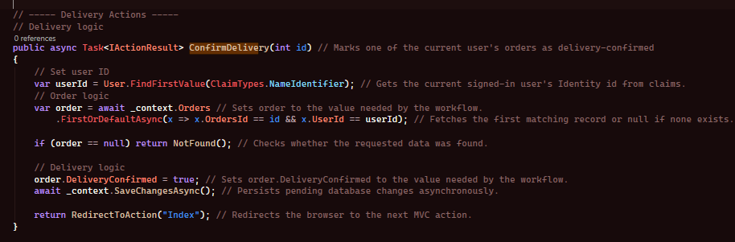This improves the realism of the flow of orders, because delivery orders now have tracking progression and the user is also able to confirm when the order is delivered or not.

Version 1.8.18 – Contact Us System
At this point, adding a proper contact us page made sense so that users or visitors can send enquiries to Greenfield Local Hub. To do this, I created a new model called ContactInquiry, and also a ContactPageViewModel so the page can handle both the form and the users previous enquiries.
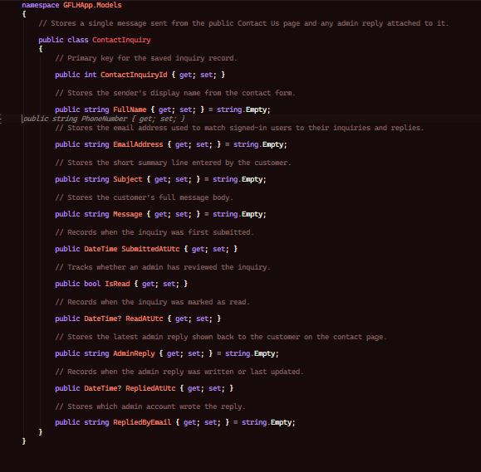
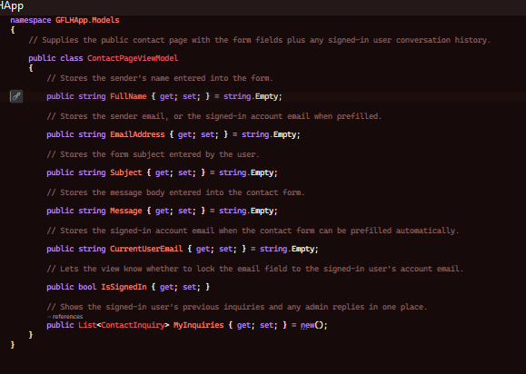
Then, in HomeController, I added the following POST method:
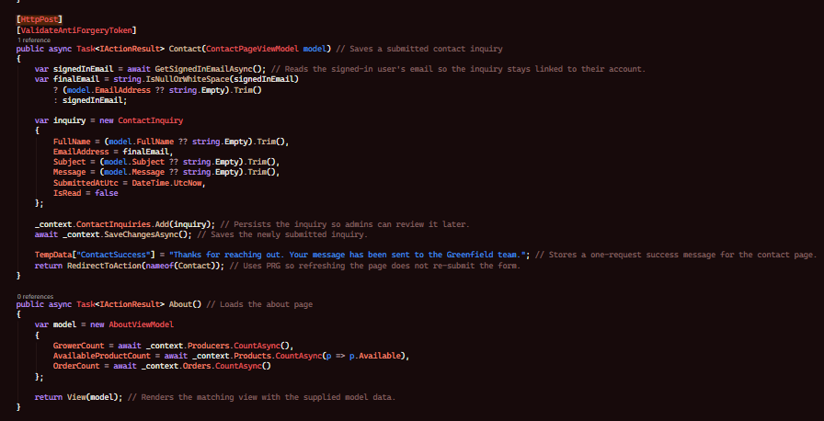This works using PRG logic so the user does not accidentally re-submit the form by refreshing the page.

I also made it so if the user is signed in, their email automatically gets used. Apart from this, signed in users are also able to see their previous enquiries and any replies they have received from admin through the contact page.

Version 1.8.18 – Admin Inquiry Management
Now that enquiries can be sent in, admins need a way to read and manage them. To do this, I added new actions to the AdminDashboardController for inquiries, viewing one inquiry in full, replying, and toggling read/unread status.
The inquiry list action starts by filtering and sorting the saved contact messages:

Now enquiries can be sent in, admins need a way to be able to read and manage them. I added
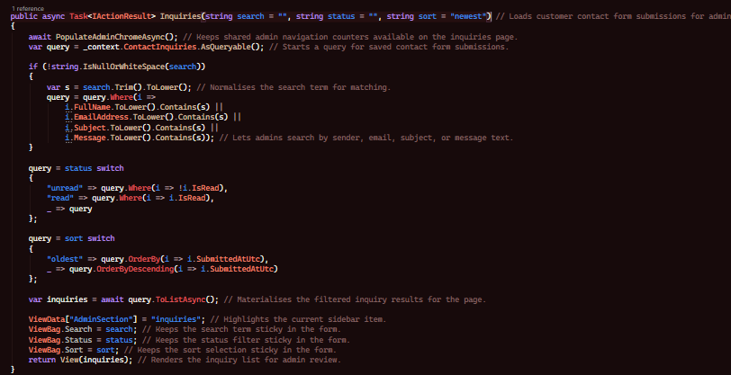Then, I added reply logic:
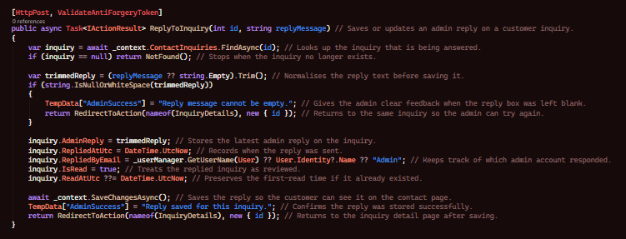This means the contact us system is now connected to the admin dashboard properly. Admins can search messages, open them, reply to them, and mark them as read or unread. The reply is then stored back onto the same inquiry so the signed in user can see the response on the contact page.
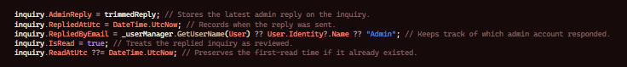

Version 1.9.18 – Admin Dashboard Management System
To make the admin side of the website more complete, I built on the dashboard so it is not just a single page, but a whole management area. The dashboard now gives admins separate pages for orders, products, producers, users, inquiries and settings.
On the Index action, I calculate dashboard statistics such as:
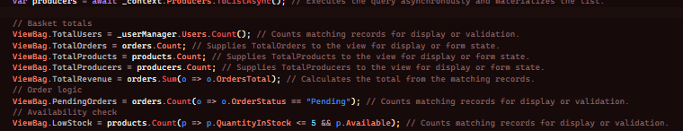I also added user role management methods:
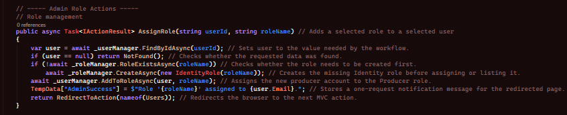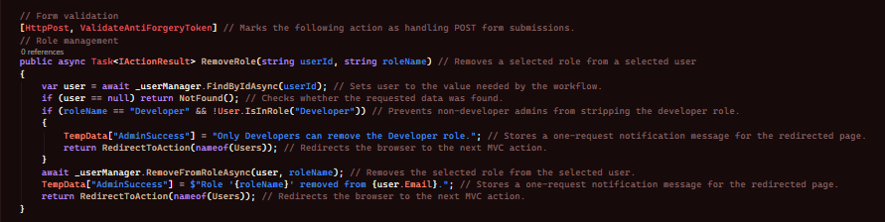
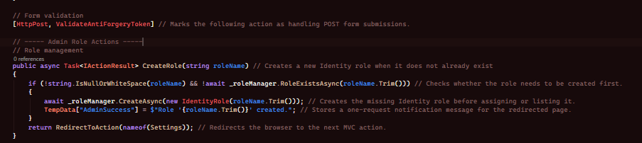This allows the admin dashboard to be used for actual site management rather than just viewing data. Admins can search orders, filter products, review producer accounts, manage users and roles, and create new roles when needed.

Version 1.9.19 – Producer Dashboard Stock Toggle and Improved Workflow
Whilst making the producer dashboard a quick way for producers to toggle product availability was implemented for ease of use. This works by checking the signed in producer and then locating the products which belong to that producer:
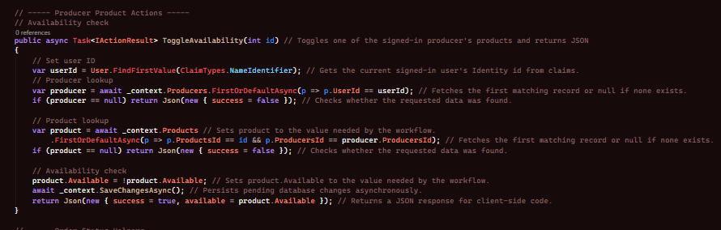This is useful because producers are able to respond to stock changes more quickly, and it also keeps the authorization safe by making sure they only toggle their own products.

Version 1.9.20 – Accessibility Menu

Accessibility was essential from early on but implementing it without structured front end and backend was illogical. So, it was added directly into the shared layout so the accessibility functions are for every page. Inside the layout I added buttons for increasing font size, decreasing font size, resetting font size, high contrast mode, dark mode and text to speech. The logic for the code was made with javascript, in accessibility.js I added the logic to make these work. For example, heres some logic:
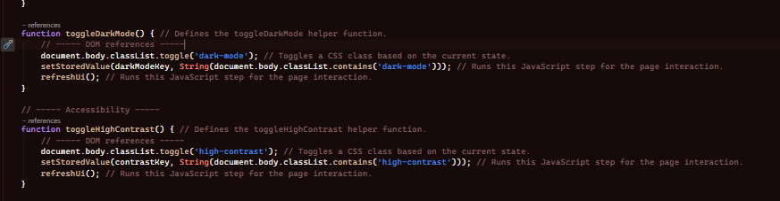There is also logic for aria-expanded, aria-pressed and remembering settings through storage. This improves accessibility and also links back to the aims from the proposal where the website should be usable for a wide range of users rather than just looking visually appealing.

Version 1.9.21 – About and Privacy Pages

The home page design was already worked on but about us and privacy pages were developed to feel professional, instead of leaving them plain they were designed to fit the rest of the website with sectioning and animation, navigation and proper structured information which targets the client brief.

For the about page we also pass a summary for statistics from the backend:
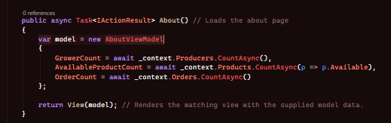
This makes the supporting pages feel connected to the rest of the project rather than just being placeholder pages. The privacy page was also expanded so it clearly explains site usage, cookies, accessibility preferences and user expectations.

Version 1.9.22 – Producer Image Upload and Image Selection
To make producer accounts feel completer and more professional, I also added support for producer images. I did not want this to just accept any random file, so I added validation for file type and file size.
The upload validation works with the following rules:
Then, I added validation logic:
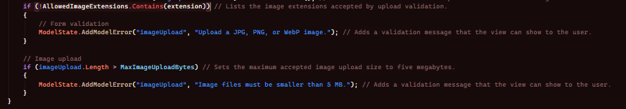Once the image passes validation, it is saved into the producer images folder with a unique file name:
This means admins can upload producer images safely, and there is also logic to choose from existing producer images already inside of the website.

Version 1.9.23 – Admin Product Controls
To improve the admin dashboard further, I also added product management controls directly into the admin area. This means admins do not have to go through the normal product CRUD pages every time if they are simply moderating stock or availability.
For example, I added a method to toggle whether a product is available:

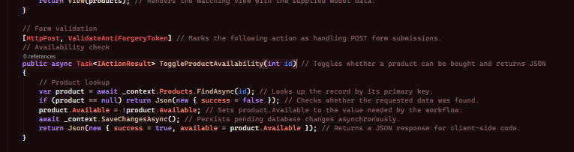I also added quick delete functionality from the dashboard:
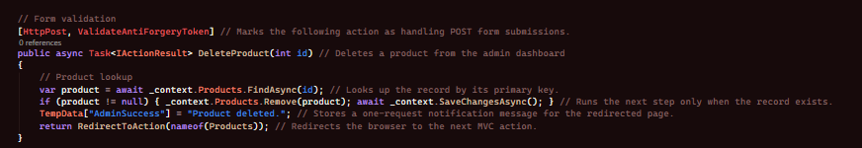
This makes the admin dashboard more practical because product moderation can now be done from one place.

Version 1.9.24 – Expanded User and Role Management
Although I already mentioned the admin dashboard management system, I also expanded this further so admins are able to search users, inspect their current roles and see how many orders they have made.
Inside of the Users action, I loop through all users and gather their current roles and order count:
This means the admin page is not just showing a list of accounts, it is showing useful management information. Alongside this, the AssignRole, RemoveRole and CreateRole methods make it possible to manage permissions directly through the dashboard.

Version 1.9.25 – Producer All Orders View and Item Cancellation
The producer dashboard originally focused on the main dashboard page and whole slices being accepted or cancelled, but it was decided to also expand this so producers can see all of their order slices on a dedicated page and cancel individual items where needed.
The all orders page is loaded through:
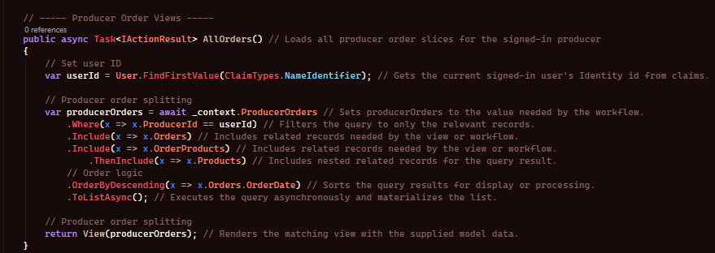This gathers all producer order slices linked to the current producer and orders them by most recent first.
I also added item-level cancellation logic:
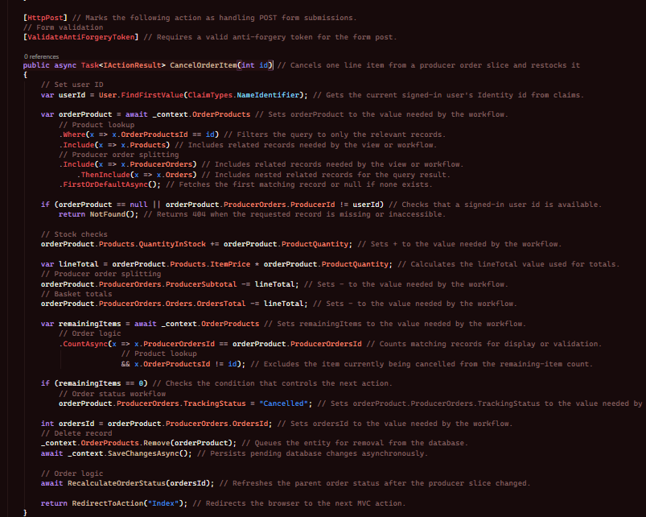

Running this checks the producer owns the order products and adds the stock back to that related product and reduces the producer subtotal and overall order total, if there are no more items left in that slice then it’ll be cancelled. This makes the producer flow more flexible since they aren’t forced to cancel the entire order.

