Task 1: Activity B – AI Log
AI model used | Gemini 3
Problem to be solved | Prompts used | Output generated | Review of generated code
I wanted to generate an image of an apple to be used for the website without copyright issues | Please generate me an image of an apple with a white background which is suitable for an e-commerce system | 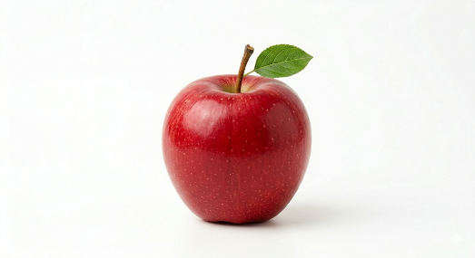 | Image of apple suitable for the web application and will be used for products of apples seeded on the website
I wanted to generate an image of broccoli to be used for the website without copyright issues | Please generate me an image of broccoli with a white background which is suitable for an e-commerce system | 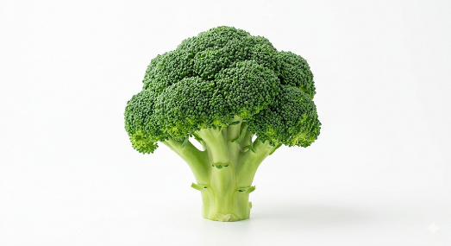 | Image of apple suitable for the web application and will be used for broccoli of apples seeded on the website
I wanted to generate an image of a carrot to be used for the website without copyright issues | Please generate me an image of a carrot with a white background which is suitable for an e-commerce system | 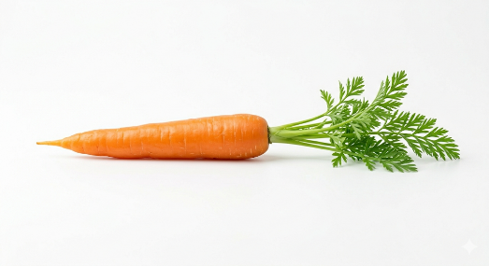 | Image of apple suitable for the web application and will be used for products of carrots seeded on the website
I wanted to generate an image of cauliflower to be used for the website without copyright issues | Please generate me an image of cauliflower with a white background which is suitable for an e-commerce system | 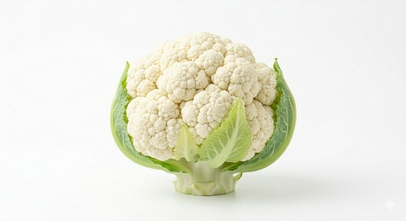 | Image of apple suitable for the web application and will be used for products of cauliflower seeded on the website
I wanted to generate an image of cheese to be used for the website without copyright issues | Please generate me an image of cheese with a white background which is suitable for an e-commerce system | 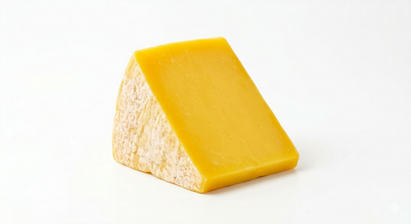 | Image of apple suitable for the web application and will be used for products of cheese seeded on the website
I wanted to generate an image of chicken breast to be used for the website without copyright issues | Please generate me an image of chicken breast with a white background which is suitable for an e-commerce system | 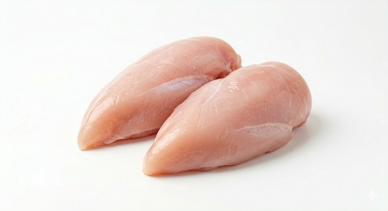 | Image of apple suitable for the web application and will be used for products of chicken breast seeded on the website
I wanted to generate an image of an egg to be used for the website without copyright issues | Please generate me an image of an egg with a white background which is suitable for an e-commerce system | 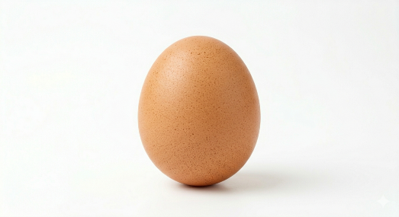 | Image of apple suitable for the web application and will be used for products of eggs seeded on the website
I wanted to generate an image of milk to be used for the website without copyright issues | Please generate me an image of milk with a white background which is suitable for an e-commerce system | 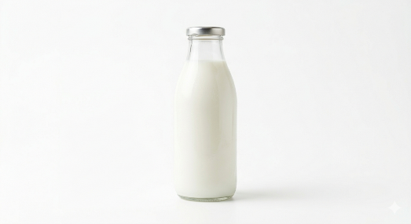 | Image of apple suitable for the web application and will be used for products of milk seeded on the website
I wanted to generate an image of mince meat to be used for the website without copyright issues | Please generate me an image of mince meat with a white background which is suitable for an e-commerce system | 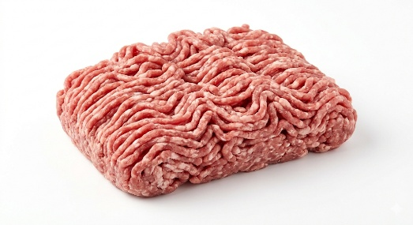 | Image of apple suitable for the web application and will be used for products of mince meat seeded on the website
I wanted to generate an image of a pear to be used for the website without copyright issues | Please generate me an image of a pear with a white background which is suitable for an e-commerce system | 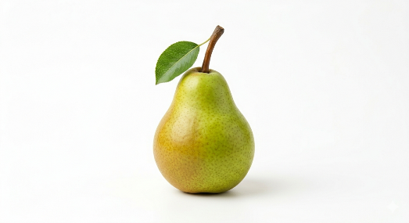 | Image of apple suitable for the web application and will be used for products of pear seeded on the website
I wanted to generate an image of a potato meat to be used for the website without copyright issues | Please generate me an image of a potato with a white background which is suitable for an e-commerce system | 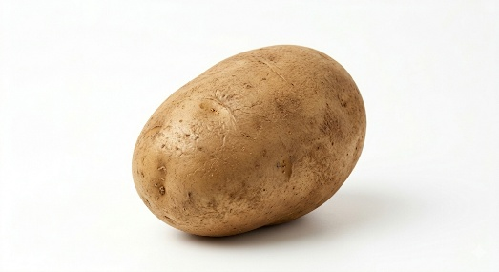 | Image of apple suitable for the web application and will be used for products of potatoes seeded on the website
I wanted to generate an image of a raspberry to be used for the website without copyright issues | Please generate me an image of a raspberry with a white background which is suitable for an e-commerce system | 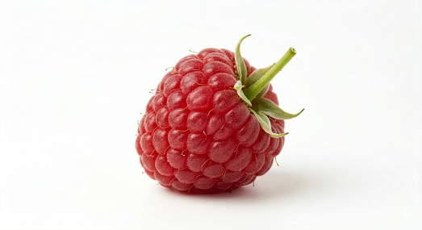 | Image of apple suitable for the web application and will be used for products of raspberries seeded on the website
I wanted to generate an image of a strawberry to be used for the website without copyright issues | Please generate me an image of a strawberry with a white background which is suitable for an e-commerce system | 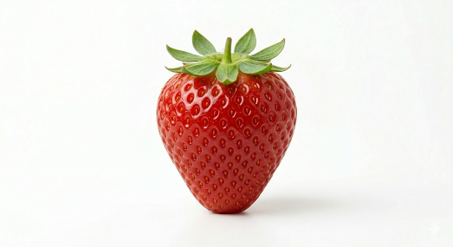 | Image of apple suitable for the web application and will be used for products of strawberries seeded on the website
I wanted to generate an image of yogurt to be used for the website without copyright issues | Please generate me an image of yogurt with a white background which is suitable for an e-commerce system | 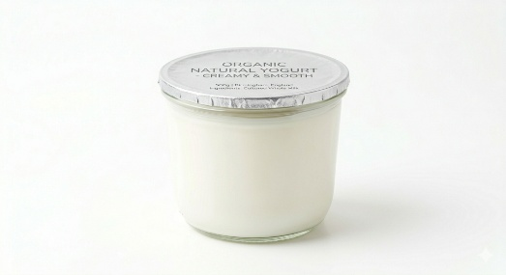 | Image of apple suitable for the web application and will be used for products of yogurt seeded on the website
I wanted to generate an image of a man holding a basket of fruit vegetables to be used for the website without copyright issues. | Please generate me an image of a man holding a basket of fruit vegetables with a white background which is suitable for an e-commerce system. Please ensure that the main focus of the image is the basket and the face isn’t shown. | 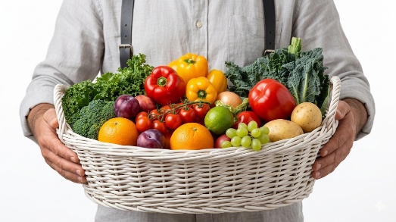 | Image of apple suitable for the web application and will be used for the home page of the website.
I wanted to generate an image for Green Valley Produce without copyright issues | Please generate a farm producer image suitable for the producers page of the website | 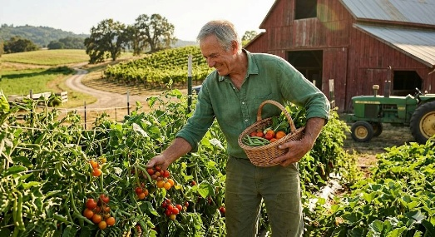 | Image suitable for the web application and used on the producers page.
I wanted to generate an image for Meadow Fresh Organic Farm without copyright issues | Please generate a farm producer image suitable for the producers page of the website | 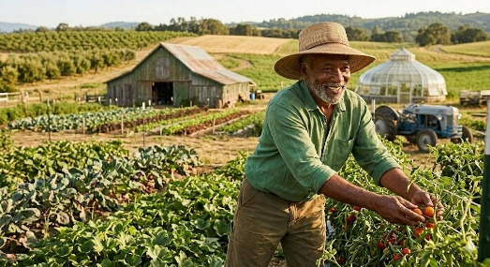 | Image suitable for the web application and used on the producers page.
I wanted to generate an image for Oakridge Harvest Hub without copyright issues | Please generate a farm producer image suitable for the producers page of the website | 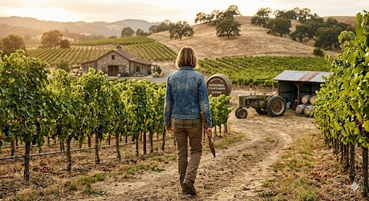 | Image suitable for the web application and used on the producers page.
I wanted to generate an image for Sunnybrook Farm without copyright issues | Please generate a farm producer image suitable for the producers page of the website | 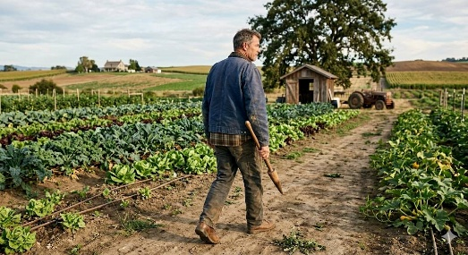 | Image suitable for the web application and used on the producers page.
I wanted to generate an image for Willowcreek Farm without copyright issues | Please generate a farm producer image suitable for the producers page of the website | 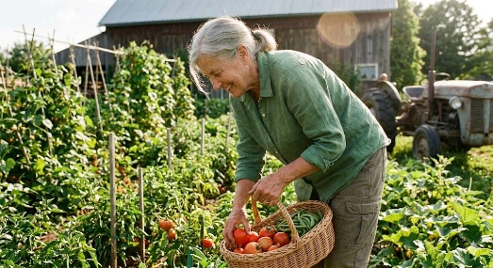 | Image suitable for the web application and used on the producers page.

AI model used | ChatGPT 5.3
Problem to be solved | Prompts used | Output generated | Review of generated code
I wanted to figure out an error I was getting as I was receiving error when using decimal data type on OrdersTotal attribute | Could you please explain this error:  Microsoft.EntityFrameworkCore.Model.Validation[30000]  No store type was specified for the decimal property 'OrdersTotal' on entity type 'Orders'. This will cause values to be silently truncated if they do not fit in the default precision and scale. Explicitly specify the SQL server column type that can accommodate all the values in 'OnModelCreating' using 'HasColumnType', specify precision and scale using 'HasPrecision', or configure a value converter using 'HasConversion'. | It explained that EFCore by default sees code as 18,2 decimal so the OrderTotal attribute was erroring | I added code to ApplicationDbContext to set the data type to 10,2. No code was generated.
Needed a small CSS review for the mobile navigation and drawer layout | Give me a review the site CSS and suggest small fixes for the mobile nav drawer, spacing and button alignment on smaller screens. | Short CSS suggestions for responsive nav spacing and drawer behaviour. | Based on the real navigation CSS in site.css. I used it as review guidance, not copied directly.
Needed a small CSS review for accessibility menu hover and focus states | Please give me suggestions for CSS improvements for the accessibility dropdown so hover, focus and keyboard states are clearer and more consistent. | Small CSS ideas for focus rings, hover states and dropdown clarity. | Based on the accessibility styles in site.css. I used it to improve readability and accessibility.
Needed a small CSS review for hero section responsiveness | Give me a review the hero section CSS and suggest responsive fixes for spacing, overflow and layout on tablet and mobile screens. | Responsive CSS suggestions for hero spacing, stacking and overflow handling. | Based on the homepage hero styles in site.css. I used as guidance while adjusting the layout.
Needed a small CSS review for product create form layout | Make suggestions for CSS fixes for the product create page so the form grid, sticky preview and inputs work better on smaller screens. | Short CSS suggestions for form rows, sticky areas and mobile layout. | Based on ProductCreate.css. It helped me identify layout areas that needed tidying.
Needed a small CSS review for admin filter bar alignment | Give me a review of the admin product filter CSS and suggest small fixes for alignment, button spacing and responsive wrapping. | CSS ideas for consistent filter controls and cleaner wrapping. | Based on AdminDashboardProducts.css. I used it as review notes for the admin UI.
Needed a small CSS review for order page cards and status sections | Please give me suggestions for CSS improvements for the orders page so cards, badges and icon rows feel more consistent and easier to scan. | Small CSS suggestions for spacing, badge balance and content grouping. | Based on the orders page styles. I used it as visual review guidance rather than direct generated code.
Needed a small CSS review for home page content cards | Give me a review of the home page CSS and suggest minor fixes for card spacing, icon balance and text rhythm across sections. | Short CSS ideas for cleaner spacing and more consistent card presentation. | Based on the home page CSS files. It helped me keep the design more consistent across sections.
Needed a small CSS review for dark mode and contrast styling | Suggest CSS improvement I could do to make dark mode and high contrast styles clearer without breaking the existing colour system. | Short CSS suggestions for contrast, readability and state visibility. | Based on the existing dark mode and contrast styles in site.css. I used it as accessibility review support.

Copyright and Acknowledgements
‘T-LEVELS’ is a registered trademark of the Department for Education.
‘T Level’ is a registered trademark of the Institute for Apprenticeships and Technical Education.
The T Level Technical Qualification is a qualification approved and managed by the Institute for Apprenticeships and Technical Education.
‘Institute for Apprenticeships & Technical Education’ and logo are registered trademarks of the Institute for Apprenticeships and Technical Education.
Pearson Education Limited is authorised by the Institute for Apprenticeships and Technical Education to develop and deliver this Technical Qualification.
Pearson and logo are registered trademarks of Pearson.
Copyright in this document belongs to, and is used under licence from, the Institute for Apprenticeships and Technical Education, © 2025

