URBAN TREE COOLING STUDY
Progress, Deliverables,
and Key Results
Professor Review Report
Canonical scientific status: STOP — Task 1 incomplete
The five-city weather-feasibility screen is complete. Satellite catalogue and geometry work is partial. No ECOSTRESS land-surface-temperature or thermal outcome was opened, no real held-out city was selected, and no 2026 observation was opened. Downstream Steps 3–14 are workflow demonstrations unless explicitly identified otherwise.

Prepared for academic review
Report date: 6 August 2026 | Version 1.0
Evidence window: summers 2018–2025; 2026 remains sealed
Prepared from the frozen requirements, append-only decision log, Task 1 gate record, output manifests, and verified deliverables.

EXECUTIVE SUMMARY

What has been accomplished
A reproducible five-city v2 study framework was built from the original step-by-step guide. Task 0 is complete; Step 1 is complete with real meteorological data; Step 2 has a complete catalogue audit and a partially completed cloud-independent geometry audit; a preliminary Step 3 simulator was exercised; and every later guide deliverable was demonstrated in a strictly separated synthetic package.
Bottom line for scientific interpretation
The project does not yet contain an empirical estimate of urban tree cooling. Its strongest verified result is a feasibility finding: atmospheric demand and antecedent dryness are not sufficiently separable within at least three of the five cities after clear-sky filtering. The defensible current design is cross-city/common-support comparison with an explicit city-confounding limitation, subject to a definitive satellite-pass audit.

Key verified results
- Only Los Angeles and Minneapolis–St. Paul met the predeclared within-city support screen. The Step 1 decision is cross_city_separation_only, not a within-city interaction claim.
- Clear-sky availability is highly uneven: 68 of 976 summer days in Miami versus 697 of 976 in Phoenix. This sampling changes the diagnostic corner support directly.
- The real ECOSTRESS catalogue contains 2,968 unique physical city-orbit passes and a 1,055-pass daytime ceiling. These are upper bounds, not usable-scene totals.
- Cloud-independent geometry was evaluated for 710 of 911 archive-available candidates. Of those evaluated, 173 passed and 537 failed; 201 remained unevaluated. The partial pass fraction was not extrapolated.
- No LST/thermal result, holdout result, or 2026 result exists. Any cooling curves, interaction surfaces, placebos, or robustness numbers in the Steps 3–14 package are synthetic demonstrations.

Evidence labels used throughout
Label | Meaning | May support a scientific finding?
Canonical empirical | Real data; frozen rules; completed and checked | Yes, within the stated preliminary scope
Empirical partial | Real nonthermal data or a durable processing checkpoint | Only for availability/process facts; not cooling
Preliminary simulation | Code and planning validation using an uncertified count | No; planning evidence only
Synthetic demonstration | Deterministic fabricated inputs and visibly labelled outputs | No; schema/workflow demonstration only

STUDY FOUNDATION

1. Study objective, scope, and guardrails
The guide asks whether urban tree cooling depends on time of day and hydroclimatic context across Phoenix, Los Angeles, Atlanta, Minneapolis–St. Paul, and Miami. The v2 implementation translated the guide into a one-entry-per-deliverable specification, preserved the existing Phoenix pilot as a regression baseline, and created a separate analysis surface so legacy work was not overwritten.

Task 0 — specification and guardrails
Task 0 is complete. It normalized 109 unique guide deliverable IDs, resolved duplicated/malformed rows in the source document without relaxing scientific requirements, established an append-only decision log, and froze the gates that prevent an incomplete feasibility audit from being mistaken for an outcome study.
Frozen element | Implemented rule
Study domains | One consistent rule: 2020 Census Urban Areas for all five cities; source and analysis geometry hashes recorded.
Time window | Summers 2018–2025 for development and feasibility; the full 2026 season remains unopened.
Weather axes | Demand from VPD; antecedent balance from prior-day-ending 30/60-day sums of precipitation minus reference ET; dryness is an explicit reversed percentile.
Sampling unit | Pass is the effective unit for weather effects; pixels and matched sets remain clustered within pass.
Satellite timing | Daytime is 10:00–18:00 local solar time, initially divided into four two-hour strata.
Geometry | Near-nadir requires at least 95% domain coverage and 95th-percentile absolute view zenith no greater than 20°.
Blinding | A held-out city is selected on quality evidence before thermal inspection; the holdout remains UNSELECTED.
Language | The study uses ‘time-of-day dependence,’ not a same-day diurnal course or hysteresis claim.

Source hierarchy for this report
When files differed in status or naming, this report treated the canonical requirements, the latest append-only decision, the Task 1 gate, and the authoritative run manifest as controlling. Figure appearance alone was never used to upgrade an artifact’s scientific status.
- Source guide: StepByStep_Guide_Urban_Tree_Cooling.docx
- Canonical requirements: docs/v2/REQUIREMENTS.md
- Decision history: docs/v2/DECISION_LOG.md
- Active gate: data/processed/v2/task1/TASK1_GATE.md
- Illustrative package manifest: data/processed/v2/illustrative_only/steps02_14/run_manifest.json

COMPLETION DASHBOARD

2. What is complete, partial, demonstrated, and not run
The table below is the shortest accurate summary of the entire guide. ‘Demonstrated’ means that the expected file structure, calculation path, and presentation were exercised with synthetic inputs; it does not mean the empirical analysis was performed.
Stage | Status / evidence | Accomplished | Still required
Task 0 | Complete — canonical | Separate v2 surface; normalized requirements; frozen domains, rules, gates, and decision log. | Nothing material for Task 0.
Step 1 | Complete — empirical | F1.1–F1.4, T1.1–T1.2, M1.1; five cities, eight summers, 4,880 city-days; QA completed. | Must later be superseded by acquisition-time usable-pass conditions.
Step 2 | Partial — empirical nonthermal | Catalogue, local-solar-time audit, metadata enrichment, cloud/view diagnosis, exact-scene audit, partial L1B GEO geometry. | 201 geometry candidates, exhaustive cloud, exact-time HRRR, definitive F2.5, usable-pass total and final gate.
Step 3 | Preliminary simulation | F3.1–F3.5/T3.1-style power, false-positive, recovery and bootstrap checks at catalogue ceiling. | Rerun with certified usable-pass count and actual acquisition-time joint distribution.
Task 2 | Inactive / not run | No canonical Task 2 input was opened. | Requires canonical Task 1 PASS and preflight.

Steps 4–14
Step | Demonstrated output | Empirical work not yet done
4 | Native-grid thermal archive, QA layers, histograms, valid counts, band-mode and geolocation schemas. | No real v2 LST archive or Step 4 source checks.
5 | Albedo, vegetation-fusion error, radiation, ET/ESI comparisons and inventories. | No real supporting-product chain or estimates.
6 | Exact-time meteorology, station validation, HRRR/ERA5 comparison, interpolation and correlations. | No definitive exact-acquisition HRRR chain.
7 | Optical timing, image lag, canopy change, land-cover vintages and focal/buffer urban form. | No empirical multi-city optical/land-cover archive.
8 | Canopy thresholds, classification, matching balance, registration sensitivity and validation. | No outcome-blind empirical classifier/matching freeze.
9 | Analysis-table schema, missingness, distributions, completeness, irrigation evidence and dictionaries. | No canonical matched-set-by-pass empirical table.
10 | Time-of-day models, common support, endpoint forest, day/night separation and diagnostics. | No empirical cooling estimate.
11 | Leave-one-simulated-city-out checks, quality panels, canopy standardization and holdout schema. | No real holdout selection or generalization result.
12 | Demand × dryness surfaces, support masking, slices, model comparisons and transition criteria. | No empirical surface or threshold claim.
13 | Placebo, night, sensitivity, radiative attenuation and uncertainty-budget workflows. | No empirical robustness or detection-limit comparison.
14 | Six synthetic paper layouts; real STOP memo; confirmatory NOT RUN report; hashed package inventory. | No empirical manuscript, holdout/2026 confirmation, public scientific release or independent rebuild.

Coverage of the source guide
Artifacts occupy all 109 normalized guide ID slots: 7 canonical Step 1 deliverables plus 102 Step 2–14 package IDs. Coverage of an ID proves that the workflow and expected deliverable structure exist; only the evidence label determines whether it is an empirical scientific result.

CANONICAL EMPIRICAL EVIDENCE

3. Step 1 — five-city weather-condition feasibility
Step 1 is the only fully completed empirical scientific stage. It asks whether atmospheric demand and antecedent climatic dryness occupy enough independent combinations to support later interaction analyses. It does not use or estimate land-surface temperature.
Step 1 decision: cross_city_separation_only
The predeclared strong case required adequate clear-sky corner support in at least three cities. Only Los Angeles and Minneapolis–St. Paul passed. The current recommendation is a cross-city/common-support comparison, with an explicit city-confounding limitation and consideration of an additional city.

City domains and clear-sky availability
City | Census UA | Area (km²) | Summer days | Clear days | Clear %
Atlanta | 03817 | 6,612.80 | 976 | 133 | 13.63%
Los Angeles | 51445 | 4,242.65 | 976 | 659 | 67.52%
Miami | 56602 | 3,223.01 | 976 | 68 | 6.97%
Minneapolis–St. Paul | 57628 | 2,628.48 | 976 | 263 | 26.95%
Phoenix | 69184 | 2,876.31 | 976 | 697 | 71.41%

Thirty-day feasibility result
City | High-demand / wet | Low-demand / dry | Combined share | Clear-sky Spearman ρ (95% CI) | Within-city support
Atlanta | 11 | 2 | 9.8% | 0.534 (0.249–0.714) | No
Los Angeles | 53 | 29 | 12.4% | 0.321 (0.135–0.452) | Yes
Miami | 2 | 2 | 5.9% | 0.328 (0.048–0.613) | No
Minneapolis–St. Paul | 31 | 5 | 13.7% | 0.540 (0.201–0.678) | Yes
Phoenix | 29 | 14 | 6.2% | 0.524 (0.421–0.593) | No

The clear-sky screen used Census-domain mean ERA5 total cloud cover at the hour nearest 14:00 local solar time, with a frozen threshold of 0.25. Spearman intervals use whole-summer blocks rather than treating individual days as independent.

STEP 1 VISUAL EVIDENCE

Clear-sky sampling changes the available joint support
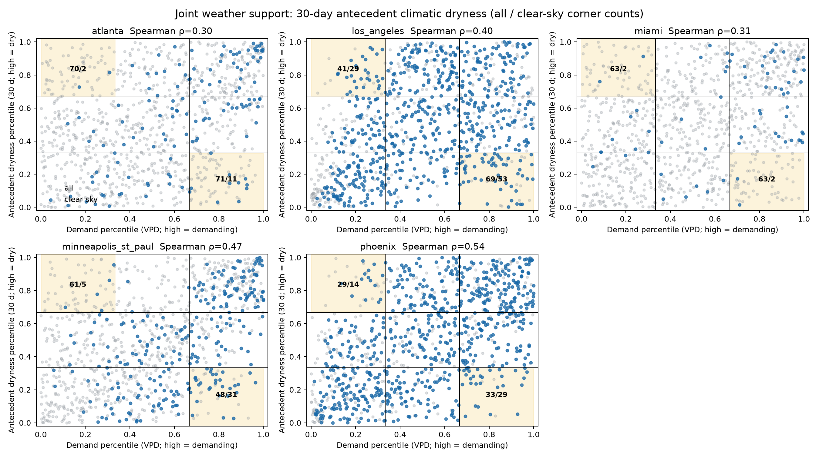
Figure 1 (F1.2). Thirty-day atmospheric-demand and antecedent-dryness support across five cities. All summer days are grey and likely clear-sky days are blue; the shaded off-diagonal corners are the diagnostic cells. Clear-sky filtering substantially thins support in Atlanta, Miami, and Phoenix.
Evidence status: Canonical empirical meteorological screening; no thermal outcome. Source: data/processed/v2/task1/step1/figures/F1.2_clear_sky_overlay.png
The figure shows why a simple ‘hot versus dry’ interaction is difficult to identify within several cities: demand and dryness are positively correlated, and the rare off-diagonal combinations become even thinner after clear-sky selection. Los Angeles and Minneapolis–St. Paul retain the best within-city support, but the five-city panel does not satisfy the strong three-city rule.
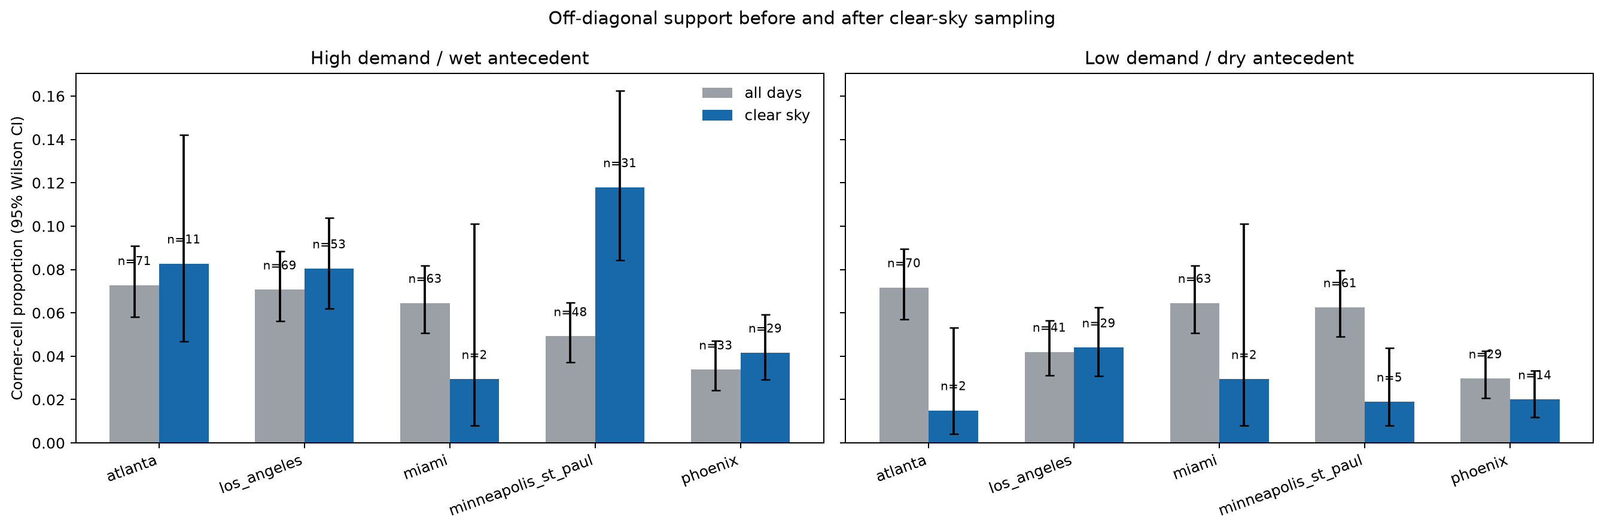
Figure 2 (F1.3). Proportions in the two diagnostic corner cells before and after likely clear-sky sampling, with Wilson 95% confidence intervals. These bars describe sampling support, not tree-cooling effects.
Evidence status: Canonical empirical meteorological screening; no thermal outcome. Source: data/processed/v2/task1/step1/figures/F1.3_corner_counts.png

STEP 1 SENSITIVITY AND QA

Thirty-day versus sixty-day antecedent windows
The ≥10% combined corner-share diagnostic changes in three cities between the required 30- and 60-day windows. This is not the full within-city support rule (≥5 days per corner and |ρ|<0.8), so window choice remains a declared sensitivity.
City | 30-day clear-sky corner share | 60-day share | ≥10% share status stable?
Atlanta | 9.8% | 11.3% | No
Los Angeles | 12.4% | 12.9% | Yes
Miami | 5.9% | 20.6% | No
Minneapolis–St. Paul | 13.7% | 7.2% | No
Phoenix | 6.2% | 8.2% | Yes

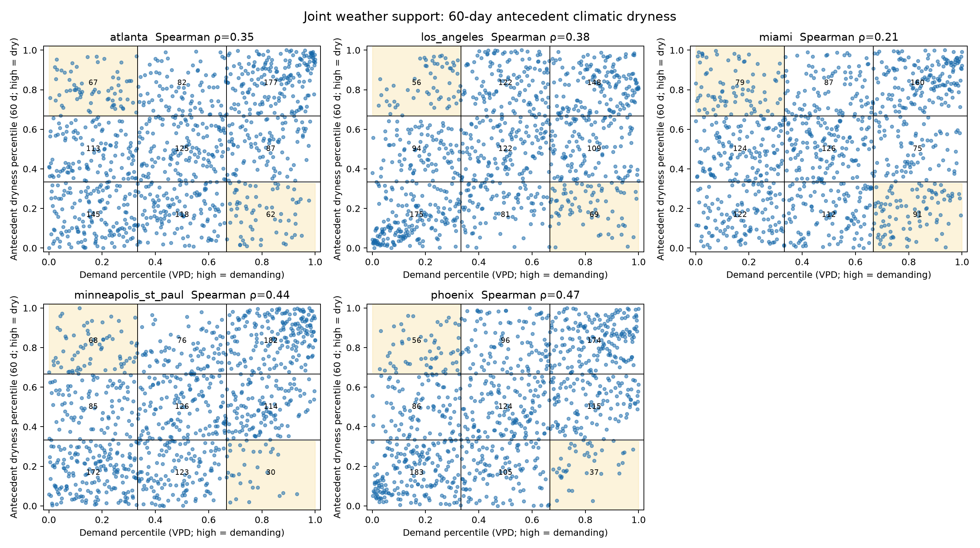
Figure 3 (F1.4). Sixty-day sensitivity version of the five-city joint-support figure. Its differences from the 30-day screen are carried forward as a design sensitivity rather than resolved by selecting a preferred window.
Evidence status: Canonical empirical meteorological sensitivity; no thermal outcome. Source: data/processed/v2/task1/step1/figures/F1.4_joint_60d.png

Quality checks and documented limitation
- Step 1 contains 4,880 unique city-date rows: 976 summer days for each of five cities across eight summers.
- Unit, percentile, cell-count, bootstrap, permutation, figure, and geometry-validity checks were completed; the repair changed no clear-day, cell, corner, or gate result.
- The analysis used 2,000 whole-summer bootstrap draws and 2,000 permutations with seed 20260801.
- Phoenix’s 30-day balance was negative in June in all 8 summers, but July’s median rose above June’s in only 3 of 8. The sign check passed; the stricter annual monsoon-rise diagnostic did not.

EMPIRICAL BUT INCOMPLETE

4. Step 2 — satellite catalogue, quality screening, and geometry remediation
Step 2 was intended to replace the daily weather screen with the actual conditions sampled by usable ECOSTRESS passes. Substantial real-data work was completed, but the definitive usable-pass total does not exist because the cloud-independent geometry audit was stopped before completion.

Catalogue results
City | Daytime catalogue-ceiling passes
Atlanta | 213
Los Angeles | 212
Miami | 120
Minneapolis–St. Paul | 298
Phoenix | 212
Total | 1,055

The live search returned 13,577 tiled granules. Provenance-preserving deduplication reduced these to 2,968 physical city-orbit passes, of which 1,055 fell between 10:00 and 18:00 local solar time. These counts precede definitive geometry, cloud, and pixel-quality screening.
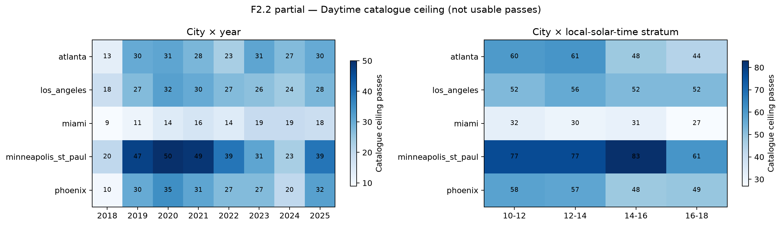
Figure 4 (partial F2.2). Daytime catalogue ceiling by city, year, and local-solar-time stratum. Minneapolis–St. Paul has the largest upper bound and Miami the smallest. The counts are not usable passes.
Evidence status: Empirical nonthermal catalogue metadata; partial and gate-ineligible. Source: data/processed/v2/task1/step2_catalogue_audit/figures/F2.2_daytime_catalogue_ceiling_heatmaps.png

STEP 2 REMEDIATION RECORD

Why the first quality count was rejected
An initial tiled-product screen left 107 nominal pre-cloud candidates. The exhaustive audit then found that tiled view angle was not cloud independent: across 127 cloud-bearing layer pairs, all 400,414 cloudy pixels had invalid tiled view_zenith values. The earlier 95% view-coverage rule therefore partly measured retrieval availability rather than physical geometry. The provisional expected total of 106.4273 pass-equivalents (floor 106) was retained only as failed diagnostic evidence and was not used as a certified count.

Cloud-independent L1B GEO remediation
Checkpoint fact | Verified value | Interpretation
Original metadata candidates | 942 | Required cloud-independent geometry census under the original rule.
Exact GEO scene identities | 1,370 | Mission-exact orbit/scene identities resolved from frozen provenance.
Available / unavailable exact scenes | 1,329 / 41 | Forty-one official objects repeatedly returned 404 while controls succeeded.
Candidate passes affected | 31 | Excluded before geometry only under the separately approved archive-available profile.
Archive-available candidates | 911 | Revised estimand; missing scenes were not imputed or replaced.
Geometry evaluated | 710 | 173 pass; 537 fail; zero unresolved among evaluated candidates.
Geometry unevaluated | 201 | All Phoenix candidates plus 14 Minneapolis–St. Paul candidates remained incomplete.

Active gate: STOP_USER_SKIPPED_D0047_GEOMETRY_710_OF_911
The 173/710 partial geometry pass fraction cannot be extrapolated: Phoenix’s 187 retained candidates were all still unevaluated, as were 14 Minneapolis–St. Paul candidates. Cloud survival, exact-acquisition HRRR, F2.5, and the definitive usable-pass total were never reached.

The 41 unavailable GEO objects
The project repeatedly attempted exact CMR searches, canonical HDF5/DMR++/OPeNDAP endpoints, and authenticated eight-byte HDF5 signature reads. Known-good sibling controls succeeded before and after the batches, while all 41 targets returned HTTP 404. A renewed Earthdata token produced the same result, ruling out token expiry. The missing objects affect 31 candidates—24 in 2020 and 7 in 2024—and were never assigned zero coverage, imputed, or replaced with adjacent scenes. The append-only decision log records that an LP DAAC restoration/re-indexing request was sent with the exact evidence packet; no external delivery receipt is stored in the repository.
City | Archive-unavailable candidate exclusions
Atlanta | 8
Los Angeles | 8
Miami | 1
Minneapolis–St. Paul | 8
Phoenix | 6

PLANNING AND CODE VALIDATION

5. Step 3 — preliminary simulation and power checks
A pass-clustered simulator was run at the 1,055-pass daytime catalogue ceiling to exercise the intended power, coefficient-recovery, transition false-positive, and bootstrap calculations. This validates the analysis machinery and supplies rough planning scales, but it cannot certify power because 1,055 is not the real usable-pass count and the predictor template used daily-weather proxies rather than complete exact-acquisition weather.
Model / target effect | Approx. minimum passes for 80% power | Status
Demand × dryness, 0.75 K | 800 | Preliminary planning only
Demand × dryness, 1.50 K | 200 | Preliminary planning only
Demand × dryness, 2.25 K | 100 | Preliminary planning only
Demand × dryness × time, 1.50 K | 400 | Preliminary planning only

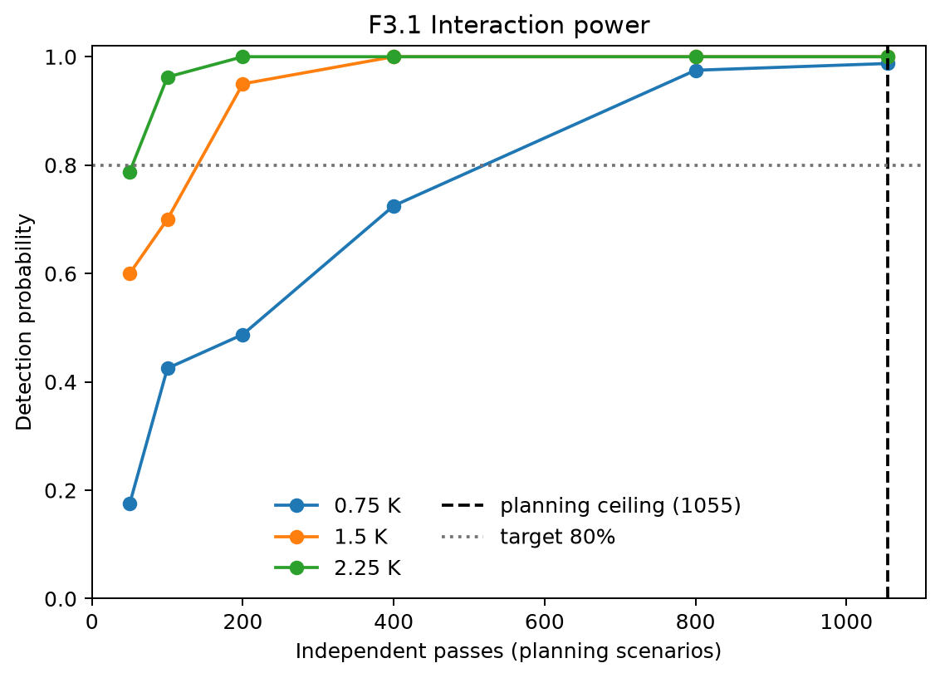
Figure 5 (preliminary F3.1). Simulated interaction detection probability versus independent-pass scenarios. The vertical marker is the unfiltered 1,055-pass catalogue ceiling, not a certified usable-pass count.
Evidence status: Preliminary simulation/code validation; scientifically gate-ineligible. Source: data/processed/v2/task1/step3_preliminary_ceiling/figures/F3.1_power_curves.png
- The maximum corrected transition-test false-positive rate across tested counts was 6.2% against a nominal 5% target.
- Pass-level block-bootstrap intervals behaved more conservatively than deliberately naive row-level intervals, supporting pass-clustered uncertainty as the intended method.

QUARANTINED WORKFLOW DEMONSTRATION

6. Steps 4–14 — what the illustrative package accomplishes
Synthetic content is not a study result
After the live geometry run was stopped, the remaining guide was completed as a deterministic, offline demonstration under illustrative_only/steps02_14. The package shows expected schemas, figures, model outputs, checks, and reporting structure without opening LST/thermal data, selecting a holdout, opening 2026, or activating Task 2.

Workflow block | What was demonstrated | Review value
Steps 4–6: data products and weather | Native-grid archive structure; masking and QA; albedo/ET/radiation; exact-time meteorology and station comparisons. | Lets a reviewer inspect variable definitions, expected checks, and failure handling before expensive downloads.
Steps 7–9: land cover and analysis table | Optical timing; canopy change; thresholding and classification; matching balance; registration sensitivity; analysis-table schema. | Shows how leakage, classification error, covariate imbalance, and missingness would be audited.
Steps 10–12: primary and interaction models | Time-of-day estimates; common support; city pooling; leave-one-city-out; demand × dryness surfaces; transition-model criteria. | Demonstrates the planned inferential presentation and masks unsupported regions.
Steps 13–14: robustness and reporting | Placebo/night tests; sensitivity tornado; uncertainty budget; six paper layouts; STOP memo; confirmatory NOT RUN protocol; package inventory. | Makes the final decision logic and reporting discipline reviewable before empirical outcome access.

Package completeness and reproducibility
- 102/102 unique Step 2–14 guide IDs present.
- 120 non-manifest artifacts: 72 visibly labelled figures and 40 origin-labelled CSV tables, plus memos and package records.
- All synthetic outputs use seed 20260805 and are package-indexed as gate-ineligible; tables are origin-labelled and marked canonical_eligible=false.
- The authoritative manifest records SHA-256 hashes for every non-manifest artifact; source inventory contains 20 hashed code/governance entries.
- Manifest SHA-256: 9027f655a9a611c2ee8c6e6e2c17f1a0c5078b670141e9d941496c44c50d7642.
- Release archive SHA-256: e457fca0bd26af69115dead7730105ae0fabca518a1c9b7a2d4fa803775a64f2.

Illustrative numbers that must not be cited as findings
For example, the synthetic endpoint table contains a fabricated equal-city late-minus-morning contrast of 0.7355 K (synthetic interval 0.6280–0.8430 K), and the synthetic robustness workflow contains a 0.057 K pavement placebo and −0.715 K night contrast. These values prove only that reporting and sensitivity code paths work. They are not estimates for Phoenix or any other real city.

ILLUSTRATIVE OUTPUT EXAMPLES

Planned study design and primary-result format
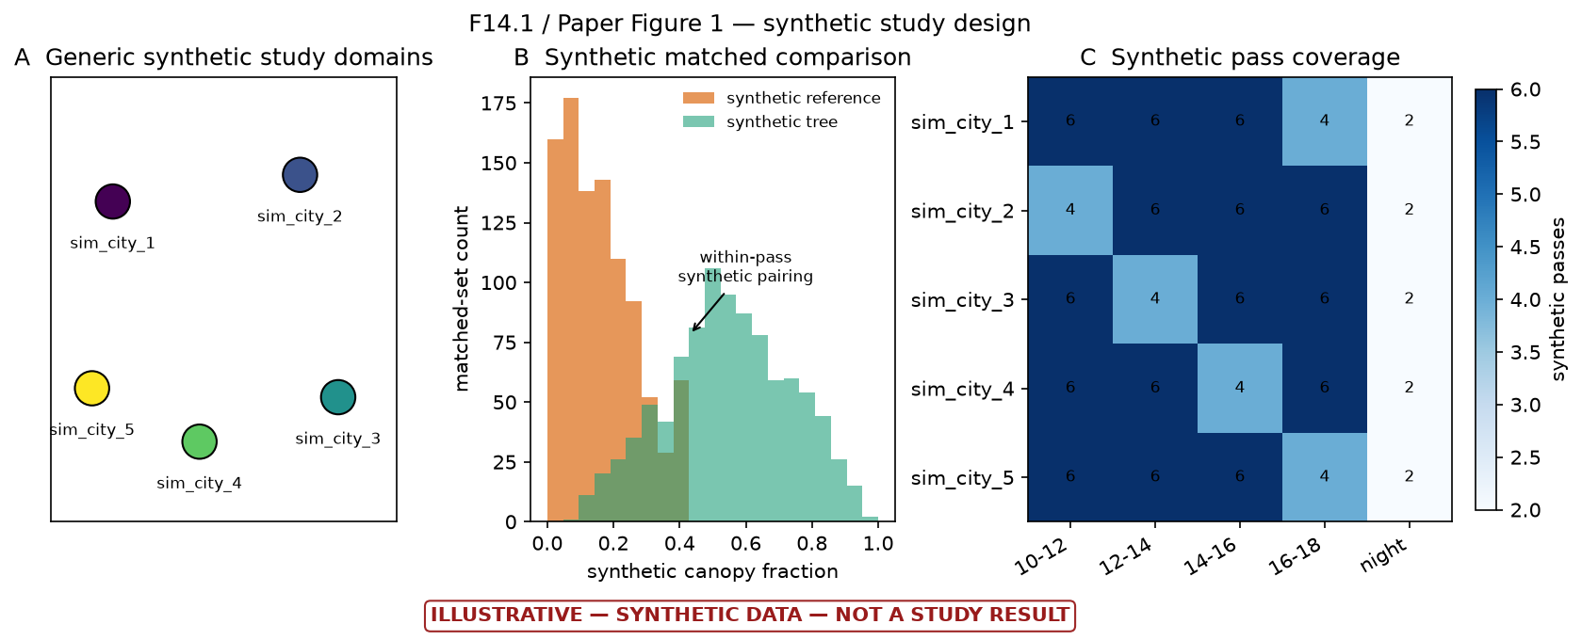
Figure 6 (illustrative F14.1). Synthetic roadmap of the intended multi-city matched comparison: generic domains, separation of tree and reference canopy fractions, and nominal local-time coverage.
Evidence status: Fully synthetic conceptual illustration; no empirical evidentiary value. Source: figures/v2/illustrative_only/steps02_14/ILLUSTRATIVE_F14.1_PAPER_FIGURE_1_study_design.png
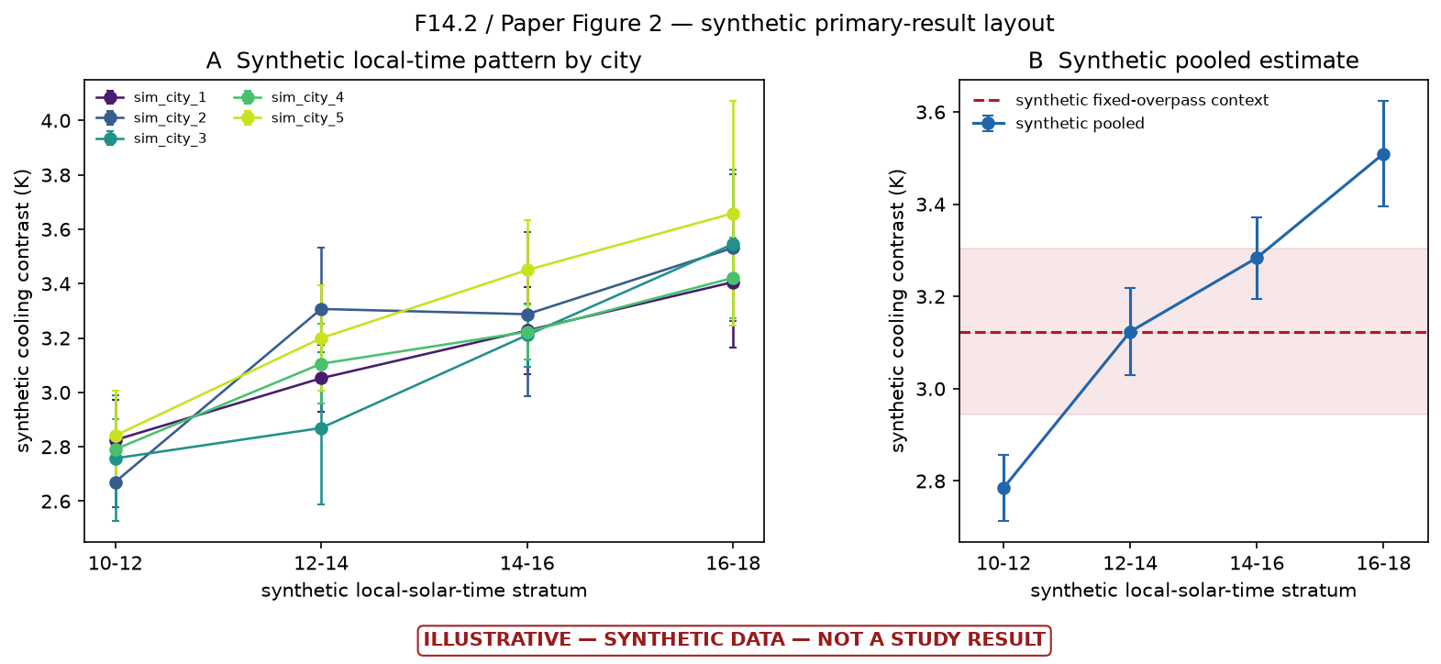
Figure 7 (illustrative F14.2). Synthetic format for city-specific and pooled cooling contrasts across local-solar-time strata. The apparent later-day increase and every uncertainty interval are fabricated.
Evidence status: Fully synthetic primary-result mock-up; no thermal data opened. Source: figures/v2/illustrative_only/steps02_14/ILLUSTRATIVE_F14.2_PAPER_FIGURE_2_primary_result.png

ILLUSTRATIVE OUTPUT EXAMPLES

Planned interaction and support display
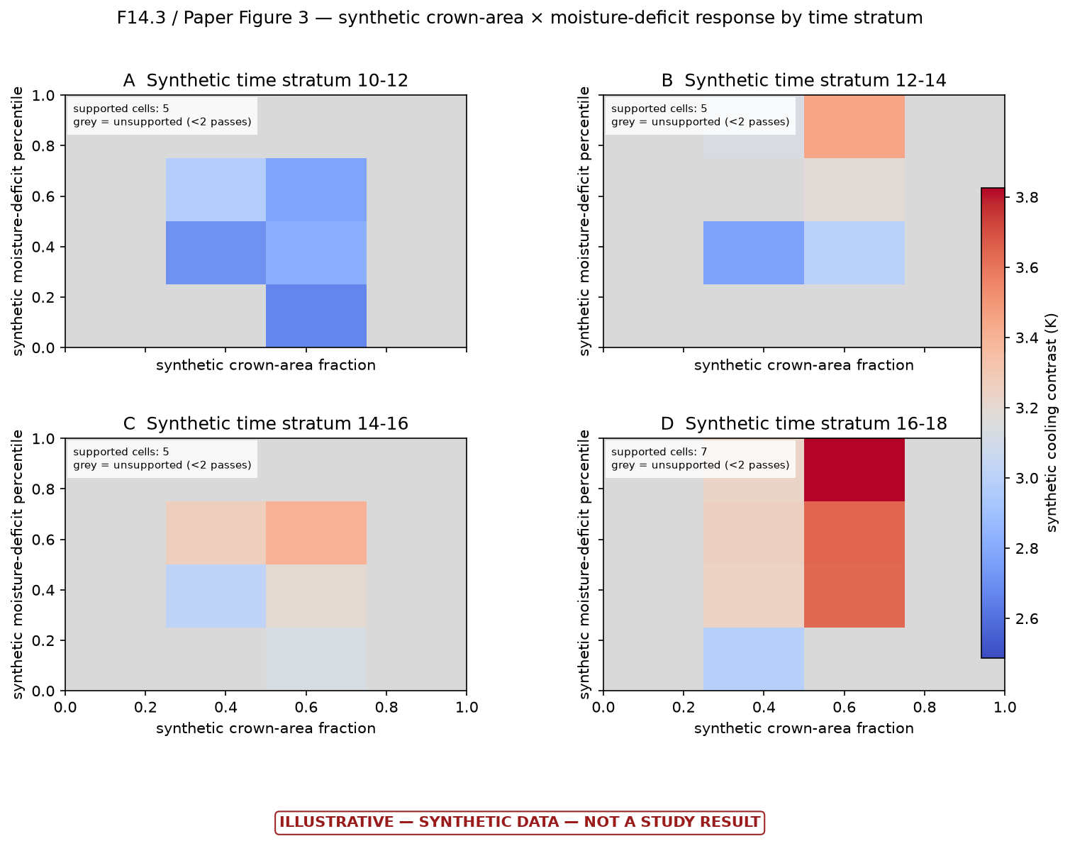
Figure 8 (illustrative F14.3). Synthetic crown-area-by-moisture-deficit response surfaces for four local-time strata. Grey cells demonstrate the rule that unsupported regions must be masked rather than interpreted.
Evidence status: Fully synthetic interaction-surface mock-up. Source: figures/v2/illustrative_only/steps02_14/ILLUSTRATIVE_F14.3_PAPER_FIGURE_3_hydroclimatic_surface.png
This display is useful because it shows the intended guardrail, not because of its colors: every real surface cell would require adequate independent-pass support before it could contribute to a threshold or interaction claim.

ILLUSTRATIVE OUTPUT EXAMPLES

Planned robustness dashboard
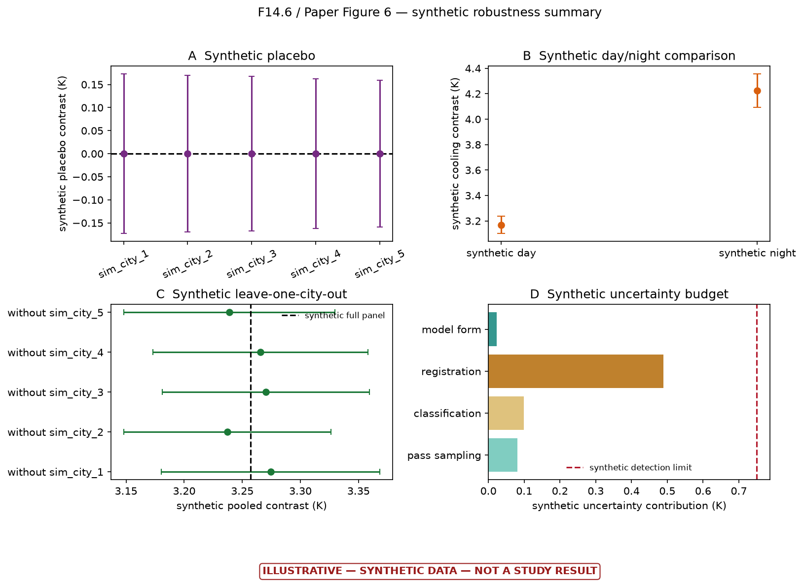
Figure 9 (illustrative F14.6). Synthetic robustness dashboard covering a placebo, day/night comparison, leave-one-city-out stability, and an uncertainty budget. Every point, interval, and contribution is fabricated.
Evidence status: Fully synthetic robustness-summary mock-up. Source: figures/v2/illustrative_only/steps02_14/ILLUSTRATIVE_F14.6_PAPER_FIGURE_6_robustness.png
The final empirical study would need all four classes of evidence to behave coherently: a near-zero placebo, an interpretable day/night pattern, city-robust estimates, and an effect that is honestly compared with the combined detection limit.

AUDITABILITY

7. Quality assurance and reproducibility record
Area | Completed evidence
Requirements control | One normalized registry; scientific cautions retained; gates and open decisions explicit.
Decision provenance | Append-only decisions D0001–D0052 and runs R0001–R0013; superseded evidence retained rather than overwritten.
Domain provenance | Official Census Urban Area identifiers, geometry hashes, repaired analysis hashes, areas and tile intersections recorded.
Step 1 inference | Whole-summer bootstrap and permutation units; exact cell identities; unit and percentile checks; window sensitivity; figure review.
Satellite provenance | Exact scene identities, official endpoints, byte-range controls, checksums and durable checkpoints recorded without exposing credentials.
Failure discipline | Missing scenes failed closed; no imputation or adjacent-scene substitution; invalid cloud-conditioned geometry count was rejected.
Automated verification | R0013 passed 139/139 v2 tests and all 17 isolated legacy test programs.
Packaging | All illustrative artifacts hashed; 20-entry source inventory and rebuild instructions included.

What the testing record does—and does not—prove
The tests provide strong evidence that the implemented schemas, gates, deterministic calculations, and package bookkeeping behave as intended. They cannot substitute for the missing geometry/cloud census, empirical thermal data, real holdout selection, or 2026 confirmation.

No-result safeguards preserved
- No ECOSTRESS LST or thermal value was opened in Task 1 or the illustrative continuation.
- The held-out city remains UNSELECTED; synthetic sim_city labels do not select a real city.
- The full 2026 record remains unopened.
- Task 2 remains inactive and the confirmatory report is explicitly NOT RUN.
- No synthetic value is eligible for manuscript, causal, policy, or confirmatory interpretation.

SCIENTIFIC LIMITS

8. What can and cannot be concluded now
Supported conclusion | Unsupported conclusion
The five-city weather screen has uneven and often thin clear-sky off-diagonal support. | Trees have a measured cooling effect of any magnitude in the v2 study.
Only two cities pass the predeclared within-city weather-support screen. | Cooling increases later in the day; the plotted later-day increase is synthetic.
The catalogue supplies broad nominal time coverage, but usable-pass totals remain unknown. | The 1,055-pass catalogue ceiling is the effective empirical sample size.
The tiled view-angle screen was cloud-conditioned and correctly rejected. | The provisional 106-pass floor is a valid or conservative usable-pass count.
Exact GEO archive gaps are real at the tested endpoints and not caused by token expiry. | The 41 objects never existed or will never be restored.
The downstream package demonstrates a coherent analysis and reporting workflow. | Placebo, night, interaction, radiative, sensitivity or holdout checks passed empirically.

Current scientific recommendation
Complete the real feasibility chain before downloading thermal outcomes. If the definitive pass-date audit preserves the Step 1 pattern, use cross-city/common-support comparisons with explicit city-confounding limitations, or redesign the city panel before outcome access.

PATH TO A CANONICAL RESULT

9. Required next work
- Complete the remaining 201 D0047 cloud-independent geometry candidates and preserve a definitive status for all 911 archive-available candidates.
- Compute a finite official cloud fraction for every geometry passer; do not extrapolate or silently drop failures.
- Complete exact-acquisition HRRR joins for every required retained pass and validate interpolation, units, and domain sampling.
- Produce definitive Step 2 outputs, especially F2.5, and reissue the feasibility decision using actual usable pass dates and acquisition-time demand.
- Run definitive Step 3 using the certified usable-pass count and actual joint distribution; issue a gate-eligible T3.1 model-support verdict.
- Obtain a canonical Task 1 PASS and resolve whether the five-city cross-city scope is sufficient or a sixth-city redesign is needed.
- Select the real holdout using quality-only evidence before inspecting thermal outcomes, then pass the Task 2 preflight and storage projection.
- Run empirical Steps 4–9 for development cities, then Steps 10–13 with pass-clustered inference and common-support restrictions.
- Freeze the complete method before opening the real held-out city or any 2026 record; then run the genuine Step 14 confirmation exactly once.
- Complete an independent rebuild. If LP DAAC restores the 41 objects, rerun the original 942-candidate exhaustive census as a separately versioned sensitivity analysis.

Practical priority order
Priority | Work | Why it comes first
1 | Finish geometry and cloud | Every downstream empirical sample-size and power claim depends on it.
2 | Finish exact-time HRRR and F2.5 | Replaces the preliminary daily/clear-sky screen with actually sampled conditions.
3 | Definitive Step 3 gate | Determines which models are supportable before thermal access.
4 | Holdout selection and Task 2 preflight | Preserves confirmatory integrity and prevents outcome-driven design choices.
5 | Empirical Steps 4–14 | Only after feasibility, power, and blinding are valid.

PROFESSOR REVIEW INDEX

10. Most important files and deliverables
The following files are the smallest review set that reconstructs the current scientific state. Paths are relative to the project root unless shown otherwise.
Review purpose | Primary file
Controlling scientific requirements | docs/v2/REQUIREMENTS.md
Complete decision and run history | docs/v2/DECISION_LOG.md
Current canonical gate | data/processed/v2/task1/TASK1_GATE.md
Step 1 recommendation | data/processed/v2/task1/step1/memos/M1.1_feasibility_gate.md
Step 1 city/cell statistics | data/processed/v2/task1/step1/tables/T1.1_city_cell_counts.csv
Step 1 domain record | data/processed/v2/task1/step1/tables/T1.2_city_domains.csv
Step 2 catalogue counts | data/processed/v2/task1/step2_catalogue_audit/tables/T2.1_daytime_catalogue_ceiling_counts.csv
Partial geometry checkpoint | data/raw/v2/ecostress/l1b_geo_geometry_D0047_archive_available/geometry_scene_checkpoint.json
Preliminary Step 3 verdict | data/processed/v2/task1/step3_preliminary_ceiling/M3.1_power_gate.md
Illustrative-package explanation | data/processed/v2/illustrative_only/steps02_14/README.md
Authoritative artifact manifest | data/processed/v2/illustrative_only/steps02_14/run_manifest.json
Step 14 scientific STOP memo | data/processed/v2/illustrative_only/steps02_14/ILLUSTRATIVE_M14.1_go_adjust_stop_memo.md
Confirmatory status | data/processed/v2/illustrative_only/steps02_14/ILLUSTRATIVE_M14.2_confirmatory_report_NOT_RUN.md

Delivered packages
Local release archive: deliverables/illustrative_steps02_14_D0052_2026-08-06.zip
Google Drive package folder: Open the Steps 2–14 package

Step 1 deliverable set
ID | File | Status
F1.1 | step1/figures/F1.1_joint_30d.png | Canonical empirical
F1.2 | step1/figures/F1.2_clear_sky_overlay.png | Canonical empirical
F1.3 | step1/figures/F1.3_corner_counts.png | Canonical empirical
F1.4 | step1/figures/F1.4_joint_60d.png | Canonical empirical
T1.1 | step1/tables/T1.1_city_cell_counts.csv | Canonical empirical
T1.2 | step1/tables/T1.2_city_domains.csv | Canonical empirical
M1.1 | step1/memos/M1.1_feasibility_gate.md | Canonical empirical

Base path for the Step 1 entries above: data/processed/v2/task1/.

APPENDIX

A. Additional thirty-day joint-support figure
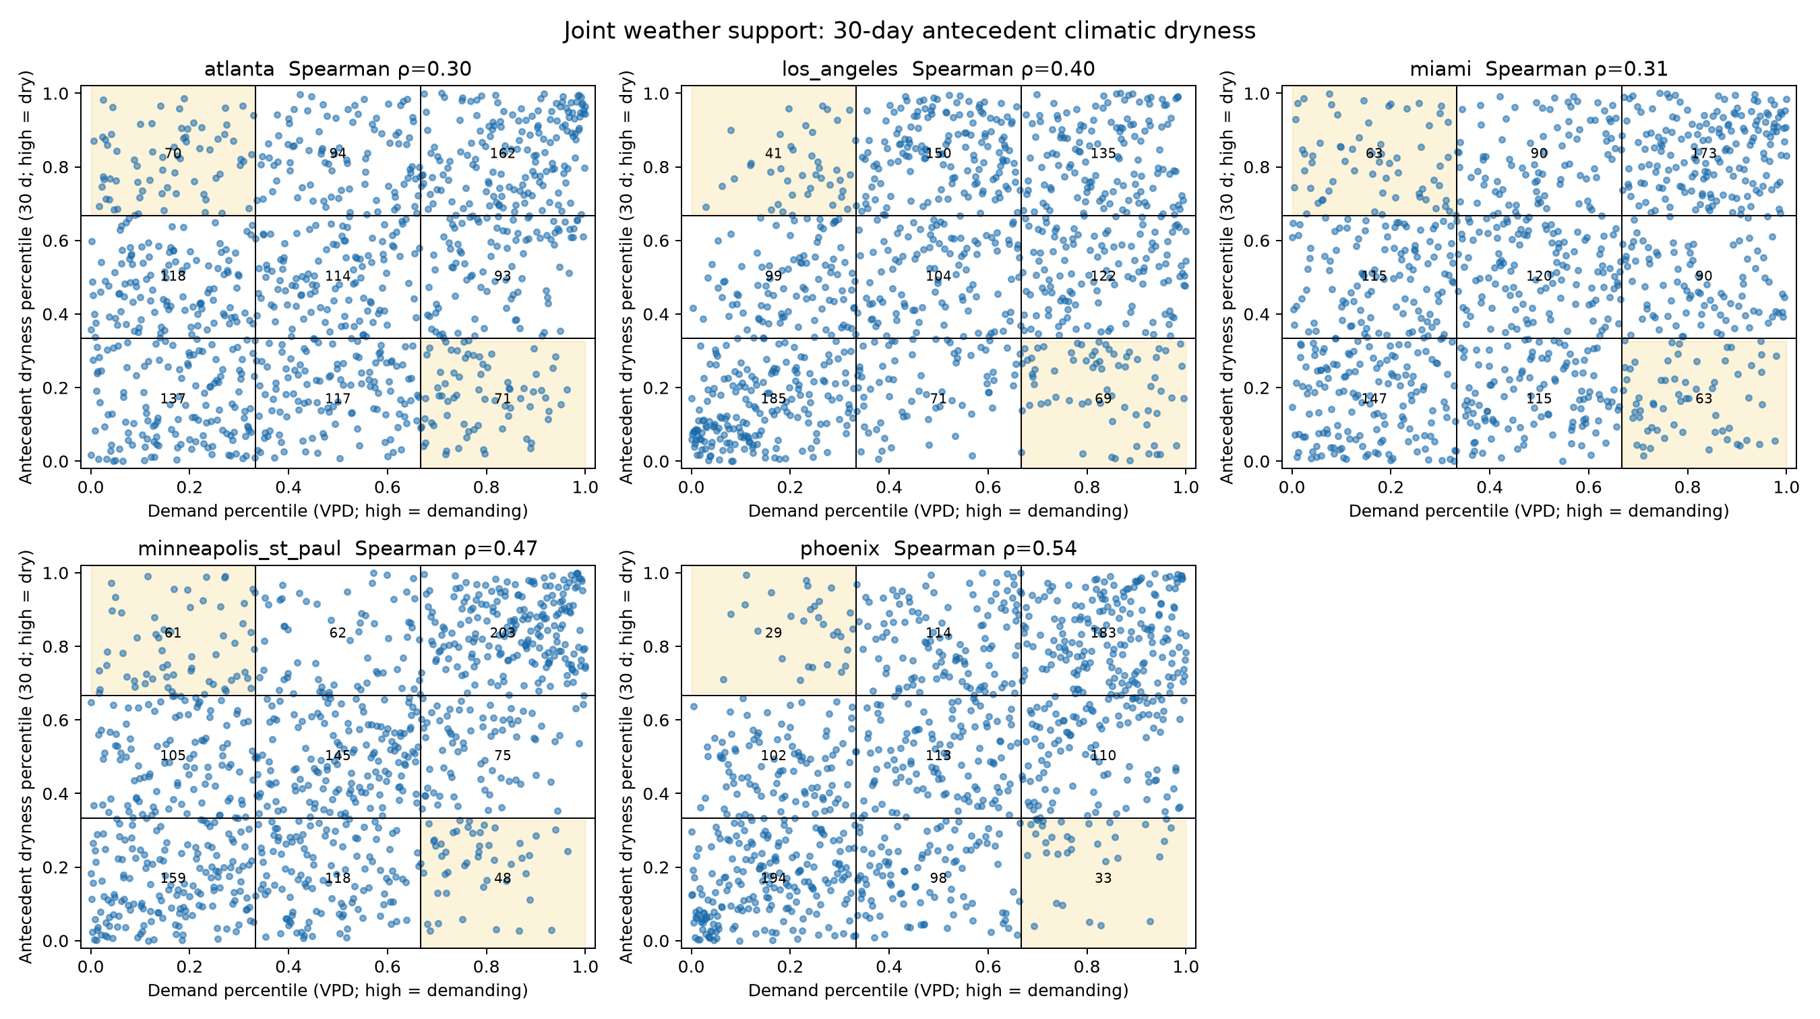
Appendix Figure A1 (F1.1). All-day five-city joint distribution using the 30-day antecedent-dryness window. Tercile boundaries, nine cell counts, diagnostic corners, and Spearman correlations are shown.
Evidence status: Canonical empirical meteorological screening; no thermal outcome. Source: data/processed/v2/task1/step1/figures/F1.1_joint_30d.png

B. Final state declaration
Professor-review conclusion
The project has a strong governance, feasibility, and reproducibility foundation; one complete empirical stage; substantial real nonthermal satellite audit work; and a comprehensive synthetic demonstration of the remaining pipeline. It does not yet have an empirical urban-tree-cooling result. Any evaluation of the work should therefore credit the completed design, Step 1 findings, archive/geometry remediation, code validation, and reproducible package while treating the canonical study as stopped pending the enumerated feasibility gates.

END OF REPORT

