Urban Tree Cooling: from my Phoenix pilot to the five-city study
Progress summary · 6 August 2026 · Jamie Lee
Where things stand: I finished every check that comes before the real analysis, and they told me to stop. I have not opened any of the temperature data, I have not picked the held-out city, and the 2026 season is still sealed.
What changed
There were two separate rounds of changes here, and they are easy to mix up. The first was your review, which I finished on the Phoenix pilot by 17 July. That is what I am calling v1. I swapped NDMI out for root-zone soil moisture, made the demand by water surface the main detector instead of the single CSI number, and moved the analysis down to the pixel level with block-group clustering. All fifteen findings are closed.
Then the step-by-step guide arrived on 1 August, and it asked for a much bigger project: five cities, eight summers, the satellite's own grid, and a feasibility check before downloading any temperature data at all. That is v2. I started it the same day and built it as a separate package, so the Phoenix pilot still runs and still passes its tests.
 | v1 — up to 17 July 2026 | v2 — from 1 August 2026
What it is | My Phoenix pilot, plus your review | My build of the step-by-step guide
Cities and years | Phoenix only, summer 2023 | 5 cities, summers 2018–2025, with 2026 sealed
City boundaries | A bounding box I drew myself | 2020 Census Urban Areas, with hashes recorded
Grid | My own 70 m grid (EPSG:32612) | The satellite's own tile grid, so temperature is never resampled
What counts as one observation | Pixels and block groups (9 pairs) | One satellite pass. I have 219, worth 159.09 pass-equivalents
Water variable | Root-zone soil moisture, which was your fix; CSI dropped to secondary | 30 and 60-day rainfall minus reference ET. Soil moisture and CSI both gone
Weather | ERA5-Land, hourly | HRRR, interpolated to the exact second of each overpass (413 of 413 hours)
Record-keeping | A design-decisions write-up | 58 frozen decisions, 17 logged runs, and gates that fail closed
Code | 16 modules, 133 tests | 30 modules, about 25k lines, 139 tests
Cooling result | I got a response surface, but no solid threshold (only 9 block groups) | None. The feasibility checks stopped me before I opened any temperature data
What I ran, and what came back
Step 1, checking the conditions. Done. I set up the five city boundaries, pulled the gridMET weather, and worked out demand and antecedent dryness for every summer day. Everything passed. The answer was that I can only separate the two effects across cities, not inside them. Only Los Angeles and Minneapolis–St. Paul passed the within-city test. Clear-sky days are also very uneven: Miami has 68 usable summer days and Phoenix has 697.
Step 2, counting the satellite passes. Done, but it says stop. I started with 2,968 passes, 1,055 of them in daylight, and 942 with the metadata I needed. Then I found a problem in my own screening. All 400,414 cloudy pixels had broken view-angle values, which meant my “good geometry” filter was really just measuring whether it was cloudy. I redid it with the L1B GEO files, which do not have that problem. That is when I hit something I could not fix: 41 of the files I needed are missing from the LP DAAC archive. I tried every route I could think of and they all came back 404, so I sent a restoration request and dropped the 31 affected passes rather than guess at them. After that the geometry finished for all 911, cloud screening ran on all 219 near-nadir passes, and the weather finished for all 413 hours. All six checks passed. The gate still says stop, and this is why: the low-demand and dry box has only 0.553 pass-equivalents in it, and the rule I set says I need at least 10.
Step 3, the backup plan. Done, also says stop. With the interaction off the table, I switched to time of day as the main question. Using the 102 real passes I have, the power comes out at 0.110 when I need 0.80, and it stays between 0.100 and 0.145 no matter which city I drop. The problem is not that I need more data. The late-afternoon flag is 99.4% predictable from the other things I have to control for, because it correlates 0.937 with solar zenith. I simulated 800 passes and still only got to 0.395.
Steps 4 to 14, built but not really run. I built all 102 remaining deliverables as clearly labelled demo versions with made-up data. They show that the code and the file formats work. They do not say anything about actual trees.
The grid you asked for, redone with v2 data
This is the grid from your review: demand along the bottom, water up the side, and n written in every box. It now holds 219 passes from five cities instead of 66 from Phoenix. One thing to flag is that v2 uses a climatic water balance on the y-axis instead of soil moisture, because the guide says not to treat reanalysis soil moisture as the water variable.
One thing to watch: the shading is how many passes landed in each box, not how much cooling there was. There is no cooling number anywhere in v2 yet, which is what the blank panel B is showing.
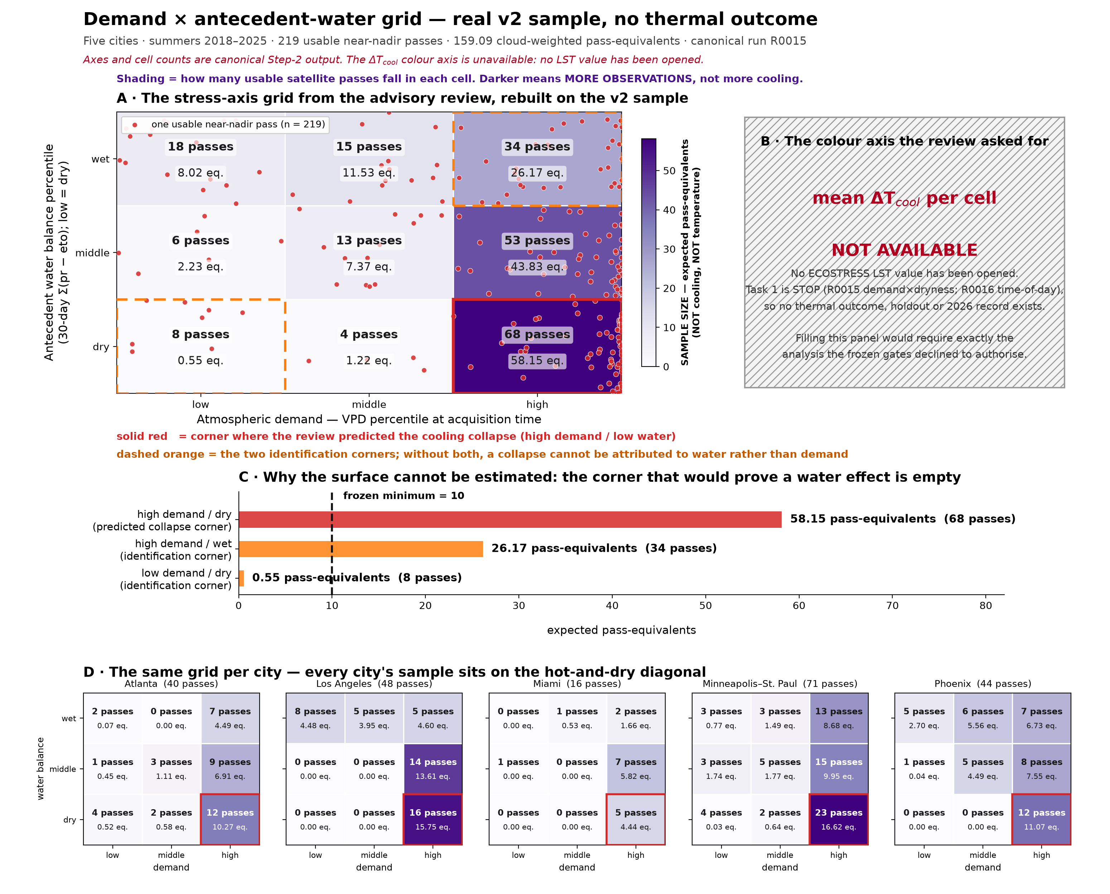
What it shows
- The box where you expected the cooling to collapse, high demand and low water, actually has more data than anywhere else on the grid: 68 passes and 58.15 pass-equivalents.
- But the two corner boxes I would need to show it is really about water, and not just about heat, hold 26.17 and 0.55 pass-equivalents when I need 10.
- So even if I filled in the colours, I could not tell a water effect apart from an ordinary hot-day effect. Hot spells are dry spells, and throwing out cloudy days makes it worse, since the wetter days are the cloudy ones.
What I think this means
I do not think this is a wasted result, even though there is no cooling number in it. I roughly tripled the sample and the interaction still is not identifiable, and the reason is built into how the satellite works: the observations I would need are the ones a thermal sensor cannot take. To keep going I would need a different question that is not tangled up with solar geometry, or data from something other than clear-sky ECOSTRESS. I did not want to lower my own thresholds after seeing the result, so I stopped.
Where this comes from: the figure and all the counts are from run R0015. The script that draws the grid imports the same classifier the pipeline uses, and it checks that it reproduces the published table exactly, 219 passes and 159.087 pass-equivalents, and errors out if it does not. The gate records are R0015 for Step 2 and R0016 / D0058 for Step 3.

