**CS673 Software Engineering** 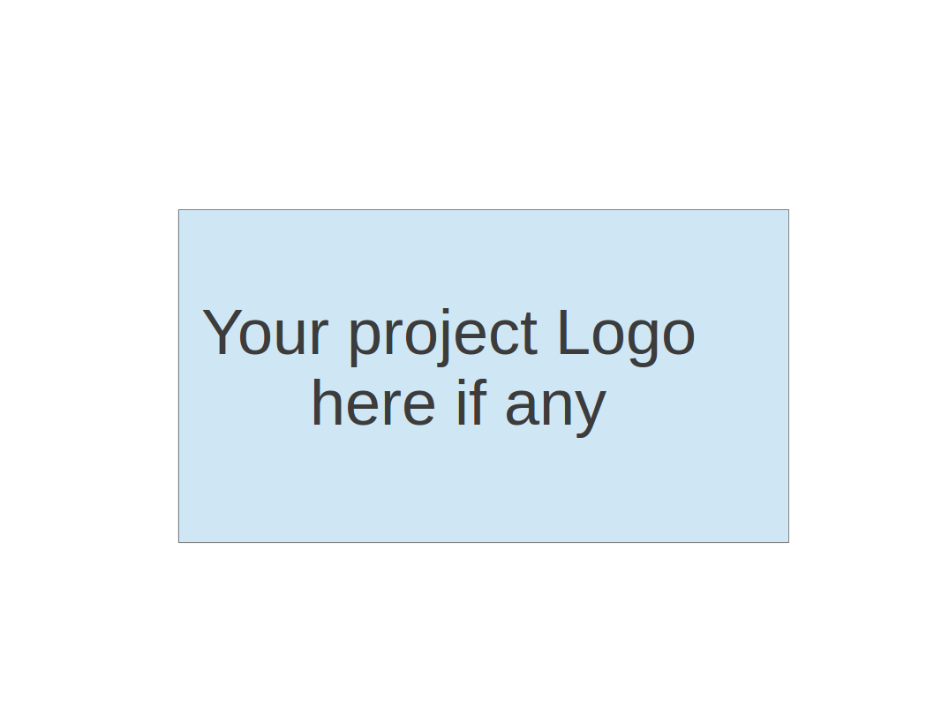

**Team X - Project Name**

**Software Design Document**

|  |  |  |  |
| --- | --- | --- | --- |
| Team Member | Role(s) | Signature | Date |
| Saloni Rawat | Team lead, Config leader |  |  |
| Mike Zhong | Back up team lead, Design and implementation leader |  |  |
| Jamie Smart | QA Leader |  |  |
| Sriram Doss | Requirements leader |  |  |
| Douyao Zhang | Security leader |  |  |
|  |  |  |  |
|  |  |  |  |
|  |  |  |  |

**Revision history**

|  |  |  |  |
| --- | --- | --- | --- |
| **Version** | **Author** | **Date** | **Change** |
| **01** | **Saloni Rawat** | **3 Oct 2019** |  |
|  |  |  |  |

Introduction

Software Architecture

Design Patterns

Key Algorithms

Classes and Methods

References

Glossary

# Introduction

In this section, give an overview of this document, and also address the design goals of your software system.

Hoopfinder is an android application that allows users to connect to other nearby interested players to organize events at nearby courts. More details on the project are available under the [SPPP](https://docs.google.com/document/d/1xOXwoxuaSoGwdceJBj4nmJrN1tKBkyNZ/edit)

The purpose of this document is to provide documentation to be used in the design and development of Hoopfinder. SDD - Software Design Document - is a design description of the system to allow for the development to proceed with an understanding what is the main expectation[1].

# Software Architecture

In this section, you will describe the decomposition of your software system, which include each component (which may be in terms of package or folder) and the relationship between components. You shall have a diagram to show the whole architecture, and class diagram for each component. The interface of each component and dependency between components should also be described. If any framework is used, it shall be defined here too. Database design should also be described if used.

As mentioned earlier, the application will be built on android platform. Android is an open source, Linux-based software stack which can be used by a number of different devices[2].

## Android Platform

The following diagram from Android developer, aims to elaborate on the major components of the platform.

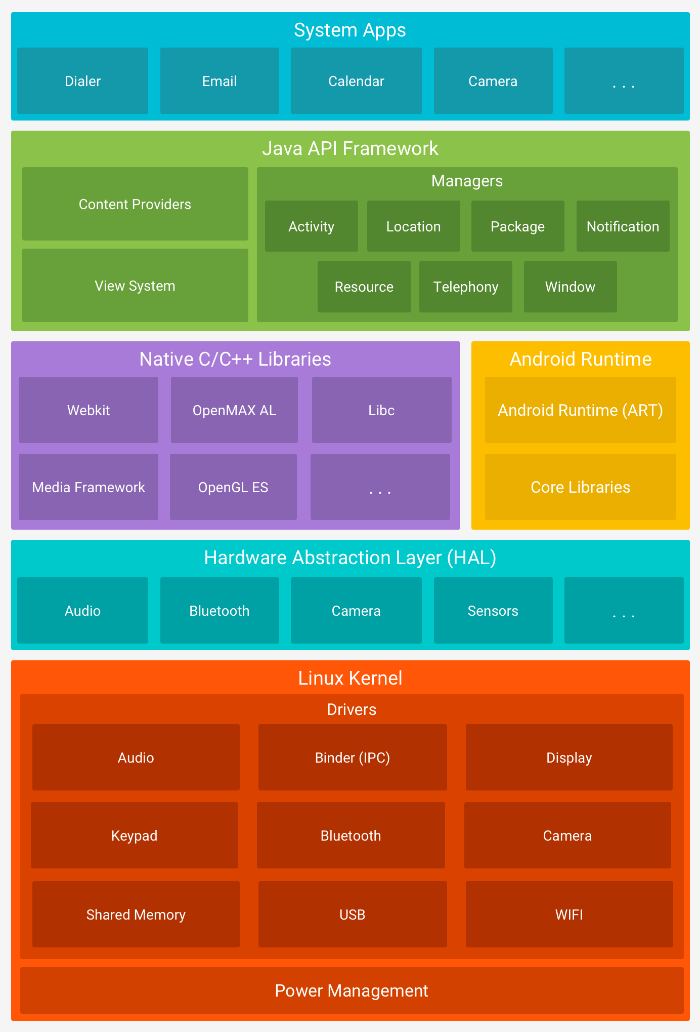

**Figure 1.** The Android software stack.

## Database - SQLite:



For storing personal information as location information, we will be using SQLite.

## Packages

|  |  |  |
| --- | --- | --- |
| Name | Purpose | Comments |
|  |  |  |
|  |  |  |

## Use Cases

# Design Patterns

In this section, you shall describe any design patterns used in your software system.

# Key Algorithms

In this section, you shall describe any key algorithms used in your software system, either in terms of pseudocode or flowchart.

# Classes and Methods

This part can be a reference to automatic generated document for all classes and methods.

# References

# Glossary

1. <http://robotics.ee.uwa.edu.au/courses/design/examples/example_design.pdf>
2. <https://developer.android.com/guide/platform>