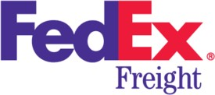

|  |  |
| --- | --- |
| ADVANCED DATA MANAGEMENT  Dr Yakub Sebastian | Kat Huynh |

# Introduction

## Domain Selection

|  |  |
| --- | --- |
| Industry | Courier Service |
| Area of interest | Logistics management |
| Things of interest | Freight Service,customers, products, trasnportation, manufacturer, and shipments |

**Business Case**

FedEx Corporation (FedEx) is one of the industry leaders in the delivery service sector, provides a full suite of value-added supply chain solutions, specialty transportation, cross border e-commerce technology services, to deliver extraordinary service to customers. Traditional distribution shipping is complex with involvements of numerous third-parties, prolongs process that cost the customer time and money. FedEx Freight service offers a direct, fast-moving solution without relying on other distributors.

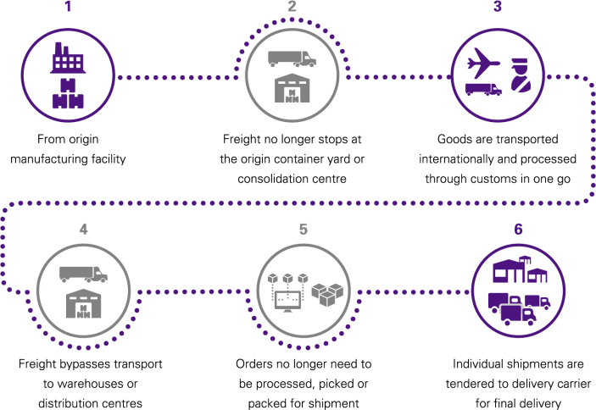

*Figure 1: FedEx Freight*

Overcoming all the unnecessarily traditional shipping, goods are picked-up from manufacturing facilities and transported internationally to its final destination. FedEx Freight processes the products through rigorous custom clearance and offers value-added services including packaging and kitting to the recipients.

Recently developing its new business model (FedEx Freight), FedEx wants to upgrade its business information system and invest in a new database. Therefore, conceptual data models (EER and UML diagrams) are required to formalise the data requirement for the upgraded business operation. In addition, FedEx also requires to map the EER model to a logical relational model to understand what semantics gets lost in the mapping process.

FedEx Freight service comprises of FedEx Branches operating around the world, along with its transportation services. The company gives the rights for each branch to monitor itself and can be identified in the database through ID and location. There are two offices working under FedEx Branch:

Global Trade Center and Supply Chain, which haves their own managers and employees. For each person, we want to store a combination of ID, name, and contact. Global Trade Office is responsible for Customer Clearance products and Supply Chain Office is in charge of packaging, kitting , and value- added services for products. It should be noted that each manager and employee can work for one and only one office, each office has one manager and may have many employees.

FedEx Freight utilise its own vehicles or contract with third-parties (uniquely identified by license number) to provide transportations for delivery services. Each branch may have many vehicles but must have equal or less than 100. There are four types of transportations FedEx Freight uses, including aircraft, watercraft, on-road and on-rail vehicle. They are all identified by their registered licensed number and its ownership status. It should be noted that in each type of vehicle, we also need to store additional fees information that belong to it: aircraft needs to have air freight charge; on-road vehicle should have route tax; on-rail vehicles includes rail free charge; watercraft has sea freight charge. Vehicles relates to the collect & ship process, where users need to have all the information of product ID, vehicle license number, delivery and pick-up time, and shipment mode, which currently comprised two types Economy and Priority modes.

The shipments are then recorded with amount of shipments and shipment date and reserved by manufacturing facilities with its own token. For manufacturing facilities database, the following information should be stored: membership number, company name, address, and contact number. A manufacturer should be uniquely identifiable by its membership ID. Manufacturers and shipments altogether reserve their own tokens, which are differentiated by its unique token number.

Manufacturing facilities have the products that need to be delivered. For each product, the database is required to store several information: ID, size, weight, pricing, restrictions, money-back guarantee, and declared-value-for-carriage (DC). The primary key “ID” is used to differentiate between products. Restriction is checked with its yes-no status to clarify whether the product is dangerous or not. FedEx Freight offers money-back guarantee on selected products, and the guarantee is recognised by the Yes/No status in the database. Declared-value for carriage (DC) is the maximum liability in connection with a shipment of the product; therefore, the value of the data is how much the payment is for any loss or damaging goods during shipment.

Customers then receive the products delivered. The database should store important information of customers such as membership ID, customer name, address, and contact number. The combination of membership number and customer name can uniquely identified each customer. Customers can choose their preferred delivery options, which are in-store pickup or standard delivery direct to final destination.

# Evaluation

|  |  |
| --- | --- |
| **Criteria** | **Expected Score Range** |
| Data Requirement Gathering | 80-100% |
| Conceptual Data Modelling | 80-100% |
| Relational Data Implementations | 80-100% |
| SQL Queries | 80-100% |

**Data Requirement Gathering:**

Throughout an in-depth research, a high-quality businesses case (FedEx Freight) is provided, and supported by proofs in Appendix. In order to develop a thorough understanding, we conducted both secondary and primary research.

* Secondary research: We obtained data and company information through company’s

website, reports, supply chain manual, previous FedEx Employee Training manual.

* Primary research: We conducted an interview with FedEx Branch Manager to obtain more insight understanding and opinion towards the proposed conceptual models. A set of questionnaires is clearly defined and prepared for the interview.

## Conceptual Data Modelling

Outcomes were presented in the form of EER and UML diagrams , which are also appropriately designed in compliance with Chen’s notation and UML notation in this unit.

|  |  |
| --- | --- |
| No of Entities | 12 |
| Key Attribute Types | 27 |
| Composite Attribute Types | 3 |
| Multiple Value Attributes | 6 |
| Derived Attributes | 1 |
| Relationships Types | 8 |
| Cardinalities | 17 |

Various degrees of a relationship set were also correctly applied: Unary Relationship

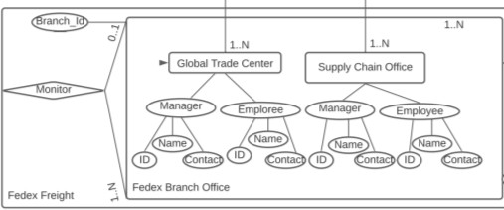

Binary Relationship

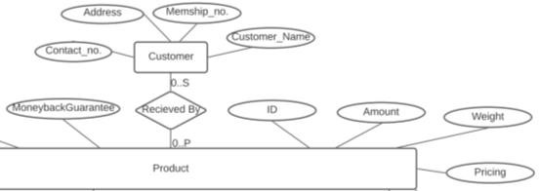

Ternary Relationship

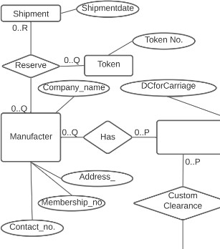

Different types of semestic data modelling were utilised:

Categorisation

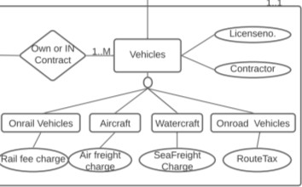

Aggregation

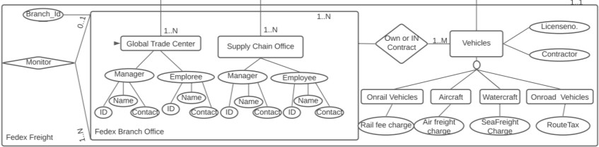

## Relational Data Implementations & SQL Queries

The relational database implementation is consistent with conceptual model with the possible loss of semantics successfully detected and several semantics declared that cannot be enforced by the EER model.

Successful indications and declaration of data constraints (i.e. NOT NULL, PRIMARY KEY, FOREIGN KEY, CHECK).

A set of real data was obtained by the interviewer to populate the table

SQL Queries. Three database query use cases are provided ranging from simple to complex practical use cases:

* Find the available Branch for FedEx Freight to start the shipment. Note that the two offices (Global Trade Center and Supply Chain Office) have to be in the same branch to process your order
* Retrieve a list of customer names that have their order delivered from flight no. V3274T
* Use nested subquery to extract customer’s information (name & contact) receive product under Economy shipment mode (Boolean-0)
* Retrieve a list for service update request using EXIST command to sort out those products that have dangerous goods restriction, no moneyback guarantee, and declared-value for carriage greater than $5000

# Key Challenge: Data Redundancy

In this database modelling process, we found it quite challenging to minimise data redundancy in the database as it continuously happens over time when we expanded the model and factored in new elements. This might be due to the initial model design and insufficient planning, where information is inefficiently structured and needlessly replicated within the same table.

As shown in figure 2, company name, address, membership number, contact number, product ID are both presented with different columns within the same table. If the manufacturer has several products to deliver or need to update, that information (i.e. Product ID) must be continuously updated along with all of Manufacturer’s attributes, resulting in data redundancy issues. If we update the Product ID (in the Product table), the new Product ID would have to be replaced in numerous places. Our database model is sizable along with the close relationship between attributes, which make us difficult to minimise the repeated data and avoid deletion/updatation anomalies.

**Manufacturers**

|  |  |  |  |  |
| --- | --- | --- | --- | --- |
| **Membership Number** | **Company Name** | **Address** | **Contact Number** | **Product ID** |
| 405149769 | VCHN Limited | 5 Figtree Dr  Sydney NSW 2127 | 0289706800 | 03335 |
| 415138532 | Pinnacle People | 115 Grenfell St,  Adelaide SA 5000 | 0881007800 | 16017 |

To cope with issue, we used Normalisation (i.e. 3NF) to reduce data modelisation. As compared to the original table, with normalisation, instead of recording the Product ID in the Manufacturer table, we recorded the information in the new table, where it’s easier to update the information with only one change in a single record.

**M-Products**

|  |  |  |
| --- | --- | --- |
| **Manufacturer_ Membership Number** | **Manufacturer_Company Name** | **Product ID** |
| 405149769 | VCHN Limited | 03335 |
| 415138532 | Pinnacle People | 16017 |

# Appendix A

**EER Diagram**

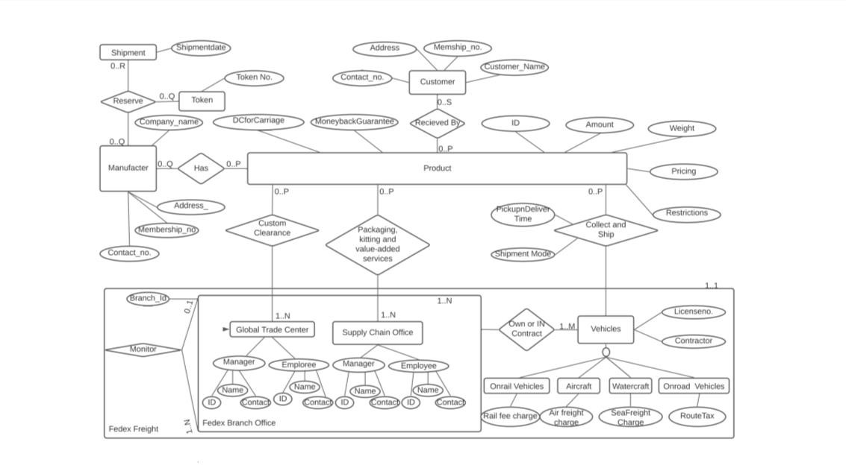

The following semantics cannot be enforced by the EER model:

Temporal aspects:

* Vehicle’s ownership status must update annually
* Each manufacturer must schedule their shipments within 8 months since the activation date of its membership number
* Inactive customer’s membership ID should be deleted after two years
* The delivery time is maximum of 30 days from the reservation time Consistency across multiple relationship types:
* Each FedEx Branch can only use their vehicles associated with the branch and cannot exceeds the branch’s requirement of number of vehicles owned and contracted
* A delivery date cannot be prior to a shipment date for any given order Integrity rules:
* Number of vehicles owned by branch should not be larger than 100
* Product ID should have a fixed format of 6 digits
* Contact number should have a fixed format of (+) (post code) (phone number), which is 11 digits in total
* MoneyBack Guarantee & Restrictions must have a format with only two possible values (yes or no)

Behavior

* A procedure of customer clearance, packaging & kitting requires to take into account information of what product in the process, which branch and who will be responsible for the process
* A procedure to collect and ship need to have additional information of which vehicle and what products to be shipped
* A procedure to reserve the shipment should take into consideration information such as token number, which manufacturers request, the shipment details, and what products are in this reservation

The EER model also does not support domains- e.g., we cannot demonstrate that the attribute type ID must be a positive integer, Shipment Date must be stored as dd/mm/yy; or Restrictions should be stored as Yes/No

**UML Diagram**

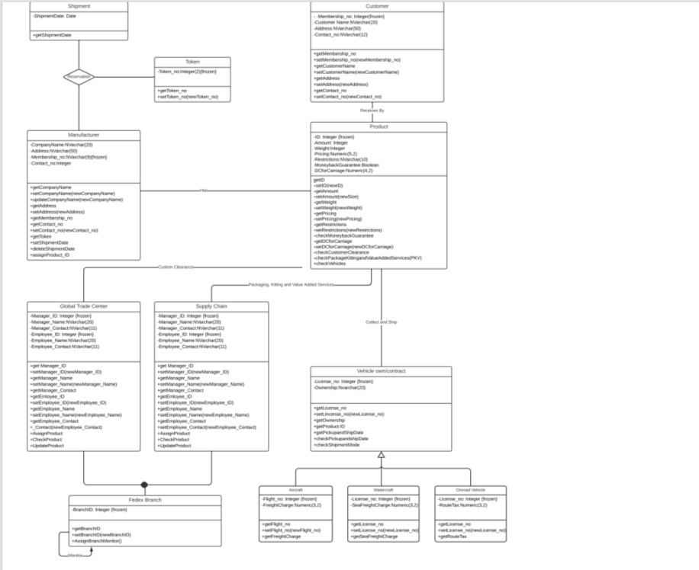

The UML diagram is semantically richer than EER model. The access modifiers of all variables have been set to private in order to secure information hiding. The methods used to access them are get, set, check, and assign. Additional methods can be added when necessary (e.g. an additional method required is when retrieving the number of shipments each vehicle can carry)

The UML diagram clearly defines the domains (e.g. integer, Boolean, string, DateTime) for each variable. In addition, there are several variables are set to frozen, which demonstrated that once a setting has been assigned to any of the variables, they can no longer be changed.

# Appendix B

**Relational Model**

Overcome the shortages from EER model, the following relational model is mapped below (primary keys are underline; foreign keys are in italics):

**FedEx Branch Office** (Branch_Id, Location, Monitor)

*MONITOR*: FOREIGN KEY refers to Branch_ID in relation to **FedEx Branch Office**: Null not allowed, on delete/update cascade

LOCATION: UNIQUE KEY in relation to **Fedex Branch Office:** Null not allowed, on delete/update cascade

**Global Trade Center_ Manager** (Manager_ID,Manager_Name,Manager_Contact)

**Global Trade Center_ Employee** (Employee_ID, Name, Contact)

**Global Trade Center** (Branch, GTC_Manager, GTC_Employee)

*Branch:* FOREIGN KEY refers to Branch_ID in relation to **FedEx Branch Office**: NULL not allowed, on delete/update CASCADE

*GTC_Manager*: FOREIGN KEY refers to Manager_ID in relation to **Global Trade Center**: NULL not allowed, on delete/update CASCADE

*GTC_Employee*: FOREIGN KEY refers to Employee_ID in relation to **Global Trade Center**: NULL not allowed, on delete/update CASCADE

**Custom Clearance** (Branch_ID, Employee_ID, Product_ID)

*Branch ID:* FOREIGN KEY refers to Branch_ID in relation to **FedEx Branch Office**: NULL not allowed, on delete/update CASCADE

*Employee_ID*: FOREIGN KEY refers to Employee_ID in relation to **Global Trade Center**: NULL not allowed, on delete/update CASCADE

*Product_ID:* FOREIGN KEY refers to Product_ID in relation to **Product**: NULL not allowed, on delete/update CASCADE

**Supply Chain Office_Manager** (Manager_ID,Manager_Name,Manager_Contact)

**Supply Chain Office_ Employee** (Employee_ID, Name, Contact)

**Supply Chain Office**(Branch, SC_Manager, SC_Employee)

*Branch:* FOREIGN KEY refers to Branch_ID in relation to **FedEx Branch Office**: NULL not allowed, on delete/update CASCADE

*GTC_Manager*: FOREIGN KEY refers to Manager_ID in relation to **Global Trade Center**: NULL not allowed, on delete/update CASCADE

*GTC_Employee*: FOREIGN KEY refers to Employee_ID in relation to **Global Trade Center**: NULL not allowed, on delete/update CASCADE

**Packaging, kitting and value-added services (**Branch ID, Employee_ID, Product_ID)

*Branch ID:* FOREIGN KEY refers to Branch_ID in relation to **FedEx Branch Office**: NULL not allowed, on delete/update cascade

*Employee_ID:* FOREIGN KEY refers to Employee_ID in relation to **Supply Chain Solutions**: NULL not allowed, on delete/update cascade

*Product_ID:* FOREIGN KEY refers to Product_ID in relation to **Product**: NULL not allowed, on delete/update cascade

**Vehicles** (License_no, Ownership)

**Railroad Vehicle** (Train_No, Cargo Charge)

*Train_no:* foreign key refers to License_no in relation **Vehicles:** NULL not allowed, delete/update cascade

**Aircraft-Vehicle** (Flight_no, SeaFreight Cost)

*Flight_no:* foreign key refers to License_no in relation **Vehicles:** NULL not allowed, delete/update cascade

**Watercraft (**Watercraft-License_no, Ownership)

*Watercraft-License_no:* foreign key refers to License_no in relation **Vehicles:** NULL not allowed, delete/update cascade

**On-road Vehicles** (License_no, RouteTax)

*License_no*: foreign key refers to License_no in relation **Vehicles:** NULL not allowed, delete/update cascade

**From Branch**: foreign key refers to Branch_ID in relation to **Branch**: NULL not allowed, on delete/update CASCADE

**Collect and Ship** (V-License, Shipping time, Shipment Mode, Prod-ID)

1. *License*: foreign key refers to License_no in relation **Vehicles own or contract**: NULL not allowed, on delete/update cascade

*Prod-ID*: foreign key refers to Product-ID in relation **Product**: NULL not allowed, on delete/update cascade

*Shipping time*: foreign key refers to Shipment Date in relation **Shipment**: Null not allowed, on delete/update cascade

**Shipment** (Shipment Date, Amount of Shipment)

**Token** (Token Number)

## Reservation

(Membership No, Token Number,Shipment_Date, Amount_Shipments,Product_ID)

*Token Number*: FOREIGN KEY refers to **Token Number** in relation to **Token**: NULL not allowed, on delete/update CASCADE

*Membership No***:** FOREIGN KEY refers to **Membership No** in relation to **Manufacturer**: NULL not allowed, on delete/update CASCADE

*Shipment_Date*: FOREIGN KEY refers to **Shipment_Date** in relation to **Shipment**: NULL not allowed, on delete/update CASCADE

*Shipment_Amount*: FOREIGN KEY refers to **Shipment_Date** in relation to **Shipment**: NULL not allowed, on delete/update CASCADE

*Product ID:* FK refers to **Product_ID** in relation to **Product**: NULL not allowed, on delete/update CASCADE

**Manufacturer (**CompanyName, Address, Membership_no, Contact_no)

Company Name is UNIQUE KEY in relation **Manufacturer:** NULL not allowed

**Customer (**Membership no, Customer Name, Address, Contact_no)

Name and Contact Number are UNIQUE KEY in relation **Customer** : NULL not allowed

**Product (**ID, Amount, Weight, Pricing, Restriction, MoneybackGuarantee, DCforCarriage, Sentby)

*Sentby:* foreign key refers to **Membership_No** in relation to **Manufacturer**: NULL not allowed, on delete/update CASCADE

**Receives (**Customer, Product, ReceiveDate)

*Customer:* foreign key refers to **Membership_No** in relation to **Customer**: NULL not allowed, on delete/update CASCADE

*Product:* foreign key refers to **Product_ID** in relation to **Product**: NULL not allowed, on delete/update CASCADE

**SQL Queries**

**Find the available Branch for FedEx Freight to start the shipment. Note that the two offices (Global Trade Center and Supply Chain Office) have to be in the same branch to process your order**

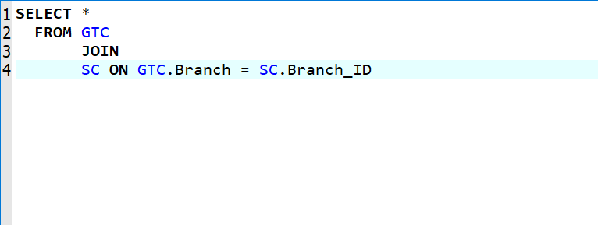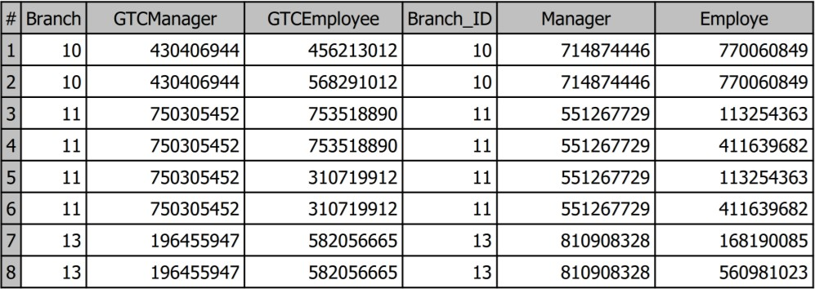

**Retrieve a list of customer names that have their order delivered from flight no. V3274T**

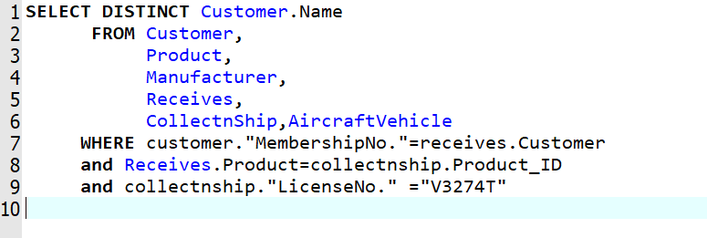

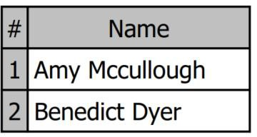

**Use nested subquery to extract customer’s information (name & contact) receive product under Economy shipment mode (Boolean-0)**

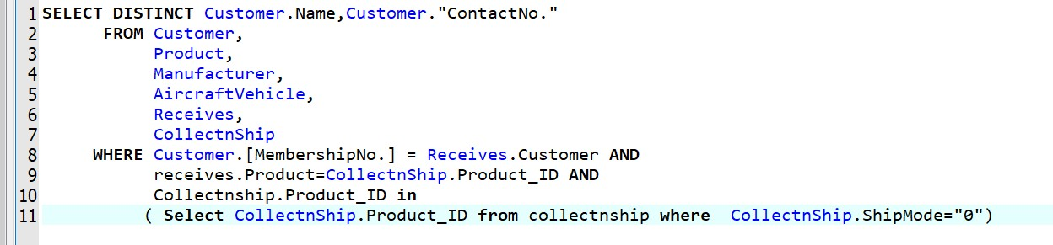

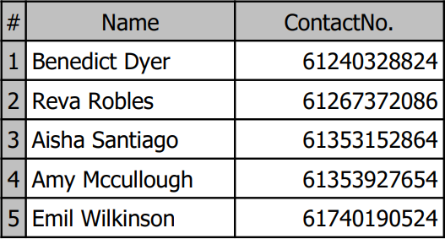

**Retrieve a list for service update request using EXIST command to sort out those products that have dangerous goods restriction, no moneyback guarantee, and declared-value for carriage greater than**

**$5000**

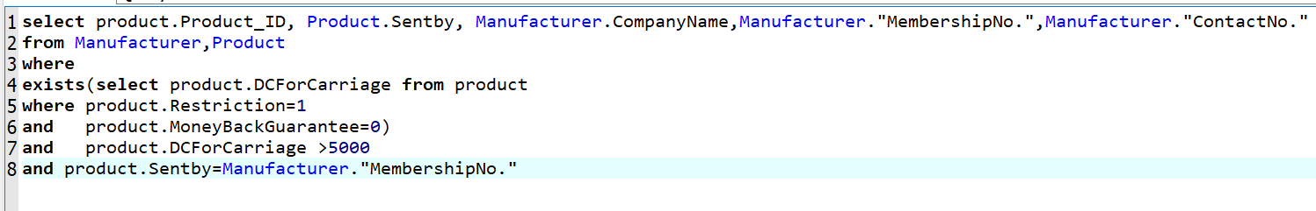

|  |  |  |  |  |
| --- | --- | --- | --- | --- |
| # | **Product_lD** | **Sentby** | **CompanyName** | **MembershipNo.** |
| **1** 215800 | | 1075628126 | Axxon | 1075628126 |
| 2 110053 | | 3116608681 | Neuron Moblie | 3116608681 |
| **3** 135098 | | 6575668092 | Reva Robles | 6575668092 |
| **4** | 244630 | 3116608681 | Neuron Moblie | 3116608681 |
| **5** 698830 | | 8287156736 | Dulux | 8287156736 |

# Appendix C

* 1. **Business Card**

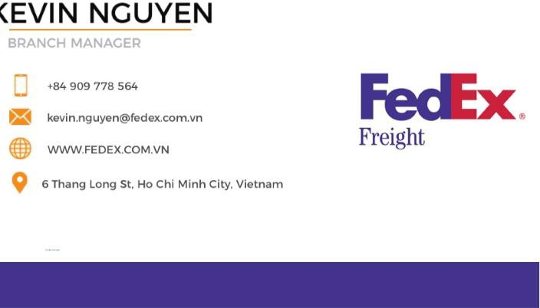

* 1. **Emails**

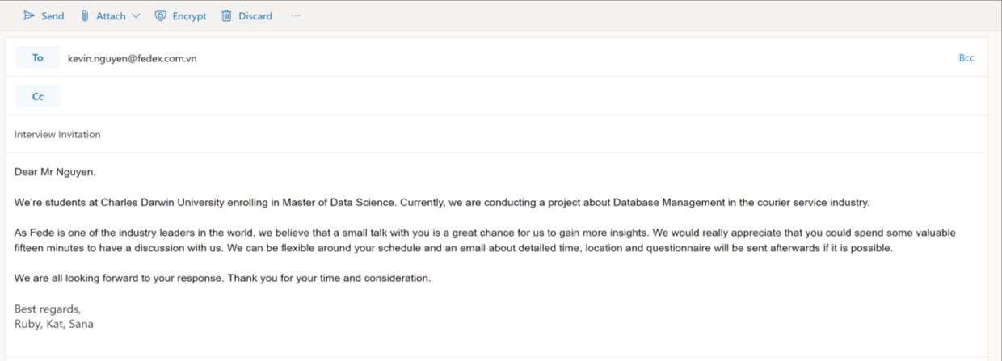

* 1. **Additional Documents**

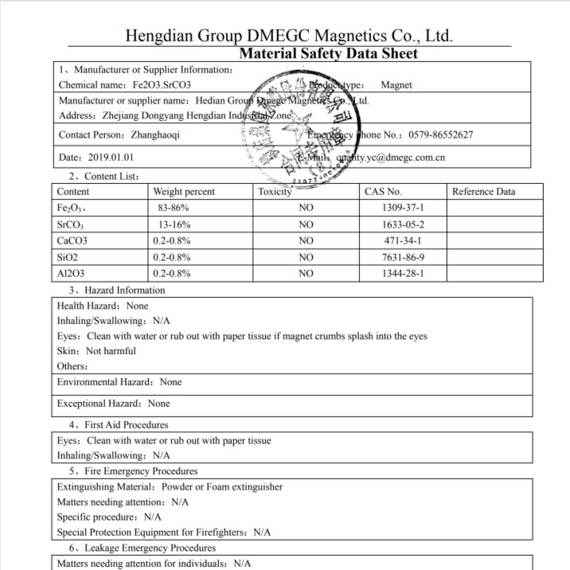

*Figure 2: Manufacturer*

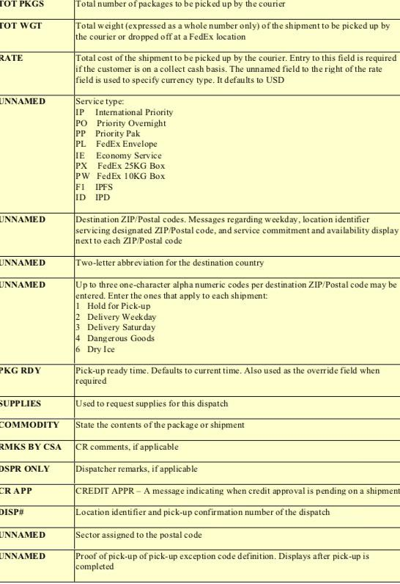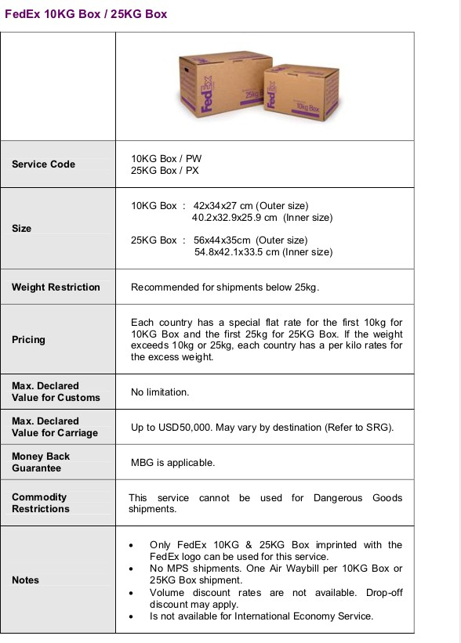

## Questionnaires

**How does FedEx Freight work?**

This service is only applicable for any shipment over 150 lbs., which is considered freight. As you can see on our website, our Freight shipping starts with opening an account for the manufacturers to enable the shipment. Once a shipment is reserved, the manufacturer is then received a token to keep track with our shipping service. Then, FedEx Freight will do rigorous customer clearance to ensure the shipment is legal or have any restrictions. We provide our customers the valued-added services of packaging and kitting that specialise for that specific product. Any request such as adding details, stamps, or heavy packaging or preservation, we’ll follow strictly to deliver the best service for our customers. After that, based on the requirements and capacity of the products and

customer’s preferred shipping mode, we will chose suitable vehicles mode by ship, aircraft, or road types to the destination

## What information of all the stakeholders do you normally store in the process?

For manufacturers or customer from the final destination, we need to create a new membership number and store all the information such as name, contact, address, preferred delivery/pickup options.

FedEx requires a lot of information relevant to the product we deliver: ID, size, weight, pricing, restrictions, moneyback guarantee mode, and any declared-value for carriage, which is the amount we’ll compensate for in case the products loss/damaged.

In each FedEx Branch, we have the branch manager and lots of staff under so we have to keep track their ID, name, contact to see who is responsible any specific task. We only have one manager who is in charge of that branch.

We also store the information of recipients, who is also our customer, of name, membership number, contact, address, and their delivery option. We’ll consider the customer is inactive and delete their information if the customer doesn’t have any shipment within two years.

## Who will be using this database?

All the information relevant to the shipping process can be accessed by our headquarter, branch, and employees. However, manager’s details cannot be accessed by employees.

## Do you have any specific rules for these information?

Oh yes, once manufactures create an account and have their membership number, they have to start to order their shipments with FedEx Freight within 6 months otherwise we’ll de-activate their membership. Besides, manufacturers and customers must book/receive at least one shipments within two years, otherwise, their status will be inactive and we have to remove their information out of the database.