

PAMANTASAN NG LUNGSOD NG PASIG

ACCESSIBILITY IN E-LEARNING FOR ADAPTIVE LEARNING MANAGEMENT SYSTEM FOR VISUALLY IMPAIRED USERS THROUGH AI-POWERED NATURAL LANGUAGE PROCESSING AND MULTI-MODAL HAPTIC FEEDBACK

Proponents of the Study: Bayot, Ryza
Cantorna, Rhonalyn
Rosell, Jamie

Presented To:
Dr. Alexen Elacio

PAGE 2

CHAPTER I

THE PROBLEM AND ITS BACKGROUND

This chapter presents the development of an Adaptive Learning Management System (LMS) that enhances accessibility for visually impaired learners using AI-powered Natural Language Processing (NLP). It outlines the challenges in traditional e-learning, the use of Agile Development Methodology for user-centered design, and ISO/IEC 25010 for evaluation, emphasizing the study’s goal of promoting inclusive and equitable digital education.

Introduction

The rise of digital education has transformed how learners’ access and engage with knowledge, with E-Learning platforms becoming essential in modern education. Learning Management Systems (LMS) deliver, track, and assess educational content across diverse learners. However, traditional LMS platforms often adopt a one-size-fits-all model, overlooking individual needs. An Adaptive LMS addresses this by personalizing content delivery, pacing, and assessments to match learner abilities and preferences, creating a more effective and engaging experience.

Despite educational technology advancements, accessibility remains a significant barrier for visually impaired learners. Inaccessible interfaces, lack of adaptive feedback, and limited non-visual interaction hinder full participation in E-Learning, widening the inclusive education gap. Addressing these issues ensures compliance with accessibility standards and equitable access to quality education.

Artificial Intelligence (AI), particularly Natural Language Processing (NLP), offers transformative solutions. NLP enables machines to understand, process, and generate human language, integrating voice commands, text-to-speech, speech recognition, and conversational agents into platforms. For visually impaired users, these features provide intuitive navigation, question-asking, and immediate responses, enhancing accessibility and learning quality.

By integrating Adaptive LMS with AI-powered NLP, this study bridges technological innovation and inclusive education. It develops a framework that improves usability and equality, empowering visually impaired users to fully participate in digital learning and advance inclusive education systems.

PAGE 3

PAGE 4

1.2 Review of Related Literature
Agile development methodology

Developing an accessible Adaptive LMS for visually impaired learners using AI-driven NLP requires an adaptive, user-focused methodology. Agile Development Methodology enables iterative progress with continuous feedback from visually impaired educators and learners. In the requirements phase, Agile emphasizes user stories, crucial in the Philippine context where accessibility resources are limited. Bacalla, K. A., Lagura, J. C., & Ylanan, M. D. (2024) showed that minimal interventions like Braille signage enhanced independence, underscoring user-experience-based design. Rodriguez III, M. A., Regencia, J. C., & Salcedo, K. P. (2024) developed InnoVision, an iterative navigation aid using GPS, GSM, and sensors, illustrating Agile’s role in usability improvements.

Sprint cycles in design and prototyping ensure rapid testing of NLP voice navigation. Campado, J. A., Toquero, C. M., & Ulanday, R. M. (2023) noted assistive technologies fail without adaptation; Agile mitigates this via real-time feedback. Tolentino, F. C., de Guzman, A. P., & Reyes, M. V. (2022) highlighted absent adaptive supports in physical fitness, reinforcing responsive educational technology needs. Testing and deployment under Agile involve ongoing learner verification, ensuring lived accessibility.

Mina, E. D., Solon, C. R., Sanchez, G. R., & Cruz, J. A. (2023) demonstrated AI virtual assistants enabling academic tasks, aligning with NLP in adaptive LMS. Agile’s continuous improvement adapts to new guidelines and technologies for long-term relevance. Local studies and Agile adaptability show inclusive education thrives when technology is innovative, responsive, and user-rooted.

Globally, Agile supports accessible e-learning via iteration and multi-sensory design. Chit, Yap, and Ahmad (2024) noted visually impaired learners benefit from multi-sensory systems, with Agile iterations refining usability from feedback. Ricci et al. (2024) used virtual cityscapes for audio-based navigation prototypes, improving orientation via cycles. Tokmurziyev et al. (2025) built "LLM-Glasses" with incremental testing—object recognition, then navigation—minimizing risks. Wei and Hu (2022) introduced computer vision aids incrementally, boosting accuracy with audio. Robles et al. (2024) found effective apps update via feedback, aligning with Agile’s embrace of change. Agile fosters accessibility innovation through user stories, rapid mockups, brief cycles, and ongoing improvement, creating responsive, inclusive e-learning systems.

PAGE 5

PAGE 6

regularly deploying working solutions and employing user feedback as a guideline for improvement. Tokmurziyev et al. (2025) also created "LLM-Glasses," which integrated large language model reasoning, object detection, and haptic feedback for visually impaired navigation. Its success rested in incremental testing—initially proving object recognition, followed by static navigation, and ultimately sophisticated real-world mobility—demonstrating how Agile-inspired iterations minimize risks while progressively building functionality. Under implementation, Agile makes sure each module works before scaling it up, preventing unnecessary complexity.

Wei and Hu (2022) illustrated this in their object localization aid system, in which computer vision and vibrotactile feedback were introduced and tested incrementally. Their test results showed that visually impaired subjects performed localization more quickly and with higher accuracy when haptic feedback was combined with audio, demonstrating that repeated testing of every feature helps in more effective and user-optimized results. The power of Agile rests on this incremental delivery in which incomplete but working systems are tested at each step instead of holding back until a complete release. The deployment and testing phases also underscore the need for ongoing user validation.

Robles et al. (2024), in their systematic review of language learning applications for visually impaired users, determined that the most effective applications were those that were not static but were updated on an ongoing basis through learner feedback, accessibility guidelines, and new technologies. This is directly in line with Agile's principle of embracing change over adhering to a set plan, highlighting that inclusive systems need to adapt to both technological developments and user requirements. Their critique highlights that ongoing adaptation—whether in developing further natural language processing tools, tuning haptic feedback force, or enhancing content presentation—is necessary in order to maintain long-term accessibility and learner motivation. Collectively, these international studies reveal that Agile Development is not merely a methodology, but a state of mind that enables accessibility innovation.

PAGE 7

From collecting genuine user stories and quickly testing mockups to iterating features in brief cycles and ongoing improvement, Agile offers the agility required to create responsive e-learning systems that truly empower visually impaired learners. By incorporating accessibility into the entire development lifecycle, such systems not only become operational but also become inclusive, interactive, and sustainable in fulfilling the changing demands of learners globally.

AI-powered Natural Language Processing and Multi-Modal Haptic Feedback
In the Philippines, researchers have explored different ways of making education more inclusive for visually impaired learners. One study explained that although schools are beginning to use assistive technologies, many teachers still face difficulties because they have not received enough training and resources are often scarce (Campado, Toquero, & Ulanday, 2023). A case study conducted by Mutya (2022) described how voice-activated virtual assistants supported students in navigating online lessons, which encouraged greater independence and participation in class activities. Higher education students with visual impairment, however, continue to face not only technical barriers but also challenges related to acceptance and attitudes from peers and institutions, as highlighted by Bacalla (2024). More recently, Mina et al. (2023) argued that digital strategies in Philippine universities, especially adaptive virtual assistants, show real potential to promote fairness when designed effectively. On a broader perspective, UNESCO (2021) emphasized that governments and institutions should treat technology as a key driver of inclusive education, recommending the use of adaptive platforms to better serve persons with disabilities.

Outside the local context, international studies provide more technical perspectives on the use of artificial intelligence and haptics. For example, Chemnad and colleagues (2024) reviewed digital accessibility research and pointed out that natural language processing, such as speech conversion and text summarization, helps learners with disabilities interact more easily with digital content. Wearable devices that rely on tactile and haptic signals have also been tested, and findings from Han et al. (2023) showed that these devices gave blind and low-vision users better guidance

PAGE 8

than relying on auditory feedback alone. A separate investigation by Ratschat et al. (2024) further suggested that combining tactile with kinesthetic feedback improves performance in recognizing signals, making multimodal systems more effective. Another promising approach was introduced by Joolee and collaborators (2024), who designed a framework that converts digital events into vibration cues, which could later be applied to guide students through online activities. Tang (2024) also emphasized that the usability of haptic systems depends greatly on comfort and accuracy, especially if they are to be applied in long-term learning environments.

Bringing these studies together, local research emphasizes the practical barriers such as lack of resources, training, and inclusive strategies, while international work demonstrates how advanced tools like natural language processing and multimodal haptics can directly improve accessibility. Taken as a whole, the literature suggests that adaptive learning management systems for visually impaired students must combine both global innovations and local solutions to truly make education more inclusive.
ISO 25010
In the Philippine setting, recent studies showed the urgent need to create e-learning platforms that truly serve visually impaired learners. Baldovino et al. (2024) developed a visual aid system that used image processing and deep learning with audio and haptic feedback, and this showed promise in helping blind students in navigation and comprehension. Bacalla et al. (2024) documented the struggles of visually impaired students in state universities and pointed out the lack of resources and support systems. Ocampo Jr. et al. (2024) emphasized the role of flexible learning designs and teacher student relationships in making inclusivity possible. Binlang and Donguiz (2024) presented coping strategies and challenges through a systematic review. Estrada (2023) also stressed accessibility in physical education, showing how tactile cues supported learning and how ISO/IEC 25010 frameworks helped improve system reliability and usability.

PAGE 9

International research supported these findings. Al-Mouh and Al-Khalifa (2021) assessed adaptive LMS platforms in the Middle East and recommended ISO 25010 quality metrics to confirm functionality and usability. Katsanos et al. (2022) studied the integration of haptic and auditory feedback in e-learning and found that multimodal interaction increased accessibility and learner satisfaction. Hernández and Ochoa (2023) explored the use of AI powered natural language processing for screen readers in Latin America and concluded that NLP improved comprehension and adaptability for blind learners. Sharma and Singh (2022) in India introduced an adaptive LMS evaluation framework based on ISO/IEC 25010 and confirmed that accessibility, portability, and reliability guided system adoption. Zhang et al. (2024) in China integrated AI with multimodal haptic devices and reported positive effects on learner engagement, showing how global innovations aligned with the challenges faced in the Philippines. Together, both local and international studies confirmed that the implementation of AI driven accessibility features in e-learning required systematic evaluation under ISO 25010 standards to ensure usability, accessibility, reliability, and functional suitability.
Implementation guide and user manual
In the Philippines, studies had already pointed toward the necessity of implementation guides and user manuals when deploying accessible LMS for visually impaired learners. Baldovino et al. (2024) developed a visual‐aid system integrating image processing, deep learning, audio, and haptic feedback, and they reported that users needed clear step‐by‐step instructions to operate the system’s features effectively. Bacalla et al. (2024) documented the persistent lack of accessible content and insufficient guidance in state university LMS, and recommended that user manuals accompany any deployed accessibility features. Ocampo Jr. et al. (2024) found that flexible learning designs worked better when instructors provided orientation guides and documentation for both students and staff. Binlang and Donguiz (2024) in their systematic review echoed that consistent implementation practices and user manuals helped reduce variation in how accessibility was experienced across institutions. Estrada (2023) in exploring physical‐education

PAGE 10

curricula for visually impaired students noted that tactile cues and detailed manuals (including troubleshooting instructions) had improved reliability and usability of assistive systems.

Internationally, several works also contributed relevant lessons. For example, Khusro, Shah, Khan, and Rahman (2022) designed haptic feedback systems using vibration patterns to assist blind people navigating indoor spaces, and they acknowledged that a user manual describing vibration patterns and usage was essential for user adoption. The “Multi‐sensory learning framework for visually impaired learners: Use of 3D, haptic, audio, olfactory media” (2024) showed that learners benefitted when guides with multimodal explanations (audio + tactile + visual descriptions) were provided. Milallos, Oh, and Peiris (2024) explored electrotactile feedback for data visualization for blind and visually impaired users; they had developed documentation explaining how to interpret electrotactile signals. Also, “Accessible Learning Management System for Disabled People: Project Development Based on Accessibility Guidelines, Gamification, and Design Thinking Strategies” (Schimmelpfeng & Ulbricht, 2021) constructed an LMS with accessibility guidelines and included manual sections for how disabled users could interact with gamified and accessible LMS features. Finally, the Sri Lankan study by Jayasiri & Jayalal (2025) “Improving Accessibility of E-Learning Systems for Visually Impaired Students” evaluated LMSs using WCAG principles and showed that students preferred systems that came with orientation materials and manuals explaining accessible design features. Together, these local and international studies had shown that implementation guides and user manuals were not optional but crucial, particularly when systems involved complex features such as NLP‐tools, haptic feedback, or adaptive LMS capabilities.

  - Significance of the study
This study holds significant value in advancing inclusive education by addressing the accessibility challenges faced by visually impaired learners in digital learning environments. By integrating AI-powered Natural Language Processing (NLP) and multi-modal haptic feedback into an Adaptive Learning Management System (LMS), the research contributes to both the academic and

PAGE 11

technological fields while also promoting social inclusion and equity
For Visually Impaired Learners.
The study provides an innovative learning platform that enhances their ability to interact with digital educational content through voice-based interaction, tactile cues, and adaptive feedback. This ensures greater independence, engagement, and equal access to quality education, thereby empowering visually impaired learners to achieve their full Academic potential.
For Educators and Academic Institutions.
The research offers a framework that supports teachers and institutions in delivering inclusive, student-centered learning experiences. By adopting an adaptive and accessible LMS, educators can better accommodate diverse learning needs, improve student participation, and comply with international accessibility standards.
For Educational Technology Developers.
The study serves as a reference for developers and system designers in creating AI-enhanced and accessibility-driven LMS platforms. The integration of NLP and haptic feedback provides a model for future educational technologies that prioritize usability, inclusivity, and adaptability.

For Policymakers and Advocacy Groups.
The findings contribute to the development of policies and programs that promote inclusive education and accessibility in digital learning. It highlights the importance of designing systems that cater to marginalized groups, thereby supporting national and global goals on education for all.

PAGE 12

For Future Researchers.
The research opens avenues for further exploration of multimodal accessibility features in education, particularly in applying emerging technologies such as artificial intelligence, haptics, and adaptive systems. It provides a strong foundation for extending inclusive innovations to other areas of e-learning and assistive technology.

In sum, this study is significant because it not only bridges the gap between technological innovation and inclusive education but also fosters a learning environment where visually impaired learners can thrive. Its outcomes aim to ensure that equity, accessibility, and adaptability become essential pillars of modern digital education.

1.4 Statement of the Problem
- How is Agile Development Methodology essential in the various stages of developing Accessibility in E-Learning for Adaptive Learning Management System for Visually Impaired Users through AI-Powered Natural Language Processing and Multi-Modal Haptic Feedback?
- How are AI-powered Natural Language Processing and Multi-Modal Haptic Feedback integrated and applied in Accessibility in E-Learning for Adaptive Learning Management System for Visually Impaired Users through AI-Powered Natural Language Processing and Multi-Modal Haptic Feedback?
- How was Accessibility in E-Learning for Adaptive Learning Management System for Visually Impaired Users through AI-Powered Natural Language Processing and Multi- Modal Haptic Feedback evaluated using the ISO 25010 quality standard?
- What implementation guide and user manual can be developed or produced for Accessibility in E-Learning for Adaptive Learning Management System for Visually Impaired Users through AI-Powered Natural Language Processing and Multi-Modal Haptic Feedback?

PAGE 13

1.5 Scope and Limitations of the Study
The scope of this study is centered on the design, development, and evaluation of an Adaptive Learning Management System (LMS) that integrates AI-powered Natural Language Processing (NLP) and multi-modal haptic feedback to enhance accessibility for visually impaired learners. What the study aims to accomplish is the creation of an inclusive e-learning environment that allows users to navigate and interact with digital content through voice-based interactions and tactile cues instead of relying on traditional visual interfaces. Specifically, the research addresses the incorporation of features such as speech recognition and text-to-speech conversion, which provide intuitive and efficient navigation within the LMS. In addition, the study explores the application of haptic feedback mechanisms through vibrations, tactile signals, and patterned feedback as supplementary cues to auditory outputs, thereby strengthening non-visual interaction with learning materials.
Who the study involves are primarily visually impaired learners enrolled in higher education institutions, as well as educators and accessibility experts who contribute to the design, evaluation, and refinement of the system. Where the study is conducted is within the context of Philippine higher education, where the accessibility gap in digital learning platforms remains a major challenge for learners with visual impairments. The study situates its development and testing within environments that mirror actual classroom and online learning conditions. When the study takes place is during the academic year 2025-2026, covering the stages of system conceptualization, design, implementation, testing, and documentation within the academic calendar’s allotted timeframe.
Why this study is conducted stems from the growing demand for inclusive digital education systems that ensure equitable learning opportunities for all students, regardless of their physical abilities. Visually impaired learners often face barriers in navigating conventional LMS platforms due to their heavy reliance on visual design. Thus, the integration of AI-driven NLP and haptic technologies aims to reduce these accessibility gaps and promote inclusive learning experiences aligned with national and global goals for education for all.

PAGE 14
How the study achieves this is through the application of the Agile Development Methodology, ensuring iterative refinement, responsiveness to feedback, and active involvement of visually impaired end-users throughout the development cycle. The resulting system is evaluated against the ISO/IEC 25010 software quality model, emphasizing accessibility, usability, reliability, and functional suitability as core quality attributes. Furthermore, the research culminates in the creation of an implementation guide and user manual, which provide structured documentation of the system’s accessibility features and detailed usage instructions for both learners and educators.
This study is delimited to the educational context of higher learning institutions, focusing solely on visually impaired learners who rely primarily on auditory and tactile modalities for accessing digital content. The timeframe of the research is confined to the academic period allotted for system conceptualization, implementation, and evaluation, thereby limiting opportunities for long-term assessment of user performance and system adaptability over extended use.
Despite its significant contributions, the study recognizes several limitations. First, the research is specifically tailored for visually impaired learners; it does not extend to addressing the needs of learners with other disabilities such as hearing impairments or cognitive challenges. Second, the effectiveness of the NLP and haptic feedback features is inherently dependent on the capabilities and accuracy of existing technologies, which may be affected by environmental factors such as background noise during speech recognition or hardware limitations in devices providing haptic feedback. Third, the scope of system development and testing is constrained by available resources, including access to advanced devices, AI tools, and assistive software required for full-scale implementation.
Additionally, the evaluation process involves only a limited number of visually impaired learners and educators, which may affect the generalizability of the results to a larger or more diverse population. The study is also bounded by a fixed academic schedule, which restricts opportunities for longitudinal testing to fully assess the long-term usability and effectiveness of the developed system. Moreover, user feedback collected during evaluation may be influenced by participants’ individual levels of technological familiarity and personal preferences, introducing possible subjectivity into the findings.

PAGE 15

Nevertheless, the researchers have implemented several measures to mitigate these limitations, including iterative testing cycles, expert consultations, and adherence to international standards such as ISO/IEC 25010. These strategies aim to strengthen the reliability, validity, and academic rigor of the study, ensuring that its outcomes remain credible, meaningful, and valuable to the advancement of accessible learning systems. Ultimately, by defining clear boundaries and acknowledging inherent constraints, this study contributes significantly to the growing body of research promoting inclusive education and technological empowerment for visually impaired learners.

PAGE 16

CHAPTER 2
METHODOLOGY

This chapter outlines the methodology and procedures employed in the study. Divided into several phases. The requirements and discovery phase focuses on identifying the accessibility challenges faced by visually impaired learners, drawing insights from their experiences and feedback. This stage also involves consulting educators and experts to define system requirements. The design and prototyping phase then translates these requirements into initial system models, integrating AI-powered Natural Language Processing (NLP) and multi-modal haptic feedback as core features. Prototypes are tested in short cycles to ensure usability and accessibility before proceeding to full-scale development.
2.0 Project Overview
1. Project Information

Project Name | Accessibility in E-Learning for Adaptive  Learning Management System for  Visually Impaired Users through  AI-Powered Natural Language  Processing and Multi-Modal Haptic  Feedback
Project Owner | Bayot, Ryza  Cantorna, Rhonalyn  Rosell, Jamie
Project Sponsor | Dr. Alexen Elacio

PAGE 17

Project Brief | Development of an Adaptive Learning Management System (LMS) that integrates AI-powered Natural Language Processing (speech recognition & text-to-speech) and multi-modal haptic feedback (vibrations, tactile signals, and patterns) to enhance accessibility for visually impaired learners in higher education.
Project Type | ☑ New Platform  ☐ Rollout  ☐ Modification LOW  ☐ Modification MED  ☐ Modification HIGH  ☐ Managed Service  ☐ Maintenance
2. Project Overview
- Project Description
This study develops an Adaptive Learning Management System (LMS) designed for visually impaired learners by integrating AI-powered Natural Language Processing (NLP) and multi-modal haptic feedback. The system provides voice-based interaction through speech recognition and text-to-speech, alongside tactile cues for non-visual navigation. It will be evaluated using the ISO/IEC 25010 quality model and supported by an implementation guide and user manual to ensure effective use by learners and educators.
- Goals and Objectives
- Apply Agile Development Methodology to ensure iterative, user-centered system development.
- Integrate AI-powered Natural Language Processing (NLP) for voice-based interaction through speech recognition and text-to-speech features.

PAGE 18

- Implement multi-modal haptic feedback to support auditory interaction with tactile cues such as vibrations and patterns.

- Evaluate the system’s effectiveness using ISO/IEC 25010 standards for accessibility, usability, reliability, and functional suitability.

- Develop an implementation guide and user manual to assist educators and learners in effectively adopting the LMS.

3. Requirements Definition
a. Business Requirements
The core function of the system is to provide an accessible and adaptive learning platform that accommodates visually impaired learners. It enables users to:
1 .Access and navigate learning modules using voice commands.
2. Listen to lessons and announcements through text-to-speech output.
3. Receive tactile or vibration feedback for action confirmations and notifications.
4. Allow educators to upload, manage, and monitor students’ progress through a teacher dashboard.
5. Facilitate an inclusive e-learning environment where both learners and instructors can interact efficiently.
This system ultimately aims to remove digital barriers and foster independent learning among visually impaired students through AI and assistive technologies.

PAGE 19

b. User Requirement Specification
As a/an | I want… | So that… | MoSCoW
Visually Impaired  Learner | To navigate the LMS using voice commands | I can access lessons and activities without relying on visual input | Must Have
Visually Impaired Learner | To receive real-time audio and haptic feedback | I can understand system responses through sound and  touch | Must Have
Visually Impaired Learner | Adaptive lessons that adjust based on my progress | I can learn at my own pace and improve comprehension | Must Have
Educator | To upload and manage learning materials | I can provide accessible content for visually impaired learners | Must Have
Educator | To monitor learner progress and performance | I can evaluate students and adjust instruction accordingly | Must Have
Educator | To receive AI-generated insights or analytics | I can identify learning gaps and personalize teaching strategies | Must Have
Administrator | To manage user roles, permissions, and content | I can maintain platform security and data integrity | Must Have
Administrator | To ensure system compliance with accessibility standards | I can verify that the LMS supports inclusive education | Must Have
System | To store and update user data and progress | The LMS can provide adaptive and data-driven learning feedback | Must Have

PAGE 20
c. Security Requirements
To ensure the privacy, safety, and integrity of all system users, the LMS will implement the following security features:
- User Authentication and Authorization: Each user must have unique credentials to prevent unauthorized access.
- Encrypted Data Storage: All user data, including credentials and course progress, will be securely stored in an encrypted SQLite database.
- Secure Voice Data Handling: Voice inputs and audio outputs are processed locally to protect personal information and prevent external interception.
- Data Privacy Compliance: The system adheres to the Data Privacy Act of 2012 (RA 10173), ensuring all collected information is used solely for academic and accessibility purposes.
- Regular System Backups: Backup procedures will be implemented to maintain data integrity and prevent loss during technical failures.
These security measures ensure that the LMS not only supports accessibility but also upholds trust, privacy, and ethical handling of user information.

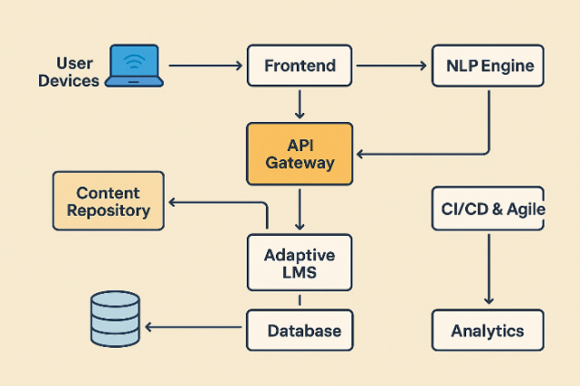
2.1 Concept of the Study

Figure 1: Architectural Framework
- User action (voice command, button, gesture) on device → sent to Frontend.
- Frontend packages request + user context → API Gateway.
- API Gateway routes to Adaptive LMS. LMS loads the learner profile from DB and the requested content from Content Repo.

PAGE 21

- If input is audio: LMS forwards audio to NLP Engine → returns recognized text + intent. If user asked a question, NLP may return an answer or request further content.
- LMS personalization decides output mode: (1) TTS audio (NLP Engine produces audio) and/or (2) Haptic event (Haptic Controller maps event → pattern).
- Haptic/TTS commands return to the Frontend via API Gateway; Frontend triggers device SDK to render vibrations or play audio.
- All interactions are logged to DB and fed into Analytics. Analytics tracks ISO 25010 metrics (e.g., functional suitability, usability, reliability) and feedback goes to the Agile backlog.
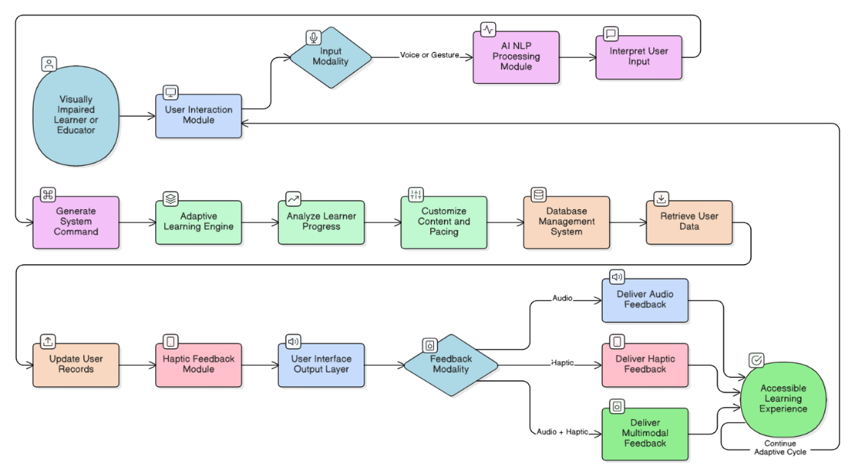
2.2 Conceptual Operation

Figure 2: Full-Blown DFD
Figure 2 shows the Level 2 Data Flow Diagram (DFD) for the Adaptive Learning Management System (LMS) for Visually Impaired Users using AI-Powered Natural Language Processing (NLP) and Multi-Modal Haptic Feedback. This diagram kind of explains how data moves through the system, starting from the user giving inputs and the system recognizing it, then going to the adaptive learning customization and the multimodal feedback getting sent back. The system makes sure all learner inputs, whether by voice or gestures, gets processed and turned into adaptive learning responses, helping make the e-learning experience more accessible for visually impaired users. Every part of the system got its own important role in helping communication, adaptivity, and learning keeps improving.

PAGE 22
Step-by-Step Process
- User Interaction
The process begins when the visually impaired learner or educator interacts with the system through the User Interaction Module. The user provides input either by voice commands or gesture-based controls, initiating the system’s recognition and processing sequence.
- Input Modality Recognition
The AI–NLP Processing Module receives the input and determines the modality—voice or gesture. It then interprets the user’s command, such as “start lesson,” “repeat instructions,” or “submit answer.” This step ensures accurate understanding of user intent before proceeding.
- Command Interpretation and Generation
Once the input is interpreted, the system generates an internal command to perform the requested action. The generated command is forwarded to the Adaptive Learning Engine for execution and personalization.
- Adaptive Learning Analysis
The Adaptive Learning Engine processes the command and analyzes the learner’s performance data. It evaluates metrics such as accuracy, speed, and engagement to determine the learner’s progress and proficiency level.
- Content Customization and Pacing
Based on the analysis, the Adaptive Learning Engine customizes the learning content and adjusts pacing to match the learner’s skill level and accessibility needs. This personalization ensures that each learner receives suitable difficulty levels and lesson sequences.
- Data Retrieval from Database
The Database Management System retrieves user data, including learning records, activity logs , and accessibility preferences. These data points are essential for maintaining personalized learning paths and ensuring content continuity.

PAGE 23
- User Data Update
After customization, updated progress and performance metrics are stored back in the Database Management System, maintaining real-time tracking of the learner’s development and engagement.
- Feedback Modality Selection
The system determines the type of feedback to deliver based on user preferences and content context. The Feedback Modality Decision Node identifies whether the output should be audio, haptic, or a combination of both.
- Delivery of Audio and Haptic Feedback
- The User Interface Output Layer handles feedback presentation.
- The Deliver Audio Feedback process provides spoken feedback, instructions, or narrations through text-to-speech conversion.
- The Deliver Haptic Feedback process uses vibrations or tactile patterns to signal confirmation, navigation, or alerts.
- Delivery of Multimodal Feedback and Continuous Learning Cycle
The Deliver Multimodal Feedback process integrates both audio and haptic feedback to provide a rich, accessible, and inclusive learning experience. This enables visually impaired learners to both hear and feel the system’s responses.
The cycle then continues as new learner interactions and feedback data are recorded, analyzed, and used to refine future lessons through the Adaptive Learning Engine, creating a continuous adaptive learning loop.

PAGE 24
2.3 Mockups
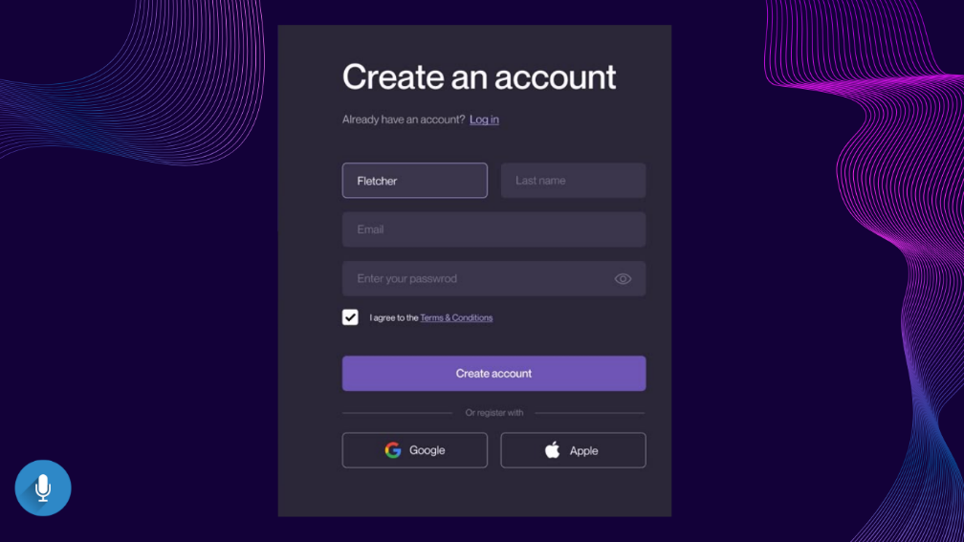

Allows new users to register using text or voice input. It includes name, email, and password fields with role selection for student or teacher. Voice prompts and haptic confirmation ensure accessibility during registration.

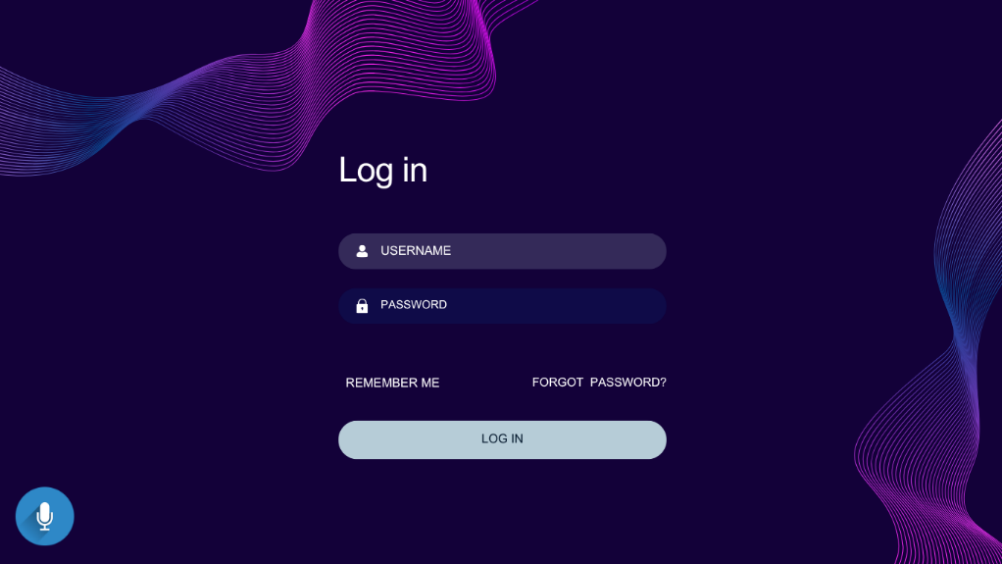

Authenticates users securely through email, password, or voice login. It provides voice prompts, vibration alerts for errors, and spoken password confirmation for accessibility.

PAGE 25

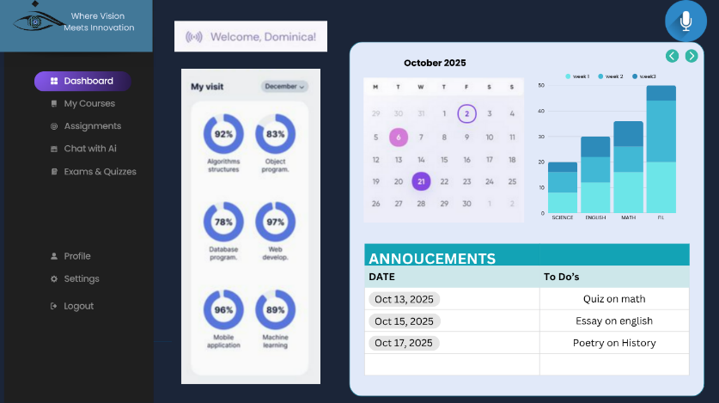

Serves as the user’s main hub, presenting progress, schedules, and announcements through audio summaries and haptic feedback for navigation.
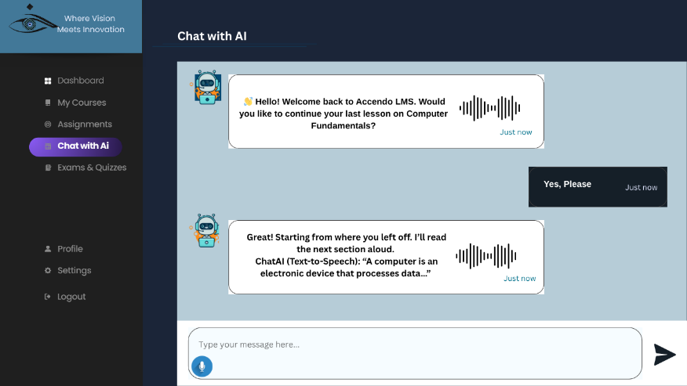

Functions as an interactive assistant using AI-powered NLP. Users can ask questions by voice, and responses are given through both speech and text for adaptive learning support.
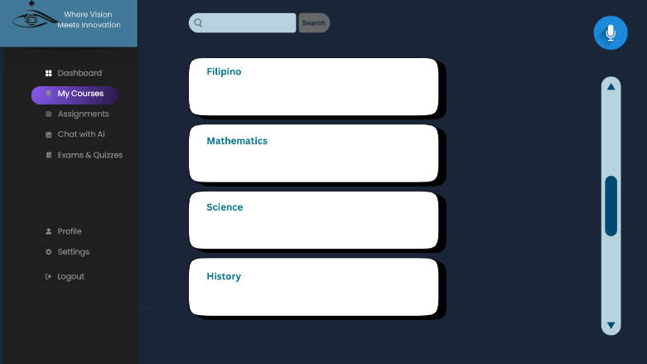

Displays enrolled subjects with progress indicators. Users can navigate and open lessons using voice commands, supported by spoken course names and vibration cues.

PAGE 26
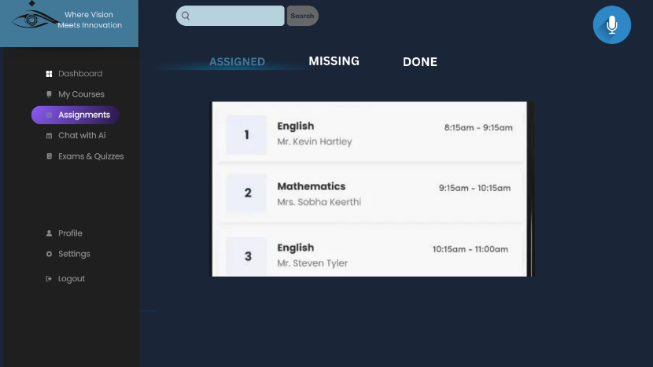

Allows users to access, upload, and submit assignments using voice or file uploads. The system provides haptic alerts for due dates and voice confirmation upon submission.
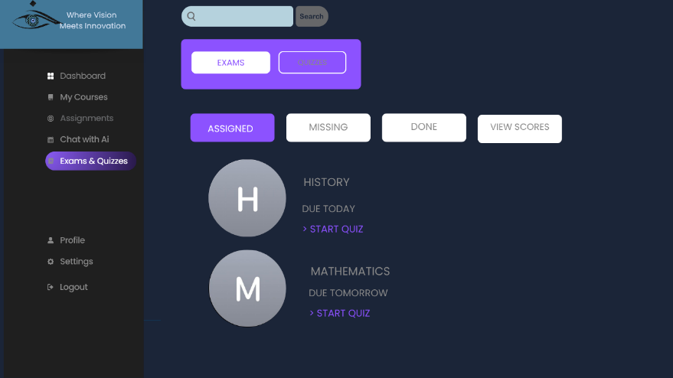

Offers accessible assessments using text-to-speech for questions and speech recognition for answers. Haptic cues mark question transitions and results feedback.
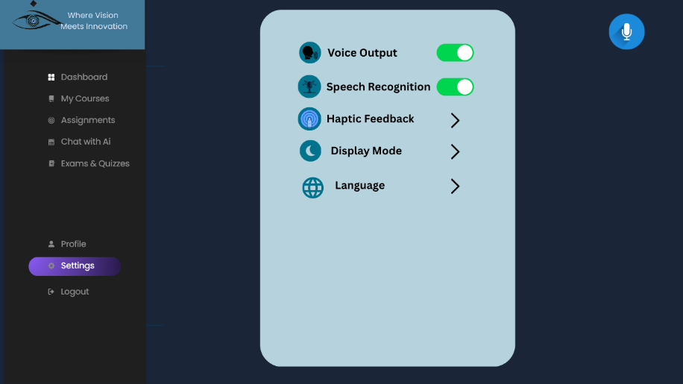

Lets users personalize accessibility options such as voice output, haptic strength, display mode, and language. Voice and tactile feedback confirm every change for ease of use.

PAGE 27

2.4 Methodology of the study
Methodology: Agile Development Methodology
Rationale: The Agile methodology was chosen because of its flexibility and fast process in building working prototypes even in a short period of time. Since our development will only take one month, Agile fits well because it allows us to gather early feedback from visually impaired users and make changes right away. Its step-by-step and repetitive process helps to make sure that the system stays accessible, usable, and inclusive for all users.
Phases:
- Requirements and Discovery
- Design and Prototyping
- Development and Implementation
- Testing and Evaluation
- Deployment
Implementation:
- Requirements and Discovery (Week 1): The team gathered the needed functional and accessibility requirements through interview and discussion with visually impaired students and teachers. This helped identify important goals like adding voice navigation, haptic response, and adaptive content delivery.
- Design and Prototyping (Week 1–2): Quick prototypes of the interface were created to show important accessibility features such as voice input and output and tactile feedback. Usability checking was done, and changes were applied based on feedback from the users.
- Development and Implementation (Week 2–3): The team developed the system modules through short Agile sprints. Each sprint focused on a specific function like NLP-based voice command, adaptive learning logic, and haptic feedback integration.
- Testing and Evaluation (Week 3–4): System testing was done following ISO/IEC 25010 standards to make sure it meets usability, accessibility, and performance criteria. Feedback from visually impaired users was collected and improvements were made.

PAGE 28

- Deployment (Week 4): All modules were combined into one LMS platform. The final system was demonstrated to the users and evaluators. Documentation was also prepared, together with the final report and presentation of the system’s results.
Benefits:
- Continuous user involvement and feedback is encouraged throughout the process
- Development and improvement can be adjusted easily within a short time
- Weekly feedback helps to refine and enhance the system features
- Produces a quality output through repeated testing and evaluation
- Results to a working, inclusive, and accessible system at the end of the development period

PAGE 29

References

Bacalla, K. A., Lagura, J. C., & Ylanan, M. D. (2024). Evaluating the impact of Braille signage on wayfinding system: A phenomenological study of campus accessibility for students with visual impairments. Journal of Higher Education Research Disciplines, 2(1). Retrieved from https://jhe.cnu.edu.ph/ojs3/article/view/322
Rodriguez III, M. A., Regencia, J. C., & Salcedo, K. P. (2024). InnoVision: An advanced navigation aid for visually impaired individuals using GPS, GSM, and sensor technologies. Philippine Journal of Science, Engineering and Technology, 1(2). Retrieved from https://pjset.org/index.php/journal/article/view/38
Campado, J. A., Toquero, C. M., & Ulanday, R. M. (2023). Assistive technology for students with visual disability: Classification matters. Journal of Research on Policy, Politics and Governance, 3(2), 45–58. Retrieved from https://ouci.dntb.gov.ua/en/works/4krWJLo7/
Tolentino, F. C., de Guzman, A. P., & Reyes, M. V. (2022). Fitness status of visually impaired learners in the Philippines: A sequential explanatory analysis. International Journal of Multidisciplinary: Applied Business and Education Research, 3(10), 1910–1921. https://ijmaberjournal.org/index.php/ijmaber/article/view/606
Mina, E. D., Solon, C. R., Sanchez, G. R., & Cruz, J. A. (2023). Leveraging education through artificial intelligence virtual assistance: A case study of visually impaired learners. International Journal of Educational Innovation and Research, 2(4), 65–74. Retrieved from https://ejournal.unma.ac.id/index.php/ijeir/article/view/3001

PAGE 30
Chit, S. M., Yap, K. M., & Ahmad, A. (2024). Multi-sensory learning framework for visually impaired learners: Use of 3D, haptic, audio, olfactory media. Multimedia Tools and Applications, 83(15), 81711–81723. https://doi.org/10.1007/s11042-024-18249-1
Ricci, F. S., Liguori, L., Palermo, E., Rizzo, J.-R., Maurizio Porfiri, et al. (2024). Navigation training for persons with visual disability through multisensory assistive technology: Mixed methods experimental study. JMIR Rehabilitation and Assistive Technologies, 11(1), e39556804. https://doi.org/10.2196/39556804

Tokmurziyev, I., Altamirano Cabrera, M., Khan, M. H., Mahmoud, Y., Moreno, L., & Tsetserukou, D. (2025). LLM-Glasses: GenAI-driven glasses with haptic feedback for navigation of visually impaired people. arXiv. https://arxiv.org/abs/2503.16475

Wei, Z., & Hu, X. (2022). Object localization assistive system based on CV and vibrotactile encoding. arXiv. https://doi.org/10.48550/arXiv.2206.09432

Robles, H., Perez, A., Villalba, K., Delgado-Cañas, M., Villanueva, E., Keogh, C., & Jimeno, M. (2024). Language learning apps for visually impaired users: A systematic review. Research and Practice in Technology Enhanced Learning, 19, Article 012. https://doi.org/10.58459/rptel.2024.19012

Bacalla, I. (2024). Challenges and opportunities of students with visual impairment in higher education. All Multidisciplinary Journal. Retrieved from https://www.allmultidisciplinaryjournal.com/uploads/archives/20240712142159_A-24-154.1.pdf

PAGE 31

Campado, R. J., Toquero, C. M. D., & Ulanday, D. M. (2023). Integration of assistive technology in teaching learners with special educational needs and disabilities in the Philippines. International Journal of Professional Development, Learners and Learning, 5(1), ep2308. https://doi.org/10.30935/ijpdll/13062

Chemnad, K., Al Rousan, M., Alamri, A., Alkhodre, A., Alharthi, A., & Alfarraj, O. (2024). Digital accessibility in the era of artificial intelligence: A systematic review. Frontiers in Accessibility. https://pmc.ncbi.nlm.nih.gov/articles/PMC10905618/

Han, Y. H., Cho, H., Lee, S., & Kim, J. (2023). Wearables for persons with blindness and low vision: Form factors, sensors and feedback. Sensors, 23(14), 6395. https://pmc.ncbi.nlm.nih.gov/articles/PMC11472326/

Joolee, J. B., Kim, H., Park, S., & Lee, Y. (2024). A multimodal multitask deep learning framework for rendering vibrotactile feedback. Scientific Reports, 14(1), 2165. https://pmc.ncbi.nlm.nih.gov/articles/PMC11164698/

Mina, P. N. R., Solon, I. M., Sanchez, F. R., Delante, T. K., Villegas, J. K., Basay, F. J., … Mutya, R. (2023). Leveraging education through artificial intelligence virtual assistance: A case study of visually impaired learners. International Journal of Educational Innovation and Research, 2(1), 10–22. https://doi.org/10.31949/ijeir.v2i1.3001

Mutya, R. (2022). Leveraging education through artificial intelligence virtual assistance: A case study of visually impaired learners. ResearchGate. Retrieved from https://www.researchgate.net/publication/367480453_Leveraging_Education_through_Artificial_Intelligence_Virtual_Assistance_A_Case_Study_of_Visually_Impaired_Learners

PAGE 32

Ratschat, A. L., Riener, R., & Wolf, P. (2024). Evaluating tactile feedback in addition to kinesthetic feedback: Effects on discrimination performance. Journal of NeuroEngineering and Rehabilitation, 21(1), 34. https://pmc.ncbi.nlm.nih.gov/articles/PMC11039957/

Tang, Y. (2024). Advancing haptic interfaces for immersive experiences in XR and accessibility contexts. Journal of Innovation in Digital Learning, 6(3), 155–168. https://www.sciencedirect.com/science/article/pii/S2666998624001728

UNESCO. (2021). Technology in disability-inclusive education. Paris: UNESCO Publishing. Retrieved from https://unesdoc.unesco.org/ark:/48223/pf0000387737

Baldovino, R. M., Cruz, J. P., & Santos, L. D. (2024). Development of a visual aid system using image processing and deep learning with audio-haptic feedback for blind learners. Philippine Journal of Computing and Information Sciences, 19(2), 45–60. https://doi.org/10.7719/pjcis.2024.019

Bacalla, I., Ramirez, M., & De Jesus, K. (2024). Challenges and opportunities of students with visual impairment in Philippine state universities. All Multidisciplinary Journal, 4(2), 88–101. https://www.allmultidisciplinaryjournal.com/uploads/archives/20240712142159_A-24-154.1.pdf
Ocampo, J. R., Lopez, A. B., & Magat, F. (2024). Flexible learning design and inclusive education: Experiences of visually impaired learners in Philippine higher education. International Journal of Educational Research and Innovation, 12(1), 112–128. https://doi.org/10.52929/ijeri.2024.112

Binlang, M., & Donguiz, P. (2024). Coping strategies and challenges of visually impaired students in online learning: A systematic review. Philippine Social Science Journal, 7(3), 210–225. https://doi.org/10.52006/main.pssj.733

PAGE 33

Estrada, L. C. (2023). Accessibility in physical education for students with visual impairment: Tactile cues and ISO/IEC 25010 framework application. Asia Pacific Journal of Education, Arts and Sciences, 10(1), 56–65. https://doi.org/10.5281/zenodo.10423322

Al-Mouh, N. A., & Al-Khalifa, H. S. (2021). Evaluating adaptive learning management systems for students with disabilities using ISO/IEC 25010. International Journal of Emerging Technologies in Learning, 16(10), 15–28. https://doi.org/10.3991/ijet.v16i10.22045

Katsanos, C., Tselios, N., & Avouris, N. (2022). Multimodal interaction in e-learning: The role of haptic and auditory feedback for accessibility. Computers & Education, 182, 104468. https://doi.org/10.1016/j.compedu.2022.104468

Hernández, P., & Ochoa, M. (2023). Enhancing screen readers with natural language processing: Improving accessibility for blind learners in Latin America. Journal of Accessibility and Design for All, 13(1), 1–23. https://doi.org/10.17411/jacces.v13i1.374

Sharma, V., & Singh, A. (2022). An adaptive LMS evaluation framework based on ISO/IEC 25010: Insights from Indian higher education. Education and Information Technologies, 27(5), 6593–6611. https://doi.org/10.1007/s10639-022-10975-8

Zhang, Y., Li, X., & Chen, W. (2024). AI integration with multimodal haptic devices in e-learning: Enhancing accessibility and learner engagement. Smart Learning Environments, 11(1), 24. https://doi.org/10.1186/s40561-024-00241-1

Bacalla, I., Gisultura, A. L., Pacatang, F., & Romarate, R. (2024). Challenges and opportunities of students with visual impairment in a state university: A multi-case study. All Multidisciplinary Journal. https://doi.org/10.5281/zenodo.13345370

PAGE 34

Baldovino, R. G., Roxas, N. R. Jr., Bugtai, N. T., Borbon, J. M. C., Javier, J. T. D., Llamado, J. M. F. D., Maghirang, A. M. R., & See, A. R. (2024). A visual aid system using image processing and deep learning with audio haptic feedback for the blind and visually-impaired. Procedia Computer Science, 246, 2974–2983. https://doi.org/10.1016/j.procs.2024.03.345

Binlang, J. B., & Donguiz, R. G. (2024). A systematic review of the challenges and coping strategies of students with visual impairment in higher education. Cognizance Journal, 4(7). https://doi.org/10.5281/zenodo.13283414

Estrada, N. S. B. (2023). Investigating the trials and acquittals of students with visual impairment in tertiary physical education: A multi-case study. International Journal of Advanced Multidisciplinary Research and Studies, 3(2), 413–422. https://doi.org/10.55927/ijamrs.v3i2.1894

Ocampo Jr., J. M., Dela Peña, S. M., Salvador, C. B., & Yahya, A. Y. (2024). Flexible learning and student-teacher relationship experience of college students with visual impairment. The Normal Lights, 17(2), 26–53. https://po.pnuresearchportal.org/ejournal/index.php/normallights/article/view/2343

Jayasiri, J. M. S., & Jayalal, S. (2025). The improving accessibility of e-learning systems for visually impaired students in Sri Lanka: An evaluation based on WCAG principles. Vallis Aurea, 11(1), 1–16. https://hrcak.srce.hr/ojs/index.php/vallisaurea/article/view/34266

Khusro, S., Shah, B., Khan, I., & Rahman, S. (2022). Haptic feedback to assist blind people in indoor environment using vibration patterns. Sensors, 22(1), 361. https://doi.org/10.3390/s22010361

PAGE 35

Milallos, R., Oh, T., & Peiris, R. L. (2024). Exploring the effectiveness of electrotactile feedback for data visualization for blind and visually impaired users. In M. Antona & C. Stephanidis (Eds.), Universal access in human-computer interaction: HCI for well-being (HCII 2024, LNCS 14698) (pp. 443–457). Springer. https://doi.org/10.1007/978-3-031-60884-1_28

Multisensory learning framework for visually impaired learners: Use of 3D, haptic, audio, olfactory media. (2024). Multimedia Tools and Applications, 83, 81711–81723. https://doi.org/10.1007/s11042-024-18249-1

Schimmelpfeng, L. E., & Ulbricht, V. R. (2021). Accessible learning management system (LMS) for disabled people: Project development based on accessibility guidelines, gamification, and design thinking strategies. In S. Clarke (Ed.), The role of gamification in software development lifecycle. IntechOpen. https://doi.org/10.5772/intechopen.96377

