Base Code Screenshots:
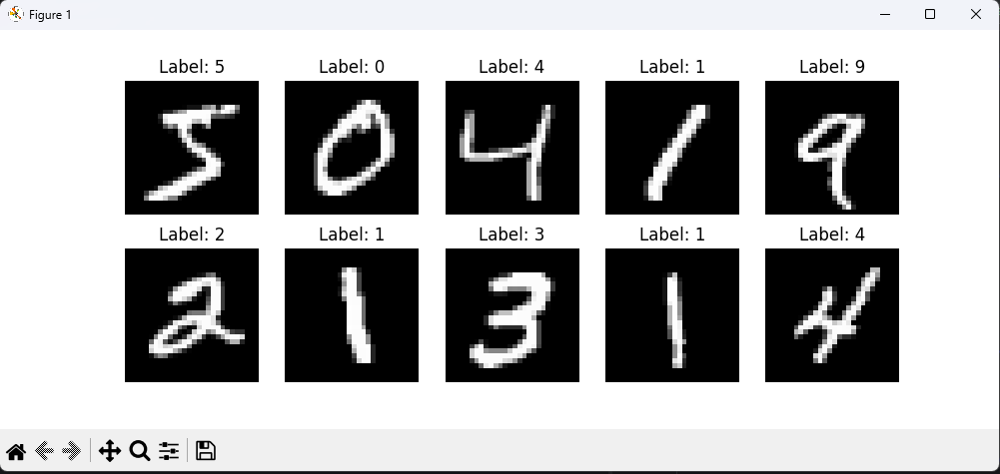

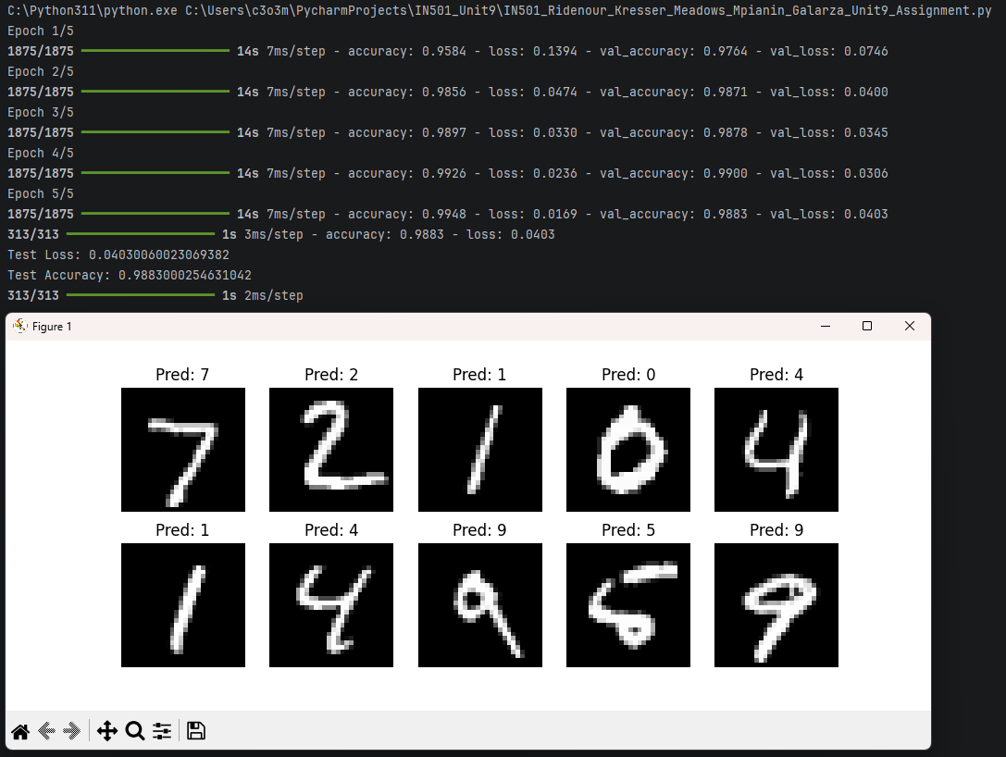
Variation #1 Screenshots

Variation #2 Screenshots

Variation #3 Screenshots

Variation #4 Screenshots

Variation #5 Screenshots
