Jamie Tran

Professor Nasheb Ismaily

DSC650 Big Data

20 June 2024

Week 3 Screenshots

**Screenshot of the query results:**

**Screenshots of 3 different SQL commands on the grades data:**

**Command 1:**

**Command 2:**

**Command 3:**

**Screenshots of uploading and copying a new dataset to Docker container:**

**Explanation of chosen dataset:**

The data set I chose was from Kaggle.com which displays the birth rates of each year from 1960 through the year 2008. I selected this particular dataset because I wanted to avoid working with a data frame with 10-20 columns when the goal of this assignment was to practice uploading our dataset and running queries on our data. This dataset contains valuable information with a fair number of rows to parse through and collect insights from.

**Screenshots of 3 different SQL commands on my selected data:**

**Command 1:**

With this first command I was looking to obtain the birth rate in the year 2000 which the query was able to display at 14 for the selected year.

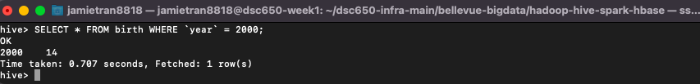

**Command 2:**

In this second command I was looking to find the average birth rate from the years 1960-2008. The query calculated that the birth rate was 20.57 for the 48-year time span.

**Command 3:**

For this last command I was only interested in viewing birth rates from the years 2000 and beyond. From this display we can see the birth rates in recent years are steadily decreasing from the average calculated in the previous query.

