Jamie Tran

Professor Nasheb Ismaily

DSC650 Big Data

1 August 2024

Week 9 Screenshots

**Screenshot confirming successful access to the NiFi UI:**

**Screenshot of the NiFi canvas showing the Processor Group:**

**Screenshot of the defined parameter within the Parameter Context:**

**Screenshot of the simple flow (GenerateFlowFile to LogAttribute):**

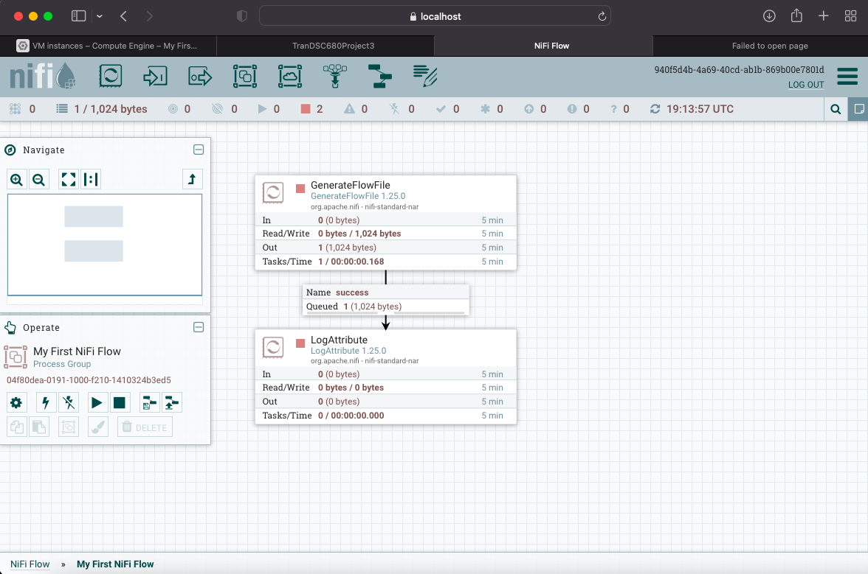

**Screenshot confirming the successful creation of the syslog collection:**

**Screenshot of the advanced NiFi flow processing and sending data to Solr:**

**Screenshot of the Solr query results:**

**Query 1:**

**Query 2:**

**Query 3:**

**Query 4:**

**Query 5:**

