Jamie Tran

Professor Nasheb Ismaily

DSC650 Big Data

24 July 2024

Week 8 Screenshots

**Screenshot showing ‘mynewcollection’ in the Solr Web Interface:**

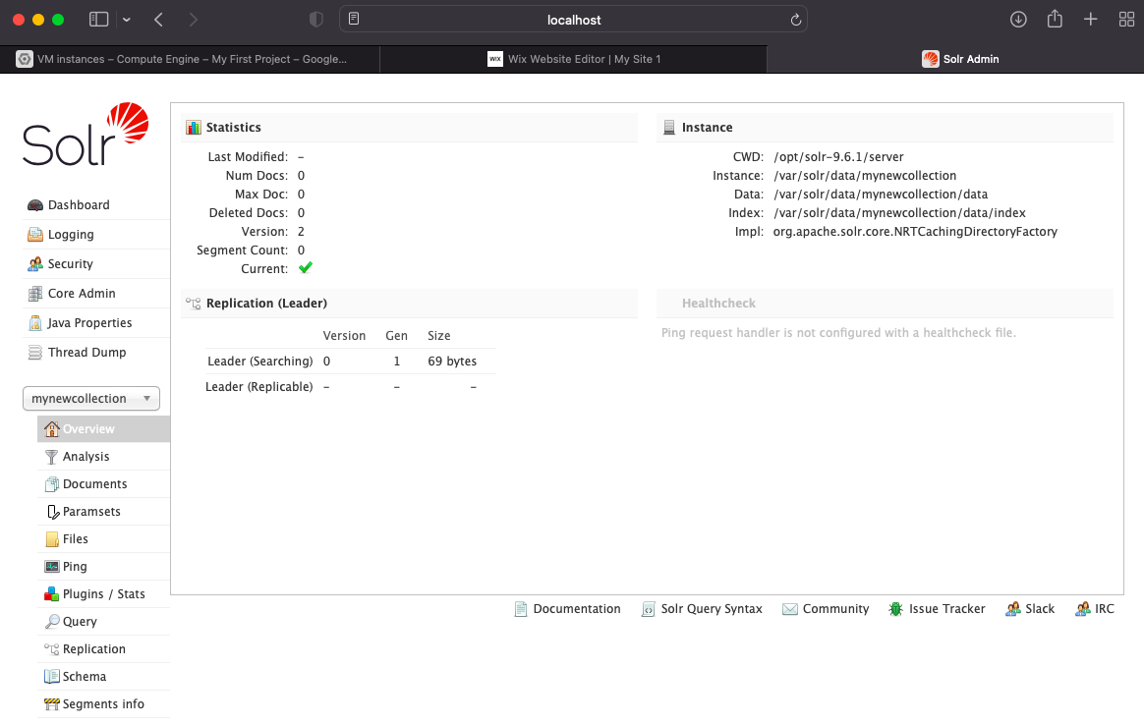

**Screenshot showing successful data ingestion messages in the terminal:**

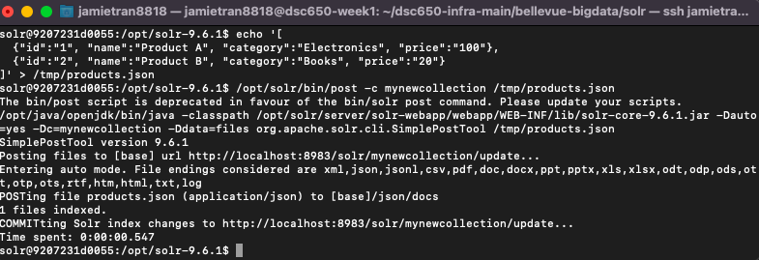

**Screenshots of the JSON response for both queries:**

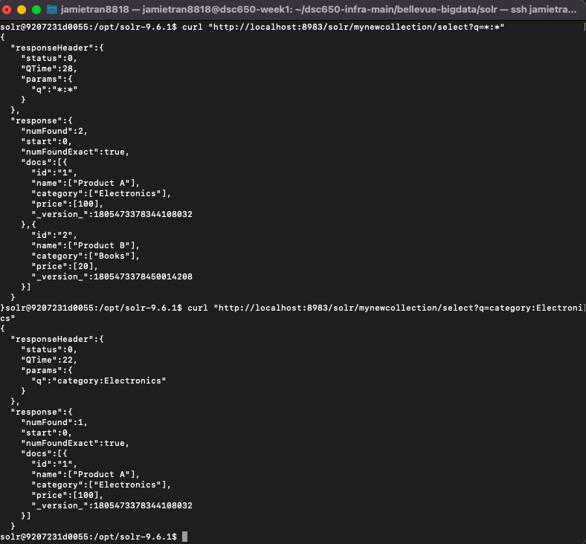

**Screenshots of different queries and their results from the Solr Web Interface:**

**Query #1:**

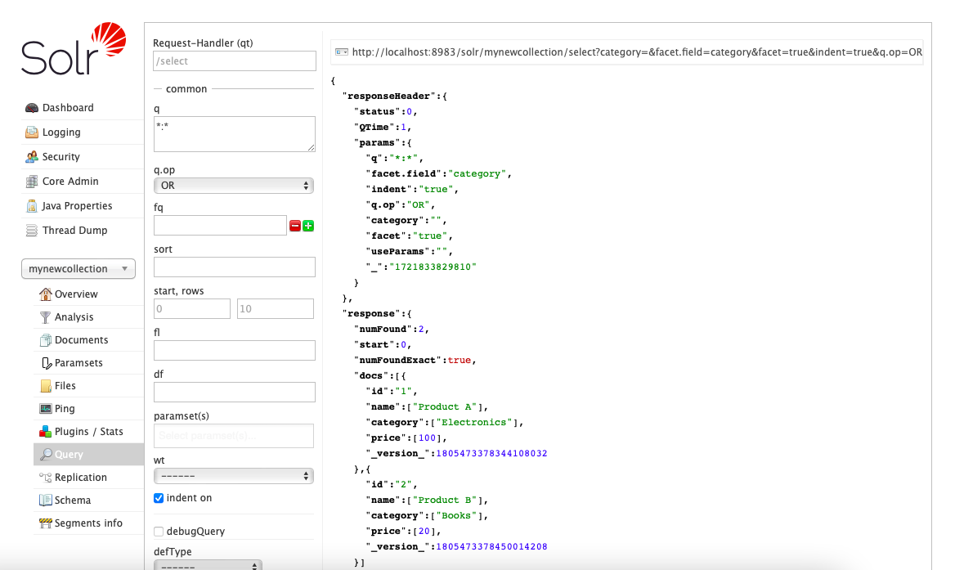 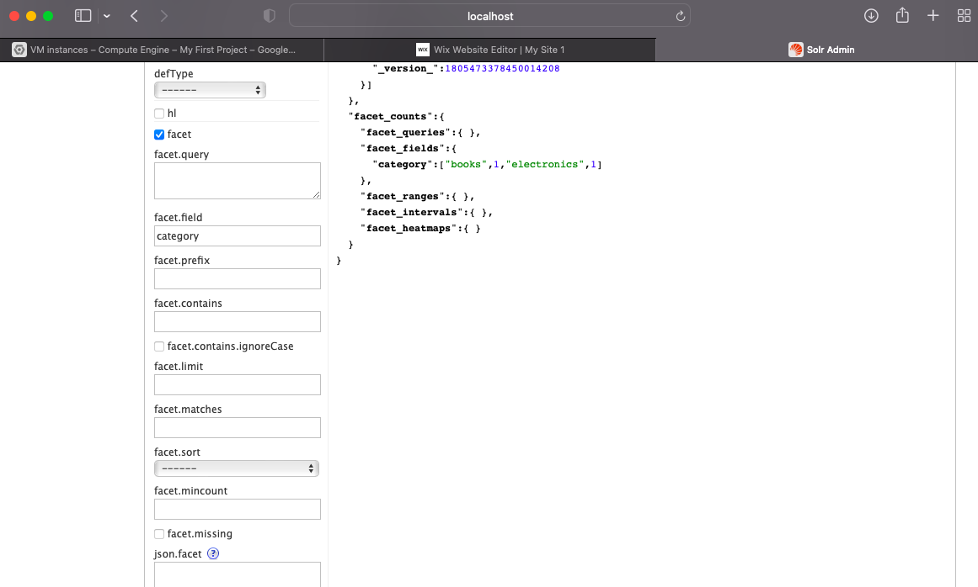

**Query #2:**

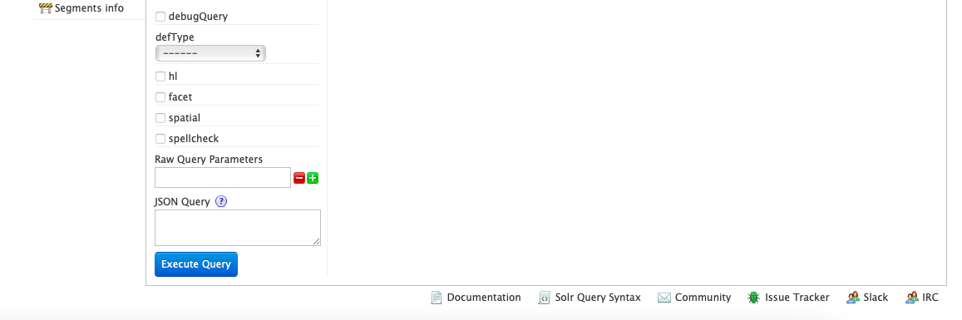

**Query #3:**

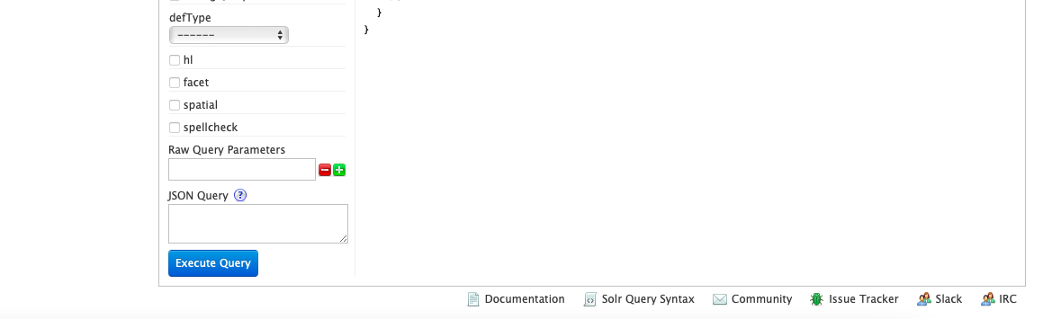

**Query #4:**

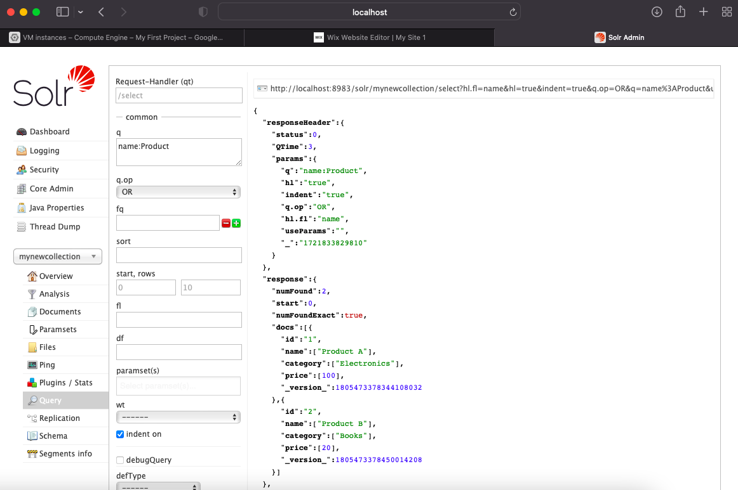

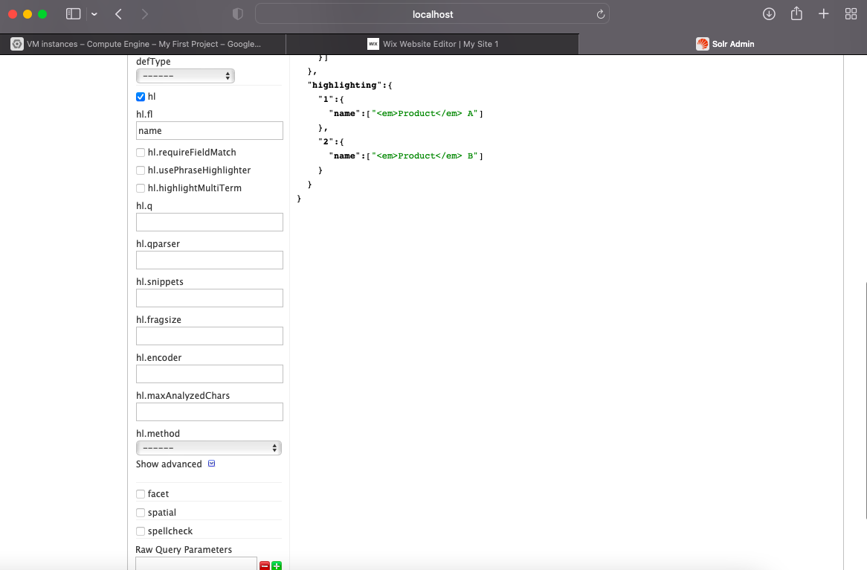

**Screenshots of different queries on your Solr collection and the query results from either the command line or the Solr Web Interface:**

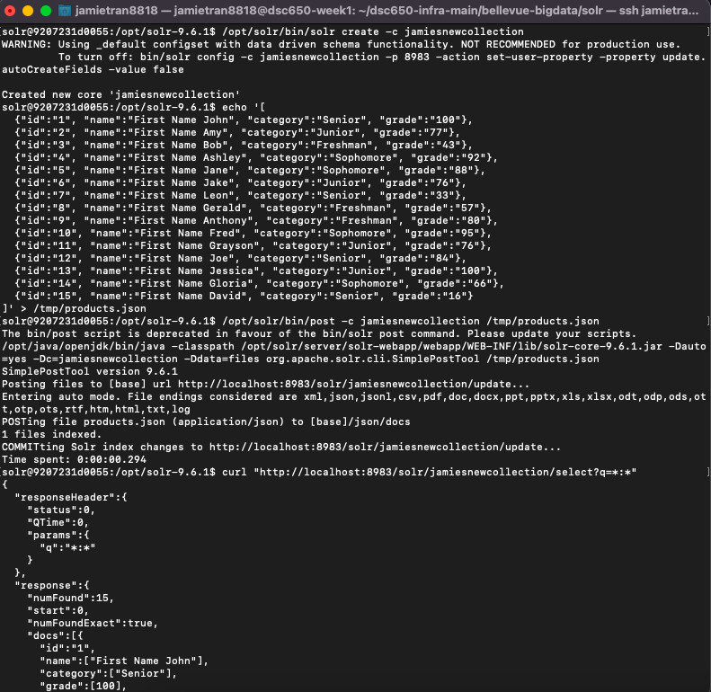

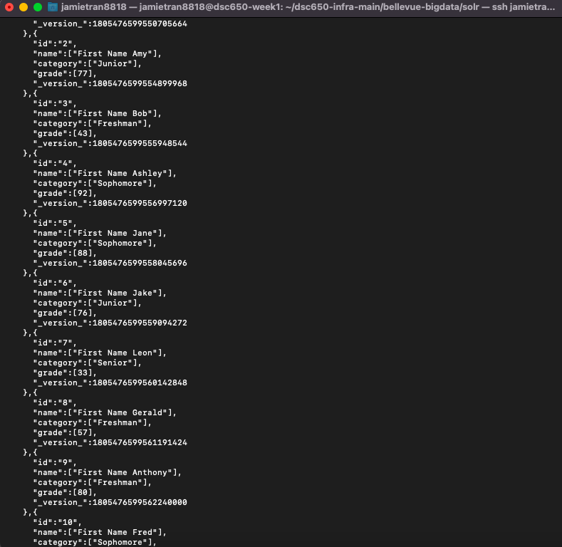

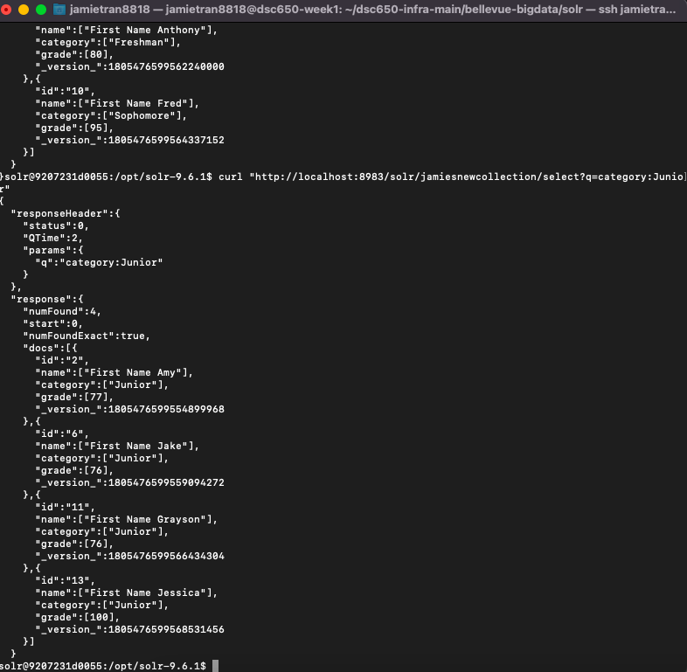

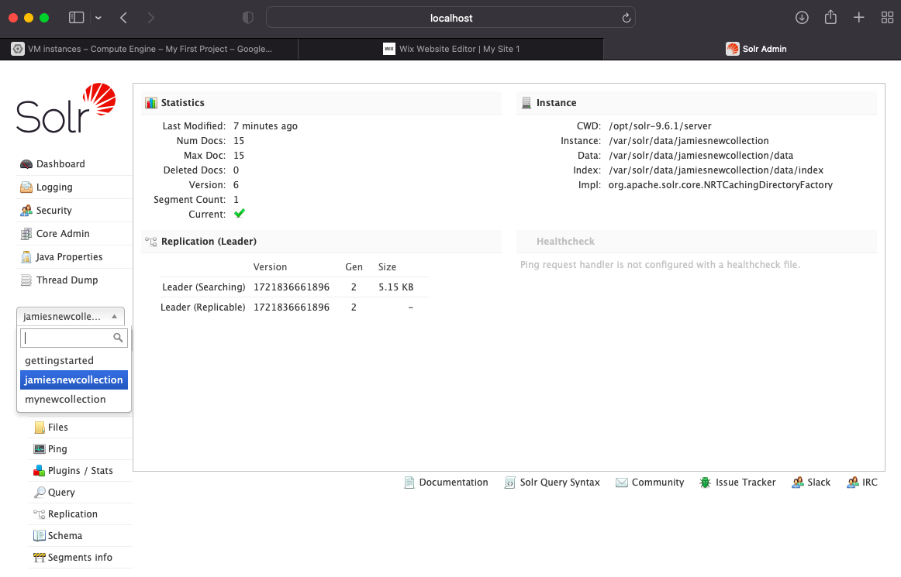

**Query #1:**

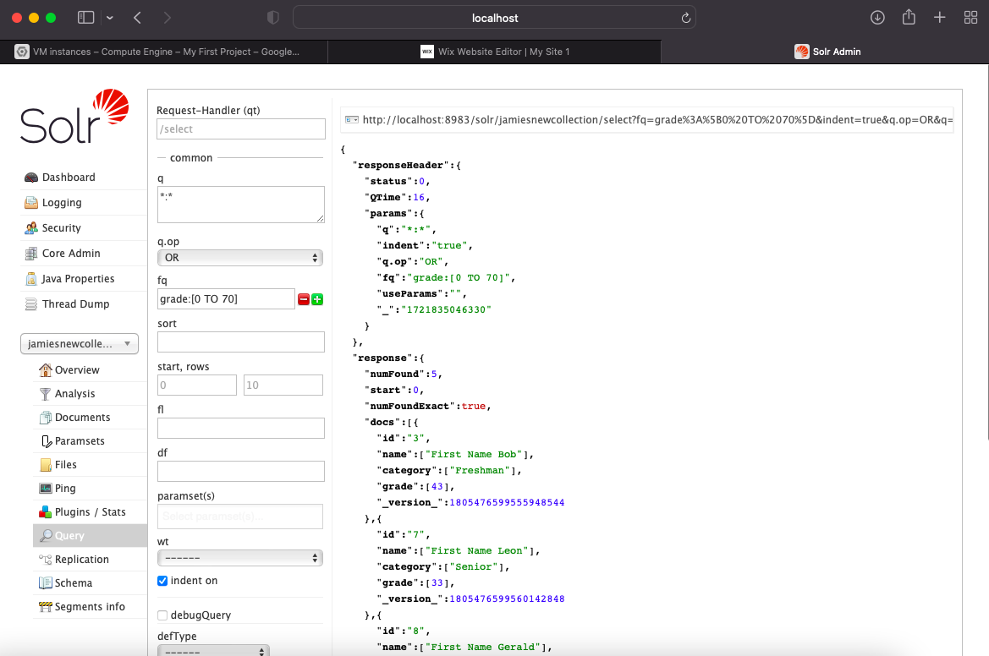 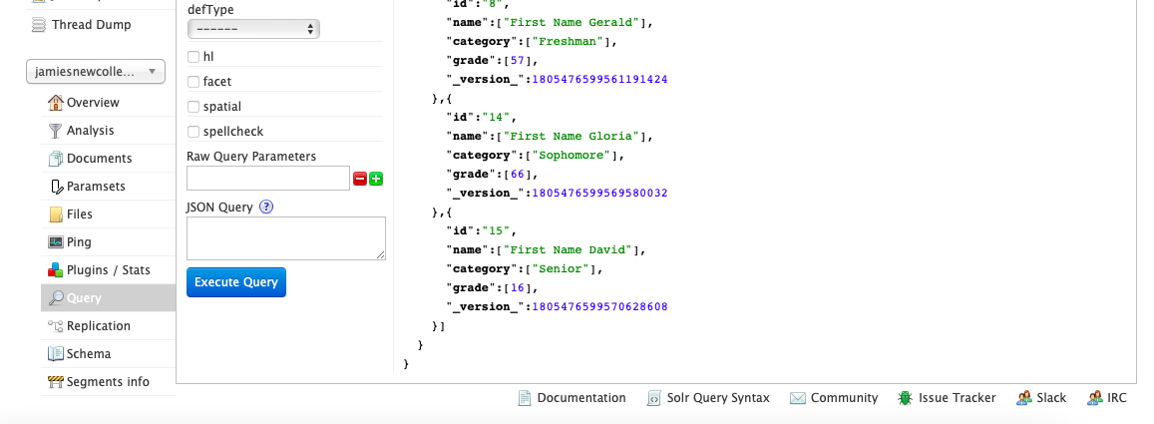

**Query #2:**

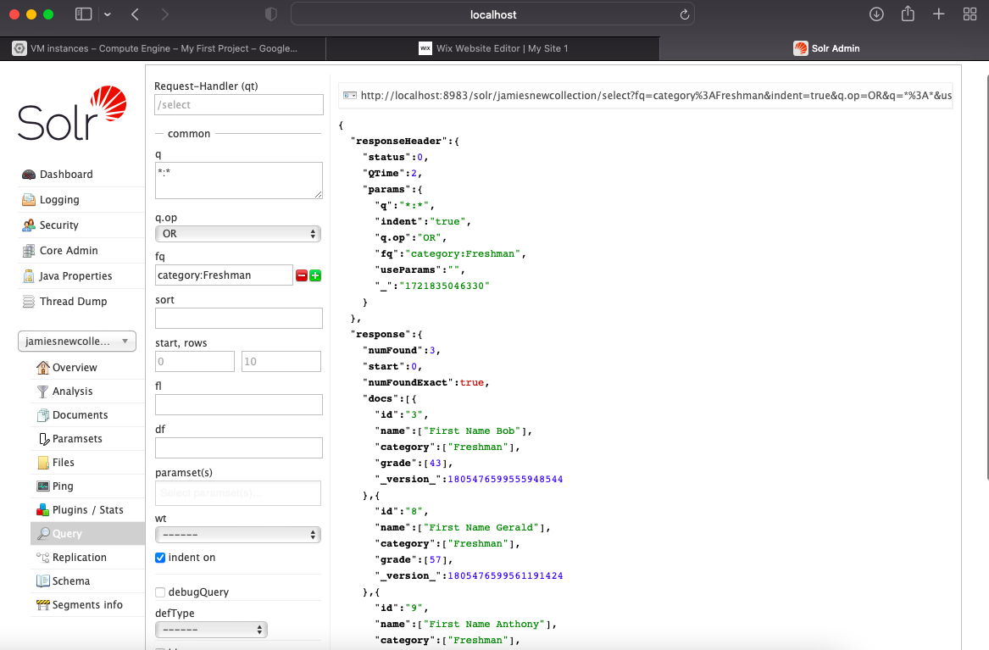 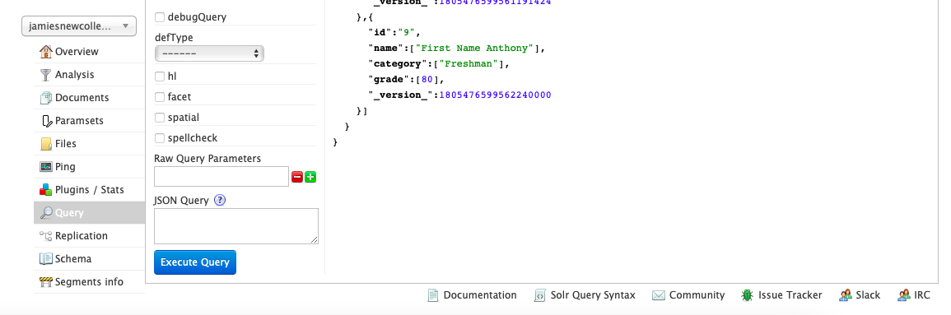

**Query #3:**

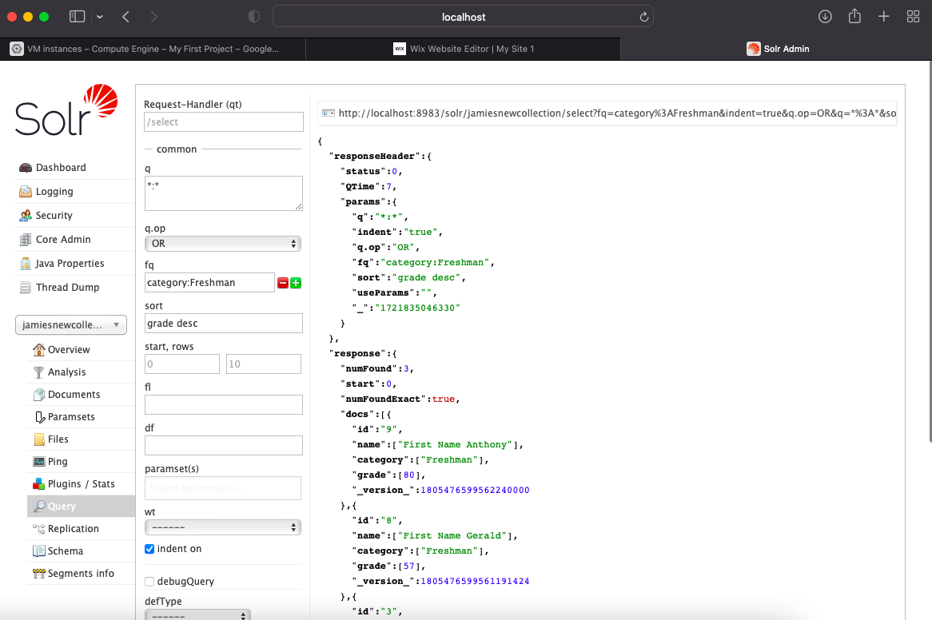 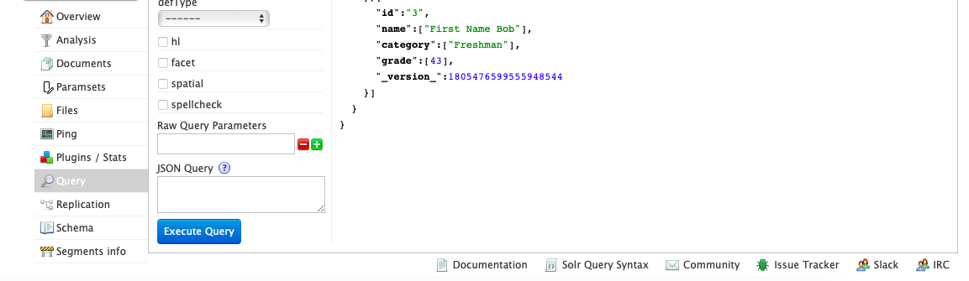

**Query #4:**

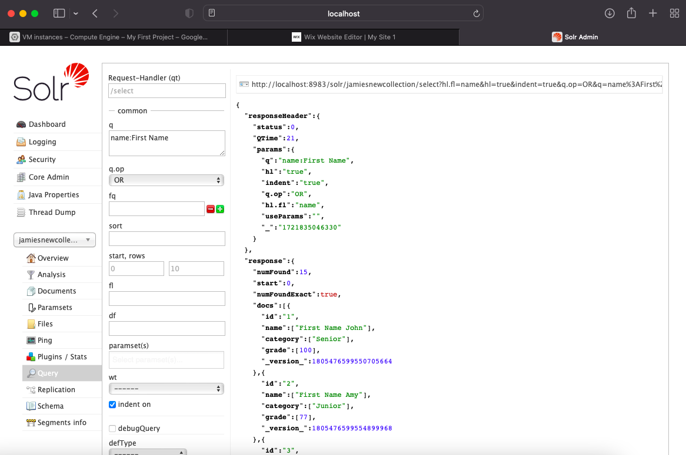

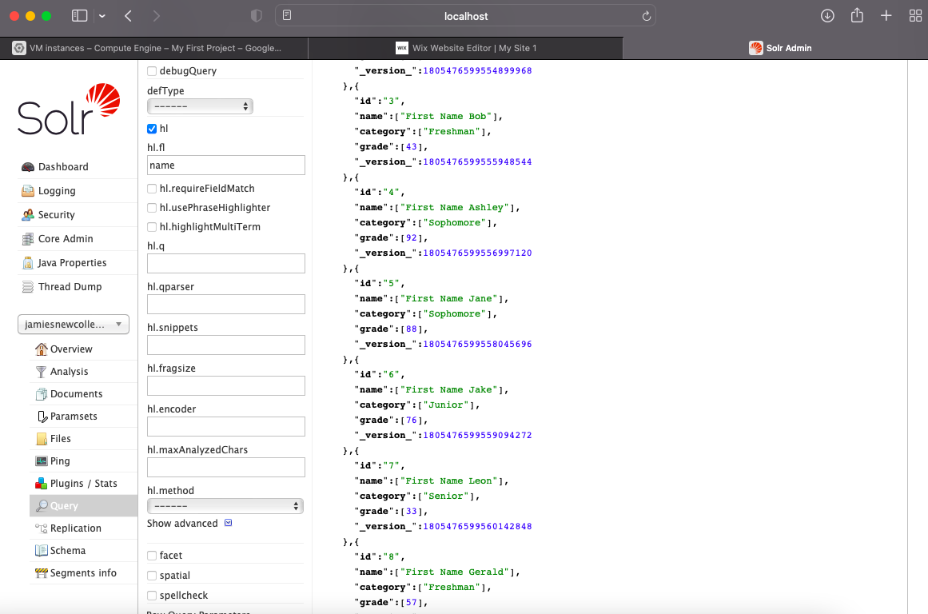

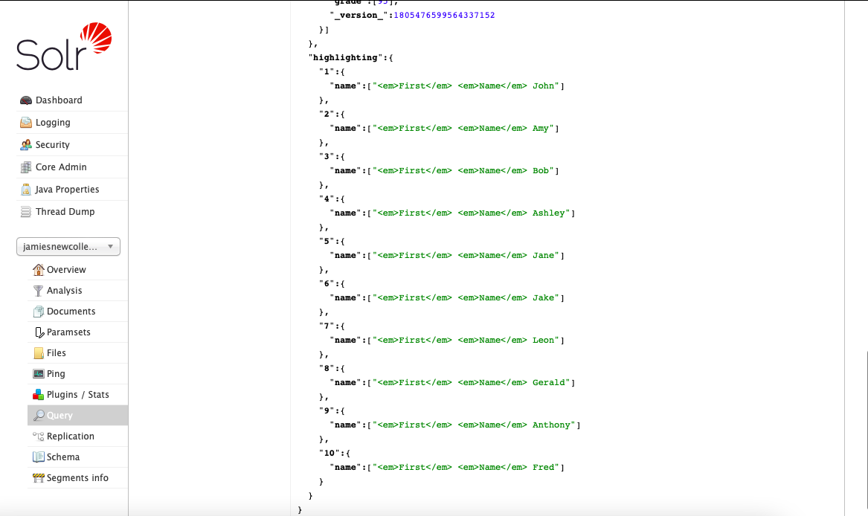

**Query #5:**



