Jamie Tran

Professor Nasheb Ismaily

DSC650 Big Data

27 June 2024

Week 4 Screenshots

**Screenshot of the SparkPi output:**

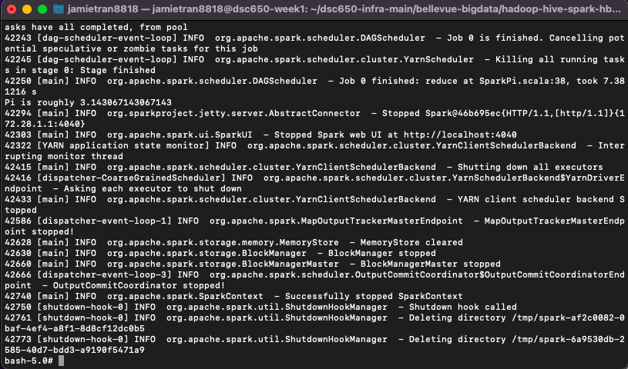

**Screenshot of the first 100 generated random numbers:**

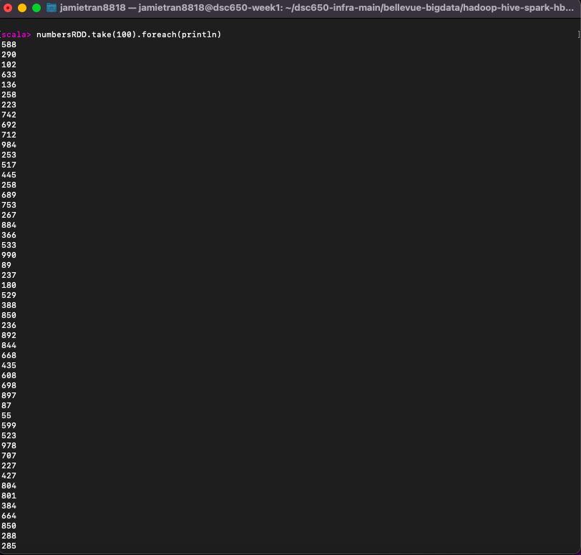

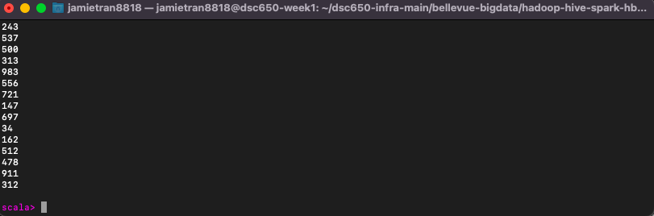

**Screenshot of a segment of the generated transformed sentences and an explanation of your unique transformation:**

**Transformation one:**

In this first transformation I capitalized every letter in each sentence.

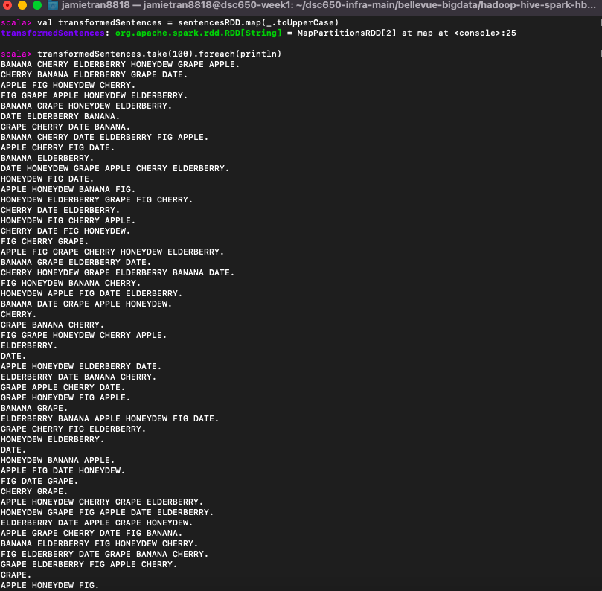

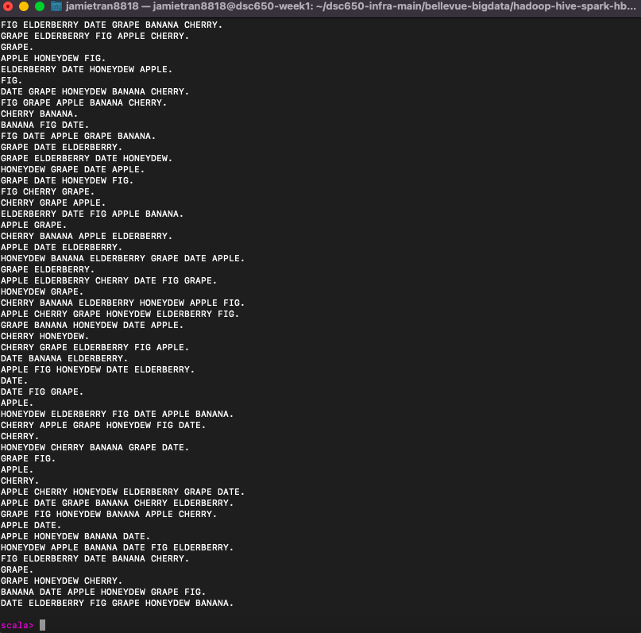

**Transformation two:**

In this second transformation I had all the words in each sentence sorted alphabetically.

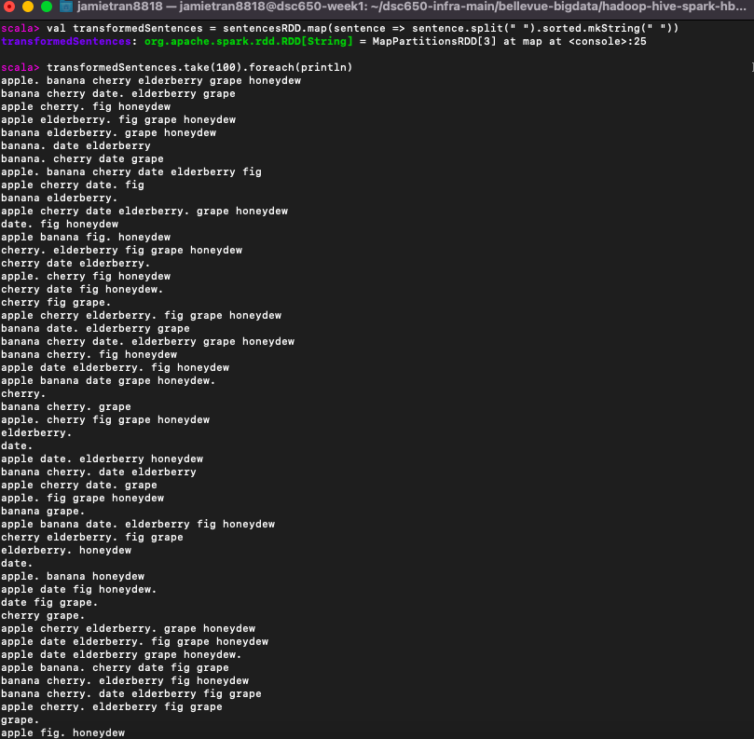 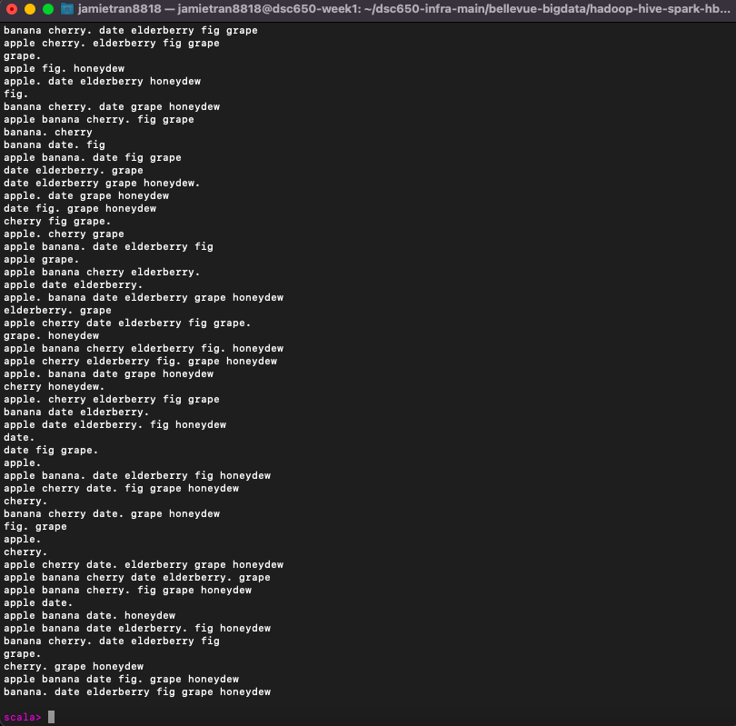

**Transformation three:**

In this final tranformation I replaced every instance of the word apple with strawberry instead.

