RESUME

**JAMI HARSHA VARDHAN**

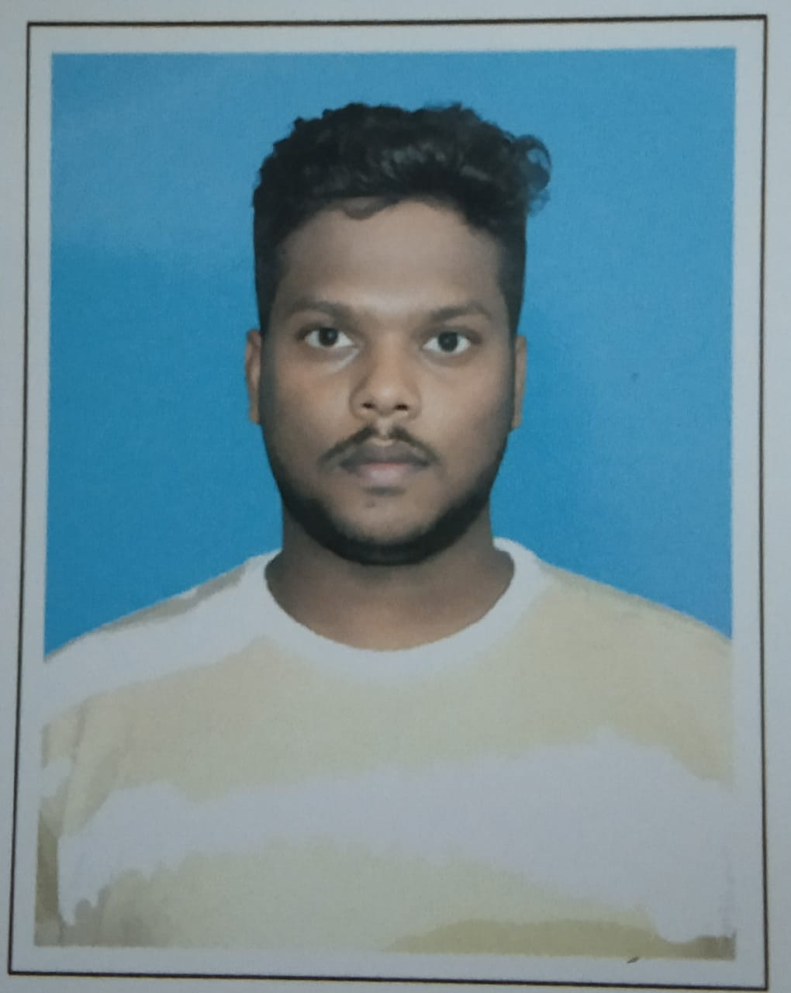

+91 9861046776

Email

I

d:

Jamiharshavardhan01@gmail.com

# OBJECTIVE

To work with an organization where can learn new skills and increase my abilities for the organizational goals as well as myself.

# EDUCATIONAL QUALIFICATION

* Perusing B tech 2nd year from GIET University,Gunpur,Rayagada,Odisha-765022
* Passed out 12th from BSEAP in 2022Marks 89%
* Passed out 10th from CBSE in 2020Marks 77%

# TECHNICAL SKILLS

* Basic Knowledge of computer
* Language: C,HTML,CSS, JavaScript, PHP, Java, SQL

**WORK EXPERIENCE**

FRESHER

# STRENGTH & HOBBIES

* Hard & Smart Working
* Honest & punctual
* Observation Skills
* Leadership Skills
* Good Communication skill
* Sports, Swimming, Drawing, Reading novels

# PERSONAL DETAILS

Father’s Name: Jami Krishna Rao

Date of Birth: 13-12-2004

Address: Main Road, Opposite Old Post office, Narayan Patna, Koraput, odisha-764014

Occupation: Student

(Jami Harsha Vardhan)