

Maven:

<dependency>  
 <groupId>org.webjars</groupId>  
 <artifactId>jquery</artifactId>  
 <version>3.3.1</version>  
</dependency>

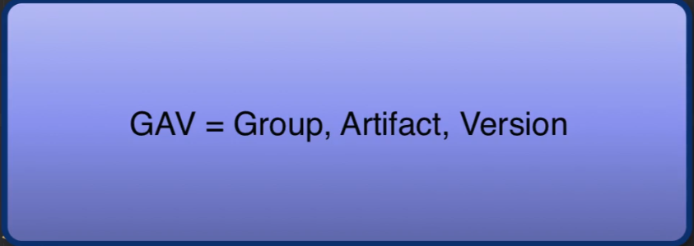

**Thymeleaf Documentation:**

<https://www.thymeleaf.org/doc/tutorials/3.0/usingthymeleaf.pdf>

