

**American International University- Bangladesh**

**CSC 3215: Web Technologies**

**CO2 and CO4 Evaluation**

**Finished Project Report**

**Spring 2019-2020**

**Project Title: Metrorail Automation**

**Section: C**

|  |  |
| --- | --- |
| Student Name | Student Id |
| Fahamin Haque Arpa | 18-37437-1 |
| Tarif Sadman | 18-36466-1 |
| Hamidur Rahman Ullash | 18-37501-1 |
| Md. Jamil Istiaq | 18-37918-2 |

**Project Description:**

This project is about Metrorail automation system. There are four type of users such as Admin, User, Employee and lastly Station Master.

**ADMIN:**

An admin can add or update user, station master and station. Can generate report for all employee’s and station master’s salary, can show some notice. Can Search the desire value whatever they want. Mainly they can access anything from the system.

**USER:**

A user can register himself and login for purchasing tickets. Can update his/her profile. Can see train departure time date everything related with buying tickets. Can give complaints to authority can download his total trips and so on.

**EMPLOYEE:**

Can login. After login he/she can manage his/her profile and update it. Can search user’s complaint. Can generate salary report etc.

**STATION MASTER:**

Can manage a station. Can update profile, generate report, generate complaints, search employees, provide notices for train departure. Mainly a station master manages the whole station system.

Our project is mainly based on these techniques. We applied all those methods to our code and create a virtual platform for metro rail ticket management system.

**Project Folder Structure:**

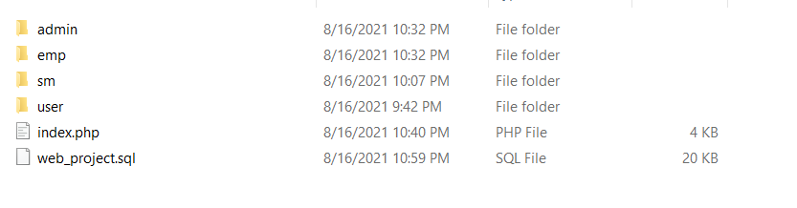

**Core Modules of the Project:**

*Here, add THREE of your CORE modules’ source code with appropriate filename as heading. (Use either* consolas or courier new *font for source code)*

***Purchase_ticket.php***

*<?php*

*include_once 'controllers/header.php';*

*include_once 'controllers/ticket_controller.php';*

*if(!isset($_SESSION["ulog"])){*

*header("Location: user_login.php");*

*}*

*?>*

*<html>*

*<head>*

*<style>*

*body{*

*background-color: rgb(204, 204, 204);*

*}*

*</style>*

*<script src="js/pur_tkt_val.js"></script>*

*</head>*

*<body>*

*<form action="" onclick="return validate()" method="POST">*

*<fieldset>*

*<legend><h1><b> Purchase Ticket </b></h1></legend>*

*<span><?php echo $err_db;?></span>*

*<table align="center">*

*<tr>*

*<td>*

*Select Route*

*</td>*

*<td colspan="2">*

*:<select id="routeTo" name="routeTo">*

*<option selected disabled>From</option>*

*<?php*

*$d=view_option();*

*foreach($d as $a){*

*if($a == $routeTo)*

*echo "<option selected>$a</option>";*

*else*

*echo "<option>$a</option>";*

*}*

*?>*

*</select>*

*--*

*<select id="routeFrom" name="routeFrom">*

*<option selected disabled>To</option>*

*<?php*

*$d=view_option();*

*foreach($d as $a){*

*if($a == $routeFrom)*

*echo "<option selected>$a</option>";*

*else*

*echo "<option>$a</option>";*

*}*

*?>*

*</select>*

*</td>*

*<td>*

*<span id="err_Toroute"><?php echo $err_Toroute; ?></span>*

*<span id="err_Fromroute"><?php echo $err_Fromroute; ?></span>*

*</td>*

*</tr>*

*<tr>*

*<td>*

*Date*

*</td>*

*<td colspan="2">*

*:<select id="tday" name="tday">*

*<option disabled selected >Day</option>*

*<?php*

*foreach($tdate as $d){*

*if($d == $date)*

*echo "<option selected>$d</option>";*

*else*

*echo "<option>$d</option>";*

*}*

*?>*

*</select>*

*<select id="tmonth" name="tmonth">*

*<option disabled selected >Month</option>*

*<?php*

*foreach($marray as $m){*

*if($m == $month)*

*echo "<option selected>$m</option>";*

*else*

*echo "<option>$m</option>";*

*}*

*?>*

*</select>*

*</td>*

*<td>*

*<span id="err_date"><?php echo $err_date; ?></span>*

*<span id="err_month"><?php echo $err_month; ?></span>*

*</td>*

*</tr>*

*<tr>*

*<td>*

*Time*

*</td>*

*<td colspan="2">*

*:<select id="time" name="time">*

*<option selected disabled>Time</option>*

*<?php*

*foreach($time_arr as $t){*

*if($t == $time)*

*echo "<option selected>$t</option>";*

*else*

*echo "<option>$t</option>";*

*}*

*?>*

*</select>*

*<select id="format" name="format">*

*<option selected disabled>AM/PM</option>*

*<?php*

*foreach($tfromat_arr as $tf){*

*if($tf == $tfromat)*

*echo "<option selected>$tf</option>";*

*else*

*echo "<option>$tf</option>";*

*}*

*?>*

*</select>*

*</td>*

*<td>*

*<span id="err_time"><?php echo $err_time; ?></span>*

*<span id="err_tformat"><?php echo $err_tformat; ?></span>*

*</td>*

*</tr>*

*<tr>*

*<td>*

*Choose Class*

*</td>*

*<td colspan="2">*

*:<select id="class" name="class">*

*<option selected disabled>Choose a class</option>*

*<?php*

*foreach($tclass_arry as $tc){*

*if($tc == $tclass)*

*echo "<option selected>$tc</option>";*

*else*

*echo "<option>$tc</option>";*

*}*

*?>*

*</select>*

*</td>*

*<td>*

*<span id="err_tclass"><?php echo $err_tclass; ?></span>*

*</td>*

*</tr>*

*<tr>*

*<td>*

*Passenger Number*

*</td>*

*<td colspan="2">*

*:<select id="passenger" name="passenger">*

*<option selected disabled>Traveller Number</option>*

*<?php*

*foreach($pnum_arr as $p){*

*if($p == $pnum)*

*echo "<option selected>$p</option>";*

*else*

*echo "<option>$p</option>";*

*}*

*?>*

*</select>*

*</td>*

*<td>*

*<span id="err_pnum"><?php echo $err_pnum; ?></span>*

*</td>*

*</tr>*

*<tr>*

*<td>*

*Passenger Type*

*</td>*

*<td colspan="2">*

*:<input type="checkbox" id="ptype" name="ptype[]" <?php if(ptypeExist("Child")) echo "checked";?> value="Child">Child*

*<input type="checkbox" id="ptype" name="ptype[]" <?php if(ptypeExist("Adult")) echo "checked";?> value="Adult"> Adult*

*</td>*

*<td>*

*<span id="err_ptype"><?php echo $err_ptype; ?></span>*

*</td>*

*</tr>*

*<tr>*

*<td>*

*Adult*

*</td>*

*<td colspan="2">*

*:<select id="adult" name="adult">*

*<option selected disabled>Select number</option>*

*<?php*

*foreach($adult_arr as $ad){*

*if($ad == $adult)*

*echo "<option selected>$ad</option>";*

*else*

*echo "<option>$ad</option>";*

*}*

*?>*

*</select>*

*</td>*

*<td>*

*<span id="err_adult"><?php echo $err_adult; ?></span>*

*</td>*

*</tr>*

*<tr>*

*<td>*

*Child*

*</td>*

*<td colspan="2">*

*:<select id="child" name="child">*

*<option selected disabled>Select number</option>*

*<?php*

*foreach($child_arr as $cd){*

*if($cd == $child)*

*echo "<option selected>$cd</option>";*

*else*

*echo "<option>$cd</option>";*

*}*

*?>*

*</select>*

*</td>*

*<td>*

*<span id="err_child"><?php echo $err_child; ?></span>*

*</td>*

*</tr>*

*<tr>*

*<td>*

*Choose Train*

*</td>*

*<td colspan="2">*

*:<select id="train" name="train">*

*<option selected disabled>Select Train</option>*

*<?php*

*$tn=view_train();*

*foreach($tn as $a){*

*if($a == $train)*

*echo "<option selected>$a</option>";*

*else*

*echo "<option>$a</option>";*

*}*

*?>*

*</select>*

*</td>*

*<td>*

*<span id="err_train"><?php echo $err_train; ?></span>*

*</td>*

*</tr>*

*<tr>*

*<td>*

*Caoach Number*

*</td>*

*<td colspan="2">*

*:<select id="cnum" name="cnum">*

*<option disabled selected >Choose Coach</option>*

*<?php*

*foreach($cnum_arr as $cn){*

*if($cn == $cnum)*

*echo "<option selected>$cn</option>";*

*else*

*echo "<option>$cn</option>";*

*}*

*?>*

*</select>*

*</td>*

*<td>*

*<span id="err_cnum"><?php echo $err_cnum; ?></span>*

*</td>*

*</tr>*

*<tr>*

*<td>*

*Sit Number<i><b><br>(*for Single passernger)<b></i>*

*</td>*

*<td colspan="2" style="vertical-align:top">*

*:<select id="sit" oninput="checksit(this)" name="sit">*

*<option disabled selected >Choose Sit</option>*

*<?php*

*foreach($num as $n){*

*if($n == $snum)*

*echo "<option selected>$n</option>";*

*else*

*echo "<option>$n</option>";*

*}*

*?>*

*</select>*

*</td>*

*<td>*

*<span id="err_snum"><?php echo $err_snum; ?></span>*

*</td>*

*</tr>*

*<tr><td colspan="3">&nbsp;&nbsp;&nbsp;</td></tr>*

*<tr>*

*<td rowspan="4" style="vertical-align:top">*

*Sit Number<i><b><br>(*for multiple passernger)<b></i>*

*</td>*

*<td align="right">First sit:</td>*

*<td style="vertical-align:top">*

*<select id="sit1" oninput="checksit_1(this)" name="sit1" >*

*<option disabled selected >Choose</option>*

*<?php*

*foreach($num1 as $n){*

*if($n == $snum1)*

*echo "<option selected>$n</option>";*

*else*

*echo "<option>$n</option>";*

*}*

*?>*

*</select>*

*</td>*

*<td>*

*<span id="err_snum1"><?php echo $err_snum1; ?></span>*

*</td>*

*</tr>*

*<tr>*

*<td align="right">Second sit:</td>*

*<td>*

*<select id="sit2" oninput="checksit_2(this)" name="sit2">*

*<option disabled selected >Choose</option>*

*<?php*

*foreach($num2 as $n){*

*if($n == $snum2)*

*echo "<option selected>$n</option>";*

*else*

*echo "<option>$n</option>";*

*}*

*?>*

*</select>*

*</td>*

*<td>*

*<span id="err_snum2"><?php echo $err_snum2; ?></span>*

*</td>*

*</tr>*

*<tr>*

*<td align="right">Third sit:</td>*

*<td>*

*<select id="sit3" oninput="checksit_3(this)" name="sit3">*

*<option disabled selected>Choose</option>*

*<?php*

*foreach($num3 as $n){*

*if($n == $snum3)*

*echo "<option selected>$n</option>";*

*else*

*echo "<option>$n</option>";*

*}*

*?>*

*</select>*

*</td>*

*<td>*

*<span id="err_snum3"><?php echo $err_snum3; ?></span>*

*</td>*

*</tr>*

*<tr>*

*<td align="right">Fourth sit:</td>*

*<td>*

*<select id="sit4" oninput="checksit_4(this)" name="sit4">*

*<option disabled selected>Choose</option>*

*<?php*

*foreach($num4 as $n){*

*if($n == $snum4)*

*echo "<option selected>$n</option>";*

*else*

*echo "<option>$n</option>";*

*}*

*?>*

*</select>*

*</td>*

*<td>*

*<span id="err_snum4"><?php echo $err_snum4; ?></span>*

*</td>*

*</tr>*

*<tr>*

*<td>*

*<h5>N.B: Choose Sit number '0', if you don't need any.</h5>*

*</td>*

*</tr>*

*<tr>*

*<td>*

*&nbsp;*

*</td>*

*<td>*

*&nbsp;*

*</td>*

*<td>*

*&nbsp;*

*</td>*

*<td>*

*<input type="submit" name="purchase" value = "Purchase" >*

*</td>*

*</tr>*

*</table>*

*</fieldset>*

*</form>*

*</body>*

*<script src="js/check_sit.js"></script>*

*</html>*

*<?php*

*include 'controllers/footer.php';*

*?>*

***payment.php***

*<?php*

*session_start();*

*include_once 'controllers/header.php';*

*include_once 'models/db_config.php';*

*include_once 'controllers/payment_controller.php';*

*if(!isset($_SESSION["ulog"])){*

*header("Location: user_login.php");*

*}*

*$email=$_SESSION["ulog"];*

*?>*

*<html>*

*<head>*

*<style>*

*body{*

*background-color: rgb(204, 204, 204);*

*}*

*.table-1{*

*font-family: arial, sans-serif;*

*border: 1px;*

*width: 100%;*

*}*

*.td-1, .th-1{*

*border: 1px solid #dddddd;*

*text-align: left;*

*padding: 8px;*

*}*

*</style>*

*</head>*

*<body>*

*<fieldset>*

*<legend><h1>Pending Ticket Information</h1></legend>*

*<table border="1" align="center" class="table-1">*

*<?php*

*$query = "SELECT u_id,tkt_id,route_from,route_to,p_date,p_time,class,p_num,t_name,c_num,sit_num,sit_num1,sit_num2,sit_num3,sit_num4,cost FROM `purchase_ticket` WHERE u_email='{$email}'";*

*$result=get($query);*

*echo "<tr>*

*<th>Ticket Num</th>*

*<th>Route From</th>*

*<th>Route To</th>*

*<th>Purchase Date</th>*

*<th>Purchase Time</th>*

*<th>Class</th>*

*<th>Pessanger Num</th>*

*<th>Train Name</th>*

*<th>Coach Num</th>*

*<th>Sit(Single)</th>*

*<th>Sit 01</th>*

*<th>Sit 02</th>*

*<th>Sit 03</th>*

*<th>Sit 04</th>*

*<th>Amount</th>*

*</tr>";*

*foreach ($result as $row){*

*echo "<tr><td align='center'>$row[tkt_id]</td>";*

*echo "<td align='center'>$row[route_from]</td>";*

*echo "<td align='center'>$row[route_to]</td>";*

*echo "<td align='center'>$row[p_date]</td>";*

*echo "<td align='center'>$row[p_time]</td>";*

*echo "<td align='center'>$row[class]</td>";*

*echo "<td align='center'>$row[p_num]</td>";*

*echo "<td align='center'>$row[t_name]</td>";*

*echo "<td align='center'>$row[c_num]</td>";*

*echo "<td align='center'>$row[sit_num]</td>";*

*echo "<td align='center'>$row[sit_num1]</td>";*

*echo "<td align='center'>$row[sit_num2]</td>";*

*echo "<td align='center'>$row[sit_num3]</td>";*

*echo "<td align='center'>$row[sit_num4]</td>";*

*echo "<td align='center'>$row[cost]</td></tr>";*

*}*

*?>*

*</table>*

*</fieldset>*

*<form action="" onclick="return validate()" method="POST">*

*<fieldset>*

*<legend><h1><b> Payment </b></h1></legend>*

*<table align="center">*

*<tr>*

*<td>*

*Payment Method*

*</td>*

*<td>*

*:<select id="pay_method" name="pay_method">*

*<option selected disabled>Choose</option>*

*<?php*

*foreach($payarr as $p){*

*if($p == $paymethod)*

*echo "<option selected>$p</option>";*

*else*

*echo "<option>$p</option>";*

*}*

*?>*

*</select>*

*</td>*

*<td>*

*<span id="err_pay"><?php echo $err_pay; ?></span>*

*</td>*

*</tr>*

*<tr>*

*<td>*

*Amount (BDT)*

*</td>*

*<td>*

*:<input id="amount" type="text" name="amount" value="<?php echo $amount;?>" placeholder="Type amount">*

*</td>*

*<td>*

*<span id="err_amount"><?php echo $err_amount;?></span>*

*</td>*

*</tr>*

*<tr>*

*<td>*

*AC Number(Bkash/Nogod/Rocket)*

*</td>*

*<td>*

*:<input id="ac_number" type="text" name="ac_number" value="<?php echo $ac_num; ?>" placeholder="Enter account number">*

*</td>*

*<td>*

*<span id="ac_err"><?php echo $ac_err;?></span>*

*</td>*

*</tr>*

*<tr>*

*<td>*

*Ticket Number*

*</td>*

*<td>*

*:<input id="tkt_number" type="text" name="tkt_number" value="<?php echo $tkt_num; ?>" placeholder="Enter Ticket number">*

*</td>*

*<td>*

*<span id="tkt_err"><?php echo $tkt_err;?></span>*

*</td>*

*</tr>*

*<tr>*

*<td>*

*&nbsp;*

*</td>*

*<td>*

*&nbsp;*

*</td>*

*<td>*

*<input type="Submit" name="payment" value = "Payment" >*

*</td>*

*</tr>*

*</table>*

*</fieldset>*

*</form>*

*</body>*

*<script src="js/payment_tkt_val.js"></script>*

*</html>*

*<?php*

*include 'controllers/footer.php';*

*?>*

***Add_station.php***

<?php

include_once 'Controllers/add_station_controller.php';

include_once 'header.php';

?>

<html>

<head><style> body {

background-color: rgb(204, 204, 204);

}

* {

box-sizing: border-box;

}

.column {

float: left;

width: 50%;

padding: 5px;

}

</style></head>

<body>

<fieldset>

<legend><h1>Information</h1></legend>

<div class="row">

<div class="column">

<table border="1">

<?php

$query1 = "SELECT s_id,s_name,r_code,cost FROM `fair_chart`";

$result1=get($query1);

echo "<tr><th>Station Serial Number</th>

<th>Station Name</th>

<th>Station Code</th>

<th>Fair</th></tr>";

?>

<?php

foreach ($result1 as $row){

echo "<tr><td align='center'>$row[s_id]</td>";

echo "<td align='center'>$row[s_name]</td>";

echo "<td align='center'>$row[r_code]</td>";

echo "<td align='center'>$row[cost]</td></tr>";}

?>

</table>

</div>

<div class="column">

<table border="1">

<?php

$query1 = "SELECT r_id,r_name,r_code,sm_name FROM `train_route`";

$result1=get($query1);

echo "<tr><th>Station Sl No</th>

<th>Station Name</th>

<th>Station Code</th>

<th>Station Master Name</th></tr>";

?>

<?php

foreach ($result1 as $row){

echo "<tr><td align='center'>$row[r_id]</td>";

echo "<td align='center'>$row[r_name]</td>";

echo "<td align='center'>$row[r_code]</td>";

echo "<td align='center'>$row[sm_name]</td></tr>";}

?>

</table>

</div>

</div>

</fieldset>

<h1><b>ADD STATION </b></h1>

<fieldset>

<form action="" method="post">

<table align="center" >

<tr>

<td> Station SL No: </td>

<td><input type="text" name="sl" value="<?php echo $sl;?>"placeholder="Station SL Number"></td>

<td><span><?php echo $err_sl;?></span></td>

</tr>

<tr>

<td> Station Name: </td>

<td><input type="text" name="name" value="<?php echo $name;?>"placeholder="Station Name"></td>

<td><span><?php echo $err_name;?></span></td>

</tr>

<tr>

<td> Station Code: </td>

<td><input type="text" name="sid" value="<?php echo $sid;?>"placeholder="Station Code"></td>

<td><span><?php echo $err_sid;?></span></td>

</tr>

<tr>

<td> Station Master Name: </td>

<td><input type="text" name="sname" value="<?php echo $sname;?>"placeholder="Station Master Name"></td>

<td><span><?php echo $err_sname;?></span></td>

</tr>

<tr>

<td> Station Fair: </td>

<td><input type="text" name="fair" value="<?php echo $fair;?>"placeholder="Station Fair Amount"></td>

<td><span><?php echo $err_fair;?></span></td>

</tr>

<tr>

<td align="right" colspan="2"><input type="submit" name="Submit" value="Add Station"></td>

</tr>

</table>

</fieldset>

</form>

</body>

</html>

<?php include_once 'footer.php'; ?>

**Database Schema:**

**Here is the schema for Metro Automation Project :**

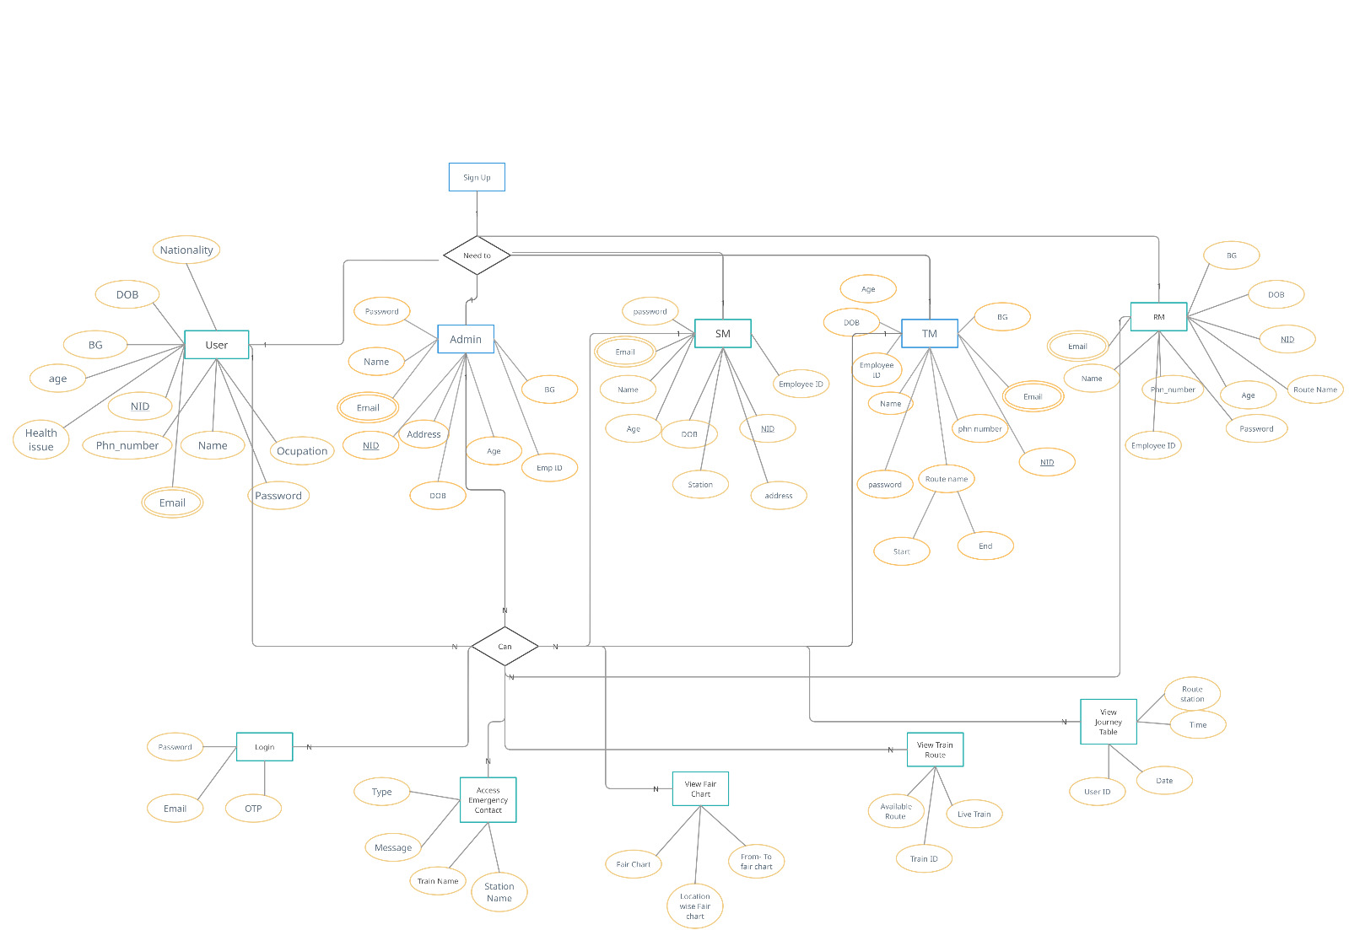

|  |  |  |  |  |  |
| --- | --- | --- | --- | --- | --- |
| **CO2 and CO4 Evaluation: Project Report Evaluation** | | | | | |
| **Completeness**  **(5)** | **Validation**  **(5)** | **Feature Implementation**  **(5)** | **Concept Understanding**  **(5)** | **Promptness (5)** | **Total (25)** |
|  |  |  |  |  |  |
|  | | | | | |