Final Project Report

Project Title: Smart Attendance System using RFID & Face Recognition
Project Description:
- The Smart Attendance System is a dual-authentication security and attendance management device designed to ensure reliable identity verification in workplaces, classrooms, and secure zones.
- The system integrates RFID card scanning with face recognition technology, requiring both verifications before granting access. This approach prevents unauthorized entry and eliminates the risk of fake or proxy attendance.
- Attendance is automatically recorded in real time once authentication is successful, removing the need for manual entry.
- The device is capable of supporting multiple users by storing RFID unique IDs and corresponding face data, making it scalable.
- Its low power consumption and portability make it suitable for classrooms, offices, and restricted areas, with potential future versions supporting battery operation.
- By combining security and automation, this project demonstrates how embedded systems and IoT principles can be applied to solve real-world challenges in attendance tracking.

Component List:
Item | Quantity | Price(tk) | Subtotal(tk)
ESP-32 CAM Development Board | 1 | 890 | 890
ESP-32 Micro-USB Download Module | 1 | 220 | 220
16x2 Serial LCD (I2C) Module Display | 1 | 340 | 340
RFID RC522 Card Reader Module | 1 | 179 | 179
RFID NFC Smart Card 13.56 MHz | 3 | 32 | 96
DC-DC Step Up Boost Converter (MT3608) | 1 | 89 | 89
18650 Li-ion Battery | 1 | 95 | 95
18650 Battery Holder – 1 Cell | 1 | 40 | 40
Breadboard Full Size Bare 830 | 1 | 145 | 145
Active Buzzer 5V | 1 | 18 | 18
5 mm Red LED | 1 | 5 | 5
220 Ohm Resistor | 1 | 5 | 5
Jumper Wires (Male to Female, 40 pcs) | 1 | 100 | 100
USB Data Cable Type-B | 1 | 180 | 180
Total |  |  | 2,402

Working Methodology:
The Smart Attendance System works by sequentially verifying RFID card data and face recognition results before granting access and recording attendance. The workflow is as follows:

Step 1 – Arduino & Component Setup
• Arduino Uno is connected to all peripheral modules.
• Each module (RFID, LCD, LEDs, buzzer) is tested individually for proper operation.

Step 2 – RFID Verification
• The user scans their RFID card using the RC522 module.
• If the card is invalid, the system directly displays “Access Denied” and activates the red LED + buzzer.
• If valid, the process moves to face recognition.

Step 3 – Face Recognition with ESP32-CAM
• Once a valid card is scanned, the LCD shows “Face Recognizing…”.
• The ESP32-CAM module captures the user’s face and compares it with stored data.
• If the face matches, the system grants access and records attendance.
• If not, access is denied.

Step 4 – Feedback Mechanisms
• LCD Display – Shows live authentication messages.
• LEDs – Green LED for granted, Red LED for denied.
• Buzzer Patterns:
- 1 beep → RFID granted
- 2 beeps → Face granted
- 3 beeps → RFID denied
- 5 beeps → Face denied
- 10-second continuous beep → Hardware/system error

Step 5 – Power Supply & Final Assembly
• The system is powered via USB or an external 5V adapter, with optional battery-based portability using a Li-ion battery and boost converter.
• All components are interconnected using jumper wires and mounted on a breadboard for prototyping.

.
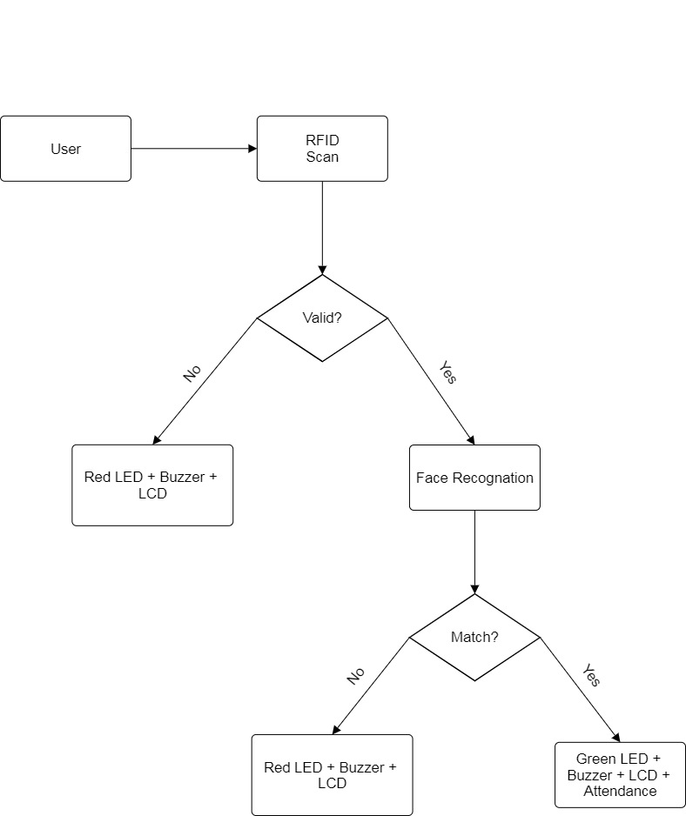
System Flow Diagram:

Future Implications & Improvements:
- Database Integration:
• Store attendance logs in a centralized database (e.g., Firebase, MySQL) for real-time monitoring by teachers/admins.
- Mobile & Web Application:
• Develop an app/dashboard to track attendance records remotely.
• Send notifications for successful or failed authentication attempts.
- Offline Face Recognition Storage:
• Extend ESP32-CAM to store more face data for multi-user scalability.
- Battery-Powered Portability:
• Use a rechargeable Li-ion pack with solar charging for outdoor or mobile use.
- Cloud & IoT Features:
• Connect to cloud servers for centralized data access across multiple classrooms or offices.
- Security Enhancement:
• Add fingerprint authentication or OTP-based mobile verification as a third factor for highly secure environments.

