In Partial Fulfillment

Of the Requirements in the Subject

Application Development and Emerging Technologies

**Ordering System for Proware Office**

**Of STI College Las Piñas**

Submitted to

Ms. Mikaela G. Arciaga

Submitted by

Magpantay, Lady Devina

Paraiso, Jewel Jashua

Tigas, James Alberione

Vega, Jamila Nicole

BSIT 312

January 2023

**Introduction**

**Project Context**

The Proware Office of STI College Las Piñas is known for managing, organizing, and releasing students’ school uniforms, t-shirts, and other wearable items that people can purchase. It also serves as a convenient location for students to purchase other school necessities, such as textbooks, ID laces, and other supplies necessary for school.

Over the years of being students at STI College Las Piñas, one thing that we have noticed is that whenever a new batch of students (newcomers) arrives, there are many individuals in queue outside the Proware office, to the point where it extends outside the school to acquire and purchase their respective uniforms.

Adopting modern technologies and methods can help improve customer service in many ways, such as by enabling faster communication, more efficient processes, quicker resolution of problems, and a better customer experience overall.

According to Kirill Ternov's research (2022), customers won't wait in line for very long before permanently leaving your store. Only 14 minutes is the maximum amount of time that customers are willing to wait. Due to the long queue, it affects people’s time and cause more inconvenience to them and the staffs as well.

The reason MPTV Corporation created Proware Ordering System, or ProOS, is that it allows the user to digitally acquire issuance slips for proware items like school uniforms, school t-shirts, and other wearable school items at STI College Las Piñas.

ProOS is an ordering system that offers convenience and flexibility to its users, and the entire process, from searching for the product to acquiring issuance slips.

Since this generation, almost everything has relevance to technology. Seamless transactions have been implemented to save time and money, increase customer confidence, and increase the chances of repeating transactions. Additionally, the staff or worker does not have to do all the extra work manually when processing electronic payments. (Sharma, 2022).

  Using the Proware Ordering System, or ProOS, one can acquire issuance slips of their choice of an item without spending too much time waiting in line. It would reduce the time consumption of the customers to be accommodated by the Proware staff every day.

**Purpose of the Project**

In customer service, prioritizing the customer and valuing their time and effort is important. Hence, being able to adapt to modernization will help speed up the process needed to acquire issuance slips.

The purpose of the Proware Ordering System (ProOS) is to help reduce the length of queuing time, which is a common problem at the Proware Office due to the large number of students enrolled at STI College Las Piñas and purchase proware items.

It has a simple-looking user interface that allows users to easily understand it. In order to use it, the system requires the user to input their student ID number before proceeding with the selection of their chosen item.

  Upon inserting the student’s ID number, the system will show items for senior high school and college students to choose from. Upon choosing the strand or course to which they belong, a list of uniforms will be shown as well.

And from there, the user can see the sizes, and input the quantity of the uniforms they will be purchasing. Upon confirming, the system will generate an issuance slip. And only then can they proceed to the cashier's office to settle their payment.

Lastly, the profile page of the admin where would be able to view transaction history and delete transactions.

This way, the acquiring of the issuance slip process of school uniforms, t-shirts, and other school items would be timesaving as they have an alternative and faster way of getting the issuance slip of the product they want to purchase.

**Objectives of the Study**

**General Objective**

The main objective of the Proware Ordering System (ProOS) is to develop system software that will speed up the acquiring process of issuance slips in the Proware Office and keep up with modernization since technology is in demand nowadays.

**Specific Objective**

* To develop a program that allows customers to acquire issuance slips quickly and efficiently without having to wait in long lines.
* To reduce the workload for the Proware staff by reducing the need to accommodate each customer individually.

**Requirement Analysis**

**Specific Requirements**

**3.1 Functional Requirements**

**3.1.1 Input Students Information**

**REQ001:** The user shall be able to input the student number.

**REQ002:** The user shall be able to confirm his/her student number.

**3.1.2 View Items**

**REQ003:** The user shall be able to view item categories.

**REQ004:** The user shall be able to browse items.

**3.1.3 Choose Items**

**REQ005:** The user shall be able to select the size of the item.

**REQ006:** The user shall be able to edit the quantity of the item.

**REQ007:** The user shall be able to delete an added item.

**3.1.3 Manage Order**

**REQ008:** The user shall be able to confirm the order.

**REQ009:** The user shall be able to cancel the order.

**REQ010:** The user shall be able to print the issuance slip.

**3.1.4 Input Admin Information**

**REQ011:** The admin shall be able to enter the admin ID.

**REQ012:** The admin shall be able to enter the admin password.

**3.1.5 Manage Transaction**

**REQ013**: The admin shall be able to view transaction history.

**REQ014**: The admin shall be able to delete transactions.

**3.2. Non-functional Requirements**

**3.2.1. Operational Requirements**

**REQ015:** The system will operate on the Windows Operating System platform.

**3.2.2. Performance Requirements**

**REQ016:** The system shall generate issuance slips upon completion of the order.

**REQ017:** The system shall store transactions in real time.

**3.2.3. Security Requirements**

**REQ018:** Only students enrolled shall be able to create an order.

**REQ019:** Only the Proware specialist or staff can view the transaction history.

**3.2.4. Cultural and Political Requirements**

**REQ020:** The system will use English language only.

**Use Cases Diagram**

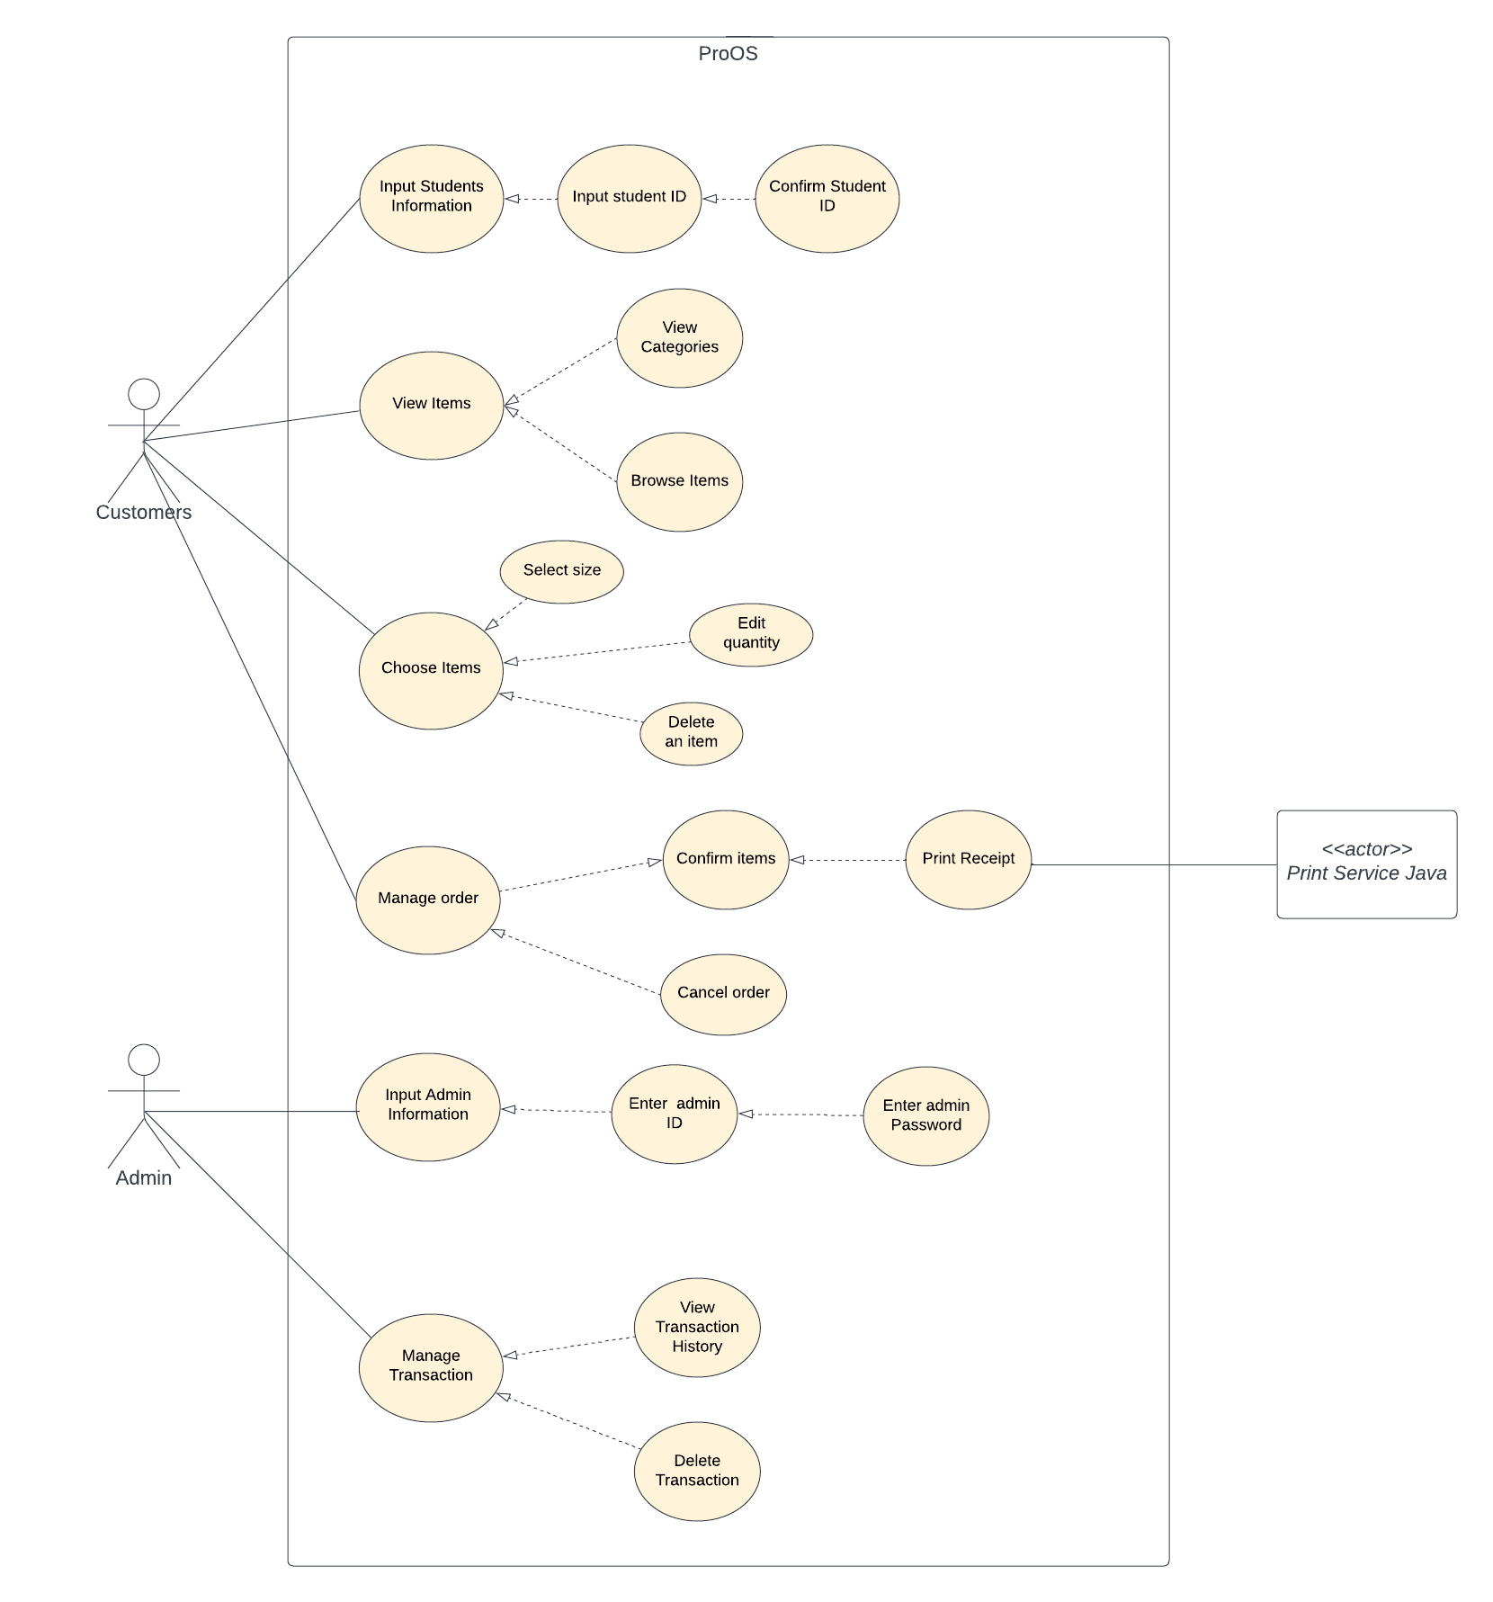

**Figure 1**

**Technical Background**

The information that are discussed in this section contains the technicality of the project. Thus, this section contains the hardware and software components that have been used in developing the system.

**Hardware**

The system software was developed by the proponents using a PC and a laptop. An operating system or an OS is responsible for managing all the software and hardware on the computer (Australia, 2022). The edition of Windows used is Windows 10 Pro.

For the system's continued development and enhancement, these devices are also employed for data collection and research. This data collection and research can be utilized to better understand how the system works, identify areas for improvement, and allow for more efficient operation.

**Software**

The Proware Ordering System (ProOS) is system software developed by MPTV Corporation specifically for STI College Las Piñas. Its purpose is to allow students to acquire issuance slip through a system, reducing the time spent waiting in line.

As a result, more people can be accommodated per day in less time per transaction.

Some of the technical terms that only IT people can understand which the proponents have used to develop the program:

* **Figma** – a collaborative web application to help with the designing of the interface, with additional features that are enabled by desktop applications for macOS and Windows.
* **NetBeans 8.0.2** – is an integrated development environment for Java.
* **Java SE Development Kit** – development environment for building apps using Java.
* **MySQL Connectors** **Java** – it connects client programs created with the java programming language.
* **XAMPP** - Apache Friends is a non-profit project that hosts the XAMPP project and promotes the Apache web server.

**Prior Arts/ Related System**

The comparison of our system to other existing systems, such as McDonald's kiosks, is that they focus on self-service food chains. The idea behind the kiosks is to provide customers with an easier and faster way to order food (Pendrill, 2022).

In the restaurant industry, they have realized that anything the staff can do will speed up the process, increase accuracy, and free up staff time to focus on other customers who might need more individualized service. Customers' wait times decreased by self-ordering kiosks, which enhances their experience overall.

As a result, their employees' capacity to improve the customer experience expands. This allows them to focus on the quality of the food, the dining room's cleanliness, and their ability to provide table service (Suddath, 2022).

KFC currently employs Oracle's MICROS RES POS system in the United States. The MICROS RES system in KFC restaurants was installed with front and back of house hardware, meaning that as a customer order their food, the kitchen can instantly see exactly what needs to be prepared.

This highly intelligent system has helped to improve customer experience and speed up transactions across KFC's restaurants. These speeds up the entire process, decreasing the time from the moment the consumer places their order and the moment they receive their food (Barraclough, 2020).

According to Luis Fernandes this year has been difficult for many airlines, air travel is likewise plagued by long lineups, delays, and cancellations all around the world. For instance, iPad-based self-service kiosks are created using the same technology that drives many travelers' personal gadgets all around the world. These self-service airport kiosks also offer a dependable choice to lessen friction at check-in and luggage drop-off areas and are more modern and flexible (Fernandes, 2022).

Therefore, we produced the idea to develop Proware Ordering System (ProOS), a digitalized Proware in which the users have options to buy their uniforms or other items that Proware has. This digitalized Proware would offer a more efficient system that allows customers to check the products they need, select their sizes, and other details.

The goal of this system is to provide faster transactions for customers, eliminating long lines and reducing the need for manual labor in the purchasing process. It aims to improve efficiency and convenience for STI students and parents. To offer a fast and convenient solution, mere reason MTV designed this system.

**Appendices**

**Concept Matrix & Preparation**

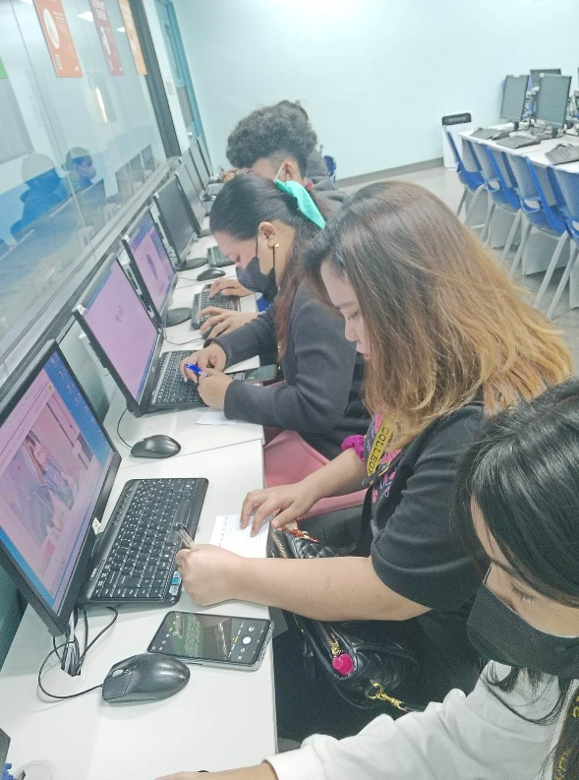

**Layout and Framing**

* **Initial Prototype**

**Figure 2:** Main page of the system

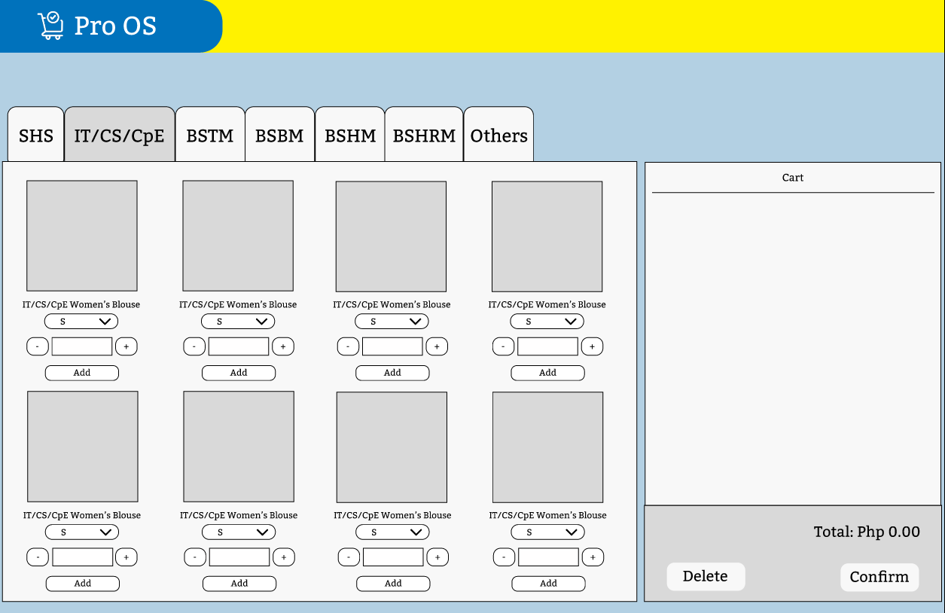

**Figure 3:** Browsing and adding items to the cart.

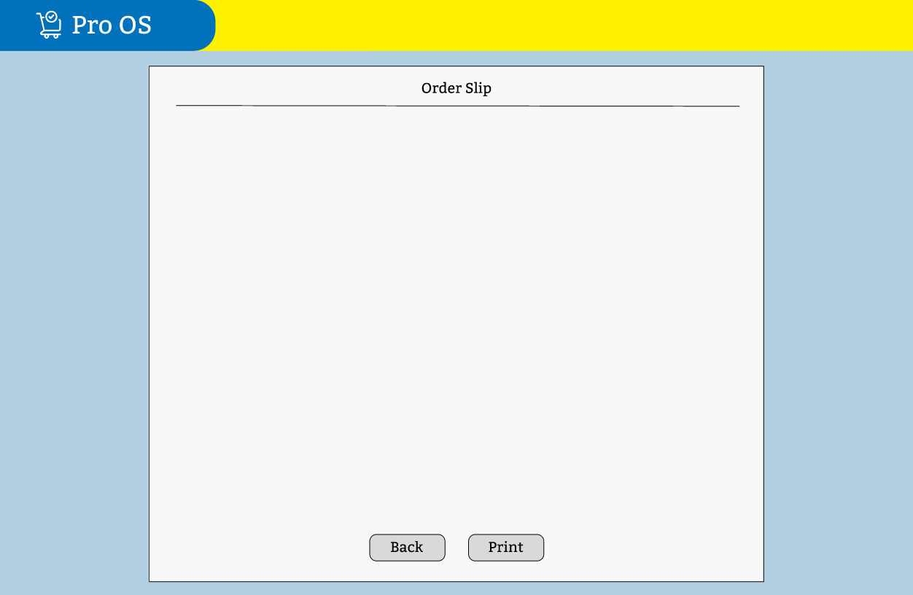

**Figure 4:** Preview of issuance slip of the products.

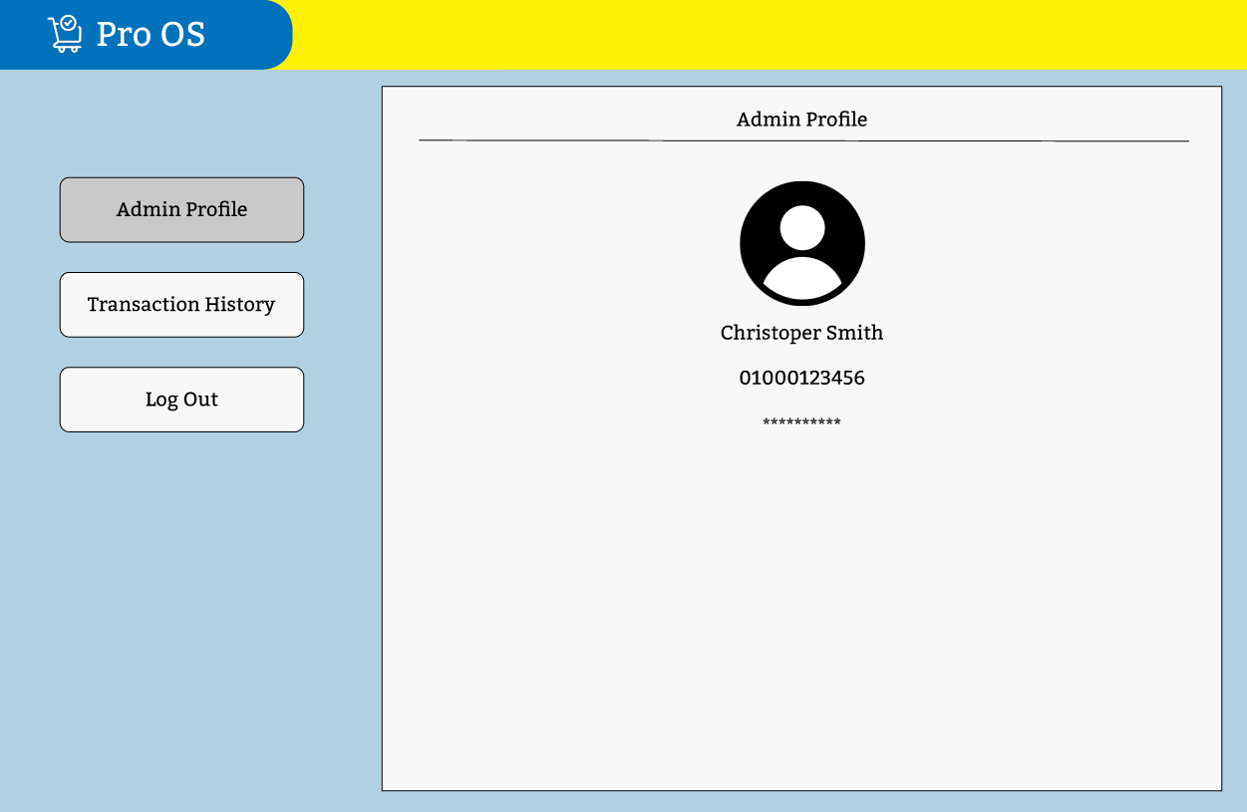

**Figure 5:** Profile page of the admin.

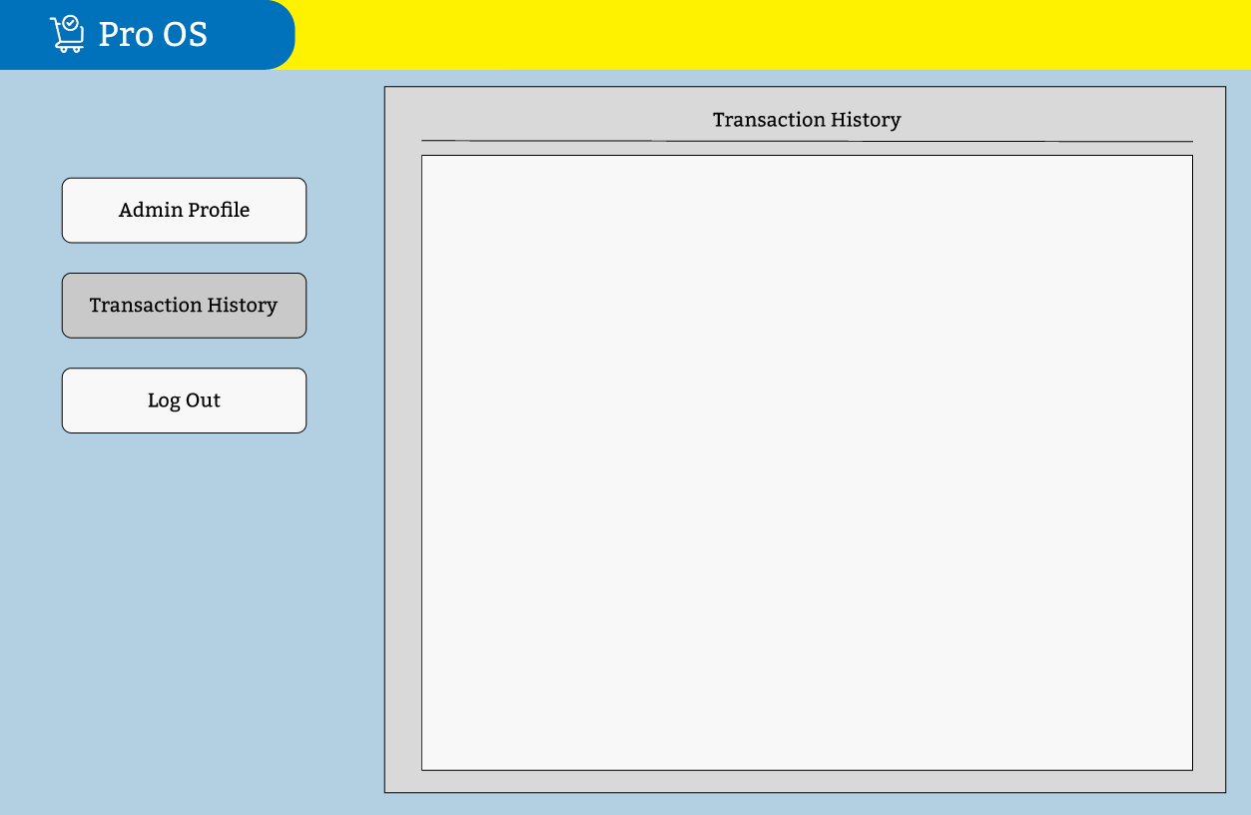

**Figure 6:** Page for transaction history.

* **Final Prototype**

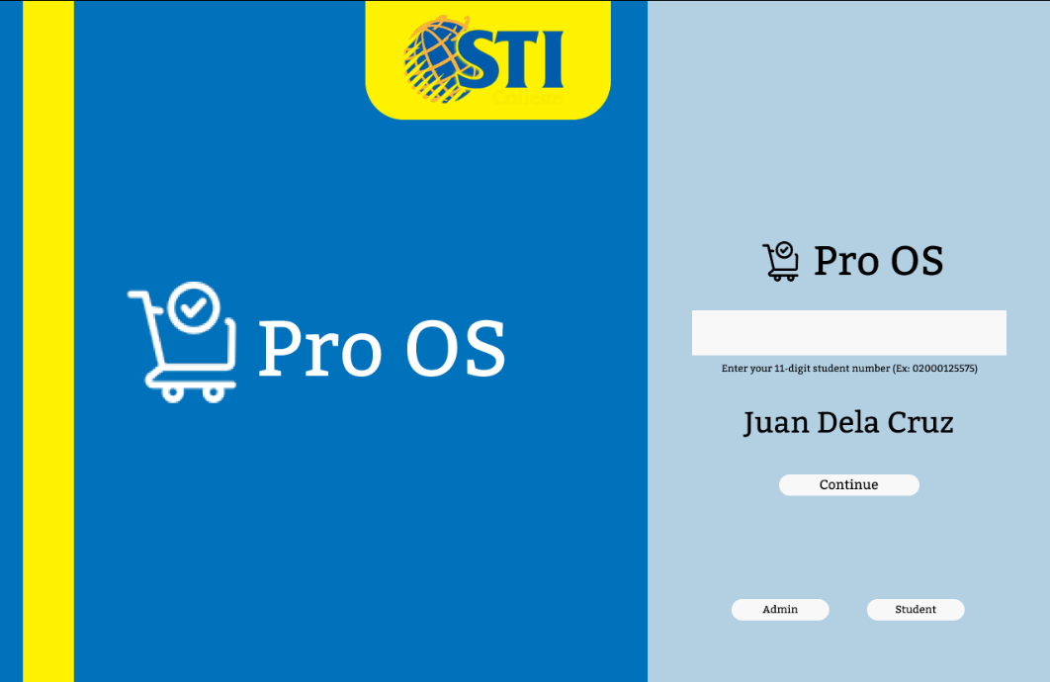

**Figure 7:** Updated main page.

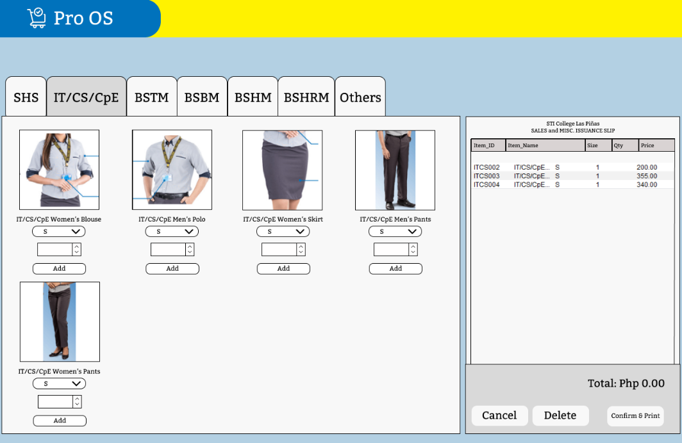

**Figure 8:** Updated create order page.

**Figure 9:** Updated admin page.

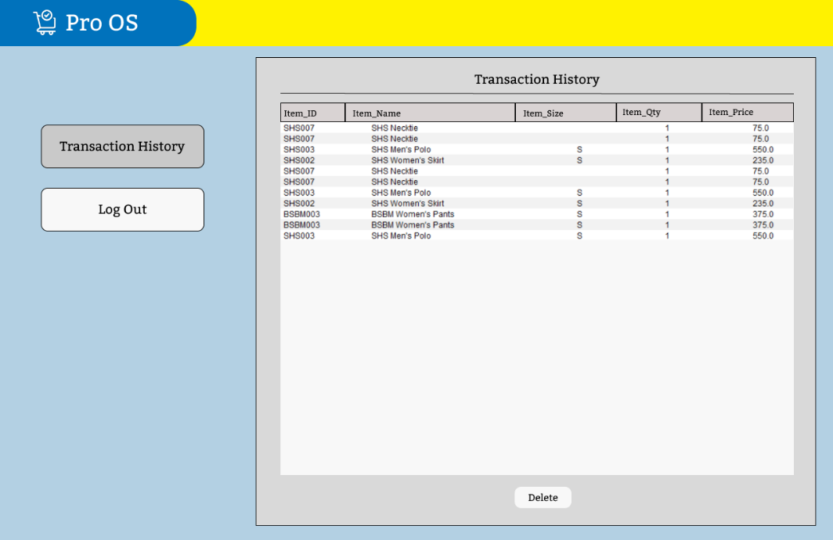

**Figure 10:** Updated transaction history page.

# **References**

* Australia, U. o. (2022). *Understanding operating systems*. Retrieved from University of Wollongong Australia: https://www.uow.edu.au/student/learning-co-op/technology-and-software/operating-systems/#:~:text=The%20operating%20system%20(OS)%20manages,as%20disk%20drives%20and%20printers.
* Balagtas, S. C. (2021, July 26). *STI College Balagtas*. Retrieved from Facebook: https://www.facebook.com/Balagtas.sti.edu/photos/a.309208818647/10159737071578648
* Barraclough, D. (2020, August 28). *The Best Examples of Restaurant POS Systems*. Retrieved from Expert Market: https://www.expertmarket.com/pos/best-restaurant-pos-system-examples
* Cainta, T. M.-S. (2018, July 27). *Tourism Management Society - STI Ortigas Cainta*. Retrieved from Facebook: https://www.facebook.com/photo/?fbid=2057013661036068&set=pcb.2057015471035887
* CData. (2023). *SQL Server Driver*. Retrieved from cdata: https://www.cdata.com/drivers/sql/jdbc/?kw=&cpn=17056622344&utm_source=google&utm_medium=cpc&utm_campaign=Search_-_Connector_-_SQL_Server&utm_content=Generic_-_SQL_Server_-_DSA&utm_term=|&kw=&cpn=17056622344&gclid=CjwKCAiA8OmdBhAgEiwAShr40_U-HjELYWlBkuaOQ
* City, S. C. (2019, December 5). *STI College Global City*. Retrieved from Facebook: https://www.facebook.com/globalcity.sti.edu/photos/pcb.2582403015170425/2582398645170862
* Fernandes, L. (2022). *Self-Service Airport Kiosks That Pack More Versatility*. Retrieved from ailatech: https://www.ailatech.com/blog/self-service-airport-kiosks-that-pack-more-versatility/?fbclid=IwAR0-l1TUWUhhhDQaxtE6ChHJ3PNystBTkMmuYKPUDAbY09St8O-HS9X_Pvg
* Fernando, S. C. (2018, April 10). *STI College San Fernando*. Retrieved from Facebook: https://www.facebook.com/sanfernando.sti.edu/posts/sti-tertiary-student-uniformseffective-1st-term-academic-year-2018-2019hospitali/1613017505412057/
* Friends, A. (2022). *XAMPP Apache + MariaDB + PHP + Perl*. Retrieved from Apache Friends: https://www.apachefriends.org/
* Iloilo, S. C. (2017, June 30). *STI College Iloilo*. Retrieved from Twitter: https://twitter.com/STIiloilo/status/880717812242821121/photo/1
* Malolos, S. C. (2018, March 15). *STI College Malolos*. Retrieved from Facebook: https://www.facebook.com/malolos.sti.edu/posts/we-are-now-accepting-grade-12-applicants-for-college-you-may-also-take-the-caree/10157182838919128/
* Muhammad, M. (2022, October 26). *How McDonald's is Leveraging Self Service Technologies*. Retrieved from WAVETEC: https://blog.wavetec.com/en/mcdonalds-leveraging-self-service-technologies
* Oracle. (2022). *Java SE 8 Archive Downloads (JDK 8u202 and earlier)*. Retrieved from Oracle: https://www.oracle.com/ph/java/technologies/javase/javase8-archive-downloads.html
* Ortigas-Cainta, S. C. (2021). *STI College Ortigas-Cainta*. Retrieved from Facebook: https://www.facebook.com/ortigascainta.sti.edu/photos/a.116274638411558/3339928849379438/?type=3&paipv=0&eav=AfY8mfVrByTeSw6_nXgmPGssJWgB7bl5jXENOPeQWAz1ARWVN7hEJXJ17KVETVj4tvQ&_rdr
* Pendrill, K. (2022). *Why Self Ordering Kiosks are Becoming the Secret Weapon for Successful Restaurants*. Retrieved from TouchBistro: https://www.touchbistro.com/blog/why-self-ordering-kiosks-are-becoming-the-secret-weapon-for-successful-restaurants/
* Piñas, S. C. (2018, March 25). *STI College Las PiñAS*. Retrieved from Facebook: https://www.facebook.com/laspinas.sti.edu/photos/kevin-santillanthailandthe-nstp-2-students-will-be-parading-on-wednesday-march-2/2073450669443193/
* Piñas, S. C. (2021). *STI College Las Piñas*. Retrieved from Facebook: https://www.facebook.com/laspinas.sti.edu
* Sharma, N. (2022). *Benefits of Making Seamless Electronic Payments*. Retrieved from Story tellers for children: https://www.storytellersforchildren.ca/benefits-of-making-seamless-electronic-payments/#:~:text=The%20advantages%20of%20this%20type,terms%20of%20processing%20electronic%20payments.
* Star, T. P. (2019, September 20). *McDonald’s provides better customer experience with PayMaya QR*. Retrieved from philstar GLOBAL: https://www.philstar.com/lifestyle/business-life/2019/09/20/1953205/mcdonalds-provides-better-customer-experience-paymaya-qr
* STI Education Services Group, I. (2015). *T-SHIRT*. Retrieved from sti.edu: https://www.sti.edu/store/category.asp?catid=4#.Y8VZmXbMLIW
* STI Education Services Group, I. (2022). *College Programs*. Retrieved from sti.edu: https://www.sti.edu/programs-tertiary.asp
* Suddath. (2022). *Customer Service: Face-To-Face Ordering vs. Kiosks*. Retrieved from Suddath: https://suddath.com/global-logistics/blog/customer-service-face-to-face-ordering-vs-kiosks/
* Ternov, K. (2021). *Customers Refusing to Wait*. Retrieved from Qminder: https://www.qminder.com/blog/queue-management/long-waiting-times-sales/#:~:text=A%20confusing%20in-store%20experience,after%20them%20check%20out%20first.
* Valencia, S. C. (2022, July 12). *STI College Valencia*. Retrieved from Facebook: https://www.facebook.com/valencia.sti.edu/photos/pcb.3275415662733883/3275412106067572?locale=en_GB
* Wikipedia. (2016). *Figma (software)*. Retrieved from Wikipedia: https://en.wikipedia.org/wiki/Figma_(software)
* Wikipedia. (2020). *NetBeans*. Retrieved from Wikipedia: https://en.wikipedia.org/wiki/NetBeans
* Wikipedia. (2022). *SQLite*. Retrieved from Wikipedia: https://en.wikipedia.org/wiki/SQLite