GIT CONFIGURATION
Local - Directory
Global - User
System – All the computer
Note: It always takes the smaller configuration though

git config --global user.name "Jamilson"
git config --global user.email "jamil0713@live.com"
git config --global core.editor "code --wait"
git config --global core.autocrlf input (in Linux y mac)
git config --global core.autocrlf true (in windows)
git config --global --list
git init

Code . – abre la terminal en vscode
Pwd (showing the route)
Ls - listing
Cd directory_name – going ahead
Cd – going backward
Cd .. Going back one directory
Cd ../.. Going back two directories
Cd folder_name – going forward
Mkdir folder_name – creating a folder
Rmdir folder_name – deleting a folder
touch nombre_archivo.txt
Git status
Git add file_name
Git rm —cache file_name (removing files from staging area)
Git commit -m "first commit" -a (This creates a commit without a previous git add)
Rm file_name (removing and file from a commit already made)
Git add file_name
Git commit –m "massege" -a (the file has been removed from the repository and stage area)
Git commit –m "massege" (This needs a previous git commit before )
Rm file_name
Git status (at this situation status displays a file deleted)
git restore <file> (to discard changes in working directory) but if we insert the next command
Git add <file> (the file which already was deleted will be on stage area)
Git commit –m 'Deleting proof'

Git restore file_name
Git checkout file_name

ls -a (poner visible archivos ocultos)
Git tag <tag_name> (to mark a specific, important point in your repository's history)
Git switch (to switch between branches)
git restore (to return files as the one in the last commit)
Git checkout (to switch between branches, return files as the one in the last commit, select commits)
git checkout, Git developers split its features into two focused commands: git switch (for branches) and git restore (for files).
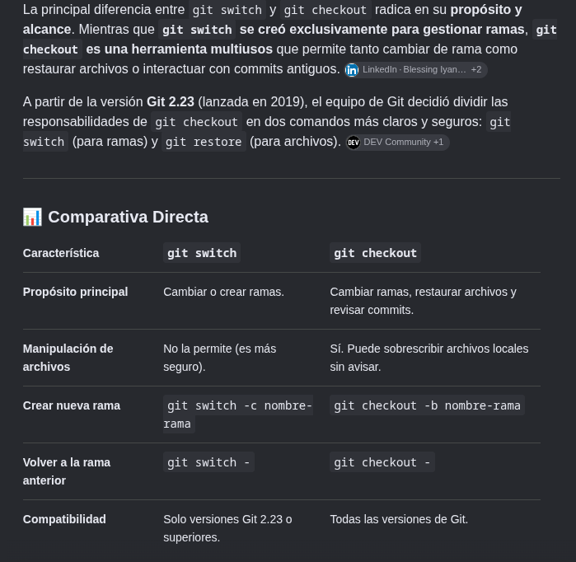
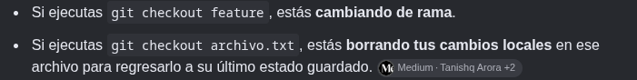
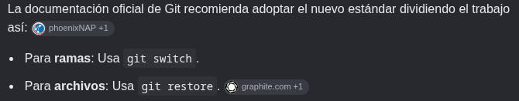

GITHUB
- Select an owner account
- Push on the green New bottom
- Name the repository
- Choose visibility (Private - Public)
- Add .gitignore
- Click the green Create repository button
In bash
- git init
- git add .
- git commit -m "Initial commit"
- git branch -M main
- git remote add origin https://github.com
- git push -u origin main

convenciones para commits
Fix fixing
Feat - feature
Refactor – rewrite without changing behavior

VLC TV
media/open network steam/paste link/rep. list
link
https://iptv-org.github.io/iptv/index.m3u

