EMCAD for 2D Brain Tumor Segmentation
Jamilul Huq Jami | Technical report

Objective and outcome

I Adapted EMCAD to four-modality axial MRI segmentation for BraTS 2020. This single PVTv2-B0–EMCAD model obtained a mean of 0.8001 on 74 held-out patients for enhancing tumor (ET), tumor core (TC), and whole tumor (WT). The final experiment took 7.51 hours of the experiment session (on one Tesla T4) and 16,000 optimizer steps. The primary constraint was that ETC (false positives) and sometimes completely missed.

Data and model adaptation
The 369 labeled cases were randomly divided into 295 training cases and 74 validation cases with seed 42. Four channels were used that is T1, contrast-enhanced T1, T2, and FLAIR. Volumes reorientated to canonical RAS and checked for spatial alignment. The data from each modality were percentile clipped and then normalized within each voxel where the data is not zero. Cropped logits and padded native axial slices within the model with multiples of 32. The mean RGB filter was scaled by 3/4 and added to the PVTv2-B0 input projection, which was taken from ImageNet. The official EMCAD decoder took on MSCAM attention and multi-scale convolutions, EUCB upsampling, LGAG skip gates, and additive fusion. Four tissue-class logits (background, necrotic/non-enhancing core, edema, and enhancing tumor) were emitted by each of the four decoder heads. Label 4 was assigned to class 3. ET={3}, TC={1,3}, and WT={1,2,3}, ensuring nested regions. The sum of the four upsampled logit maps was used as a prediction. The fused-output loss plus 0.5 times mean auxiliary-head loss was minimized during training. We employed 0.5 cross-entropy + 0.5 foreground multi-class soft-Dice loss for each head. There were a total of 3,919,899 parameters in the model.

Training protocol
Training completed 40 budget epochs × 400 steps with batch size 8, totaling 128,000 sampled slices. Each batch used two patients; tumor-bearing slices were selected with probability 0.67, otherwise sampling from all axial slices. All 295 training patients contributed. Paired flips and mild intensity augmentation were applied only during training.
AdamW used learning rate 1×10⁻⁴ and weight decay 0.01, with two budget epochs of linear warmup followed by cosine decay, gradient clipping at norm 1, and mixed precision. Full-volume validation ran every two budget epochs; the checkpoint with the highest mean ET/TC/WT Dice was selected.

Internal validation results
Region | Dice mean ± SD | HD95 mean mm | HD95 median mm
ET | 0.6677 ± 0.3123 | 53.526 | 2.828
TC | 0.8380 ± 0.1393 | 9.354 | 5.354
WT | 0.8946 ± 0.0765 | 11.660 | 4.527
Macro mean | 0.8001 | 24.847 | —

Evaluation and efficiency
All axial predictions were reconstructed into 3D patient volumes before scoring. Dice and HD95 were averaged over patients and then equally over regions and SD denotes variation across patients. HD95 used physical voxel spacing, 6-connected voxel surfaces, and the maximum of the two directed 95th percentiles. Both-empty masks received Dice 1 and HD95 0; exactly one empty mask received Dice 0 and a volume-diagonal penalty of 371.43 mm.
PyTorch 2.11.0+cu128 on a Tesla T4 recorded peak allocated/reserved training memory of 0.664/0.723 GiB. Mean synchronized compute time was 0.123 s/step; mean end-to-end time including batch fetch was 1.259 s/step (median 0.163 s; p95 8.462 s). Accumulated training-step time was 5.61 h; measured session time including validation and checkpoint overhead was 7.51 h.

Learning behavior and failure analysis
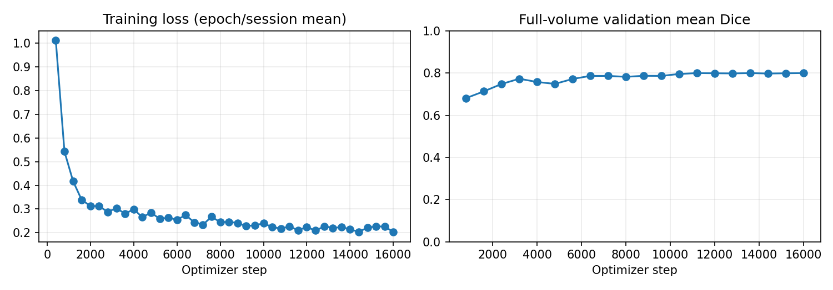
Figure 1 Training loss and full-volume validation mean Dice across optimizer steps. Validation gains largely plateaued after approximately 10,000–12,000 steps.
ET produced zero Dice in 10 of 74 patients: eight had false-positive ET where the reference was empty, one had a completely missed ET region (case 295), and one had nonempty masks with no overlap (case 323). Nine one-empty-mask penalties contributed 84.4% of the summed ET HD95. This explains the difference between its mean HD95 of 53.53 mm and median of 2.83 mm. For the 65 cases with both masks nonempty, mean ET HD95 was 9.51 mm; this diagnostic subset does not replace the primary all-patient result.

Conclusion and reproducibility
The experiment establishes an initial 2D EMCAD baseline with stronger WT and TC overlap than ET performance. only one seed and one internal split were evaluated, and that split also selected the checkpoint.

References
[1] Rahman MM, Munir M, Marculescu R. EMCAD: Efficient Multi-scale Convolutional Attention Decoding for Medical Image Segmentation. CVPR 2024, 11769–11779. Official code: https://github.com/SLDGroup/EMCAD
[2] BraTS 2020 data and evaluation definitions: https://www.med.upenn.edu/cbica/brats2020/tasks.html

