How do different factor affect the NBA players’ salary

CREST GOLD

2022-08-09

Table of Contents

# Executive Summary

This report aims to find the correlation of the player statistics in the year before and the salary of that player in the year after.

We found player statistics for 2021-2022 season and their respective salary in 2022-2023 season. We have collect the player statistics and salary of 384 NBA players that played in 2021-2022 and have salary in the 2022-23 season. The player statistics is collected from [Basketball Reference](https://www.basketball-reference.com/) and [NBA official website](https://www.nba.com/). The detailed links are listed below in the Source of files section.

We started with merging the the data from different source and removing repeated variables.

In the exploratory data analysis, we start with univariate analysis of the response variable salary and then explore the correlation of individual variables with salary.

In the modelling section, we use the RMSE score on the train set to determine the final model. We have 10 fold cross validation on each model (the 10 fold all use RMSE to hyperparameter tuning). The root mean squared error (RMSE) is a measure of prediction error while R-squared is a measure of the proportion of variation explained by the model.  
We have included the following modelling methods:

* Linear Regression (Train RMSE: 0.4996, R-squared: 0.7285)
* Lasso Regression (Train RMSE: 0.5246, R-squared: 0.7076)
* Elastic Net Regression (Train RMSE: 0.5134, R-squared: 0.7178)
* Stepwise Regression (Train RMSE: 0.5072, R-squared: 0.7535)
* Decision Tree (Train RMSE: 0.5096, R-squared: 0.6438)
* Random Forest (Train RMSE: 0.2326, R-squared: 0.7097)
* Neural Network (Train RMSE: 0.6170, R-squared: 0.6624)

As the Random Forest Model has the lowest RMSE, we chose it as the final model for our prediction. It has 0.4835 of estimate out-of-bag RMSE.

In the interpretation part, we will mainly use the stepwise regression, linear regression and principle component analysis to analyse. We will not use the random forest model as it is hard to give interpretation on a random forest model.

In the analysis, imperial units are used as it is the common unit systems in the NBA. All the salary is record in USD.

# Understanding of the problem

We want to use player statistics to find out what kind of players with which kind of attribute will result in higher salary in modern NBA.  
There are 59 explanatory predictive variable after removing repetitive variable in the raw dataset with salary as the responsive variable.

## Source of files:

player_PGstats_2021.csv – NBA players statistics per game in 2021-2022 season  
source: <https://www.basketball-reference.com/leagues/NBA_2022_per_game.html>  
player_Adstats_2021.csv – NBA players advance statistics in 2021-2022 season source: <https://www.basketball-reference.com/leagues/NBA_2022_advanced.html>  
salary2022.csv – NBA players contract in 2022-2023 season onward  
source: <https://www.basketball-reference.com/contracts/players.html>  
bio.csv – NBA player bio (height and weight)  
source: <https://www.nba.com/stats/players/bio/?Season=2021-22&SeasonType=Regular%20Season&sort=PLAYER_NAME&dir=1>

# Loading and Exploring Data

## Loading libraries required

Load libraries required for the analysis.

library(knitr)  
library(plyr)  
library(dplyr)  
library(tidyr)  
library(caret)  
library(ggplot2)  
library(corrplot)  
library(stringr)  
library(scales)  
library(randomForest)  
library(glmnet)  
library(rpart)  
library(lubridate)  
library(plotly)  
library(forcats)  
library(psych)  
library(ggExtra)  
library(reshape2)  
library(tree)  
library(MASS)  
library(Metrics)  
library(rattle)  
library(neuralnet)  
library(sigmoid)  
opts_chunk$set(echo = TRUE, cache = TRUE)  
opts_chunk$set(tidy.opts = list(width.cutoff = 80), tidy = TRUE, fig.height = 6, fig.width = 9)

## Loading data files

Read in the data that were downloaded from the sources.

pgstats <- read.csv("files/2022/player_PGstats_2021.csv")  
adstats <- read.csv("files/2022/player_Adstats_2021.csv")  
salary <- read.csv("files/2022/salary2022.csv")  
bio <- read.csv("files/2022/bio.csv")

## File description

### player_PGstats_2021.csv

NBA players statistics per game in 2021-2022 season  
source: <https://www.basketball-reference.com/leagues/NBA_2022_per_game.html>  
The file contains NBA player per-game statistics in 2021-22 season, including points, assists, rebounds, blocks, and steal et al..

dim(pgstats)

## [1] 812 31

str(pgstats)

## 'data.frame': 812 obs. of 31 variables:  
## $ Rk : int 1 2 3 4 5 6 6 6 7 8 ...  
## $ Player : chr "Precious Achiuwa" "Steven Adams" "Bam Adebayo" "Santi Aldama" ...  
## $ Pos : chr "C" "C" "C" "PF" ...  
## $ Age : int 22 28 24 21 36 23 23 23 26 23 ...  
## $ Tm : chr "TOR" "MEM" "MIA" "MEM" ...  
## $ G : int 73 76 56 32 47 65 50 15 66 56 ...  
## $ GS : int 28 75 56 0 12 21 19 2 61 56 ...  
## $ MP : num 23.6 26.3 32.6 11.3 22.3 22.6 26.3 9.9 27.3 32.3 ...  
## $ FG : num 3.6 2.8 7.3 1.7 5.4 3.9 4.7 1.1 3.9 6.6 ...  
## $ FGA : num 8.3 5.1 13 4.1 9.7 10.5 12.6 3.2 8.6 9.7 ...  
## $ FG. : num 0.439 0.547 0.557 0.402 0.55 0.372 0.375 0.333 0.448 0.677 ...  
## $ X3P : num 0.8 0 0 0.2 0.3 1.6 1.9 0.7 2.4 0 ...  
## $ X3PA : num 2.1 0 0.1 1.5 1 5.2 6.1 2.2 5.9 0.2 ...  
## $ X3P. : num 0.359 0 0 0.125 0.304 0.311 0.311 0.303 0.409 0.1 ...  
## $ X2P : num 2.9 2.8 7.3 1.5 5.1 2.3 2.8 0.4 1.5 6.6 ...  
## $ X2PA : num 6.1 5 12.9 2.6 8.8 5.3 6.5 1 2.7 9.6 ...  
## $ X2P. : num 0.468 0.548 0.562 0.56 0.578 0.433 0.434 0.4 0.533 0.688 ...  
## $ eFG. : num 0.486 0.547 0.557 0.424 0.566 0.449 0.45 0.438 0.588 0.678 ...  
## $ FT : num 1.1 1.4 4.6 0.6 1.9 1.2 1.4 0.7 1 2.9 ...  
## $ FTA : num 1.8 2.6 6.1 1 2.2 1.7 1.9 0.8 1.1 4.2 ...  
## $ FT. : num 0.595 0.543 0.753 0.625 0.873 0.743 0.722 0.917 0.865 0.708 ...  
## $ ORB : num 2 4.6 2.4 1 1.6 0.6 0.7 0.1 0.5 3.4 ...  
## $ DRB : num 4.5 5.4 7.6 1.7 3.9 2.3 2.6 1.5 2.9 7.3 ...  
## $ TRB : num 6.5 10 10.1 2.7 5.5 2.9 3.3 1.5 3.4 10.8 ...  
## $ AST : num 1.1 3.4 3.4 0.7 0.9 2.4 2.8 1.1 1.5 1.6 ...  
## $ STL : num 0.5 0.9 1.4 0.2 0.3 0.7 0.8 0.3 0.7 0.8 ...  
## $ BLK : num 0.6 0.8 0.8 0.3 1 0.4 0.4 0.3 0.3 1.3 ...  
## $ TOV : num 1.2 1.5 2.6 0.5 0.9 1.4 1.7 0.5 0.7 1.7 ...  
## $ PF : num 2.1 2 3.1 1.1 1.7 1.6 1.8 1 1.5 1.7 ...  
## $ PTS : num 9.1 6.9 19.1 4.1 12.9 10.6 12.8 3.5 11.1 16.1 ...  
## $ player_id: chr "achiupr01" "adamsst01" "adebaba01" "aldamsa01" ...

### player_Adstats_2021.csv

player_Adstats_2021.csv – NBA players advance statistics in 2021-2022 season source: <https://www.basketball-reference.com/leagues/NBA_2022_advanced.html>  
This file contains NBA player advance statistics in 2021-22 season, including PER (player efficiency rating), win shares, box score, and VORP (value over replacement player) et al..

dim(adstats)

## [1] 812 30

str(adstats)

## 'data.frame': 812 obs. of 30 variables:  
## $ Rk : int 1 2 3 4 5 6 6 6 7 8 ...  
## $ Player : chr "Precious Achiuwa" "Steven Adams" "Bam Adebayo" "Santi Aldama" ...  
## $ Pos : chr "C" "C" "C" "PF" ...  
## $ Age : int 22 28 24 21 36 23 23 23 26 23 ...  
## $ Tm : chr "TOR" "MEM" "MIA" "MEM" ...  
## $ G : int 73 76 56 32 47 65 50 15 66 56 ...  
## $ MP : int 1725 1999 1825 360 1050 1466 1317 149 1805 1809 ...  
## $ PER : num 12.7 17.6 21.8 10.2 19.6 10.5 10.5 10.2 12.7 23 ...  
## $ TS. : num 0.503 0.56 0.608 0.452 0.604 0.475 0.474 0.497 0.609 0.698 ...  
## $ X3PAr : num 0.259 0.003 0.008 0.364 0.1 0.497 0.483 0.688 0.684 0.018 ...  
## $ FTr : num 0.217 0.518 0.466 0.242 0.223 0.16 0.153 0.25 0.13 0.428 ...  
## $ ORB. : num 8.7 17.9 8.7 9.4 7.8 2.7 3 0.8 1.9 12 ...  
## $ DRB. : num 21.7 22 26.1 16.1 18.7 11.5 11 15.6 10.9 24.5 ...  
## $ TRB. : num 14.9 19.9 17.5 12.6 13.4 7.1 6.9 8.5 6.5 18.4 ...  
## $ AST. : num 6.9 16.1 17.5 7.7 6.3 16.1 16.1 15.5 7.6 8.2 ...  
## $ STL. : num 1.1 1.6 2.2 0.8 0.6 1.5 1.5 1.7 1.2 1.2 ...  
## $ BLK. : num 2.3 2.7 2.6 2.5 4 1.5 1.4 2.4 1 3.7 ...  
## $ TOV. : num 11.3 19.6 14.4 9.9 8 11.3 11.2 13.1 6.7 12.7 ...  
## $ USG. : num 18.5 12 25 18.4 22.4 24.1 24.8 17.9 15.2 18.1 ...  
## $ X : logi NA NA NA NA NA NA ...  
## $ OWS : num 0.4 3.8 3.6 -0.1 2.1 -1.1 -1.1 0 2.8 5.4 ...  
## $ DWS : num 2.1 3 3.5 0.4 1 1.1 0.9 0.2 1.4 3 ...  
## $ WS : num 2.5 6.8 7.2 0.3 3.1 0.1 -0.1 0.2 4.2 8.5 ...  
## $ WS.48 : num 0.07 0.163 0.188 0.044 0.141 0.003 -0.005 0.07 0.11 0.225 ...  
## $ X.1 : logi NA NA NA NA NA NA ...  
## $ OBPM : num -2 1 1.7 -4.2 1.3 -1.8 -1.7 -2.9 0.6 2.7 ...  
## $ DBPM : num -0.6 1 2.1 -1.5 -0.6 -1.1 -1.3 1.2 -0.2 1.2 ...  
## $ BPM : num -2.6 2 3.8 -5.7 0.7 -2.9 -3 -1.7 0.4 3.9 ...  
## $ VORP : num -0.2 2 2.7 -0.3 0.7 -0.3 -0.3 0 1.1 2.7 ...  
## $ player_id: chr "achiupr01" "adamsst01" "adebaba01" "aldamsa01" ...

### salary2022.csv

salary2022.csv – NBA players contract in 2022-2023 season onward  
source: <https://www.basketball-reference.com/contracts/players.html>  
This file contains NBA players’ salary, types of contract and the guaranteed amount of money from the contract.

dim(salary)

## [1] 448 12

str(salary)

## 'data.frame': 448 obs. of 12 variables:  
## $ Rk : int 1 2 3 4 5 6 7 8 9 10 ...  
## $ Player : chr "Stephen Curry" "Russell Westbrook" "LeBron James" "Kevin Durant" ...  
## $ Tm : chr "GSW" "LAL" "LAL" "BRK" ...  
## $ X2022.23 : chr "$48070014" "$47063478" "$44474988" "$44119845" ...  
## $ X2023.24 : chr "$51915615" "" "" "$46407433" ...  
## $ X2024.25 : chr "$55761216" "" "" "$49856021" ...  
## $ X2025.26 : chr "$59606817" "" "" "$53282609" ...  
## $ X2026.27 : chr "" "" "" "" ...  
## $ X2027.28 : chr "" "" "" "" ...  
## $ Signed.Using: chr "Bird" "Bird Rights" "Bird" "Bird" ...  
## $ Guaranteed : chr "$215353662" "$47063478" "$44474988" "$193665908" ...  
## $ player_id : chr "curryst01" "westbru01" "jamesle01" "duranke01" ...

### bio

bio.csv – NBA player bio (height and weight)  
source: <https://www.nba.com/stats/players/bio/?Season=2021-22&SeasonType=Regular%20Season&sort=PLAYER_NAME&dir=1>  
This file contains the height and weight of NBA players in season 2021-22.

dim(bio)

## [1] 605 4

str(bio)

## 'data.frame': 605 obs. of 4 variables:  
## $ Player: chr "Aaron Gordon" "Aaron Henry" "Aaron Holiday" "Aaron Nesmith" ...  
## $ Team : chr "DEN" "PHI" "PHX" "BOS" ...  
## $ Weight: int 235 210 185 215 190 225 200 241 174 240 ...  
## $ Height: chr "6-8" "6-5" "6-0" "6-5" ...

# Preprocessing Data

## Merge data tables

We merge the tables by their primary key (pgstats.player_id) and foreign key (salary.player_id) by inner join (only take the entries which exist in both table). We treat the players that received salary but have not played any game as outliers.

Merge player per-game statistics and advance statistics.

merged <- merge(pgstats, adstats, by = c("player_id", "Tm"))

Since there is players that has changed team in the middle of the season, We use the total stats (indicated by Tm = “TOT”).

repeated <- names(which(table(merged$player_id) > 1))  
  
for (i in 1:length(repeated)) {  
 id <- repeated[i]  
  
 use <- merged[which(merged$player_id == id & merged$Tm == "TOT"), ]  
 temp_tm <- merged$Tm[max(which(merged$player_id == id))]  
 merged <- merged[merged$player_id != id, ]  
 merged <- rbind(merged, use)  
 merged$Tm[merged$player_id == id] <- temp_tm  
}

Remove and rename some variable to increase readability.

merged <- merged %>%  
 dplyr::select(!c(Rk.y, Player.y, Pos.y, Age.y, MP.y, G.y, X, X.1)) %>%  
 rename(Rk = Rk.x, Player = Player.x, Position = Pos.x, Age = Age.x, Game_played = G.x,  
 FGpct = FG., X3Ppct = X3P., X2Ppct = X2P., eFGpct = eFG., FTpct = FT., TSpct = TS.,  
 ORBpct = ORB., DRBpct = DRB., TRBpct = TRB., ASTpct = AST., STLpct = STL.,  
 BLKpct = BLK., TOVpct = TOV., USGpct = USG., WSper48 = WS.48, Game_started = GS,  
 MP = MP.x)

The salary dataset contains multiple entries for players who had changed their team in the middle of the season. The salary for each repeated entries are the same.

salary <- salary %>%  
 group_by(Player, player_id, X2022.23) %>%  
 summarise(Tm = Tm[1], Signed.Using = Signed.Using[1], Guaranteed = sum(as.numeric(grep(pattern = "[0-9]+",  
 Guaranteed))), Rk = Rk[1])

Merge the remain datasets.

merged <- merge(merged, salary, by = c("player_id"))  
bio <- bio %>%  
 dplyr::select(!Team) %>%  
 rename(Player.x = Player)  
merged <- merge(merged, bio, by = c("Player.x"), all.x = TRUE)

## Save table

write.csv(merged, "dataset/all2022.csv")

### Read in the saved table

all <- as.data.frame(read.csv("dataset/all2022.csv"))

dim(all)

## [1] 384 60

There are 384 entries.

str(all)

## 'data.frame': 384 obs. of 60 variables:  
## $ X : int 1 2 3 4 5 6 7 8 9 10 ...  
## $ Player.x : chr "Aaron Gordon" "Aaron Holiday" "Aaron Nesmith" "Aaron Wiggins" ...  
## $ player_id : chr "gordoaa01" "holidaa01" "nesmiaa01" "wiggiaa01" ...  
## $ Tm.x : chr "DEN" "WAS" "BOS" "OKC" ...  
## $ Rk.x : int 198 244 406 581 250 85 448 97 328 497 ...  
## $ Position : chr "PF" "PG" "SF" "SG" ...  
## $ Age : int 26 25 22 23 35 30 20 27 28 19 ...  
## $ Game_played : int 75 63 52 50 69 81 61 41 39 72 ...  
## $ Game_started: int 75 15 3 35 69 44 12 18 10 13 ...  
## $ MP : num 31.7 16.2 11 24.2 29.1 28.6 20.2 28 15.9 20.7 ...  
## $ FG : num 5.8 2.4 1.4 3.1 3.9 3.5 3 2.5 2.4 3.5 ...  
## $ FGA : num 11.1 5.4 3.5 6.7 8.2 9 7.5 6.2 4.5 7.3 ...  
## $ FGpct : num 0.52 0.447 0.396 0.463 0.467 0.391 0.408 0.398 0.534 0.474 ...  
## $ X3P : num 1.2 0.6 0.6 0.8 1.3 1.9 0.9 1 0.2 0.4 ...  
## $ X3PA : num 3.5 1.6 2.2 2.8 3.8 4.8 3.2 3.1 0.5 1.6 ...  
## $ X3Ppct : num 0.335 0.379 0.27 0.304 0.336 0.404 0.289 0.333 0.286 0.248 ...  
## $ X2P : num 4.6 1.8 0.8 2.3 2.6 1.6 2.1 1.5 2.3 3.1 ...  
## $ X2PA : num 7.7 3.7 1.3 4 4.4 4.2 4.2 3.2 4 5.7 ...  
## $ X2Ppct : num 0.605 0.477 0.612 0.573 0.582 0.378 0.498 0.462 0.568 0.539 ...  
## $ eFGpct : num 0.573 0.504 0.481 0.525 0.546 0.499 0.47 0.48 0.551 0.502 ...  
## $ FT : num 2.3 0.9 0.4 1.2 1.2 2.7 0.6 1.4 1.1 2.3 ...  
## $ FTA : num 3.1 1.1 0.5 1.7 1.4 3.3 0.8 1.8 1.6 3.2 ...  
## $ FTpct : num 0.743 0.868 0.808 0.729 0.842 0.822 0.7 0.795 0.651 0.711 ...  
## $ ORB : num 1.7 0.4 0.3 1 1.6 0.6 1.2 0.8 1.3 1.9 ...  
## $ DRB : num 4.2 1.6 1.4 2.5 6.1 4.3 4 2.8 2.8 3.5 ...  
## $ TRB : num 5.9 1.9 1.7 3.6 7.7 4.9 5.2 3.6 4.1 5.5 ...  
## $ AST : num 2.5 2.4 0.4 1.4 3.4 3 2.1 4 1.2 2.6 ...  
## $ STL : num 0.6 0.7 0.4 0.6 0.7 1 0.6 1.7 0.3 0.8 ...  
## $ BLK : num 0.6 0.1 0.1 0.2 1.3 0.3 0.6 0.4 0.6 0.9 ...  
## $ TOV : num 1.8 1.1 0.6 1.1 0.9 1.1 1.5 1.4 1.1 2 ...  
## $ PF : num 2 1.5 1.3 1.9 1.9 2.7 1.4 2.6 2.6 3 ...  
## $ PTS : num 15 6.3 3.8 8.3 10.2 11.7 7.6 7.4 6 9.6 ...  
## $ PER : num 15.3 12.6 7.3 10.3 16.7 13.7 12 11.7 13.1 16 ...  
## $ TSpct : num 0.602 0.544 0.507 0.556 0.574 0.559 0.485 0.528 0.577 0.552 ...  
## $ X3PAr : num 0.312 0.305 0.632 0.409 0.466 0.534 0.432 0.492 0.119 0.223 ...  
## $ FTr : num 0.276 0.201 0.143 0.252 0.167 0.363 0.11 0.285 0.358 0.442 ...  
## $ ORBpct : num 6.1 2.6 2.9 4.3 6 2.1 6 3.3 9 10.1 ...  
## $ DRBpct : num 14.3 10.3 13.6 11 22.2 16.6 20.8 11.2 19.3 18.9 ...  
## $ TRBpct : num 10.3 6.5 8.4 7.6 14.3 9.2 13.3 7.3 14.1 14.5 ...  
## $ ASTpct : num 11.6 20.7 5.4 8.5 16.4 15.7 16.5 18.5 10.6 19.1 ...  
## $ STLpct : num 0.9 2 1.7 1.2 1.2 1.8 1.5 3 1 1.9 ...  
## $ BLKpct : num 1.7 0.7 0.8 0.8 4.2 1.1 2.9 1.1 3.5 4.1 ...  
## $ TOVpct : num 12.5 15.4 13.8 12.6 9.6 9.7 16.4 16.5 17.4 18.8 ...  
## $ USGpct : num 19.7 18.7 17.2 15.3 14.8 17.7 20 13.3 17.1 22 ...  
## $ OWS : num 3.2 0.5 -0.4 0.5 3.7 3.2 -1.1 0.7 0.4 0.8 ...  
## $ DWS : num 2 0.9 0.9 0.8 3.8 2.9 1.5 1.2 0.5 1.3 ...  
## $ WS : num 5.2 1.5 0.4 1.2 7.6 6.1 0.4 2 0.9 2.1 ...  
## $ WSper48 : num 0.105 0.068 0.038 0.048 0.181 0.126 0.014 0.082 0.07 0.068 ...  
## $ OBPM : num 0.5 -1.9 -4.9 -3.4 1.4 -0.4 -2.7 -2.2 -3.2 -1.6 ...  
## $ DBPM : num -1.1 0.3 0.7 -0.9 2.9 1.2 0.1 2.3 0.3 0.6 ...  
## $ BPM : num -0.6 -1.7 -4.3 -4.3 4.3 0.8 -2.6 0.2 -2.9 -1 ...  
## $ VORP : num 0.9 0.1 -0.3 -0.7 3.2 1.7 -0.2 0.6 -0.1 0.4 ...  
## $ Player.y : chr "Aaron Gordon" "Aaron Holiday" "Aaron Nesmith" "Aaron Wiggins" ...  
## $ X2022.23 : chr "$19690909" "$1968175" "$3804360" "$1563518" ...  
## $ Tm.y : chr "DEN" "ATL" "IND" "OKC" ...  
## $ Signed.Using: chr "Bird" "Minimum Salary" "1st Round Pick" "" ...  
## $ Guaranteed : int 1 1 1 0 1 1 1 1 1 1 ...  
## $ Rk.y : int 63 362 266 430 48 139 281 154 261 278 ...  
## $ Weight : int 235 185 215 190 240 214 NA 186 250 NA ...  
## $ Height : chr "6-8" "6-0" "6-5" "6-4" ...

## Remove repeated variables

### Player Name

sum(all$Player.x != all$Player.y)

## [1] 1

Since there is no difference in the player name, I will remove player.y and renaming player.x to name

all <- all %>%  
 dplyr::select(!Player.y) %>%  
 rename(name = Player.x)

### Rank

It is rank in their original respective table (alphabetical order of player name in player statistics tables and salary in 2022-23 season for salary table).  
Since, it doesn’t carry any extra information, I will remove both of the variables.

all <- all %>%  
 dplyr::select(!c(Rk.x, Rk.y))

### Team

Tm.x is the team the player in in 2021-22 season while Tm.y is the team of 2022-23 season. I will change Tm.x to team_2021 and Tm.y to team_2022.

all <- all %>%  
 rename(team_2021 = Tm.x, team_2022 = Tm.y)

# Exploratory analysis

## The response variable: salary

The aim of this project is to predict the salary next year. I will remove the salary of 2023-24 season onward and change the X2022.23 to numeric variables.

all <- all %>%  
 rename(salary = X2022.23) %>%  
 mutate(salary = as.numeric(str_extract(salary, "[0-9]+")))

plot_ly(data = all %>%  
 drop_na(salary), x = ~salary, type = "histogram", nbinsx = 30) %>%  
 layout(title = "Frequency Diagram of NBA salary in 2022-23 season", xaxis = list(title = "yearly salary (USD)"),  
 yaxis = list(title = "frequency"))

The salary is highly right skewed. This is expected as the top NBA players are paid more in order for the team to keep their top players.  
There is high frequency concentrated on 0 to 2 million range. This might be because of the existence of minimum salary in NBA, which is 1 million to 3 million per year depending on their experience (Adams, 2022). I will keep that in mind.

summary(all$salary)

## Min. 1st Qu. Median Mean 3rd Qu. Max. NA's   
## 333333 2196960 5837760 10131574 13955840 48070014 1

The salary of salary of NBA players in 2022-23 season (who played in 2021-22 season) ranges from 3.3 million USD to 48.1 million USD. The median of the salary is 5.8 million USD and the mean is 10 million USD.

## Important Numeric Variables

I will first use the correlation with salary to get a feel on the numeric variables on the response variables

### Correlation with salary 2022-23

numVar <- which(sapply(all, is.numeric))  
numVarNames <- names(numVar)  
length(numVarNames)

## [1] 50

There are 50 numeric variables

all_numVar <- all[, numVar]  
all_numVar <- dplyr::select(all_numVar, !X)  
  
cor_Mat <- cor(all_numVar, use = "pairwise.complete.obs")  
  
cor_names <- names(sort(cor_Mat[, "salary"], decreasing = TRUE))[1:20]  
  
cor_Mat <- cor_Mat[cor_names, cor_names]  
  
corrplot.mixed(cor_Mat, tl.pos = "lt")

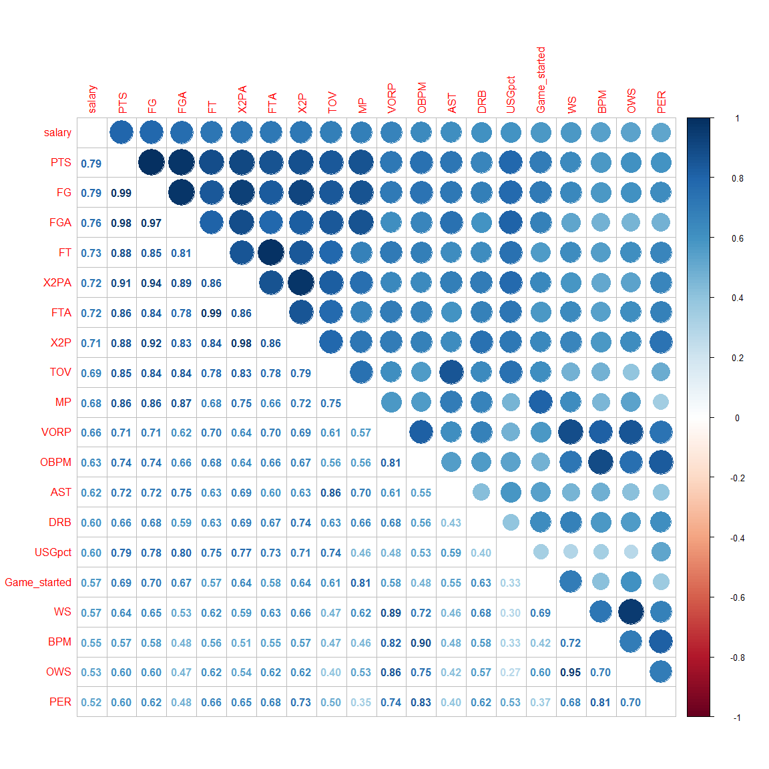

We chose three variables that show high correlation with the salary: Points per game, Value Over replacement player, and assists per game.  
The correlation shows a high multicollinearity among predictive variables.  
For example:

* FG, FGA, FT, X2PA, FTA, X2P, TOV, and MP all have correlation higher 0.8 with PTS.
* OWS has 0.95 correlation with WS
* BPM has 0.9 correlation with OBPM

### Points

PTS:

PTS - Points per game

It has the highest correlation with salary among the numeric variables (0.7944907). It is the average point per game played.

ggplotly(ggplot(all %>%  
 drop_na(PTS, salary), aes(x = PTS, y = salary)) + geom_point(col = "blue") +  
 geom_smooth(formula = y ~ x, method = "loess") + labs(title = "points per game in NBA 2021-22 vs salary in NBA 2022-23",  
 x = "points per game", y = "yearly salary (USD)"))

There is a clear linear correlation between salary and points per game. The correlation is smaller when the points per game is below about 9 but increase after it goes above 9 points.

ggplotly(ggplot(all %>%  
 drop_na(PTS, salary), aes(x = PTS)) + geom_histogram(bins = 30) + labs(title = "Frequency Distribution of points per game in NBA 2021-22",  
 x = "points per game", y = "Frequency"))

### Value Over Replacement player

Value Over Replacement Player:

VORP - Value Over Replacement Player (available since the 1973-74 season in the NBA); a box score estimate of the points per 100 TEAM possessions that a player contributed above a replacement-level (-2.0) player, translated to an average team and prorated to an 82-game season.

Although FG, FGA, FT etc are more highly correlated, they are also highly correlated to points per game (> 0.75). I will look at the next one that is not highly correlated to points per game. It has a correlation of (0.6645534) with salary. It is a estimate of the value provide provide player over a below average player.

ggplotly(ggplot(all %>%  
 drop_na(VORP, salary), aes(x = VORP, y = salary, label = ifelse(VORP <= -0.9 |  
 VORP > 6, name, ""))) + geom_point(col = "blue") + geom_smooth(formula = y ~  
 x, method = "loess") + geom_smooth(formula = y ~ x, method = "glm", linetype = "dotted",  
 col = "red", se = FALSE) + labs(title = "Value over replacement player in NBA 2021-22 vs salary in NBA 2022-23",  
 x = "VORP", y = "yearly salary (USD)") + geom_text(size = 3)) %>%  
 style(textposition = "right")

It shows clear linear correlation except some in both extreme of the VORP. The non-linear part are due to the outliers while the general trend still shows positive correlation.

### Assists

Assists:

AST - Assists per game

It has a high correlation with salary while not a having such a high correlation with points per game. It has a correlation of (0.6154281) with salary. It is the passes that lead to a field goal for the team.

ggplotly(ggplot(all %>%  
 drop_na(AST, salary), aes(x = AST, y = salary, label = ifelse(AST > 8, name,  
 ""))) + geom_point(col = "blue") + geom_smooth(formula = y ~ x, method = "loess") +  
 geom_smooth(formula = y ~ x, method = "glm", linetype = "dotted", col = "red",  
 se = FALSE) + labs(title = "Assists per game in NBA 2021-22 vs salary in NBA 2022-23",  
 x = "Assists per game", y = "yearly salary (USD)") + geom_text(size = 3)) %>%  
 style(textposition = "right")

It show positive correlation until it goes above 6 assists per game where it shows negative correlation. This maybe explained by that the players with high assist are usually not the first attacking choice of the team which means they might not be the top player of the team and thus lower salary.

# Imputing missing data and factorising character variables.

## Impute missing data

Nacol <- names(which(colSums(is.na(all) | all == "") > 0))  
sort(colSums(sapply(all[Nacol], function(x) is.na(x) | x == "")), decreasing = TRUE)

## Signed.Using Weight Height X3Ppct Position FTpct   
## 49 17 17 14 8 5   
## salary   
## 1

### Salary

I will impute the salary since it is the most important variable of the dataset (response variable).

kable(all[is.na(all$salary), c("X", "name", "salary")])

|  | X | name | salary |
| --- | --- | --- | --- |
| 146 | 146 | Ish Wainright | NA |

The salary of Ish Wainright is 125000 USD spotrac (n.d.) (source: [spotrac](https://www.spotrac.com/nba/phoenix-suns/ishmail-wainright-74220/), Accessed: 05/08/2022).

all$salary[all$name == "Ish Wainright"] <- 125000

### Signed.Using

Signed.Using:

The type of contract use to sign

Changing the value with capitalisation difference to the same to make it the same factor.

unique(all$Signed.Using)

## [1] "Bird" "Minimum Salary" "1st Round Pick"   
## [4] "" "Cap Space" "MLE"   
## [7] "Bi-Annual Exception" "Mini MLE" "Early Bird"   
## [10] "1st Round pick" "Sign and Trade" "Bird Rights"   
## [13] "Room Exception" "1st round pick" "Non Bird"   
## [16] "Cap space"

all$Signed.Using[grep("^1st [Rr]ound [Pp]ick", all$Signed.Using)] <- "1st round pick"  
all$Signed.Using[grep("Cap [Ss]pace", all$Signed.Using)] <- "Cap space"

THe NAs mean nothing special about the signing of the contract. The NAs are replaced by “None”.

all$Signed.Using[is.na(all$Signed.Using) | all$Signed.Using == ""] <- "None"

ggplotly(ggplot(all, aes(x = fct_reorder(as.factor(Signed.Using), salary, .fun = "mean"),  
 y = salary, fill = Signed.Using)) + geom_boxplot() + geom_point(stat = "summary",  
 fun = "mean") + labs(title = "Type of contract vs salary", x = "Type of contract",  
 y = "yearly salary (USD)") + theme(axis.text.x = element_text(angle = 45, hjust = 1)))

There are no clear ordinal element in the Signed.Using variable so it will be kept as a character variable.

### Height and Weight

Some of the players height and weight are missing. We manually searched up each player and input them. The data are from [Basketball Reference](https://www.basketball-reference.com/).

kable(all[which(is.na(all$Weight) | is.na(all$Height)), c("name", "Weight", "Height")])

|  | name | Weight | Height |
| --- | --- | --- | --- |
| 7 | Aleksej Pokusevski | NA | NA |
| 10 | Alperen Şengün | NA | NA |
| 22 | Boban Marjanović | NA | NA |
| 24 | Bogdan Bogdanović | NA | NA |
| 25 | Bojan Bogdanović | NA | NA |
| 29 | Brandon Boston Jr. | NA | NA |
| 75 | Dāvis Bertāns | NA | NA |
| 185 | Jonas Valančiūnas | NA | NA |
| 204 | Jusuf Nurkić | NA | NA |
| 245 | Luka Dončić | NA | NA |
| 253 | Marcus Morris | NA | NA |
| 285 | Nikola Jokić | NA | NA |
| 286 | Nikola Vučević | NA | NA |
| 315 | Robert Williams | NA | NA |
| 346 | Théo Maledon | NA | NA |
| 373 | Vlatko Čančar | NA | NA |
| 378 | Willy Hernangómez | NA | NA |

I will manually search up their height and weight.

all$Weight[which(is.na(all$Weight))] <- c(190, 235, 290, 220, 226, 185, 225, 265,  
 290, 230, 218, 284, 260, 237, 175, 236, 250)  
  
all$Height[which(is.na(all$Height))] <- c("7-0", "6-9", "7-3", "6-6", "6-7", "6-7",  
 "6-10", "6-11", "6-11", "6-7", "6-8", "6-11", "6-10", "6-8", "6-4", "6-8", "6-11")

Change height unit from feet to inches.

heightinch <- as.numeric(sapply(all$Height, function(x) substring(x, 1, 1))) * 12 +  
 as.numeric(sapply(all$Height, function(x) substring(x, 3, nchar(x))))  
  
all$Height <- heightinch

g1 <- ggplot(all, aes(x = as.numeric(Height), y = as.numeric(Weight), col = as.numeric(salary),  
 size = salary)) + geom_point(alpha = 0.7) + theme_minimal() + labs(title = "Weight, Height and salary") +  
 scale_color_continuous(high = "#132B43", low = "#56B1F7")  
  
ggMarginal(g1, type = "boxplot")

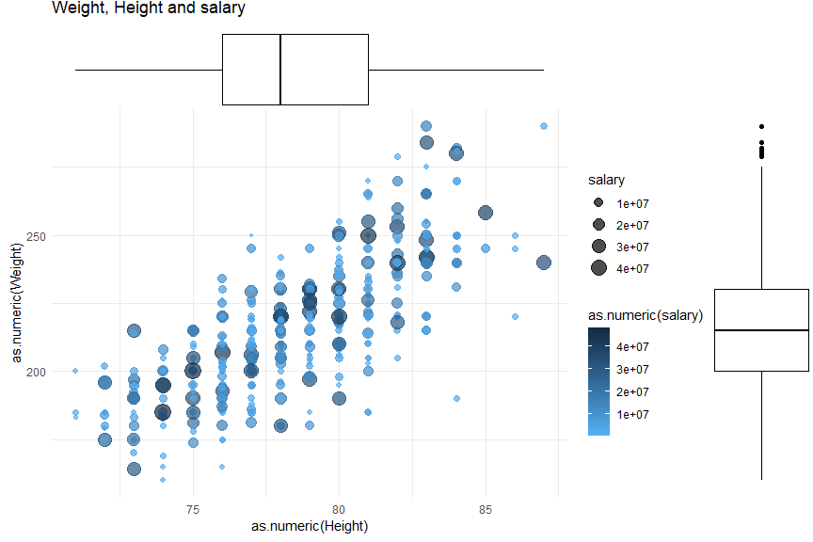 There clear positive correlation between height and weight but there is no visible correlation with salary.

### X3Ppct

X3Ppct:

3 point field goal percentage

Some players had not made any 3 points attempt in the season which become NA.

kable(all[which(is.na(all$X3Ppct)), c("name", "X3P", "X3PA", "X3Ppct")])

|  | name | X3P | X3PA | X3Ppct |
| --- | --- | --- | --- | --- |
| 21 | Bismack Biyombo | 0 | 0 | NA |
| 82 | DeAndre Jordan | 0 | 0 | NA |
| 147 | Ivica Zubac | 0 | 0 | NA |
| 150 | Jaden Springer | 0 | 0 | NA |
| 176 | Jericho Sims | 0 | 0 | NA |
| 269 | Mitchell Robinson | 0 | 0 | NA |
| 273 | Moses Brown | 0 | 0 | NA |
| 280 | Nic Claxton | 0 | 0 | NA |
| 281 | Nick Richards | 0 | 0 | NA |
| 291 | Onyeka Okongwu | 0 | 0 | NA |
| 351 | Tony Bradley | 0 | 0 | NA |
| 364 | Tyrell Terry | 0 | 0 | NA |
| 368 | Udoka Azubuike | 0 | 0 | NA |
| 370 | Vernon Carey Jr. | 0 | 0 | NA |

I will impute by setting to 0 if there is no 3 point attempt.

all$X3Ppct[which(is.na(all$X3Ppct))] <- sapply(which(is.na(all$X3Ppct)), function(x) ifelse(all$X3PA[x] ==  
 0, 0, all$X3P[x]/all$X3PA[x]))

ggplotly(ggplot(all, aes(x = X3Ppct, y = salary)) + geom_point() + geom_smooth(col = "red",  
 formula = y ~ x, method = "glm") + labs(title = "3 point percentage vs salary",  
 x = "3 point field goal percentage", y = "yearly salary (USD)"))

It shows a slight but not significant correlation between salary and 3 point percentage. Most players’ three point percentage lies between 20% and 43%.

ggplotly(ggplot(all, aes(x = X3Ppct, y = salary, col = Position)) + geom_point() +  
 geom_smooth(formula = y ~ x, method = "glm") + facet_grid(Position ~ .) + labs(title = "3 point percentage vs salary for each position",  
 x = "3 point field goal percentage", y = "yearly salary (USD)"))

There are little to none correlation if separate to each position. This might be the result of the modern NBA requires everyone to have certain degree of three point ability regardless of their position.

### Position

The position of the following is

kable(all[is.na(all$Position), c("name", "Position")])

|  | name | Position |
| --- | --- | --- |
| 18 | Armoni Brooks | NA |
| 97 | Didi Louzada | NA |
| 99 | Domantas Sabonis | NA |
| 202 | Justin Holiday | NA |
| 237 | Larry Nance Jr. | NA |
| 287 | Norman Powell | NA |
| 331 | Spencer Dinwiddie | NA |
| 365 | Tyrese Haliburton | NA |

I will impute manually by search up their primary position

all$Position[is.na(all$Position)] <- c("SG", "SF", "PF", "SG", "PF", "SG", "PG",  
 "PG")

ggplot(all, aes(x = Position, y = salary, fill = Position)) + geom_boxplot() + labs(title = "salary distribution for each position")

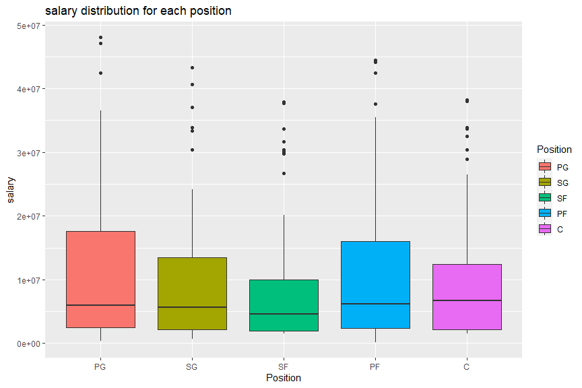 Although there are a number corresponding to each position in basketball, the above show no ordinal correlation with the salary. Hence, I will keep it as a factor.

### FTpct

FTpct:

Free throw percentage

Some players had not made a free throw attempt throughout the season which is record as NA.

kable(all[which(is.na(all$FTpct)), c("FT", "FTA", "FTpct")])

|  | FT | FTA | FTpct |
| --- | --- | --- | --- |
| 150 | 0 | 0 | NA |
| 205 | 0 | 0 | NA |
| 251 | 0 | 0 | NA |
| 325 | 0 | 0 | NA |
| 364 | 0 | 0 | NA |

I will impute by setting to 0 if there is no free throw attempt.

all$FTpct[which(is.na(all$FTpct))] <- sapply(which(is.na(all$FTpct)), function(x) ifelse(all$FTA[x] ==  
 0, 0, all$FT[x]/all$FTA[x]))

ggplotly(ggplot(all, aes(x = FTpct, y = salary)) + geom_point() + geom_smooth(formula = y ~  
 x, method = "glm") + labs(title = "Free throw percentage vs salary", x = "free throw percentage",  
 y = "yearly salary (USD)"))

### Guaranteed

Guaranteed:

The amount of a player's remaining salary that is guarenteed.

Since it is a direct indication of the salary, I will remove this variable.

all <- dplyr::select(all, !Guaranteed)

## Factorizing Character Variables

Find all character variables:

chrVar <- names(which(sapply(all, is.character)))  
chrVar

## [1] "name" "player_id" "team_2021" "team_2022" "Signed.Using"

### Player Id and playe name

I will keep tempfor now to keep track of each entries but will remove them before fitting the model.

### Team

ggplotly(ggplot(all, aes(x = fct_reorder(as.factor(team_2021), salary, median, .desc = TRUE),  
 y = salary, fill = reorder(as.factor(team_2021), salary, .fun = "mean", decreasing = TRUE))) +  
 geom_boxplot() + labs(title = "Salary for each team", x = "team in 2021-22",  
 y = "yearly salary in 2022-23 (USD)") + theme(axis.text.x = element_text(angle = 45,  
 hjust = 1)) + guides(fill = guide_legend(title = "Team")))

ggplotly(ggplot(all, aes(x = fct_reorder(as.factor(team_2022), salary, median, .desc = TRUE),  
 y = salary, fill = reorder(as.factor(team_2022), salary, .fun = "mean", decreasing = TRUE))) +  
 geom_boxplot() + labs(title = "Salary for each team", x = "team in 2022-23",  
 y = "yearly salary in 2022-23 (USD)") + theme(axis.text.x = element_text(angle = 45,  
 hjust = 1)) + guides(fill = guide_legend(title = "Team")))

all$team_2021 <- as.factor(all$team_2021)  
all$team_2022 <- as.factor(all$team_2022)

### Signed.Using

I will also remove this variable as this might be a direct indication to the salary of the player.

all <- dplyr::select(all, !Signed.Using)

# Visualization

## The response variable: salary

Although I have already done some visualization, I will visualize it again.

summary(all$salary)

## Min. 1st Qu. Median Mean 3rd Qu. Max.   
## 125000 2189160 5823098 10105516 13931408 48070014

ggplotly(ggplot(data = all, aes(x = "", y = salary)) + geom_boxplot() + labs(y = "salary") +  
 coord_flip() + theme_minimal())

The salary (in USD) ranges from 0.1 million to 48.1 million with mean of 10.1 million and median of 5.8 million.

ggplotly(ggplot(data = all, aes(x = salary)) + geom_histogram(bins = 50) + labs(title = "Frequency distribution of salary",  
 x = "yearly salary (USD)", y = "frequency") + theme_minimal())

As from above, the data is highly right skewed and has a large spike in about 2 million.

g1 <- ggplot(all, aes(x = Age, y = salary)) + geom_point(alpha = 0.7) + theme_minimal() +  
 geom_smooth(formula = y ~ x, method = "glm") + labs(title = "Age vs Salary")  
ggMarginal(g1, type = "boxplot")

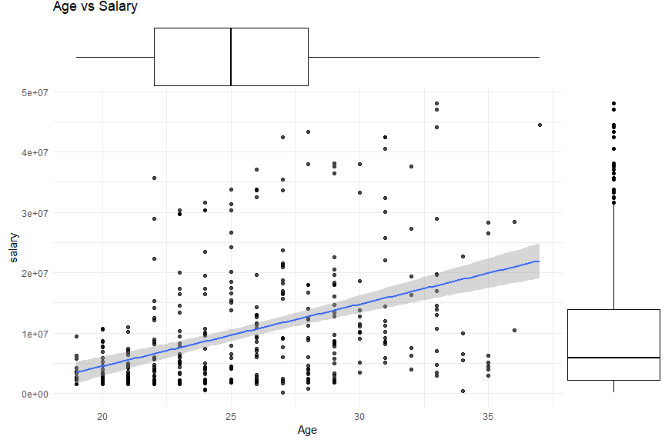 There are a clear positive correlation of age and salary. This can be due to various reason including the existence of rookie contract, experience players general earns more and players with longer experience have a higher minimum salary.

## Grouping predictors

Group variables to different categories:

* Player bios: Basic information of the players
* Attendance: Measures of players’ actually played
* shooting: General shoot attributes
* 2 pointers: 2 point shooting attributes
* 3 pointers: 3 point shooting attributes
* Free throw: Free throw shooting attributes
* Rebounding: Rebounding attributes
* Playmaking: Team play attributes
* Defence: defence related attributes
* Advance: Advance statistics that measure overall performance

pbio <- c("Age", "Height", "Weight")  
  
attendence <- c("Game_played", "Game_started", "MP", "USGpct")  
  
shooting <- c("FG", "FGA", "FGpct", "eFGpct", "PTS", "TSpct")  
  
X2_point <- c("X2P", "X2PA", "X2Ppct")  
  
X3_point <- c("X3P", "X3PA", "X3Ppct", "X3PAr")  
  
Free_throw <- c("FT", "FTA", "FTpct", "FTr")  
  
rebounding <- c("ORB", "DRB", "TRB", "ORBpct", "DRBpct", "TRBpct")  
  
playmaking <- c("AST", "TOV", "ASTpct", "TOVpct")  
  
defence <- c("STL", "BLK", "PF", "STLpct", "BLKpct")  
  
overall_adstats <- c("PER", "OWS", "DWS", "WS", "WSper48", "OBPM", "DBPM", "BPM",  
 "VORP")

### Player Bio

all_bio <- melt(all, id.vars = "salary", measure.vars = pbio)  
  
ggplot(all_bio, aes(x = value, y = salary)) + geom_point() + geom_smooth(formula = y ~  
 x, method = glm) + facet_wrap(vars(variable), scales = "free")

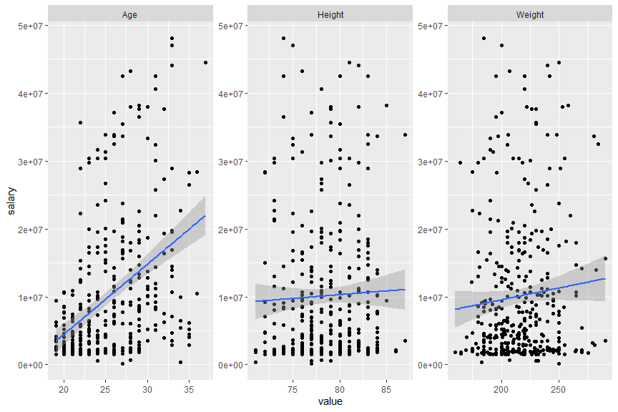 The age show clear correlation while height and weight do not show much. It is reasonable as different position requires different height and weight and different player with different height has their own play style that suits their body. There is no clear correlation of their body and their performance and thus salary.

### Attendence

all_attendence <- melt(all, id.vars = "salary", measure.vars = attendence)  
  
ggplot(all_attendence, aes(x = value, y = salary)) + geom_point() + geom_smooth(formula = y ~  
 x, method = glm) + facet_wrap(vars(variable), scales = "free")

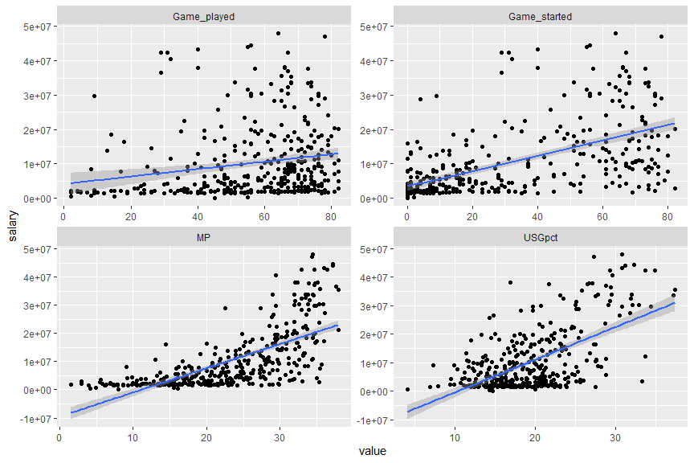 All of the attributes show positive correlation. This make sense as player with stronger performance get played more and get paid more. Both attendance and salary are related to player performance.

### Overall shooting

all_ovSh <- melt(all, id.vars = "salary", measure.vars = shooting)  
  
ggplot(all_ovSh, aes(x = value, y = salary)) + geom_point() + geom_smooth(formula = y ~  
 x, method = glm) + facet_wrap(vars(variable), scales = "free")

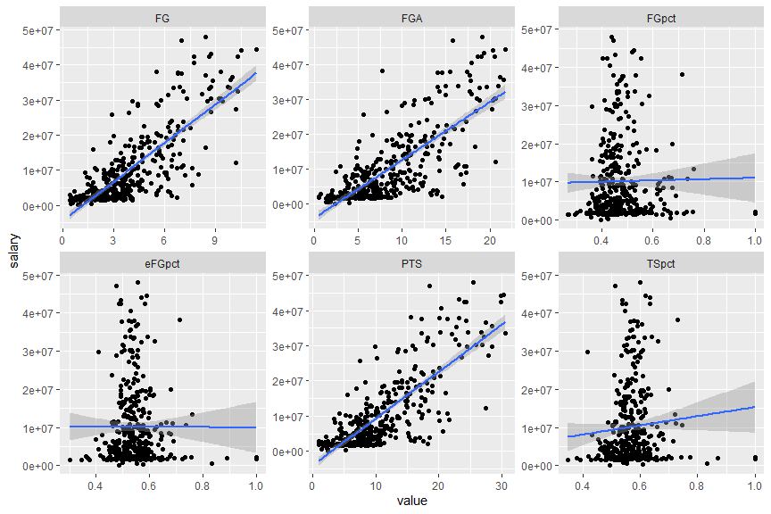

Field goal percentage is directly correlated to FG and FGA and it doesn’t have large correlation to salary. Effective field goal percentage is removed as it is similar to true shooting percentage and it has less correlation.

cor(all$FG, (all$FGA * all$FGpct))

## [1] 0.9999042

all <- all %>%  
 dplyr::select(!eFGpct)

### 2 Pointers

all_X2 <- melt(all, id.vars = "salary", measure.vars = X2_point)  
  
ggplot(all_X2, aes(x = value, y = salary)) + geom_point() + geom_smooth(formula = y ~  
 x, method = glm) + facet_wrap(vars(variable), scales = "free")

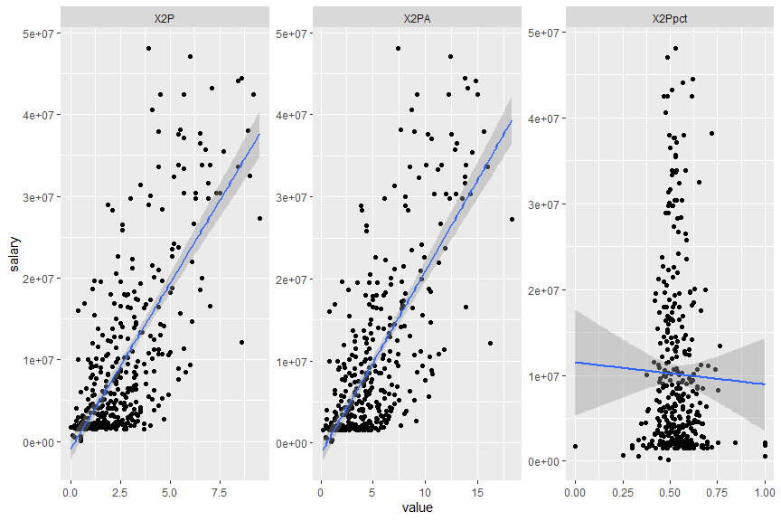 It is out of expectation that 2 point field goal percentage has a negative correlation with salary. This can be due to players who shoot more tends to decrease in shooting percentage from fatigue while player with few attempt is easier to maintain high shooting percentage. At the same time players who shoot more are usually the top player of the team and thus have higher salary.

### 3 Pointers

all_X3 <- melt(all, id.vars = "salary", measure.vars = X3_point)  
  
ggplot(all_X3, aes(x = value, y = salary)) + geom_point() + geom_smooth(formula = y ~  
 x, method = glm) + facet_wrap(vars(variable), scales = "free")

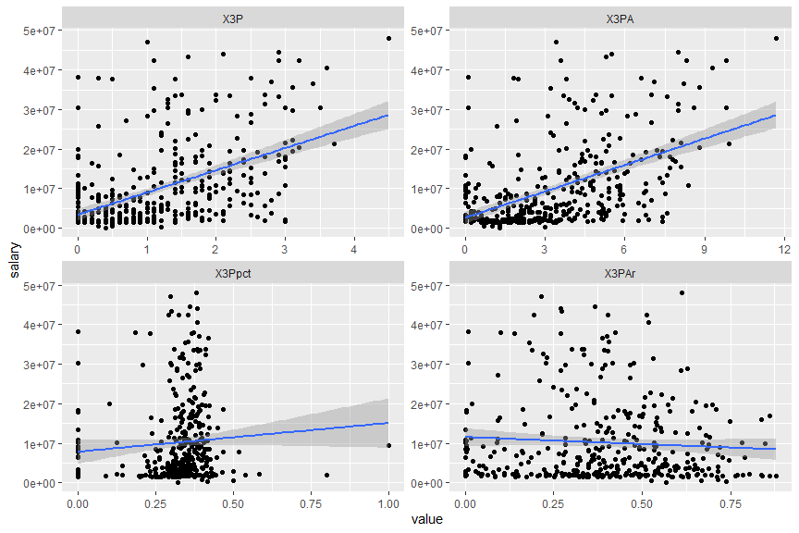 All except 3 point attempt rate shows a positive correlation which make sense, as really high 3 point attempt rate shows that the players have small attempt rate and relies on little ways of scoring which are often a role player and thus paid less.

### Free throw

all_ft <- melt(all, id.vars = "salary", measure.vars = Free_throw)  
  
ggplot(all_ft, aes(x = value, y = salary)) + geom_point() + geom_smooth(formula = y ~  
 x, method = glm) + facet_wrap(vars(variable), scales = "free")

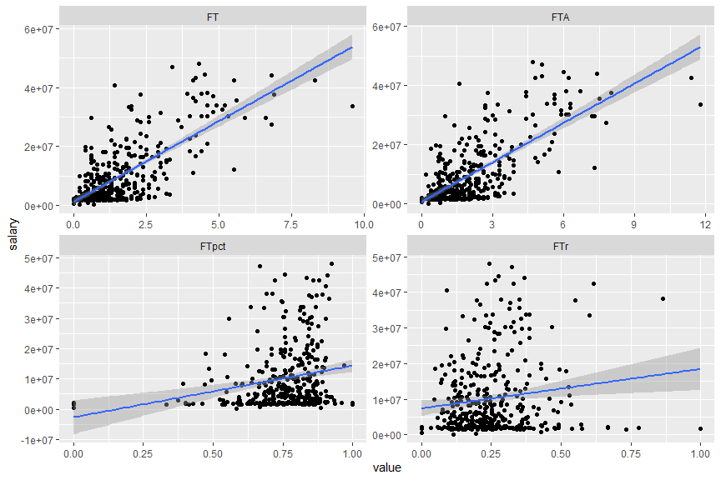 All attributes have a positive correlation with salary.

### Rebounding

all_rb <- melt(all, id.vars = "salary", measure.vars = rebounding)  
  
ggplot(all_rb, aes(x = value, y = salary)) + geom_point() + geom_smooth(formula = y ~  
 x, method = glm) + facet_wrap(vars(variable), scales = "free")

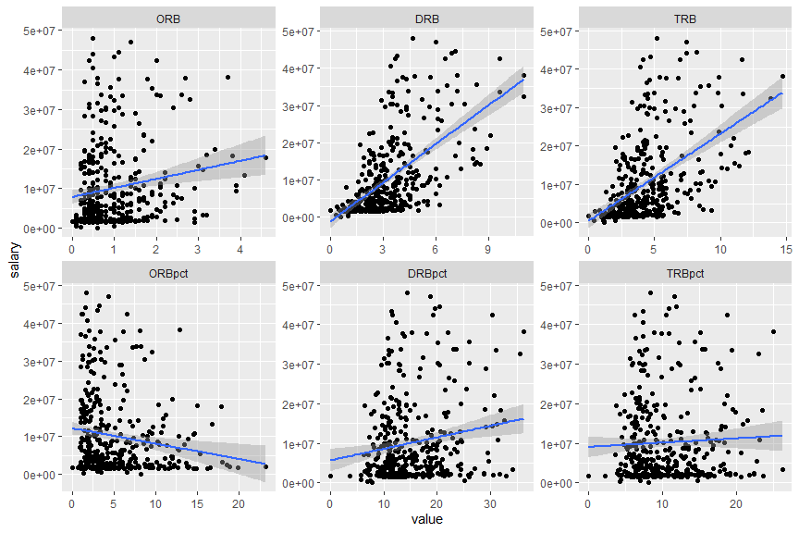 It is out of expectation that the offensive rebound percentage show a negative correlation. This might be explained by only role player will attempt to grab offensive rebound to conserve main player stamina.

### Playmaking

all_pm <- melt(all, id.vars = "salary", measure.vars = playmaking)  
  
ggplot(all_pm, aes(x = value, y = salary)) + geom_point() + geom_smooth(formula = y ~  
 x, method = glm) + facet_wrap(vars(variable), scales = "free")

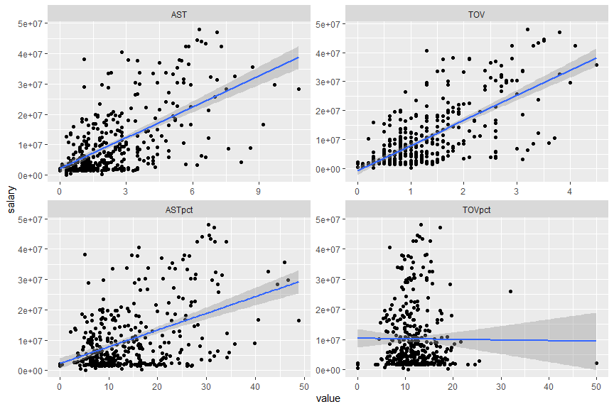 The plots show a strong correlation of turnover and salary. This is because the top players have more usage of the ball and thus easier to turnover the ball.

### Defending

all_df <- melt(all, id.vars = "salary", measure.vars = defence)  
  
ggplot(all_df, aes(x = value, y = salary)) + geom_point() + geom_smooth(formula = y ~  
 x, method = glm) + facet_wrap(vars(variable), scales = "free")

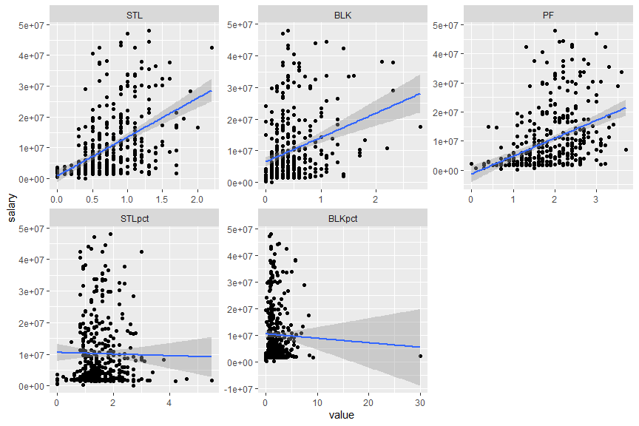

### Overall performance

all_ovAd <- melt(all, id.vars = "salary", measure.vars = overall_adstats)  
  
ggplot(all_ovAd, aes(x = value, y = salary)) + geom_point() + geom_smooth(formula = y ~  
 x, method = glm) + facet_wrap(vars(variable), scales = "free")

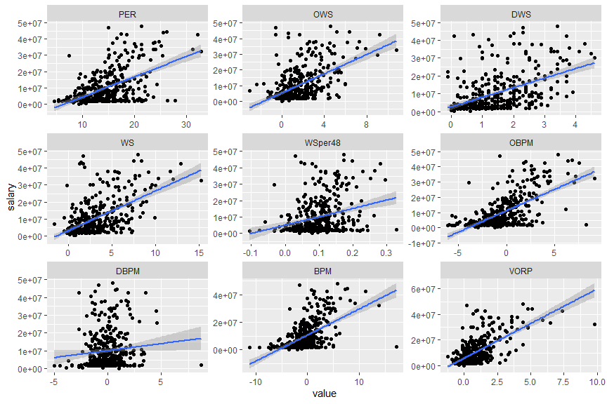

# Feature Engineering

To reduce complexity of the model, I will combine and delete some variables. A high complexity model will result in overfitting which will lead to a lower accuracy in predicting unseen data.  
Before this, I will save a copy of original data for possible future operation.

write.csv(all[, !names(all) %in% c("X")], "dataset/cleaned_data.csv")

## Character variables

### Player Id and name

I will remove player id and name since it unique for each player and thus cannot use in regression, but I will save the player id and name in another variables to take reference from.

players <- all[, c("player_id", "name")]  
all <- dplyr::select(all, !c(player_id, name))

### Teams

It show little correlation and this research is mainly about the players’ individual statistics. Hence, it is removed.

cor(as.numeric(fct_reorder(as.factor(all$team_2021), all$salary, median)), all$salary)

## [1] 0.2288759

cor(as.numeric(fct_reorder(as.factor(all$team_2022), all$salary, median)), all$salary)

## [1] 0.1704062

There is no clear correlation between salary and team as each team will have varying salary for their star players and bench players. I will remove this variable.

all <- dplyr::select(all, !c(team_2021, team_2022))

## Importance of each variable

quick_rf <- randomForest(salary ~ ., data = all, ntree = 100, importance = TRUE)  
  
imp_rf <- randomForest::importance(quick_rf)  
imp_df <- data.frame(Variables = row.names(imp_rf), MSE = imp_rf[, 1])  
imp_df <- imp_df[order(imp_df$MSE, decreasing = TRUE), ]  
  
ggplot(imp_df[1:20, ], aes(x = reorder(Variables, MSE), y = MSE, fill = MSE)) + geom_bar(stat = "identity") +  
 labs(x = "Variables", y = "% increase MSE if variable is randomly permuted") +  
 coord_flip() + theme(legend.position = "none")

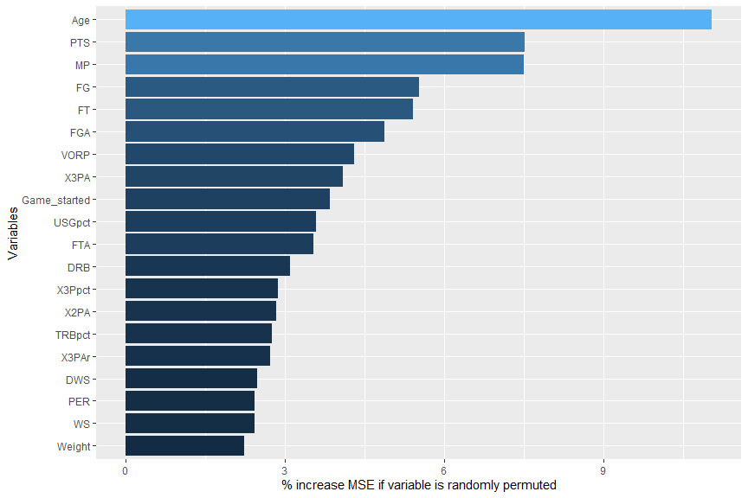

## Net Possession Gained

There are steal, block and offensive rebounds per game record but their correlation is not very strong. I will combine them into possession gain to make a stronger variable as these action will all result in a possession gain for the team.

cor(all$STL, all$salary)

## [1] 0.460643

cor(all$BLK, all$salary)

## [1] 0.2902457

cor(all$ORB, all$salary)

## [1] 0.1674434

Removing steal, block and offensive rebounds per game and add possession gain.

all <- all %>%  
 mutate(possGain = STL + BLK + ORB) %>%  
 dplyr::select(!c(STL, BLK, ORB))

## Possession Lost

I will combine turn-overs and personal fouls to become possession. These variables have a low importance in the random forest. These actions will result in an possession lost.

imp_df$MSE[imp_df$Variables %in% c("TOV", "PF")]

## [1] 1.880236 1.047104

all <- all %>%  
 mutate(possLost = TOV + PF) %>%  
 dplyr::select(!c(TOV, PF))

## field goal missed + remove field goal percentage and field goal attempt

I will remove anything about two pointer as it is just portion of field goal that is not three pointers.

all <- all %>%  
 dplyr::select(!c(X2P, X2PA, X2Ppct))

I will remove free throw, field goal and 3 point percentage and attempts. I will replace them by free throw, field goal and 3 three point missed.

all <- all %>%  
 mutate(FGM = FGA - FG, X3M = X3PA - X3P, FTM = FTA - FT) %>%  
 dplyr::select(!c(FGA, FGpct, X3PA, X3Ppct, FTA, FTpct))

## Removing Game played and add starter

I will remove game started and replace it will starter. It will be define whether that player has start for more than 50% of their game played. I will also remove game played as it is directly related to minutes played while minutes played has a stronger correlation and importance. I will also change minutes play per game to minutes played in total

all <- all %>%  
 mutate(starter = ifelse(Game_started/Game_played >= 0.5, 1, 0), MP = MP * Game_played) %>%  
 dplyr::select(!c(Game_started, Game_played))  
all$starter <- as.factor(all$starter)

## Win share

I will remove win share and win share per 48 as it is just sum of defensive and offensive win share.

all <- dplyr::select(all, !c(WS, WSper48))

## Total rebound

I will remove total rebound as it is the sum of offensive and defensive rebound while defensive rebound has stronger correlation and importance.

all <- dplyr::select(all, !TRB)

## Box score

I will remove Box Plus or minus as it is the sum of offensive and defensive box score.

cor(all[, c("OBPM", "DBPM", "BPM", "salary")])[, "salary"]

## OBPM DBPM BPM salary   
## 0.6356575 0.1026086 0.5481368 1.0000000

imp_df[imp_df$Variables %in% c("OBPM", "DBPM", "BPM"), ]

## Variables MSE  
## OBPM OBPM 1.5791844  
## BPM BPM 0.7975069  
## DBPM DBPM 0.2255854

cor(all$OBPM + all$DBPM, all$BPM)

## [1] 0.9998765

all$BPM <- NULL

## Free throw rate and three point rate

I will remove them as their are directly related to field goal and field goal missed.

all$FTr <- NULL  
all$X3PAr <- NULL

# Preparing data for modelling

As I am not sure about the effect of the variables on the model, I will not remove any extra variable but look at the results first

rm(list = ls()[!ls() %in% c("all", "players")])

## Preprocessing predictor variables

numVar <- names(which(sapply(all, is.numeric)))  
salary <- all$salary  
player_name <- all$name  
numVar <- numVar[!numVar %in% c("salary", "X", "name")]  
all_num <- all[, numVar]  
all_fac <- all[, !names(all) %in% c(numVar, "salary", "name", "X")]

There are 30 numeric predictors and 2 factor predictor.

### Removing skewness of variables

I will use min max normalization for variable with negative value to turn all data to positive.  
Variables that are highly right skewed (skewness > 0.8) are natural logged to reduce skewness.  
Variables that are highly left skewed (skewness < -0.8) are squared to reduce skewness.

log_names <- c()  
minMax <- c()  
sq_names <- c()  
for (i in 1:ncol(all_num)) {  
 if (any(all_num[, i] <= 0)) {  
 process <- preProcess(as.data.frame(all_num[, i]), method = "range")  
 all_num[, i] <- predict(process, as.data.frame(all_num[, i]))  
 minMax <- c(minMax, i)  
 }  
 if (skew(all_num[, i]) > 0.8) {  
 all_num[, i] <- log(all_num[, i] + 1)  
 log_names <- c(log_names, i)  
 } else if (skew(all_num[, i]) < -0.8) {  
 all_num[, i] <- all_num[, i]^2  
 sq_names <- c(sq_names, i)  
 }  
}  
log_names <- names(all_num)[log_names]  
minMax_names <- names(all_num)[minMax]  
sq_names <- names(all_num)[sq_names]

These column have been log + 1 due to its skewness.  
(The + 1 is to prevent logging 0 which result in NA)

### Normalizing Data

The remaining data is normalized by feature scaling and mean normalization.

all_num[!names(all_num) %in% log_names] <- as.data.frame(scale(all_num[!names(all_num) %in%  
 log_names]))

### One hot encoding for categorical variables

I will convert all the remaining variables to numeric (it is required by many machine learning algorithm).

all_fac <- as.data.frame(model.matrix(~. - 1, as.data.frame(all_fac)))

## Dealing with the skewness of response variable

skew(salary)

## [1] 1.564389

The skewness of salary is too high which will be harder to fit a model

qqnorm(salary)  
qqline(salary)

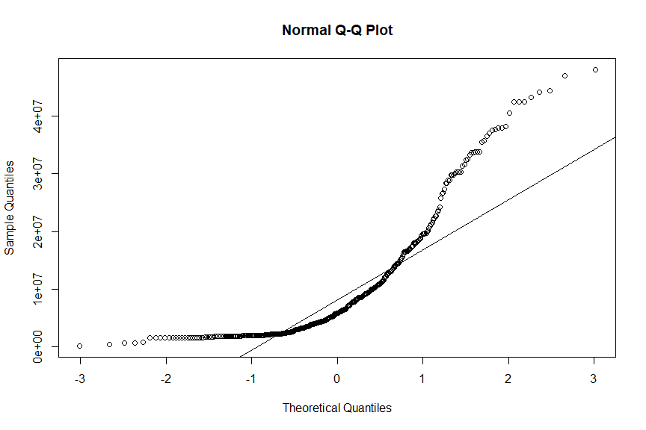 This is a QQ plot where the x axis are the theoretical quantiles while y axis are the sample quantile. The diagonal line is where sample theoretical quantiles perfectly aligned. The placementment of the point indicate the skewness of the sample.

Salary is too right skewed and not normally distributed.

salary <- log(salary)  
skew(salary)

## [1] 0.04653786

After logging, the points lie more towards the line (less skewed).

qqnorm(salary)  
qqline(salary)

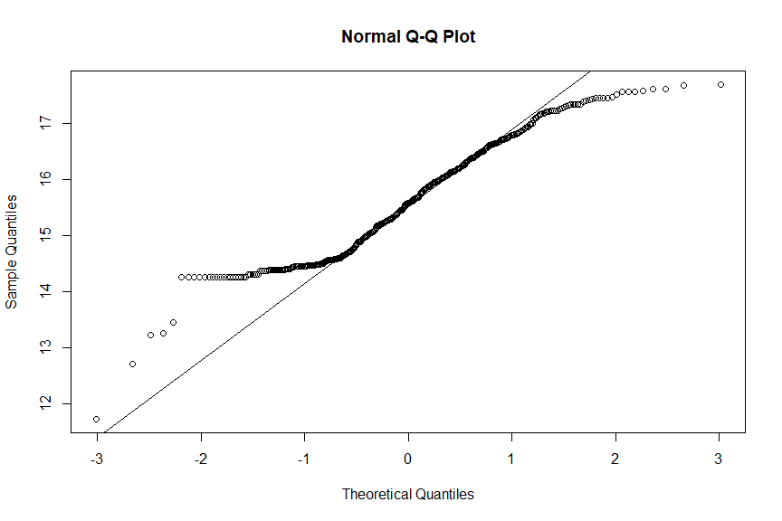

plot(x = 1:length(salary), y = sort(salary))  
abline(h = 14)

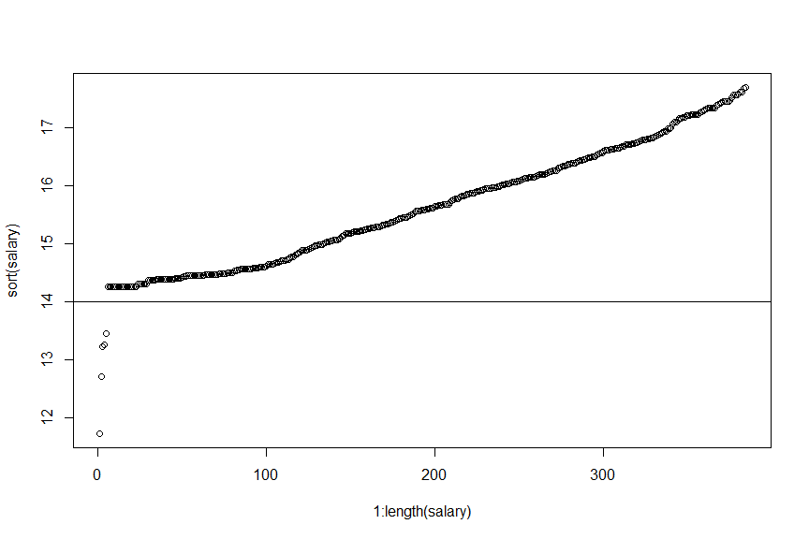

### Combining data

I treat log(salary) < 14 as outlier and remove them from the data.

all_noNorm <- cbind(X = 1:nrow(all), salary = salary, all[, numVar], all_fac)  
alldata <- cbind(X = 1:nrow(all), salary = salary, all_num, all_fac)  
row.names(alldata) <- players$name  
name <- players$name[alldata$salary > 14]  
alldata <- alldata[alldata$salary > 14, ]  
all_noNorm <- all_noNorm[alldata$salary > 14, ]

## Spliting training and testing set

I will use train-test split and 10 fold cross validation in the training set,

inTrain <- sample(1:2, size = nrow(alldata), prob = c(0.8, 0.2), replace = TRUE)  
train <- alldata[inTrain == 1, ]  
test <- alldata[inTrain == 2, ]  
train_noNorm <- all_noNorm[inTrain == 1, ]  
test_noNorm <- all_noNorm[inTrain == 2, ]

write.csv(alldata[, -c(1, 2)], "dataset/normalized_data.csv")

# Modelling

In the modelling I will use the cross validation root mean squared error to determine which model to choose.

## Linear regression

mod_lm <- lm(salary ~ . - X, data = train)

plot(mod_lm, which = 1)

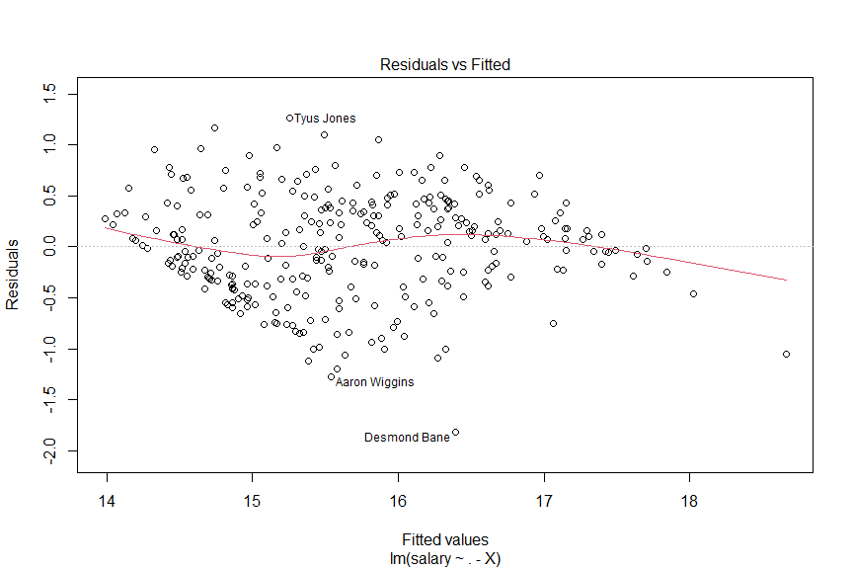

plot(mod_lm, which = 2)

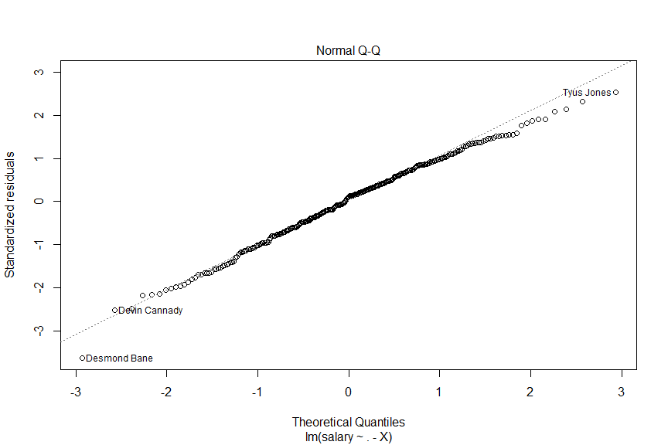

plot(mod_lm, which = 3)

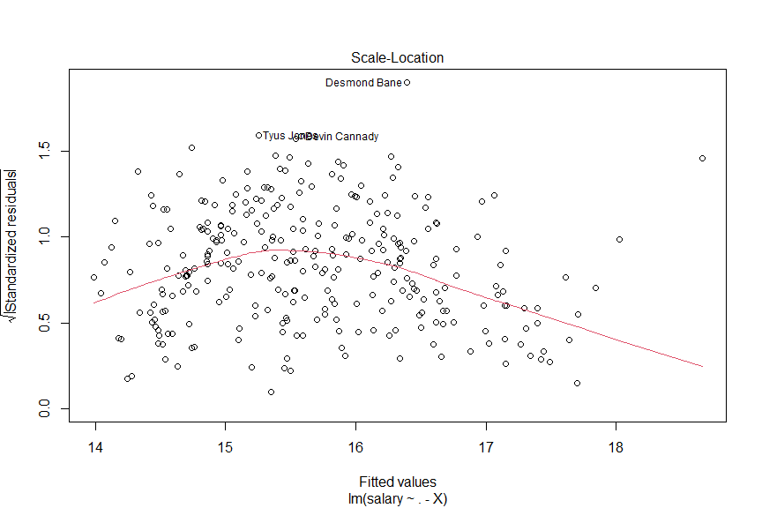

plot(mod_lm, which = 4)  
abline(h = 4/nrow(train))

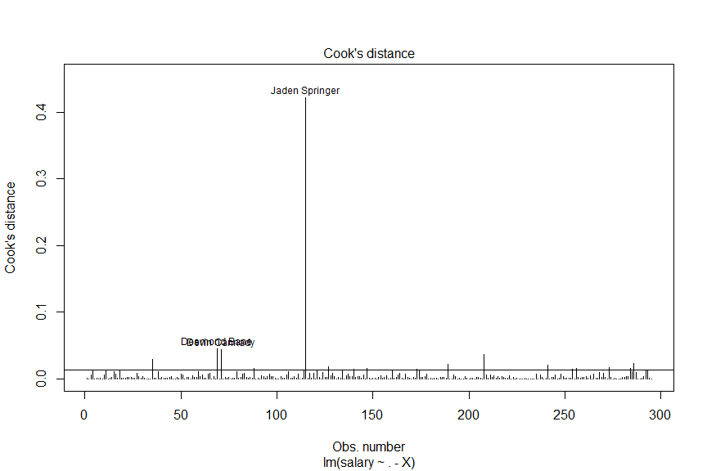 The cook’s distance measures the residual and leverage of that point. It represent the degree of influence on the regression model. We will take a look at the player with high cook’s distance.

sort(cooks.distance(mod_lm), decreasing = TRUE)[1:3]

## Jaden Springer Desmond Bane Devin Cannady   
## 0.42218052 0.04500047 0.04449516

players[players$name %in% names(which(cooks.distance(mod_lm) > 4/nrow(train))), ]

## player_id name  
## 43 edwarca01 Carsen Edwards  
## 91 banede01 Desmond Bane  
## 93 cannade01 Devin Cannady  
## 114 kaminfr01 Frank Kaminsky  
## 150 sprinja01 Jaden Springer  
## 166 culveja01 Jarrett Culver  
## 180 harrijo01 Joe Harris  
## 189 poolejo01 Jordan Poole  
## 220 loveke01 Kevin Love  
## 240 jamesle01 LeBron James  
## 264 portemi01 Michael Porter Jr.  
## 308 tuckera01 Rayjon Tucker  
## 322 westbru01 Russell Westbrook  
## 324 beysa01 Saddiq Bey  
## 344 taylote01 Terry Taylor  
## 365 halibty01 Tyrese Haliburton  
## 367 jonesty01 Tyus Jones

summary(mod_lm)

##   
## Call:  
## lm(formula = salary ~ . - X, data = train)  
##   
## Residuals:  
## Min 1Q Median 3Q Max   
## -1.82226 -0.31639 0.05619 0.35760 1.27033   
##   
## Coefficients: (1 not defined because of singularities)  
## Estimate Std. Error t value Pr(>|t|)   
## (Intercept) 16.483750 1.394815 11.818 < 2e-16 ***  
## Age 0.307495 0.037006 8.309 5.45e-15 ***  
## MP -0.328533 0.100108 -3.282 0.00117 **   
## FG 1.411302 1.044245 1.352 0.17771   
## X3P -0.162821 0.181761 -0.896 0.37119   
## FT -0.317065 1.277467 -0.248 0.80418   
## DRB 2.461169 1.768175 1.392 0.16514   
## AST 3.371172 1.418029 2.377 0.01816 *   
## PTS -1.402118 0.895750 -1.565 0.11873   
## PER 0.373310 0.677644 0.551 0.58218   
## TSpct -2.156322 2.921740 -0.738 0.46117   
## ORBpct 2.857177 3.851514 0.742 0.45886   
## DRBpct 6.086728 6.086241 1.000 0.31821   
## TRBpct -11.152085 9.186810 -1.214 0.22588   
## ASTpct -3.406084 1.245786 -2.734 0.00669 **   
## STLpct -0.259637 0.752566 -0.345 0.73037   
## BLKpct 0.398177 1.442842 0.276 0.78279   
## TOVpct 0.989632 1.092366 0.906 0.36580   
## USGpct 0.034019 0.155156 0.219 0.82662   
## OWS 2.474102 1.415557 1.748 0.08168 .   
## DWS 0.230342 0.102941 2.238 0.02610 *   
## OBPM 0.137806 0.139308 0.989 0.32348   
## DBPM -0.044575 0.090066 -0.495 0.62108   
## VORP -1.675764 1.884377 -0.889 0.37467   
## Weight -0.040123 0.059448 -0.675 0.50032   
## Height 0.134180 0.071508 1.876 0.06172 .   
## possGain 0.411751 1.275648 0.323 0.74712   
## possLost -0.001725 0.107122 -0.016 0.98717   
## FGM 0.181024 0.270827 0.668 0.50447   
## X3M 0.333070 0.161365 2.064 0.04001 *   
## FTM 1.307387 0.587963 2.224 0.02704 *   
## PositionC -0.220577 0.196897 -1.120 0.26364   
## PositionPF -0.135904 0.143901 -0.944 0.34583   
## PositionPG -0.207653 0.124694 -1.665 0.09706 .   
## PositionSF -0.214658 0.115568 -1.857 0.06439 .   
## PositionSG NA NA NA NA   
## starter1 0.206174 0.108258 1.904 0.05796 .   
## ---  
## Signif. codes: 0 '***' 0.001 '**' 0.01 '*' 0.05 '.' 0.1 ' ' 1  
##   
## Residual standard error: 0.5332 on 259 degrees of freedom  
## Multiple R-squared: 0.7608, Adjusted R-squared: 0.7285   
## F-statistic: 23.54 on 35 and 259 DF, p-value: < 2.2e-16

### Glossary of the summary

* Residual
  + The difference between each predict value and actual value
  + It ranges from -1.8222 to 1.2703
* Coefficients
  + Estimate
    - The estimate value of the weight
  + Std. Error
    - The standard error of the weight (Similar to standard deviation)
  + t value
    - The number of standard error of the estimate weight from 0
  + p value
    - The probability of getting the estimate weight if the actual weight is 0
* Residual standard error
  + The standard deviation of residuals
* R-squared
  + The estimate proportion of the responsive variable the model has accounted for
* F-statistics
  + p value: the probability of getting these weight provided that the null hypothesis is all weight is zero.

The r squared of the model is 0.7608406

rmse(train$salary, mod_lm$fitted.values)

## [1] 0.4996236

rmse(test$salary, predict(object = mod_lm, newdata = test))

## [1] 0.5427067

The train root mean squared error is 0.4996236 while the testing (out of bag) root mean squared error is 0.5427067.

## Lasso regression

train_control <- trainControl(method = "cv", number = 10)  
param_grid <- expand.grid(alpha = 1, lambda = seq(0.001, 0.1, by = 5e-04))  
  
mod_lasso <- train(salary ~ . - X, data = train, method = "glmnet", trControl = train_control,  
 tuneGrid = param_grid)

Final model hyperparameter

mod_lasso$bestTune

## alpha lambda  
## 30 1 0.0155

lambda is the regularization penalt.

The coefficient of the final model:

coef(mod_lasso$finalModel, mod_lasso$bestTune$lambda)

## 37 x 1 sparse Matrix of class "dgCMatrix"  
## s1  
## (Intercept) 14.627020415  
## Age 0.281093896  
## MP .   
## FG 0.216383524  
## X3P .   
## FT .   
## DRB 0.683145734  
## AST .   
## PTS .   
## PER .   
## TSpct .   
## ORBpct -0.065845405  
## DRBpct .   
## TRBpct .   
## ASTpct -0.117123868  
## STLpct -0.200340328  
## BLKpct 0.786544105  
## TOVpct .   
## USGpct .   
## OWS 0.004649154  
## DWS 0.003991165  
## OBPM .   
## DBPM .   
## VORP 1.322332179  
## Weight .   
## Height 0.037242954  
## possGain 0.315031195  
## possLost .   
## FGM 0.254924634  
## X3M 0.108150531  
## FTM 0.672180412  
## PositionC -0.017661106  
## PositionPF 0.034136845  
## PositionPG .   
## PositionSF .   
## PositionSG 0.090828654  
## starter1 0.332252523

mod_lasso$results$Rsquared[mod_lasso$results$lambda == mod_lasso$bestTune$lambda]

## [1] 0.707579

The r squared of the best tuned model is 0.707579.

rmse(predict(mod_lasso), train$salary)

## [1] 0.5245659

rmse(predict(mod_lasso, test), test$salary)

## [1] 0.5291957

The train root mean squared error is 0.5245659 while the testing (out of bag) root mean squared error is 0.5291957.

## Elastic Net Regression

mod_elaNet <- train(salary ~ . - X, data = train, method = "glmnet", tuneLength = 10,  
 trControl = trainControl(method = "cv", number = 10))

mod_elaNet$results$Rsquared[which.min(mod_elaNet$results$RMSE)]

## [1] 0.7177684

The R squared is 0.7177684

rmse(predict(mod_elaNet), train$salary)

## [1] 0.5133823

rmse(predict(mod_elaNet, test), test$salary)

## [1] 0.5344562

The train root mean squared error is 0.5133823 while the testing (out of bag) root mean squared error is 0.5344562.

## Step AIC

mod_stepAIC <- stepAIC(mod_lm, scope = list(upper = ~., lower = ~1), trace = FALSE,  
 direction = "both")

RSS <- sum((mod_stepAIC$fitted.values - train$salary)^2)  
TSS <- sum((train$salary - mean(train$salary))^2)  
RSQ <- 1 - RSS/TSS  
RSQ

## [1] 0.7535305

The R-squared is 0.7535305 and the AIC value is -364.5193241

mod_stepAIC$coefficients

## (Intercept) Age MP FG DRB AST   
## 15.6844715 0.2904833 -0.2329144 1.4273136 2.1189764 2.6561159   
## PTS TRBpct ASTpct BLKpct OWS DWS   
## -1.2030373 -1.9317407 -2.3767727 1.0820445 1.4693787 0.1176143   
## Height FGM X3M FTM starter1 PositionSG   
## 0.1077515 0.2414456 0.1694718 1.2876026 0.1944891 0.1708528

rmse(mod_stepAIC$fitted.values, train$salary)

## [1] 0.5072018

rmse(predict(mod_stepAIC, test), test$salary)

## [1] 0.5224379

The train root mean squared error is 0.5072018 while the testing (out of bag) root mean squared error is 0.5224379.

## Decision Tree

mod_dt <- train(salary ~ ., data = train_noNorm[, -1], method = "rpart", trControl = trainControl("cv",  
 number = 10), tuneLength = 20)

Final model hyperparameter

mod_dt$bestTune

## cp  
## 12 0.007485759

cp indicate the complexity of the tree.

fancyRpartPlot(mod_dt$finalModel, main = "Decision Tree", type = 1)

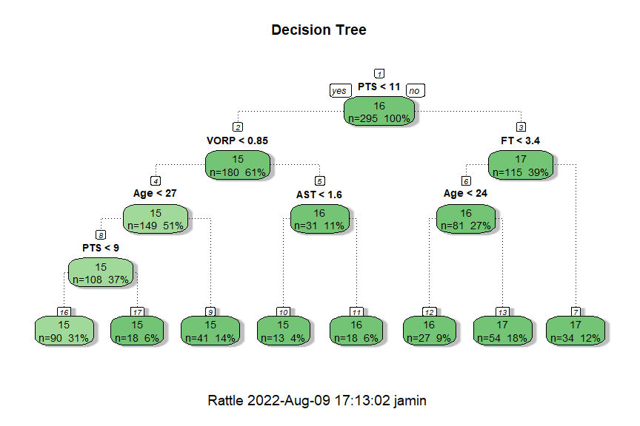

mod_dt$results$Rsquared[as.numeric(row.names(mod_dt$bestTune))]

## [1] 0.6438431

The R-squared of the model is 0.6438431

rmse(train_noNorm$salary, predict(mod_dt))

## [1] 0.509649

pred <- predict(mod_dt, test_noNorm)  
rmse(test_noNorm$salary, pred)

## [1] 0.5939312

The train root mean squared error is 0.509649 while the testing (out of bag) root mean squared error is 1.2798995.

## Random Forest

mod_rft <- train(salary ~ ., train[, -c(1)], method = "rf", trControl = trainControl(method = "cv",  
 number = 10))

Final model hyperparameter:

mod_rft$bestTune

## mtry  
## 2 19

mtry is the number of sample in each resampling.

rsq_rft <- mod_rft$results$Rsquared[as.numeric(row.names(mod_rft$bestTune))]

The R-squared is 0.7097135.

rmse(predict(mod_rft$finalModel, train), train$salary)

## [1] 0.2325683

rmse(predict(mod_rft$finalModel, test), test$salary)

## [1] 0.4834867

The train root mean squared error is 0.2325683 while the testing (out of bag) root mean squared error is 0.4834867.

## Neural Network

For the neural network, I have tested with different number of layers and node and this is the final mode hyperparameter with 100 node in first hidden layer, 75 nodes on second hidden layer and 50 node in third hidden layer. (The experimental record can be found in neural_network_train_record.md)

tunegrid_neural <- c(100, 75, 50)  
tunegrid_neural <- as.data.frame(t(matrix(tunegrid_neural, nrow = 3)))  
colnames(tunegrid_neural) <- c("layer1", "layer2", "layer3")  
mod_neur <- train(salary ~ . - X, data = train, method = "neuralnet", tuneGrid = tunegrid_neural,  
 trControl = trainControl(method = "cv", number = 10, verboseIter = TRUE), linear.output = TRUE)  
mod_neur$results$RMSE

mod_neur$results$Rsquared

## [1] 0.6624476

The R-squared is 0.6624476.

mod_neur$results$RMSE[as.numeric(row.names(mod_neur$bestTune))]

## [1] 0.6170212

rmse(test$salary, predict(mod_neur$finalModel, test))

## [1] 0.6328699

The train root mean squared error is 0.6170212 while the testing (out of bag) root mean squared error is 0.6328699.

# InterpretatioN

## Pinciple Component Analysis

all_pca <- alldata  
all_pca$X <- NULL  
all_pca <- as.matrix(all_pca)  
rownames(all_pca) <- name  
  
pca <- prcomp(all_pca, scale = TRUE)  
  
pca.var <- pca$sdev^2  
pca.var.per <- round(pca.var/sum(pca.var), 5)  
  
ggplot(data.frame(value = pca.var.per, index = 1:length(pca.var.per)), aes(x = index,  
 y = pca.var.per)) + geom_bar(stat = "identity") + theme_minimal()

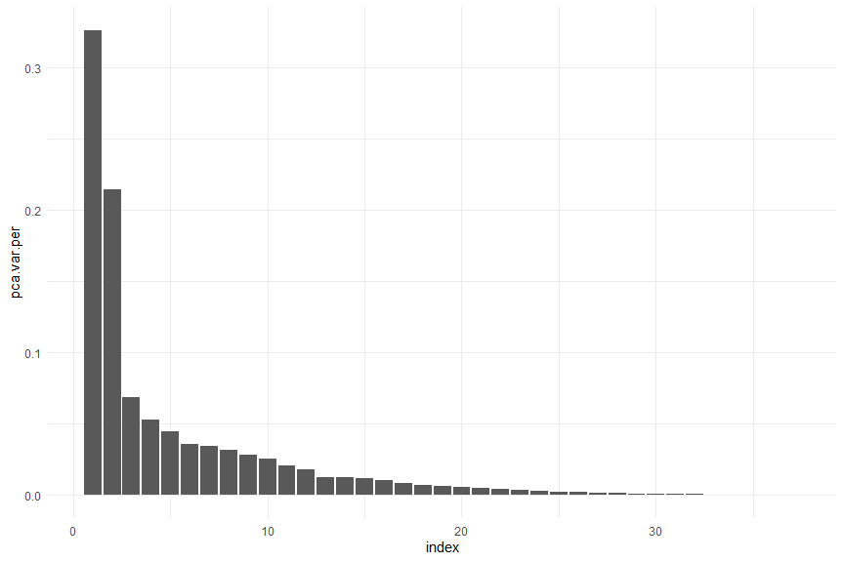

pca.data <- data.frame(Sample = rownames(pca$x), X = pca$x[, 1], Y = pca$x[, 2],  
 id = 1:nrow(pca$x))  
  
ggplot(pca.data, aes(x = X, y = Y, label = id)) + geom_text() + xlab(paste("PC1 - ",  
 pca.var.per[1], "%", sep = "")) + ylab(paste("PC2 - ", pca.var.per[2], "%", sep = "")) +  
 theme_minimal() + ggtitle("My PCA Graph")

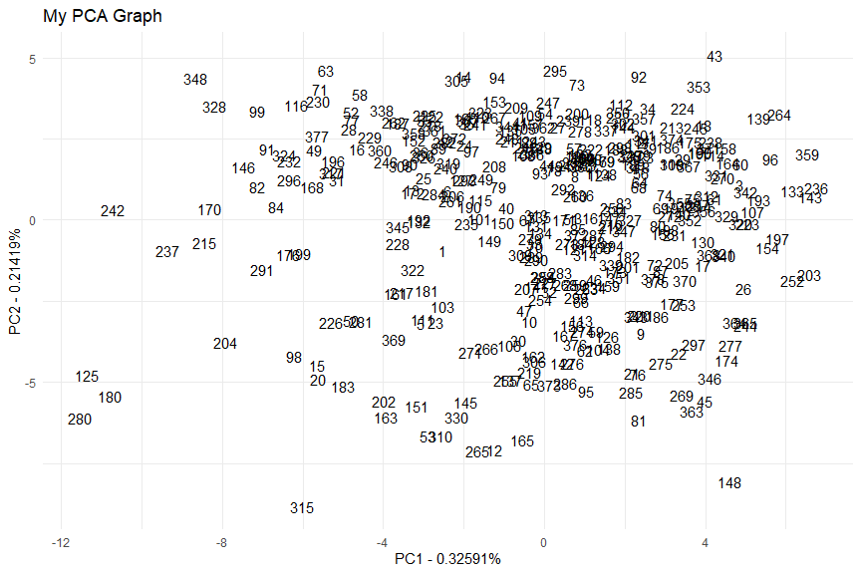

loading_score <- pca$rotation[, 1]  
gene_scores <- abs(loading_score)

I will plot out the principle components that contains more than 5% of information of the original dataset.

count = 0  
for (i in 1:length(pca.var.per)) {  
 if (pca.var.per[i] < 0.05) {  
 break  
 } else {  
 print(ggplot(data.frame(score = pca$rotation[, i], var = names(pca$rotation[,  
 i])), aes(x = reorder(var, abs(score)), y = abs(score), fill = ifelse(loading_score >  
 0, "positive", "negative"))) + geom_bar(stat = "identity") + theme_minimal() +  
 theme(axis.text.x = element_text(angle = 45, hjust = 1, size = 7)) +  
 scale_color_manual(values = list(positive = "blue", negative = "red")) +  
 labs(title = paste0("Principle Component ", as.character(i), " (", as.character(pca.var.per[i] *  
 100), "%)"), x = "variable", y = "proportion"))  
 }  
}

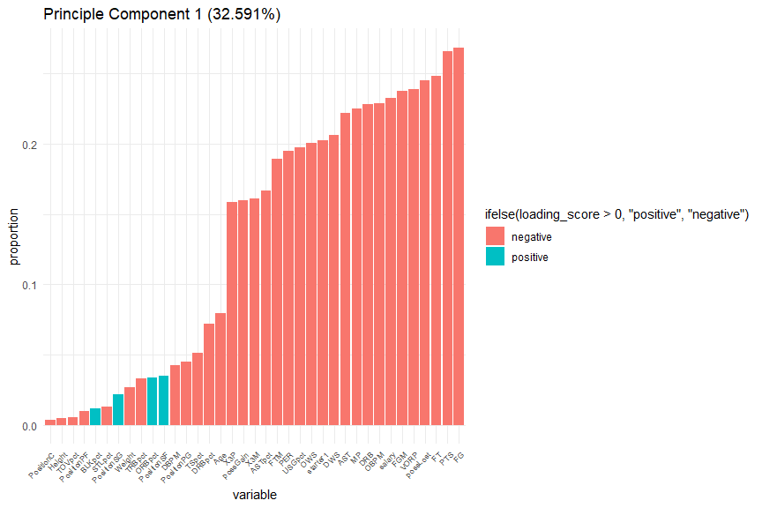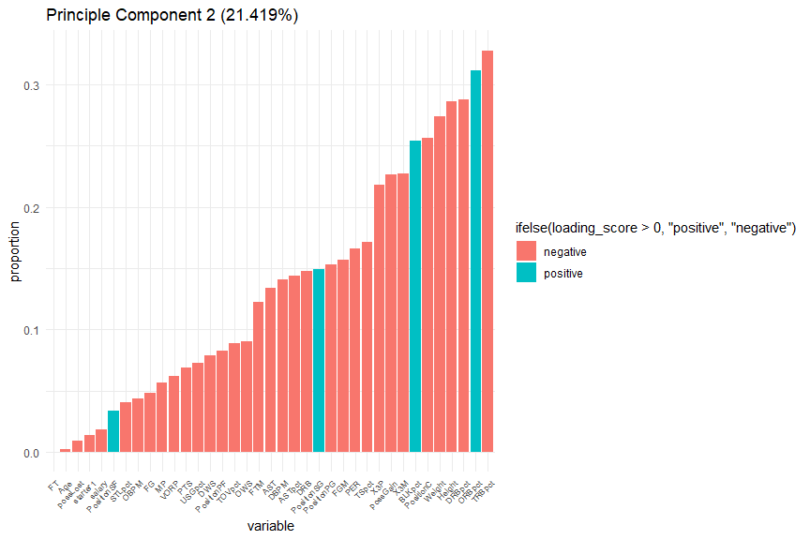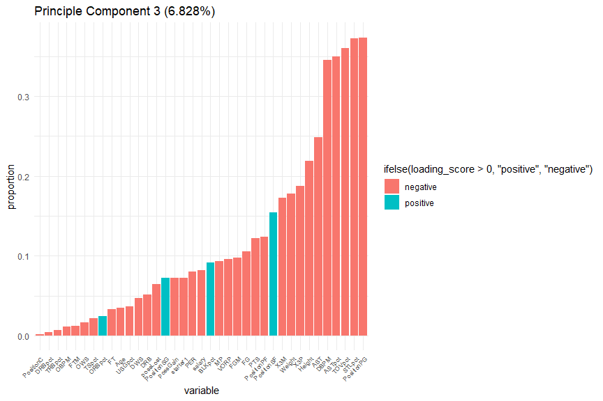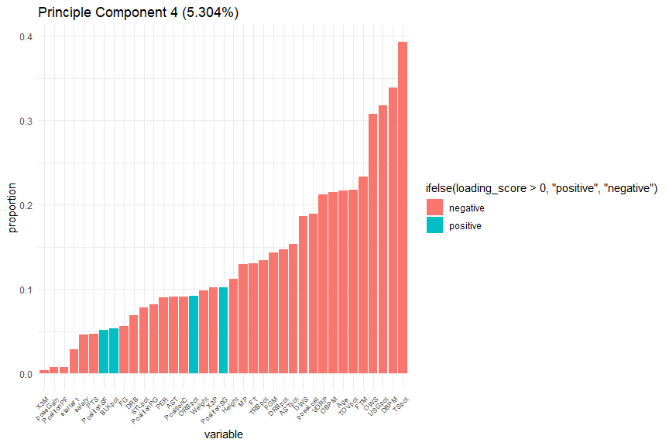

cor_Mat <- cor(data.frame(alldata[, numVar], pca$x[, 1:4]))  
  
cor_high <- names(which(rowSums(abs(cor_Mat[, c("PC1", "PC2", "PC3", "PC4")]) > 0.5) >  
 0))  
cor_high <- cor_high[!cor_high %in% c("PC1", "PC2", "PC3", "PC4")]  
options(scipen = 100)  
round(cor_Mat[cor_high, c("PC1", "PC2", "PC3", "PC4")], digits = 2)

## PC1 PC2 PC3 PC4  
## MP -0.78 0.16 0.15 -0.18  
## FG -0.93 0.13 0.17 0.08  
## X3P -0.55 0.61 0.30 -0.14  
## FT -0.86 0.00 0.05 0.18  
## DRB -0.79 -0.42 0.08 0.10  
## AST -0.77 0.38 -0.39 0.13  
## PTS -0.92 0.19 0.19 0.07  
## PER -0.68 -0.47 -0.13 -0.13  
## TSpct -0.18 -0.48 0.03 -0.55  
## ORBpct 0.12 -0.88 -0.04 0.13  
## DRBpct -0.25 -0.81 0.01 0.21  
## TRBpct -0.12 -0.92 -0.01 0.19  
## ASTpct -0.58 0.40 -0.56 0.22  
## STLpct -0.04 0.11 -0.59 -0.11  
## BLKpct 0.04 -0.71 -0.15 -0.07  
## TOVpct -0.02 -0.25 -0.57 0.31  
## USGpct -0.68 0.20 0.06 0.45  
## OWS -0.70 -0.25 0.03 -0.43  
## DWS -0.72 -0.22 -0.08 -0.26  
## OBPM -0.79 -0.12 -0.02 -0.30  
## DBPM -0.15 -0.40 -0.55 -0.47  
## VORP -0.83 -0.18 -0.15 -0.30  
## Weight -0.09 -0.77 0.28 0.14  
## Height -0.02 -0.80 0.35 0.16  
## possGain -0.55 -0.64 -0.12 -0.01  
## possLost -0.85 -0.03 -0.10 0.27  
## FGM -0.83 0.44 0.16 0.20  
## X3M -0.56 0.64 0.27 0.00  
## FTM -0.66 -0.34 -0.02 0.33

corrplot(cor_Mat[c("PC1", "PC2", "PC3", "PC4"), cor_high], tl.pos = "lt", method = "number")

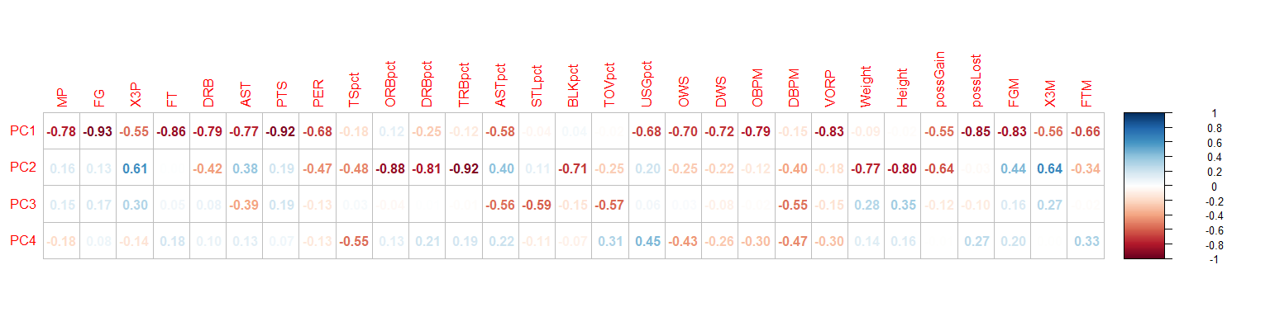

Adams, L., 2022. [NBA minimum salaries for 2022/23](https://www.hoopsrumors.com/2022/07/nba-minimum-salaries-for-2022-23.html#:~:text=Those%20deals%20will%20only%20count,with%20two%20years%20of%20experience).

spotrac, n.d. [Ishmail wainright](https://www.spotrac.com/nba/phoenix-suns/ishmail-wainright-74220/).