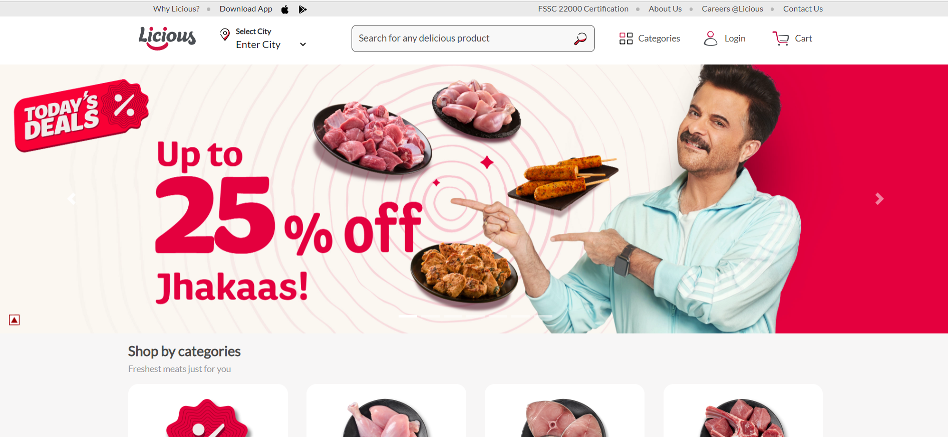

**PROJECT NAME: LICIOUS**

**JAMI SAITEJA**

**Overview:**

Licious website which is India's first D2C Unicorn, headquartered in Bengaluru, Karnataka, India. The company operates on a farm-to-fork model, owning the entire back-end supply chain and cold chain

**Home Page :-**

* Here clicking on any option on the Navbar will redirect the user to the respective Product Page.
* Clicking on select city will select city of your choice and we have a search bar where anybody can search their respective products easily.
* Clicking on Login will display an animated Login/SignUp window for login and sign up. Clicking on Cart will display a cart window where all the products added to cart will be shown.
* Now coming on Categories. I have added categories, by clicking on options we can navigate to respective product page. User can directly purchase the product from here.
* All of these functions are working properly.

### Login Window :-

* Here we have a login windows which slides from right when user click on login button near cart.
* From here user can easily register to our website.
* User simply needs a mobile number to SignIn/SignUp in account and and a valid OTP (which comes on user screen).
* Than after login that Login Button will change in Logout button.
* Buy clicking on that user can easily Logout from our Website.

### Product Page (Today's Deal) :-

* This is one of the product pages of our website.
* In this user gets an regular update about new deals, reducing of product Price and offers coming in Licious.
* Clicking on the Add To Cart Button will add products to the cart.

**Cart Window :-**

* Here all the products added to the cart will be shown. At the bottom there is total price of the cart and the proceed to Checkout button. Clicking on that button will redirect the user to the Address Page .

### Address Page:-

* Here the user has to fill in his Location or shipping details and click Proceed to Checkout button.
* Clicking on that button will redirect the user to the Payment Page.

**Payment Page:-**

* This is the payment page where the user can pay the payment through card,UPI. After that user have to click on Confirm button to confirm Payment.

**Technologies used in Licious**

* Front-End:
  + Html
  + CSS
  + Bootstrap
  + React
* Dynamic:
  + JavaScript
* Database:
  + MongoDB
* Code compilers:
  + Visual studio code
  + Git bash
  + Git hub
  + NodeJS.

**GitHub Link:** <https://github.com/jamisaiteja/Licious-Clone-Second-Project-Edu>