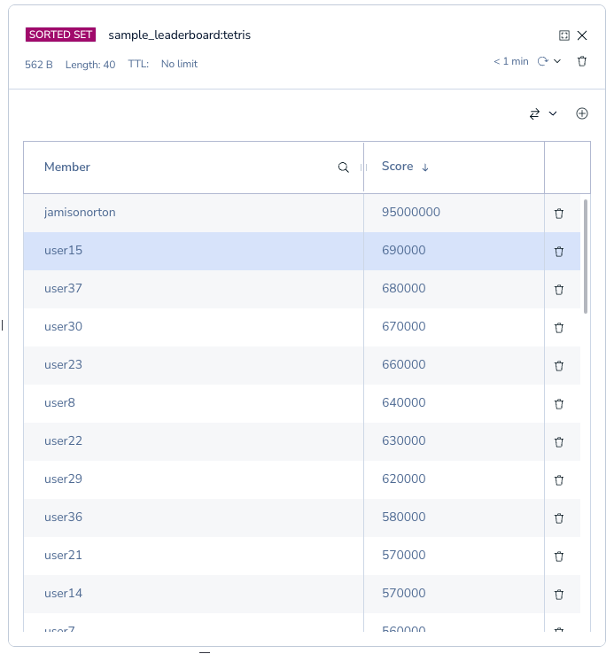
Figure 1- screenshotA
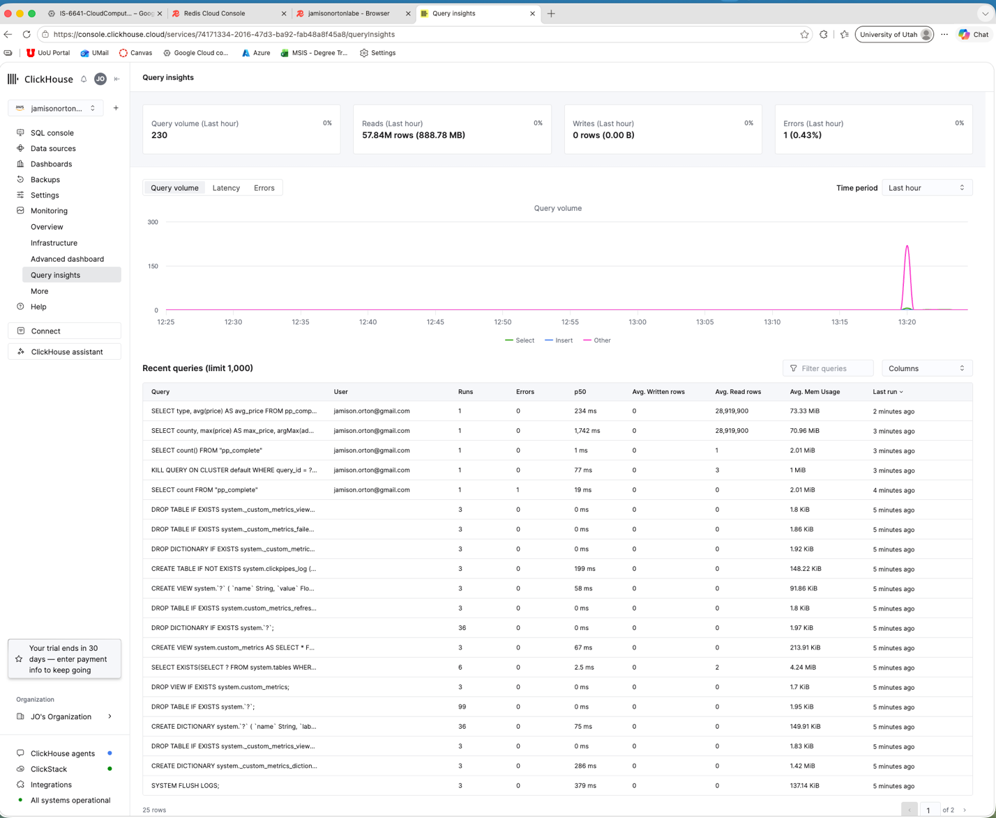
Figure 2- screenshotB
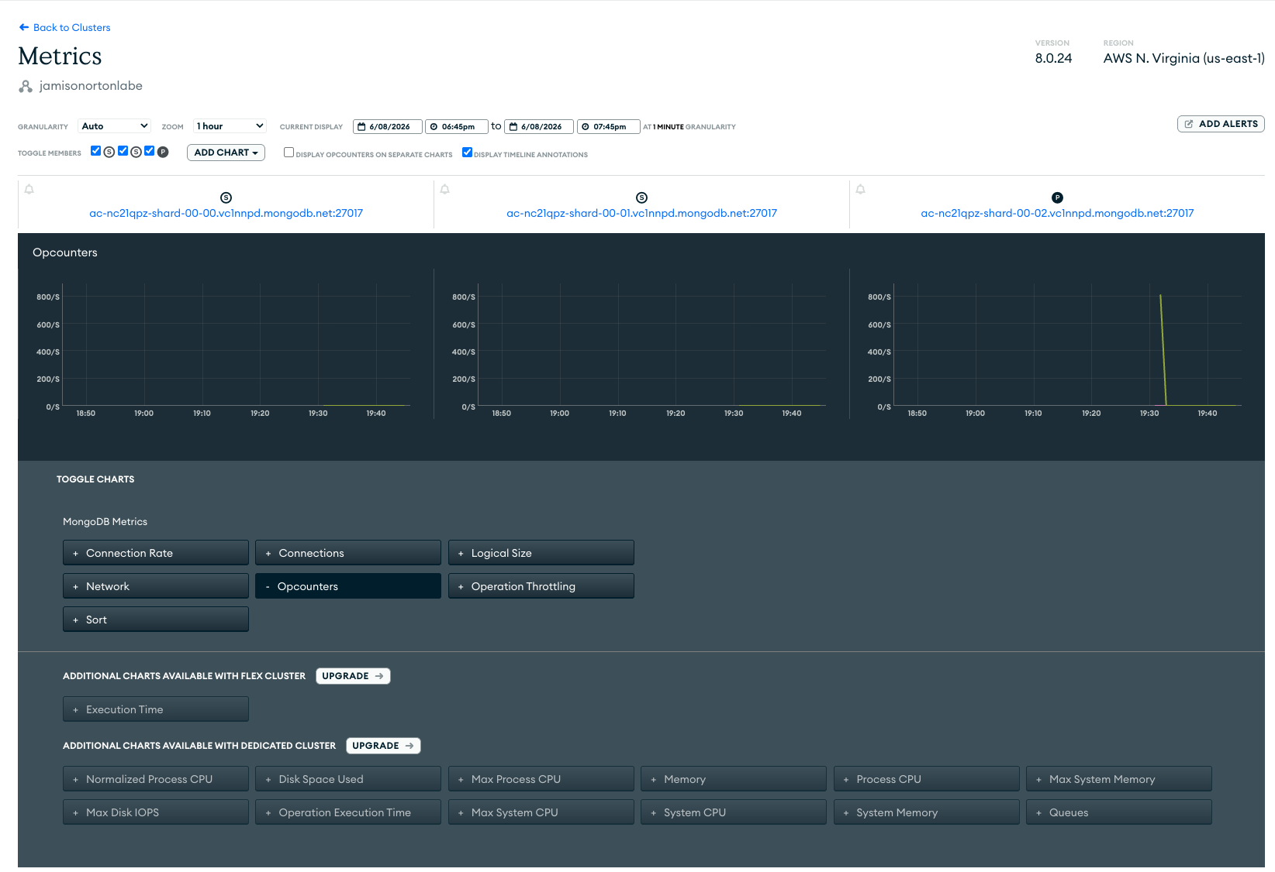
Figure 3- screenshotC
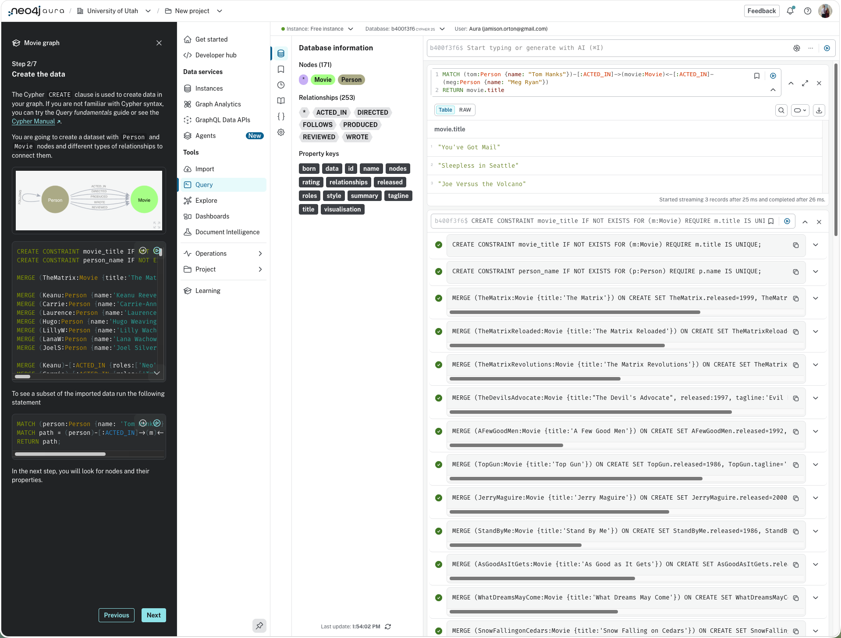
Figure 4- screenshotD

Lab E – Create and Explore NoSQL Databases
In my opinion I think the query language for ClickHouse was the most intuitive. It seemed like it was the easiest to see SELECT statements and seemed the most like traditional SQL. I think MongoDB was the most different from traditional SQL. It was the one that didn’t really have any select statements but instead had the JSON that you had to parse through. However, MongoDB seemed like it was the least typed language. It seemed very quick once you knew the syntax to get the information you were looking for.
My experience with this lab was excitement. I enjoyed seeing the other ways people hosts databases and a variety of vendors to do it. As a Web App developer, I have a lot of knowledge in the Postgres world specifically with Neon and Prisma, but I have also use MongoDB for an app I built for a class. I think I prefer to use something like Postgres and MySQL just because I feel it works the best in my brain for finding the correct queries but if you do it the right way it seems each can get you the same information. I found each set was able to get me a list of movies that Tom Hanks starred in.

