-- b. Create a view, "Lab001.OrderDetail" based on the user-friendly
-- order details query below
CREATE OR ALTER VIEW Lab001.OrderDetail AS
SELECT oh.OrderDate,
oh.OrderID,
cu.FirstName,
cu.LastName,
cu.AddressLine1,
cu.City,
cu.RegionAbbr,
cu.PostalCode,
p.ProductName,
ol.Quantity,
p.ProductPrice
FROM Lab001.customer cu, Lab001.OrderHeader oh, Lab001.OrderLine ol, Lab001.product p
WHERE cu.CustomerID=oh.CustomerID AND
oh.OrderID=ol.OrderID AND
ol.ProductID=p.ProductID
GO
-- c. Select all rows and columns from Lab001.OrderDetail and take a screenshot
SELECT * FROM Lab001.OrderDetail;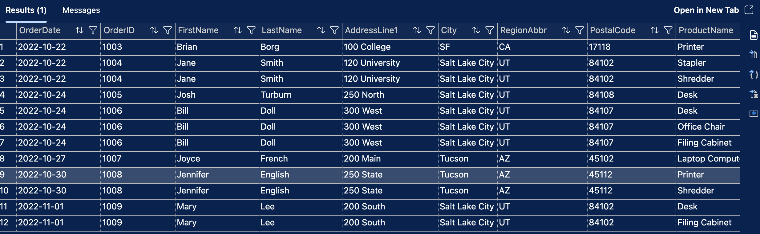
-- c. Increase price for product by $10
UPDATE Lab001.product
SET ProductPrice = ProductPrice + 10.00
WHERE ProductID = 101
GO
-- d. Verify trigger has worked
SELECT *
FROM Lab001.ProductPriceAudit
GO
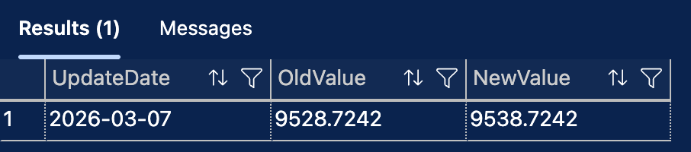
ALTER TABLE Lab001.ProductPriceAudit
ADD price_change_percentage NUMERIC(10,3);
GO
-- f. Update the Lab001.AuditPriceChangeTrigger trigger to add the price percentage change
CREATE OR ALTER TRIGGER Lab001.AuditPriceChangeTrigger
ON [Lab001].[product]
FOR UPDATE
AS
BEGIN
SET NOCOUNT ON;
DECLARE @oldValue MONEY;
DECLARE @newValue MONEY;
DECLARE @percentageChange NUMERIC(10,3);
SELECT @oldValue = ProductPrice FROM deleted;
SELECT @newValue = ProductPrice FROM inserted;
SET @percentageChange =
CASE
WHEN @oldValue = 0 THEN NULL
ELSE ((@newValue - @oldValue) * 100) / @oldValue
END;
INSERT INTO Lab001.ProductPriceAudit
(
UpdateDate,
OldValue,
NewValue,
price_change_percentage
)
VALUES
(
GETDATE(),
@oldValue,
@newValue,
@percentageChange
);
END
GO

-- g. Increase price for product by 10%
UPDATE Lab001.product
SET ProductPrice = ProductPrice * 1.1 -- 10% price incrase
WHERE ProductID = 101
GO
-- h. Verify the trigger has worked by selecting all rows and
-- columns from Lab001.ProductPriceAudit and take a screenshot
SELECT *
FROM Lab001.ProductPriceAudit
GO
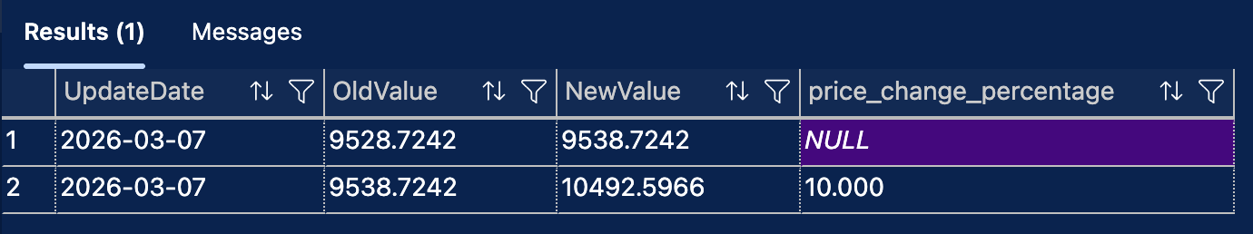

-- c. Create a new function called Lab001.calculate_discounted_percent that takes
-- a product id and a new price and returns the discount percentage
CREATE OR ALTER FUNCTION Lab001.calculate_discounted_percent(
@productID INT,
@newPrice NUMERIC(10,3))
RETURNS MONEY
AS
BEGIN
DECLARE @returnValue AS MONEY;
SELECT @returnValue = ((ProductPrice - @newPrice)/ProductPrice)
FROM [Lab001].[product]
WHERE [Lab001].[product].ProductID = @productID
RETURN(@returnValue)
END
GO
-- For example, if ProductID 103 was discounted to $29.50 it would return approx 0.81
-- d. Run the function discounting ProductID 103 to $29.50 and take a screenshot
SELECT Lab001.calculate_discounted_percent(103, 29.50) AS DiscountedPercent
GO
