Multi-Site Enterprise Routing Lab – OSPF + BGP Redistribution using Cisco Packet Tracer

Overview
This lab simulates a small enterprise with a Head Office and Branch Office connected via an ISP. The goal is to demonstrate multi-protocol routing using OSPF inside each site and BGP towards the ISP, with route redistribution between OSPF and BGP.

Topology
- R1-HQ: Head Office core router (OSPF Area 0)
- R2-HQ: Head Office edge router (OSPF Area 0, BGP to ISP)
- R3-BR: Branch router (OSPF Area 1, BGP to ISP)
- R4-ISP: ISP router (BGP core)

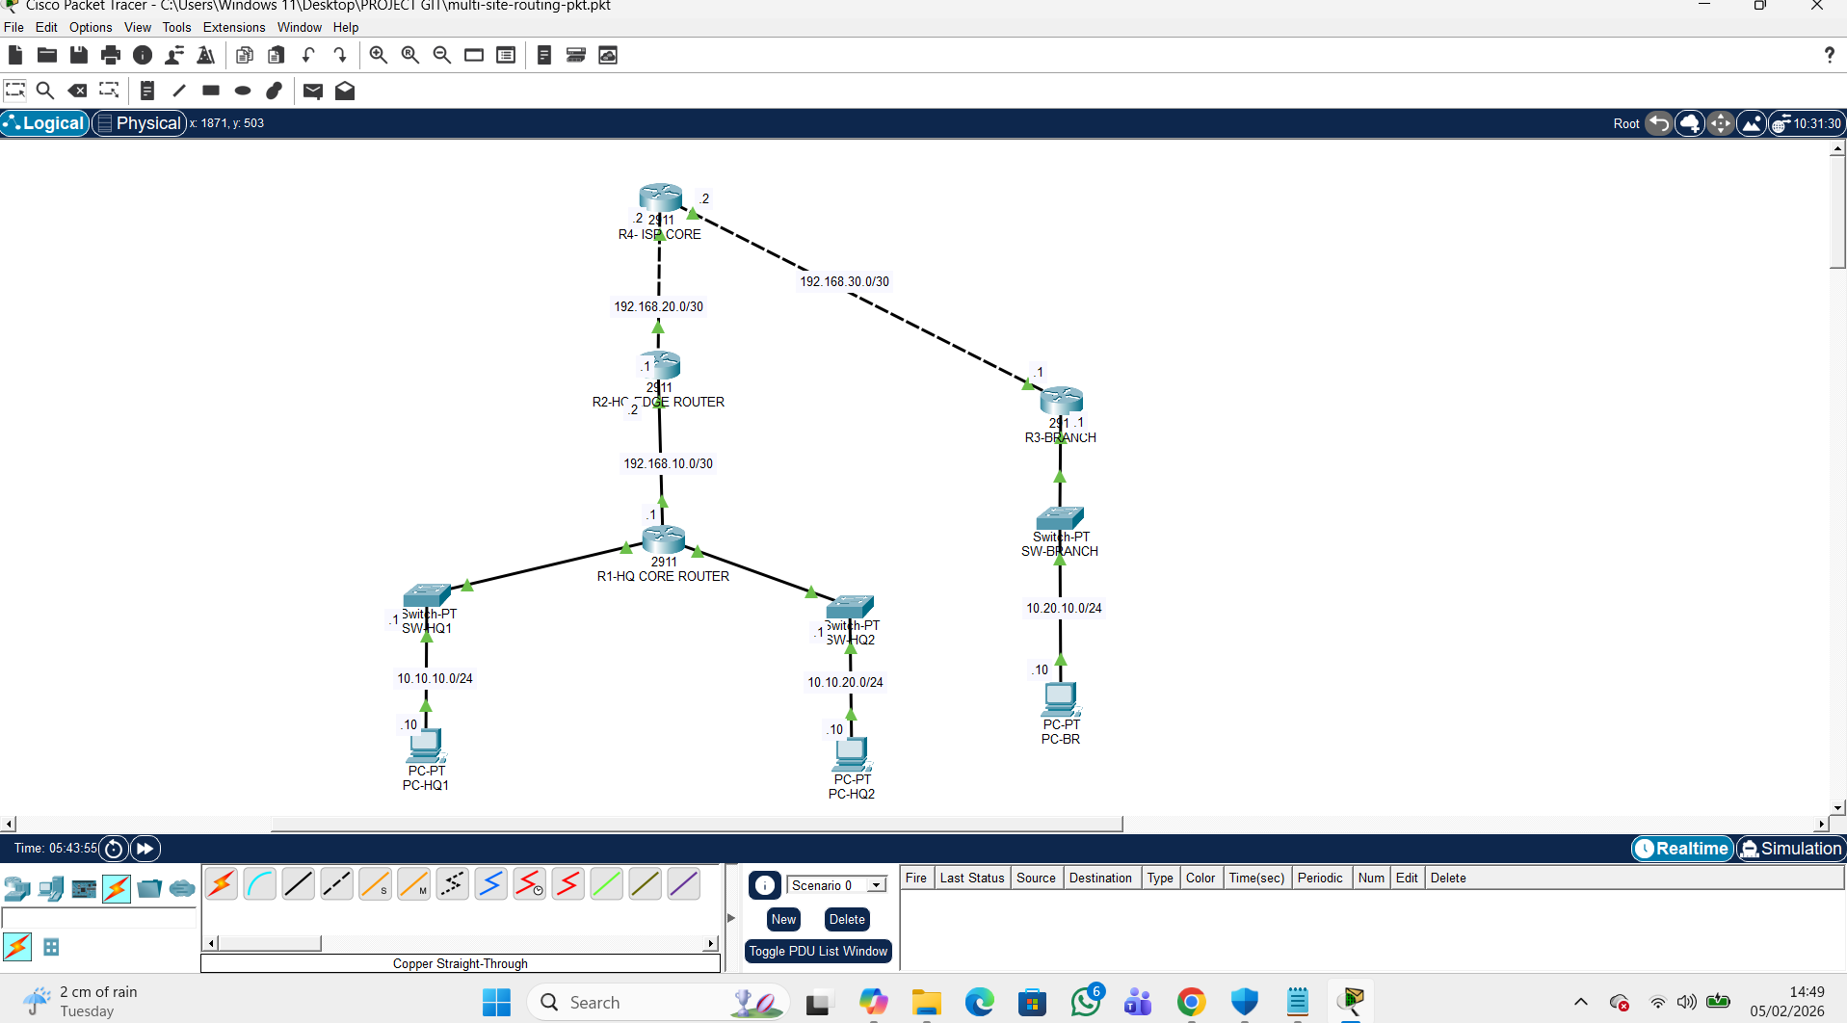

IP Addressing
DEVICE | Interface | IP Address | Description
R1-HQ | G0/1 | 10.10.10.1/24 | HQ LAN 1
R1-HQ | G0/2 | 10.10.20.1/24 | HQ LAN 2
R1-HQ | G0/0 | 192.168.10.1/30 | Link to R2-HQ
R1-HQ | Lo0 | 11.1.1/32 | Router ID
R2-HQ | G0/1 | 192.168.10.2/30 | Link to R1-HQ
R2-HQ | G0/0 | 192.168.20.1/30 | Link to R4-ISP
R2-HQ | Lo0 | 2.2.2.2/30 | Router ID
R3-HQ | G0/1 | 10.20.20.1/24 | Branch LAN
R3-HQ | G0/0 | 192.168.30.1/30 | Link to R4-ISP
R3-HQ | Lo0 | 3.3.3.3/32 | Router ID
R4-ISP | G0/0 | 192.168.20.2/30 | Link to R2-HQ
R4-ISP | G0/1 | 192.168.30.2/30 | Link to R3-BR
R4-ISP | Lo0 | 4.4.4.4/32 | Router ID

Routing Design
- OSPF:
- Area 0: R1-HQ, R2-HQ, Head Office LANs
- Area 1: R3-BR, Branch LAN

- BGP:
- R2-HQ (AS 65010) ↔ R4-ISP (AS 65000)
- R3-BR (AS 65020) ↔ R4-ISP (AS 65000)

- Redistribution:
- On R2-HQ and R3-BR: OSPF ↔ BGP

Verification
- show ip route
- show ip ospf neighbor
- show ip bgp summary
- End-to-end pings between HO and Branch PCs.

Files
- multi-site-routing.pkt – Packet Tracer file
- configs – Router configuration files
- images – Topology diagram and verification screenshots

