PART A — Laboratory Environment & CI/CD Tools (40 Marks)
Q1. Cloud Environment Provisioning & Application Access (20 Marks)
Launch a development instance on AWS or Azure, open the necessary ports, and deploy a simple web server on it so it is reachable from your browser.
Screenshots/files required:
• Instance/VM details page showing it is running — 5 marks
• Security group/NSG rules showing SSH (22) and HTTP (80) access allowed — 5 marks
• Successful SSH login and a simple web server (e.g., Nginx or python http.server) running, accessed via browser/curl — 6 marks
• Output verifying the CI/CD tool versions available on the instance (git, docker, jenkins) — 4 marks
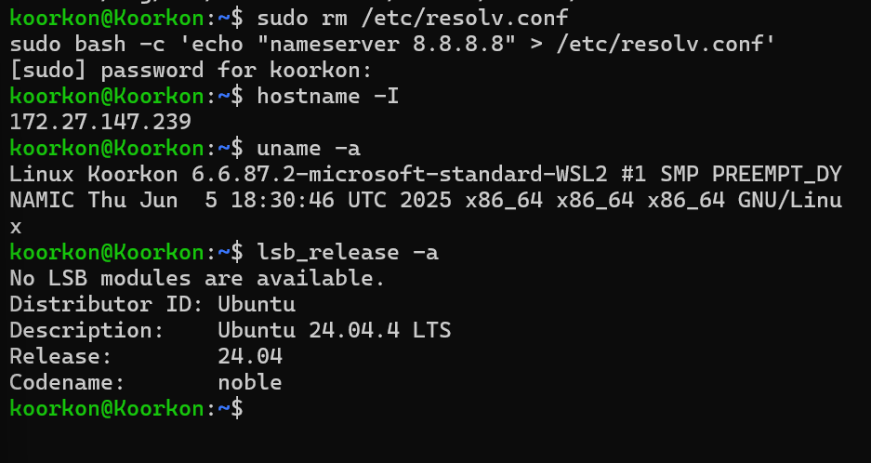
Q2. Docker Image Build & Push via Jenkins (20 Marks)
Write a Dockerfile for the given application, trigger your Jenkins pipeline to build the image, push it to the registry with a tag, and run the container.
Screenshots/files required:
• Dockerfile used for the application — 5 marks
• Jenkins console output showing the image built successfully — 6 marks
• Registry push confirmation showing the image tag — 5 marks
• Container run output / browser screenshot confirming the application is accessible — 4 marks

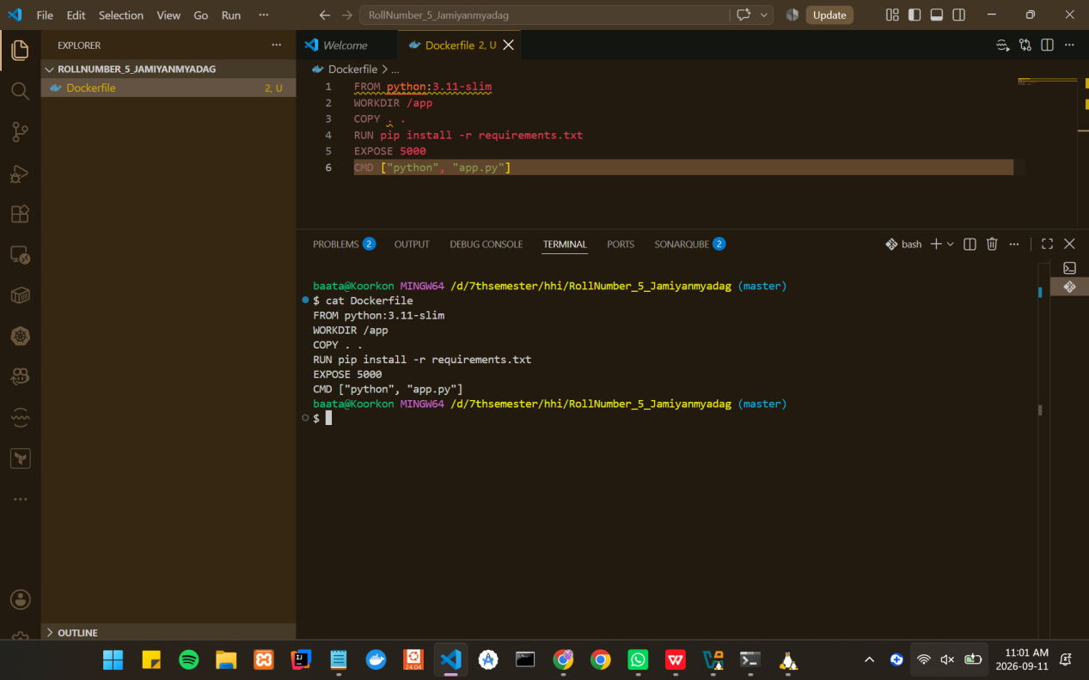

Q3. Selenium WebDriver Script — Basic Functional Testing (30 Marks)
Write a Selenium script that opens a given website, verifies the page title, and performs one form interaction (e.g., entering a search term and submitting).
Screenshots/files required:
• Full script code — 6 marks
• Terminal/IDE output showing the script executed successfully — 6 marks
• Assertion/log confirming the page title or URL matches the expected value — 8 marks
• Browser screenshot showing the result of the form interaction (e.g., search results page) — 10 marks
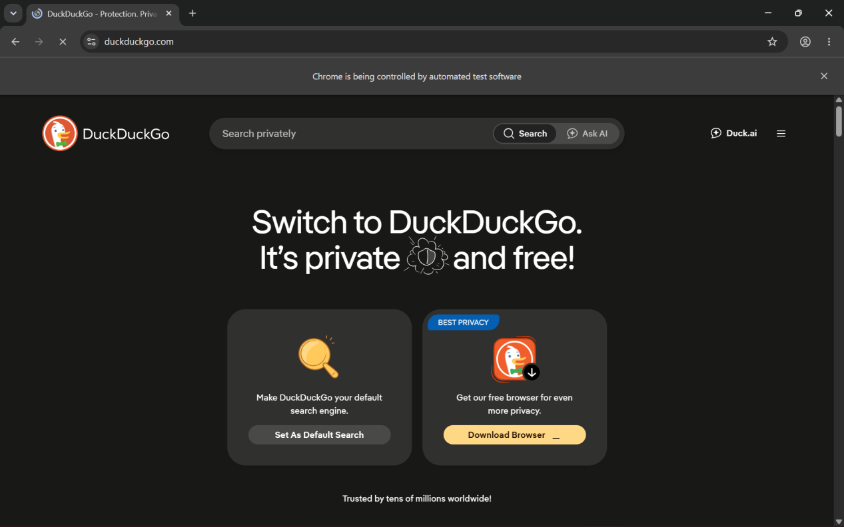
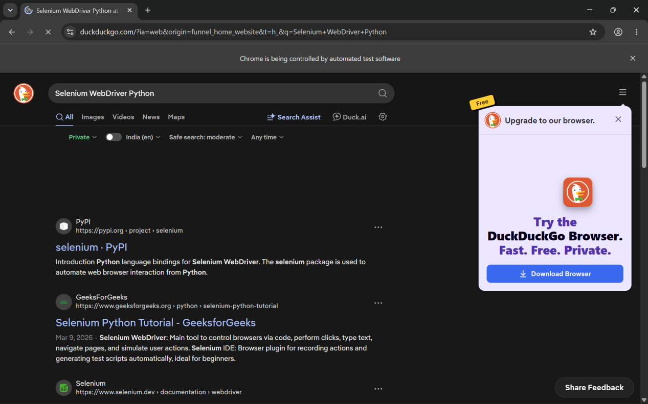
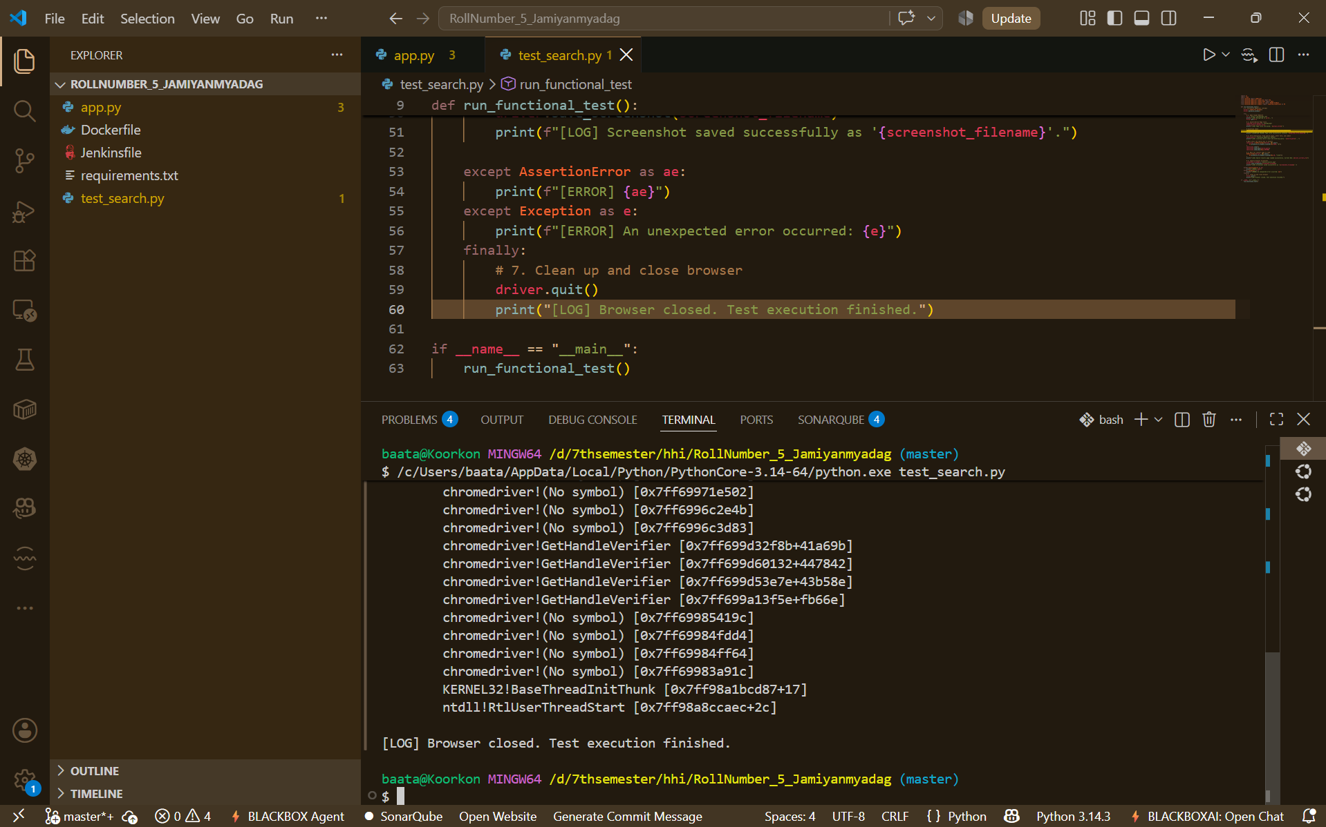

Q4. Executing a Test Suite & Generating a Report (30 Marks)
Write a suite of at least 3 test cases covering different functionalities (e.g., login, navigation, form validation), run the suite, and generate a basic HTML/JUnit report. Add the suite as a stage in your Jenkins pipeline.
Screenshots/files required:
• Test suite code covering at least 3 test cases — 10 marks
• Console/runner output showing all test cases executing — 8 marks
• Generated HTML/JUnit report showing pass/fail results — 8 marks
• Jenkins pipeline stage showing the suite added as a build step — 4 marks
