Plane Detection Summative
James Paterson – fdqd43
The finished program provides high quality plane detection and decent object detection through dense stereo matching.
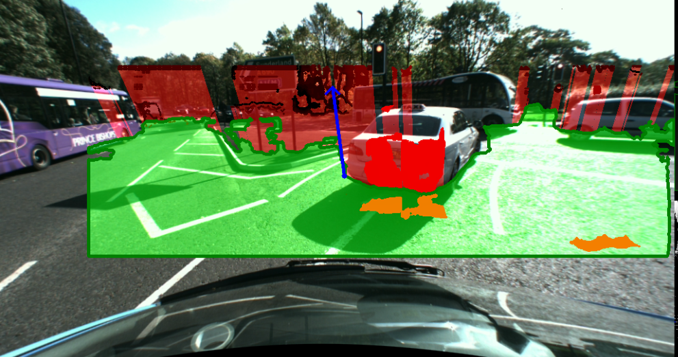
Example image. Plane is illustrated in transparent green, obstacle points in solid shades of red, and estimated obstacle collision areas in transparent red. The normal to the plane is shown as a blue arrow.

Image Processing Workflow
The two images are sent through a five stage pipeline when being processed.

Preprocessing
The left and right images are first converted to grayscale. They are then subject to a histogram equalisation and then a gamma correction of magintude 2, to increase contrast and aid in the dense matching. Experiments with Lab conversion and equalisation in the L channel were attempted but eventually discarded.
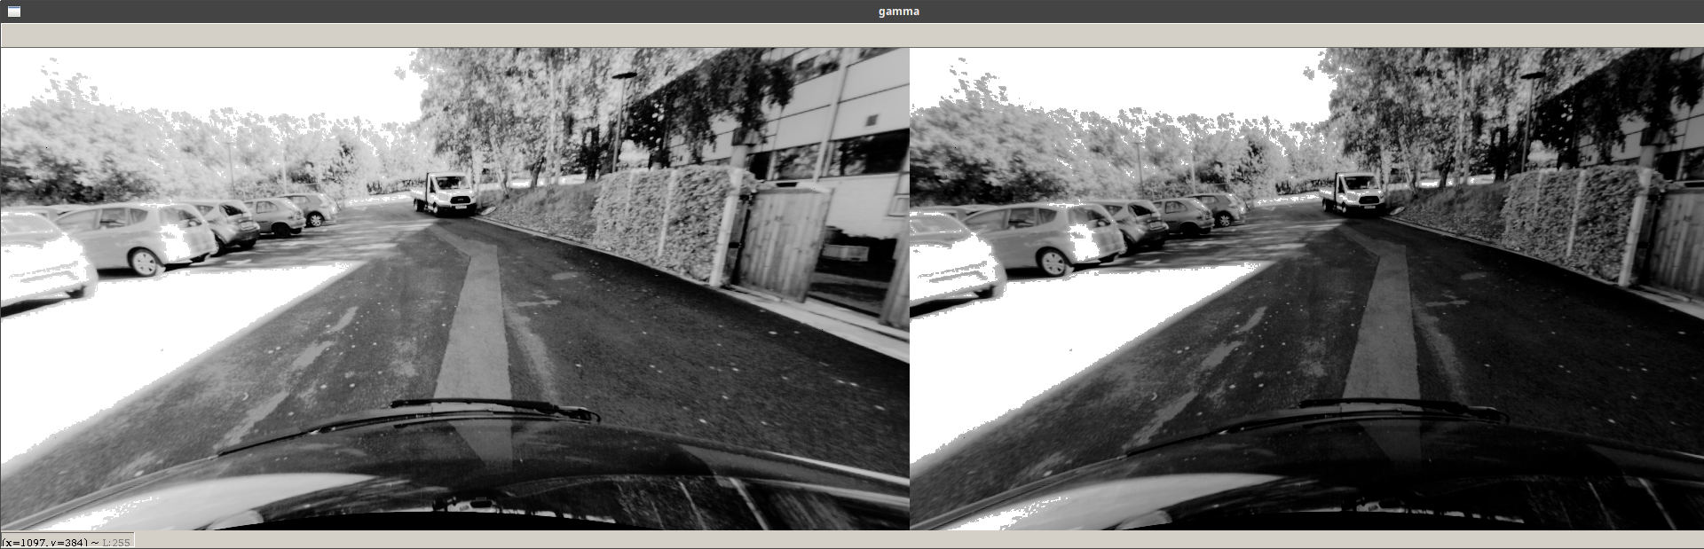
Left image before and after gamma correction
The disparity image is then generated, and is subject to several corrections. It is first processed with filterSpeckles to remove errors in the disparity image. “Holes” of zeros/negative numbers are then filled in by an average of the row. This works well to preserve horizontal gradient.
The disparity image is then cropped to above the bonnet, and to remove most of the sky. This is done to avoid depth errors as the sky has little texture and often causes the appearance of large flat obstacles.
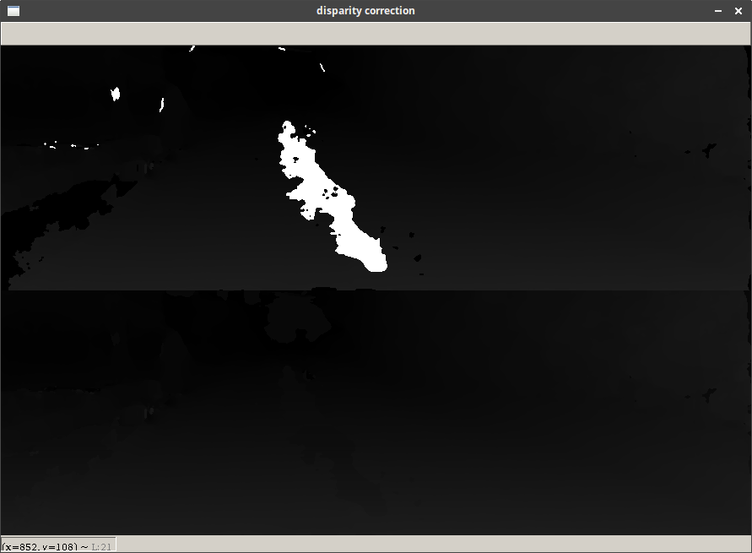
Disparity before and after correction. Note the large black area filled in in the bottom left.

RANSAC
The ransac is straightforward and very performant. It can do 200 random plane trials in ~0.2s, and 2000 in ~2.75 seconds based on trials on my laptop. Once the points have been projected to 3D, we perform a set number of RANSAC trials. We select 3 non-colinear points from the sample set using the code supplied, and calculate the plane coefficients. As an optimisation, we first normalise the normal to the plane. If the normal is not mainly in the Y direction, then we know the plane cannot be a valid road plane as it has a roll of over 45 degrees in one of the other dimensions, so we discard it and move to the next. We then calculate the distances from the plane of every point in the disparity map. To quickly check the number that are below some threshold (plane_fuzz), we convert the list to a binary list using numpy and sum it, which is much faster than a for loop. This number is compared and if more points are matched we store the coefficients.
As another optimisation we also check the last plane to make sure it doesn’t fit the new one as well, but this rarely is the case.

Plane Retrieval
The final plane is then selected by the set of coefficients that matched the most points in the RANSAC. We also calculate the normalised normal vector, and project and store the centre of the plane for use in drawing the normal. The points are then drawn onto a black image for use in noise removal.
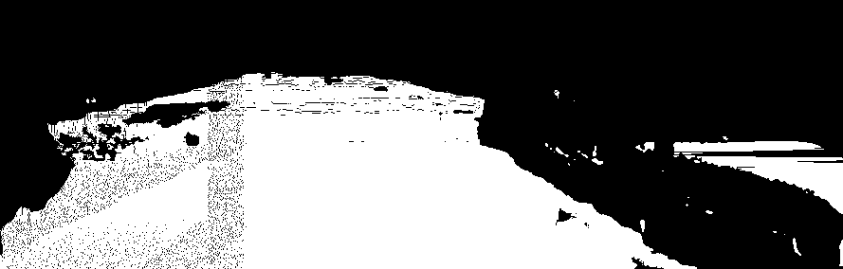
Raw data from the plane
The image is then dilated slightly to close 1px lines and holes that sometimes appear. The largest contour (A contiguous area of pixels) is then selected, and drawn onto the disparity map and image, along with the normal.
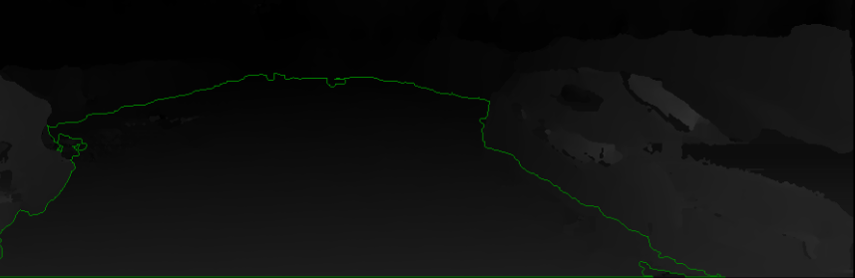
Disparity map with filtered plane overlaid
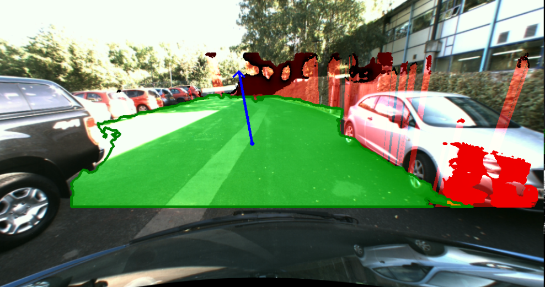
Stylised plane drawn onto colour image
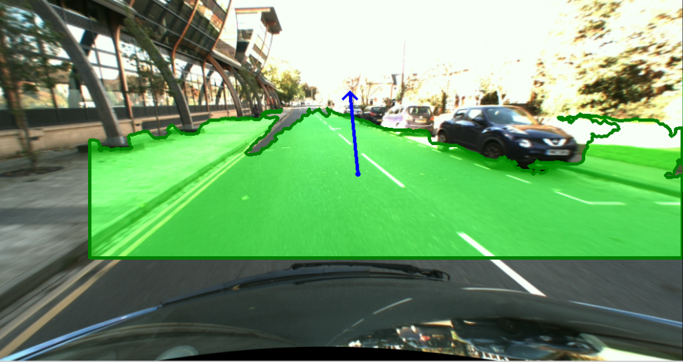
Another sample plane and normal, this time with no object detection

Object Detection
The object detection is primarily based on the paper “Road Surface and Obstacle Detection Based on Elevation Maps” [1]. First, the 3D points are classified into a discrete set of cells arranged in the X and Z directions. We count the number of points in each cell, and store it, to measure of the density of 3D information in that area. Another array is also created, this time of the amount of points in our road plane at each Z index of the image, giving us the estimated density of road information. This array is then processed with a rolling average to smooth any outliers.
This approach now allows us to compare the expected density of the road at some Z-index with the actual density. We calculate a quotient actual_density/expected density and if it’s over a set threshold (Paper suggests 6), we consider it an obstacle. We add to the obstacle by starting a recursive procedure on the neighbours, which adds points close to the obstacle point with quotient over a lower threshold (3). Points which could be on the plane are checked and discarded, as they are not obstacles.
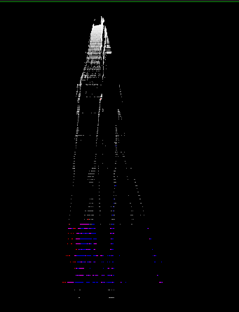
Example density map. The camera is positioned at the top of the image. An obstruction is visible in the data at the upper right of the image
The line with each obstacle point and the normal to the plane is then used to find the point of intersection with the plane. This line is then drawn in light red, to show the boundary of the obstacle relative to the plane.
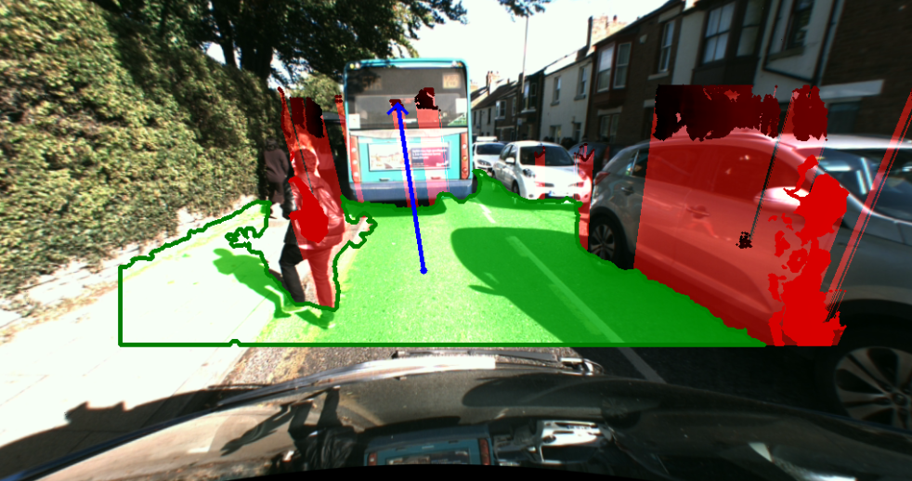
Dual object detection of Jaywalker & adjacent car

Output
The plane and obstacles are drawn onto empty masks, then added to the left image. The normal is then drawn on top.

Evaluation

Plane Detection
I used a representative sample of 50 images, the results are below:

Observation | Plane completely wrong  (No road in plane, plane oriented incorrectly, etc etc) | Plane mostly wrong  (Plane more than a quarter undrivable terrain, objects classified as drivable, most of road not found) | Plane mostly correct  (Surface is completely drivable, most of surface is road, most of the road is captured) | Plane almost entirely correct  (Surface is entirely road with no obstacles or pavement classified as drivable)
Number of occurences | 0 | 5 | 32 | 13

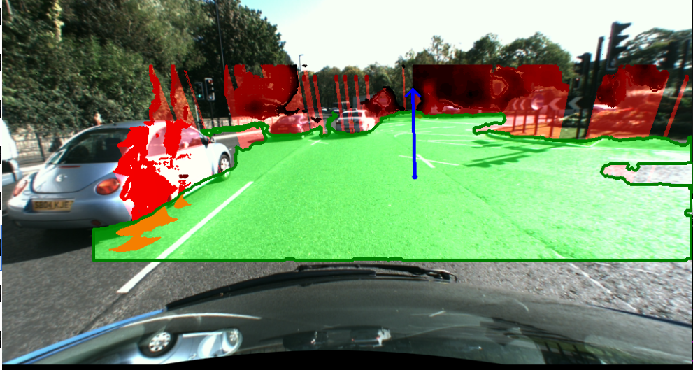
Perfect/Near Perfect detection
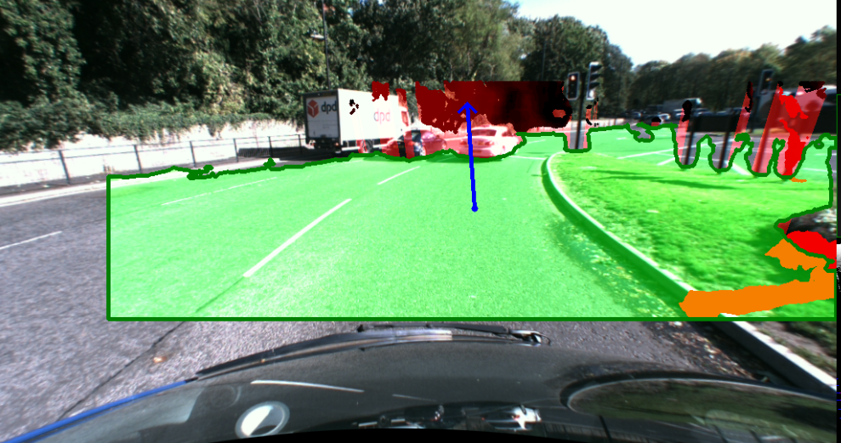
Imperfect/Good detection (Sidewalk detected as road)

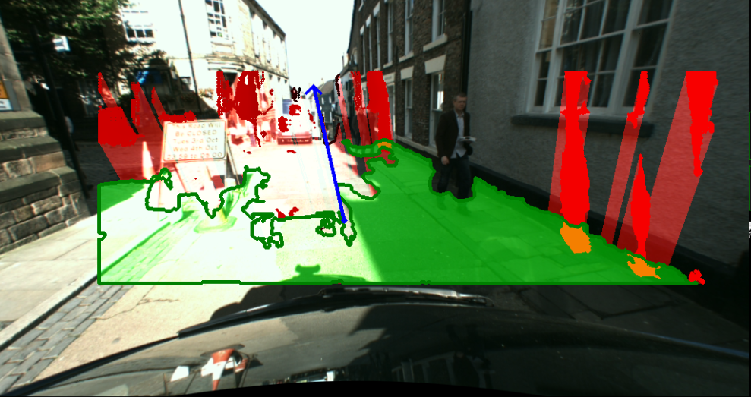
Mostly wrong/Bad detection
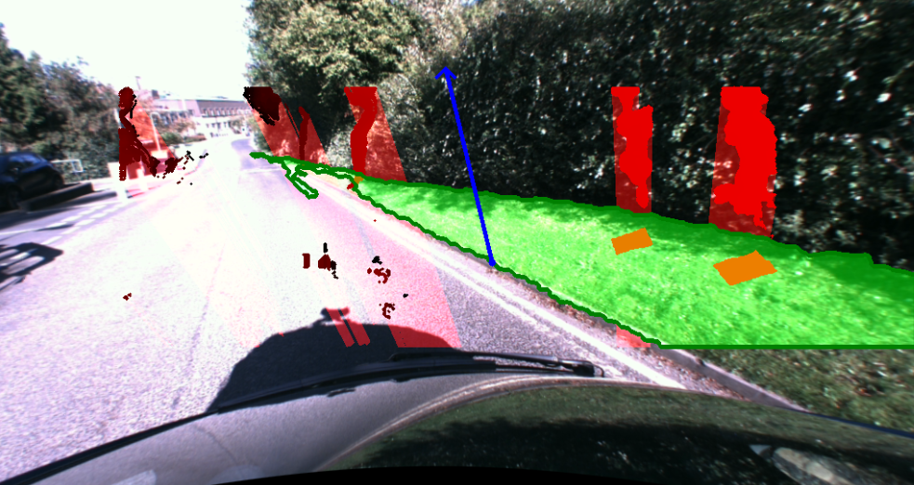
Completely wrong detection
From this basic analysis, we can estimate that around ~90% of images are good detections. The program tends to fail in two scenarios. Firstly, when large chunks of road are overexposed, which screws up the disparity mapping. This could possibly be fixed with luminosity transforms, but I tried a Lab transform and it did not work. The second scenario is when most of the image is an obstacle or pavement, causing the mapping to snap to another feature.
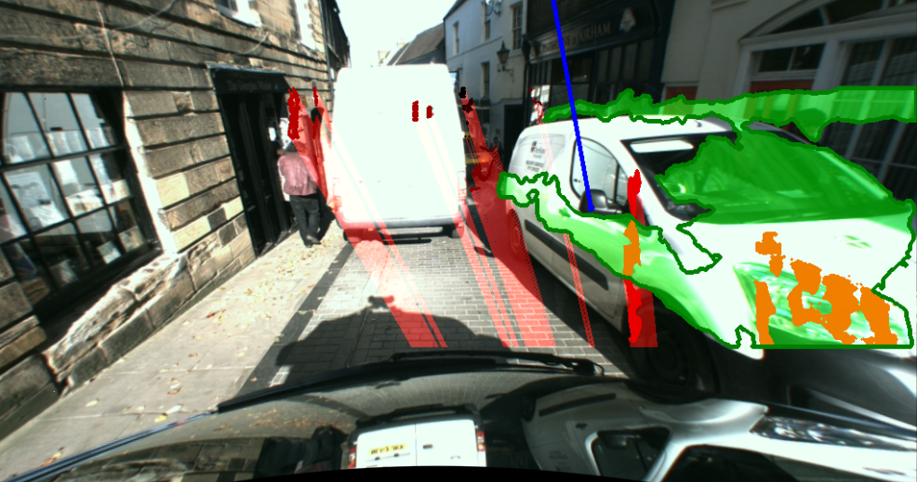
An interesting detection, where the plane of the van is larger than the plane of the floor!

Object Detection
Object detection is suprising resilient. There are not enough valid comparisons to make a good statistical analysis, but multiple objects are detected often detected well. Some good detections are shown below:
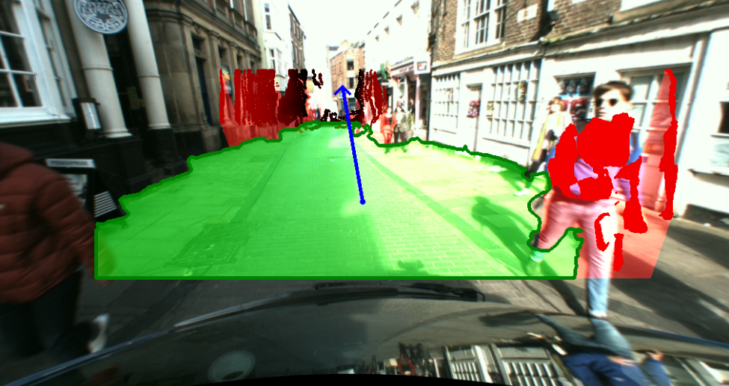
Good detection of pedestrian

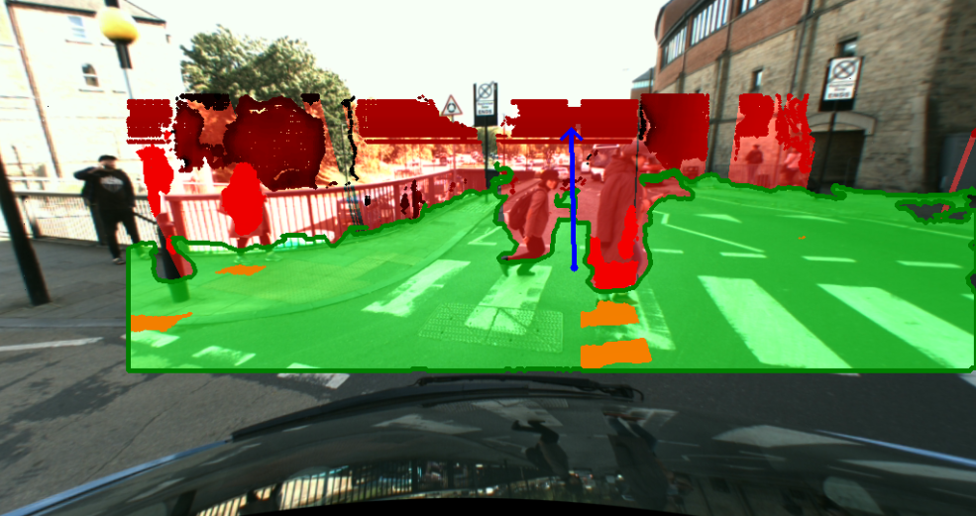
Good detection of pedestrians, lampost and railing.
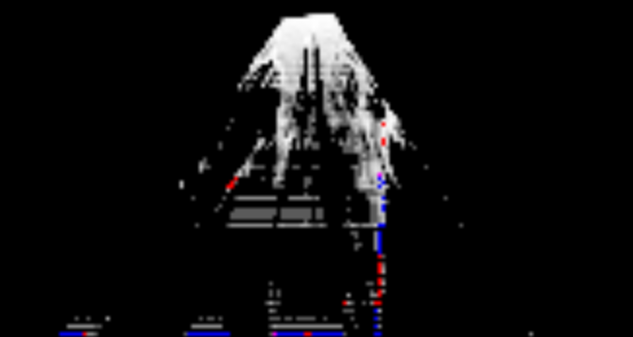
Density map for the above image, zoomed. You can see the two pedestrians in the density map.
The approach does have problems. The main one is that it is heavily reliant on the disparity map. Large objects with no/little texture are frequently not flagged as obstacles due to a lack of 3D points at those locations. Additionally, some objects low to the ground are not detected as obstacles due to both a lack of 3D points, and closeness to the plane. Distant objects are rarely detected as well due to there being less 3D data at a larger z-index. Some square artifacts are also generated occasionally as well.
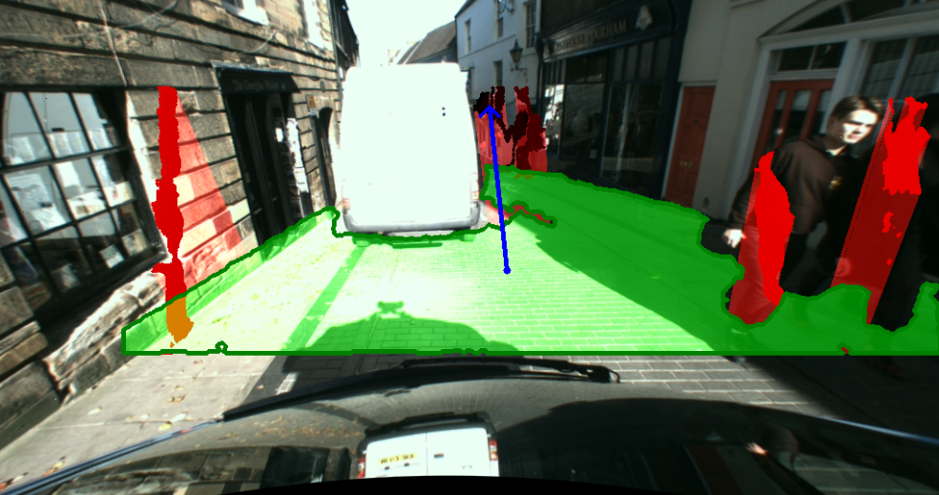
Good detection of people on right, but no detection of van due to little texture, leading to bad disparity .
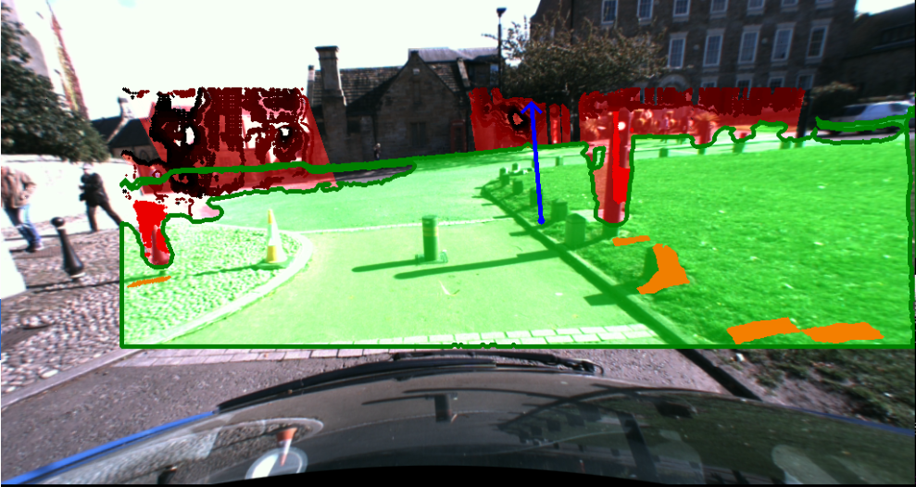
Small bollard and cone objects are not detected.

References
1 - Road Surface and Obstacle Detection Based on Elevation Maps from Dense Stereo, Florin Oniga et al, retrieved from the following URL at 16:00 27 Nov 2017: http://users.utcluj.ro/~onigaf/files/pdfs/oniga_road_surface_ITSC2007.pdf

