Plane Detection Summative
James Paterson – fdqd43

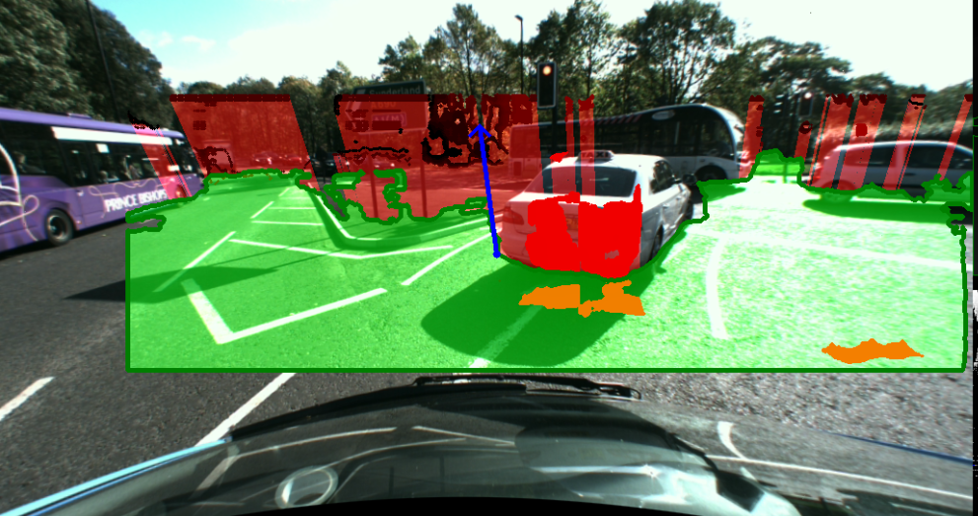
Example image. Plane illustrated in transparent green, obstacle points in solid shades of red, and obstacle collision areas in transparent red. The normal to the plane is shown in blue.

Image Processing Workflow

Preprocessing
The left and right images are first converted to grayscale. They are then subject to a histogram equalisation and then a gamma correction to increase contrast. Experiments with Lab conversion and equalisation in the L channel were attempted but eventually discarded.
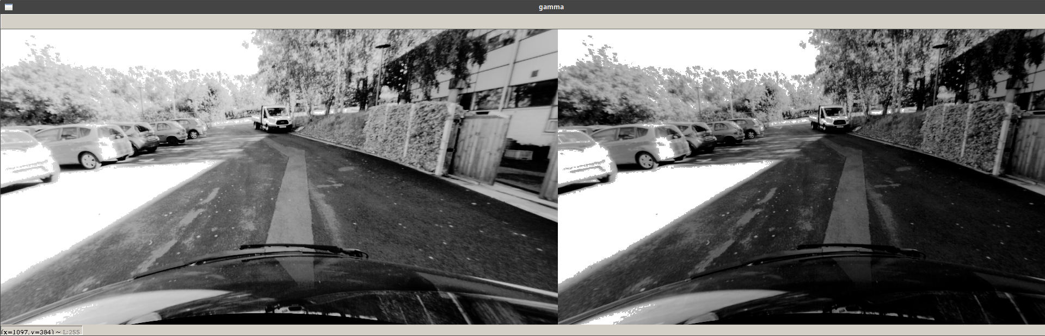
Left image before and after gamma correction
The disparity image is then generated, and is subject to several corrections. It is first processed with filterSpeckles, then “holes” of zeros/negative numbers are then filled in by an average of the row. This aims to preserve horizontal gradient.
The disparity image is then cropped to above the bonnet, and to remove most of the sky. This is done to avoid depth errors as the sky has little texture and often causes the appearance of large flat obstacles.
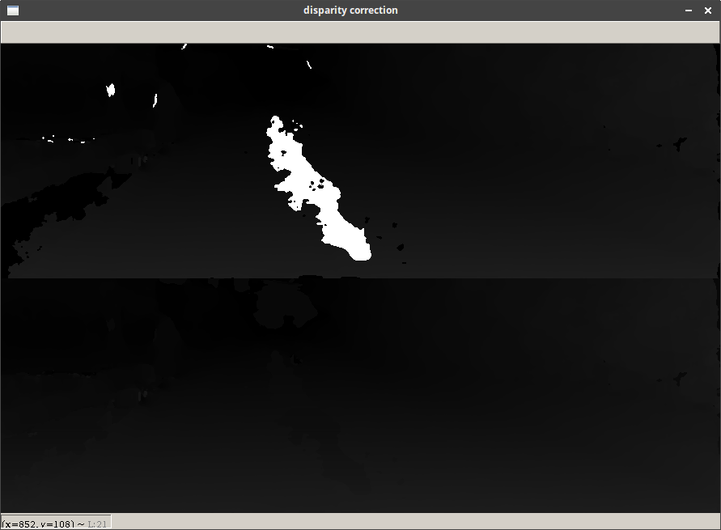
Disparity before and after correction. Note the large black area filled in in the bottom left.

RANSAC
The plane detection is straightforward and very performant. The points are projected to 3D, then we perform a set number of RANSAC trials. We select 3 non-colinear points from the sample set using the code supplied, and calculate the plane coefficients. As an optimisation, we see if the normal is is mainly in the Y direction. If it’s not then we know the plane cannot be a valid road as it has too much roll in one of the other dimensions, so it is discarded. We then calculate the distances from the plane of every 3D point. To quickly check the number that are below some threshold (plane_fuzz), we convert the list to a binary list using numpy and sum, which is faster than a loop. This number is compared and if more points are matched than the current best we store the coefficients.
As another optimisation, we also check the last plane to make sure it doesn’t fit the new one as well.
In testing, I averaged 200 trials in ~0.2s, and 2000 in ~2.75 seconds on my laptop.

Plane Retrieval
The final plane is then selected by the set of coefficients that matched the most points in the RANSAC. We normalise the normal vector, and project and store the centre of the plane for use in drawing theinormal.
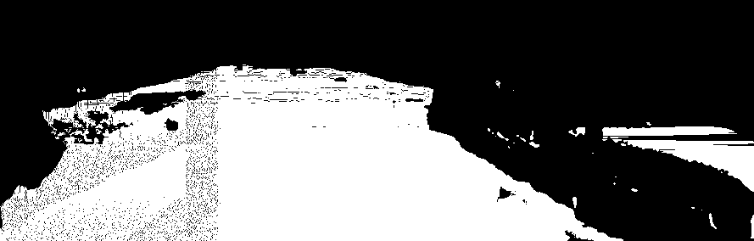
Raw data from the plane
The raw points are then drawn onto a black image. It is then dilated slightly to close 1px lines and holes that appear. The largest contour (A contiguous area of pixels) is selected, and drawn onto the disparity map and image, along with the normal.
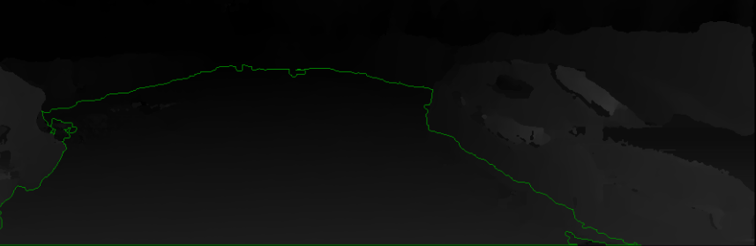
Disparity map with plane overlaid
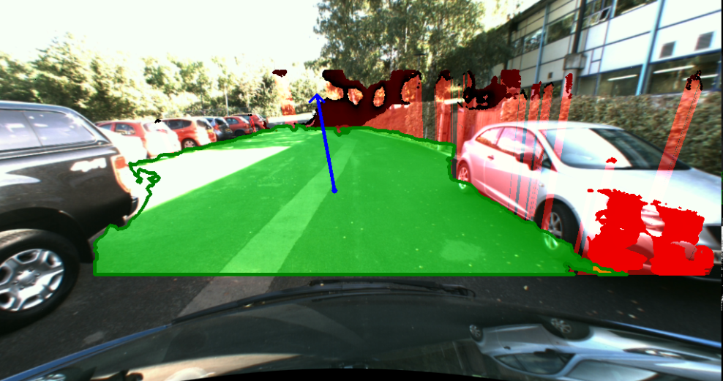
Plane drawn onto colour image
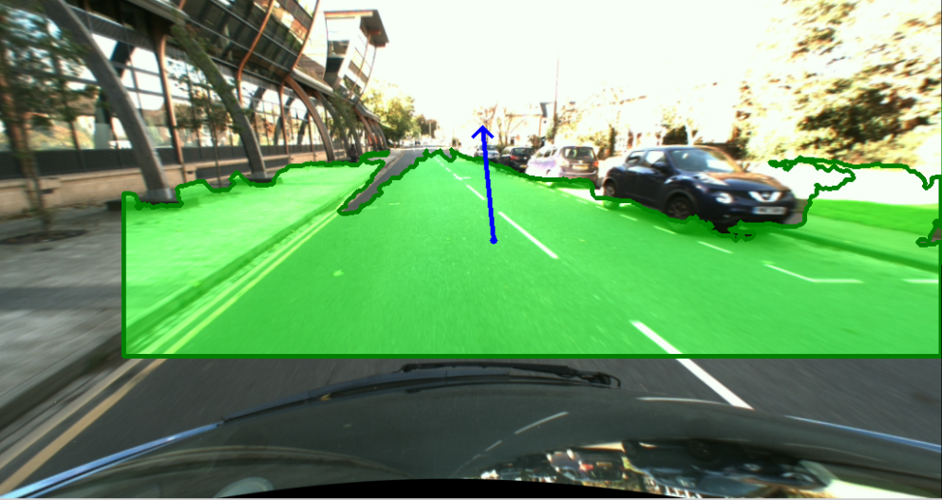
Another plane and normal, with no object detection

Object Detection
The object detection is based on the reference [1]. First, the 3D points are classified into a set of cells by their X and Z directions. We count the number of points that fall into cell, and store the count to measure of the density of 3D information. We also measure the amount of road points in each Z index of the image - the estimated density of the road surface. This is then filtered with a rolling average to smooth any outliers.
This approach now allows us to compare the expected density of the road at some Z-index with the actual density. We calculate a quotient actual_density/expected density and if it’s over a set threshold, we consider it an obstacle. We add to the obstacle by starting a recursive procedure on the neighbours, which adds points close to the obstacle point with quotient over a lower threshold (3). Points which could be on the plane are checked and discarded, as they are not obstacles.
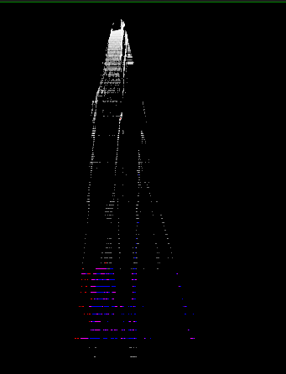
Example density map. The camera is positioned at the top of the image.
The line with each obstacle point and the normal to the plane is then used to find the point of intersection with the plane. This line is then drawn in light red, to show the boundary of the obstacle relative to the plane.
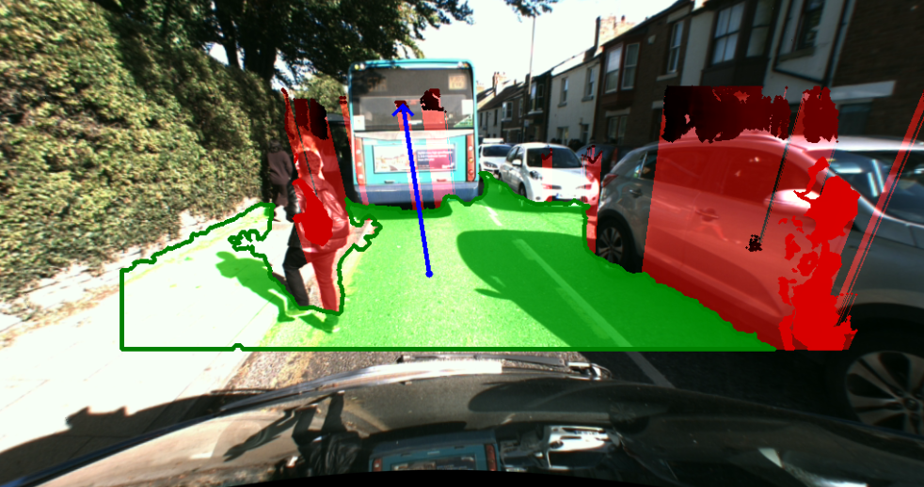
Dual object detection of Jaywalker & adjacent car

Output
The plane and obstacles are drawn onto empty masks, then added to the left image. The normal is then drawn on top.

Evaluation

Plane Detection
I used a representative sample of 50 images, the results are below:

Observation | Plane completely wrong  (No road in plane, plane oriented incorrectly, etc etc) | Plane mostly wrong  (Plane more than a quarter undrivable terrain, objects classified as drivable, most of road not found) | Plane mostly correct  (Surface is completely drivable, most of surface is road, most of the road is captured) | Plane almost entirely correct  (Surface is entirely road with no obstacles or pavement classified as drivable)
Number of occurences | 0 | 5 | 32 | 13

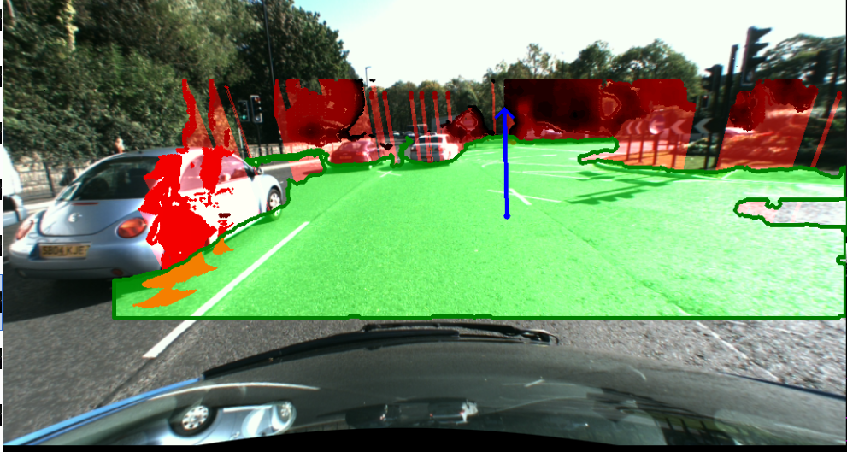
Perfect/Near Perfect detection
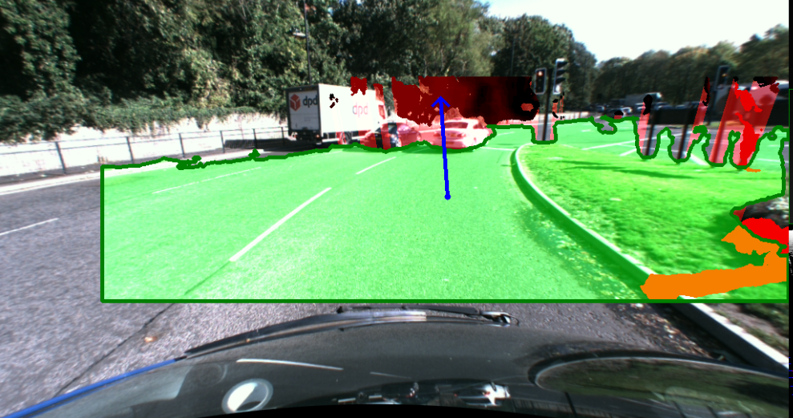
Imperfect/Good detection

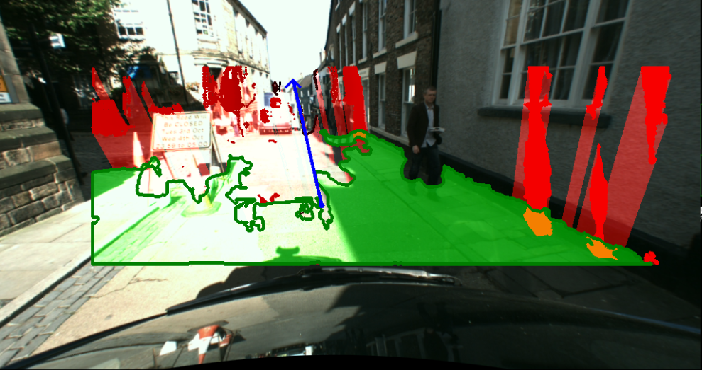
Mostly wrong/Bad detection
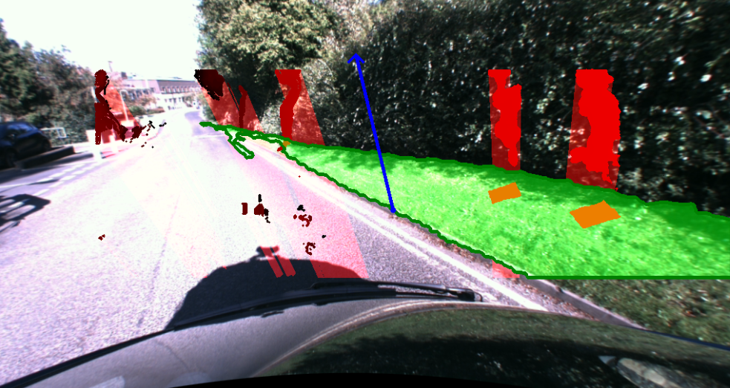
Completely wrong detection
From this, we can estimate that ~90% of images are good detections. The program tends to fail in two scenarios. Firstly, when chunks of road are overexposed, which confuses the disparity mapping. This could possibly be fixed with luminosity transforms, but I tried a Lab transform and it did not work. The second scenario is when most of the image is an obstacle or pavement, causing the mapping to snap to another feature.
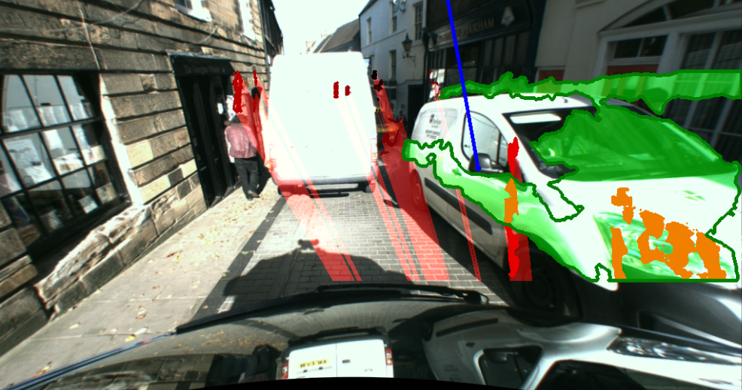
An interesting detection exibiting this problem

Object Detection
Object detection is suprisingly resilient. Multiple objects are detected often detected well. Some good detections are shown below:
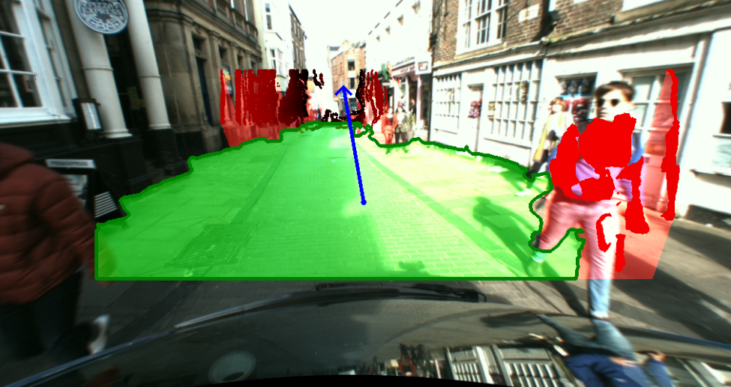
Good detection of pedestrian

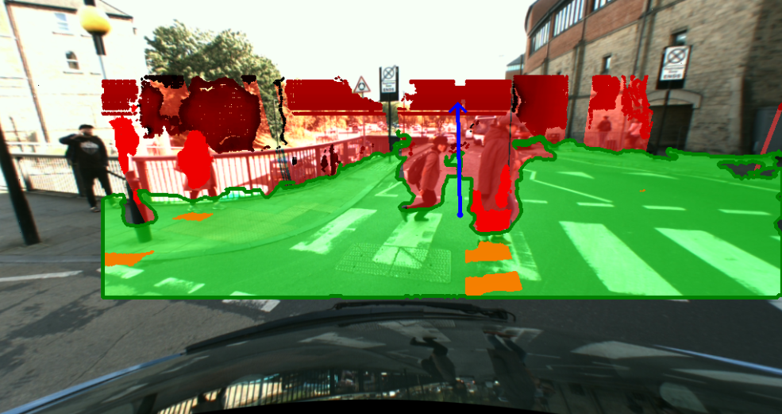
Good detection of pedestrians, lampost and railing.
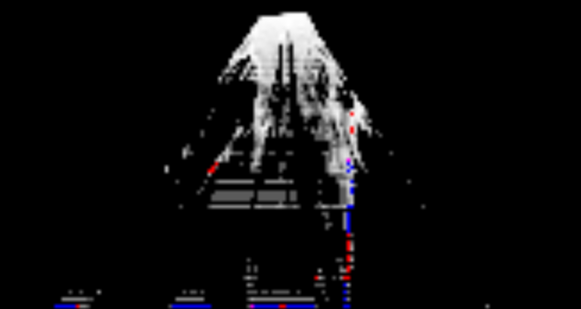
Density map for the above image, zoomed. You can see the two pedestrians in the density map.
The approach does have problems. The main one is that it is heavily reliant on the disparity map. Large objects with no/little texture are frequently not flagged as obstacles due to a lack of 3D points at those locations. Additionally, some objects low to the ground are not detected as obstacles due to both a lack of 3D points, and closeness to the plane. Distant objects are rarely detected as well due to there being less 3D data at a larger z-index. Some square artifacts are also generated occasionally as well.
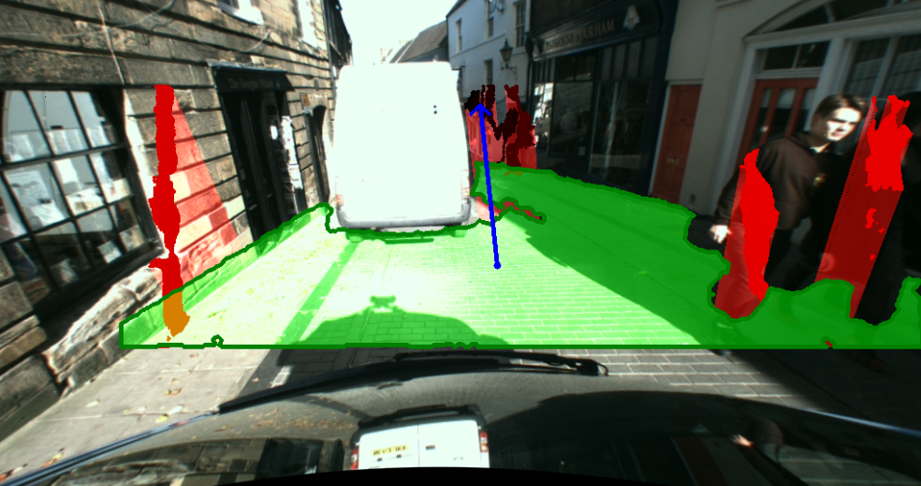
Good detection of people on right, but no detection of van due to bad disparity .
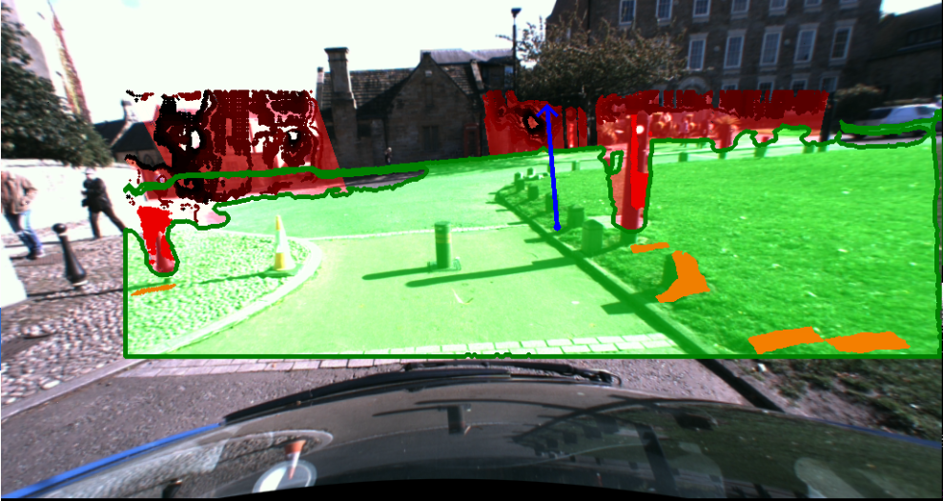
Small bollard and cone objects are not detected. Square artifacts also present in bottom right

References
1 - Road Surface and Obstacle Detection Based on Elevation Maps from Dense Stereo, Florin Oniga et al, retrieved from the following URL at 16:00 27 Nov 2017: http://users.utcluj.ro/~onigaf/files/pdfs/oniga_road_surface_ITSC2007.pdf
~850 words minus captions and tables, I couldn’t fit the object detection stuff in without it.
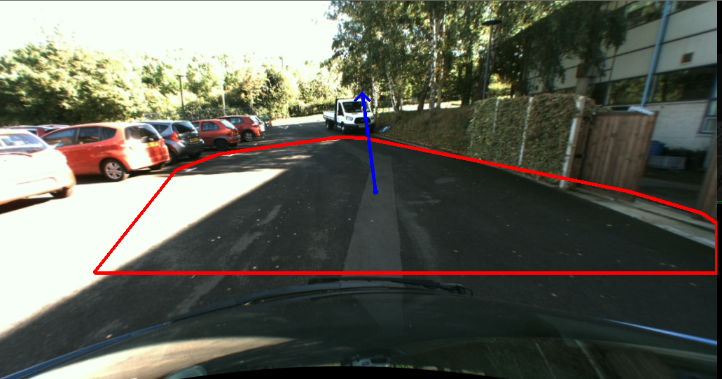
Enable with redLineMode=True

