AWP – Descriptions of the Templates

The Accessible Web Page project consists in part of a set of web pages and that can be used as templates for creating accessible materials that provide text-to-speech support. In addition to the page templates the project also contains other resource files that support page behavior and appearance. This document describes the various templates. It also highlights some editing and feature details that are not covered in other how to guides about creating custom pages from some of these templates.

Table of Contents Pages:

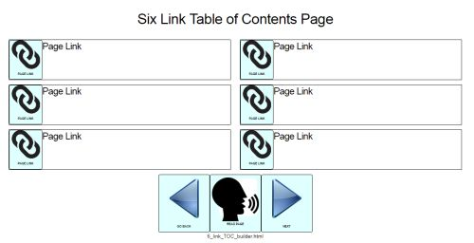  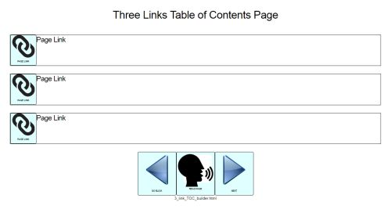 | There are two pages that are intended to be used as tables of contents, one with 6 links in two columns, and one with 3 links in a single column. Both have a banner at the top, and the navigation button strip at the bottom.  Each link button resides inside a text box that shows a copy of the link button’s label. The message attribute of the link button is not shown but will be read if the user clicks anywhere inside the text box. If no message is defined the label is read.  Each text box can hold more than one button, but only the leftmost button will be activated when the user clicks, or scans to and selects any button inside the text box. So, it makes sense to have only one button per text box

Question and Answer Pages:

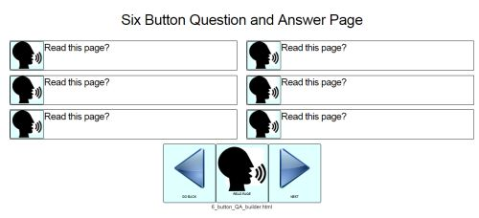  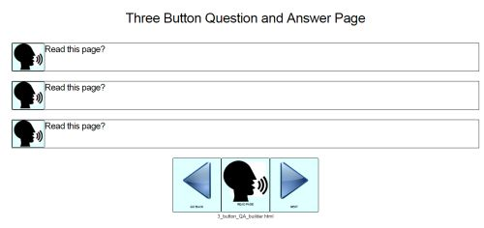 | There are two pages that are intended to be used as question and answer pages, one with 6 answers in two columns, and one with 3 answers in a single column. Both have a banner useful for posing a question at the top, and the navigation button strip at the bottom.  Each answer button resides inside a text box that shows a copy of the answer button’s label. The message attribute of the answer button is not shown, but will be read if the user clicks anywhere inside the text box. If no message is defined the label is read.  Each text box can hold more than one button, but only the leftmost button will be activated when the user clicks or scans and selects any button inside the text box. So, it makes sense to have only one button per text box

Story Pages:

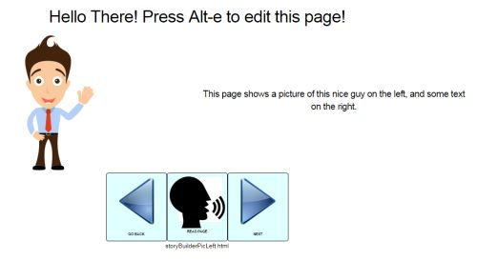  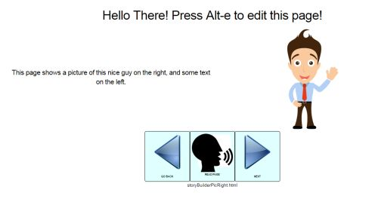 | There are two pages that are intended to be used as story pages. Both have a banner that will be read when the page opens, and a block of text that will be read as well. One page places a picture on the left, and the other the picture on the right. Both pages have a navigation button strip at the bottom.  If you only want the block of text to be read when the page opens, then remove the text from the page’s banner attribute in the editor.  If you only want the page text to be read when the user clicks the Read Page button, open the editor. Use the Select Next Actor buttons to move the orange highlight to the Read Page button. Set the Set Action for Btn X field to the _readStoryText command. Save the result.  Here are tips for making poems and stories sound and look better:  If you want to cause a pause in the text-to-speech output without inserting normal punctuation, insert the dash character followed by space as in: introducing – Mister Magoo!  If you want create a line break in your text to improve its appearance place the HTML break tag, <br>, in your story’s text as in: I think that I should never see. <br> A poem lovely as a tree.  The line break tag won’t appear, but a new line will be generated.

The Grid Builder:

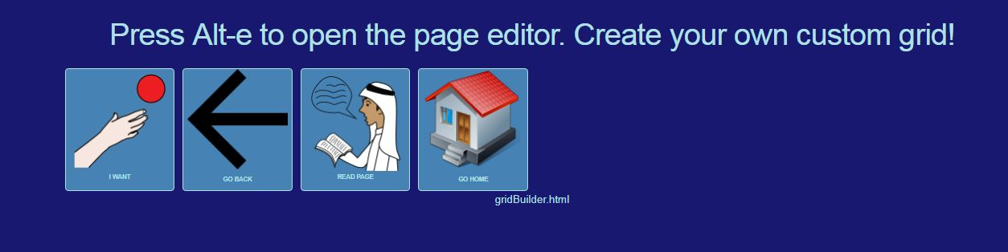  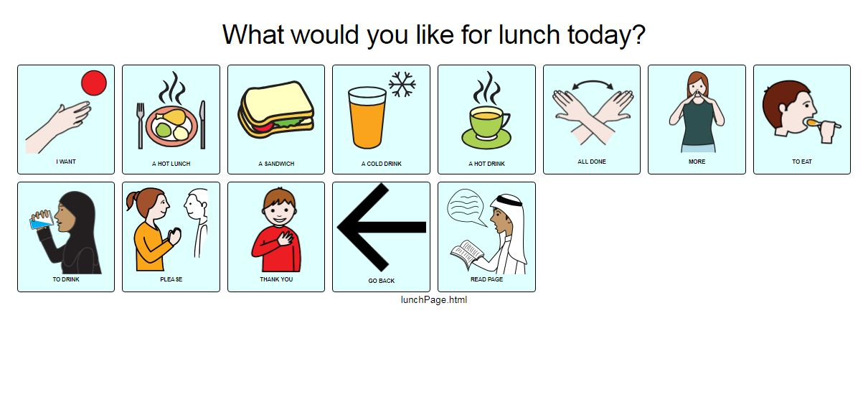  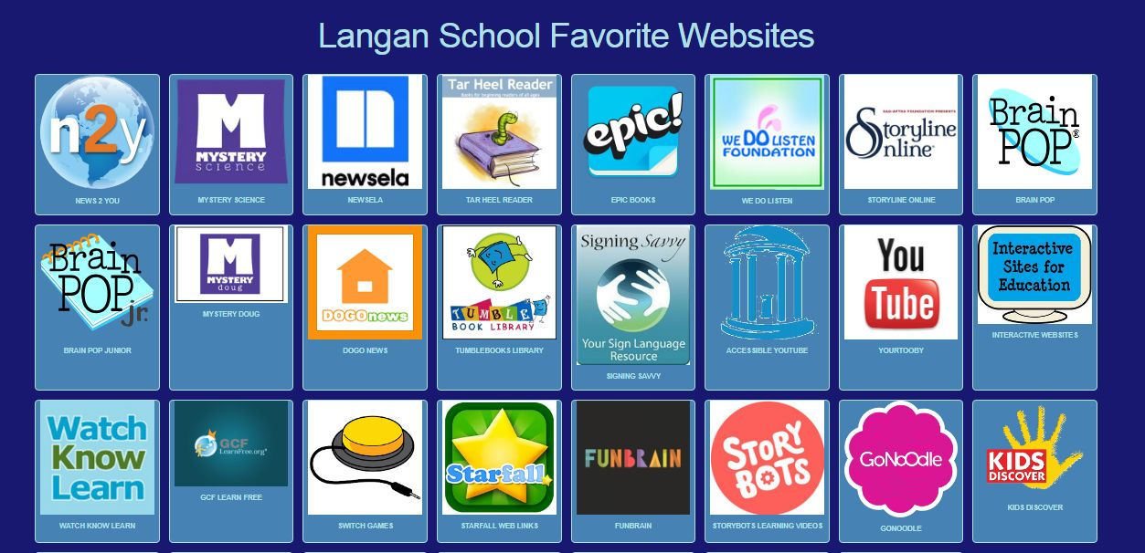 | The Grid Builder page allows you to make an arbitrarily large grid of buttons. Because the grid will reformat itself based on the width of the users view-port, you can’t assign buttons to columns and rows. As the view-port narrows the number of columns is reduced. So, when inserting buttons remember that they will scanned in left to right order from top to bottom. A page banner is located at the top of the page. There is no navigation/button strip.  The grid of buttons can have both link “actors” or button actors. A grid of just link actors can be useful to create a page of favorite web links as in Symbaloo – except thr awp grid supports Tab/Enter navigation (which can also support switch scanners) and has text-to-speech built-in.  Grids can be combined to create a simple multi-page speech generating device. The commands available to button actors provide support for sentence building by modifying the page banner. Currently, there is no mechanism to preserve a banner’s text between pages, so make sure you design pages to permit forming complete sentences with on any given page where you expect users to do so. Only linear scanning is supported by the inherent Tab/Enter navigation method used in the AWP project pages. With that in mind, keep your pages short and simple if you are supporting switch scanners.

Simple 2 and 4 Choice Communications Pages:

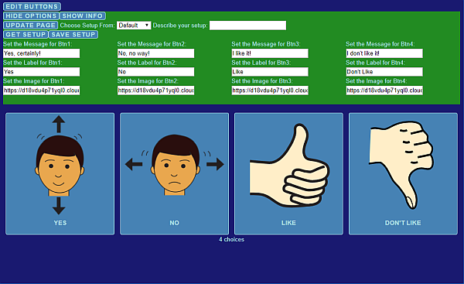  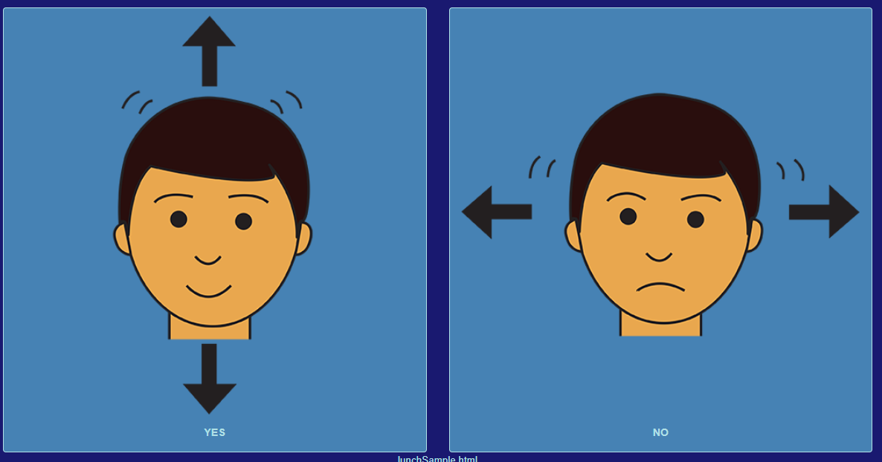 | These pages are simple 2 or 4 button pages that are intended for basic communication needs. The built-in editor can use local storage on your device to save up to 12 setups.  The default 4 choice page is shown to the left. The editor is shown open revealing all the attributes you can change for each button. To see any changes you make click the Update Page button. After redefining the buttons, if you want to save your work as a re-usable setup, select one of the numbered setups from the drop-down menu and provide a description. Then click Save Setup. The saved setup is stored in local storage indefinitely unless the local storage cache is cleared. It can be retrieved by selecting the numbered setup from the drop down menu and selecting the Get Setup button. The description you associated with the numbered setup will help you identify the setup your looking for.

YouTube Viewer Page:

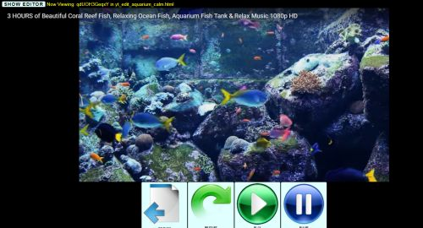  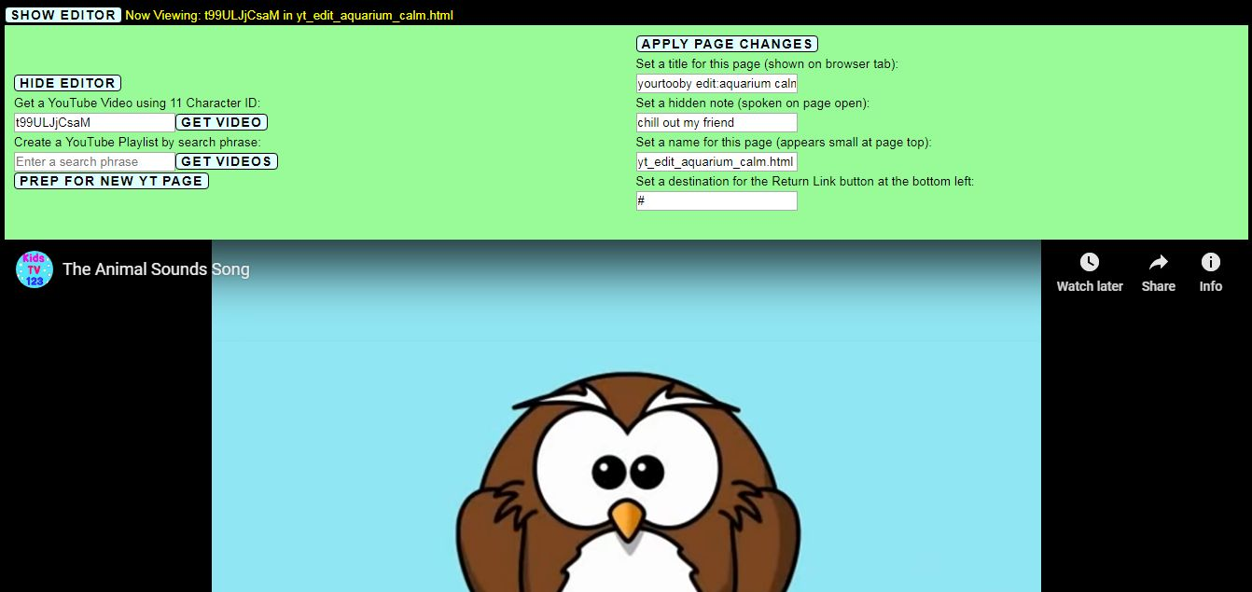 | The YouTube viewer offers a simplified, easy access interface and provides text-to-speech. You can define what video will play when the page opens.  The default page opens with the aquarium video as shown to the left. There is a navigation/control strip shown at the bottom that you cannot change except to define a URL for the return link button. The controls allow the user to navigate back to another page, reload the video, play or pause.  If you use the Edge browser to open the template stored on your hard drive the page may not work properly. Instead, use Google Chrome or Firefox to view and edit this template. If you post your edited version of the AWP YouTube viewer page on your website the Edge browser will work properly – just not if the page is stored locally.  Editing the YouTube viewer requires that the page is saved using the preferred method (copying the html content and saving the result using a text editor as described elsewhere.) Saving the page using the “Save webpage, complete” method will not work. The page also needs to be prepared properly.  To edit the page, open the editor by clicking the Show Editor button. Paste the 11 character YouTube video identifier into the text box for that purpose. Click the Get Video button. If your video loads successfully, reopen the editor. Edit the other page properties to change the page title, a page name that appears at the top of the page, a hidden note that is read when the page opens, and the return link URL. Finally, click the Prep For New YT Page button – this is crucial. The video will disappear but don’t worry! You should then proceed with the preferred method for saving your new page. Reopen your new saved page to see if it works.  There is a bonus feature in the editor that allows you to obtain a list of up to 20 videos by entering a search phrase in the text box provided for that purpose and clicking the Get Videos button. This will also expose more control buttons that allow you to move back and forth over the video list. You cannot save a playlist YouTube Viewer page yet.

