Intelligence Directorate Report

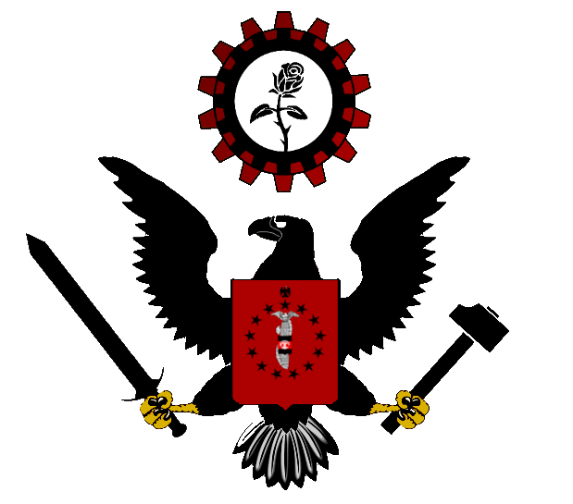

Report on the Desert War in Rhodendia

The Intelligence Directorate has been closely monitoring the escalating resistance war unfolding within the apartheid state of Rhodendia. The resistance movement, led primarily by the United Liberation Front (ULF), poses a significant challenge to the stability and legitimacy of the Rhoden regime. This report aims to provide a comprehensive analysis of the current situation, including the key actors, goals, and history of the conflict.

**Key Actors:**

* United Liberation Front (ULF):
  + Ideology: Revolutionary Front
  + The primary driving force behind the resistance war, the ULF comprises a coalition of various opposition groups united in their goal to overthrow the apartheid regime. They have mobilized significant support among marginalized communities and have been instrumental in organizing protests, strikes, and acts of civil disobedience.

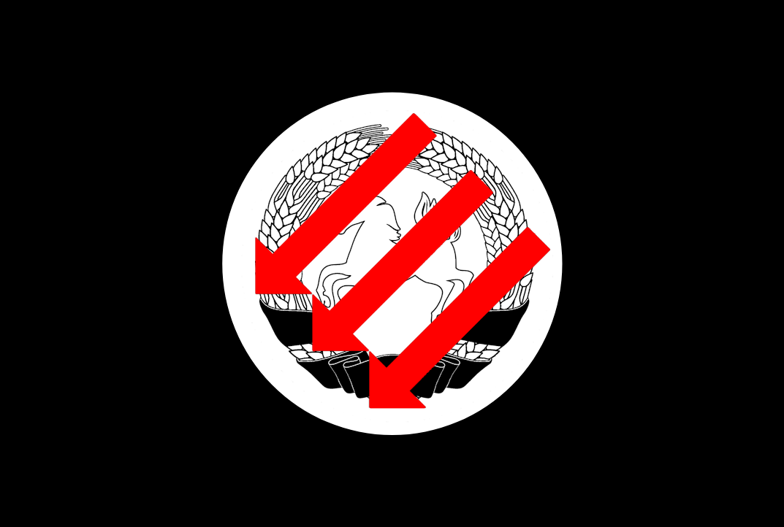

Unofficial Flag of the ULF

* Rhoden Security Forces:
  + The Rhoden regime has responded to the resistance war with brutal repression, deploying its security forces to suppress dissent and maintain control. Reports indicate widespread human rights abuses, including extrajudicial killings, torture, and arbitrary arrests, perpetrated by government forces against perceived enemies of the state.
* Rhoden National Coalition
* **Rhoden National Party (RNP)**
  + Ideology: Right-Wing Populism
  + Beliefs: Advocates for the maintenance and preservation of white minority rule in Rhodendia. Promotes apartheid policies that segregate and oppress non-white populations. Emphasizes the superiority of the white Rhoden ethnic group and seeks to protect its interests at the expense of others.
* **Herrenvolk Unity Front (HUF)**
  + Ideology: Paternalistic Conservatism
  + Beliefs: Supports the continuation of the existing system of governance, where the white minority holds exclusive political power and privileges. Seeks to maintain social order and stability through the enforcement of apartheid laws and the suppression of dissent among non-white populations.
* **Rhoden Conservative Alliance (RCA)**
  + Ideology: Paleoconservatism
  + Beliefs: Advocates for the preservation of traditional values and social structures within the context of white minority rule. Supports policies that uphold the dominance of the white Rhoden ethnic group and the maintenance of apartheid institutions.
* Non-Coalition Parties
* **Rhoden Reform Coalition (RRC)**
  + Ideology: Christian Progressivism
  + Beliefs: Advocates for the gradual dismantling of apartheid policies and the establishment of a more inclusive and egalitarian society. Supports reforms that aim to address socioeconomic disparities, promote racial integration, and protect the rights of all citizens regardless of race. Seeks to work within the existing political framework to achieve incremental progress towards equality and justice.
* **Rhoden Volkish Party (RVP)**
  + Ideology: National Socialism
  + Beliefs: Advocates for the establishment of a totalitarian state based on racial purity and supremacy. Promotes extreme xenophobia, and the complete subjugation of non-white populations. Seeks to impose a fascist regime that enforces strict social hierarchies and eliminates all opposition to white minority rule.

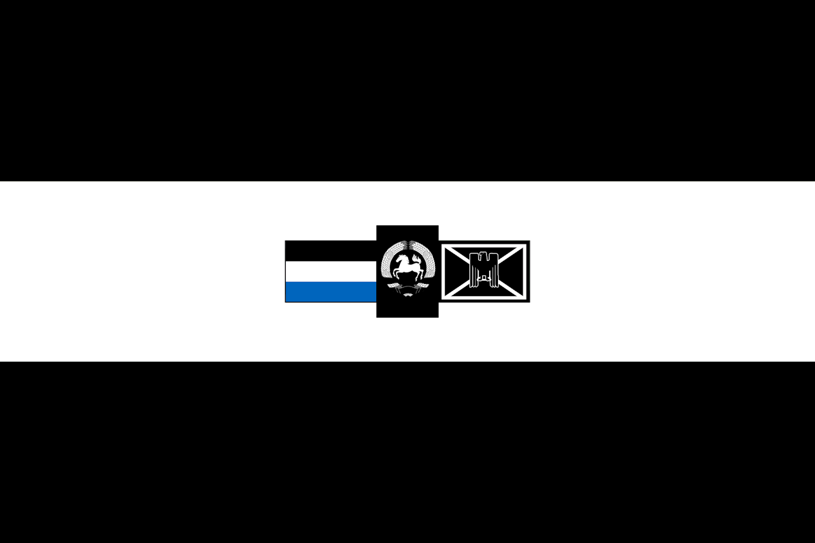

Flag of Rhodendia

International Support Networks:

**Rhodendia Fremden Widerstandsbewegung (RFW)**

Rhodendia Foreign Resistance Movement

Allegiance: Rhodendia

A foreign volunteer group known as the Rhodendia Foreign Resistance Movement emerged as staunch supporters of the apartheid regime. Comprised of mercenaries, ideologues, and disillusioned individuals from various corners of the globe, the RFRM espouses a radical ideology that glorifies white supremacy and authoritarianism.

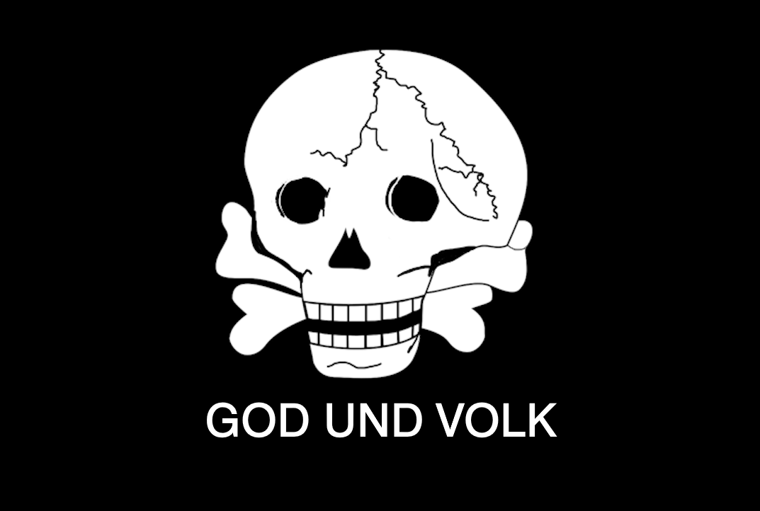

Unofficial Flag

**Falkish Legionary Corps**

The Falkish Legionary Corps (FLC) is a military advisor group formed by the Falkish Government as a response to the rising resistance movement in Rhodendia, primarily composed of military personnel who have served in the Yorinoto War. The FLC operates as a force committed to preserving white minority rule and suppressing the aspirations of the indigenous population in Rhodendia while also deepening relations between Rhodendia and the Falkish Empire.



Flag of the Falkish Empire

**History**

**Colonial Settlement 1900-41**

The Falkish Empire, seeking to expand its territory and exploit natural resources, would colonize the territory of Rodendia imposing a system of racial segregation and discrimination in Rhodendia. The Falkish implemented policies of exploitation and domination, subjugating the indigenous population and exploiting the country's natural resources for the benefit of the colonial power.

**Rhodendian Uprising and Falkish Decision for Independence 1941-65**

Independence came with the Rhodendian Uprising of 43 (Called the Der Sandaufstand or The Sand Uprising by the Falkish). Triggered by a brutal crackdown on peaceful protests by the Falkish colonial authorities from 1941 to 43, the uprising ignited widespread discontent and resistance across Rhodendia.

The uprising was sparked by the infamous Rhodendian massacre of 56 where Falkish security forces opened fire on unarmed demonstrators, resulting in the deaths of dozens of innocent civilians, including women and children. The massacre galvanized the Rhodendian populace and drew international condemnation, shattering the facade of colonial benevolence.

In response to the massacre and mounting pressure from both within and outside Rhodendia, the Falkish Empire made the historic decision to grant independence to Rhodendia. Recognizing the aspirations of Rhodendia's nationalist movement and the desire for self-determination among its people, the Falkish government initiated negotiations with Rhodendian leaders to facilitate a peaceful transition to independence.

**Post-Independence and the Apartheid Regime**

Despite achieving independence, Rhodendia faced numerous challenges in the post-colonial era. The legacy of colonial oppression and exploitation left deep scars on Rhodendian society, exacerbating social, economic, and political divisions within the newly independent nation.

Rhodendia's ruling elite, comprised primarily of white Falkish settlers, sought to maintain their privileged status and economic dominance through the implementation of apartheid policies. Apartheid laws enforced racial segregation, institutionalized discrimination, and restricted the rights and freedoms of non-white populations, sparking widespread resistance and discontent among the indigenous population.

**The Yorinoto War (1970-76)**

In the wake of the Rhodendian Independence and escalating apartheid repression, neighboring countries, including Cambridia, Parim, and Chawsbury, declared war on Rhodendia in a coordinated effort to topple the apartheid regime and support the liberation struggle.

The international intervention was motivated by solidarity with the oppressed people of Rhodendia and a desire to uphold principles of justice and human rights. However, the conflict quickly devolved into a protracted and bloody struggle, with the Rhoden regime receiving military support from the Falkish and foreign volunteers.

Despite initial gains by the coalition forces, Rhodendia's well-equipped and determined military, coupled with support from external backers, managed to repel the invading armies and maintain control over its territory. The intervention ultimately failed to achieve its objectives, resulting in heavy casualties and further entrenching the apartheid regime's grip on power.

**Apartheid Resistance and the United Liberation Front (ULF): (1979-Present)**

The ULF emerged as the vanguard of the resistance movement, leading protests, strikes, and acts of civil disobedience against the apartheid regime. Inspired by the spirit of independence and fueled by grievances over racial discrimination and economic exploitation, the ULF galvanized widespread support among Rhodendia's diverse ethnic groups.

The resistance war in Rhodendia represents a continuation of the struggle for liberation and self-determination that began with the achievement of independence from the Falkish Empire. The ULF and its allies remain steadfast in their commitment to dismantling the apartheid regime and building a society based on justice, equality, and democratic governance.