Development of a Web-Based Health Monitoring System with SMS Notification Reminders of Pregnant Women and Malnourished Children for the Rural Health Unit of Sierra Bullones

In Partial Fulfillment of the Requirements for the Degree of
BACHELOR OF SCIENCE IN INFORMATION SYSTEM (BSIS)
CAPSTONE I

MAGALLANES, JAMMAEL
AYENTO, MICHAEL
MAHINAY, IGGY LOUIS
LITUB, PRINCESS JELYN
COSARES, RHEA JAY CELINE
June 2026
CHAPTER I
INTRODUCTION
Recently, digital technologies have become more important in healthcare. They help improve service delivery, manage data better, and lead to better patient outcomes, especially in primary care. However, many local health facilities still use traditional manual systems, which can reduce efficiency and effectiveness. Studies have shown that electronic health systems make data more accurate, give quicker access to patient information, and improve healthcare services, particularly for maternal and child health programs [1].
The Primary Care Facility Sierra Bullones and Birthing Center keeps maternal and child health records by hand. For pregnant women, staff write information in a logbook called the Target Client List (TCL) to track their care. For children, they use Operation Timbang (OPT) to assess and monitor nutrition. Since all records are kept manually, they can be lost, damaged, or have errors. Patients need to come to the health center for check-ups. Staff remind patients about follow-ups with notes or by talking to them. Sometimes, midwives send extra reminders by text or phone.
However, the current system presents several challenges. The reliance on manual records increases the risk of data loss and makes it difficult to efficiently organize and retrieve patient information. Tracking pregnant women and identifying malnourished children becomes more complicated due to the lack of a centralized and automated system. Additionally, the process is time-consuming, as health personnel must manually search through records, which can delay service delivery. Studies support that manual healthcare systems often lead to delays, reduced accuracy, and gaps in patient monitoring, particularly in community-based healthcare settings [2].
The proposed system will be utilized by key personnel within the facility, including Nurse Deployment Program (NDP) staff, midwives, one assigned doctor, and a designated encoder. Typically, each barangay is assigned one NDP and one midwife, ensuring that healthcare services are distributed across the community.
In response to these challenges, this capstone project aims to design and develop a digital system that will improve the management of maternal and child health records in the facility. The proposed system seeks to replace manual processes with an automated solution that enhances data storage, simplifies tracking and monitoring, reduces the workload of healthcare workers, and improves communication through features such as automated reminders. Ultimately, the system aims to provide more efficient, accurate, and reliable healthcare services, aligning with studies that emphasize the effectiveness of digital health technologies in improving patient outcomes and healthcare delivery.

CHAPTER II
REVIEW OF RELATED LITERATURE
Impact of Inefficient Manual Record of Health Monitoring
Effective health monitoring plays a crucial role in improving maternal and child healthcare services. However, many healthcare facilities, particularly in rural and underserved areas, still rely on manual record-keeping systems to manage patient information. These traditional methods often lead to fragmented patient records, difficulties in retrieving health data, and delays in monitoring patient progress. As a result, healthcare providers may encounter challenges in tracking children's nutritional status, monitoring prenatal visits, and ensuring timely follow-up care for both mothers and infants.
A recent study by Troyee et al. [3] highlighted the lack of continuous health monitoring and limited access to prenatal care among pregnant women in rural and developing regions. This gap in healthcare services contributes to higher rates of maternal and infant mortality as well as unmanaged pregnancy-related complications. Similarly, Guillermo [4] emphasized the limitations of conventional prenatal monitoring practices, which often fail to provide efficient and timely tracking of maternal health conditions.
Moreover, Senthilsingh et al. [5] examined the inefficient manual monitoring of maternal health and child growth in Anganwadi centers. The study revealed that manual documentation results in delayed data reporting, increased workload for health workers, and challenges in addressing malnutrition and other health risks among children in low-income communities. Inefficient monitoring systems limit the ability of healthcare providers to respond quickly to emerging health concerns, thereby affecting the quality of maternal and child healthcare services.
Furthermore, Black et al. [6] identified maternal undernutrition as a significant health issue, particularly in regions such as Asia and Africa. Although the prevalence of women with low body-mass index (BMI) has slightly declined over the past two decades, maternal undernutrition remains widespread. Poor maternal nutrition during pregnancy can lead to fetal growth restriction, which increases the risk of neonatal mortality and negatively affects child development.
In addition, Khalil et al. [7] noted that manual record-keeping systems are not only time-consuming but also vulnerable to physical damage, data loss, and limited accessibility. These limitations hinder the efficient sharing of patient information across healthcare facilities, ultimately affecting the continuity and quality of healthcare services.

Evolution of SMS and Digital Health Technologies in Healthcare Monitoring
With the continuous advancement of information technology, healthcare systems have increasingly adopted digital tools to improve patient monitoring, communication, and service delivery. Mobile health technologies, particularly Short Message Service (SMS), have become widely used for sending healthcare reminders, notifications, and health education to patients. These digital approaches help healthcare providers maintain consistent communication with patients and improve adherence to medical appointments and health monitoring activities.
Mendoza et al. [8] introduced the development of the WOMB web-based system, which aims to improve maternal and infant healthcare through digital health monitoring. The system provides centralized medical records, automated appointment reminders, predictive data analytics, and improved communication between mothers and healthcare providers. By integrating these features, the system enhances the efficiency, accuracy, and accessibility of healthcare services while complying with international software quality standards.
Similarly, Hailemariam et al. [9] proposed the use of SMS reminders as a strategy to encourage pregnant women to attend healthcare visits on time. The study demonstrated that SMS-based notifications can improve attendance in antenatal care, skilled birth services, and postnatal check-ups, particularly in low- and middle-income countries where access to healthcare services may be limited.
In another study, Mannolkar et al. [10] presented an automated and non-invasive health monitoring system designed to detect malnutrition and anemia more efficiently. The system integrates Body Mass Index (BMI) assessment with hemoglobin estimation using a near-infrared optical method that utilizes red and infrared LEDs. This approach eliminates the need for invasive blood tests, providing a faster and more convenient method for health assessment.
Furthermore, Shafi et al. [11] proposed a web-based patient health monitoring system to address challenges in continuous patient care, particularly during the COVID-19 pandemic. The system collects real-time health data such as pulse rate, blood oxygen saturation, and body temperature. These data are transmitted wirelessly to a cloud-based storage platform where healthcare professionals can remotely access and monitor patient information through a web interface. This approach allows early detection of health issues while minimizing direct contact between patients and medical personnel.
Additionally, Wang et al. [12] highlighted that digital health interventions, including mobile applications and web-based monitoring platforms, significantly contribute to improving maternal and neonatal health outcomes. These technologies enhance healthcare communication, facilitate efficient health monitoring, and support better clinical decision-making processes among healthcare providers.

Research Gap and Contribution of the Proposed System
Although previous studies have demonstrated the advantages of digital health monitoring systems and SMS-based healthcare technologies, several limitations remain in existing solutions. Many existing studies primarily focus on maternal healthcare monitoring. For example, the system developed by Guillermo [4] mainly focuses on prenatal care monitoring and improving communication between healthcare professionals and pregnant women. Similarly, the Digital Prenatal Healthcare System with SMS Notification focuses on maintaining prenatal health records and sending SMS reminders for pregnant mothers. However, this system does not include monitoring tools for undernourished or malnourished children, limiting its scope to prenatal healthcare management Billones [13].
On the other hand, some studies concentrate mainly on nutrition monitoring or malnutrition detection without integrating maternal healthcare monitoring within the same system. For instance, research on malnutrition screening focuses on nutritional assessment and monitoring but lacks communication features such as SMS reminders for medical appointments Serón-Arbeloa [14]. Likewise, web-based nutrition education platforms prioritize improving nutrition awareness and detecting stunting but do not provide a comprehensive system for monitoring both maternal and child health services Aldhyno Yoghatama [15].
Additionally, certain digital health systems focus primarily on electronic health record management but do not integrate automated patient reminder systems or monitoring tools that support multiple healthcare programs Rosita et al. [16]. Other studies, such as research on child nutrition prediction using machine learning algorithms, concentrate on predicting stunting risks but do not provide a complete monitoring platform that supports healthcare service management and patient follow-up Kirana et al. [17].
These limitations highlight the need for a more integrated healthcare monitoring system that combines patient record management, communication tools, and health data analysis within a single platform.
To address these gaps, the proposed study titled “Development of a Web-Based Health Monitoring System with SMS Notification Reminders of Pregnant Women and Malnourished Children for the Rural Health Unit of Sierra Bullones” aims to provide a comprehensive digital solution for maternal and child healthcare monitoring. Unlike previous systems, the proposed system integrates automated SMS notification reminders, a scheduling and follow-up management dashboard, health reports and analytics, nutritional progress visualization, and offline-first data entry capabilities.
By combining centralized digital health monitoring with automated SMS communication and offline data synchronization, the proposed system aims to improve healthcare monitoring efficiency, strengthen patient follow-up processes, and assist healthcare workers in delivering more effective maternal and child health services, particularly in rural communities.
REVIEW OF RELATED SOFTWARE
This chapter presents a review of related software relevant to the proposed Web-Based Health Monitoring System with SMS Notification Reminders for Pregnant Women and Malnourished Children for the Rural Health Unit of Sierra Bullones. The purpose of this section is to analyze existing systems that provide health monitoring, maternal care tracking, and nutritional monitoring functionalities. By examining their features, advantages, and limitations, the researchers were able to determine the improvements needed for the proposed system.
Several existing systems demonstrate how digital technologies can support healthcare services through centralized databases, monitoring dashboards, and mobile health applications. These systems help healthcare professionals track patient health conditions, manage health data, and improve access to medical services.

- RAPIDSMS-MCH
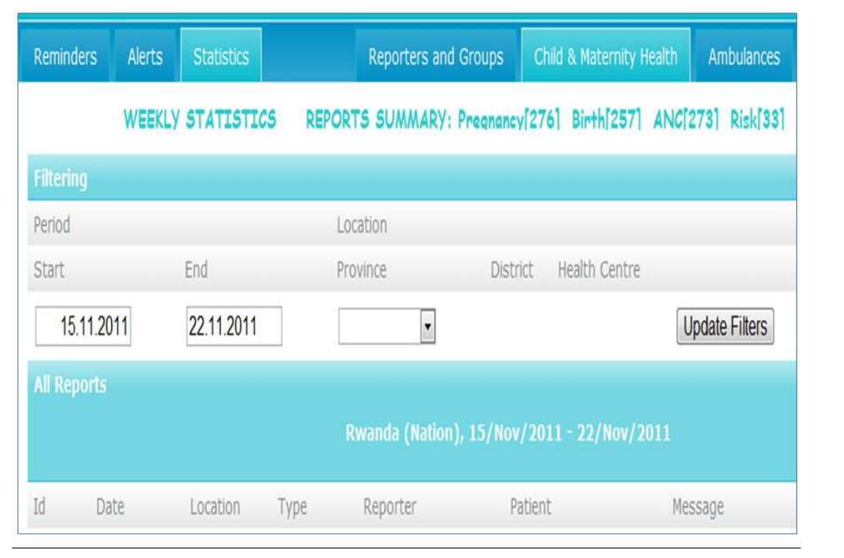
Figure 1. Rwanda RAPIDSMS-MCH Web user Interface
Rwanda’s RapidSMS-MCH was developed under the leadership of the Rwanda Ministry of Health [18]. The RapidSMS-MCH system was designed to provide an SMS-based platform, enabling effective and real-time two-way communication for action, between CHWs at community level, and the rest of the health system (ambulance, health facility staff, and District Hospital and Central level) through mobile phones. The primary expected result of the system is an improved access to antenatal, postnatal care, institutional delivery, and emergency obstetric care. In addition, RapidSMS provides a database for keeping clinical records of maternal care delivery.

- WOMB
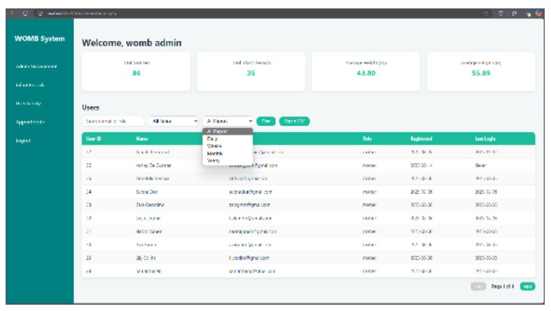
Figure 2. WOMB Web-Based Maternal and Infant Health Monitoring System
The WOMB system, developed by Mendoza et al. [8] is a web-based platform designed to support maternal healthcare and infant monitoring through integrated data analytics and smart algorithms. The system allows healthcare professionals to collect and store maternal health information such as prenatal check-up records, pregnancy progress, and infant health indicators in a centralized database.
One of the notable features of the system is its ability to analyze collected health data using intelligent algorithms that help healthcare professionals identify possible health risks during pregnancy. It also provides visualization tools that make it easier for healthcare providers to interpret medical data and monitor maternal health trends [8]. By transforming health records into organized digital information, the system improves efficiency in managing maternal healthcare services.
Despite its strengths in data analysis and monitoring, the system focuses more on analytical capabilities rather than patient communication. The platform does not emphasize automated communication tools that notify patients regarding scheduled prenatal visits or follow-up care [8]. In comparison, the proposed system integrates automated SMS notification reminders, ensuring that pregnant women receive timely alerts regarding their prenatal appointments and necessary health monitoring activities.
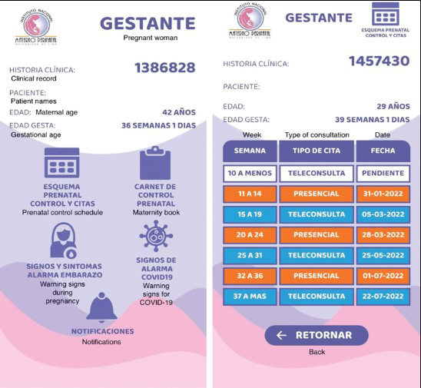
- Mobile Health Application for Prenatal Care Monitoring
Figure 3. Mobile Health Application for Prenatal Care Monitoring
The mobile health application developed by Novoa et al. [19] was designed to support prenatal care monitoring during the COVID-19 pandemic by providing remote healthcare services to pregnant women. The application allows pregnant women to monitor pregnancy-related symptoms, access health information, and communicate with healthcare professionals even when physical visits to healthcare facilities are limited.
Through the application, healthcare providers can also track patient information remotely, ensuring that pregnant women continue to receive medical guidance and monitoring despite external challenges such as lockdowns or mobility restrictions [19]. The use of digital health platforms during the pandemic demonstrated how mobile technologies can help maintain continuity of maternal healthcare services.
However, the application focuses mainly on remote monitoring and communication between patients and healthcare professionals. It does not provide a comprehensive system for managing health records for both maternal and child health in a single platform [19]. The proposed system improves this by integrating maternal health monitoring and child nutrition monitoring within one centralized web-based system that can be used by healthcare staff at the Rural Health Unit.

- Educational and Monitoring Mobile Application for Pregnant Women
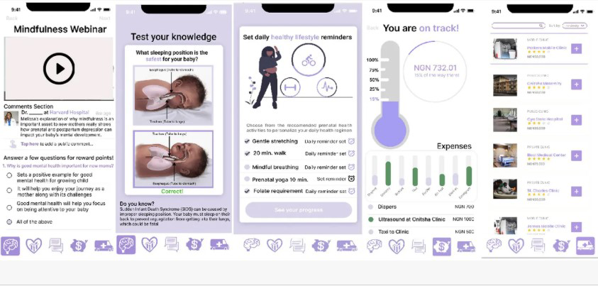
Figure 4. Educational and Monitoring Application for Pregnant Women
The mobile application developed by Babatunde et al. [20] focuses on providing educational resources and monitoring tools for pregnant women through a digital platform. The system was designed to improve maternal health awareness and encourage pregnant women to follow proper prenatal care practices.
The application includes pregnancy tracking tools, health monitoring features, and educational content that helps pregnant women better understand pregnancy-related health conditions and the importance of regular medical check-ups [20]. By increasing access to health information, the application helps promote better maternal health practices among users.
Despite its contribution to maternal health education, the application mainly focuses on patient self-monitoring and learning. It does not include administrative monitoring features that allow healthcare institutions to manage multiple patient records simultaneously or generate community health reports [20]. The proposed system addresses this gap by providing a centralized monitoring dashboard for RHU staff, automated report generation, and community health analytics, which allow healthcare workers to monitor maternal and child health cases more effectively.
- iClinicSys
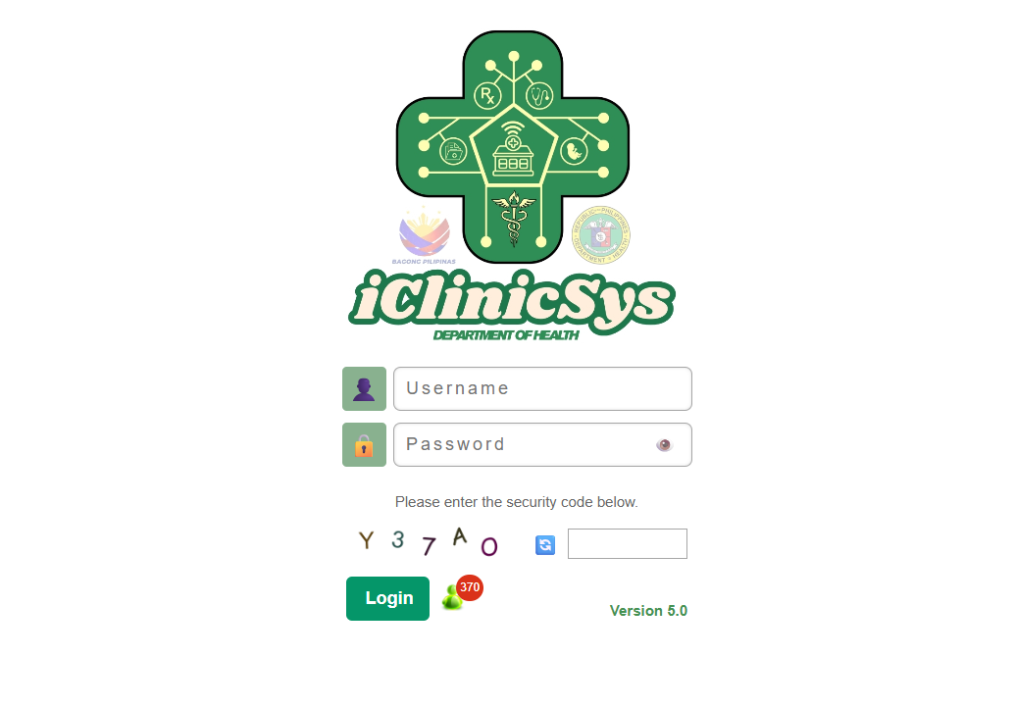
Figure 5: iClinicSys Login Page
iClinicSys [21] is a system owned by the DOH that efficiently and effectively monitors patient cases in rural health units (RHUs). iClinicSys is an electronic medical record and health information system designed to support the operations of primary care facilities, including Rural Health Units (RHUs), Health Centers (HCs), and Barangay Health Stations (BHS). It automates service delivery processes to ensure efficient and accurate monitoring of patient care within the health facility. As a standardized platform, iClinicSys also serves as the reference model for Electronic Medical Record systems aligned with the Department of Health’s (DOH) National Health Data Reporting, PhilHealth’s Primary Care Benefits (PCB), and other national eHealth initiatives. With iClinicSys, health information becomes readily accessible [21]. The system not only empowers healthcare providers with a comprehensive view of patient records but also facilitates timely and informed decision-making.
Matrix of Comparison
This section contains a table showing the comparison of the different related software applications.
Table 1. Matrix of Comparison
Features | Web-Based Health Monitoring System for Pregnant Women and Malnourished Children | RAPIDSMS_MCH | WOMB | Mobile Health Application for Prenatal Care Monitoring | Educational and Monitoring Mobile Application for Pregnant Women | iClinciSys
Auto SMS Notification Reminders | ✓ | ✓ |  |  |  | ✓
Scheduling and Follow-up Management Dashboard | ✓ | ✓ | ✓ | ✓ | ✓ | ✓
Reports and Analytics for the RHU | ✓ |  | ✓ | ✓ |  | ✓
Nutritional Progress Visualization | ✓ |  |  |  |  | ✓
Offline-First Data Entry | ✓ | ✓ |  |  |  | ✓

CHAPTER III
METHODOLOGY
Software Requirements Specification
Product Scope
This study aims to build a web-based health monitoring system with SMS reminder notifications for pregnant women and malnourished children at the Sierra Bullones Rural Health Unit. The project targets key processes like patient record management, health monitoring and tracking, SMS notifications, and report generation. It draws in various stakeholders too, such as the Nurse Deployment Program (NDP), midwives, doctor, and the data encoder.
The system will be built on a local development server. Once development wraps up, tests will be conducted to make sure it lines up with what users want and streamlines the manual processes at the health facility.
To determine whom to test, the researchers will apply a non-probability sampling method, namely a purposive sampling method. Individuals will be selected using purposive sampling based on their roles and practical experience in working with maternal and child health data. These respondents will include doctors, midwives, and health staff who are directly involved in monitoring the pregnant women and malnourished children.
For the health personnel, the researchers will coordinate directly with the Rural Health Unit to request participation in testing. The respondents will be approached personally and will be asked if they are willing to test the system. A schedule will then be arranged based on their availability.
A usability test will be conducted to evaluate the system. The researchers will use a standardized questionnaire based on the System Usability Scale (SUS), which consists of 10 statements rated from Strongly Disagree to Strongly Agree. The questionnaire will be used to measure the usability, efficiency, and user satisfaction of the system.
The respondents will participate voluntarily during the testing process. The researchers will also conduct functionality testing to ensure that all features of the system, such as patient record management, monitoring, and SMS notifications, work properly for each type of user.
During the testing phase, feedback from respondents will be collected to identify areas for improvement. The responses gathered will be analyzed using descriptive statistics, and the results will be summarized using graphs generated through Google Forms.
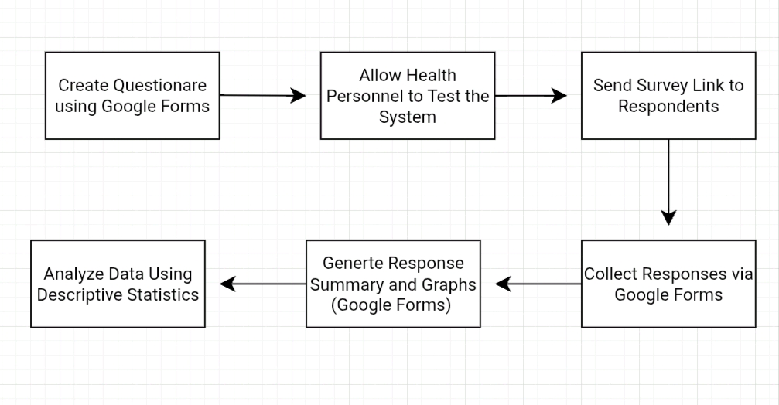
Figure 6. Data Collection and Analysis Process
The use of Google Forms in collecting survey responses helped minimize the cost of materials and made data collection more efficient. It also allowed automatic generation of charts and summaries, making the analysis faster and more accurate.
The collected data from the usability test were used to evaluate the system’s performance and identify necessary improvements. The results served as a basis for enhancing the functionality, usability, and overall effectiveness of the developed health monitoring system.
Functional Requirements
The software is divided into six main functionalities: Manage Maternal Records, Manage Child Nutrition Records, Manage Users and Access Control, Generate Reports and Analytics, Send SMS Notifications, and Manage Patient Enrollment.
Manage Maternal Records involves the management and monitoring of pregnant women in the RHU. This includes registering pregnant women, tracking their health status, monitoring pregnancy stages (trimesters), and maintaining comprehensive health records. The system facilitates the classification of risk levels low, medium, or high based on clinical data to ensure proper prenatal care.
Manage Child Nutrition Records involves comprehensive nutrition tracking for children aged 0-59 months. This includes registering children and recording their physical measurements such as weight and height. The system automatically calculates the nutritional status (Normal, Underweight, or Severely Underweight) based on WHO/DOH standards, eliminating manual calculation errors and identifying at-risk cases for immediate intervention.
Manage Users and Access Control involves comprehensive user account management and Role-Based Access Control (RBAC). This includes user registration and a specialized approval workflow where the Administrator reviews pending applications and assigns specific roles such as Doctor, Nurse, Midwife, or Encoder. This ensures data security and proper authorization across all health monitoring modules.
Generate Reports and Analytics provides users with high-level statistics and detailed health summaries. This allows the staff to view dashboard analytics, such as the count of high-risk cases and nutritional trends. The system also enables the generation of professional PDF reports for individual maternal or child records with official RHU branding.
Send SMS Notifications involves the automated and manual dispatch of health alerts and appointment reminders. This allows the system to notify patients of upcoming prenatal check-ups or urgent health risks. By utilizing an integrated SMS API, the system improves patient engagement and ensures timely follow-ups for critical health interventions.
Manage Patient Enrollment involves the initial registration and categorization of patients into either the maternal or child nutrition services. This includes collecting essential patient data such as name, birthdate, and barangay location. This module serves as the primary entry point, automatically linking the patient to the relevant health monitoring record upon enrollment.
Non-Functional Requirements
The system provides various non-functional capabilities for users to have a reliable, secure, and efficient experience while managing health information.
Security: The system implements Role-Based Access Control (RBAC) and CSRF protection to safeguard sensitive health data. All administrative actions are recorded in an audit log with IP addresses to ensure accountability.
Performance: The application is optimized for speed, ensuring that all page loads and database queries including complex nutritional status calculations complete within 2 seconds.
Usability: The interface is designed with a responsive "Soft UI" aesthetic using Tailwind CSS, providing an intuitive experience on both desktop workstations and mobile tablets used by health workers in the field.
Reliability: The system ensures data integrity through soft-delete functionality (archiving) and regular database backups, maintaining a 99.5% uptime for continuous health monitoring.
Current Manual Workflow
Currently, the Rural Health Unit of Sierra Bullones follows a manual process in managing maternal and child health records. The workflow involves multiple steps that rely heavily on handwritten records and manual follow-ups.
During patient visits, pregnant women and children go to the health center for check-ups. The health personnel, such as midwives and Barangay Health Workers (BHWs), manually record patient information in logbooks. For pregnant women, data is recorded in the Target Client List (TCL), while for children, the Operation Timbang (OPT) is used to monitor nutritional status.
After recording the data, health workers monitor the condition of patients by reviewing the logbooks. Tracking of pregnant women and identification of malnourished children are done manually, which requires time and effort in searching records.
For follow-ups, reminders are given through verbal communication, written notes, or manual text messages. In some cases, BHWs conduct house-to-house visits to remind patients about their scheduled check-ups and health monitoring activities.
When retrieving patient information, health personnel manually search through logbooks, which can be time-consuming and prone to errors. The lack of a centralized system makes it difficult to organize, update, and access patient records efficiently.
This manual workflow presents several challenges, including the risk of data loss or damage, delayed monitoring, and increased workload for healthcare staff. These limitations affect the overall efficiency and quality of healthcare services provided by the Rural Health Unit.
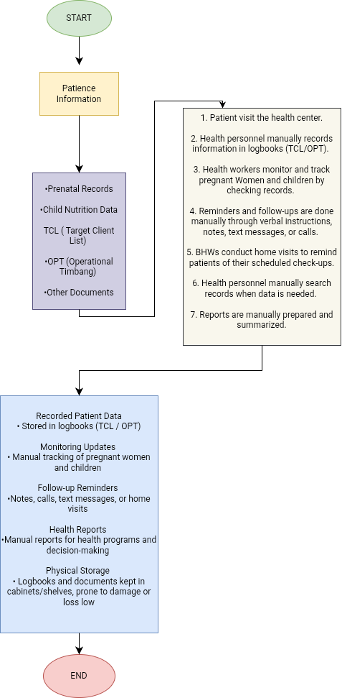
Figure 7: BPMN Diagram of Current (Manual) Process
Proposed Process (Automated System)
Business Process Model and Notation (BPMN) is utilized to visually represent the step-by-step operations of the NutriCare health management system. From an Information Systems perspective, analyzing the workflow is essential in identifying operational bottlenecks within the traditional manual tracking of the Rural Health Unit. This approach provides a clear graphical view of the end-to-end flow of seven integrated process streams ranging from role-based authentication to automated health monitoring highlighting the efficiency improvements introduced by the proposed automated system compared to the manual process.
The system’s process architecture is orchestrated through an event-driven design that balances synchronous user interactions with asynchronous background processing. When a health worker initiates a Maternal or Child Nutrition record, the system immediately executes validation logic and triggers background listeners. These listeners manage the automated dispatch of SMS and Email notifications via communication APIs and generate real-time Slack alerts for high-priority cases, such as malnourished children or high-risk pregnancies. By offloading these computationally heavy tasks including DomPDF-based report generation and complex BMI Z-score calculations to an asynchronous job queue, the system ensures a highly responsive interface for RHU staff while maintaining a rigorous audit trail of all health interventions.
After health assessments are completed, the system utilizes the gathered data to update Graphical Trend Lines, providing a visual representation of a patient's progress over time. For administrative compliance, the system features an on-demand Report Generation tool. Using predefined templates and the Dompdf library, the system transforms raw database entries into formalized monthly and quarterly reports suitable for DOH submission. These generated PDF files are assigned unique identifiers and stored securely within the system for future retrieval and audit, ensuring accuracy and compliance with official health standards
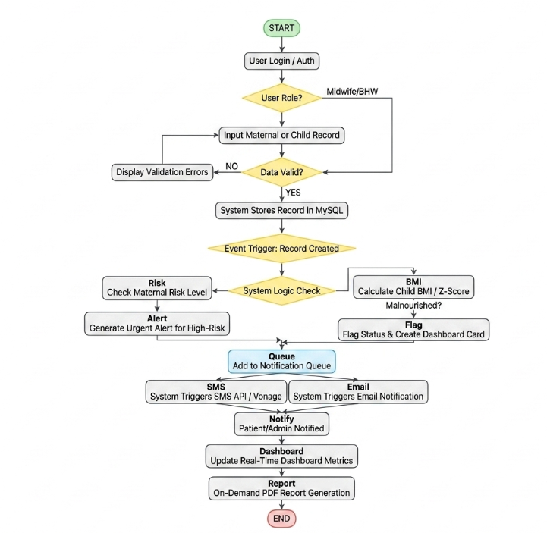
Figure 8: BPMN Diagram of Proposed (Automated) Process
Project Design
This section shows the various architecture and technologies used in the development of the system. The system uses a modern, scalable backend architecture combined with contemporary frontend technologies to deliver a robust rural health management solution specifically tailored for the Rural Health Unit of Sierra Bullones.
Laravel and the MVC Architecture
The system was developed using Laravel 12.56.0, a modern PHP framework developed to standardize the development process by automatically processing non-business logic relationships and allowing programmers to focus on implementing specific health management logic.
The NutriCare system strictly adheres to the classic Model-View-Controller (MVC) architectural pattern, providing a clear separation between data handling, business logic, and the presentation layers. This architecture ensures that the system remains modular and maintainable as the volume of health records increases.
Laravel uses the Model-View-Controller architecture as a three-way division of the application. The Model layer, located in app/Models/, utilizes Eloquent ORM to manage data persistence and relationships for entities such as Maternal Record, Patient, and Child Nutrition Record. These models handle critical data casting for health-specific dates and provide mass assignment protection. The Controller layer handles incoming HTTP requests and executes queries directly through the models to maintain an efficient codebase. Finally, the View layer utilizes the Blade templating engine to render the user interface, incorporating reusable components and secure form handling to provide a consistent experience for the RHU staff.
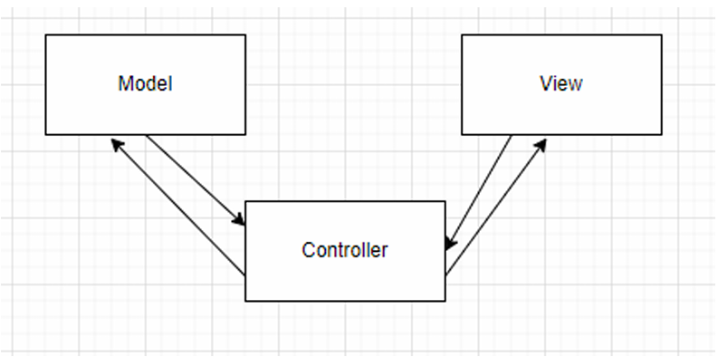
Figure 9. MVC Architecture
Frameworks and APIs
The system was created using various modern Frameworks and APIs to ensure a high-performance and responsive experience. Tailwind CSS 3.4.19, a utility-first CSS framework, was used to develop the front end alongside Blade, Laravel’s templating engine. This combination allows for a mobile-first design, ensuring the system is accessible on both desktop computers and mobile devices used by health workers in the field. For lightweight frontend interactivity, such as responsive menu toggles, Alpine.js 3.4.2 was integrated into the view layer.
For the back end, the system utilizes Laravel Breeze 2.4 for its authentication scaffolding, providing a secure foundation for user registration, login, and profile management. Eloquent, Laravel’s built-in object-relational mapper, is used to interact with the MySQL 8.0 database to manage records for patients and health programs. The system also utilizes Vite 7.0.7 as a modern build tool for asset bundling and performance optimization. Security is further enhanced through custom middleware, specifically IsAdmin and IsUser, which enforce role-based access control across all system routes.

Use Case Diagram
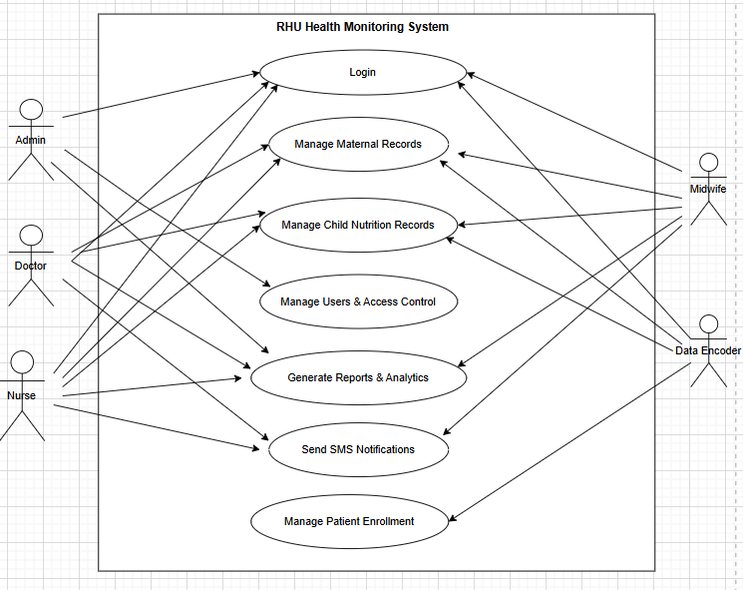
Figure 10. RHU Health Monitoring System Overview
The Use Case Diagram involves all actors including the Admin, Doctor, Nurse, Midwife, and Data Encoder. Before accessing the system, users must log in using their registered accounts. The Admin manages users and access control, while healthcare staff such as doctors, nurses, and midwives handle maternal and child health records, generate reports, and send SMS notifications. The Data Encoder is responsible for patient enrollment and initial data entry. The system includes major functions such as managing maternal records, managing child nutrition records, managing users, generating reports, sending notifications, and enrolling patients. These processes are connected through «include» relationships for required actions and «extend» relationships for optional actions like SMS notifications.
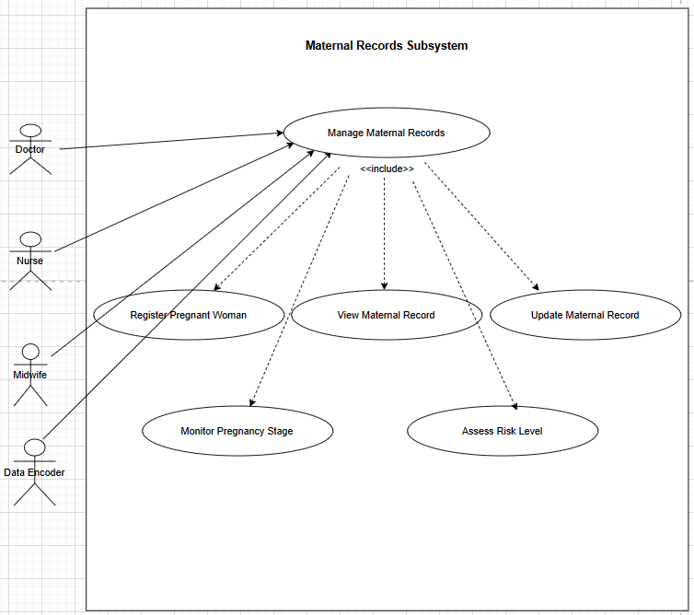
Figure 11. Maternal Records Management
The Maternal Records Subsystem involves the Doctor, Nurse, Midwife, and Data Encoder in managing maternal health information. The process starts with registering a pregnant woman, followed by viewing and updating maternal records. Healthcare staff monitor the pregnancy stage and assess the risk level of each patient based on recorded data. All processes are interconnected and required in managing maternal records, ensuring that patient information is accurate and up-to-date. This allows healthcare providers to identify high-risk pregnancies and provide timely medical attention.
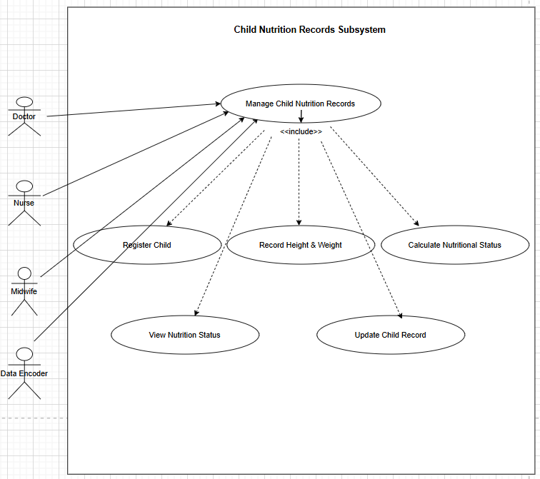
Figure 12. Child Nutrition Records Management
The Child Nutrition Records Subsystem involves the Doctor, Nurse, Midwife, and Data Encoder in monitoring the nutritional status of children. The process begins with registering the child, followed by recording physical measurements such as height and weight. The system then calculates the nutritional status and allows users to view the results. Users can also update child records when necessary. All processes are required and connected to ensure proper monitoring and evaluation of child health, helping healthcare providers identify undernourished children and take appropriate action.
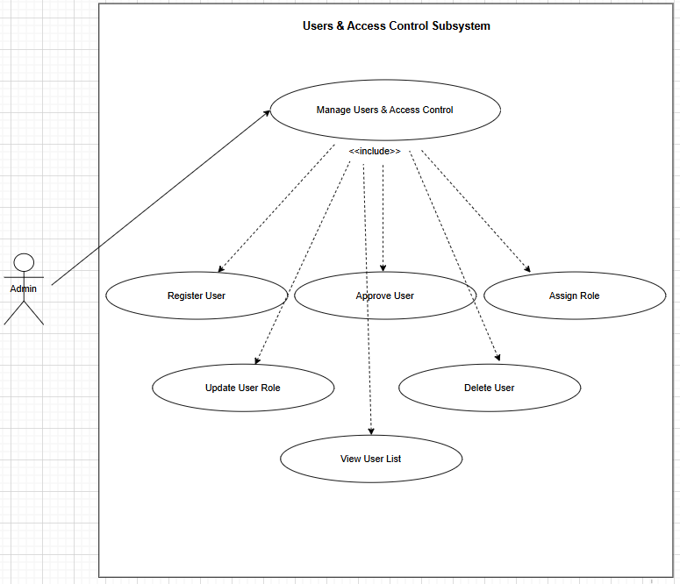
Figure 13. Users and Access Control Management (Admin Only)
The Users and Access Control Subsystem involves only the Admin, who is responsible for managing all system users. The process starts with registering a new user, followed by approving the account and assigning the appropriate role. The Admin can also manage user permissions, view the list of users, and activate or deactivate accounts when necessary. All processes are essential in controlling access to the system, ensuring that only authorized users can use specific features and maintaining system security.
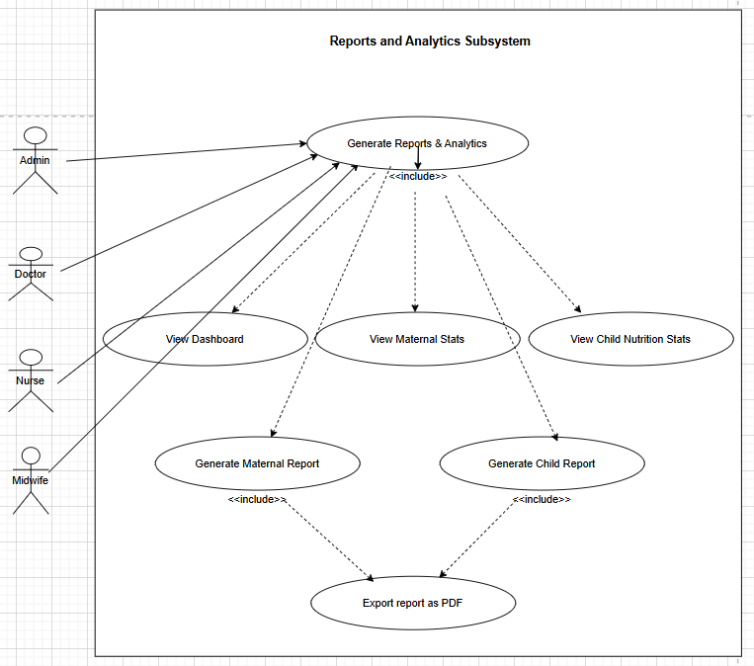
Figure 14. Generate Reports and Analytics
The Reports and Analytics Subsystem involves the Admin, Doctor, Nurse, and Midwife in accessing and generating system reports. Users can view the system dashboard, analyze maternal and child health statistics, and generate reports based on stored data. The system also allows users to export reports into PDF format for documentation purposes. All processes are required and connected to provide accurate and timely information, helping healthcare providers monitor trends and support decision-making.
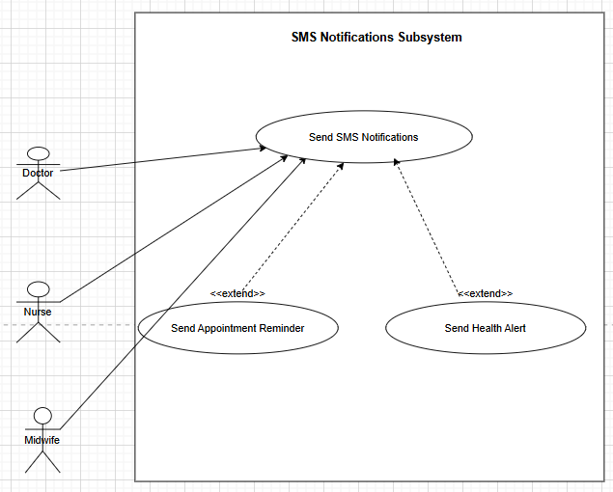
Figure 15. Send SMS Notification
The SMS Notifications Subsystem involves the Doctor, Nurse, and Midwife in sending messages to patients. The main process is sending SMS notifications, which may include appointment reminders or health alerts depending on the situation. These actions are optional and only triggered when needed, such as scheduled check-ups or identified health risks. This subsystem helps improve communication between healthcare providers and patients, ensuring timely follow-ups and better patient engagement.
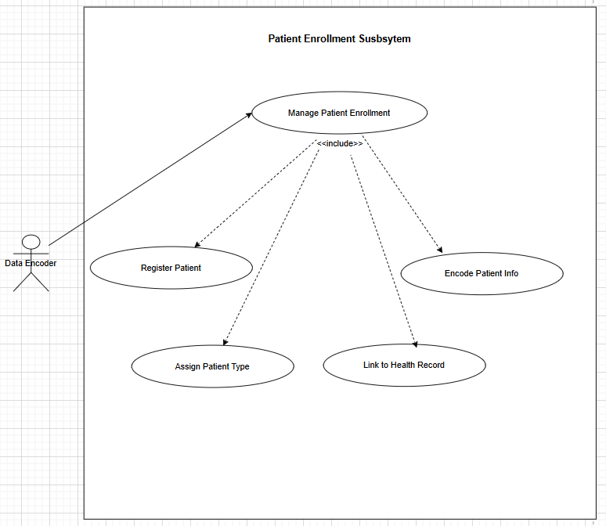
Figure 16. Patient Enrollment Management
The Patient Enrollment Subsystem involves the Data Encoder in registering patients into the system. The process starts with registering the patient, followed by encoding personal information such as name, birthdate, and location. The encoder then assigns the patient type, whether maternal or child, and links the patient to the appropriate health record. All processes are required to ensure that patient information is properly recorded and integrated into the system for further monitoring and management.
Entity Relationship Diagram
The Entity Relationship Diagram (ERD) presents the overall database structure of the system. It illustrates the entities involved, their attributes, and the relationships between them. This diagram provides a clear representation of how data is organized, stored, and interconnected within the rural health unit management system.
The system consists of several key entities, including users, patients, maternal records, child nutrition records, sessions, and background job trackers. Each entity represents a major component of the system’s functionality.
The users entity stores information about healthcare administrators and workers, including their hashed credentials, profile details, and system roles. This entity is crucial for managing access via the integrated middleware. The patients entity acts as the primary registry for the system, containing demographic data such as birthdates and barangay locations. Each patient is categorized to determine which specific health program they belong to, ensuring that medical history is correctly organized.
The maternal records entity tracks pregnancy-specific data, such as checkup dates, pregnancy stages, and delivery estimates. It includes a risk level classification to prioritize care for high-risk mothers. Similarly, the child nutrition records entity stores growth milestones, including weight and height measurements. It automatically classifies the nutritional status of children to help health workers identify cases of malnutrition.
Additionally, the system includes infrastructure entities like sessions for managing user logins, and jobs or failed jobs for handling background tasks. These ensure that the system remains responsive during heavy data processing. The audit-ready structure is further supported by timestamps in every entity, allowing for precise tracking of when records were created or updated.
The relationships between these entities ensure data integrity and consistency. For example, a single user (health worker) can manage multiple maternal or child records, while each patient record is uniquely linked to their respective health program data. These relationships are strictly enforced using foreign key constraints within the MySQL database to prevent orphaned data and ensure a maintainable system architecture.
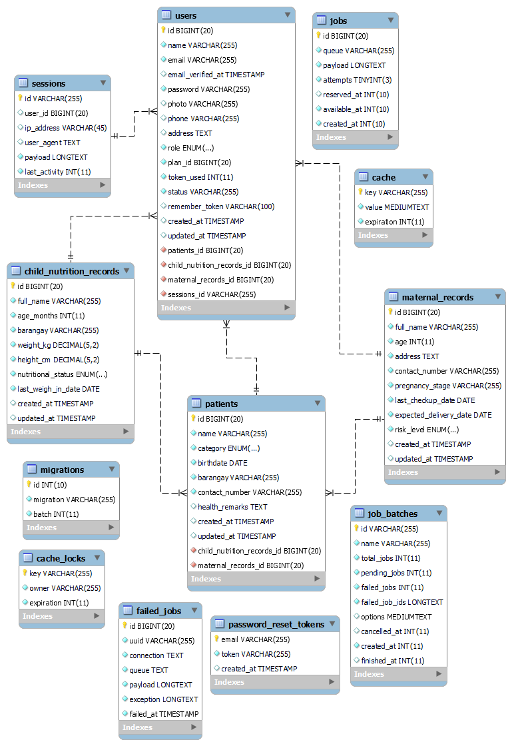
Figure 17: NutriCare Entity Relationship Diagram
Activity Diagram
The system currently has five (5) users namely Administrator, Doctor, Nurse, Midwife, and Data Encoder. The following figures will show the activity diagrams that illustrate how these users interact with the system during specific functionalities or scenarios.
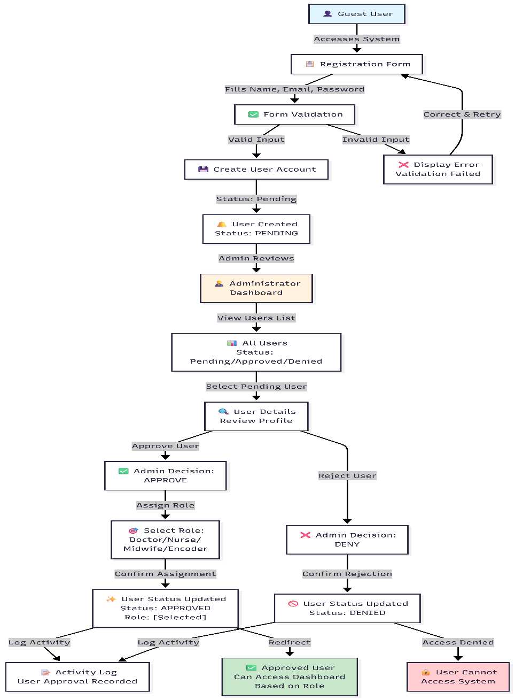
Figure 18: User Authentication & Role-Based Approval
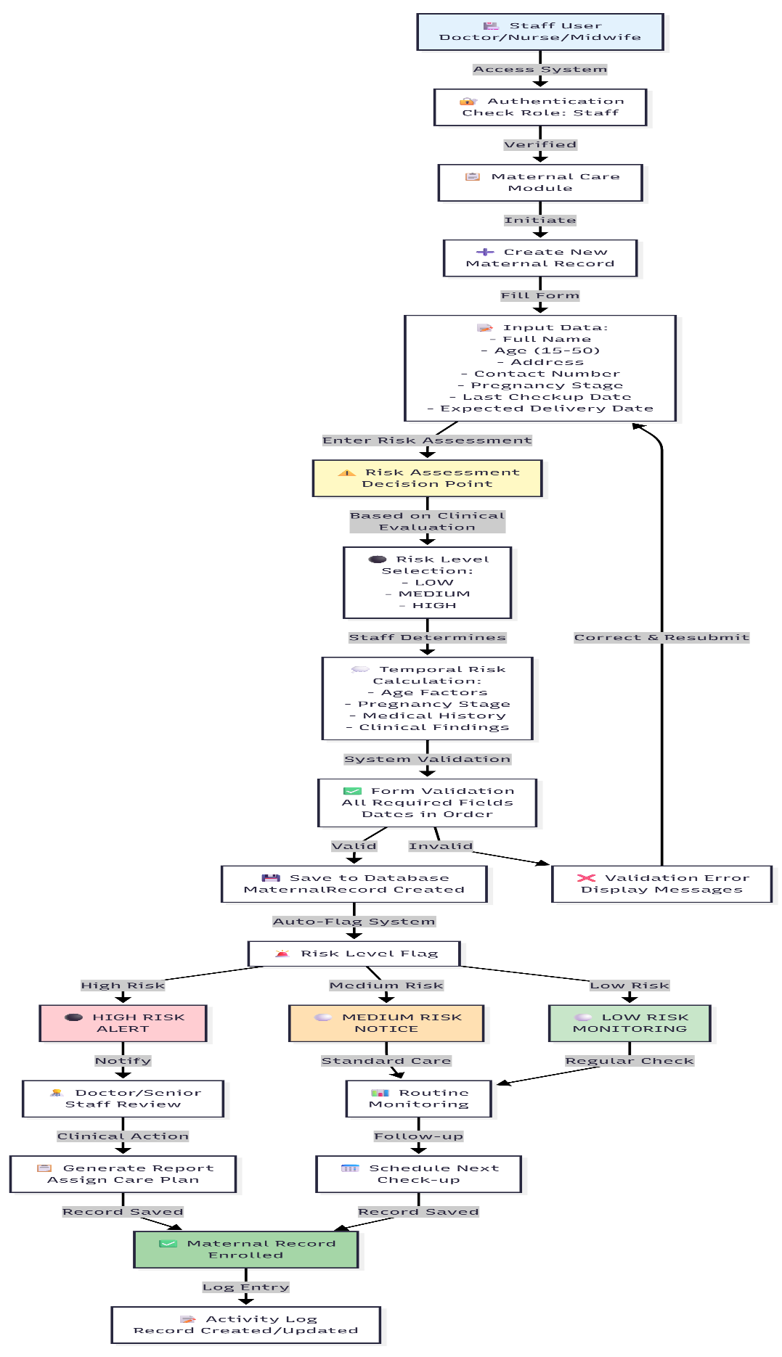
Figure 19: Maternal Health Enrollment & Risk Calculation
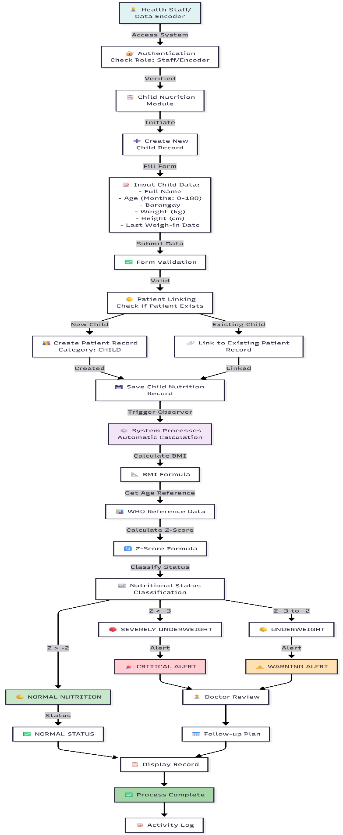
Figure 20: Child Nutrition Tracking & Automated Calculation
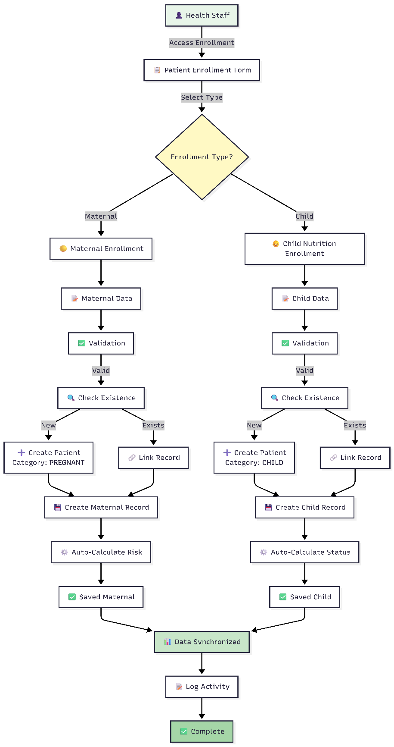
Figure 21: Patient Management & Automatic Linking
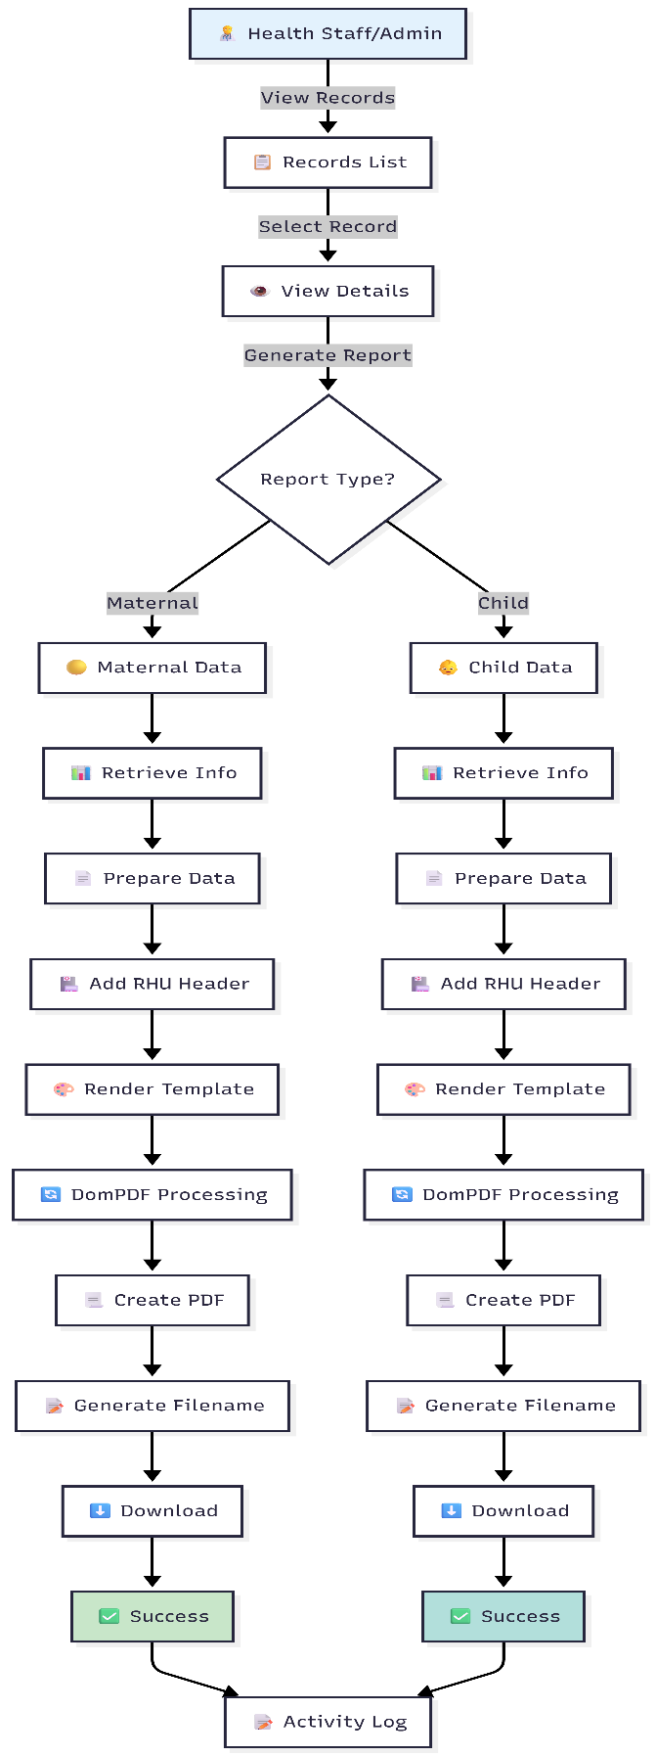
Figure 22: Report Generation & PDF Export
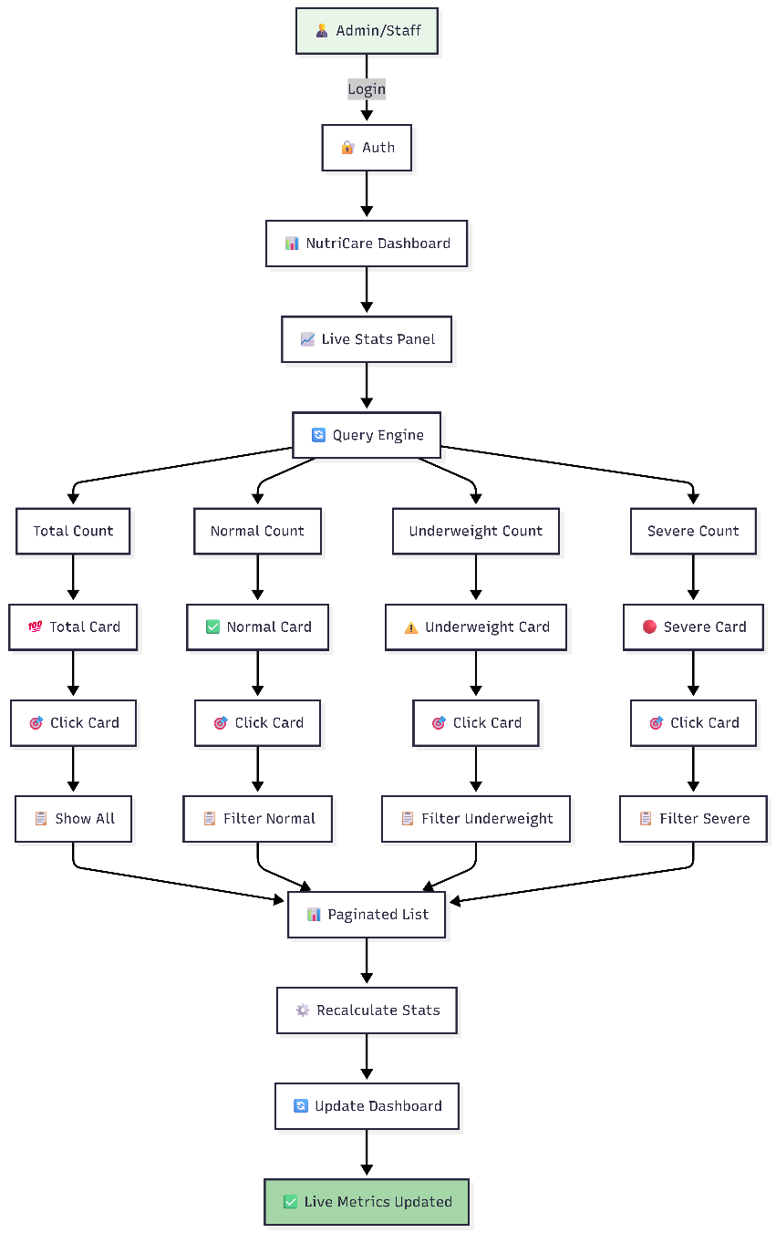
Figure 23: Dashboard Analytics & Statistics
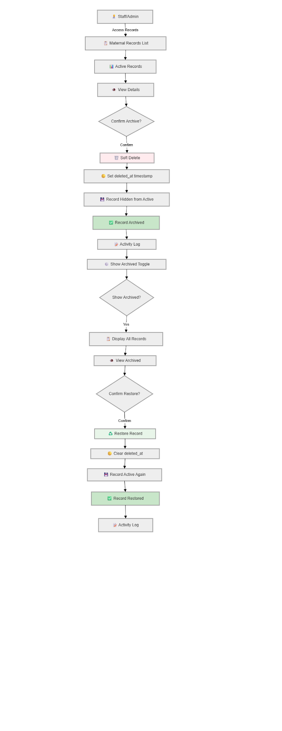
Figure 24: Record Management - Archive & Restore
Application Prototype
This section presents the high-fidelity graphical user interface (GUI) of the NutriCare platform. Unlike traditional static wireframes, these screenshots represent the functional evolutionary prototype of the system, showcasing the actual implementation of the "Soft UI" design system, responsive dashboards, and automated health monitoring modules developed using Laravel and Tailwind CSS.
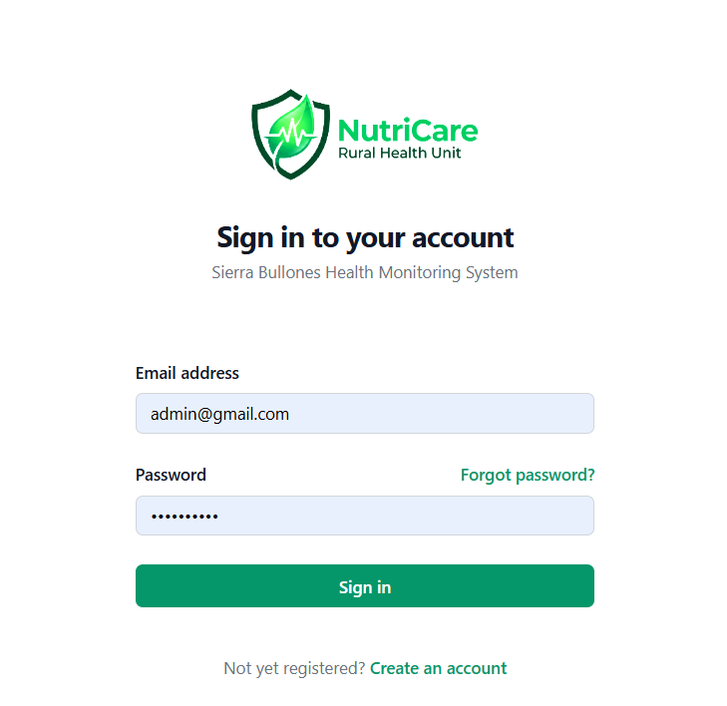
Figure 25: Login Page
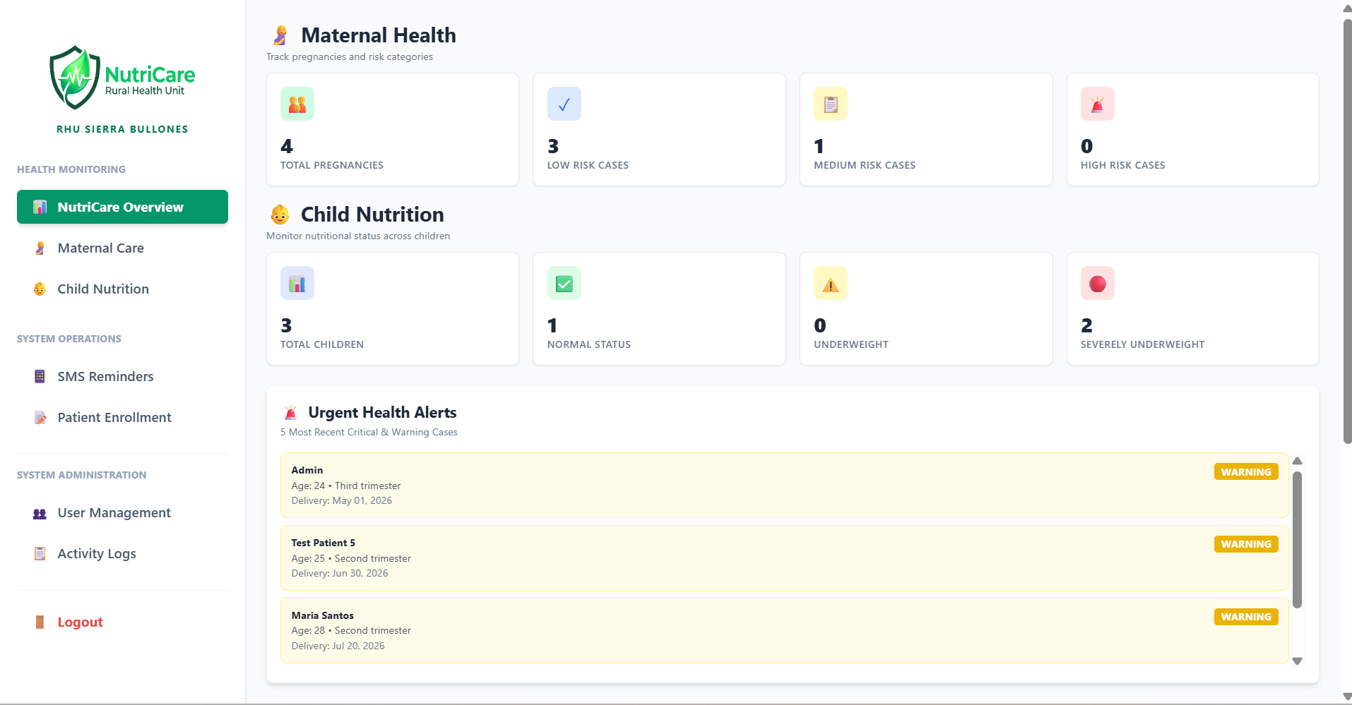
Figure 26: Admin Dashboard Page
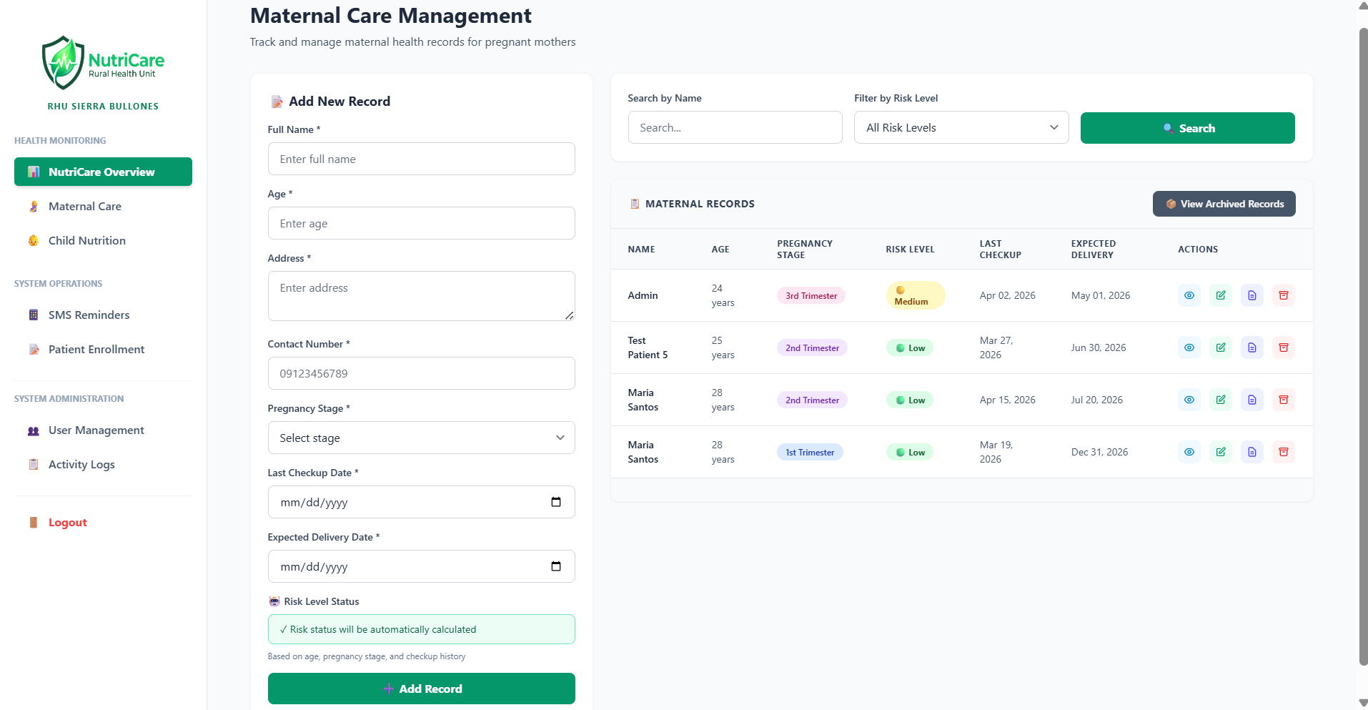
Figure 27: Maternal Care Page
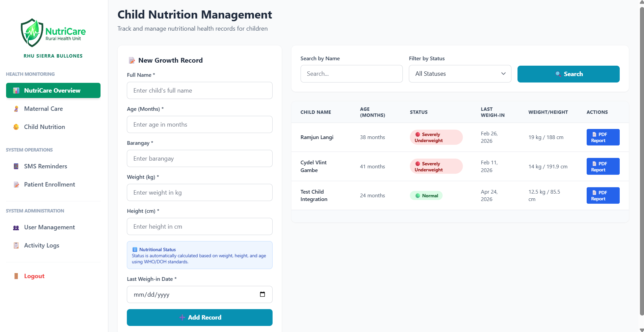
Figure 28: Child Nutrition Page
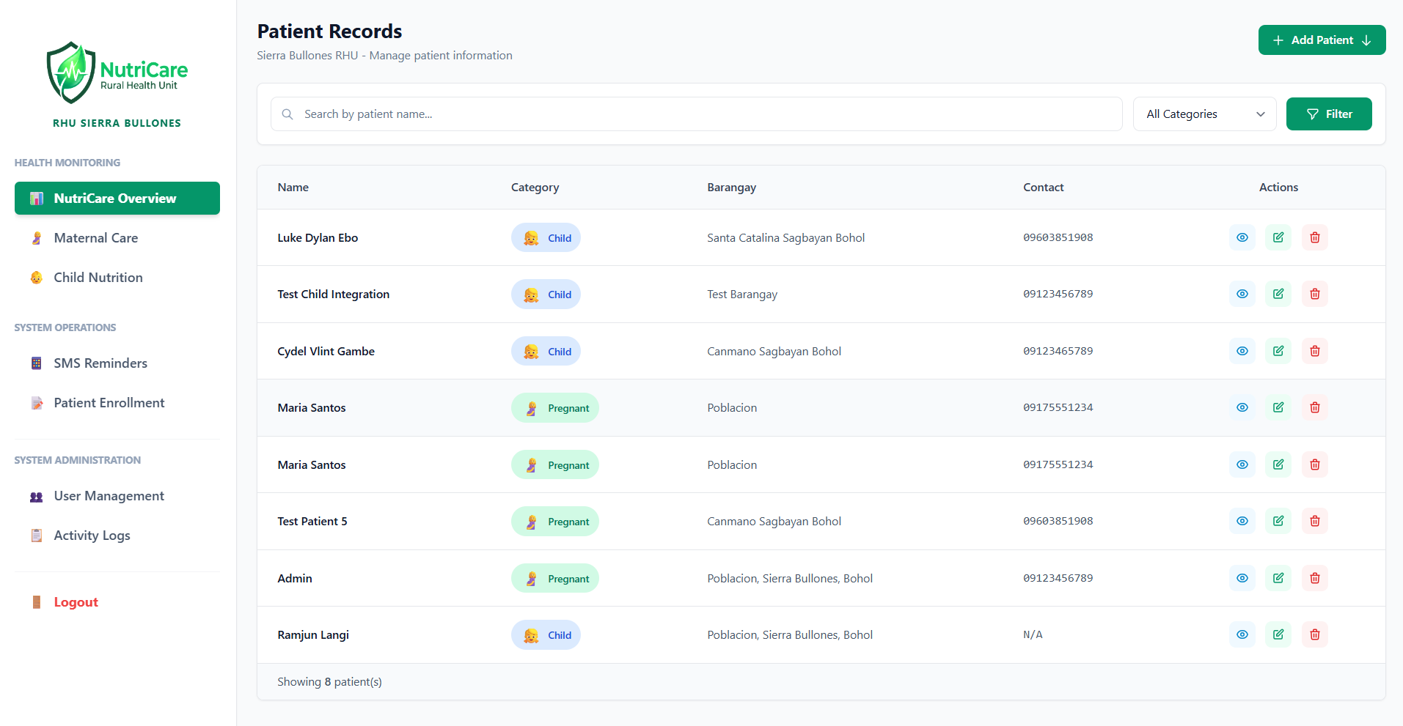Figure 29: Patient Records Page
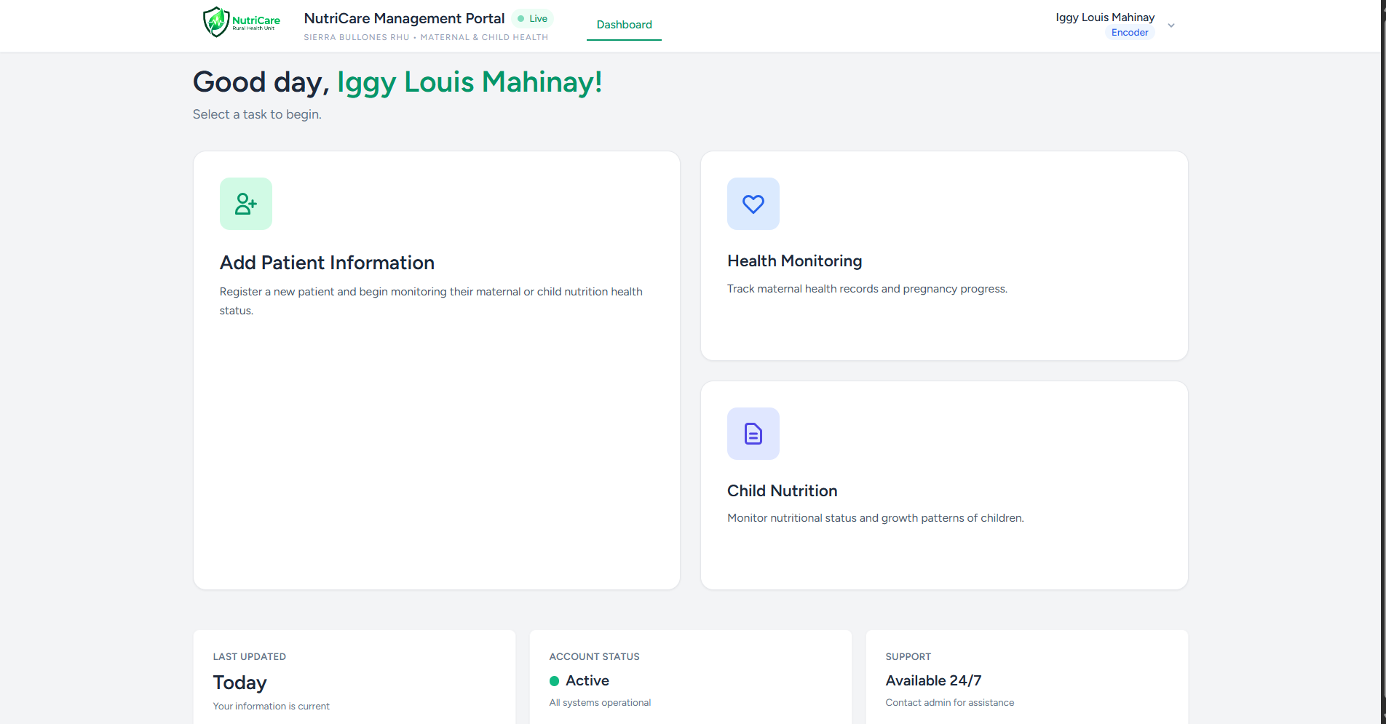
Figure 30: User Dashboard Page
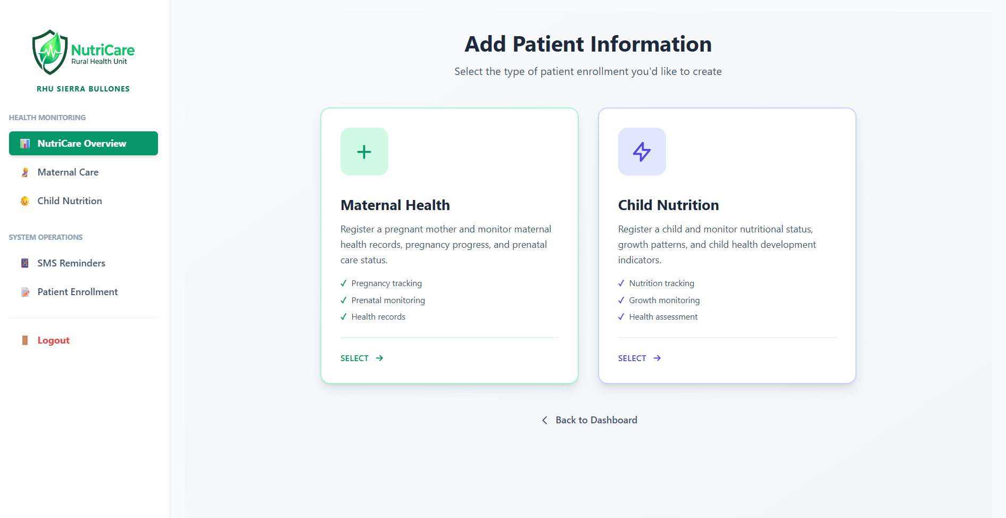
Figure 31: User Dashboard Page/ Add Patient

References
[1] Hossain, S., Amees, M., Alam, A. F. & Ahmad, N. 2026. Electronic Medical Records for Maternal and Child Health Care: A Bibliometric Study. Clinical Pediatrics 65(2), p. 99228261418459. https://doi.org/10.1177/00099228261418459
[2] Punzalan, V. C., Cruz, M. M. & Cruz, M. M. 2025. Health workforce issues and recommended practices in the implementation of Universal Health Coverage in the Philippines: a qualitative study. Human Resources for Health 23. https://doi.org/10.1186/s12960-025-00988-3

[3] Troyee, T., Raihan, M., & Arefin, M. (2020). Health Monitoring of Expecting Mothers using Multiple Sensor Approach: "Preg Care". 2020 2nd International Conference on Advanced Information and Communication Technology (ICAICT), 77-82. https://doi.org/10.1109/ICAICT51780.2020.9333514
[4] Guillermo, M. L.(2025).SEEK-ing enhanced antenatal care quality: Strengthening governance and pregnancy tracking in Mati City, Davao Oriental, Philippines. Philippine Journal of Health Research and Development, 29(4), 17-25. https://doi.org/10.4103/PJHRD.PJHRD_30_25
[5] Senthilsingh, C., Sujihelen, L., Franklin, R., Grace, L., & Sivasangari, A. (2023). Growth Monitoring of Children and Pregnant Women using IoT Devices. 2023 2nd International Conference on Automation, Computing and Renewable Systems (ICACRS), 1593-1597. https://doi.org/10.1109/icacrs58579.2023.10405379
[6] Black, R. E., Victora, C. G., Walker, S. P., Bhutta, Z. A., Christian, P., de Onis, M., & Maternal and Child Nutrition Study Group. (2013). Maternal and child undernutrition and overweight in low-income and middle-income countries. The Lancet, 382(9890), 427-451. https://doi.org/10.1016/S0140-6736(13)60937-X
[7] Khalil, A., Ahmad Sunawari, A., Ismail, S., Abdul Jamil, A. (2024). Development of a Web-Based Maternal Health Monitoring System: Advancing Beyond Manual Record-Keeping. In: Lai, K.W., Yeoh, P.S.Q. (eds) Biomedical Engineering. Series in BioEngineering. Springer, Singapore. https://doi.org/10.1007/978-981-97-9294-8_1
[8] Mendoza., L., Geraldo., M., Francisco., H., Domingo., M., Regencia., J., & Kagakit, M. (2025). WOMB: A Web-Based System for Maternal Support and Infant Health Tracking With Integrated Data Analytics and Smart Algorithms. International Journal of Latest Technology in Engineering Management & Applied Science. https://doi.org/10.51583/ijltemas.2025.1410000025
[9] Hailemariam, T., Atnafu, A., Gezie, L. D., & Tilahun, B. (2024). Effect of short message service reminders in improving optimal antenatal care, skilled birth attendance and postnatal care in low-and middle-income countries: a systematic review and meta-analysis. BMC medical informatics and decision making, 25(1), 1. https://doi.org/10.1186/s12911-024-02836-1
[10] S. Mannolkar, S. M. George, M. R, N. P and D. P. Bharathi, "Assistive System for Monitoring Malnutrition in Children," 2025 10th International Conference on Signal Processing and Communication (ICSC), Noida, India, 2025, pp. 761-766. https://doi.org/10.1109/icsc64553.2025.10968423
[11] Shafi I, Din S, Farooq S, Díez IdlT, Breñosa J, Espinosa JCM, et al. (2024) Design and development of patient health tracking, monitoring and big data storage using Internet of Things and real time cloud computing. PLoS ONE 19(3): e0298582. https://doi.org/10.1371/journal.pone.0298582
[12] Wang, J., Tang, N., Jin, C., Yang, J., Zheng, X., Jiang, Q., Li, S., Xiao, N., & Zhou, X. (2025). Association of Digital Health Interventions with Maternal and Neonatal Outcomes: Systematic Review and Meta-Analysis. Journal of medical Internet research, 27, e66580. https://doi.org/10.2196/66580
[13] Billones, G. A., Dorilag, C., Osden, K. M., & Cordevilla, A. J. (2023). Digitalization of Prenatal Healthcare System with SMS Notification for the Health Centers in Negros Occidental. Kabatiran, 1(1), 39–44. https://doi.org/10.61864/kabatiran.v1i1.38
[14] Serón-Arbeloa, C., Labarta-Monzón, L., Puzo-Foncillas, J., Mallor-Bonet, T., Lafita-López, A., Bueno-Vidales, N., & Montoro-Huguet, M. (2022). Malnutrition Screening and Assessment. Nutrients, 14(12), 2392. https://doi.org/10.3390/nu14122392
[15] Aldhyno Yoghatama and Endang Wahyu Pamungkas 2025. Development of a Web-Based Platform for Nutrition Education and Early Stunting Detection. bit-Tech. 8, 1 (Aug. 2025), 395–403. https://doi.org/10.32877/bt.v8i1.2559
[16] Riska Rosita, Tominanto, Siti Farida, Andi Yulianto, and Husna Sarirah Husin. 2024. Developing Electronic-Based Maternal and Child Health Monitoring. (2024). Journal of Maternal and Child Health, 9(6), 870-882. https://doi.org/10.26911/thejmch.2024.09.06.02
[17] Kirana, C. et al. 2025. Child Nutrition Prediction for Stunting Prevention Using K-Nearest Neighbor (K-NN) Algorithm. Journal of Information Systems and Informatics. 7, 4 (Dec. 2025), 3571–3586. https://doi.org/10.63158/journalisi.v7i4.1322
[18] Ngabo, F., Nguimfack, J., Nwaigwe, F., Mugeni, C., Muhoza, D., Wilson, D. R., Kalach, J., Gakuba, R., Karema, C., & Binagwaho, A. (2012). Designing and Implementing an Innovative SMS-based alert system (RapidSMS-MCH) to monitor pregnancy and reduce maternal and child deaths in Rwanda. The Pan African medical journal, 13, 31. 10.11604/pamj.2012.13.31.1864
[19] Novoa, R. H., Meza-Santibañez, L., Rodríguez-Hilario, N., Torres-Osorio, J., Jáuregui-Canchari, V., Huang-Yang, X., Melgarejo, W. E., Bazo-Alvarez, J. C., & Ventura, W. (2023). Development of a Mobile Health Application Based on a Mixed Prenatal Care in the Context of COVID-19 Pandemic. Revista brasileira de ginecologia e obstetricia : revista da Federacao Brasileira das Sociedades de Ginecologia e Obstetricia, 45(4), 179–185. https://doi.org/10.1055/s-0043-1768998
[20] Babatunde, A. O., Ayede, A. I., Colangelo, A., Nguyen, T. D., Aborode, A. T., Umeh, C., Hernandez, M. P., Ayede, O. I., & Ayede, O. O. (2025). Development of an educational and monitoring mobile application for pregnant women in Nigeria. Frontiers in public health, 12, 1368631. https://doi.org/10.3389/fpubh.2024.1368631
[21] Department of Health - Zamboanga Peninsula. (2024.). iClinicSys - Health Information System. Retrieved from https://clinicsys.doh.gov.ph/login/

