Data visualisation CA1

Jamie McFarlane (Student no. 19175329)

Table of Contents
1. Introduction 2
1.1. Background 2
1.2. Data used 2
1.3. Common design choices 3
2. Data visualisations 4
2.1. The rise in purchasing over time 4
2.2. Online purchasing across the EU28 5
2.3. The demographics of online purchasing 6
2.4. Spending brackets within the EU28 7
2.5. Types of goods and services being purchased 8
2.6. Consumer buying strategies 10
2.7. Problems buying online and seller location 11
3. References 12
4. Appendix: Infographic 14

Introduction

Background
This project is an exploration of online purchasing within the European Union (EU28). This has risen dramatically over the past couple of decades and has already had an important number of consequences for society such as logistics, the environment and consumer behaviour (Hultkrantz and Lumsden, 2001; Fichter, 2002; Srinivasan, Anderson and Ponnavolu, 2002; Hunter and Wilson, 2015; Eurostat, 2020). The questions we wish to answer are how are individuals in different EU states adopting e-commerce, what are some key demographics and behaviours relating to this, and are individuals experiencing problems when engaging in e-commerce. In doing so, we hope to build a picture for the viewer of what characteristics online purchasers possess within the EU.

Data used
Three datasets were extracted from the Eurostat database using the R Eurostat package (Lahti et al., 2017). Compiled, the datasets had a total of 4,615,144 rows and 6 columns (see tables 1 and 2). Most of this data was ultimately discarded, being combinations of locations, years and demographics that were not needed and the actual numbers of rows used for individual graphs varied in the tens or hundreds of rows.
Table 1: Eurostat information and length of datasets
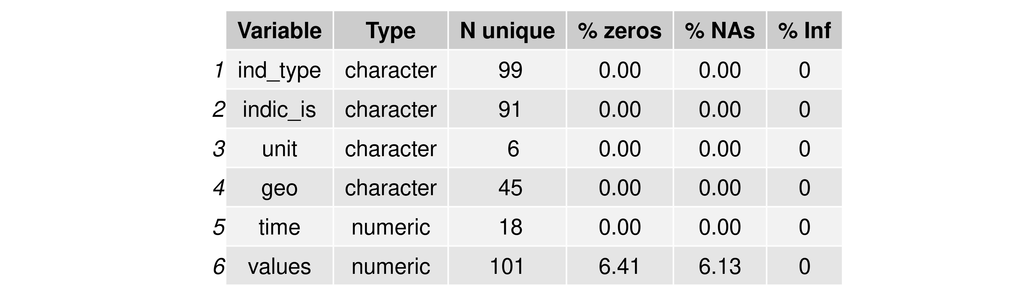Table 2: Columns and aberrant values present in the combined dataset.
Missing values were present and though imputation was considered, this was ultimately not necessary as the did not interfere with developing the visualisations for this project. These datasets were modified by a dictionary function in the Eurostat package to replace the database codes with human-readable labels. Map coordinate data and flag icon data were imported using the maps and ggflags R packages respectively (Deckmyn, 2018; Goldie, 2020).

Common design choices
There were some design choices that were shared among the visualisations. The fonts used for this project were the Helvetica and Helvetica Neue families. Since the subject matter was technological in nature, a cleaner, futuristic and informative tone was desired. Because of this, serif and display fonts were excluded. The base and highlighting colours chosen were #1E448A and #FDCB0B respectively, the colours of the EU commissions flag. Gradient colour scales and colour-blind safe complementary colours were extended from this using online tools (An, 2020; Nichols, 2020).

Data visualisations

The rise in purchasing over time
This first thing we wish to communicate is the current and future significance of online purchasing by showing its growth over time (figure 1).
Showing the composition of online purchasing over time and for the different purchasing rates, will give an indication of how commonplace these sorts of behaviours are becoming in society.
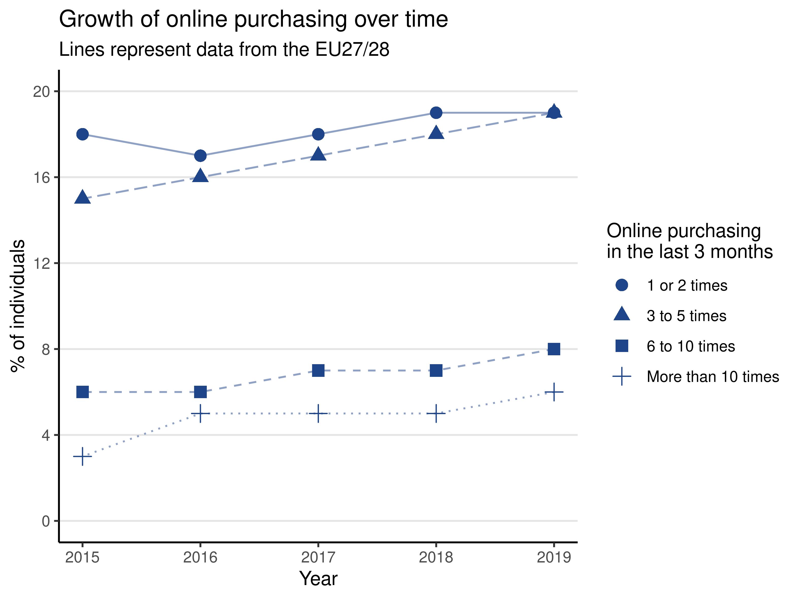Figure 1: Growth of online purchasing over time
For this graph, the number of dimensions was low, so they were included in the one chart (Ward, Grinstein and Keim, 2015, p. 293). Different linetypes and shapes were used to help distinguish them via pre-attentive processing (Ward, Grinstein and Keim, 2015, p. 100). Here, the frequency of the linetype is related to the rate of online purchasing. Horizontal gridlines help perceive the values of the different points, but were coloured lightly so as not to interfere (Kirk, 2019, p. 22).
The visual shows a general increasing trend of online purchasing. However, the comparison over time between the different purchasing frequencies shows that less than five times is much more common. While online purchasing is increasing, there is a possible split between people who use it sparingly and people who use it a lot. There is seemingly a more reliable increase in purchasing between 3-5 times, than the others which tend to plateau. It would seem from this comparison, that this purchasing frequency might become the most common type if trends continue.

Online purchasing across the EU28
The second message we want to communicate is the nationality of the online purchaser, by visualising how online purchasing rates differ between both states and broader EU regions (figure 2).
It is important to show, on a high level, how the different EU states compare in terms of making purchases online in the past year. Arguably, this could also be an indirect economic indicator (Lawrence and Tar, 2010).
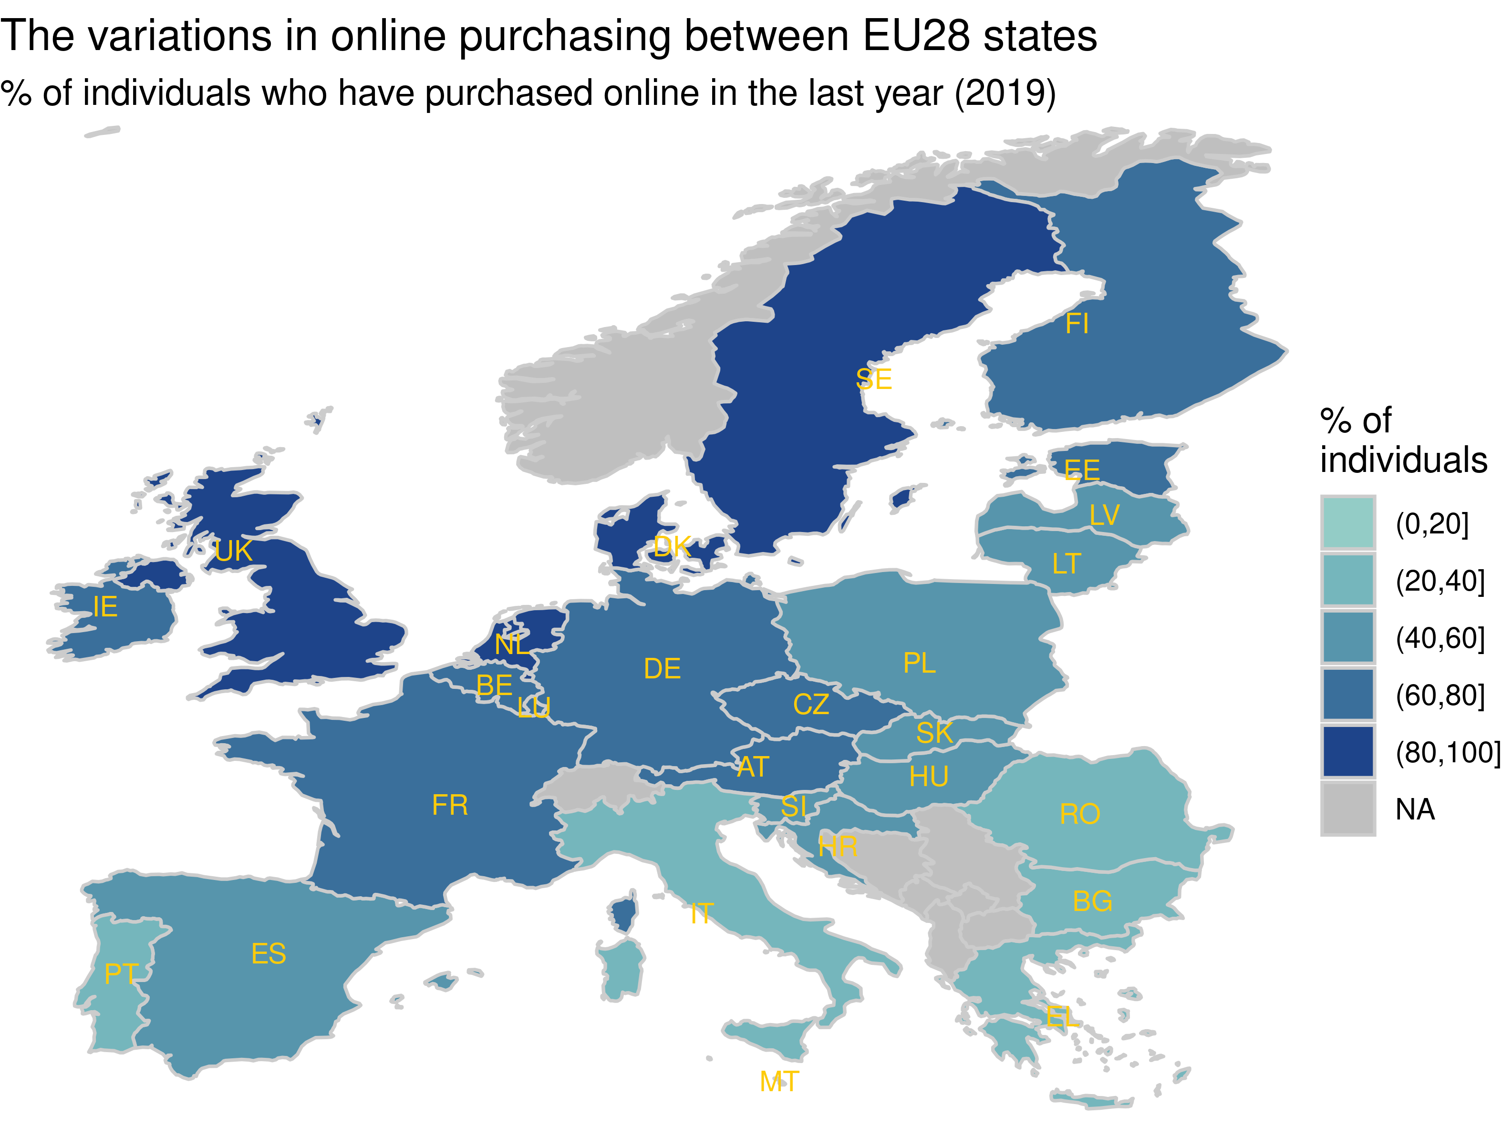Figure 2: How EU28 states differ in online purchasing
Since the number of dimensions of geographical data are high, a chloropleth was chosen to visualise this. Comparisons of both states and broader regions are possible, though the downside of this is that finer detail is hidden (Ward, Grinstein and Keim, 2015, p. 240). The colour scale has been binned to allow for easier comparison of similar and contrasting regions, though care has been taken to scale this evenly and not mislead the viewer (Monmonier, 2018, p. 43). EU states were annotated as space was sufficient for labelling at a high level (Kirk, 2019, p. 180).
The visualisation shows that some states have much different online purchasing rates than others, favouring states that are typically assumed to be wealthier. This appears to be higher in western, central and northern EU states, and a line could almost be drawn to separate these from Southern and Eastern Europe. This insight will become relevant again later.

The demographics of online purchasing
Here, we want to communicate the demographic differences for buying online (figure 3).
This can help with understanding how diverse online purchasers have become recently and whether gender and age gaps are universally applicable among the EU states (Hernández, Jiménez and José Martín, 2011; Lian and Yen, 2014).
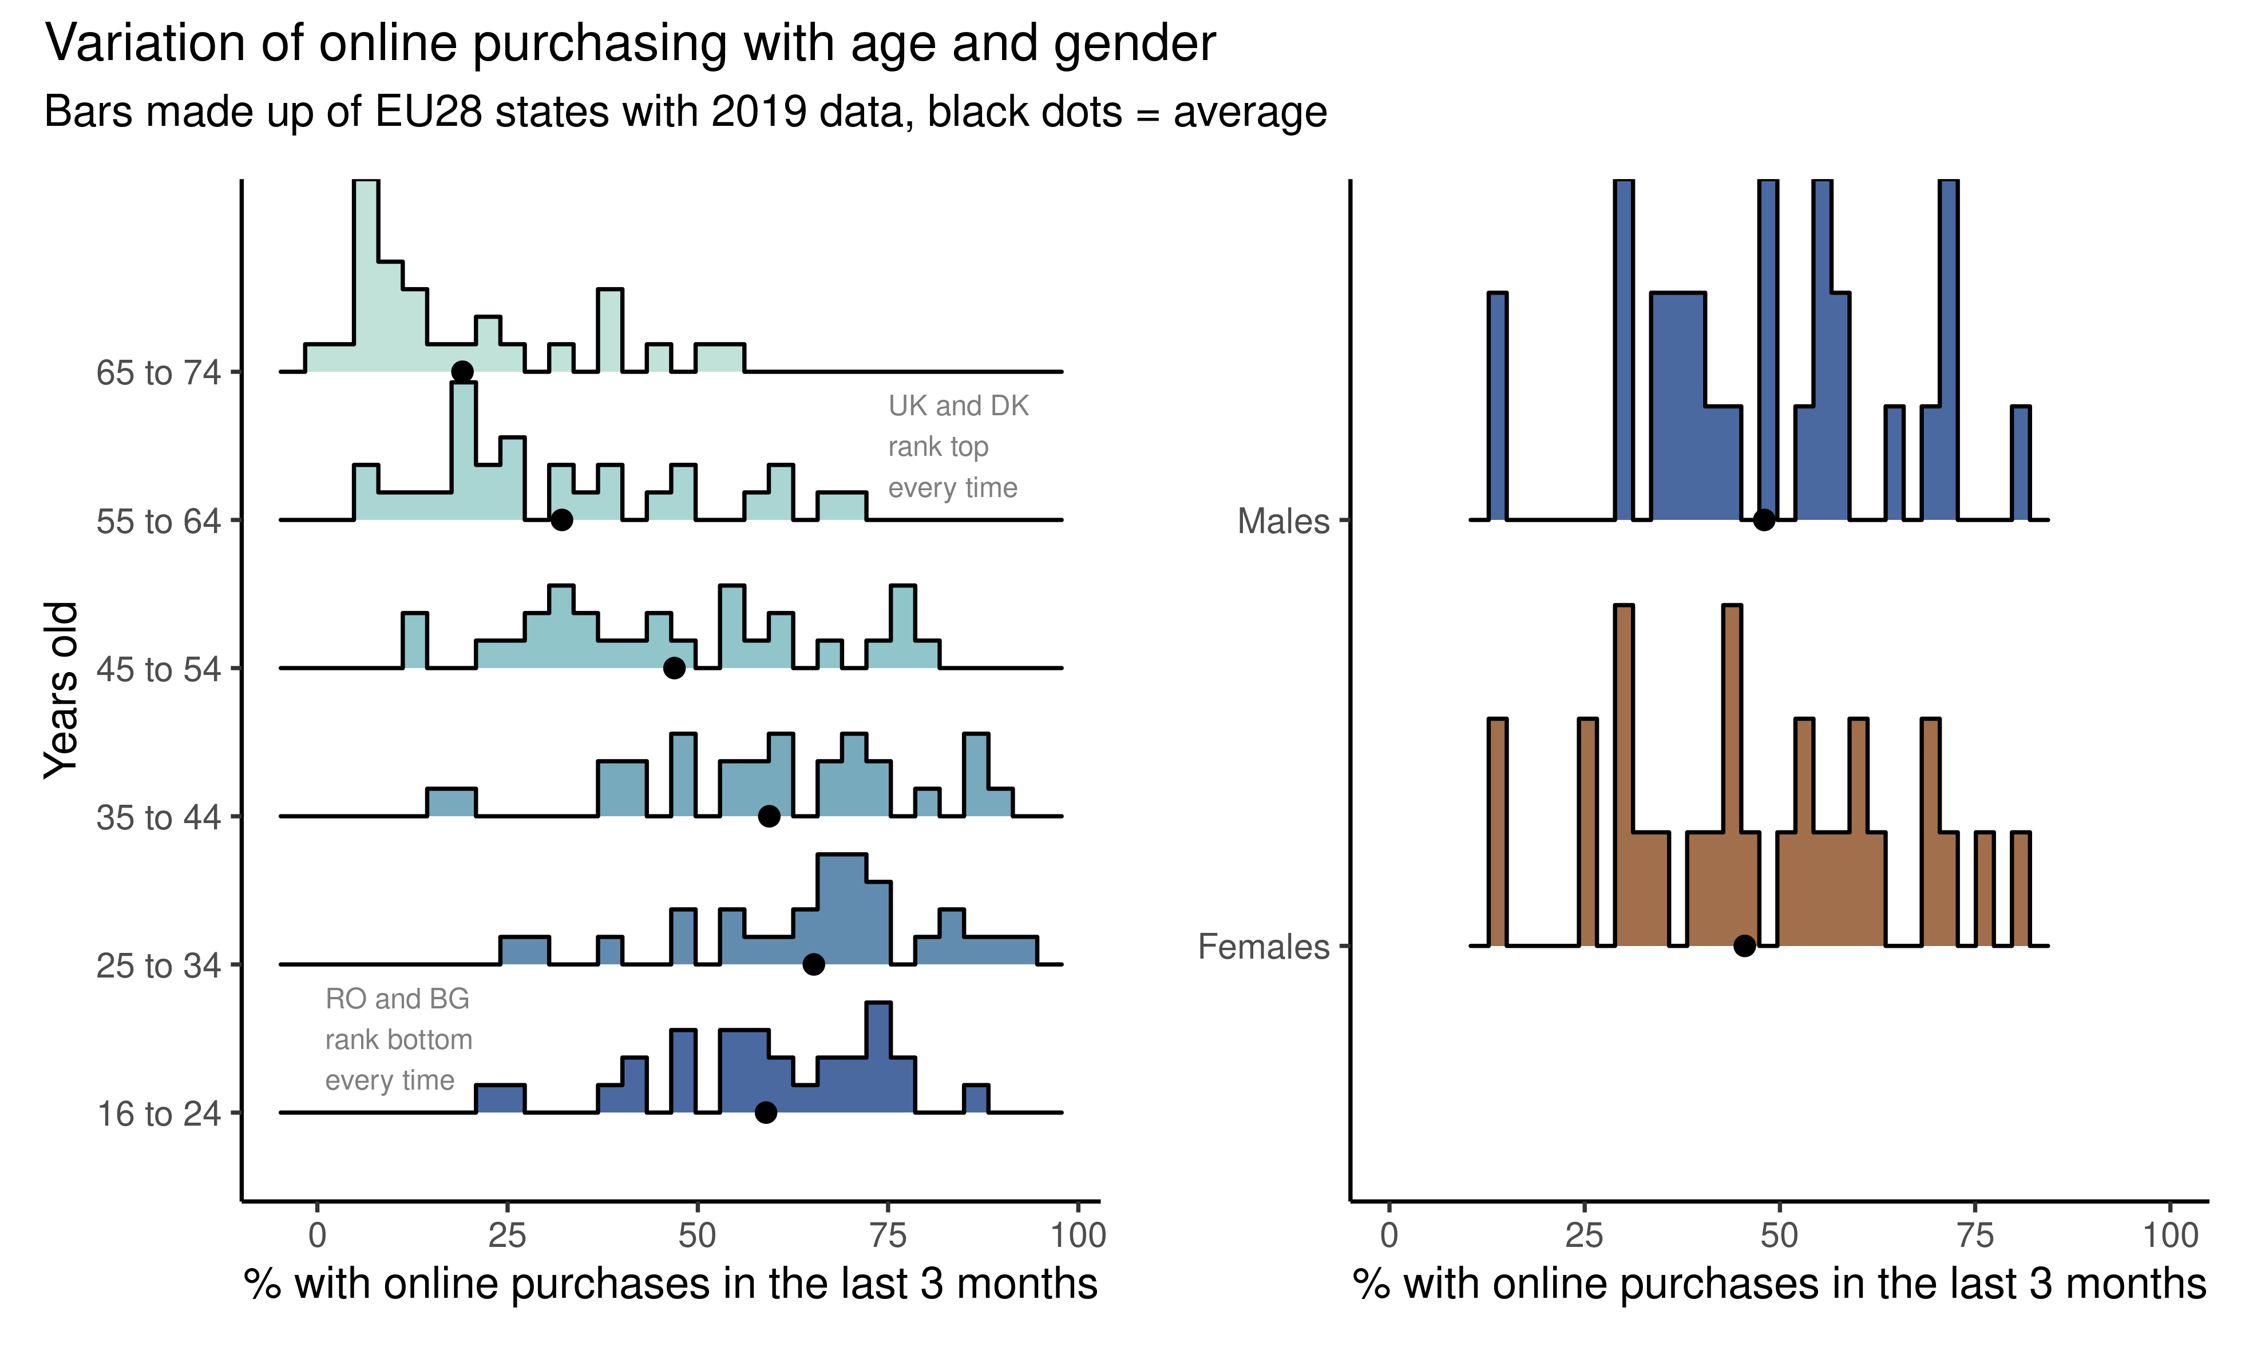Figure 3: Online purchasing in EU28 states by age and gender
A variant of density plots were selected, showing quantitative values (Kirk, 2019, p. 155). They can suggest if the different EU states are homogeneous or diverse with respect to certain variables and also display outliers. Colour is used here to help lead the eye up the chart with the increasing age groups, and enhance the distinction between gender groups. Black dots to represent the mean were added to aid with comparisons. Captions were added to reveal hidden aspects of the age data (Kirk, 2019, p. 241).
Unsurprisingly, the means show that younger generations tend to be more likely to have made purchases, but there is very little difference for genders. It could be inferred that 16-24 year old’s maybe don’t spend as much as 25 - 34 year olds for financial reasons. In terms of distribution, the different groups seemed fairly homogenous and the annotations reveal that ranking may be somewhat stable throughout these groups.

Spending brackets within the EU28
We will now begin to slowly shift towards consumer behaviour, and the next visual intends to communicate how much the EU28 citizens tend to spend online (figure 4).
This is an important characteristic of online shoppers and, is related to not only their wealth, but also their engagement and satisfaction towards online purchasing (Srinivasan, Anderson and Ponnavolu, 2002).
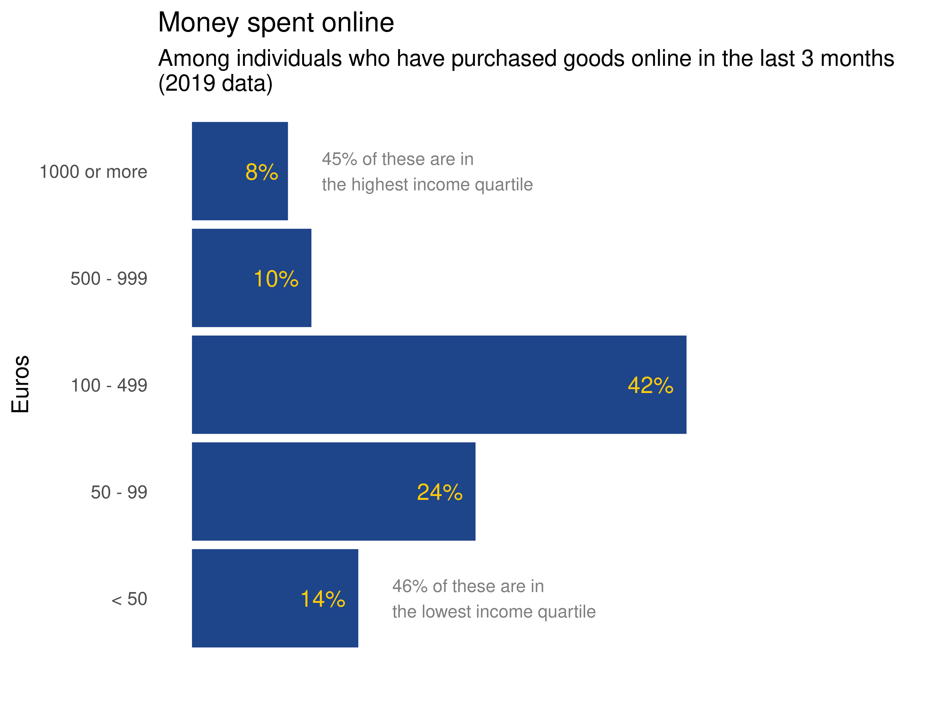Figure 4: The different online spending brackets in the EU28
In terms of techniques, an annotated column chart was used. A distribution would have been preferred, but limitations with the data prevented this. Captions relating to income quartiles, contextualized the message we are trying to communicate. 2% of the data is unaccounted for, as an artefact of the source data.
The comparison among items shows that the 100 - 499 spending bracket is the most common. The categories do seem to follow a fairly normal distribution upon first glance, but they are not even in scale and this interpretation should be cautioned. The annotations indicate that a disproportionate amount of the highest and lowest brackets are occupied by the highest and lowest income quartiles. This is not surprising, but confirms that this data falls largely in line with peoples wealth.

Types of goods and services being purchased
We now want to explore what the most popular categories of online purchases are and, out of individuals who are active online shoppers, which states purchase tend to purchase these the most (figure 5).
Up until now, what people are actually spending money on has not been exposed. There are a very diverse number of things that one could spend money on (from clothes and movies to e-learning), and it will be interesting to see if certain states have strong favourites when it comes to online purchases.
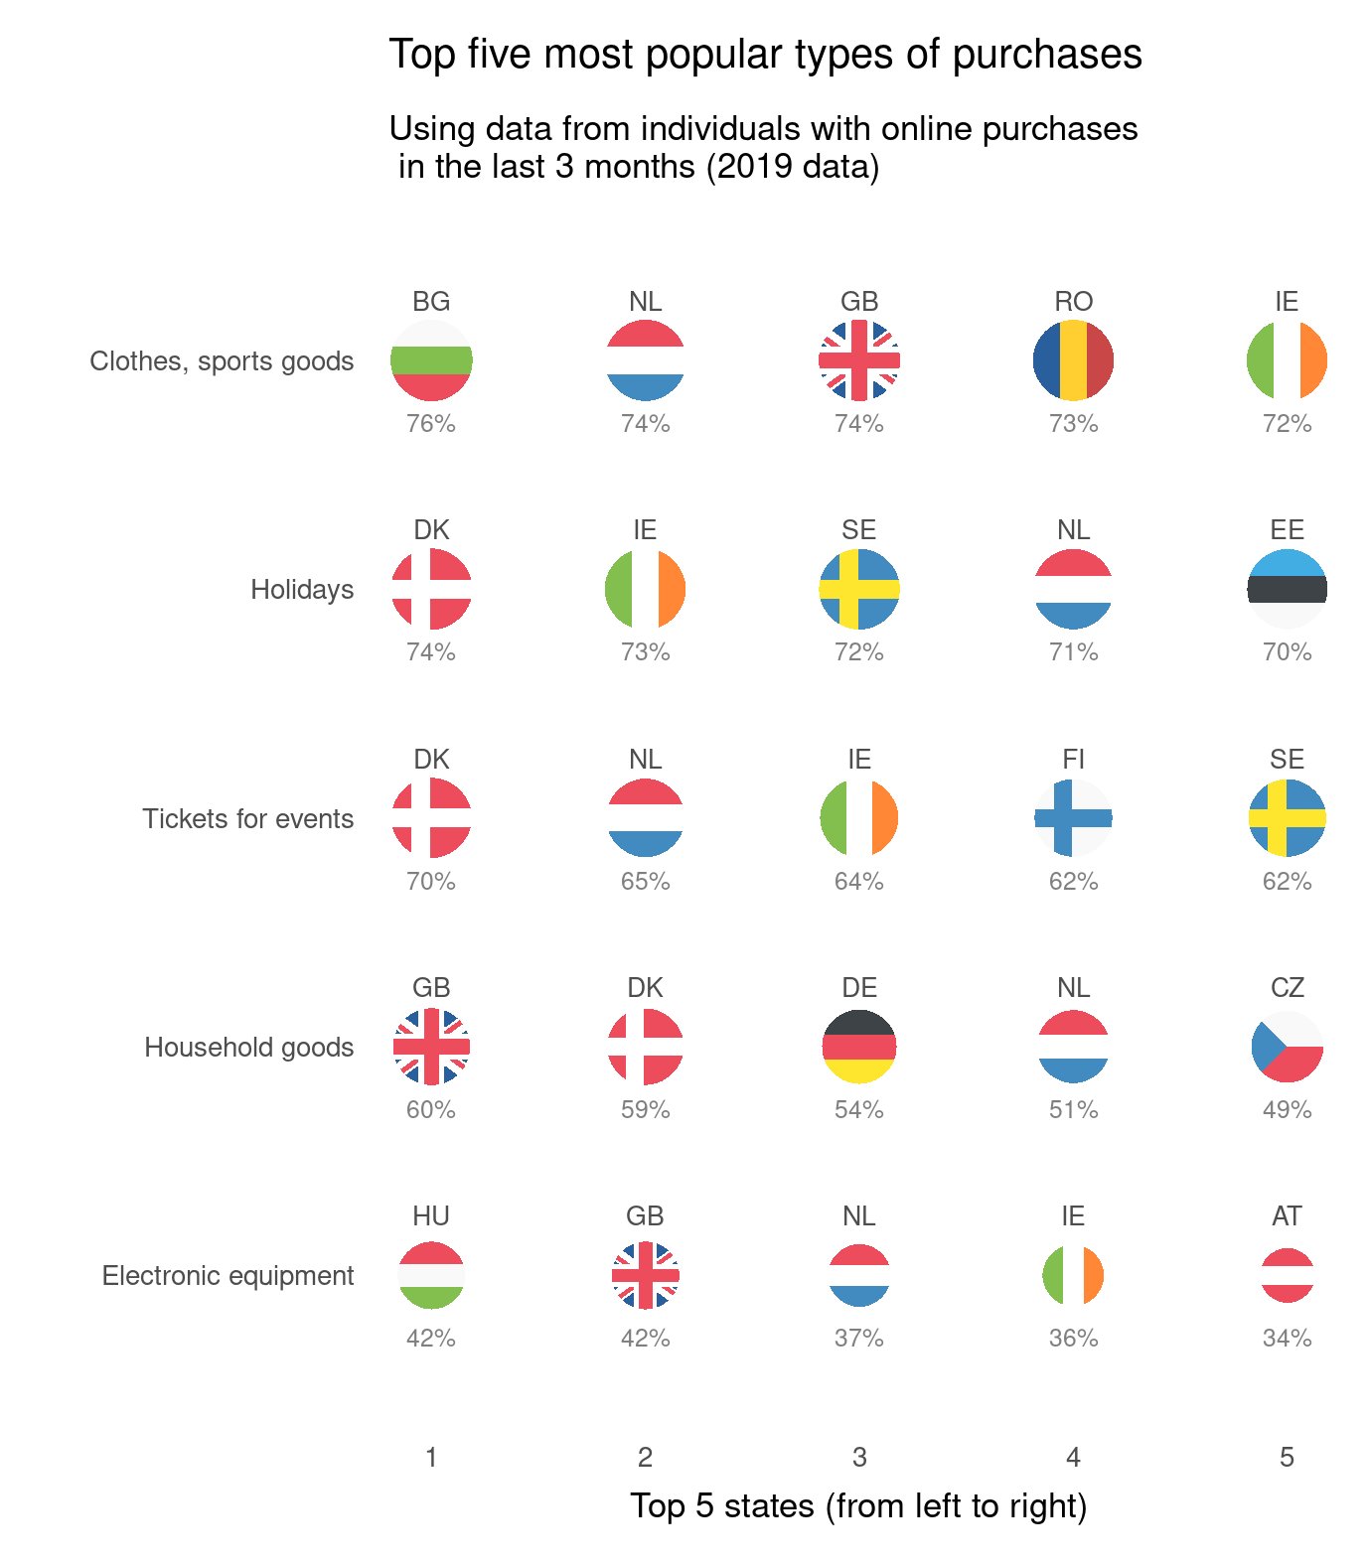Figure 5: Top five most popular types of purchases
For the method a bubble chart was used, in a table layout, using only the top five in the categories of purchases and states. This was decided to deal with the high dimensionality of the data. Bubble areas were scaled by purchase popularity to take advantage of pre-attentive processing (Ward, Grinstein and Keim, 2015, p. 100). Note that there may be a slight error in how this scaling was technically executed. For clarity, quantitative keys were added and labelled flag icons filled the bubble areas. The variables along the x and y axis were sorted to provide rankings and make comparisons among the many items easier to make.
When considering the category rankings are not surprising in hindsight, but are informative to call out. Clothing was the most popular category, possibly helped by the booming fast fashion industry, while holidays and event tickets are industries dominated by online selling. In terms of state preferences, Western and North European states again feature heavily. However, given that these rankings will be influenced by amount of purchasing within three months, there are surprises here. This visual suggests that Eastern European states such as Bulgaria, Romania and Estonia purchase more than expected in some categories, despite their earlier rankings.

Consumer buying strategies
Moving further into behaviour, we would know like to communicate how purchasers strategise when making online purchases (figure 6).
This will help build up our picture of them between in general, being suggestive of their levels of experience and caution as shoppers (Spake, Zachary Finney and Joseph, 2011).
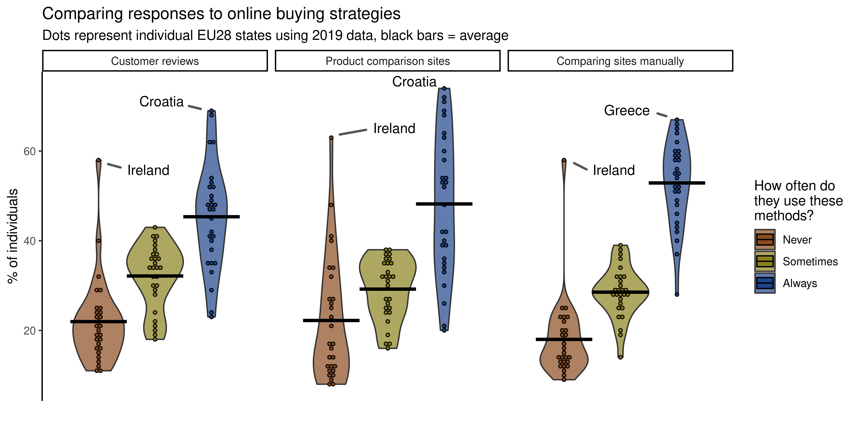Figure 6: Comparison of online purchasing strategies
There are 3 components to this chart. Firstly, the mean lines allow for a casual comparison between the three buying strategies. Secondly, the violin component allows us to see how reliable our inferences are, with respect to individual states. Thirdly, the individual points allow us to identify the presence of outliers. Annotations for the states at the top of always and never give us a little insight into the ranking of states. Since the main goal here was to compare groups and shapes, gridlines were omitted (Kirk, 2019, p. 155). The ordering was important for frequency of strategy used, but not the type of strategy. For this particular dataset, we were constrained to use a percentage of all individuals.
It shows that most consumers generally tend to be proactive using these techniques, using them at least some of the time. When comparing the means, comparing sites manually is the most popular method on average, and one could speculate that frugality is a driving factor here. However, while people who always use these methods are the most abundant, their distributions are the most spread out among states, meaning we cant easily apply that rule universally. There are also some obvious exceptions to the rule. Ireland tends to be a stark outlier here, with around 60% of shoppers not using these methods. The south eastern states seem to occupy the top spots here, suggesting the are much more careful shoppers.

Problems buying online and seller location
For the final visualisation, we wanted to shift to a decision related to consumer behaviour and its consequences; choosing to purchase goods from outside the EU. Specifically, we will show how that the risk of problems increases the further afield individuals look to make purchases (figure 7).
Not only is the potential association between seller location and potential problems interesting in itself, this will also further build up our picture of online purchasers, showing their general preferences for purchasing from local or more remote sellers.
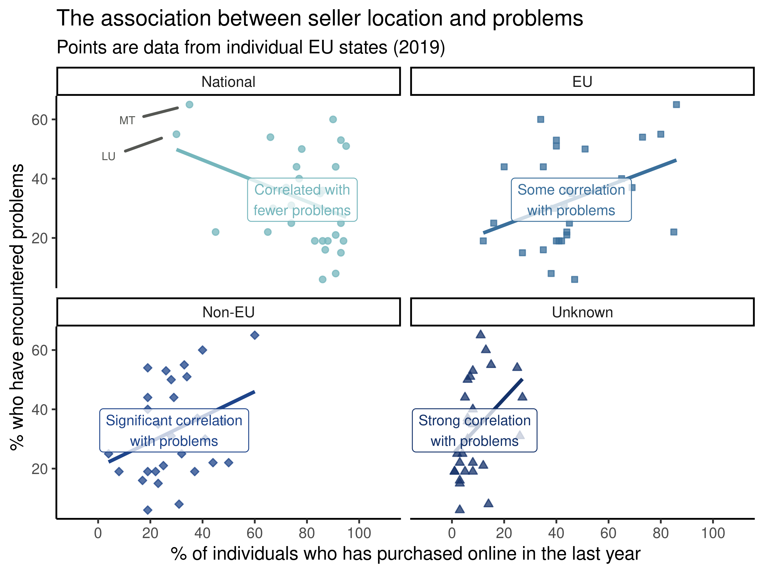Figure 7: Association between seller locations and problems
Scatter plots were used for this visualisation. Correlations were highlighted with regression lines and their significance was captioned to add clarity. Reference lines were judged to not be needed here as precise point estimation was not the main goal and might make the plot too busy (Kirk, 2019, p. 166). Different panels were also used for each seller location to make the visual less cluttered. The variations in colour and shape are not essential here, but do help distinguish the panels and leads the viewer through them.
The plot(s) show a clear trend, where the further afield one looks, the more likely one is to encounter problems. It also shows that proximity to the purchasers location is associated with how likely they are to order from there, though with varying spreads of distributions on the x-axis. Malta (MT) and Luxembourg (LU) are unexpected outliers, having a lot of problems when ordering locally. However, its outside of the scope of this project to dig deeper.

References
An, H. (2020) hihayk/scale. Available at: https://github.com/hihayk/scale (Accessed: 9 November 2020).
Deckmyn, A. (2018) maps: Draw Geographical Maps. Available at: https://CRAN.R-project.org/package=maps (Accessed: 9 November 2020).
Eurostat (2020) Online shopping continues to grow, Eurostat - Statistics Explained. Available at: https://ec.europa.eu/eurostat/web/products-eurostat-news/-/DDN-20200420-2 (Accessed: 9 November 2020).
Fichter, K. (2002) ‘E-Commerce: Sorting Out the Environmental Consequences’, Journal of Industrial Ecology, 6(2), pp. 25–41. doi: https://doi.org/10.1162/108819802763471762.
Goldie, J. (2020) rensa/ggflags. Available at: https://github.com/rensa/ggflags (Accessed: 9 November 2020).
Hernández, B., Jiménez, J. and José Martín, M. (2011) ‘Age, gender and income: do they really moderate online shopping behaviour?’, Online Information Review, 35(1), pp. 113–133. doi: 10.1108/14684521111113614.
Hultkrantz, O. and Lumsden, K. (2001) ‘The impact of e-commerce on transport.’, in. European conference of ministers of transport, Lisbon, Portugal: ECMT. Available at: http://citeseerx.ist.psu.edu/viewdoc/download?doi=10.1.1.581.6360&rep=rep1&type=pdf (Accessed: 11 September 2020).
Hunter, J. and Wilson, M. (2015) Cross-border online shopping within the EU - Learning from consumer experiences. Brussels, Belgium: ANEC. Available at: http://www.anec.eu/attachments/ANEC-RT-2015-SERV-005.pdf (Accessed: 9 November 2020).
Kirk, A. (2019) Data Visualisation: A Handbook for Data Driven Design. 2nd Edn. London: SAGE.
Lahti, L. et al. (2017) ‘Retrieval and analysis of Eurostat open data with the eurostat package.’, R Journal, 9(1), pp. 385–392. Avialable at: https://journal.r-project.org/archive/2017/RJ-2017-019/RJ-2017-019.pdf (Accessed: 9 November 2020).
Lawrence, J. E. and Tar, U. A. (2010) ‘Barriers to e-commerce in developing countries’, Information, society and justice journal, 3(1), pp. 23–35. Available at: http://repository.londonmet.ac.uk/88/ (Accessed: 9 November 2020).
Lian, J.-W. and Yen, D. C. (2014) ‘Online shopping drivers and barriers for older adults: Age and gender differences’, Computers in Human Behavior, 37, pp. 133–143. doi: 10.1016/j.chb.2014.04.028.
Monmonier, M. (2018) How to Lie with Maps. 3rd Edn. edition. Chicago, IL: University of Chicago Press.
Nichols, D. (2020) Coloring for Colorblindness. Available at: http://www.davidmathlogic.com/colorblind/ (Accessed: 9 November 2020).
Spake, D. F., Zachary Finney, R. and Joseph, M. (2011) ‘Experience, comfort, and privacy concerns: antecedents of online spending’, Journal of Research in Interactive Marketing, 5(1), pp. 5–28. doi: 10.1108/17505931111121507.
Srinivasan, S. S., Anderson, R. and Ponnavolu, K. (2002) ‘Customer loyalty in e-commerce: an exploration of its antecedents and consequences’, Journal of Retailing, 78(1), pp. 41–50. doi: 10.1016/S0022-4359(01)00065-3.
Ward, M., Grinstein, G. and Keim, D. (2015) Interactive Data Visualization: Foundations, Techniques, and Application. 2nd Edn. Boca Raton, FL: A K Peters.

Appendix: Infographic
(Next page).
