Data and web mining CA2
“Drilling down in global poverty”
Jamie McFarlane (Student no. 19175329)

Table of Contents
1. Introduction 2
1.1. Background 2
2. Visual design process 3
2.1. Formulating the brief 3
2.2. Working with data 3
2.3. Editorial thinking 5
2.4. Design solution 5
3. Technique, style, layout and colour 9
4. Presentation and discussion of results 10
5. Conclusions 11
6. References 12
7. Appendix: Accessing the dashboard 13

Introduction

Background
Information about global poverty faces a communication challenge with the general public. In-depth discussions are largely relegated to NGOs and academic literature, while the general public are occasionally provided high-level information which can be framed with editorialisation (Kim, Carvalho and Davis, 2010). Issues that the developing world faces can also be misrepresented and communicated virally, as exemplified by the “Kony 2012” phenomenon. The interrelationships between global poverty and important topics in the public consiousness such as climate change and pandemics are increasing the need for access to poverty information (Hubacek et al., 2017; Sumner, Hoy and Ortiz-Juarez, 2020). NEED TO AMEND TO EMPOWER RESEARCHERS
The World Bank has been at the forefront of poverty research for the last twenty years. Research on global poverty has become more open in recent years, with the World Bank efforts to compile and provide open access to PovcalNet (World Bank, 2020). This allows anyone to replicate the findings of the World Bank’s poverty research and reports, and provides a easy to use APIs for R and Stata.
This project attempts to normalise global absolute poverty across different economies and provides a convenient and holistic interface for exploring different measures of world poverty. The tools embedded in website provide methods to graph, aggregate and display data from its database. However, these are not really suitable for casual or curious members of the general public. There is an opportunity to simplify this interface into a reactive dashboard, suitable for consumption by the general public who do not have an overly convenient means of consumption.

Visual design process
The general layout the visual design process was adapted from Kirk (2019).

Formulating the brief
A key part of formulating the brief for visual design is formulating the brief for the project (Kirk, 2019, p. 61). The intended audience was an important circumstance that shaped the project. These were both members of the general public, who may be a mixture of receptive and indifferent to the message, and researchers looking for a method to quickly corroborate other reported statistics around poverty. The former group will require something that is somewhat simplified as well as visually appealing, while the latter will require access to a large number of metrics to be useful.
Since the purpose of the dashboard was to make the data on offer more accessible, we decided to offer an exploratory visualisation experience (Kirk, 2019, pp. 84–86). This tends to be better suited to people with pre-existing knowledge of the subject, so a lot of simplification is needed if the general public is to be included. Simplified explanations of some metrics will also need to be provided.
In terms of narrative, we wish to convey how different countries compare in terms of poverty, the trends of poverty over time, and how different measures of poverty relate to each other.
The message that poverty is reducing worldwide has been communicated to the general public, which might lead to people underestimating the problem as it exists today (Reddy and Minoiu, 2007).
One of the first things an end-user might do is inspect their own country. With this baseline established, adding in a different country from a developing national will allow them to quickly visualise the scale of poverty in those countries.
An additional narrative is the ability to compare metrics and see how these change over time with respect to different countries.
In addition to the specifications and narrartive components of formulating a brief for the project, there were other considerations too. In terms of constraints, only one developer was involved in the project with a strict deadline. Leveraging existing expertise in the R language was decided upon. The R language was chosen to be used for every step of the development . R provides arguably the most powerful data pre-processing, analysis and visualisation toolset available, and relying solely on R for all steps in the design process reduces the amount of disparate dependencies. This includes removing the reliance of proprietary dash-boarding software. The most significant third-party package used was Shiny, which provides a framework for creating Javascript web-based dashboards.
The development of the dashboard began with sourcing the data and selecting the technology used to create it.

Working with data

The data used to develop the dashboard consisted of five datasets (table 1). The main data source was the povcalNet R API, which provided poverty metrics from 1990 to 2018. This was supplemented with additional metrics of Life Expectancy and GDP per capita from the World Bank R API. Map coordinate data was extracted from the rworldmap R package. The merging of these data sources was supported by extractions of extra data labels from these different sources.
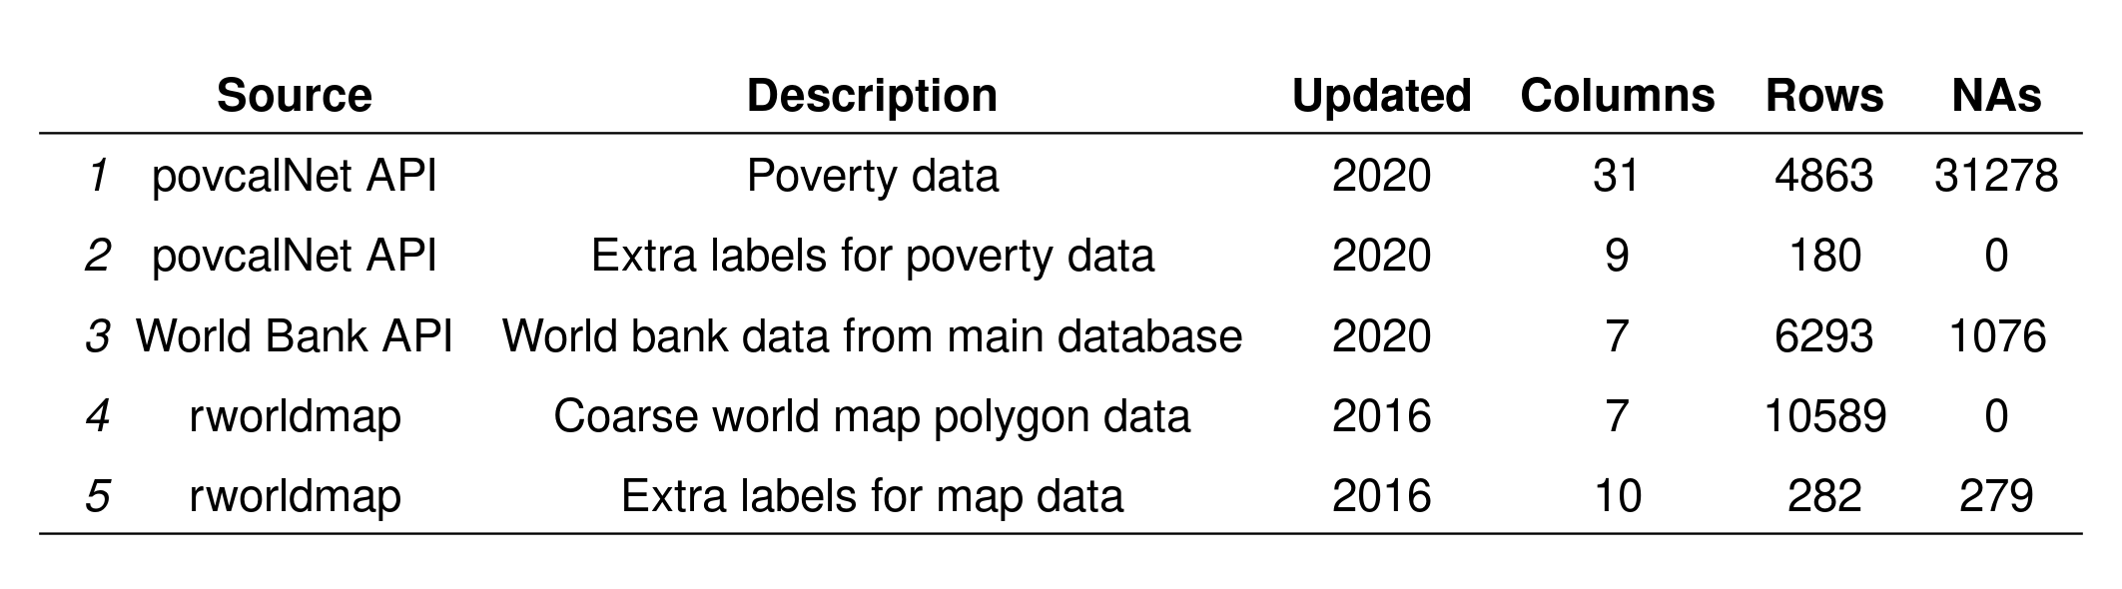

The final merged dataset was a 288,279 row X 14 column table, with a mixture of numeric poverty metrics, character labels, time data and map coordinate data. Despite the automatic imputation of gaps in the poverty data, provided by the R API, a number of missing values still remained. The was mostly the result of some countries simply not capturing data at all.
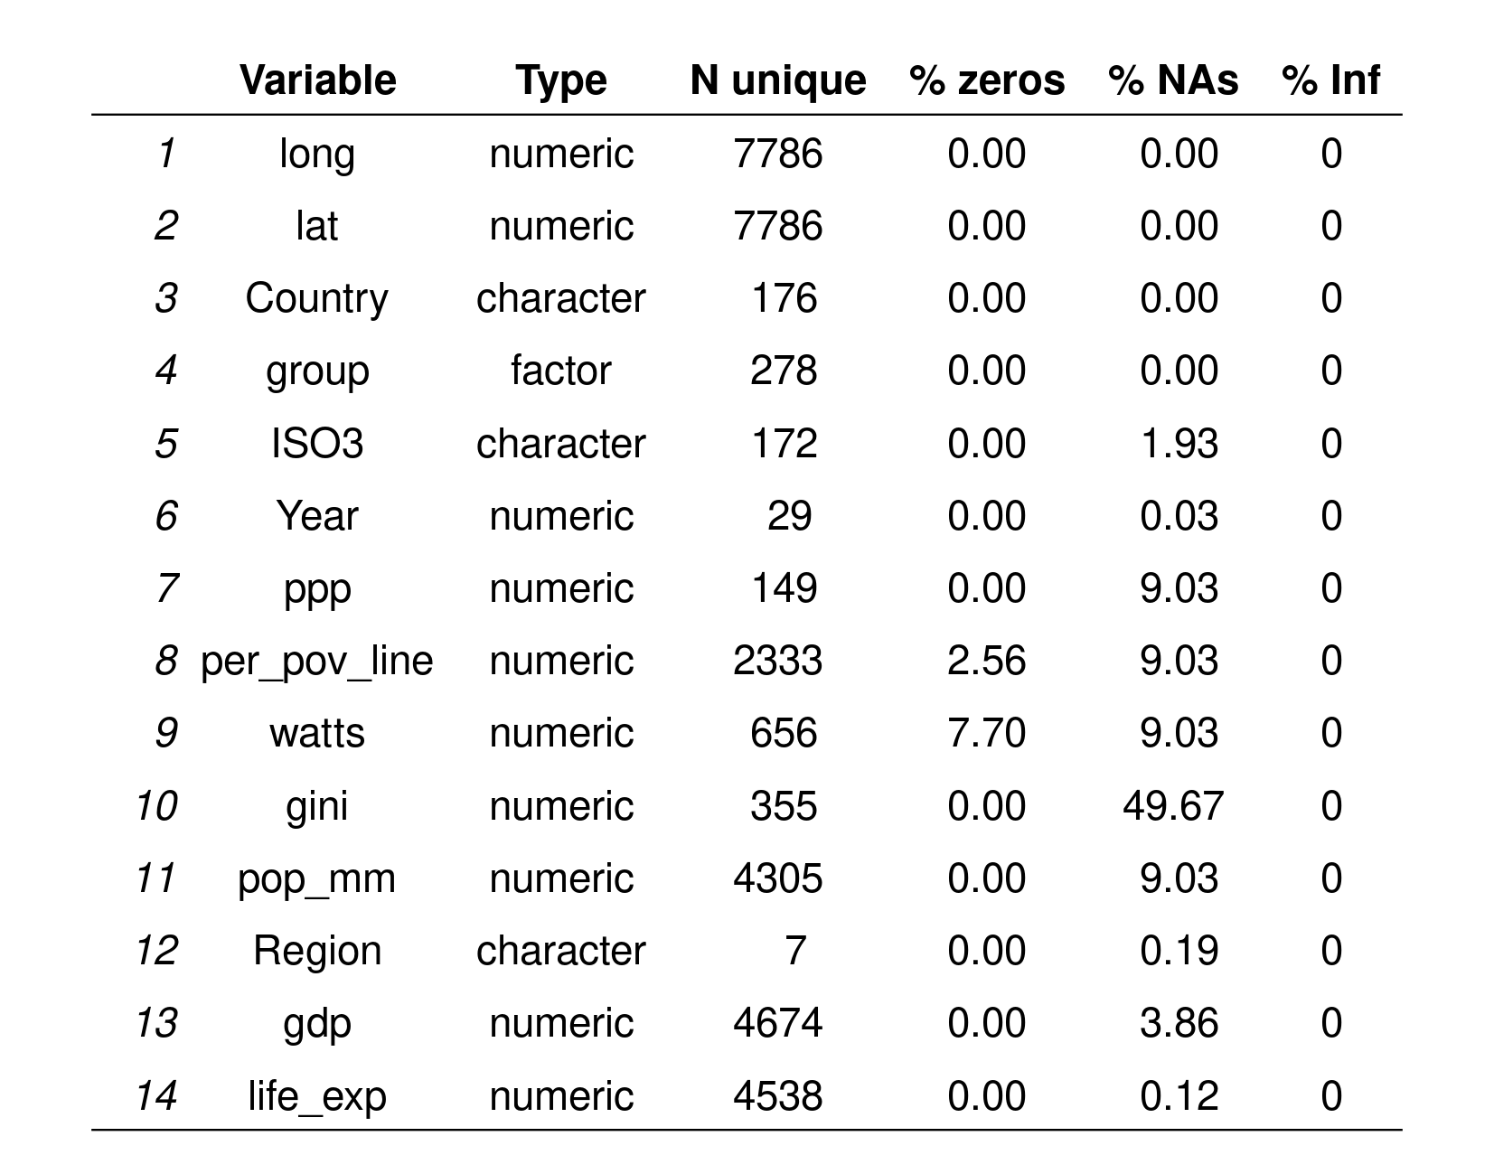

Some measures such as the Gini measurements are imperfect, really making thes best of it. https://stonecenter.gc.cuny.edu/files/2019/02/review_of_all_the_ginis_Smeeding-latner.pdf
Data was extracted using R based APIs. The disparate data sources were merged on ISO 3166-1 alpha-3 country codes (ISO3). Some pre-processing was needed to transform World Bank codes to this format and despite ISO3 being a standardised format, some discrepancies still had to be fixed manually (e.g. Kosovo being encoded as “KOS” or “XKX).
The size of the dataset has a significant effect on the lag in loading visualisations and can have a detrimental effect on usability (Liu and Heer, 2014). Some compromises had to be made to reduce down the size of the data. Firstly, the available years to explore was constrained from 1990 to 2018. Less important metrics such as population deciles were dropped and the remaining ones rounded down to three or four decimal places. A map coordinates dataset with a reduced polygon count and smaller island omitted was deliberately chosen to reduce down the size further. Antarctica was also removed from all datasets. Within the Shiny application itself, the data reactively splits into two datasets, one for the world map, and a smaller one for the other visualisations.
Throughout the processing of the data, ad-hoc summaries and simple visualisations of data characteristics were employed to ensure the processing was being done correctly and to help understand the contents of the datasets.

Editorial thinking
A number of judgements had to be made about what to include in our visualisation. In terms of angle, we wish to show how countries differ in terms of world poverty and how this changes over time. In terms of framing, we will include a number of centrally important measures of poverty, but not be exhaustive. Some measures are merely small variations on other metrics and will clutter the design. Some additional metrics to provide context such as life expectancy and GDP per capita. In terms of focus, we will use techniques to highlight areas which differ greatly from other countries in terms of these metrics.

Design solution
A number of decisions also needed to be made about how to best visually portray the data, beginning with how we will represent the data.
Iterative wireframing was used throughout the design process (figure X). We can see that the original concept only included a central map visualisation, surrounded by controls on the left, summary statistics on the bottom and drill-down components on its right. This evolved with the introduction of an alternative central view of the data, a “Gapminder” style visual. The final form, where a tabbed interface is used to alternate between the two central views is not captured.
The representations were a chloropleth, a bubble chart, summary a line chart and a table with heatmap elements. Variations in size, position, colour hue and colour lightness were employed atributes, varied to show differences in the data.
For interactivity, we relied on enabling participation throughout the visualisation, which is key to an exploratory design. This includes the used of variable selection, date filtering and drilldowns upon data selection. Highlighting was intended, but was ultimately not included due to unfamiliarity with the technology used to develop the dashboard. Annotation was employed by both using tooltips upon hover, as via popups.
The project and chart composition of the visualisation was somewhat guided by the shinydashboard framework used, with rectangular charts neatly separated out into discrete boxes. Controls were placed on the left hand side, including means to select variables and the year of data, a reset button for the drilldowns. The drilldowns were placed right of the central primary visualisation. Summary statistics were above the main visual to help ground its complexity, especially when repeatedly filtering the data over time either manually or when animated. These are important to conveying the general narrative that poverty both changes over time, is strongly contrasted between countries, and is an ongoing problem.
Finally, we wanted to include animation to allow the user to see how poverty variables change over time. This was included, but due to the unfamiliarity with map data types and the framework used, was greatly limited in update speed and is not given prominance.
In terms of project composition, the layout is conventional, with a title at top, information below and the main graphic taking the centre of screen. The drill-downs take the right hand side of the screen, aligning with a Western audiences tendency to read left to right. The tabbed interface in the centre was needed to save space, but both the primary visuals overlapped in the information conveyed anyway.
The general blue, provides a functional harmony thoughout the visual, while preventing it from looking too dull. For comparisons, the colours used were both contrasting, but also colour-blind safe for 99% of the population (Trubetskoy, 2017). Colour hue is used to draw the eye when making comparisons in table and world map.

To achieve this, we will facilitate the manipulation and interrogation of data and use different techniques for engaging users.

** Data visualisation

An elegent and very well-known example of this is the Gapminder visualisation (Rosling and Zhang, 2011). We will leverage this method to explore different measures of poverty.
Wanted the chloropleth to be the primary view
Wanted to avoid multiple tabs
To manage the volume of possible views, users were given control over years and ...

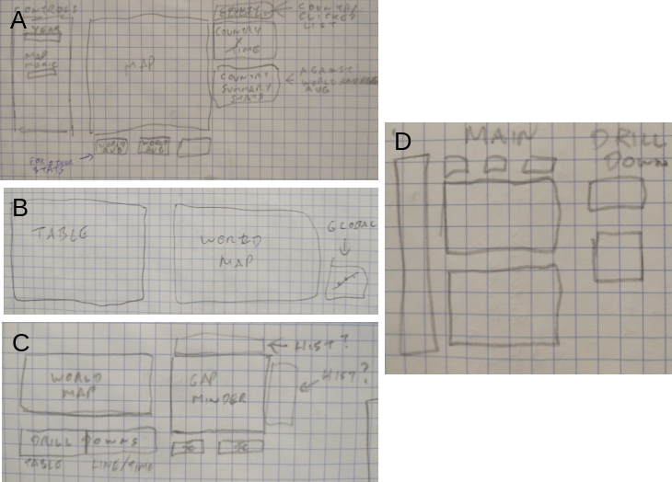
"Formulating the brief: Timescale, Setting, Format, Purpose map"
"Editorial thinking: Angle, framing, focus"
"Data representation: Chart types"
"Good design: Trustworth design has fuinctional performance"
"It is accessible in that it is useful, unobtrusive and has visual accessibility"
"Elgent, in that it doesnt have feature creep, minmises clicks and is fun"

"Composition": Relationships between elements and how they will appear
"Project composition": Layout and hierarchy of the project
"Chart composition": Shape, size and layout choices of the cahrts.
How big will they be and why?

Scales
Drilldowns sort automatically
Trustworthy: Scales reset between metrics
Accessible: Only one tab
Elegent: Things are aligned
Unity: Chart in middle brings things together(?)

Annotation used to inform the viewer.
Title gives the general idea
Others give assistance for dashboard behaviour, to prevent surprises. It states limitations. It is not an intriduction, which would be too long. More of a help if people need it.
Captions explain what advanced metrics mean in simple terms. Good for intended audience.
Chart labels and legends used sparingly to minimise clutter.
PLotly automatically provides the occasional helper annotation when the user is interacting with things.
Sans-serif fonts.

“expand the phyical limits of what can be shown in a physical space
"Expand physical limtis of what can be shown in a limited space"
"Facilitate manipulation of data"
"Facilitate interrogation of data"
"Different techniques for engaging users"
"Organise thinking" : "We want to use data adjustments and presentation adjustment for this"
"Event" -> "Control" -> "Function" (Kirk p224)
"Framing" Framing was used extensively. We used framing of the data, to subset out specific periods of time. Framing also was used for drilldowns
"Navigating" Navigating was used for exploring a map and clusters of bubbles. Re-frames the data.
"Animating" the progression of metrics over time. Both manual and automatic. Suitable for this temporal data.
"Contributing" The user will provide contributing data alot. (Kirk p232)
"Focussing" Used on table to visually emphasise things (p235). Also for Gapminder. And tiles.
"Annotating" used for map and gapminder, to view more details in tooltip. And table.
"Orientating" used in the line chart. P237

Presentation and discussion of results
The final exploratory dashboard comprised of a number of visuals
One can clearly see a broad difference in regional wealth, between Western countries and developing world countries in Africa, South America and Asia.
For example, one might assume that following the fall of the Soviet Union in the early 1990’s, the indicators of poverty would be very high. While they are higher than Western countries, they still are dwarfed by those in the developing world such as Brazil.
- The world map
- The Gapminder
- The high level tiles
- THe line plot
- The summary table
There were also a number of problems with the dashboard.
The startup for the dashboard is negatively affected by the latency problem. At first, it looks like the dashboard simply isn’t working, before the dataset loads in a visuals are displayed. Also, while the line chart displays an annotation to explain why it is empty and provides instruction, the table below it is empty and looks untidy.
While some of the metrics were more obscure, the Watt’s Index was unfortunately unreliable. It sometimes defaulted to producing non-varying values of -1, which upset the visualisations and possibly caused confusion.

Conclusions
My personal reflections about the project are very mixed. Ultimately, I feel that the deliverable succeeded in satisfying the brief in several ways, but also failed in several areas. It does deliver an interactive experience, with several decent visualisation methods and good drill-down functionality. However, it also lacks a strong narrative which would make it communicative to the general public and also lacks polish.
A key personal takeaway from this project was learning the Shiny dashboarding framework, which was of great personal importance. However, as an experienced R user, but having no experience with reactive programming this, provided a steep learning curve in a short space of time. The effort spent in grappling with this was definitely at the expense of the deliverable for the project. This problem was compounded with my inexperience in map data types had significantly increased the time it took for me to process the data and develop the visuals. Both of these led to the problems of the refresh rate of the data, the inability to provide highlighting on the chloropleth, and the general lack of polish as it simply led to me running out of time.
If I could repeat this project, I would have used Shiny again, but avoided geographical type data.
What I learned

References

Appendix: Accessing the dashboard

