**Familiarity with UNIX/Linux: Part 1**  
James Miller  
Grand Canyon University  
CST 315: Operating Systems  
Dr. Citro  
Feb 12, 2023

**GitHub Link**

<https://github.com/jammil002/Project1--Unix-Command-Line>

**Project Description**

This program is a simple command line interpreter, also known as a shell. The user can enter commands to be executed one at a time, or they can run commands in batch mode by providing a text or batch file as input.

**Project Approach**

There was a couple step to making a command line interpreter. You begin with taking user input, handling that said input, running the needed commands, and handling bash input. I broke each part up into their own individual functions. This allowed me to think through each part as an individual component. The program must first get user input, the user input must be tokenized, and finally each command is run as its own child process.

**Parsing** **Algorithm**

Input is tokenized based on “;” or “\n” characters. This tokenized input is then added to an array. This array is sent to the execute function. A for loop will go through each individual command. A child process will then be created and the command with be executed within the said process. The parent process will wait for the child to finish and continue the loop to the next command.

**Code Explanations** 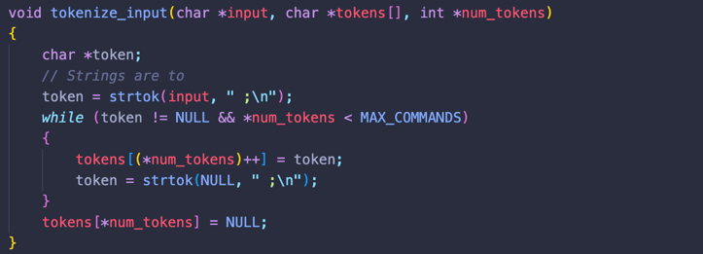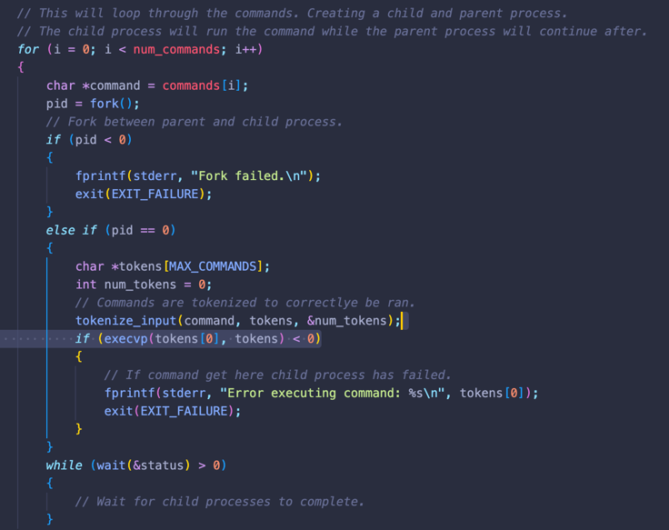

Code 2

Code 1

Code 1: After the input is tokenized and added to an array the commands are sent to be executed. The fork command is used to create a child process. The current command in the loop will be ran while the parent waits for the command to finish. Once this process finishes the loop will continue.

Code 2: This function will format the user input to be used as commands. The user input will be loop through and each will be tokenized by a “;” or “\n” character.

**References**

Neso Academy [@nesoacademy]. (2019, July 25). *fork() and exec() System Calls*. Youtube. https://www.youtube.com/watch?v=IFEFVXvjiHY

CodeVault [@CodeVault]. (2020, May 15). *Executing commands in C*. Youtube. https://www.youtube.com/watch?v=uh2FqejQRk8