
INDUSTRIAL MANAGEMENT
Project Report
Digital Twin-Driven Strategic Demolition Plan for
Circular Asset Management of Bridge Infrastructures

Abstract
Economic growth plays an important role in the rapid increase in construction of transportation and bridge infrastructures, which in turn causes enormous greenhouse gas emissions contributing directly to climate change. An innovative and effective method, so-called Building Information Modeling (BIM), to sustainably manage detailed lifecycle of infrastructures, has been recently adopted to revolutionise the Architecture, Engineering and Construction (AEC) industry. Its major function is to sustainably optimise all detailed stages of an infrastructure asset’s lifecycle. A three-dimensional architectural BIM incorporating three additional dimensions (time, cost, and carbon emissions) has then been created in this study to virtualise the whole lifecycle performance of bridge infrastructure through BIM data. For circular asset management, multi-scale details of assets and infrastructures are indispensable. On this ground, these information dimensions are highly critical to asset managers to assure not only public safety, but also sustainability over the whole lifecycle. It is thus critical to quantify carbon footprint in order to identify better alternative solutions for construction and maintenance, resulting in carbon neutrality and carbon credit. Our digital twin (DT), driven by the BIM, has embedded demolition scenarios whose lifecycle cost and carbon footprint can be quantified and optimized simultaneously. Our study is the first to also demonstrate circular end-of-life management through strategic demolition planning that enhances circular economy practice. This aspect is novel and has not been commonly adopted in practice. Our study reveals that the construction stage of the asset lifecycle for this study is the main contributor to carbon emissions and costs stemming from raw materials and their productions. This eventually leads to significant waste at the end of asset’s life, requiring strategic demolition plan to maximise reuse, repurpose, and recycle of materials, parts and components. Our innovative DT is capable of dealing with the cradle-to-cradle lifecycle management. Another co-benefit of using the BIM-based digital twin is to minimise streamlining design, re-work, mitigating risk, and real time processing of design changes in all stakeholders, reducing the effect on carbon emissions, costs, and time schedules. All dimensions (i.e. 6D) can be updated and recalculated in real time when cross-linked with inspections and condition monitoring, generating real-time digital twin driven solutions.

Introduction

Background
Economic growth all over the world has caused a rapid increase in the construction of transportation networks and bridge infrastructures. But there is a downside, all this construction causes enormous greenhouse gas emissions, which directly contribute to climate change. Bridges do not last forever. Every bridge has a design life (typically 100 years). After that, they need to be demolished and rebuilt. The problem is, most bridge owners and government agencies do not have a clear, data-driven plan for when to demolish, how much it will cost, and how much carbon will be released during that demolition. This leads to poor decisions, wasted money, and unnecessary pollution.

This is where the concept of the Digital Twin comes in. A Digital Twin is a virtual copy of a physical object — in this case, a bridge. This virtual copy is connected to real-world data (sensors, inspection records, BIM data) and is continuously updated throughout the bridge's life. By studying this digital version, engineers and managers can make smarter decisions about maintenance, repair, and ultimately demolition planning — without having to physically inspect every structure every time.

The Research Paper
The research paper this project is based on — "Digital twin-driven strategic demolition plan for circular asset management of bridge infrastructures" by Sakdirat Kaewunruen, Connor O’Neill1 & Pasakorn Sengsri addresses this exact problem. The authors developed an innovative method using Building Information Modeling (BIM) as the foundation of the Digital Twin. They extended the standard 3D BIM model with three additional dimensions:
- 4D — Time: tracking the bridge age, remaining life, and lifecycle phases
- 5D — Cost: calculating construction, maintenance, and demolition costs
- 6D — Carbon Emissions: measuring CO₂ released in each phase of the lifecycle

The paper's core goal is circular asset management — managing infrastructure in a way that reduces waste and environmental impact, reusing materials wherever possible, and making demolition a planned and sustainable event rather than an emergency response.

Why This Project Matters
India alone has thousands of bridges, many of which were built several decades ago and are now approaching or past their design life. Without a proper system to monitor and plan for their end-of-life, these structures become safety hazards and result in emergency demolitions that are expensive and environmentally damaging. Applying Digital Twin concepts even in a simplified simulation form as done in this project helps us understand how data-driven lifecycle management can make a real difference in public infrastructure management.

This project simulates the Digital Twin concept using Python programming. Three bridges of different ages, sizes, and materials are modelled. For each bridge, the simulation calculates their current health condition, total lifecycle cost, and total carbon footprint, and presents this information through visual dashboards.

Key Concepts from the Research Paper

Building Information Modeling (BIM)
Building Information Modeling (BIM) is a digital method for creating and managing all the data about a structure throughout its entire lifecycle. Unlike a regular CAD drawing (which only shows geometry), a BIM model contains rich information about every component of the structure its material, cost, expected lifespan, and maintenance schedule. The research paper used BIM as the data backbone of the Digital Twin. According to the paper, BIM has been recently adopted across the AEC industry to "sustainably optimise all detailed stages of an infrastructure asset's lifecycle."

Digital Twin Technology
A Digital Twin is a real-time virtual replica of a physical asset that is continuously updated using sensor data, inspection records, and engineering models. In the context of bridge management, the Digital Twin allows engineers to:

- Monitor the current health and structural condition of the bridge remotely
- Predict how the bridge condition will change over the coming years
- Calculate future maintenance and demolition costs in advance
- Estimate the total carbon footprint of the bridge across all lifecycle phases
- Prioritise which bridges need urgent attention in a network of many bridges

The research paper describes the Digital Twin as a "three-dimensional architectural BIM incorporating three additional dimensions (time, cost, and carbon emissions)" to virtualise the whole lifecycle performance of a bridge.

Circular Asset Management
Traditional infrastructure management focuses only on construction and maintenance. Circular asset management is a broader, more sustainable approach that treats every stage of the asset lifecycle including demolition and material recovery as part of a planned circular process. The research paper emphasises that "for circular asset management, multiscale details of assets and infrastructures are indispensable." By knowing in advance when a bridge will reach its end-of-life, managers can plan the demolition strategically: scheduling it during low-traffic periods, arranging for maximum material recycling, and minimising disruption and environmental impact.

Lifecycle Phases of a Bridge
According to the research paper, a bridge goes through distinct lifecycle phases, each with its own cost and carbon contribution:

Phase | Description | Key Metric
Construction | Materials sourced, bridge is built. Largest single cost and carbon event. | Capital cost + embodied carbon
Operation & Maintenance | Bridge is in service. Regular inspections, repairs, and upkeep done each year. | Annual maintenance + operational carbon
End-of-Life/Demolition | Bridge is taken down. Materials are processed — ideally recycled. | Demolition cost + demolition carbon

Project Methodology

Approach Overview
The methodology follows the same multi-dimensional lifecycle analysis approach described in the research paper, implemented as a Python simulation. The overall approach has three steps:
- Model each bridge as a Digital Twin object with BIM-style parameters
- Calculate condition score, lifecycle cost, and carbon emissions for each bridge
- Visualise results through dashboards and produce a comparative analysis for demolition prioritisation

Bridge Parameters Used
Three bridges were modelled. Each bridge is characterised by BIM data parameters:

Parameter | Bridge A | Bridge B | Bridge C
Name | River Crossing Bridge A | City Overpass Bridge B | Industrial Link Bridge C
Type | RC Girder | Steel Composite | Prestressed Concrete
Year Built | 1968 | 1995 | 2010
Current Age | 57 years | 30 years | 15 years
Span | 180 m | 120 m | 95 m
Deck Area | 2,400 m² | 1,600 m² | 1,200 m²
Remaining Life | 43 years | 70 years | 85 years
Location | NH-6, West Bengal | Ring Road, Kharagpur | Industrial Zone, Kolkata

Condition Score Model
The bridge health score is calculated using an exponential decay model. Bridges do not degrade linearly — they are in relatively good shape for a long time and then deteriorate faster as they approach end-of-life. The formula used is:

Condition Score = 100 × e^(−0.02 × Age)

Score Range | Condition | Recommended Action
80 – 100 | Excellent | Routine monitoring only
60 – 79 | Good | Schedule regular inspections
40 – 59 | Fair | Plan major repairs
20 – 39 | Poor | Urgent intervention needed
0 – 19 | Critical | Plan demolition immediately

Lifecycle Cost Model
The total lifecycle cost of each bridge is the sum of three components:
- Construction Cost: Unit cost per m² × deck area. Industry standard of $3,500/m² used.
- Maintenance Cost: 1.5% of construction cost per year, accumulated over the bridge's current age.
- Demolition Cost: 25% of construction cost (demolition typically costs a quarter of the build price).

Total Lifecycle Cost = Construction + Maintenance + Demolition

Carbon Emissions Model
Carbon emissions are calculated for all three lifecycle phases, consistent with the Life-cycle Assessment (LCA) approach referenced in the research paper:
- Construction Phase: 850 kg CO₂/m² (embodied carbon of materials and construction energy)
- Operation Phase: 12 kg CO₂/m²/year (maintenance activities, transport, repairs)
- Demolition Phase: 180 kg CO₂/m² (demolition machinery, material transport, processing)

Source Code — Explanation

Overview of the Code Structure
The entire simulation is written in a single Python file: bridge_digital_twin.py. The code is organised into 8 clearly commented sections. Python was chosen because it is easy to read, and has powerful charting libraries (Matplotlib, NumPy) that allow us to produce output visualisations.

- Section 1:- Bridge Data (BIM Parameters): Defines all properties of the bridge — name, age, material, deck area, location.
- Section 2:- Cost Calculations: Functions to compute construction, maintenance, and demolition costs.
- Section 3:- Carbon Emission Calculations: Functions to compute carbon emissions for each lifecycle phase.
- Section 4:- Health & Condition Assessment: Applies the exponential decay model to give each bridge a condition score and label.
- Section 5:- Yearly Projection Data: Generates year-by-year data across the full 100 year design life for plotting.
- Section 6:- Terminal Report: Prints a formatted status report for each bridge to the screen.
- Section 7:- Visualisation (Dashboard Charts): Creates the 4-panel dashboard chart and multi-bridge comparison chart.
- Section 8:- Main Program: Creates the three bridge objects and runs everything.

The Bridge Digital Twin Class
The most important part of the code is the BridgeDigitalTwin class. Just as a BIM model is a structured template for storing all bridge data, our class defines what data every bridge must have and what calculations it can perform. Here is how a bridge is created in the code:
# Creating Bridge A — an older bridge from 1968 bridge1 = BridgeDigitalTwin(
name = "River Crossing Bridge A", year_built = 1968, bridge_type = "Reinforced Concrete Girder", span_meters = 180, deck_area_m2 = 2400, material = "Reinforced Concrete",
location = "Highway NH-6, West Bengal"
)

Once created, the bridge object automatically calculates its age (2025 − 1968 = 57 years) and remaining life (100 − 57 = 43 years). All cost and carbon values flow from these base parameters, just as they would in a BIM Digital Twin system.

Key Calculation Functions

Condition Score Function
def get_condition_score(self): decay_rate = 0.02 score = 100 * math.exp(-decay_rate * self.age) return round(score, 1)

This function applies the exponential decay model. For Bridge A (age 57 years): score = 100 × e^(−0.02×57) = 32.0 — classified as "Poor" condition. This matches what we would expect for a 57-year-old reinforced concrete bridge approaching the latter half of its design life.

Total Lifecycle Cost Function
def get_total_lifecycle_cost(self): return (self.get_construction_cost() + self.get_total_maintenance_cost() + self.get_demolition_cost())

This sums all three cost phases to give the full lifecycle cost — a critical number for infrastructure budget planning and circular asset management decisions.

Total Carbon Footprint Function
def get_total_carbon(self): return (self.get_construction_carbon() + self.get_operation_carbon() + self.get_demolition_carbon())

This mirrors the 6D BIM carbon accounting described in the research paper, summing emissions from all three lifecycle phases. The result is reported in both kilograms and tones of CO₂ equivalent.

Results and Output Charts

Terminal Output — Bridge Status Reports
When the simulation runs, it prints a detailed text report for each bridge. This is what a Digital Twin monitoring dashboard would display to an asset manager. Below is the output for Bridge A:
================================================================= BRIDGE DIGITAL TWIN - STATUS REPORT
=================================================================
Bridge Name : River Crossing Bridge A
Type : Reinforced Concrete Girder
Year Built : 1968 | Current Age : 57 years
Remaining Life: 43 years

--- CONDITION ASSESSMENT ---
Health Score : 32.0 / 100
Condition : Poor

--- LIFECYCLE COST --- Construction : $ 8,400,000
Maintenance : $ 7,182,000
Demolition : $ 2,100,000
TOTAL : $17,682,000

--- CARBON EMISSIONS ---
Construction : 2,040,000 kg CO2
Operation : 1,641,600 kg CO2
Demolition : 432,000 kg CO2
TOTAL CARBON : 4,113,600 kg (= 4,113.6 tonnes CO2) =================================================================

Dashboard Chart — Bridge A (River Crossing Bridge, Built 1968)
The first output chart is a 4-panel dashboard for Bridge A — the oldest bridge in our study, built in 1968. This bridge is 57 years old with a condition score of 32/100 (Poor). The dashboard shows four panels:
- Top-left — Condition Score Graph: The red dashed vertical line marks "now". The bridge is in the lower orange-to-red zone, showing significant deterioration.
- Top-right — Cumulative Cost Graph: The gap between the total cost line and the construction cost line is the accumulated maintenance spend — already over $7 million.
- Bottom-left — Carbon Emissions Bar Chart: The construction phase dominates the carbon footprint. Demolition phase is also significant at 432 tonnes CO₂.
- Bottom-right — Summary Card: A quick-read summary of all key metrics, as you would see on a real Digital Twin monitoring screen.
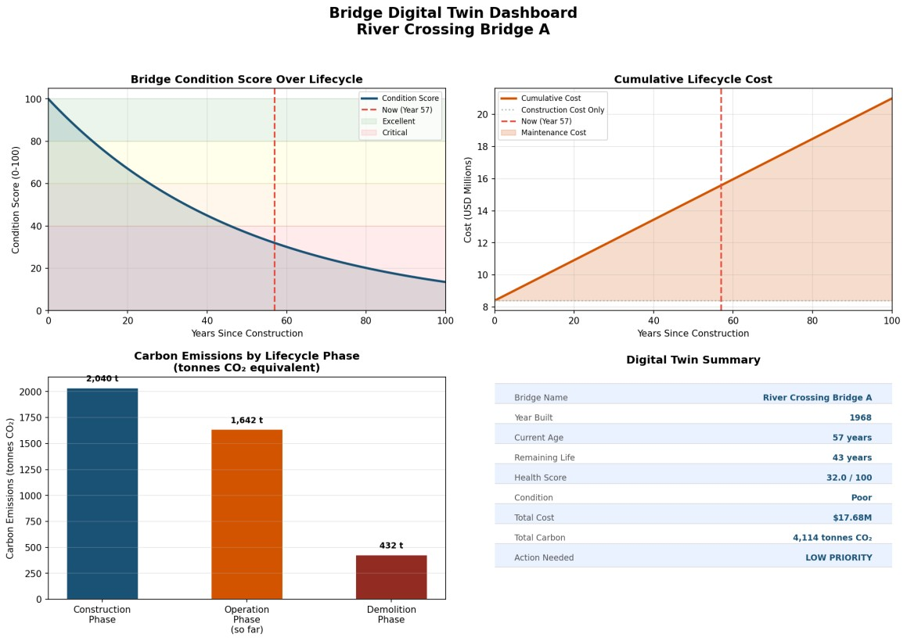
Figure 1: Digital Twin Dashboard — River Crossing Bridge A (Built 1968, Age: 57 years, Score: 32/100 — Poor)

Dashboard Chart — Bridge B (City Overpass, Built 1995)
Bridge B was built in 1995 and is currently 30 years old with a condition score of 54.9/100 (Fair). It is a Steel Composite structure with a smaller deck area than Bridge A. The dashboard shows a bridge that still has 70 years of remaining life — it is in its middle age. Maintenance costs are accumulating but the bridge is not yet in urgent need of attention. The carbon analysis shows lower construction emissions than Bridge A, reflecting the smaller deck area.
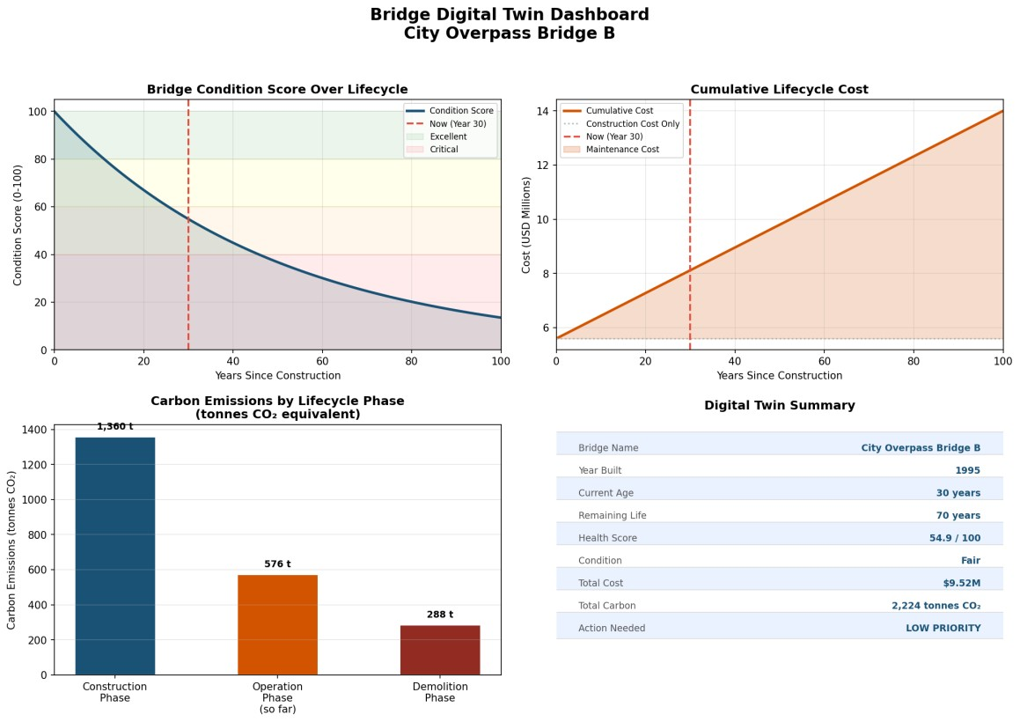
Figure 2: Digital Twin Dashboard — City Overpass Bridge B (Built 1995, Age: 30 years, Score: 54.9/100 — Fair)

Dashboard Chart — Bridge C (Industrial Link, Built 2010)
Bridge C is the newest bridge in our study, built in 2010 and only 15 years old. It has a health score of 74.1/100 (Good) and 85 years of remaining life. The cumulative cost graph shows that maintenance costs are minimal so far. The condition score graph shows this bridge is still in the green zone. From a circular asset management perspective, this bridge needs no immediate action — only regular monitoring.

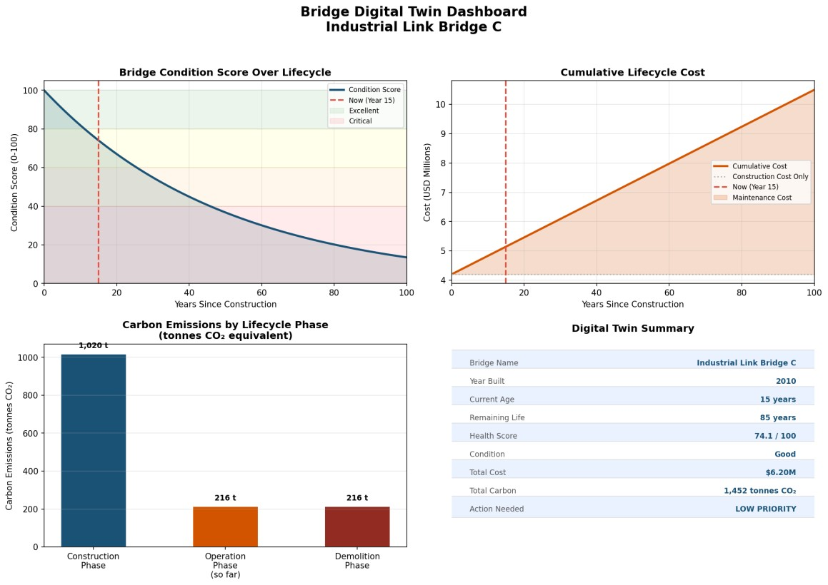
Figure 3: Digital Twin Dashboard — Industrial Link Bridge C (Built 2010, Age: 15 years, Score: 74.1/100 — Good)

Multi-Bridge Comparison Chart — Demolition Priority Assessment
The final chart is the most important one from a strategic demolition planning perspective. It compares all three bridges side by side across three key metrics: health score, remaining useful life, and total lifecycle carbon footprint. This directly mirrors the multi-scale BIM analysis described in the research paper allowing asset managers to quickly identify which bridge needs priority attention.
From this chart, it is immediately clear that Bridge A requires the highest priority attention it has the lowest condition score (32/100), shortest remaining life (43 years), and the largest carbon footprint. Bridge C, on the other hand, is in good shape and needs only routine monitoring.

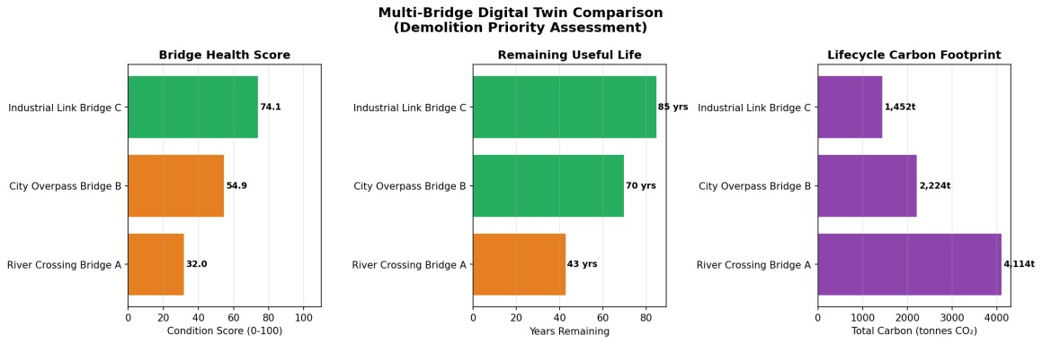
Figure 4: Multi-Bridge Comparison Chart — Health Score, Remaining Life, and Carbon Footprint across all three
bridges

Discussion

Connecting Results to the Research Paper
The research paper's central contribution is that by creating a BIM-based Digital Twin with time, cost, and carbon dimensions, infrastructure managers can make smarter, data-driven decisions about their assets' end-of-life. Our simulation demonstrates exactly this. When we look at Bridge A -- a 57-year-old reinforced concrete girder bridge — the Digital Twin immediately tells us:
- Its current condition is Poor (32/100), deteriorating on an exponential curve
- It has spent $7.18 million on maintenance in 57 years — 85% of its original construction cost
- Its total lifecycle carbon footprint is 4,113 tonnes CO₂
- It still has 43 years of remaining design life, so demolition is not yet urgent — but planning should begin soon

This is precisely the kind of actionable intelligence the research paper argues for, not just knowing a bridge is old, but knowing exactly where it stands in its lifecycle, what it has cost so far, and what it will cost to eventually demolish — so that the demolition can be planned strategically and sustainably.

Limitations of the Simulation
This project is a simplified academic implementation. The research paper's actual BIM model is far more sophisticated, incorporating:
- 3D geometric models linked to actual structural data and real sensor readings
- Detailed material-level carbon accounting using Environmental Product Declarations (EPDs)
- Integration with GIS systems for network-level bridge management
- Dynamic cost models that account for inflation and material price changes over time

Our Python simulation uses industry-average parameter values rather than real sensor data, and the exponential decay model is a simplification of actual structural deterioration. Despite this, the methodology model the bridge as a multi-dimensional data object, calculate condition, cost, and carbon across all lifecycle phases, and compare multiple assets is directly aligned with the research paper's approach.

Real-World Application
The value of the Digital Twin approach becomes enormous when scaled up. Imagine a state highway department managing 500 bridges. Instead of manually inspecting each one and making decisions, a Digital Twin system can:
- Automatically rank all bridges by urgency of action needed
- Generate 10-year maintenance and demolition budget forecasts automatically
- Identify clusters of bridges that will need demolition in the same period and plan resource allocation
- Track the total carbon commitment of the entire bridge portfolio and identify reduction opportunities through strategic material recycling during demolition

This is the vision of circular asset management that the research paper advocates for — and it all starts with the Digital Twin model that gives you reliable, real-time data on every asset.

Conclusion
This project successfully implements a Python-based Digital Twin simulation for bridge lifecycle management, based directly on the methodology described in the research paper by Sakdirat Kaewunruen, Connor O’Neill & Pasakorn Sengsri. The key conclusions are:

- Digital Twin works: By representing a bridge as a multi-dimensional data object (BIM parameters + time + cost + carbon), we can generate comprehensive lifecycle intelligence from simple inputs.
- Lifecycle cost is dominated by maintenance: For an older bridge like Bridge A (57 years), maintenance costs have already accumulated to 85% of the original construction cost. This reinforces the research paper's argument for proactive asset management.
- Construction phase dominates carbon: For all three bridges, the construction phase produces the largest share of carbon emissions. This highlights the importance of material selection in reducing environmental impact.
- Comparison enables prioritisation: The multi-bridge comparison chart immediately identifies which bridge needs priority attention exactly the "strategic demolition plan" the paper proposes.
- Circular asset management is achievable: With data-driven Digital Twin tools, managers can plan demolitions sustainably — scheduling material recovery, minimising waste, and reducing the carbon cost of bridge renewal.

In conclusion, the Digital Twin concept combining BIM with lifecycle cost and carbon analysis represents a powerful, practical approach to sustainable infrastructure management. This project demonstrates that even a simplified implementation of these ideas can yield meaningful, actionable insights for bridge asset managers.

