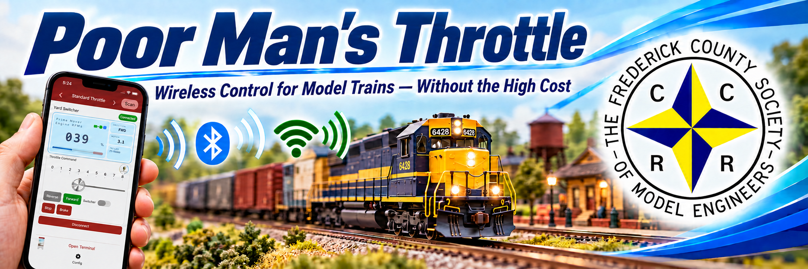
A practical alternative to high-cost wireless train control  PMT combines a smartphone app, a small low-cost ESP32 controller, and inexpensive electronics for traditional track-powered DC layouts and battery-powered locomotives. | THE GOAL  Make wireless model train control accessible to anyone who wants to build it.

WHY I BUILT PMT  • Wireless throttle systems can be expensive, closed, and difficult to justify for hobbyists who simply want reliable walk-around control.  • Battery-powered locomotive builders need a capable phone-based option without investing hundreds of dollars in proprietary hardware.  • Traditional DC layouts can suffer from low-speed hum, weak starting torque, and jerky slow-speed operation. | CORE FEATURES
  WHY IT RUNS BETTER
  PMT uses PWM (Pulse Width Modulation) to control the motor electronically for smoother low-speed running, stronger starts, less hum, and wireless walk-around operation.
  DRIVE & BRAKE  Control speed and direction, stop quickly, simulate realistic acceleration and slowing, use variable braking, and switch to a reduced-speed yard mode. | BLUETOOTH + WI-FI  Bluetooth is the normal wireless connection. Optional Wi-Fi can provide a second connection if it is configured.
  SPEED TUNING  Shape how a locomotive responds to the throttle and visually speed-match two or more locomotives so they run smoothly together. | SAFETY & BATTERY  Stop every connected locomotive in an emergency. An optional battery monitor can show voltage, current, and power and can warn, limit speed, or stop the motor when battery voltage gets too low.
  LIGHTS, SOUNDS & FUNCTIONS  Set up to 12 customizable functions for lights, accessories, bell, horn, crew chatter, and your own sound effects. More function slots are planned in a near-term release. | AUTOMATION  Create schedules and reusable operating routines, including recorded command sequences that can play back with their original timing.
  CONFIGURATION  Change settings wirelessly, keep them after power-off, back them up, restore or copy them to another locomotive, and give each device an easy-to-recognize name. | OPEN & EXPANDABLE  Works with several common motor-control boards, supports secure wireless software updates on ESP32-S3 builds, can connect with compatible external software, and shares the app with Poor Man's Module and Poor Man's Turbine devices.

TRADITIONAL DC  Electronic motor control from steady track power | BATTERY POWER  Locomotives powered by onboard batteries | DIY / MAKERS  Low-cost, widely available parts | ANY SCALE  Especially useful for G scale
MORE THAN A THROTTLE
The app is the control center for a growing model-railroad system that goes well beyond basic speed and direction.
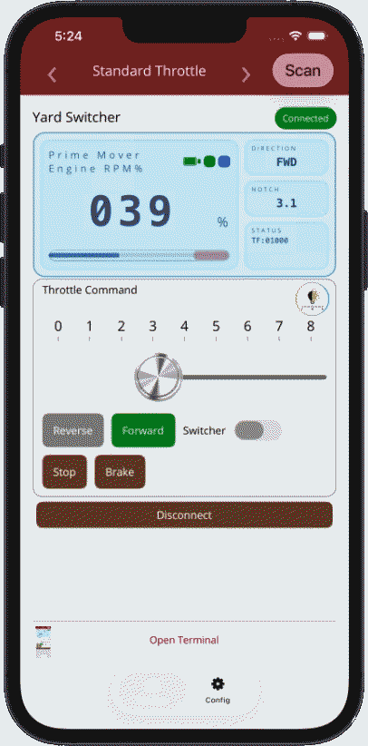  ACTUAL STANDARD THROTTLE  Screenshot from the supplied PMT project
  THREE OPERATOR MODES  Choose Novice, Standard, or Expert controls. Novice mode can be locked for youngsters, guests, or anyone who needs a simpler throttle. | SETUP & TROUBLESHOOTING  Built-in help, troubleshooting tools, direct settings controls, and installer diagnostics are available when you want to go beyond the basic screens.
  MULTIPLE LOCOMOTIVES  Run groups of locomotives together, control their shared functions, still reach individual locomotive functions, and visually speed-match them so they pull together smoothly. | CUSTOM SOUND  Use steam or diesel sound profiles, install your own sound recordings, assign custom sounds to buttons, and share complete sound sets with other PMT users.
  PERSONALIZATION  Personalize the app with your railroad's look and colors, choose from multiple languages, and use accessibility-focused options. | BEYOND LOCOMOTIVES  The same app can control locomotives, Poor Man's accessory modules, and Poor Man's Turbine devices. Advanced users can also connect compatible external software.
ESP32-S3 BUILD AT A GLANCE Motor Driver → Optional Sound → Optional Battery Management
ESP32-S3 is the small, inexpensive controller board at the heart of this PMT build.
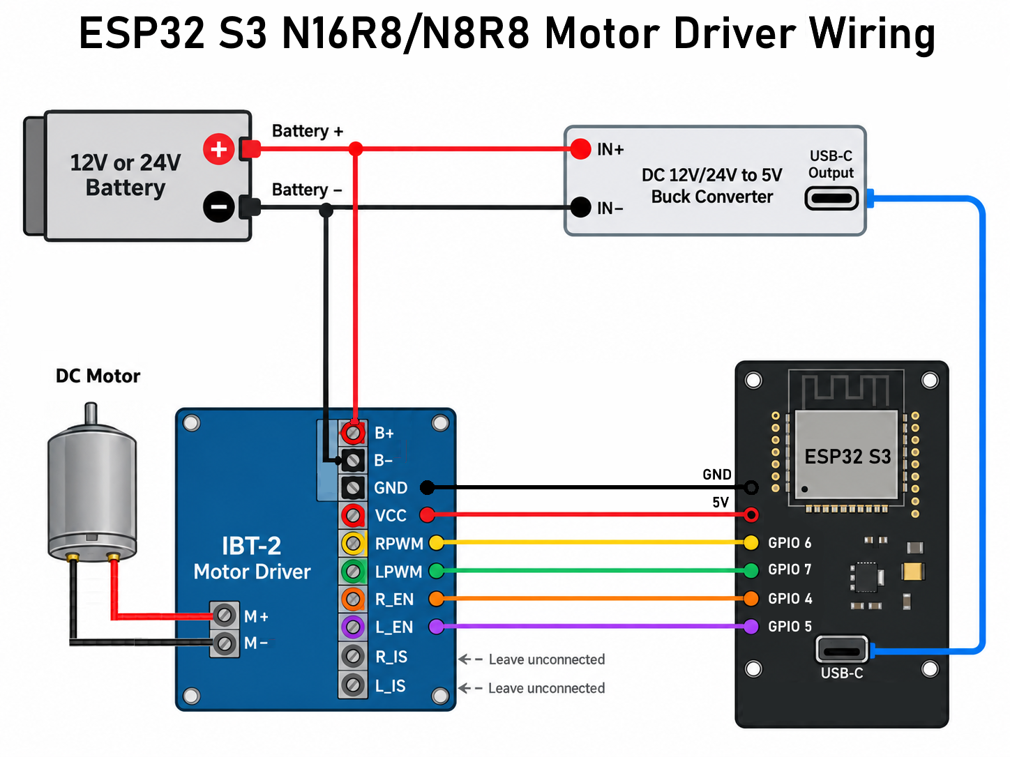 | 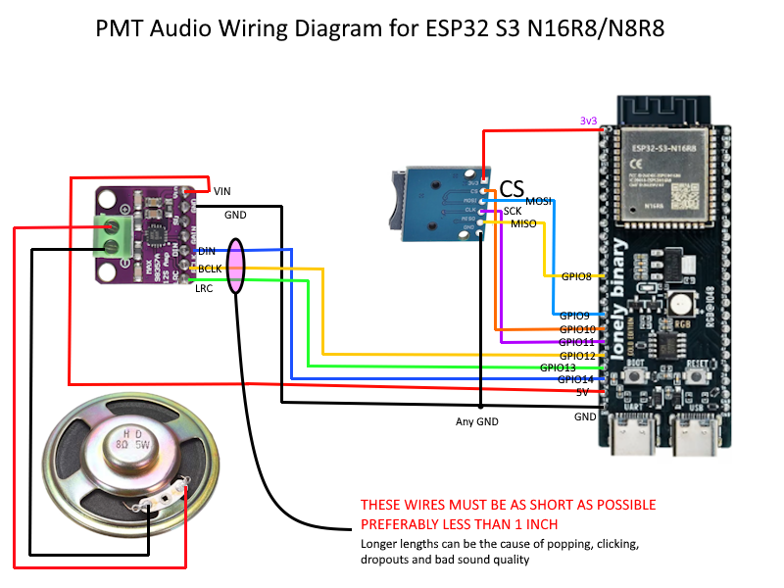 | 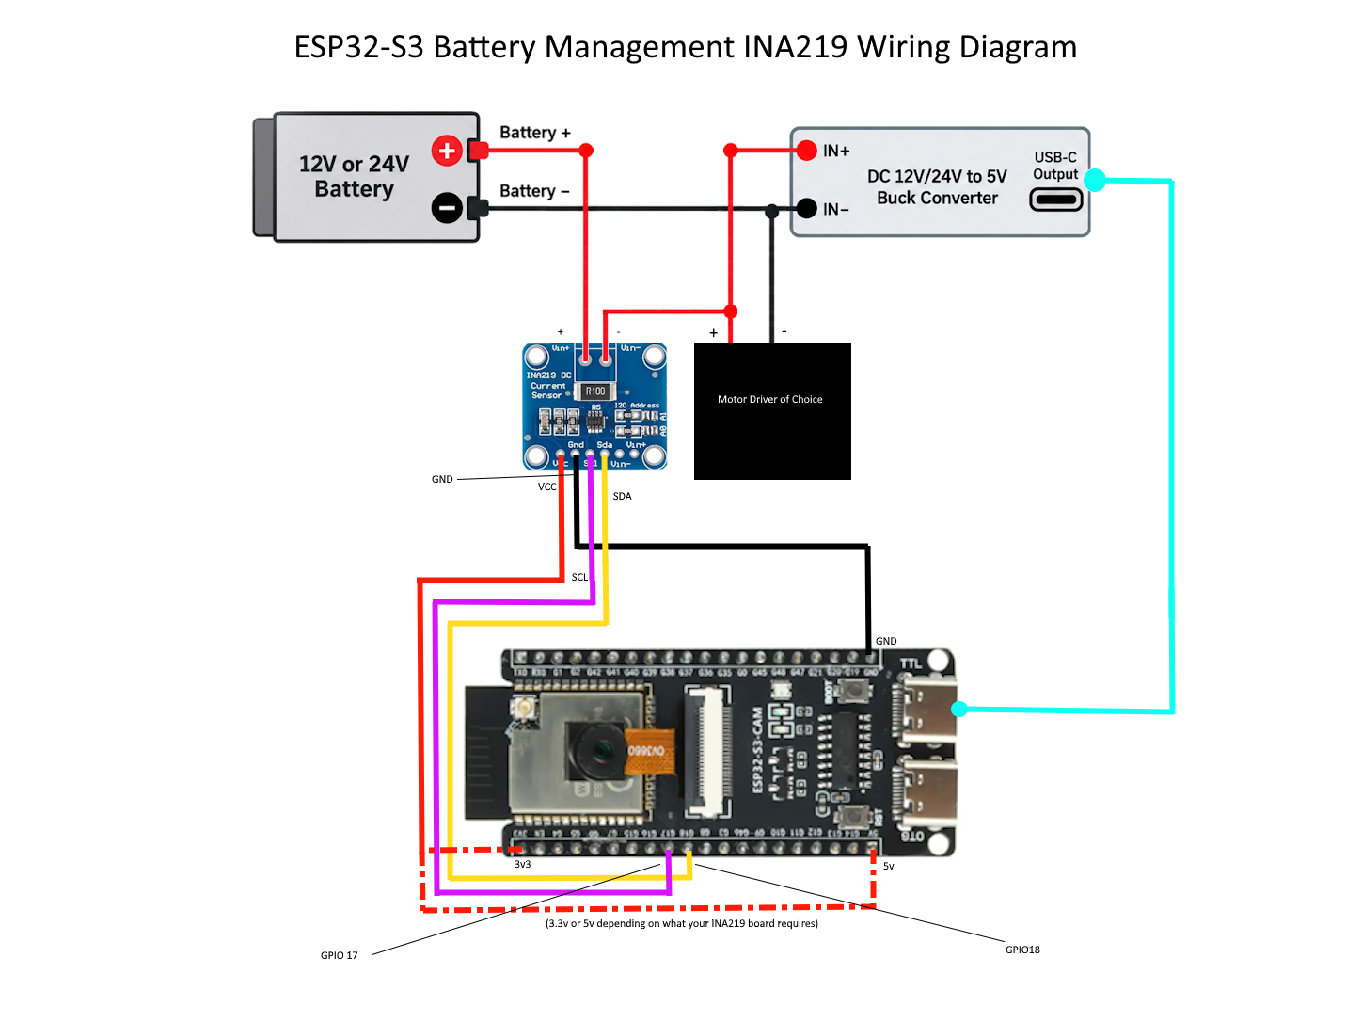
1 MOTOR DRIVER  CORE INSTALLATION  ESP32-S3 motor-driver (motor-control board) wiring | 2 SOUND  OPTIONAL ADD-ON TO #1  ESP32-S3 sound-system wiring | 3 BATTERY MANAGEMENT  OPTIONAL ADD-ON TO #1  ESP32-S3 battery-monitoring / management wiring
  SCAN FOR INSTALLATION GUIDE |   SCAN FOR INSTALLATION GUIDE |   SCAN FOR INSTALLATION GUIDE
GET INVOLVED Scan or type the address - this flyer is designed for print
  INSTALLATION HUB  jamocle.github.io/  PoorMansThrottle-DIY/Installer/ |   FULL DOCUMENTATION  https://jamocle.github.io/  PoorMansThrottle-DIY/Installer/home.html  #documentation  Documentation page |   PROJECT FILES (GITHUB)  github.com/jamocle/  PoorMansThrottle-DIY |   iOS + ANDROID APPS  https://jamocle.github.io/  PoorMansThrottle-DIY/Installer/home.html  #app-installation,app-installation-android,  app-installation-apple  App installation page
BUILD IT • TUNE IT • RUN IT |  | LEARN • SHARE • HELP IT GROW

