Jamoma Workshop

Alexander Refsum Jensenius,ª Timothy Place,^{b} Trond Lossius,^{c}
Pascal Baltazar,^{d} Dave Watson
^{a)} University of Oslo & Norwegian Academy of Music, a.r.jensenius@imv.uio.no
^{b)} Electrotap, tim@electrotap.com
^{c)} BEK - Bergen Center for Electronic Arts, lossius@bek.no
^{d)} GMEA - Groupe de Musique Electroacoustique d’Albi-Tarn, pb@gmea.net

Jamoma
Jamoma is an open-source project for developing a structured and modularized approach to programming in Max/MSP and Jitter. The main idea of Jamoma is the module, which is built up of a separate algorithm patcher and a patcher containing the graphical user interface. Figure 1 shows examples of the three main types of modules: control, audio and video.
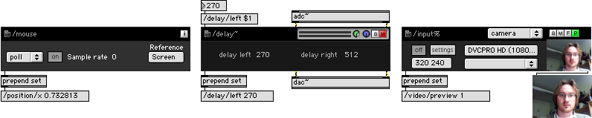
Figure 1. Examples of the three main types of modules (from left): control, audio and video.

Besides providing a large collection of ready-made modules, one of the core strengths of using Jamoma in Max development is that it simplifies the creation of large projects by enforcing a structured approach to the patching. Jamoma uses Open Sound Control (OSC) for internal and external messaging, thus making it easy to Recent development adds support for cues, various types of mappings and an extensive ramping library including a modular function and dataspace library.
Description of the Workshop
The workshop is aimed at beginning and intermediate Jamoma users. Participants should be familiar with Max/MSP and Jitter to get the most out of the workshop. We advise participants to download the latest version of Jamoma before the workshop.
- Introduction:
  - The idea behind Jamoma, the need for modularity and flexibility
  - Using version control in development, updating Jamoma from the SVN repository
- Working with Jamoma:
  - Creating a patch from modules
  - Communicating to and from modules
  - Ramping of parameters
  - Mapping between modules
  - Setting up cues
- Developing a module:
  - The algorithm
  - The module patcher
  - Handling presets
  - Documentation
- Examples of scientific and artistic projects using Jamoma

More information about the workshop at: http://www.jamoma.org/wiki/JamomaWorkshopInGenova2008

http://www.jamoma.org
http://jamoma.svn.sourceforge.net/viewvc/jamoma/

