OS ASSIGNMENTS
EXPERIMENT 5:
CODE:
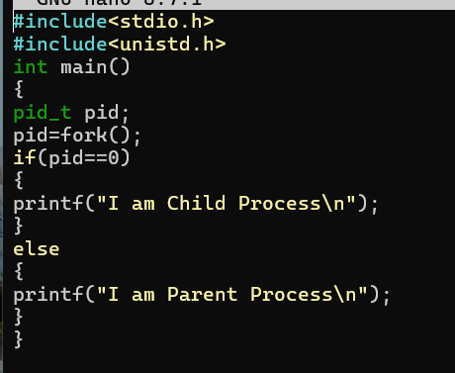
Output:
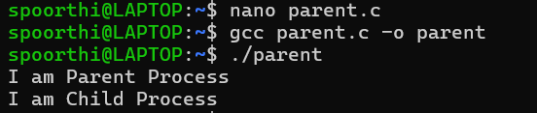
EXPERIMENT 6
CODE:
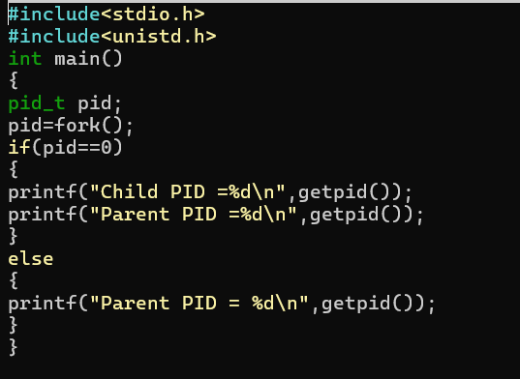
OUTPUT:
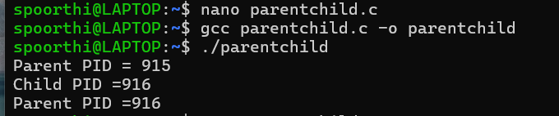
EXPERIMENT 7
CODE:
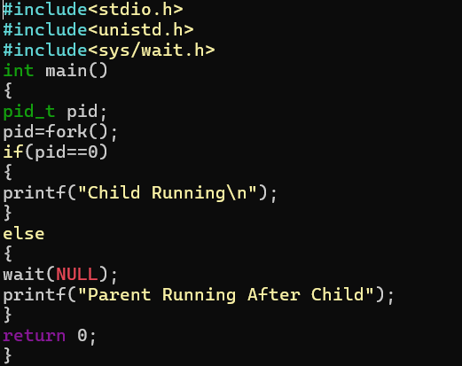
Output:
