OPERATING SYSTEM
1.EXPERIMENT
CODE:
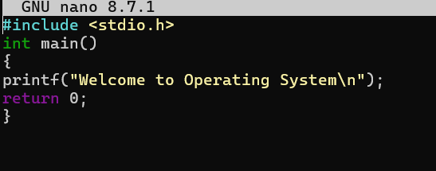
OUTPUT:
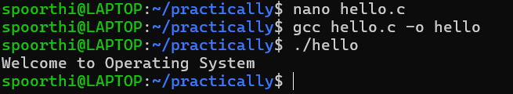
------------------------------------------------------------------------------------------------------------
2.EXPERIMENT
CODE:
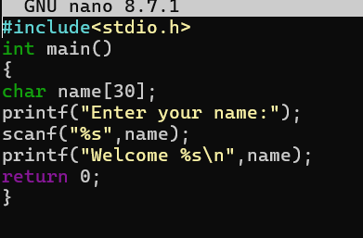
OUTPUT:
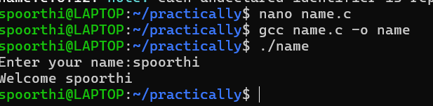
3.EXPERIMENT
CODE:
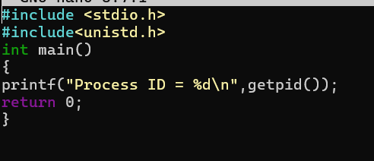
OUTPUT:
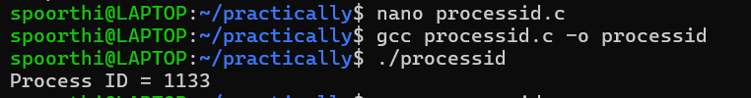
4.EXPERIMENT
CODE:
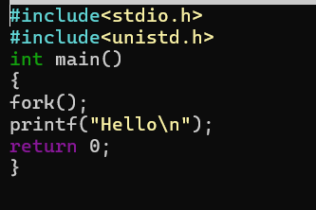
OUTPUT:
