**Video game sales prediction: machine learning regression for predicting video game sales**

**ABSTRACT:**

***The video game sales prediction: machine learning regression for predicting video game sales. the video games are installed so many people. so do project by using machine learning regression for predicting video game sales.***

***INTRODUCTION:***

***Video game industry needs accurate sales in an exponential market growth. so we have to predict the buying nature of several video game followers by using historical sales data. This study involves extracting the video game sales data and analysing which game has more sales globally when compared to other countries. with this we used machine learning techniques which predict the sales of video game in the market. This approach is useful to several industries which are interested in predicting the sales data.***

***TECHNOLOGIES:***

*The technologies are used for video game sales prediction: machine learning regression for predicting video game sales. They are sales prediction, machine learning and also linear regression.*

**DESIGN:**

*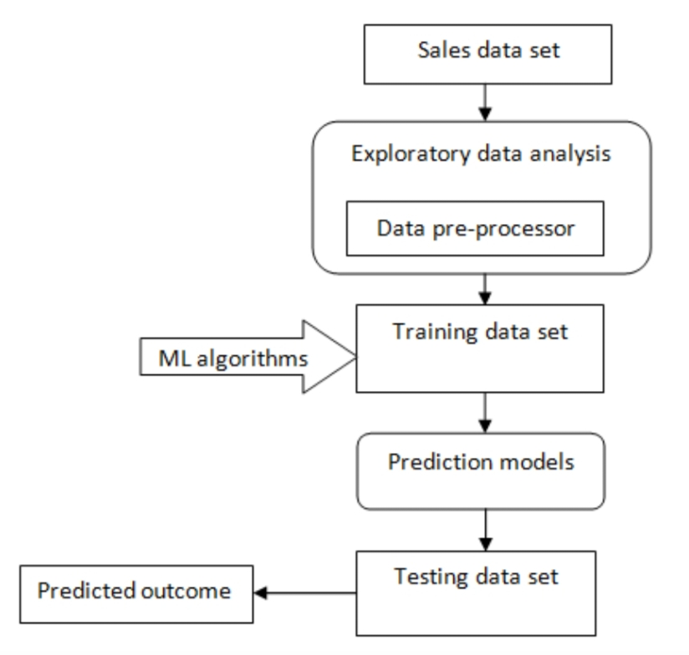There are few steps of the video game sales:*

**CONCLUSION:** *sales prediction is a crucial part of the strategic planning process. It allows a company to forecast how the company will perform in the future. Predicting sales of a company is not only for planning new opportunities, but also allow knowing the negative trends that appear in the prediction.*

**EXPECTED OUT PUT:**

*The prediction of sales on video games has done and also game has more sales in the market globally. For predicting sales of video games applied several machine learning algorithms.*