### Experience

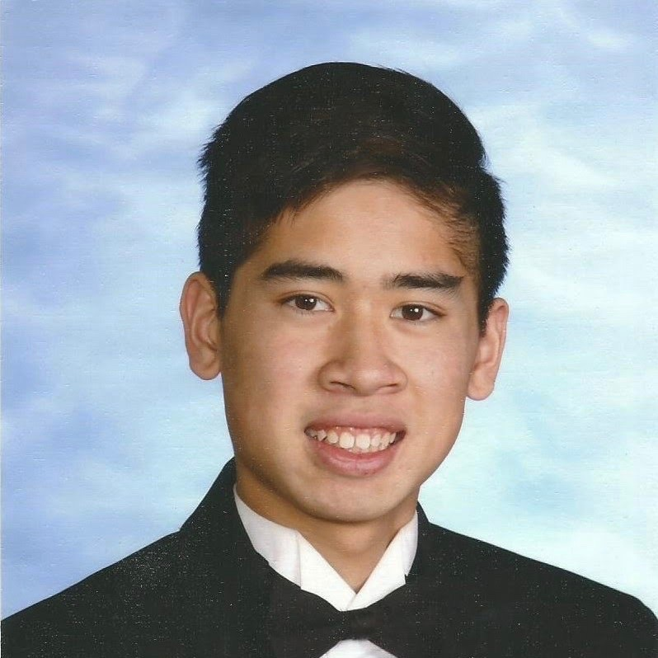

John Dang

Senior at evergreen valley high school

# Objective

Current high school senior and incoming computer science undergraduate student seeking summer software engineering internship.

## Skills

Programming: Java, HTML, Python, CSS, JavaScript, Git, Github

Robotics: Programming, Electrical, Mechanical

Other: Microsoft Office

## Contact and social

Email: john.amq.dang@gmail.com

Phone: 669-294-3916

LinkedIn: linkedin.com/in/johnamqdang

Github: github.com/jamqd

Website: johndang.me

#### FRC Lead and FTC Secretary • EVHS Robotics

##### 2015 - 2018

This is the place for a brief summary of your key responsibilities and accomplishments.

#### COSMOS Student • UC Davis

##### summer 2017

This is the place for a brief summary of your key responsibilities and accomplishments.

### Education

#### UCLA • Computer SCience and Engineering

##### 2018 - 2022

Achievement Scholarship Recipient

#### Evergreen valley High School

##### 2014 – 2018

GPA: 4.0 (Unweighted), 4.31 (Weighted)

AP Courses: Computer Science, Physics C, Calculus BC, Calculus AB, Statistics, Macroeconomics, US Government, World History, English Language

### Awards/Projects