Sukhdeep kaur(721440)

Assignment-4

Data Visualization

Screenshots of visualization with python

Using two libraries Numpy and matplotlib

**NumPy** is a library for the [Python programming language](https://en.wikipedia.org/wiki/Python_(programming_language)), adding support for large, multi-dimensional [arrays](https://en.wikipedia.org/wiki/Array_data_structure) and [matrices](https://en.wikipedia.org/wiki/Matrix_(math)), along with a large collection of [high-level](https://en.wikipedia.org/wiki/High-level_programming_language) [mathematical](https://en.wikipedia.org/wiki/Mathematics) [functions](https://en.wikipedia.org/wiki/Function_(mathematics)) to operate on these arrays.

**Matplotlib.pyplot** is a plotting library used for 2D graphics in python programming language. It can be used in python scripts, shell, web application servers and other graphical user interface toolkits.

Program in Python

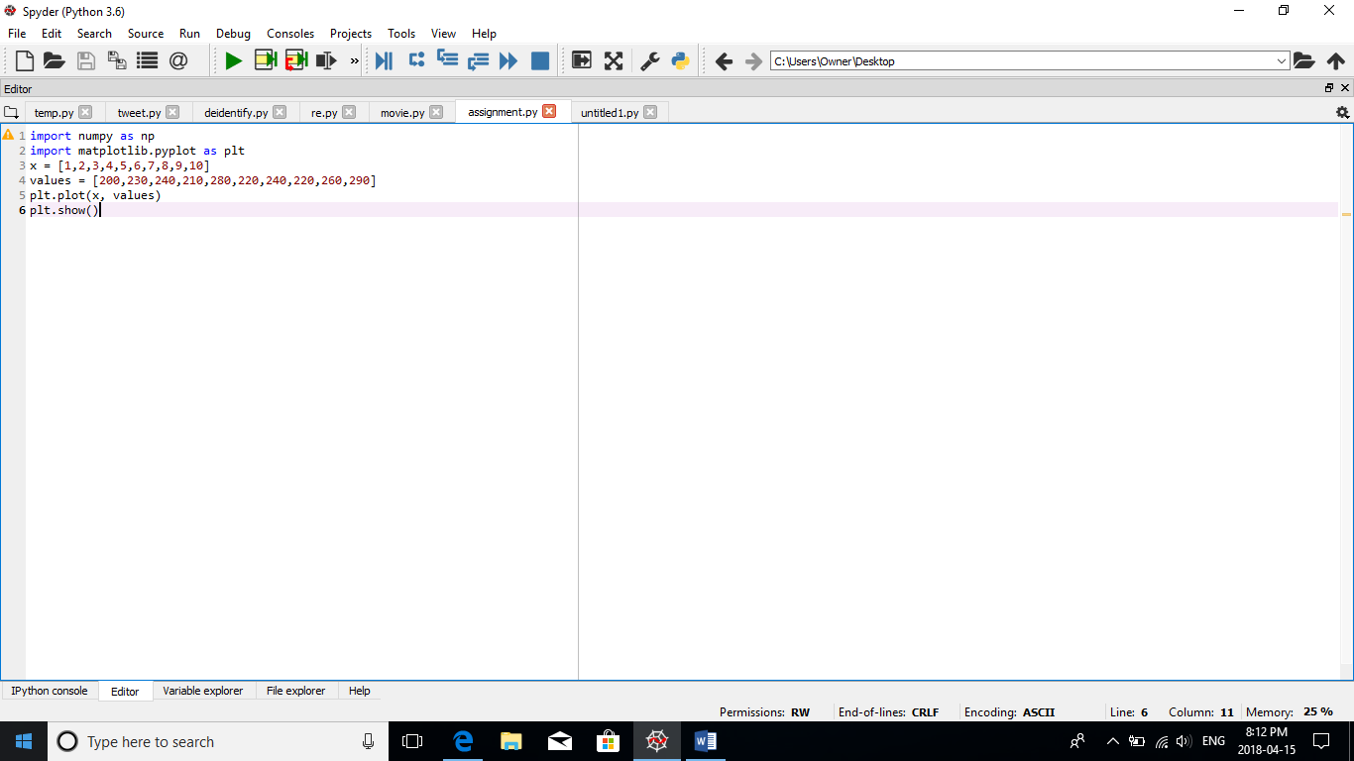

Output is seen in below figure

