CentOS7搭建GitLab服务器
1. 安装依赖软件
yum -y install policycoreutils openssh-server openssh-clients postfix
2.设置postfix开机自启，并启动，postfix支持gitlab发信功能
systemctl enable postfix && systemctl start postfix
3.下载gitlab安装包，然后安装
centos 7系统的下载地址:https://mirrors.tuna.tsinghua.edu.cn/gitlab-ce/yum/el7
wget https://mirrors.tuna.tsinghua.edu.cn/gitlab-ce/yum/el7/gitlab-ce-8.0.0-ce.0.el7.x86_64.rpm
rpm -i gitlab-ce-8.0.0-ce.0.el7.x86_64.rpm

4.修改gitlab配置文件指定服务器ip和自定义端口：
vim /etc/gitlab/gitlab.rb
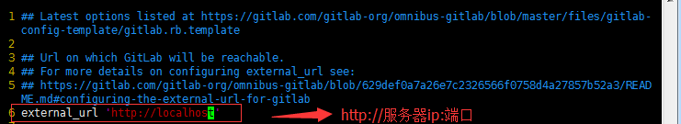
退出并保存

5.重置并启动GitLab
执行：
gitlab-ctl reconfigure
gitlab-ctl restart
ok: run: gitlab-git-http-server: (pid 3922) 1s
ok: run: logrotate: (pid 3929) 0s
ok: run: nginx: (pid 3936) 1s
ok: run: postgresql: (pid 3941) 0s
ok: run: redis: (pid 3950) 0s
ok: run: sidekiq: (pid 3955) 0s
ok: run: unicorn: (pid 3961) 1s
提示“ok: run:”表示启动成功
6.访问 GitLab页面
如果没有域名，直接输入服务器ip和指定端口进行访问
第一次登录修改密码
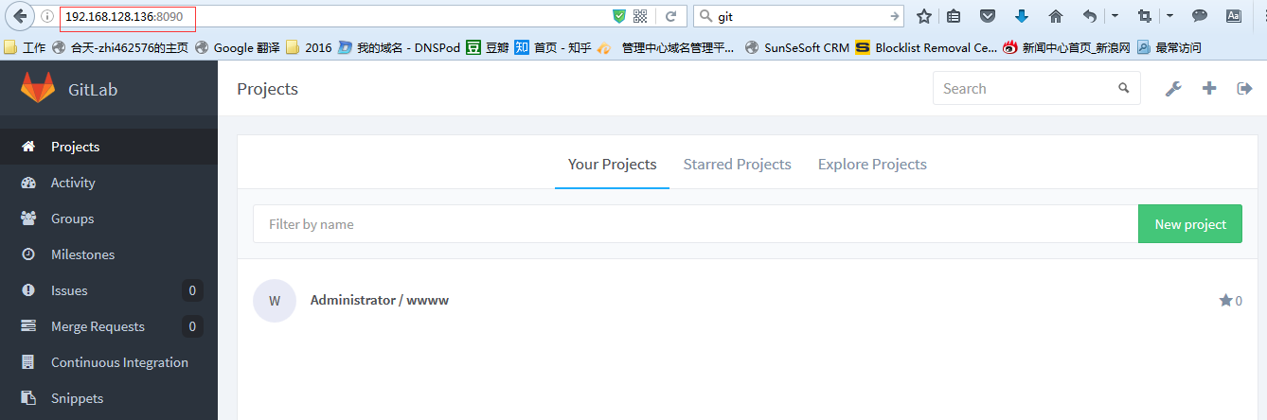

6.设置gitlab发信功能，需要注意一点：
vim /etc/gitlab/gitlab.rb
gitlab_rails['smtp_enable'] = true
gitlab_rails['smtp_address'] = "smtp.163.com"
gitlab_rails['smtp_port'] = 465
gitlab_rails['smtp_user_name'] = "janeeyer111@163.com"
gitlab_rails['smtp_password'] = "qinxxxxx"
gitlab_rails['smtp_domain'] = "163.com"
gitlab_rails['smtp_authentication'] = :login
gitlab_rails['smtp_enable_starttls_auto'] = true
gitlab_rails['smtp_tls'] = true
gitlab_rails['gitlab_email_from'] = 'janeeyer111@163.com'

gitlab-ctl reconfigure

gitlab-ctl restart

进入控制台：
gitlab-rails console
测试邮件发送：
Notify.test_email('janeeyer111@163.com', '测试报告', '这是我的测试报告，请查收!').deliver_now

