Manfred Fink

Work-Report Drysal-Project: Stellenbosch 25th February – 10th March 2007-03-09

- 25th February: Arrival
- 26th February:
  - Discussion with Prof. Dr. Martin Fey, Dr. Andrei Rozanov and Willem de Clercq about the working plan: first task is the implementation of conceptual salt modelling routines in JAMS-J2k-S. These routines should be adaptations of the existing J2k-S nitrogen routines. A second task is the preparation and the presentation of a lecture about the modelling of the nitrogen-cycle on Tuesday the 6th March.
- 27th February:
  - Work on the implementation of the salt routines.
- 28th February:
  - Work on the implementation of the salt routines.
- 1st March:
  - First draft of the salt routines for J2k-S has been implemented. The components are:
    - j2kpotCropGrowthsalt: Crop growth routine that calculates biomass and the plant salt pool.
    - j2k_soil_salt: Component that describes the salt movement in the soil including: plant uptake, decomposition of plant residues, leaching of salt out of the soil, lateral salt movement and capillary rise of salt.
    - J2KsaltRoutinglayer: The salt routing component, which manages the lateral fluxes from model unit to model unit.
    - J2KGroundwaterNaCl: The ground water salt component that calculates the mixing and the delay of salt in the groundwater.
    - J2KProcessReachRouting_NaCl: The salt routing component in the reach segments, which manages the lateral fluxes reach segment to reach segment.
    - InitJ2KNaClSoillayer: Initialising routine for the soil salt pools.
    - InitJ2KGroundwaterNaCl: Initialising routine for the groundwater salt pools.
  - A test run of the new implemented salt model was carried of with a test data set that reflects middle European conditions. The amount of salt that enters the system via atmospheric deposition was increased to a south African level. This was done to see some reaction of the System. A result of is model application is shown up in figure 1.

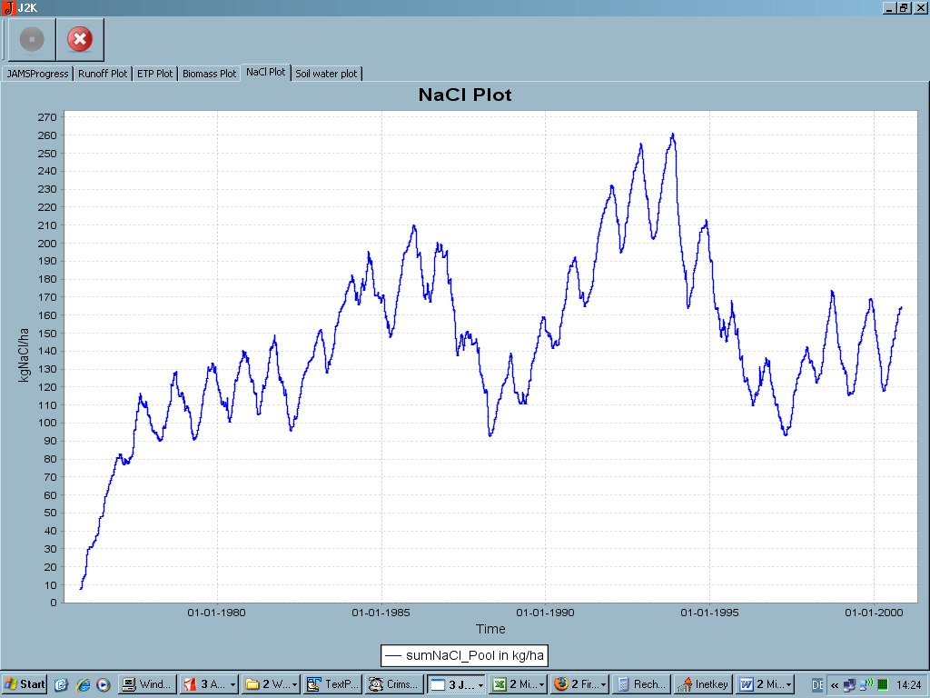
Figure 1: Average salt amount in the soil profile.

The curve of the soil salt pool shows that after 7 years of simulation equilibrium is reached. The dryer years in the middle of the 80ies and in the beginning of the 90ies are characterised with higher salt amount, which is very plausible.
  - Discussion with Prof. Dr. Martin Fey, Dr. Andrei Rozanov and Willem de Clercq about d writing a paper about the modelling of a soil profile. The exiting salt measurements from a soil profile should be reproduced in a Hydrus1D application using a long term climate record. Start of the modelling is in Stellenbosch.
- 2nd March: Field trip with Willem de Clercq: Explanation of the landscape of the Berg-river catchment including visits of the goedertrou, sandspruip subcatchments. The installed measurement equipment of both subcatchments was shown as well.
- 5th March: Perpetration of the lecture for Tuesday
- 6th March:
  - Presentation of the lecture about the modelling of the nitrogen-cycle.
  - Afterwards discussion with Willem de Clercq, Dr. Andrei Rozanov and Dr. Nebo Jovanovic about the possibility to model nitrogen pollution caused by clear cutting. They would like to include the nitrogen modelling in the upcoming proposal.
  - Start of the Hydrus1D modelling
- 7th March:
  - Continuing of the Hydrus1D modelling
  - Discussion with Dr. Eduard Hoffmann about the j2k-salt modelling. Especially the effect of the implementation of salt stress were discussed.
- 8th March:
  - Field trip with Dr. Freddie Ellis: Explanation of the soils of the whole Berg-river catchment including a visit in the Klein Berg subchatchment. Explanation with different soil profiles and the existing soil map. Explanation of the soil and land use relationship and the use different melioration measures.
  - First results of the Hydrus1D modelling (Figure 2).
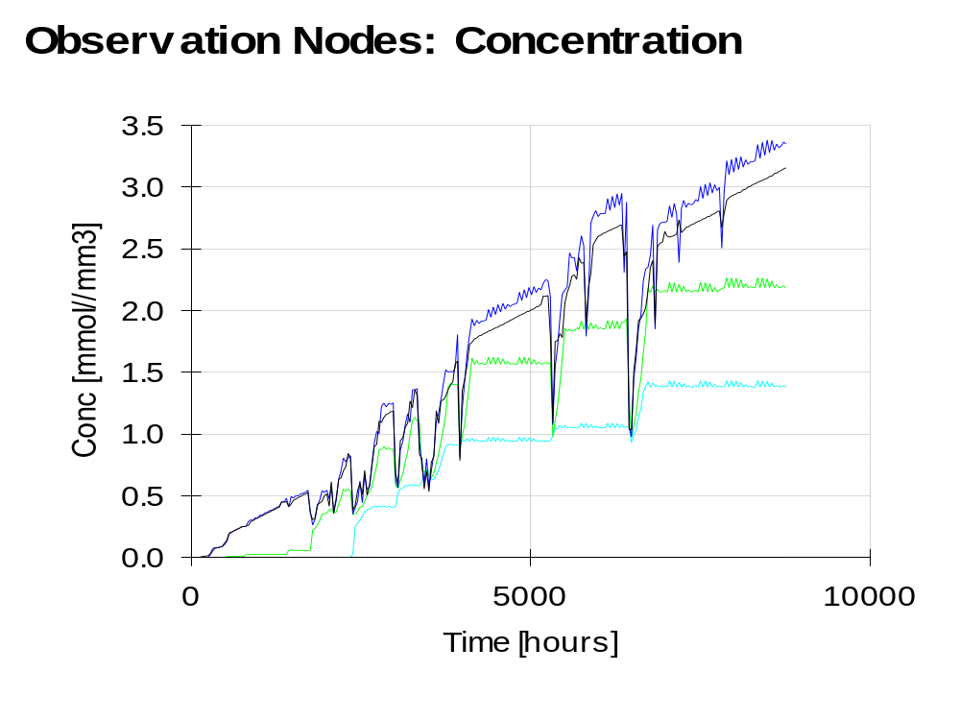
Figure 2: Salt concentrations after one year of simulation in different depth of the soil profile.
- 9th March:
  - Discussion with Prof. Dr. Martin Fey, Willem de Clercq and Anton Kunecke about the possibility to use of longer climate records for the Hydrus1D modelling.
  - Report writing.

